CMS FLOW (VIDEO) PROBLEMS
Problem in case CMS videos are not working in your computer
Here goes the solution…
The Internet Explorer 5.5 or above has by-default setting of blocking any type of pop-ups from any URL. As all the video of CMS Flow are in pop-up windows, we have to allow only Punjab University website to show all the pop-ups.
Step 1: Open Internet Explorer
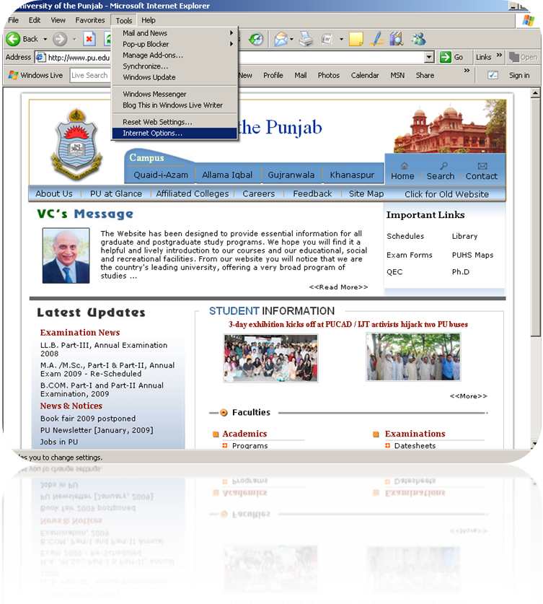
Step 2: Click on Tools → Internet Options …

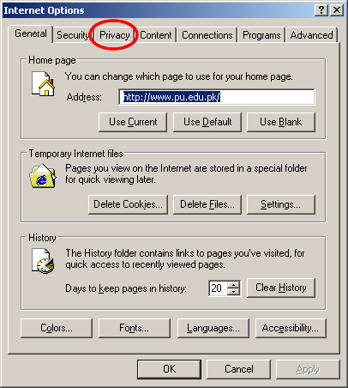
Step 3: Click on ‘Privacy’ tab
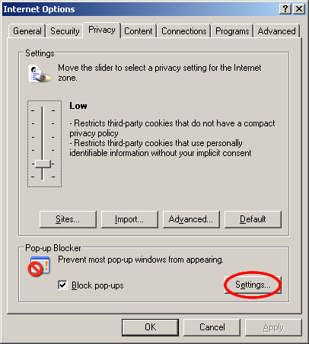
Step 4: Click on ‘Settings…’ button
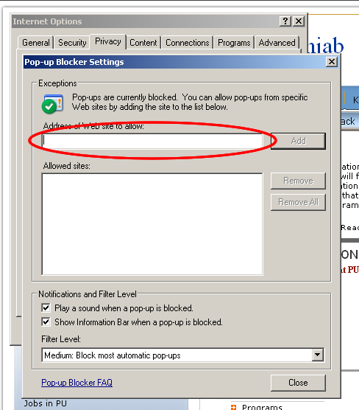
Step 5: Type “www.pu.edu.pk” in the highlighted area. This highlighted area is called as ‘Address of the website to allow. By adding Punjab University URL here, you can allow pop-ups from Punjab university web site.
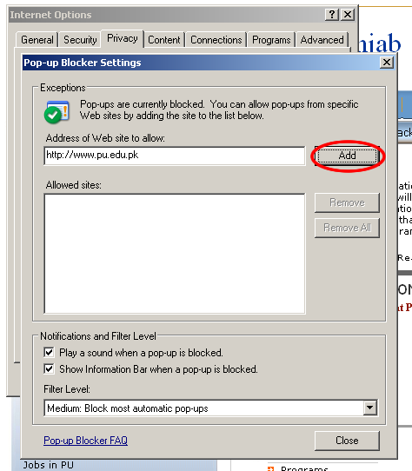
Step 6: Click ‘Add’ button and the given Punjab University web site address will be entered in your Allowed sites:
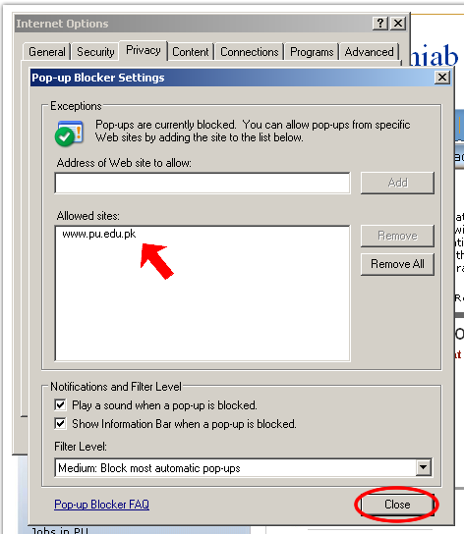
Step Last: Close this window by press ‘Close’ button and then press ‘OK’ ok Privacy window (Internet Options windows) and then try open the given CMS Flow URL.
www.pu.edu.pk/cmsflow
----------------------------------------------------------------

Please contact Information Technology Centre in case of any else query.
IT Centre Phone Number:- 9231119

