Academic Advisement
Created on Thursday, July 02, 2009
Copyright & Trademarks
Copyright © 2003, 2007, Oracle. All rights reserved. Powered by OnDemand Software. Distributed by Oracle under license from Global Knowledge Software LLC. © 1998-2007. All rights reserved.

The information contained in this document is subject to change without notice. If you find any problems in the documentation, please report them to us in writing. This document is not warranted to be error-free. Except as may be expressly permitted in your license agreement for these Programs, no part of these Programs may be reproduced or transmitted in any form or by any means, electronic or mechanical, for any purpose.

If this documentation is delivered to the United States Government or anyone using the documentation on behalf of the United States Government, the following notice is applicable:

U.S. GOVERNMENT RIGHTS
The U.S. Government’s rights to use, modify, reproduce, release, perform, display, or disclose these training materials are restricted by the terms of the applicable Oracle license agreement and/or the applicable U.S. Government contract.

Oracle, JD Edwards, PeopleSoft, and Siebel are registered trademarks of Oracle Corporation and/or its affiliates. Other names may be trademarks of their respective owners.

Table of Contents
Academic Advisement Reports 1
Request Advisement Report 1

Academic Advisement Reports

Request Advisement Report

Procedure

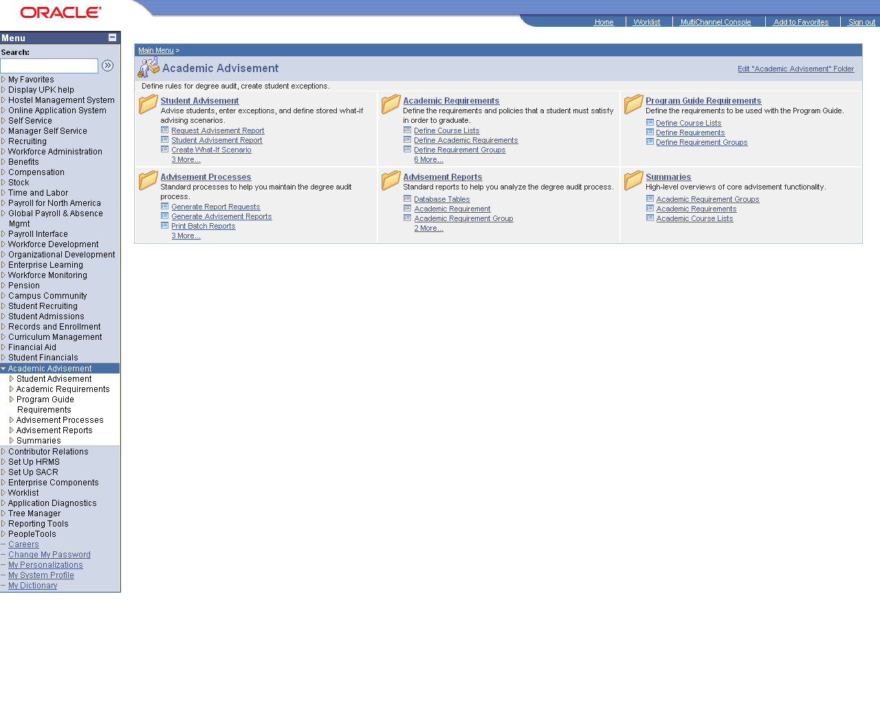

Step | Action
 | Click the Request Advisement Report link.

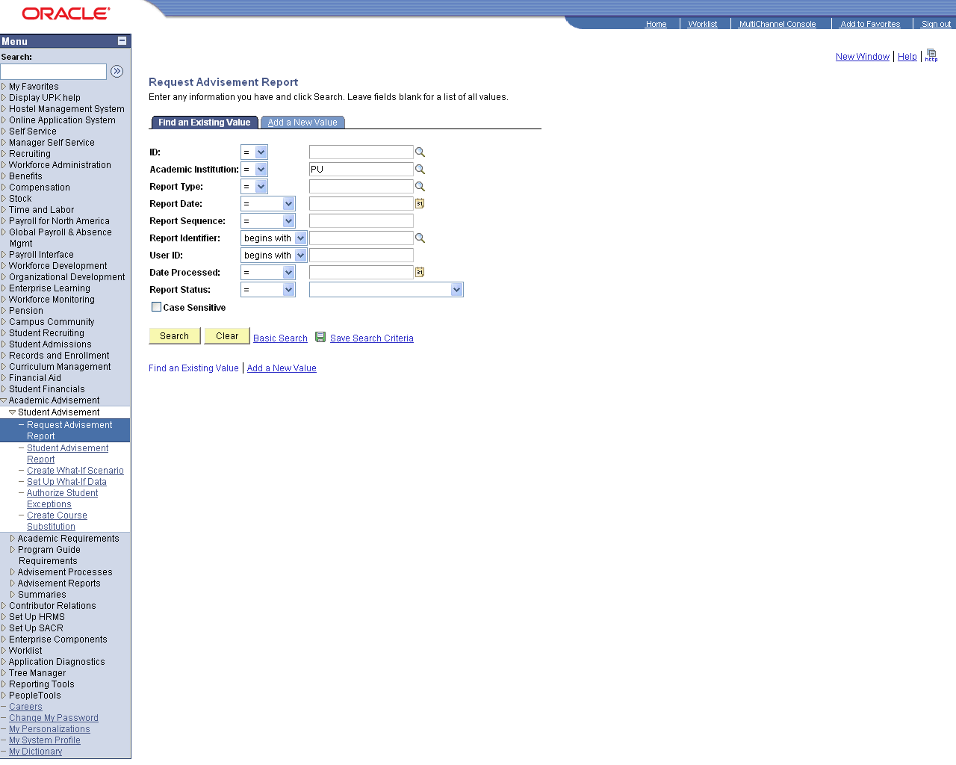

Step | Action
 | Click the Add a New Value tab.
 | Enter the desired information into the ID field. Enter "05pu001".
 | Click the Look up Report Type (Alt+5) button.
 | Click an entry in the Description column.
 | Click the Add button.

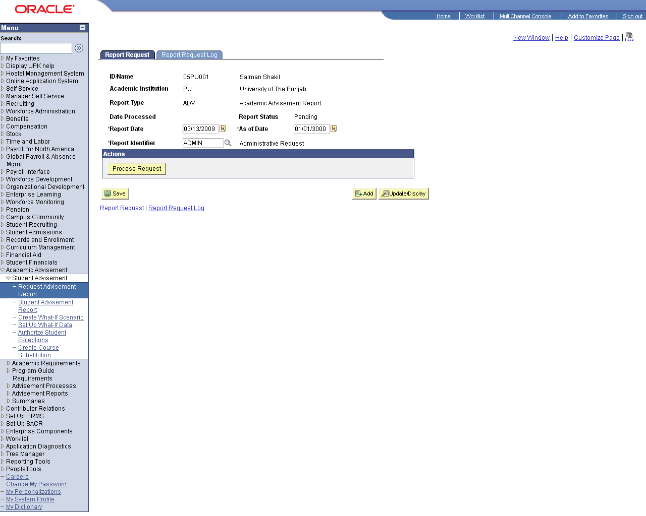

Step | Action
 | Click the Process Request button.

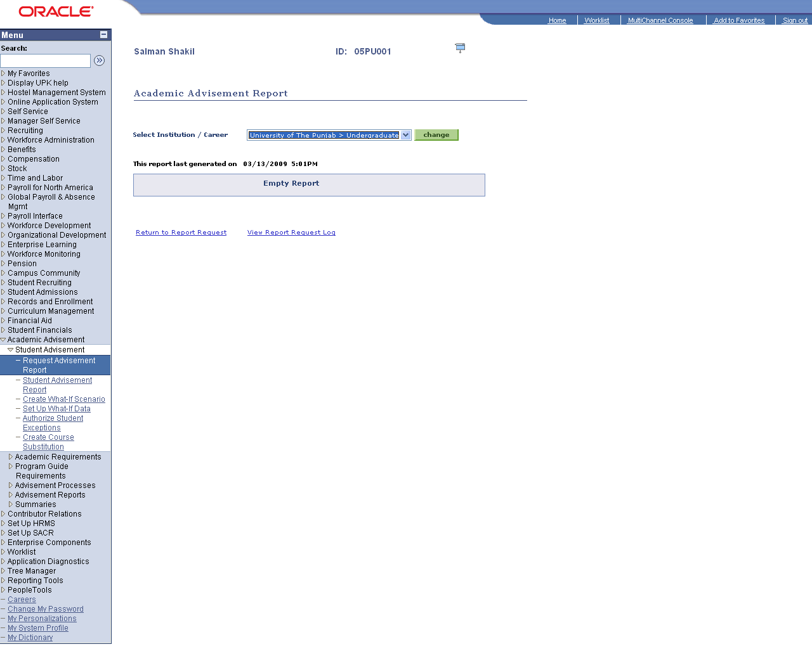

Step | Action
 | Click the Change button.
 | Click the Return to Report Request link.

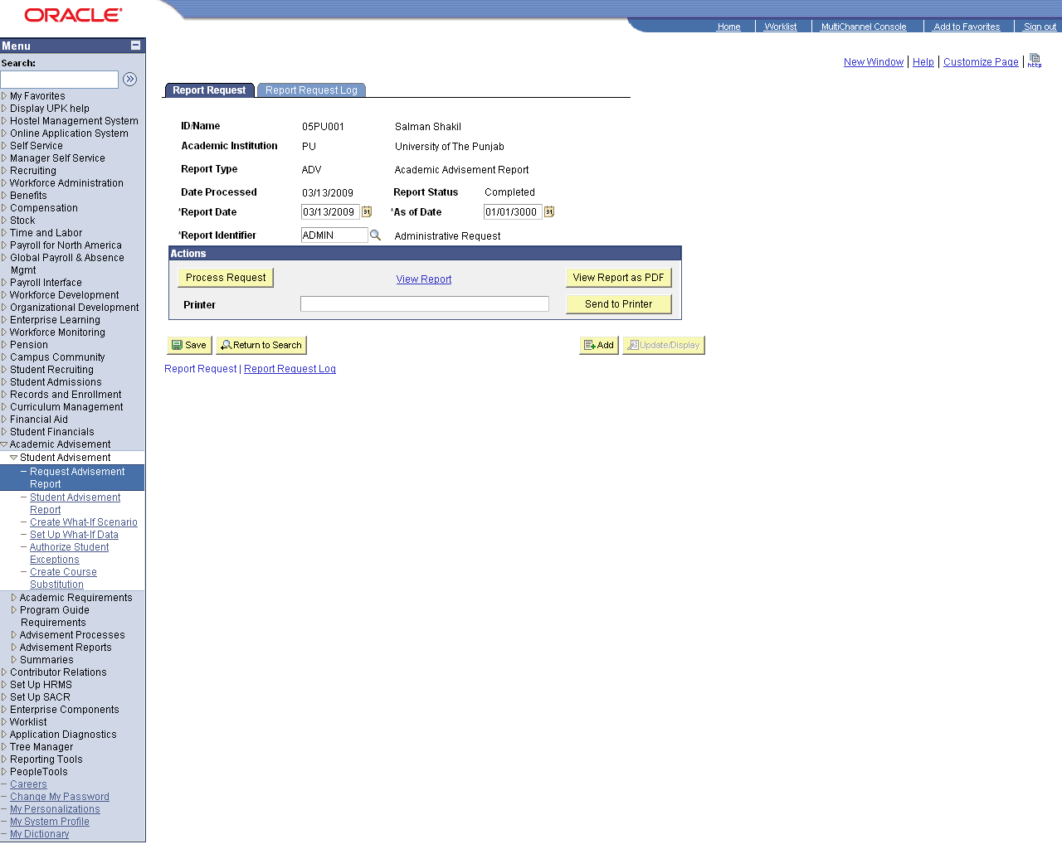

Step | Action
 | Click the View Report as PDF button.

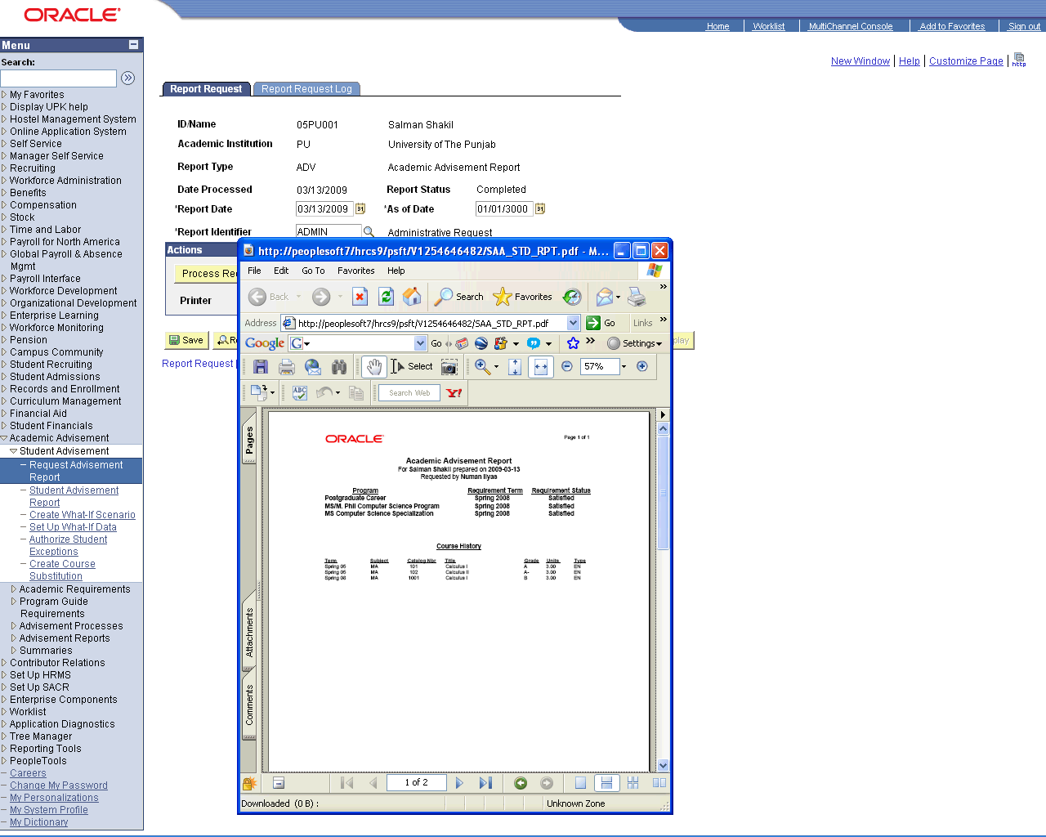

Step | Action
 | Click the Maximize/Restore button.
 | End of Procedure.

