Campus Community
Created on Thursday, April 30, 2009
Copyright & Trademarks
Copyright © 2003, 2007, Oracle. All rights reserved. Powered by OnDemand Software. Distributed by Oracle under license from Global Knowledge Software LLC. © 1998-2007. All rights reserved.

The information contained in this document is subject to change without notice. If you find any problems in the documentation, please report them to us in writing. This document is not warranted to be error-free. Except as may be expressly permitted in your license agreement for these Programs, no part of these Programs may be reproduced or transmitted in any form or by any means, electronic or mechanical, for any purpose.

If this documentation is delivered to the United States Government or anyone using the documentation on behalf of the United States Government, the following notice is applicable:

U.S. GOVERNMENT RIGHTS
The U.S. Government’s rights to use, modify, reproduce, release, perform, display, or disclose these training materials are restricted by the terms of the applicable Oracle license agreement and/or the applicable U.S. Government contract.

Oracle, JD Edwards, PeopleSoft, and Siebel are registered trademarks of Oracle Corporation and/or its affiliates. Other names may be trademarks of their respective owners.

Table of Contents
Maintaining Biographical Information 1
Add/Update a Person 1
Add/Update Names 10
Add/Update Work Experience 14
Add/Update Relationships 17
Maintaining Contact Information 23
Add/Update Addresses 23
Add/Update Phones 26
Add/Update Emergency Contacts 30
Maintaining Identification Information 37
Add/Update Photo 37
Add/Update Citizenship Information 41
Maintaining Participation Information 49
Add/Update Athletic and Extracurricular Activities 49
Add/Update Accomplishments 55
Maintaining Helath Information 65
Add/Update Immunizations and Health Data 65
Add/Update Health Exam Data 71
Maintaining Checklist Information 91
Create Checklist 91
Assign Checklist 100
Maintaining Comments 109
Create Comment 109
Assign Comment 112
Maintaining Service Indicators 117
Assign and Manage Service Indicators 117
Mass Assign and Mass Release 124

Maintaining Biographical Information

Add/Update a Person

Procedure

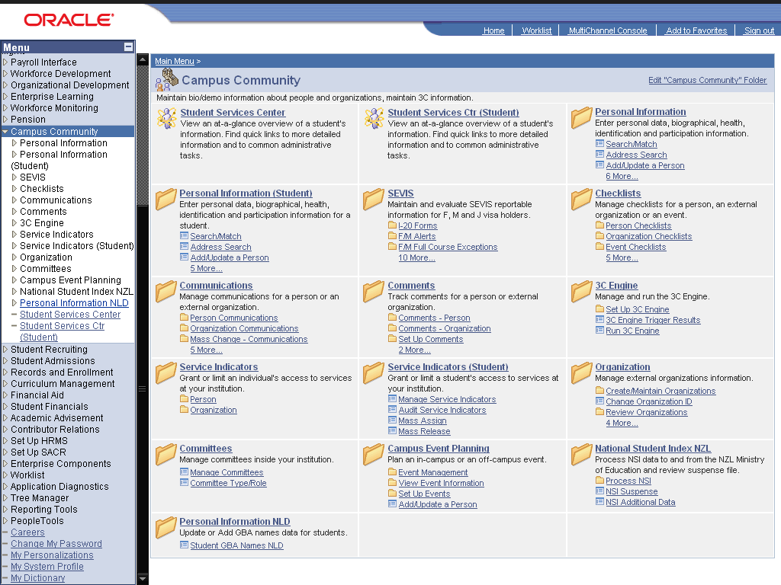

Step | Action
Click the Personal Information (Student) link.
Click on the "Personal Information" link if you want to add/update information about instructor or staff.
 | Click the Add/Update a Person link.

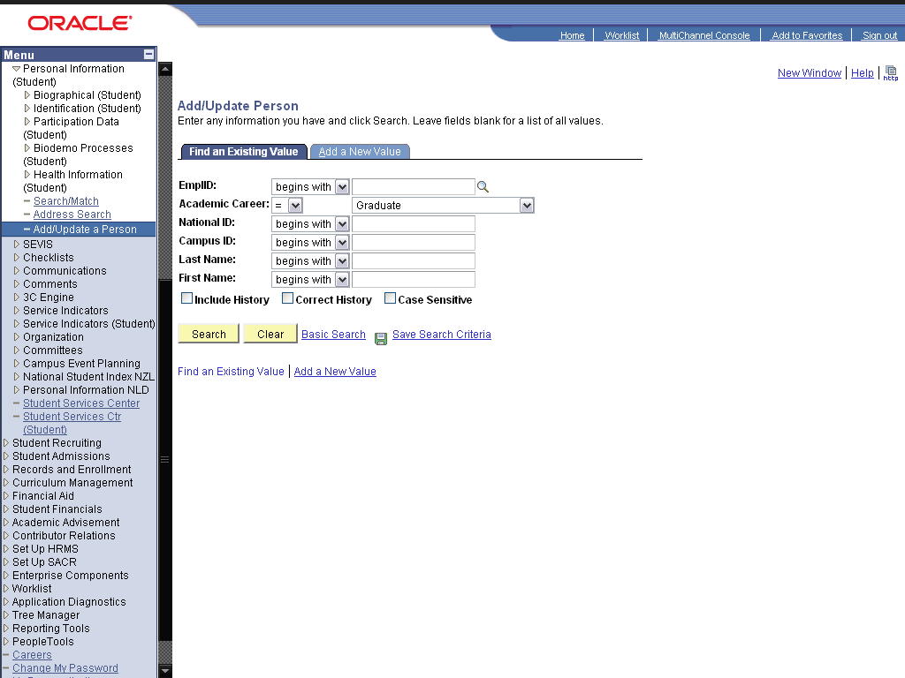

Step | Action
 | Click the dd a New Value link.
 | Enter the desired information into the ID: field. Enter "2009DES001".
 | Click the Add button.

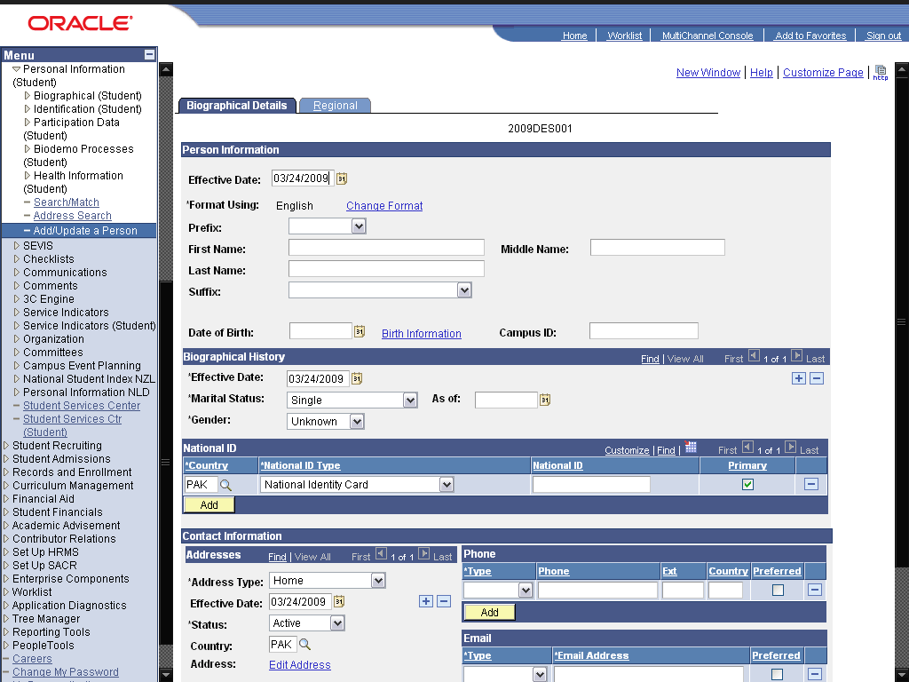

Step | Action
 | Click the cell.

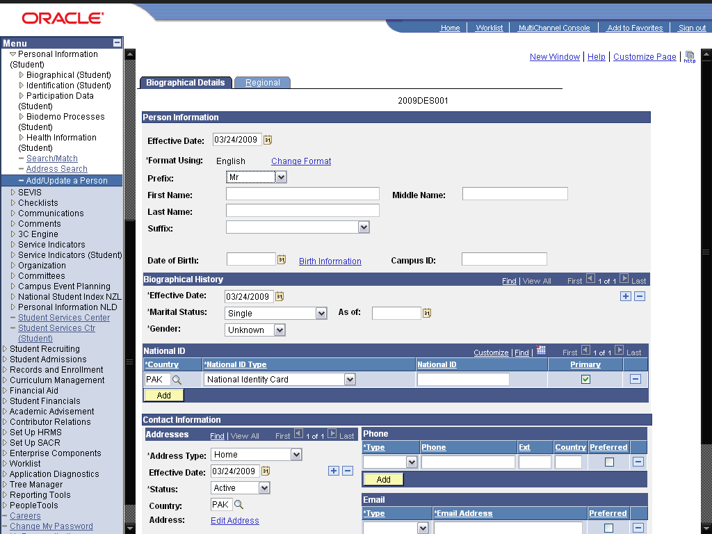

Step | Action
 | Enter the desired information into the First Name: field. Enter "Kashaan".
 | Enter the desired information into the Last Name: field. Enter "Saleem".
 | Click the Choose a date (Alt+5) graphic.
 | Click the 1 link.
 | Enter the desired information into the Campus ID: field. Enter "2009DSN109".

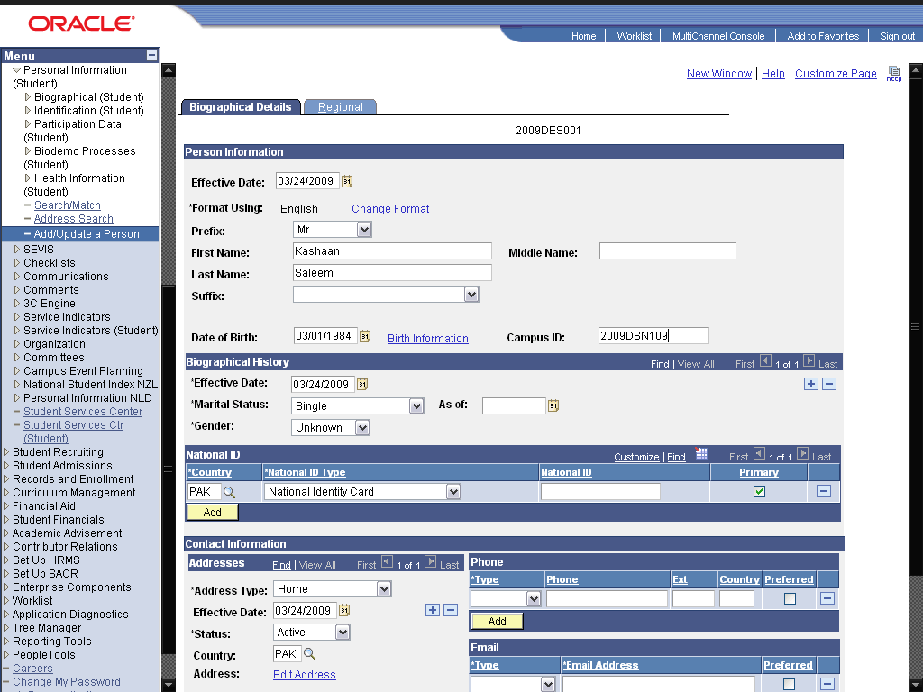

Step | Action
 | Click the cell.

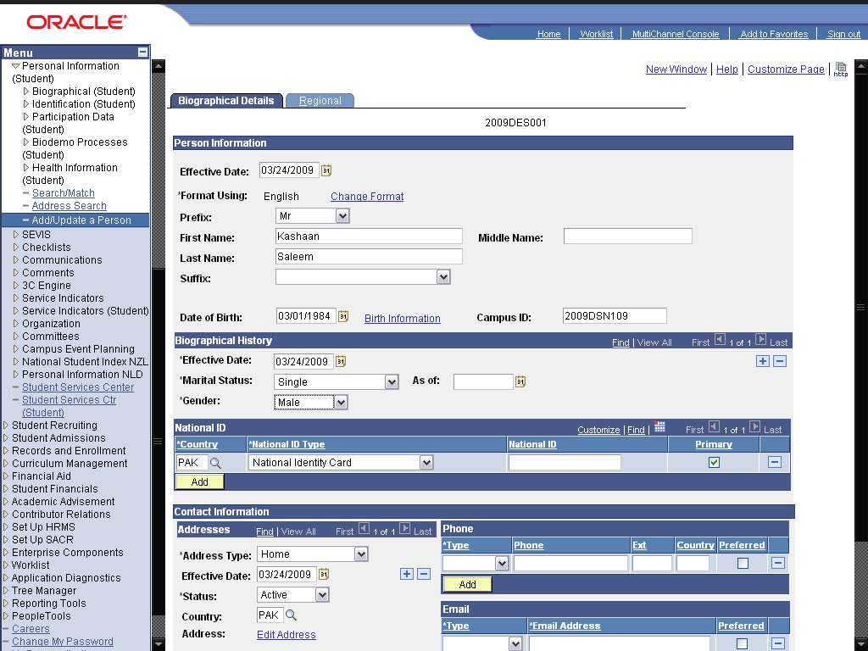

Step | Action
 | Enter the desired information into the field. Enter "36592-45896-4".
 | Click the cell.
 | Click the Edit Address link.
 | Enter the desired information into the Address 1: field. Enter "128 - A Garden Town".
 | Enter the desired information into the City: field. Enter "Lahore".
 | Enter the desired information into the State: field. Enter "PUNJAB".
 | Enter the desired information into the County: field. Enter "Pakistan".
 | Click the OK graphic.

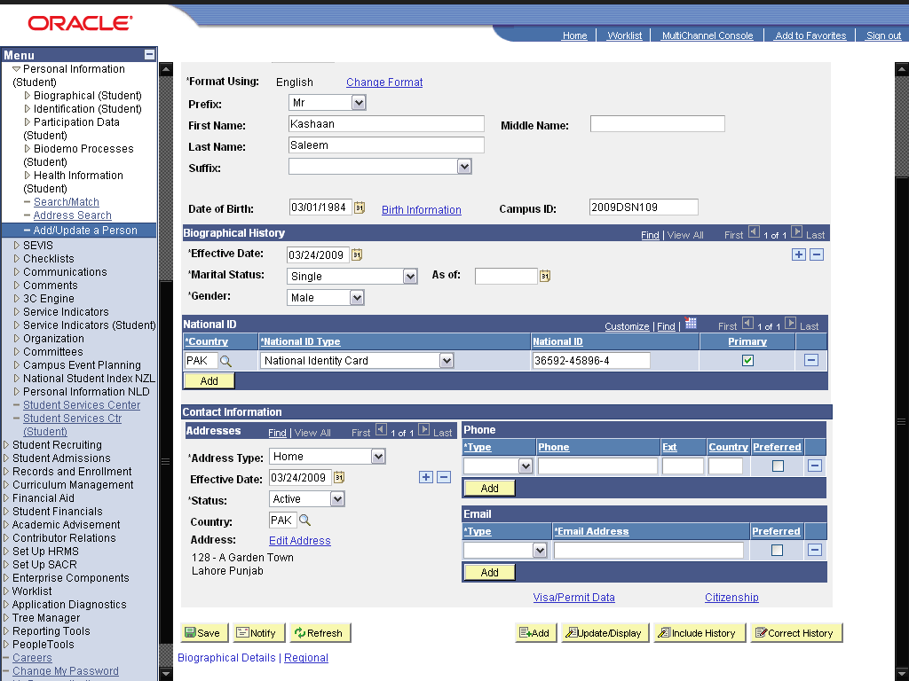

Step | Action
 | Click the *Type link.

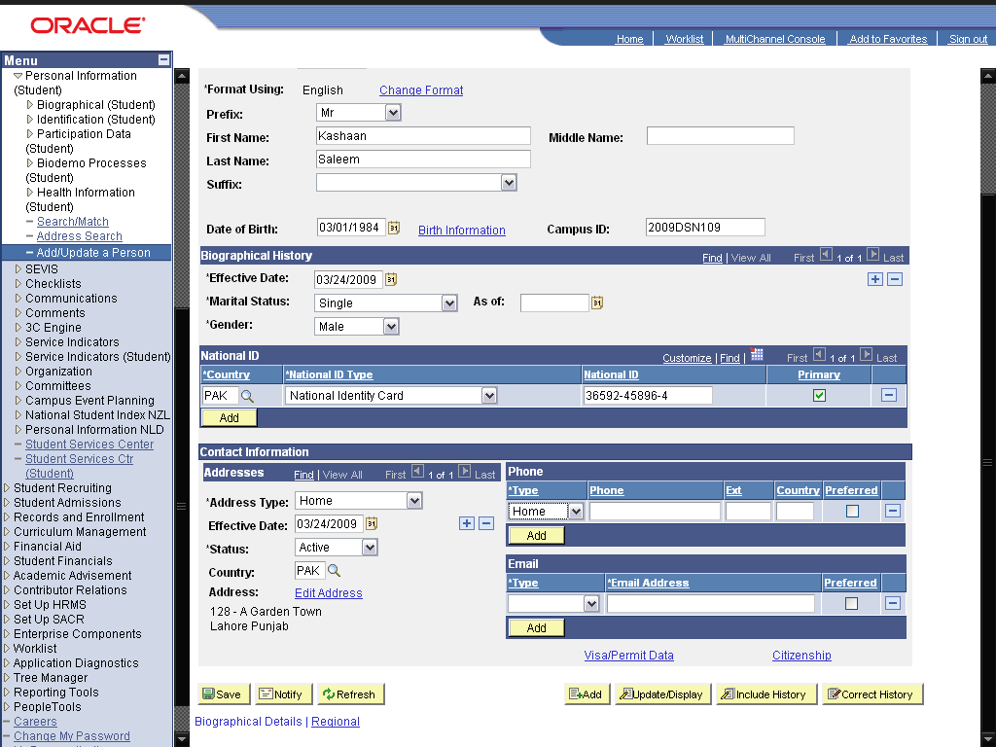

Step | Action
 | Enter the desired information into the field. Enter "0427586459".
 | Enter the desired information into the field. Enter "092".

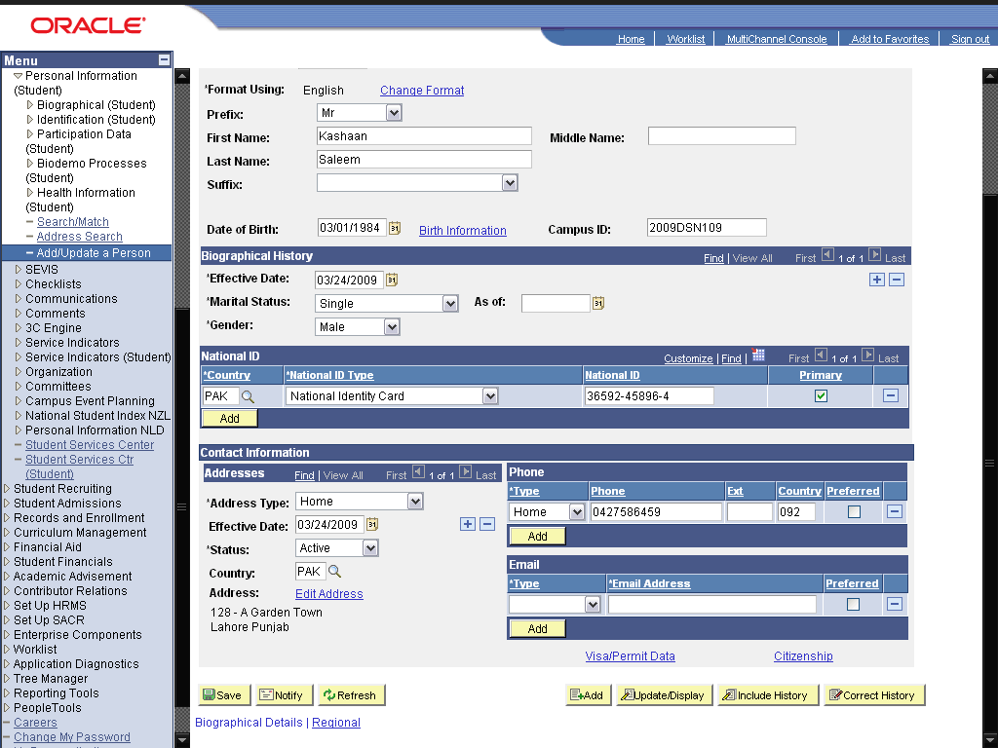

Step | Action
 | Click an entry in the list.

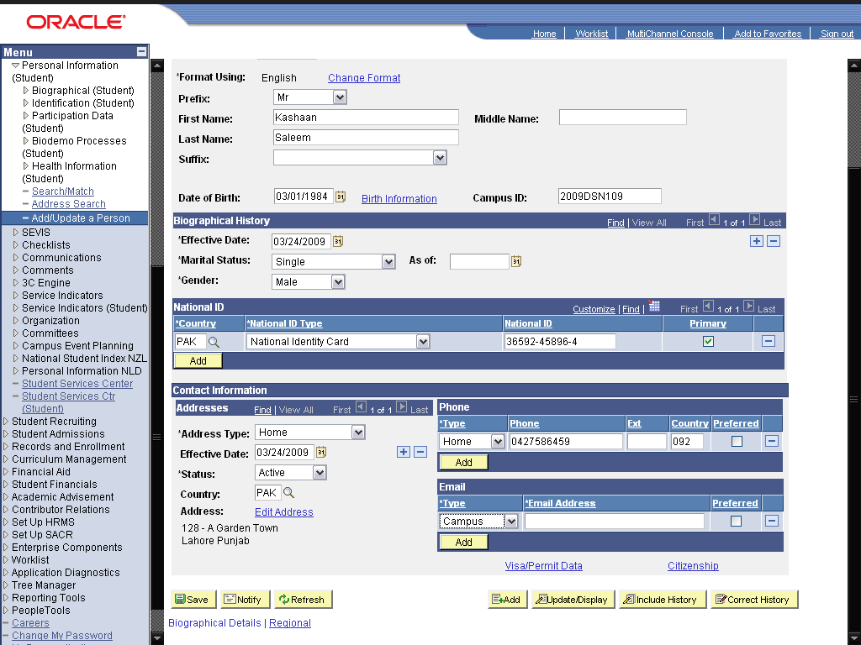

Step | Action
 | Enter the desired information into the field. Enter "kashaan@gmail.com".
 | Click the option.
 | Click the option.
 | Click the Save button.
 | End of Procedure.

Add/Update Names

Procedure

this is the introduction to the topic ...

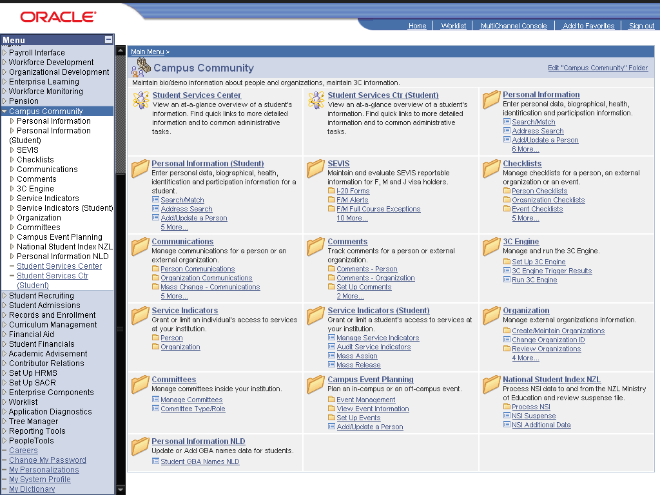

Step | Action
 | Click the Personal Information (Student) link.
 | Click the Biographical (Student) link.
 | Click the Names link.

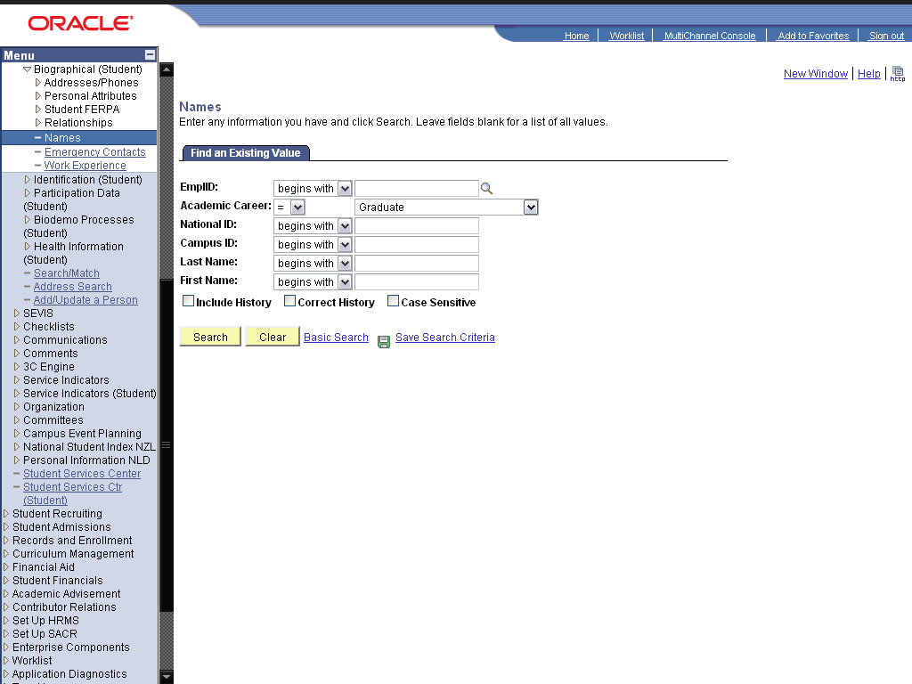

Step | Action
 | Click the Search button.
 | Click the 2009DES001 link.

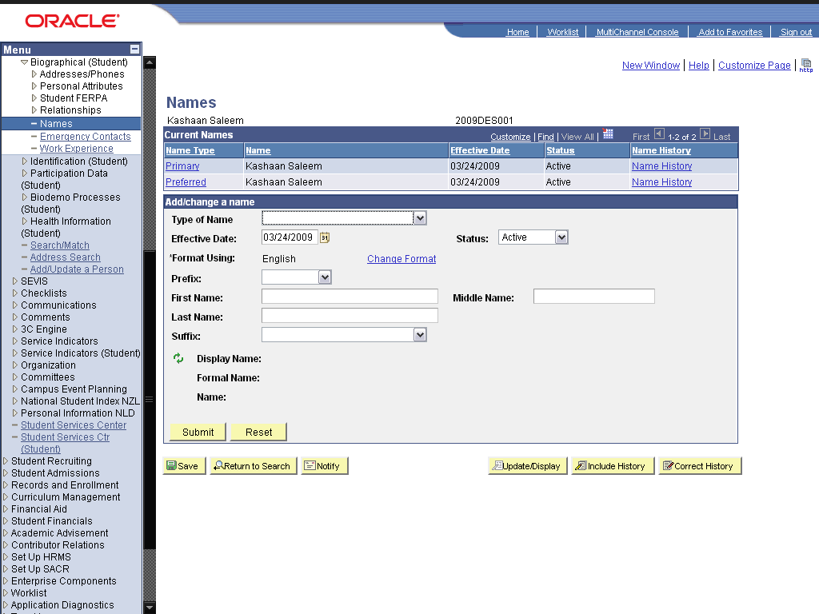

Step | Action
 | Click an entry in the list.
 | Click an entry in the list.

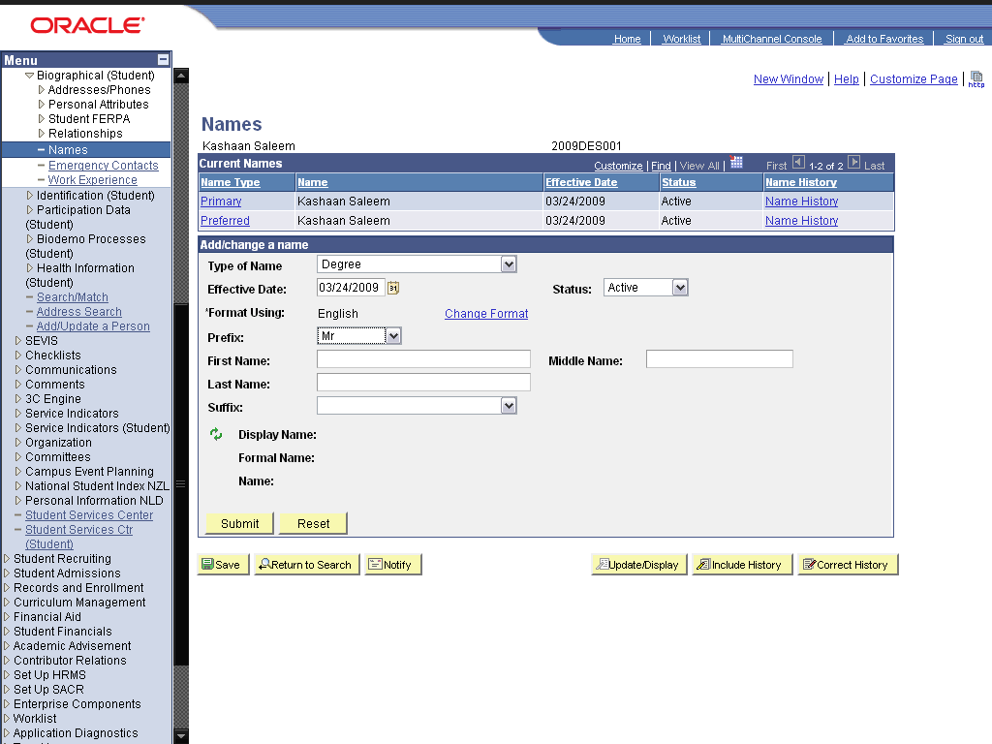

Step | Action
 | Enter the desired information into the First Name: field. Enter "Kashaan".
 | Enter the desired information into the Middle Name: field. Enter "A".
 | Enter the desired information into the Last Name: field. Enter "Saleem".
 | Click the Refresh the NAME field graphic.
 | Click the Submit button.
 | Click the Save button.
 | End of Procedure.

Add/Update Work Experience

Procedure

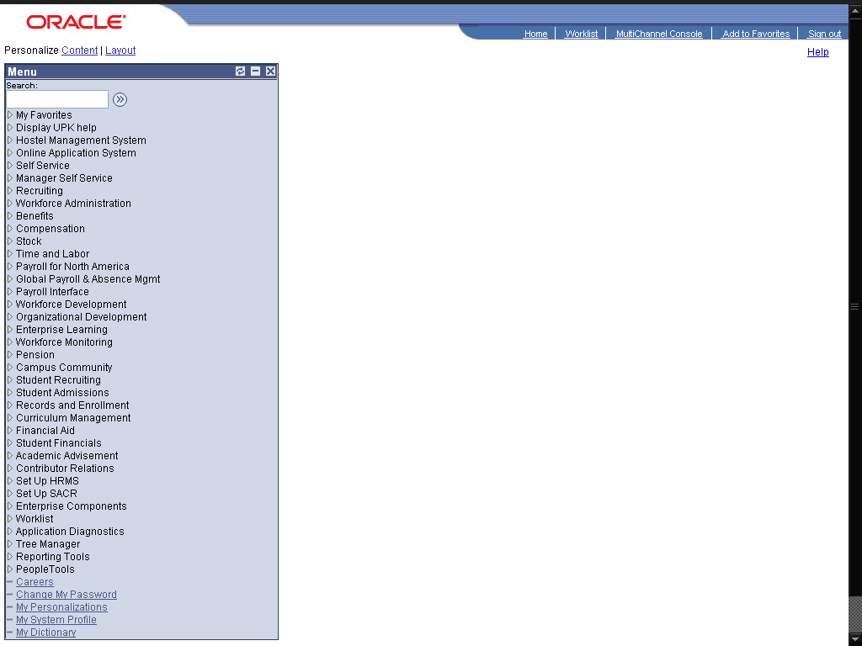

Step | Action
 | Click the Campus Community link.

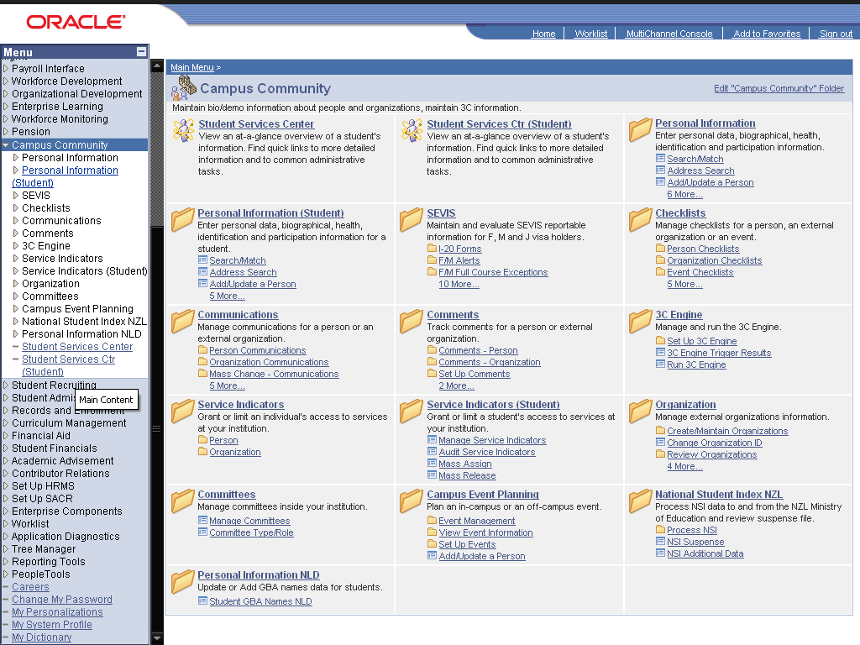

Step | Action
 | Click the Personal Information (Student) link.
 | Click the Biographical (Student) link.
 | Click the Work Experience link.

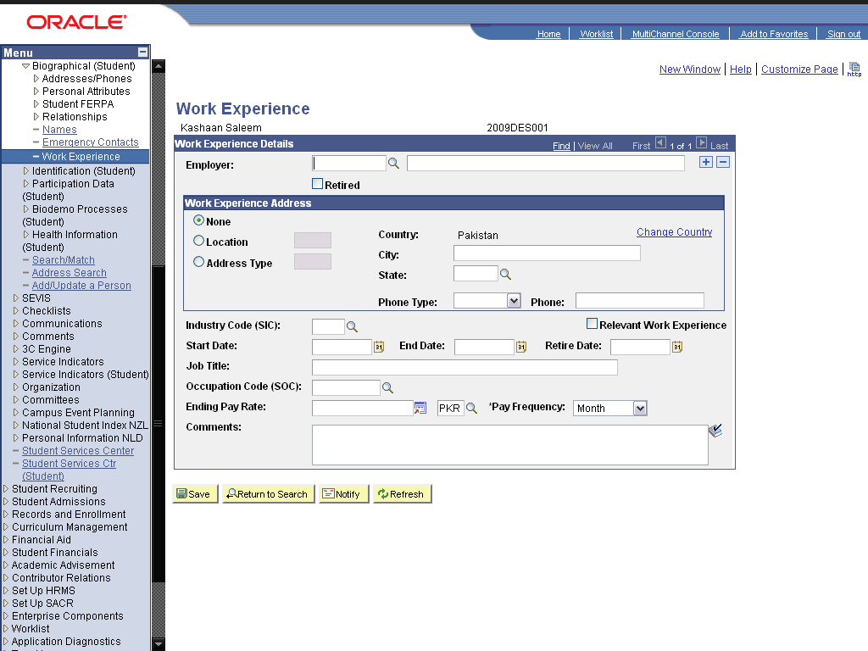

Step | Action
 | Click the Look up (Alt+5) graphic.
 | Click the Higher Edu Comm, Pakistan link.
 | Click in the Date field.
 | Click in the Date field.
 | Enter the desired information into the field. Enter "Administrator".
 | Click the Save button.
 | End of Procedure.

Add/Update Relationships

Procedure

Step | Action
 | Click the Campus Community link.

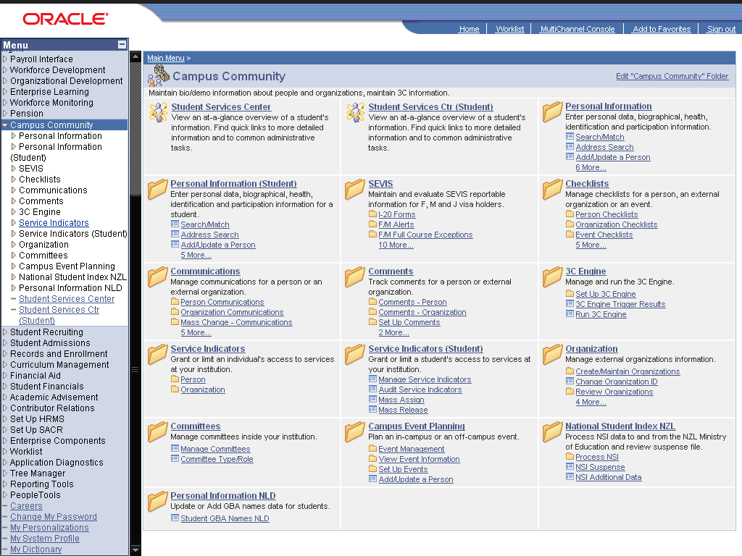

Step | Action
 | Click the Personal Information (Student) link.
 | Click the Biographical (Student) link.
 | Click the Relationships link.
 | Click the Relationships link.

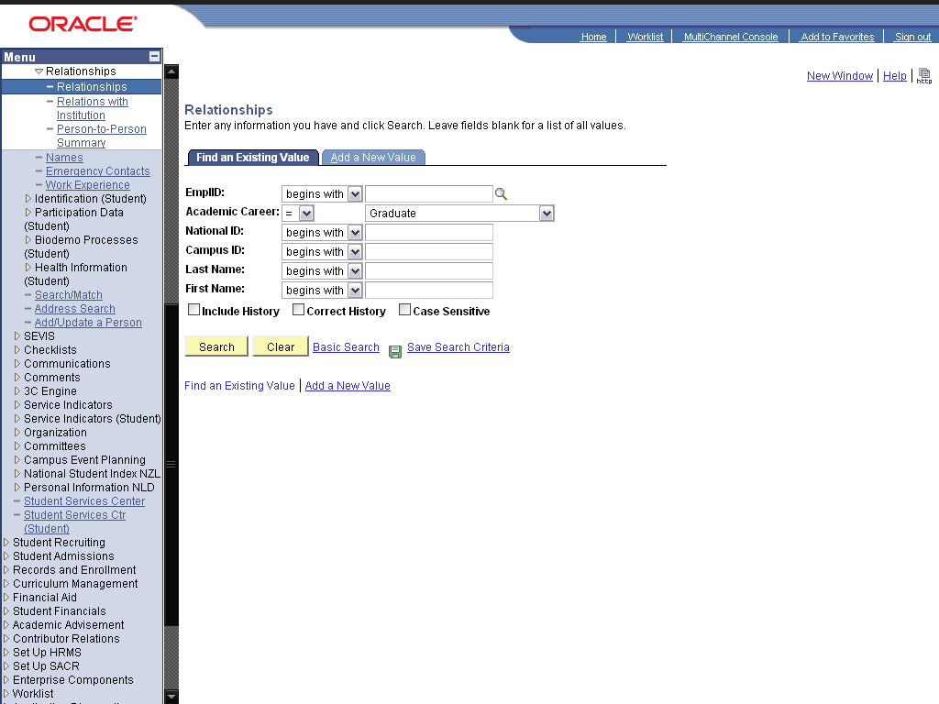

Step | Action
 | Click the dd a New Value link.
 | Enter the desired information into the field. Enter "2009des001".
 | Click the Add button.
 | Click the *Relationship: list.

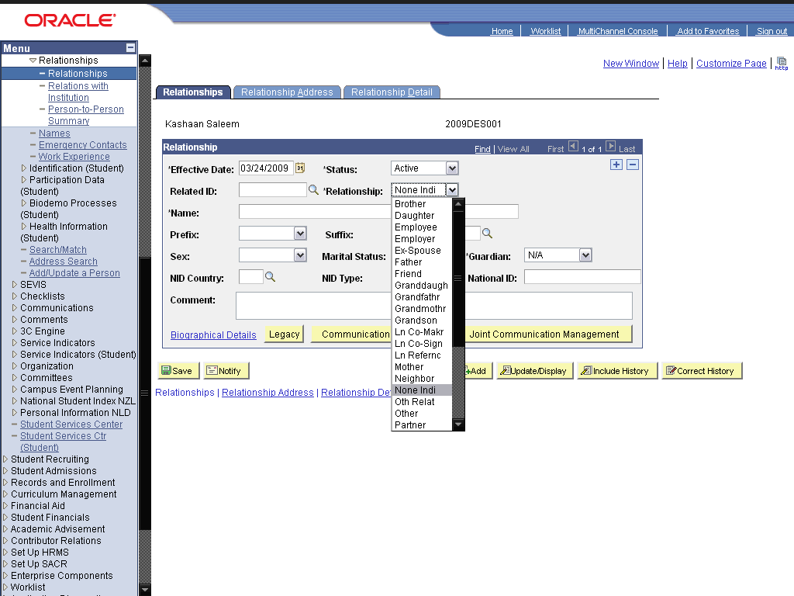

Step | Action
 | Click an entry in the list.

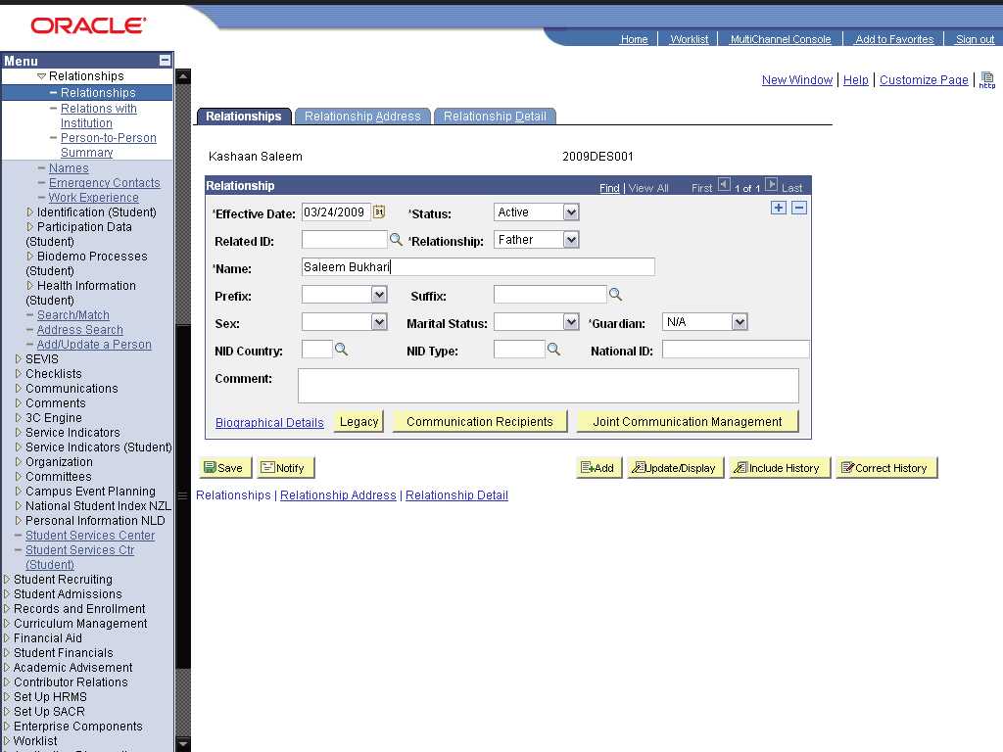

Step | Action
 | Enter the desired information into the *Name: field. Enter "Bukhari, Saleem".
 | Click the Save button.
 | End of Procedure.

Maintaining Contact Information

Add/Update Addresses

Procedure

Step | Action
 | Click the Campus Community link.

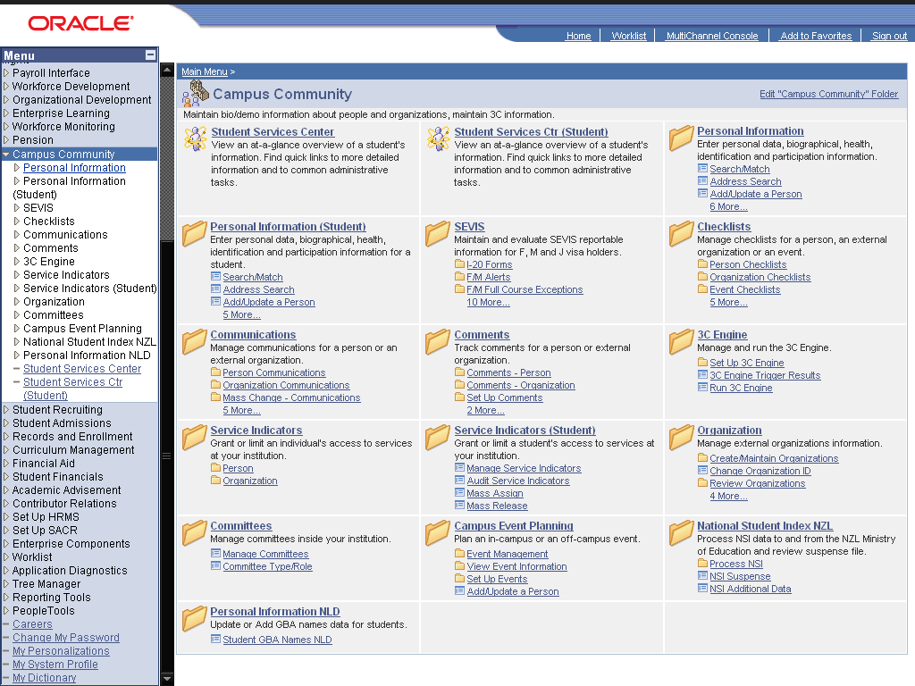

Step | Action
 | Click the Personal Information (Student) link.
 | Click the Biographical (Student) link.
 | Click the Addresses/Phones link.
 | Click the Addresses link.

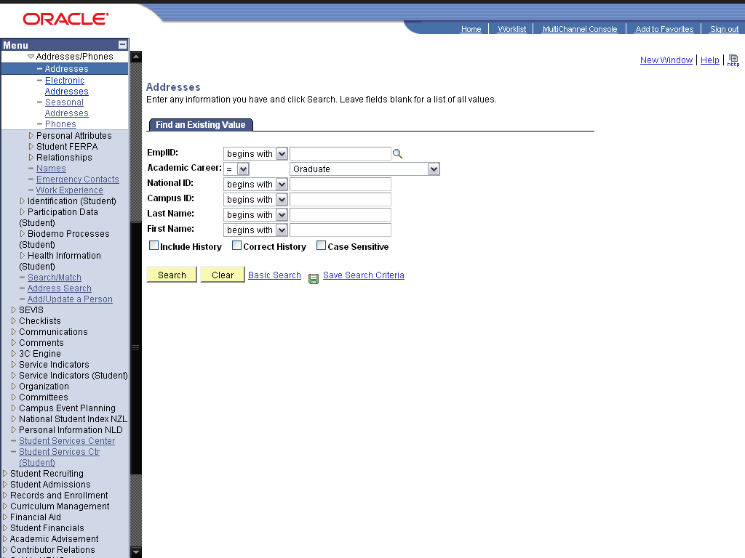

Step | Action
 | Click the Search button.
 | Click the 2009DES001 link.
 | Click the option.
 | Click the Edit Address link.
 | Enter the desired information into the Address 1: field. Enter "168 / 2 Chuburji".
 | Enter the desired information into the City: field. Enter "Lahore".
 | Enter the desired information into the State: field. Enter "PUNJAB".
 | Enter the desired information into the County: field. Enter "Pakistan".
 | Click the OK graphic.
 | Click the Submit button.
 | Click the Save button.
 | End of Procedure.

Add/Update Phones

Procedure

Step | Action
 | Click the Campus Community link.

Step | Action
 | Click the Personal Information (Student) link.
 | Click the Biographical (Student) link.
 | Click the Addresses/Phones link.
 | Click the Phones link.

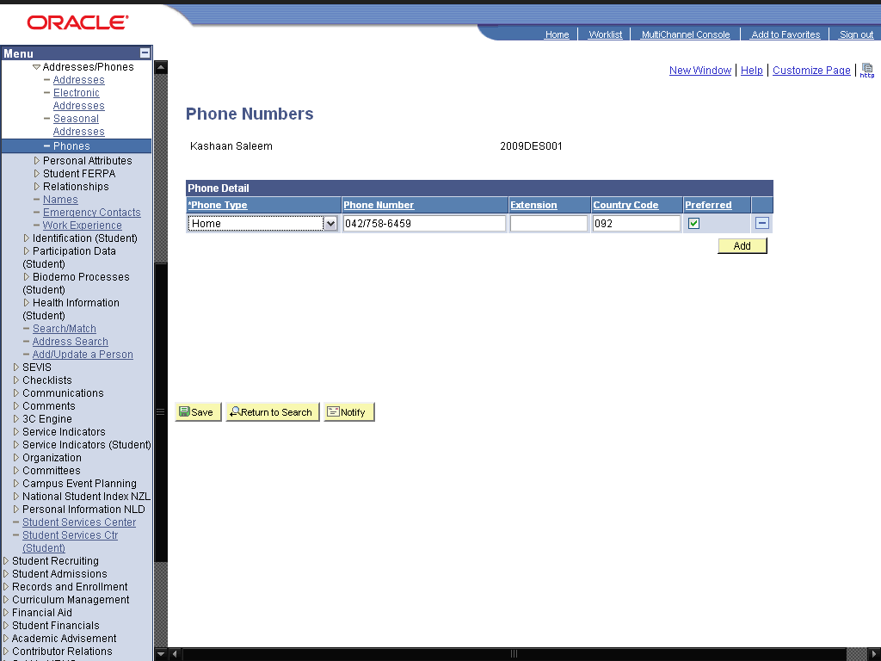

Step | Action
 | Click the Add a new row at row 1 (Alt+7) graphic.

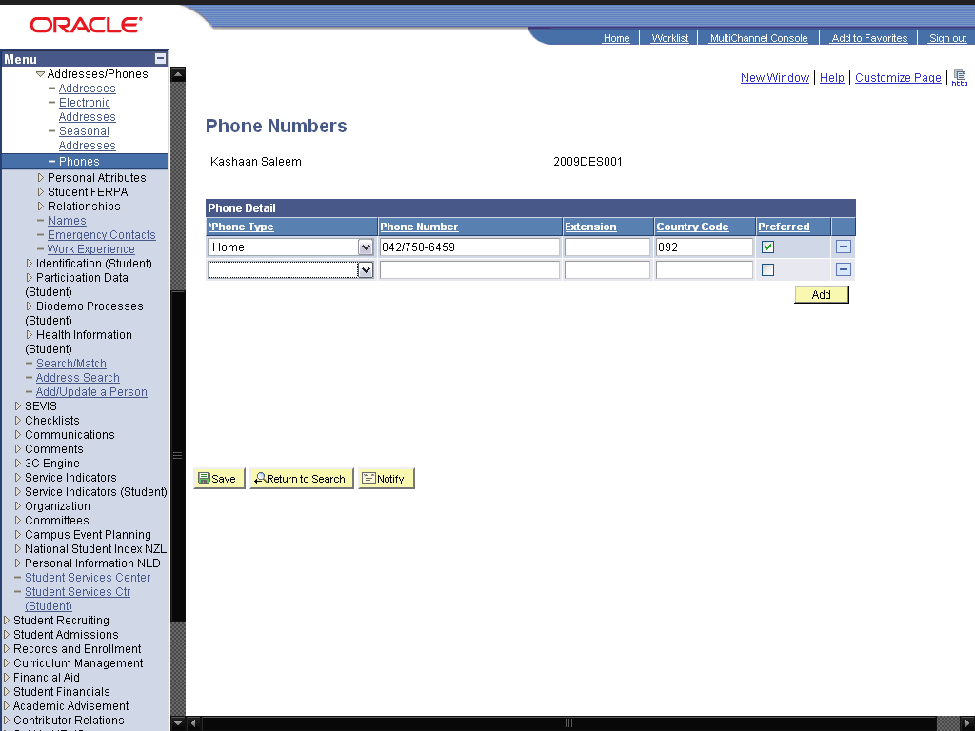

Step | Action
 | Click the cell.

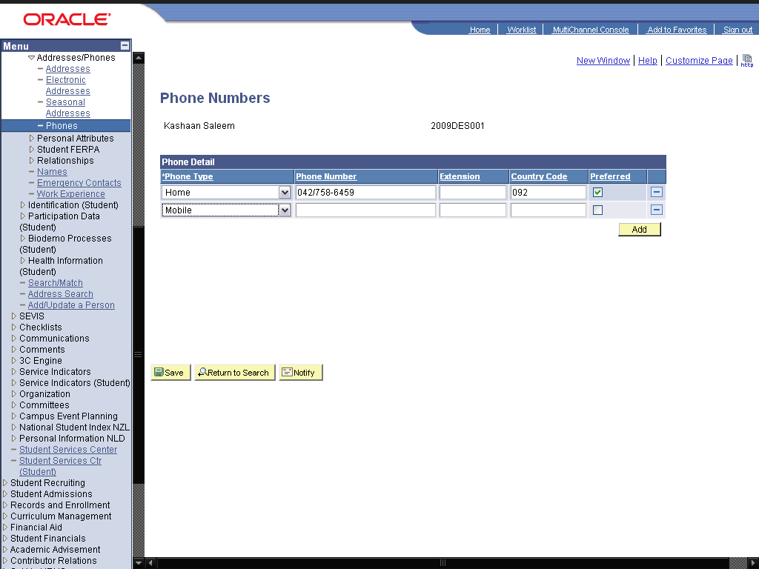

Step | Action
 | Enter the desired information into the field. Enter "03224856985".
 | Click the Save button.
 | End of Procedure.

Add/Update Emergency Contacts

Procedure

Step | Action
 | Click the Campus Community link.

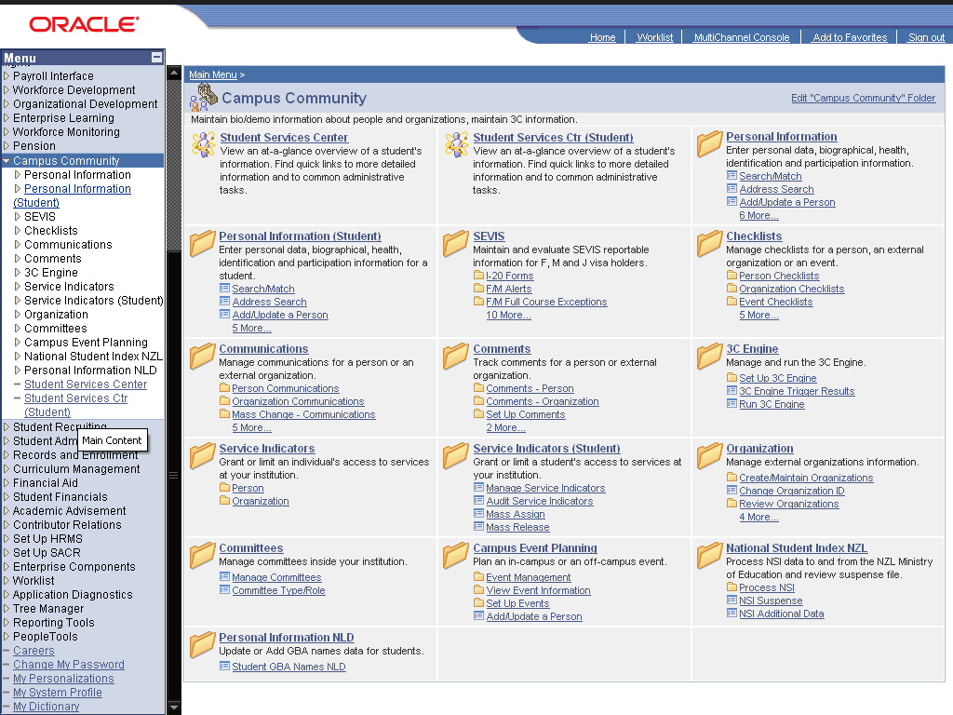

Step | Action
 | Click the Personal Information (Student) link.
 | Click the Biographical (Student) link.
 | Click the Emergency Contacts link.

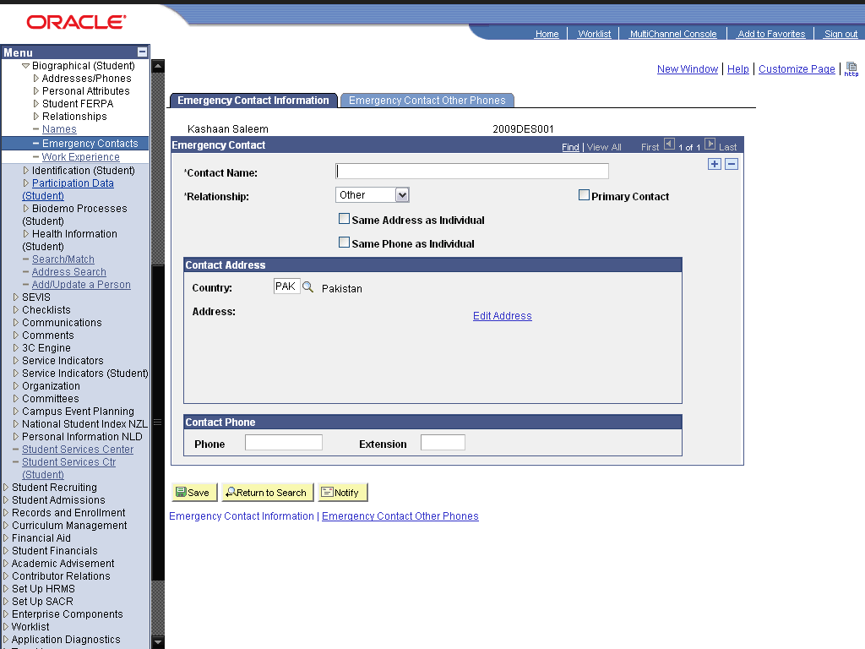

Step | Action
 | Enter the desired information into the *Contact Name: field. Enter "Saleem Bukhari".

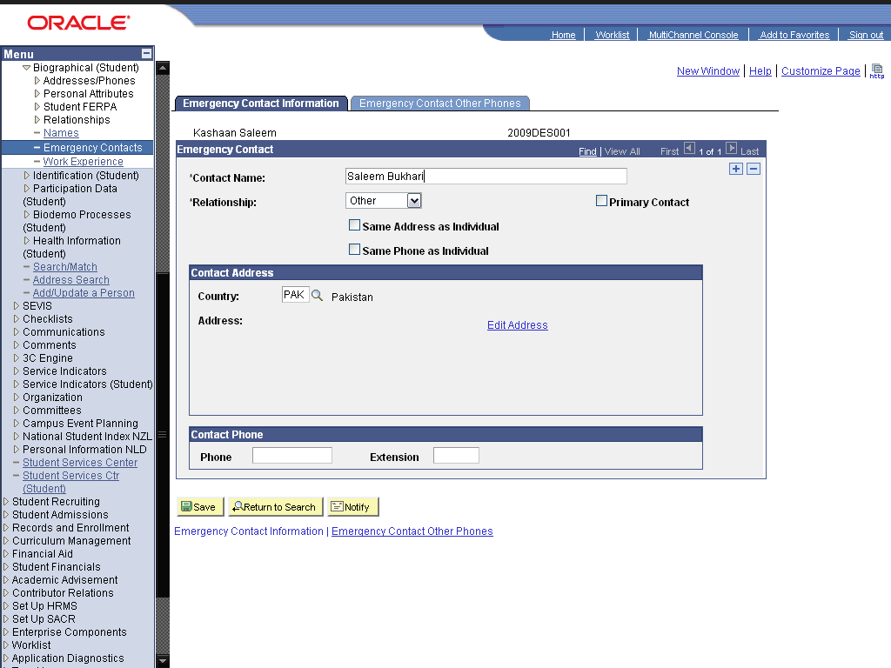

Step | Action
 | Click the cell.

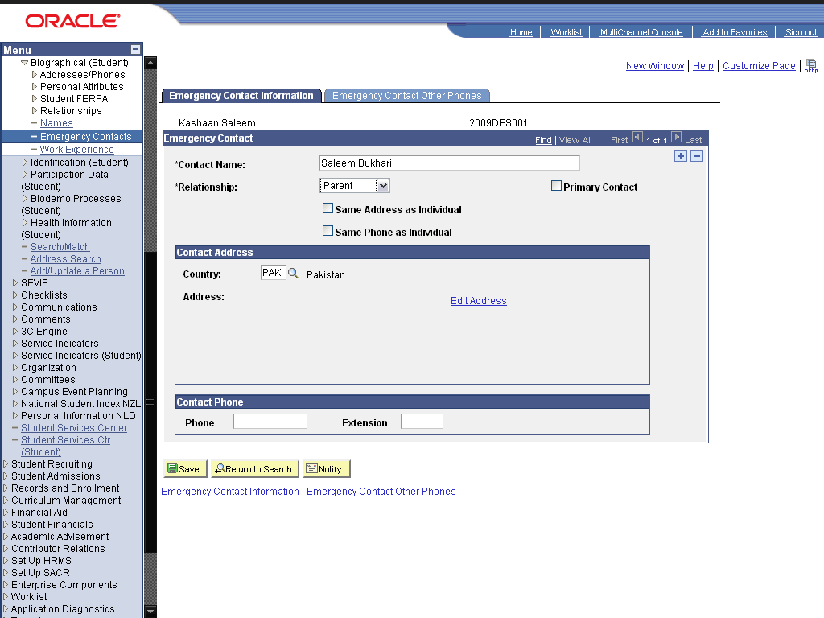

Step | Action
 | Click the Edit Address link.
 | Enter the desired information into the Address 1: field. Enter "195/A Employers Housing Scheme".
 | Enter the desired information into the City: field. Enter "Faisalabad".
 | Enter the desired information into the State: field. Enter "PUNJAB".
 | Enter the desired information into the County: field. Enter "Pakistan".
 | Click the OK graphic.
 | Enter the desired information into the field. Enter "042985685".
 | Enter the desired information into the field. Enter "092".
 | Click the Primary Contact option.
 | Click the Save button.
 | End of Procedure.

Maintaining Identification Information

Add/Update Photo

Procedure

Step | Action
 | Click the Campus Community link.

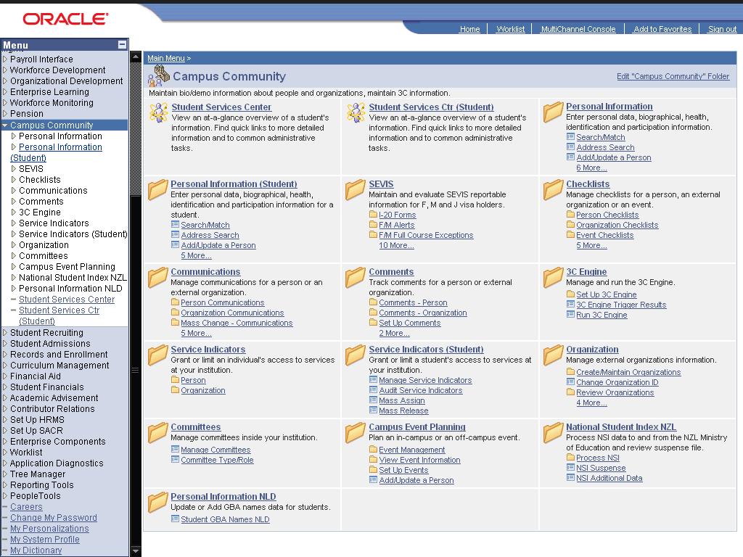

Step | Action
 | Click the Personal Information (Student) link.
 | Click the Identification (Student) link.
 | Click the Photo link.

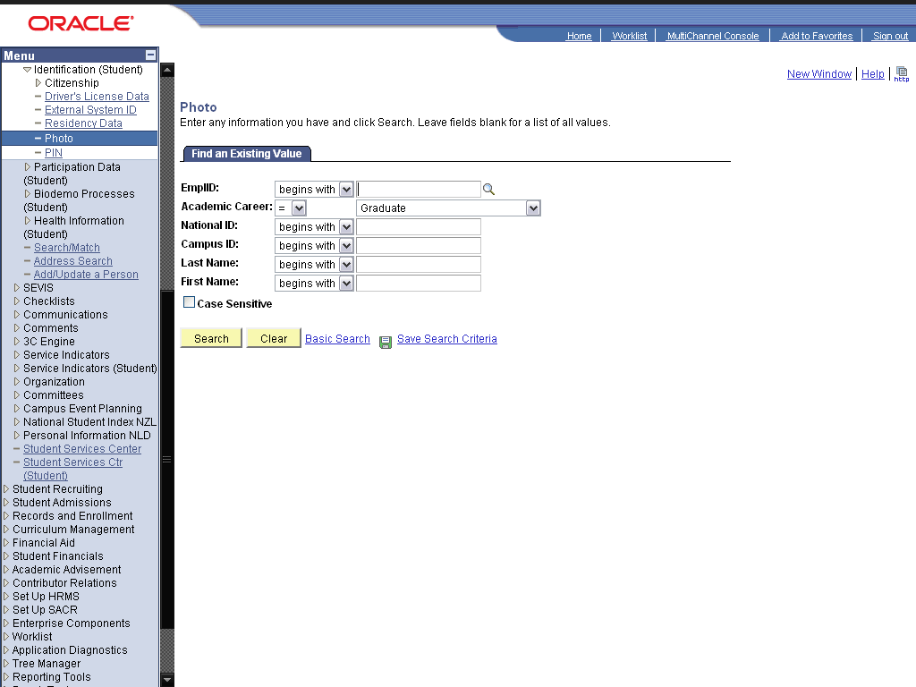

Step | Action
 | Click the Search button.
 | Click the 2009DES001 link.
 | Click the Add Photo Button graphic.
 | Click the Browse… button.

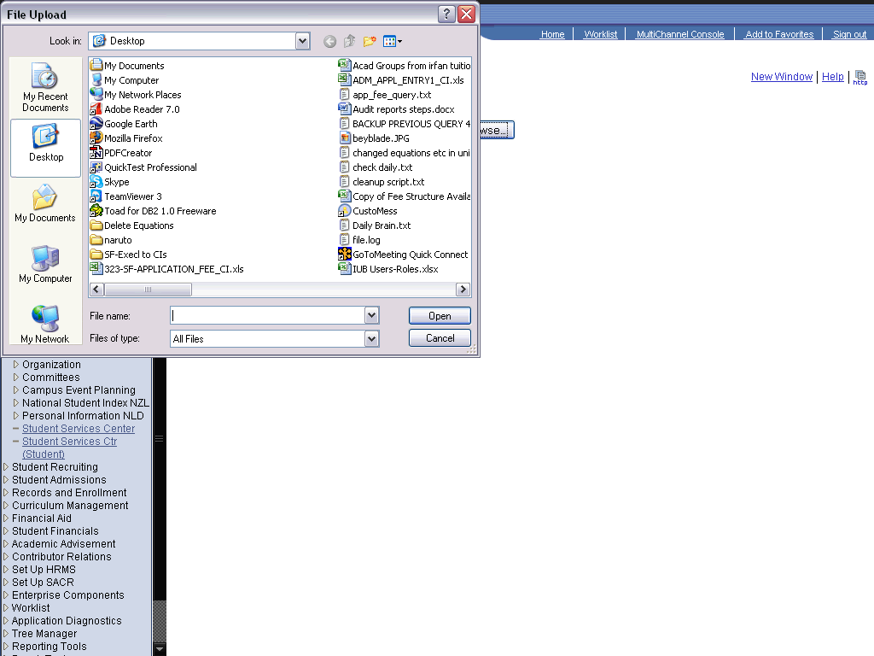

Step | Action
 | Click the student.jpeg list item.
 | Click the Open button.

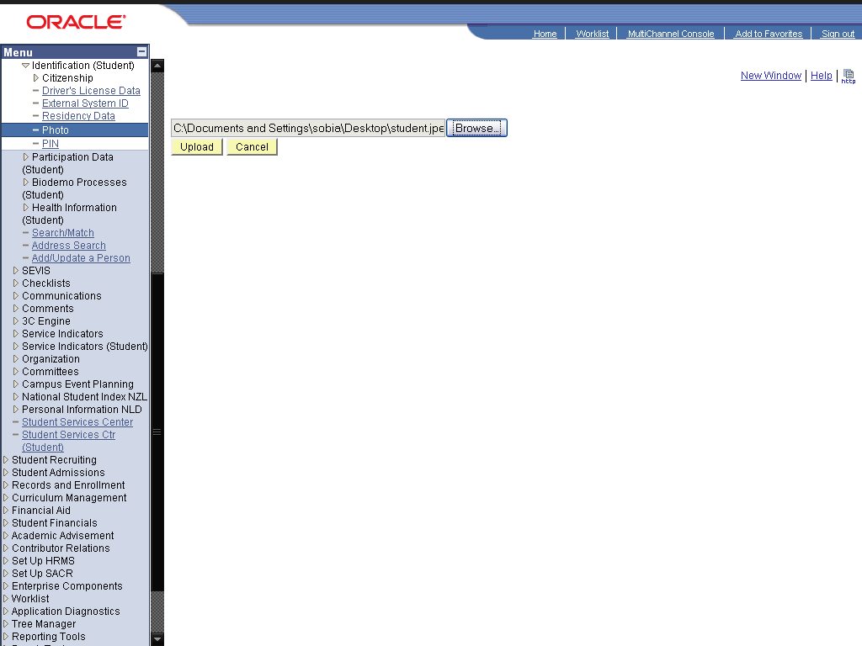

Step | Action
 | Click the Upload button.
 | Click the Save button.
 | Click the OK button.
 | End of Procedure.

Add/Update Citizenship Information

Procedure

Step | Action
 | Click the Campus Community link.

Step | Action
 | Click the Personal Information (Student) link.
 | Click the Identification (Student) link.
 | Click the Citizenship link.
 | Click the Citizenship and Passport link.

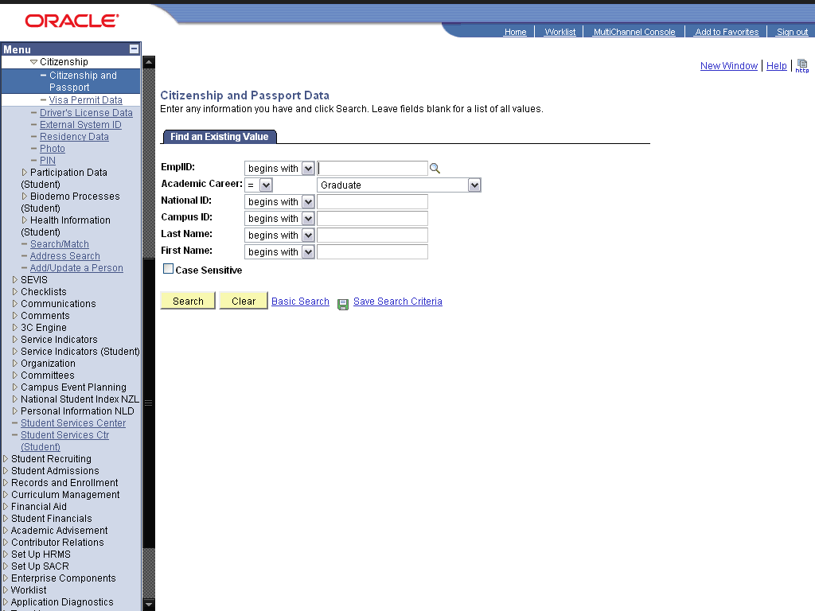

Step | Action
 | Click the Search button.
 | Click the 2009DES001 link.
 | Enter the desired information into the field. Enter "PAK".

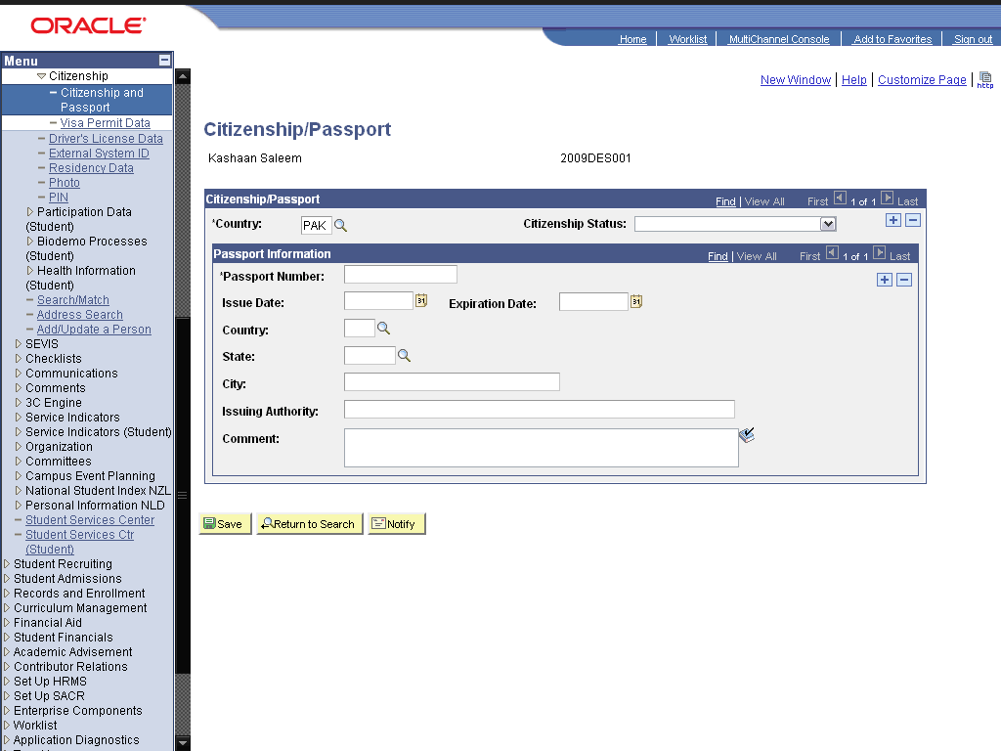

Step | Action
 | Click the cell.

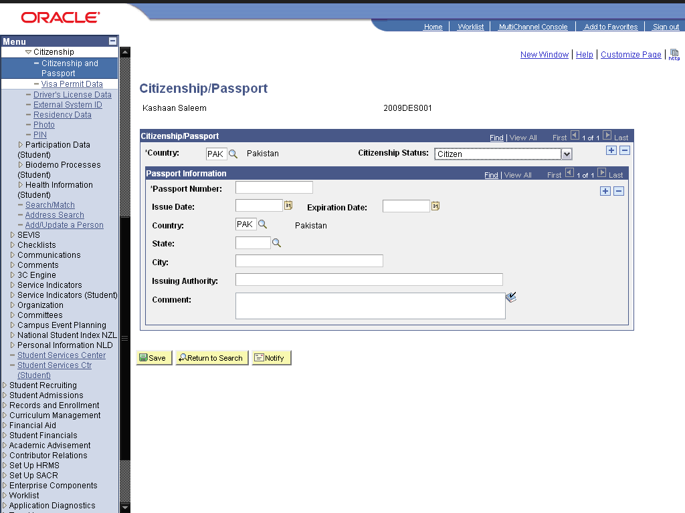

Step | Action
 | Enter the desired information into the *Passport Number: field. Enter "J1296584".
 | Enter the desired information into the Issue Date: field. Enter "01/01/2006".
 | Enter the desired information into the Expiration Date: field. Enter "01/01/2011".
 | Enter the desired information into the State: field. Enter "PUNJAB".
 | Enter the desired information into the City: field. Enter "Lahore".
 | Enter the desired information into the Issuing Authority: field. Enter "Pakistan".
 | Click the Save button.
 | Click the Visa Permit Data link.

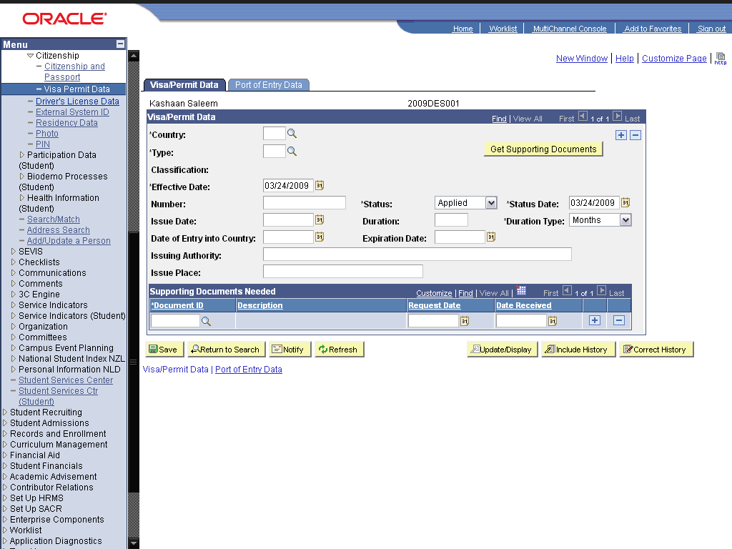

Step | Action
 | Enter the desired information into the field. Enter "PAK".
 | Click the Look up Type (Alt+5) graphic.
 | Click the Residence link.
 | Enter the desired information into the Number: field. Enter "5KL1256".
 | Enter the desired information into the Issue Date: field. Enter "01/05/2005".
 | Enter the desired information into the Duration: field. Enter "36".
 | Enter the desired information into the Date of Entry into Country: field. Enter "01/25/2005".
 | Enter the desired information into the Expiration Date: field. Enter "01/05/2007".
 | Click the Save button.
 | End of Procedure.

Maintaining Participation Information

Add/Update Athletic and Extracurricular Activities

Procedure

Step | Action
 | Click the Campus Community link.

Step | Action
 | Click the Personal Information (Student) link.
 | Click the Participation Data (Student) link.
 | Click the Athletic Participation link.

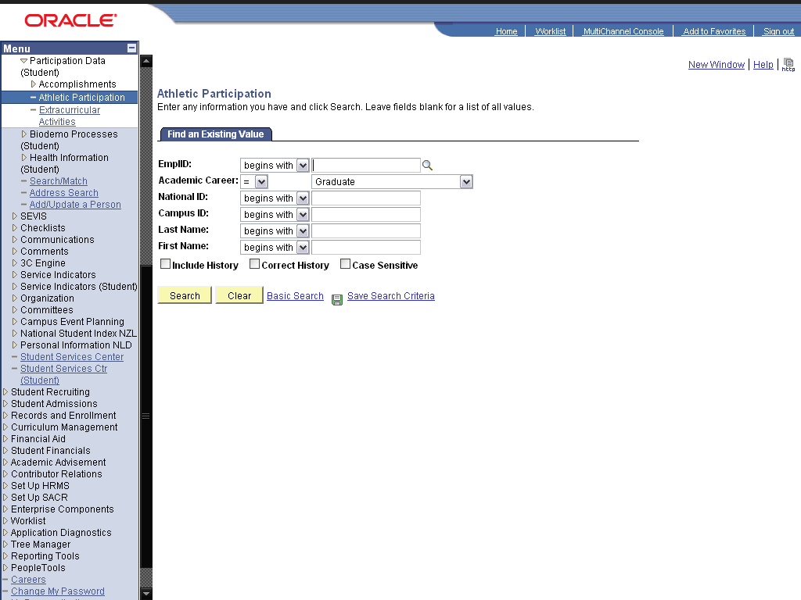

Step | Action
 | Click the Search button.
 | Click the 2009DES001 link.

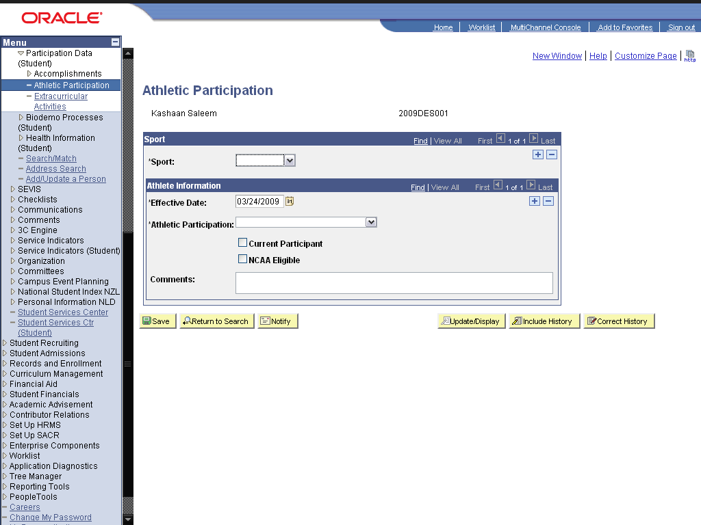

Step | Action
 | Click in the Sports field.
 | Click the cell.

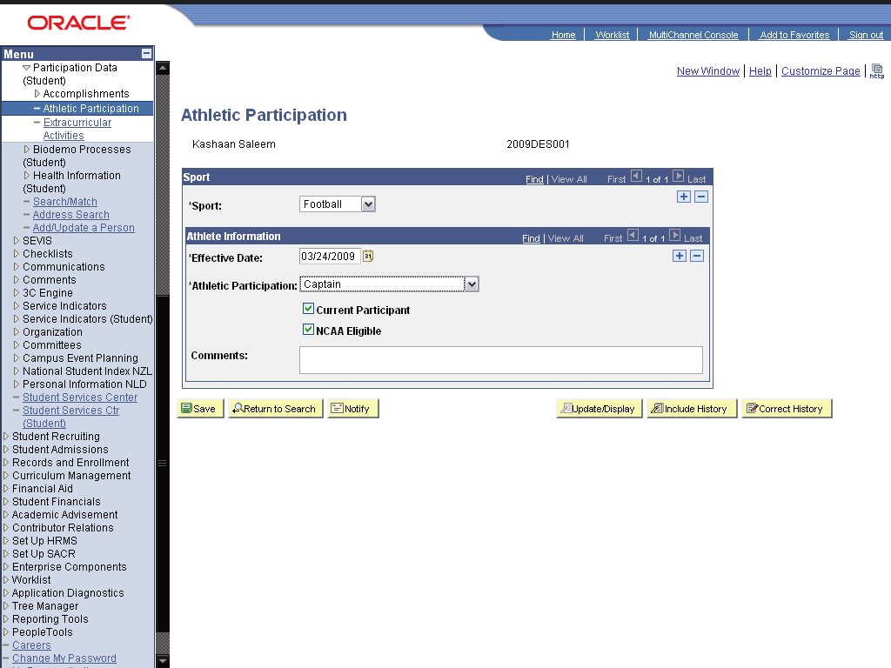

Step | Action
 | Click the Save button.
 | Click the Extracurricular Activities link.

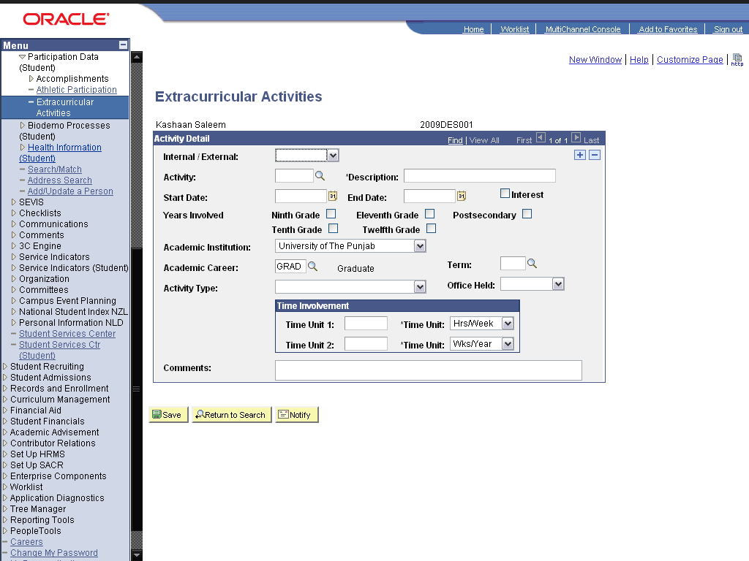

Step | Action
 | Click in the Internal/ External: field.

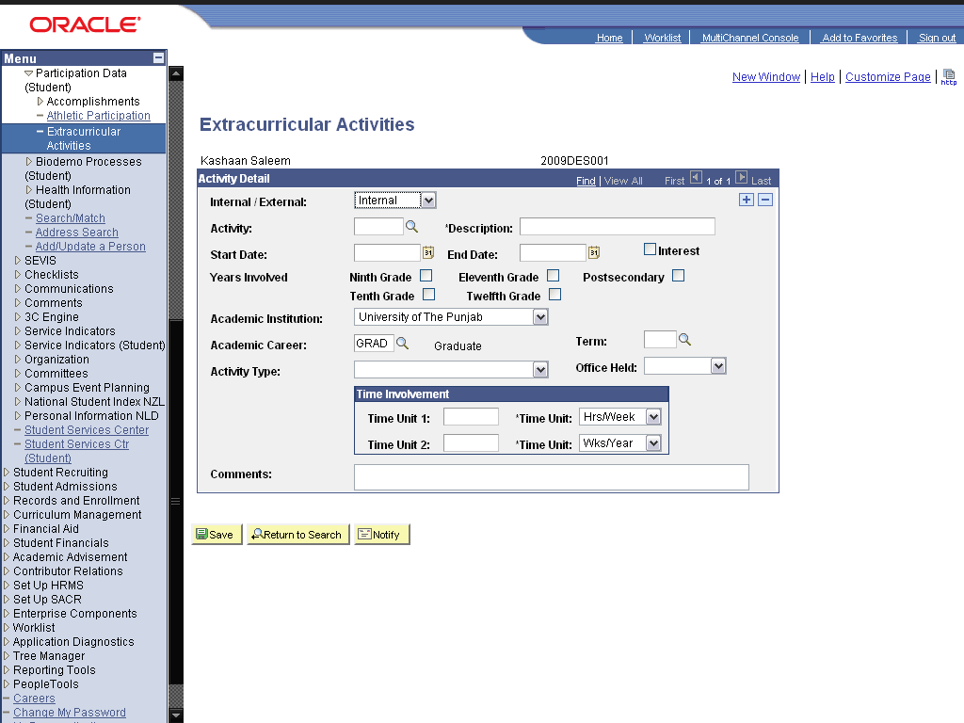

Step | Action
 | Click the Look up Activity (Alt+5) graphic.
 | Click the Class President link.
 | Click in the End Date field.
 | Click the Save button.
 | End of Procedure.

Add/Update Accomplishments

Procedure

Step | Action
 | Click the Campus Community link.

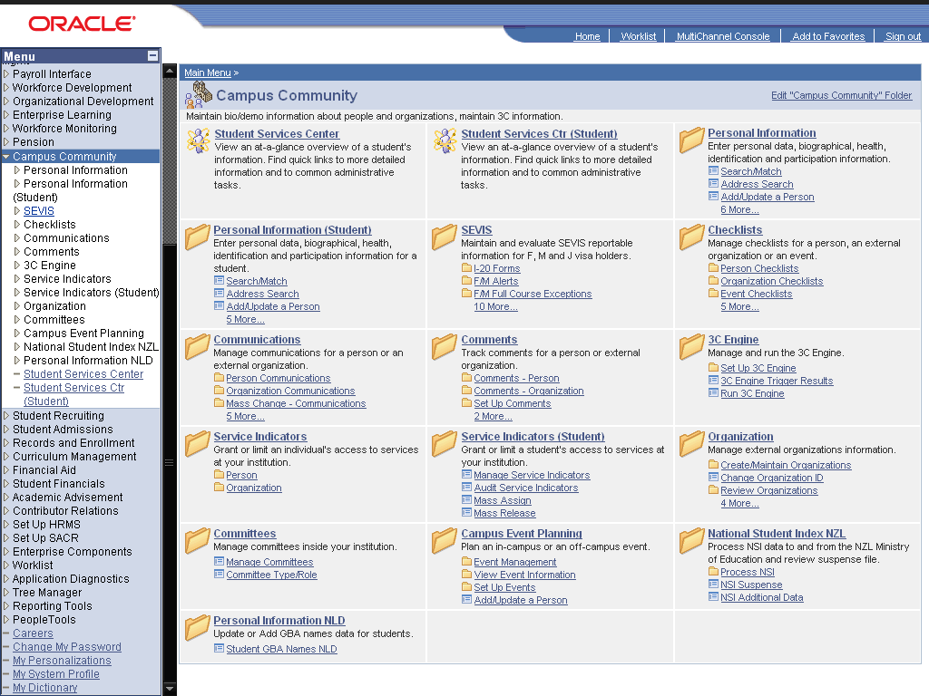

Step | Action
 | Click the Personal Information (Student) link.
 | Click the Participation Data (Student) link.
 | Click the Accomplishments link.
 | Click the Honors and Awards link.

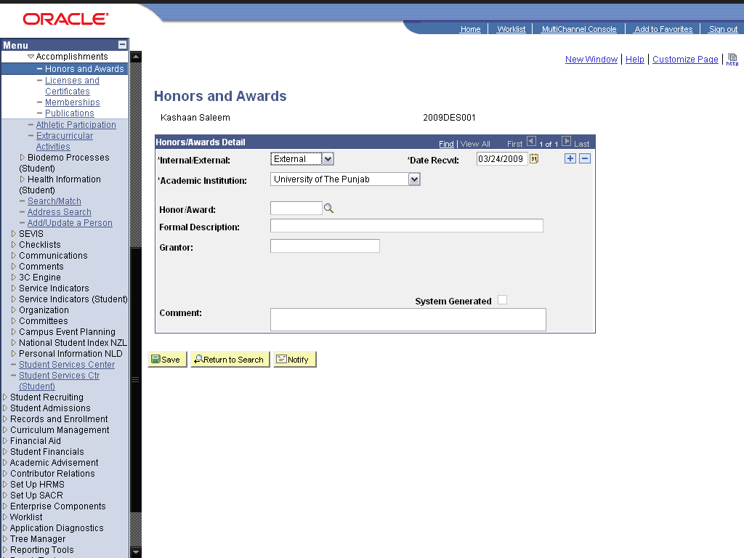

Step | Action
 | Click the *Academic Institution: list.

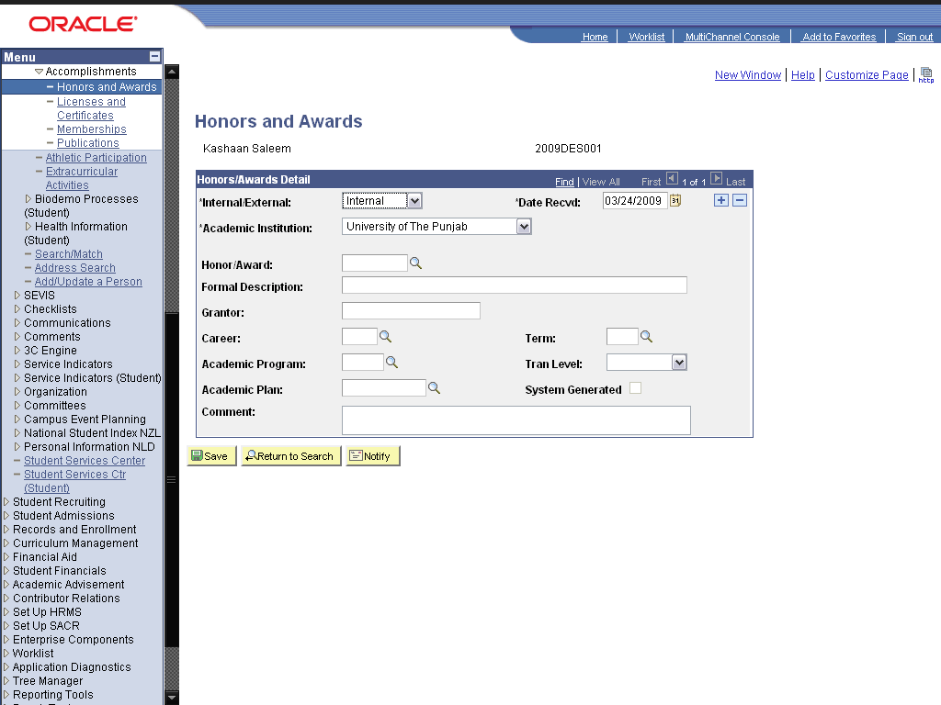

Step | Action
 | Click the Look up Honor/Award (Alt+5) graphic.
 | Click the Dean's List link.
 | Enter the desired information into the Career: field. Enter "GRAD".
 | Enter the desired information into the Term: field. Enter "0091".
 | Click the Save button.

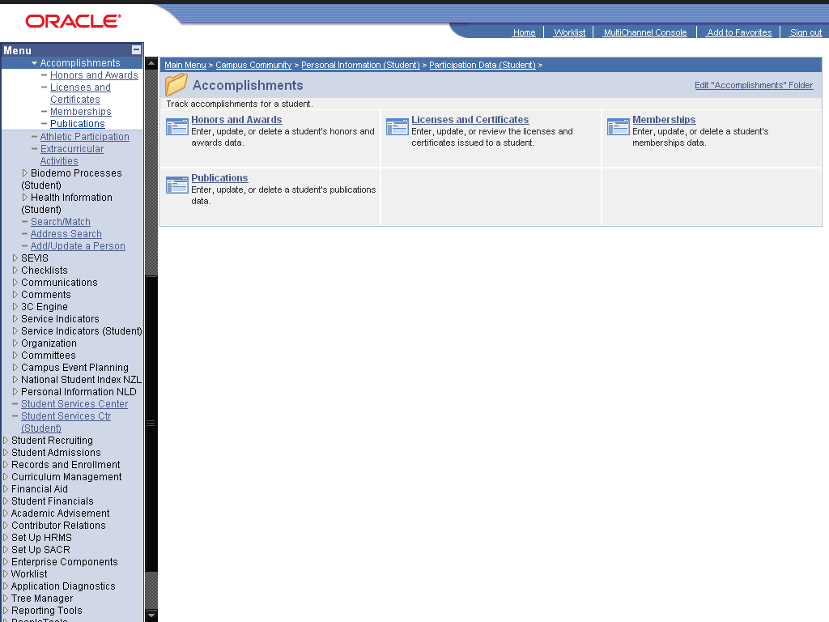

Step | Action
 | Click the Publications link.

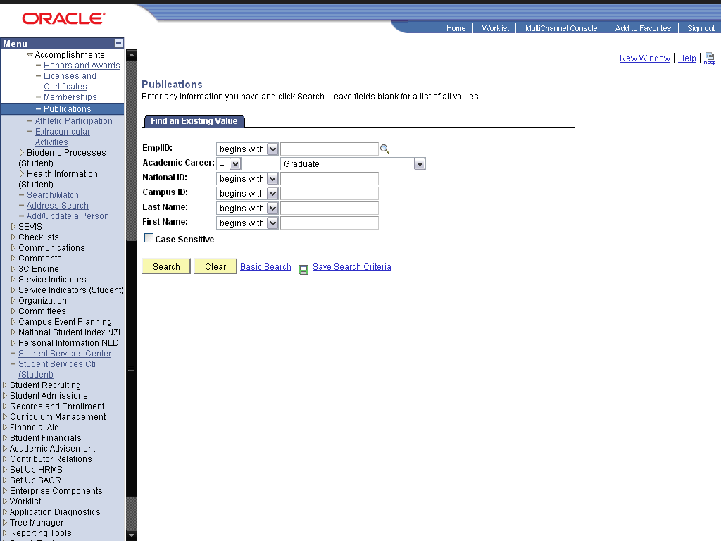

Step | Action
 | Click the Search button.
 | Click the 2009DES001 link.

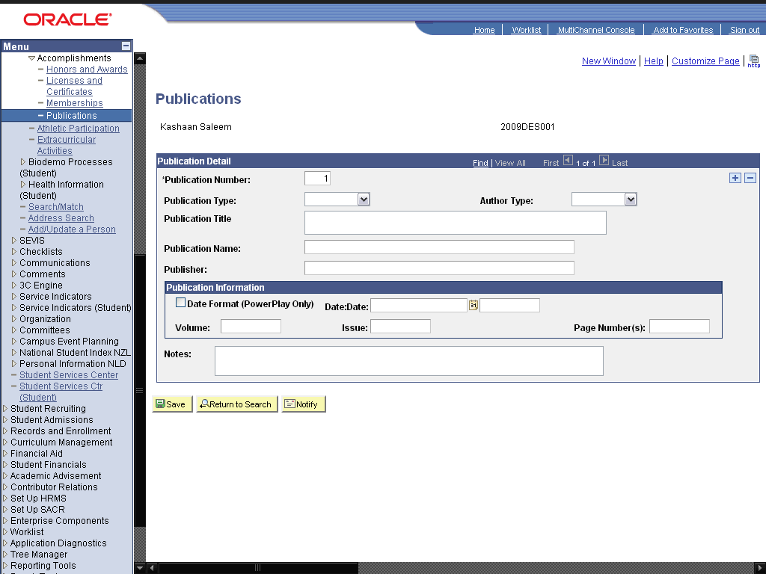

Step | Action
 | Click in the Publication Title field.
 | Click the cell.

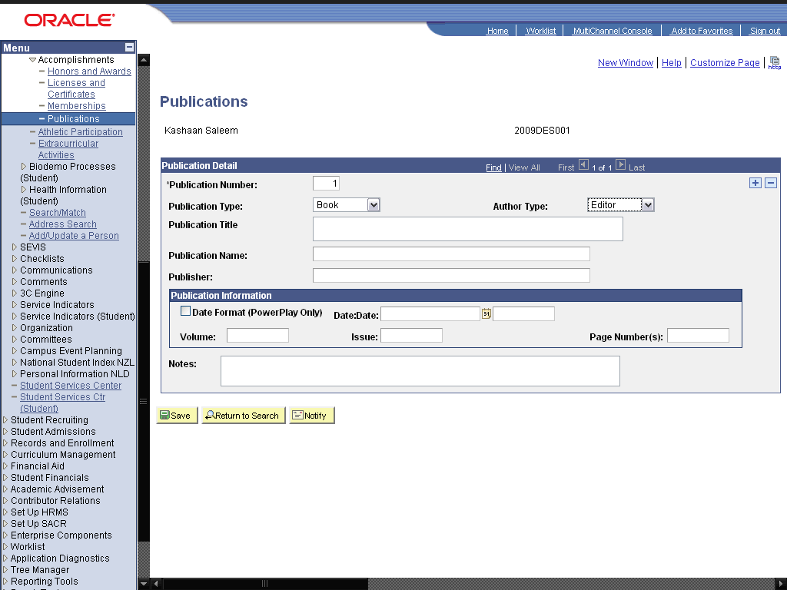

Step | Action
 | Enter the desired information into the Publication Title field. Enter "Introduction to Assembly Language".
 | Enter the desired information into the Publication Name field. Enter "Introduction to Assembly Language".
 | Enter the desired information into the Publisher: field. Enter "Azeem Text Books".
 | Click the Save button.
 | End of Procedure.

Maintaining Helath Information

Add/Update Immunizations and Health Data

Procedure

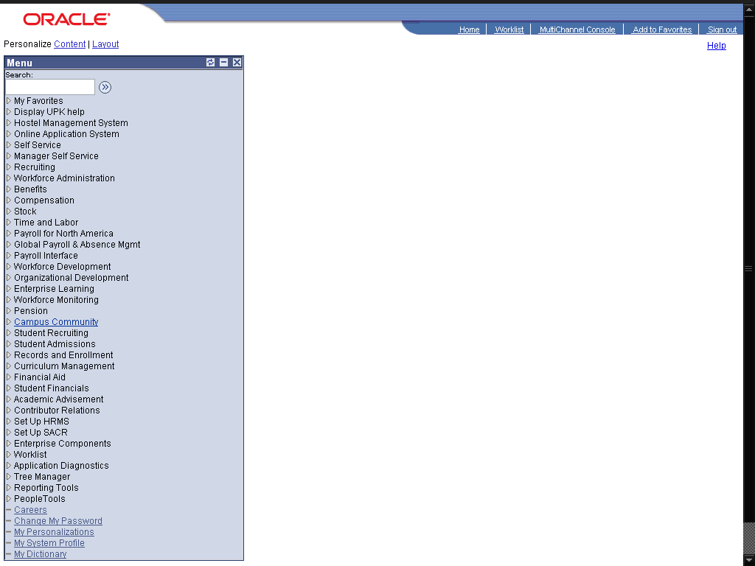

Step | Action
 | Click the Campus Community link.

Step | Action
 | Click the Personal Information (Student) link.
 | Click the Health Information (Student) link.
 | Click the Immunizations and Health link.

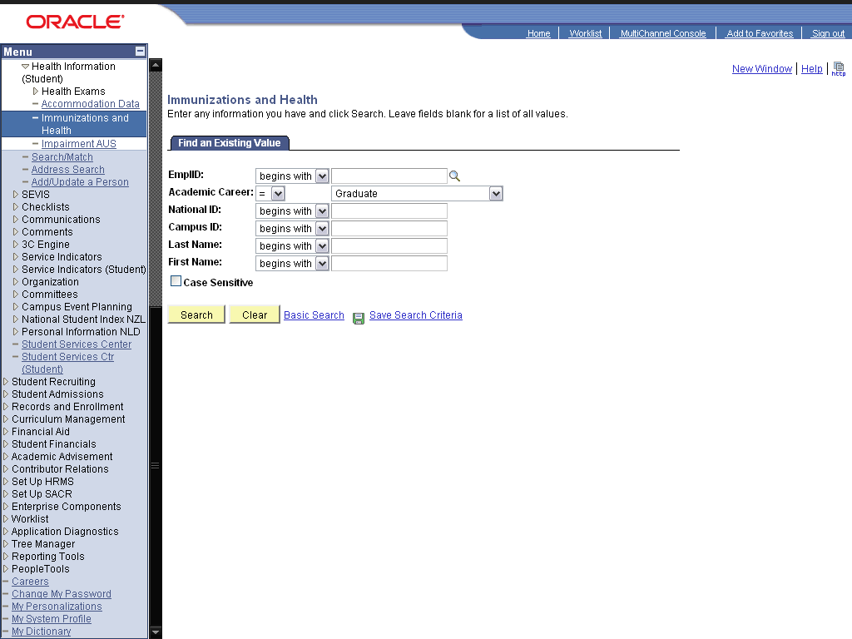

Step | Action
 | Click the Search button.
 | Click the 2009DES001 link.
 | Click the Look up Immunization (Alt+5) graphic.
 | Click the Hepatitus B link.
 | Enter the desired information into the Date Taken: field. Enter "01/01/2009".
 | Enter the desired information into the Expiration Date: field. Enter "01/01/2011".

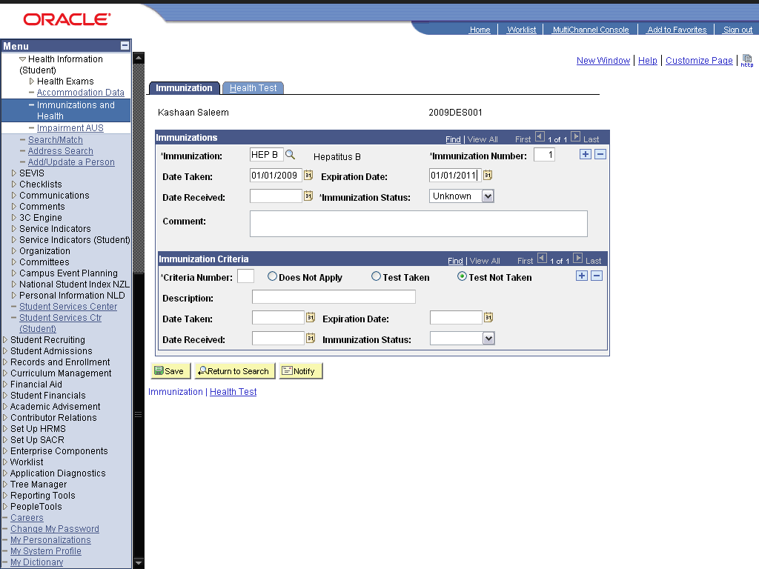

Step | Action
 | Click the cell.

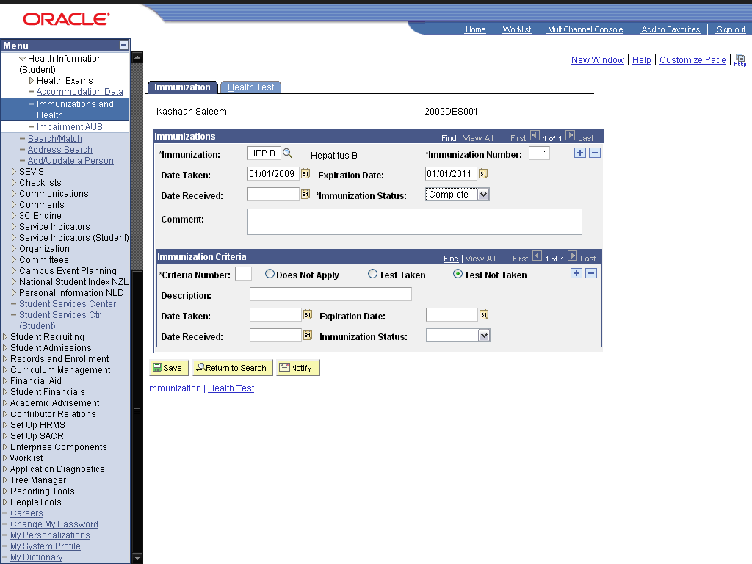

Step | Action
 | Click the ealth Test link.
 | Click the Look up Health Test (Alt+5) graphic.
 | Click the Blood CP link.
 | Enter the desired information into the Date Taken: field. Enter "01/25/2009".
 | Enter the desired information into the Date Received: field. Enter "01/25/2011".
 | Enter the desired information into the Test Value: field. Enter "2.5".

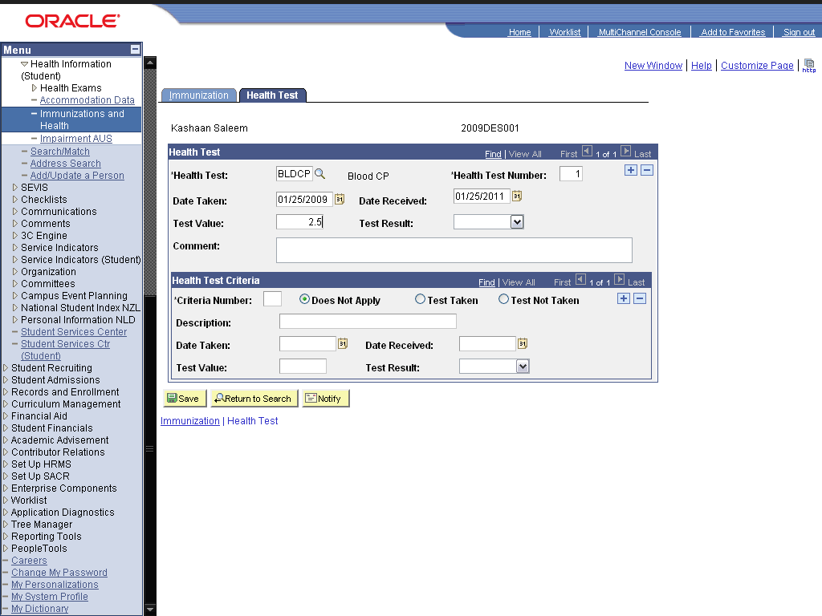

Step | Action
 | Click in the Test Result field.

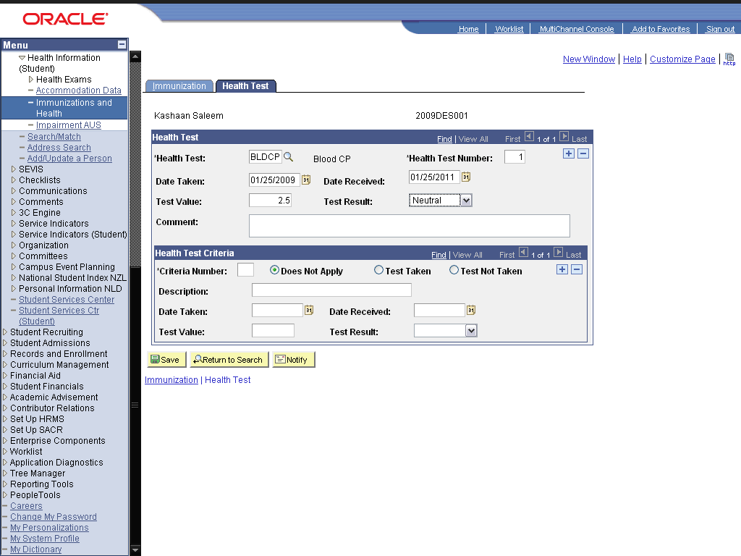

Step | Action
 | Click the Save button.
 | End of Procedure.

Add/Update Health Exam Data

Procedure

Step | Action
 | Click the Campus Community link.

Step | Action
 | Click the Personal Information (Student) link.
 | Click the Health Information (Student) link.
 | Click the Health Exams link.
 | Click the Audiometric Exam link.

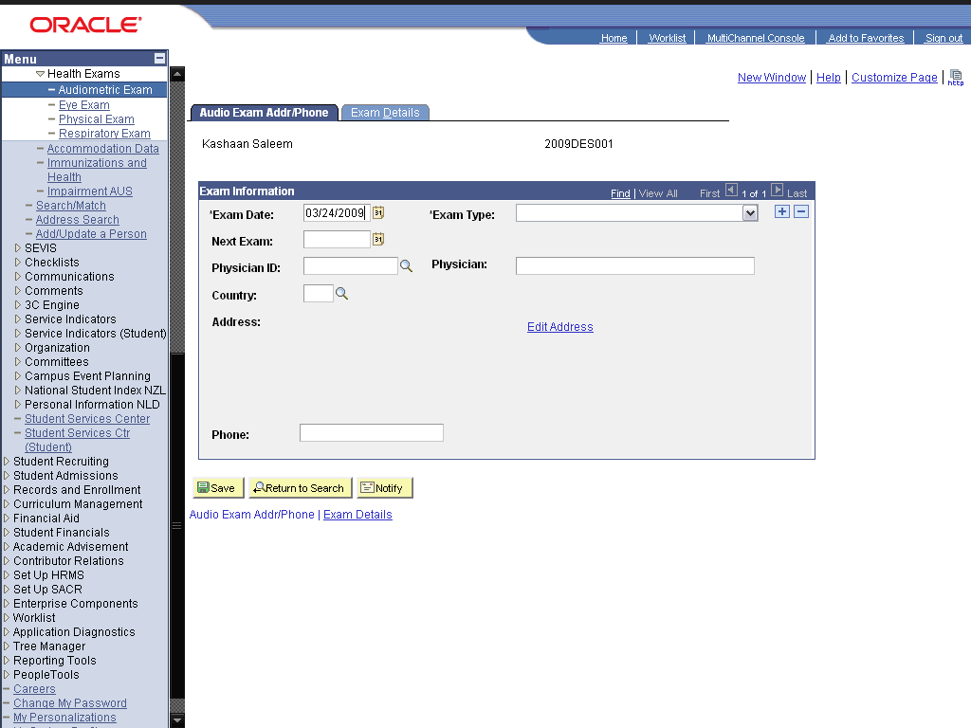

Step | Action
 | Click the *Exam Type: list.

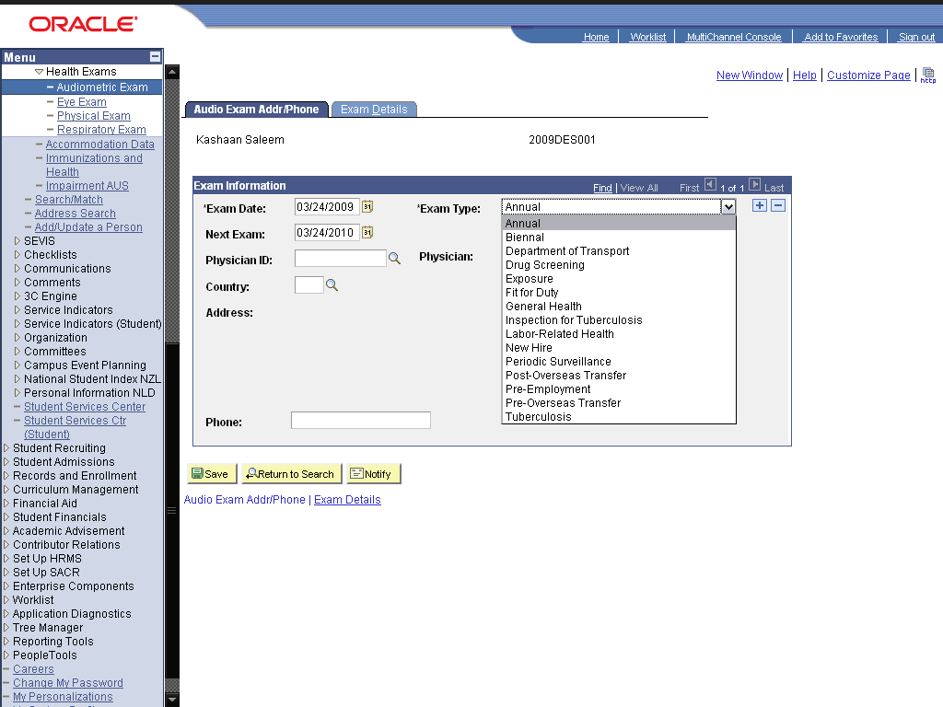

Step | Action
 | Click the cell.

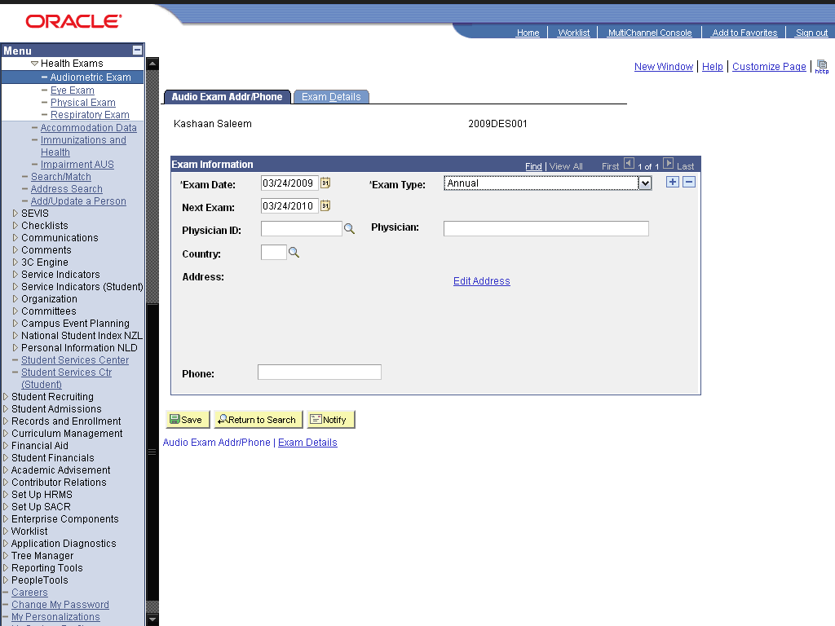

Step | Action
 | Click the Look up Physician ID (Alt+5) graphic.
 | Click the 00001924003 link.
 | Click the Exam link.
 | Enter the desired information into the Audiometer Serial #: field. Enter "1".

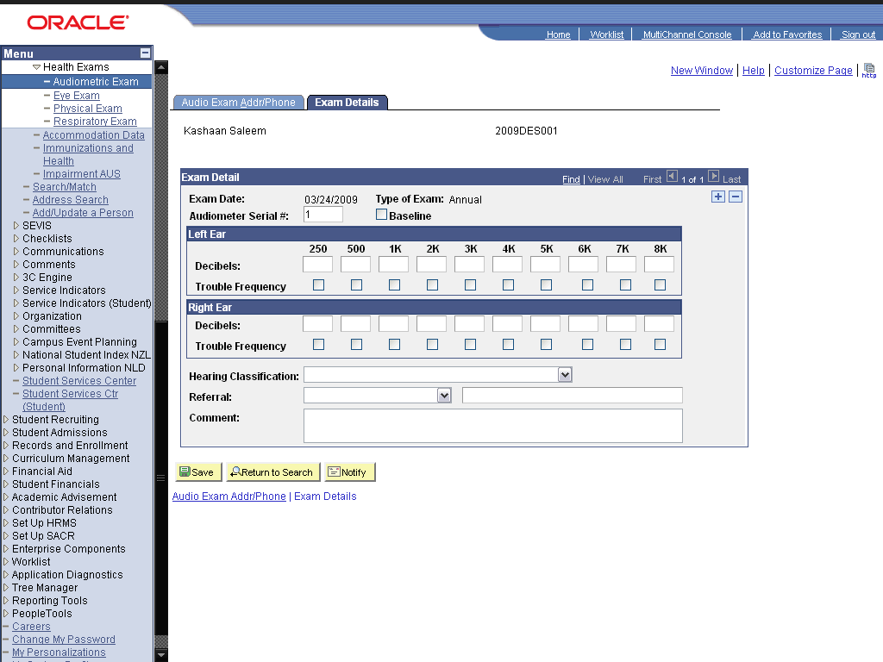

Step | Action
 | Enter the desired information into the Decibels: field. Enter "-10".
 | Enter the desired information into the 500 field. Enter "10".
 | Enter the desired information into the 1K field. Enter "20".
 | Enter the desired information into the 8K field. Enter "150".

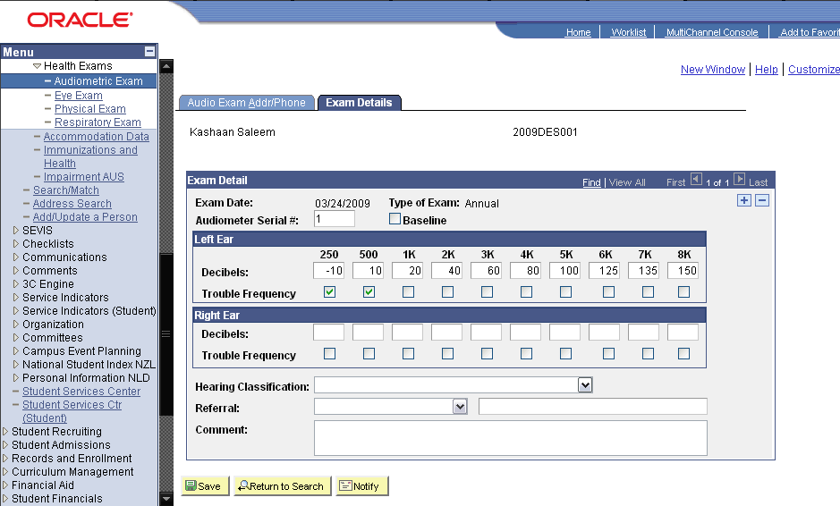

Step | Action
 | Click in the Hearing Classification: field.

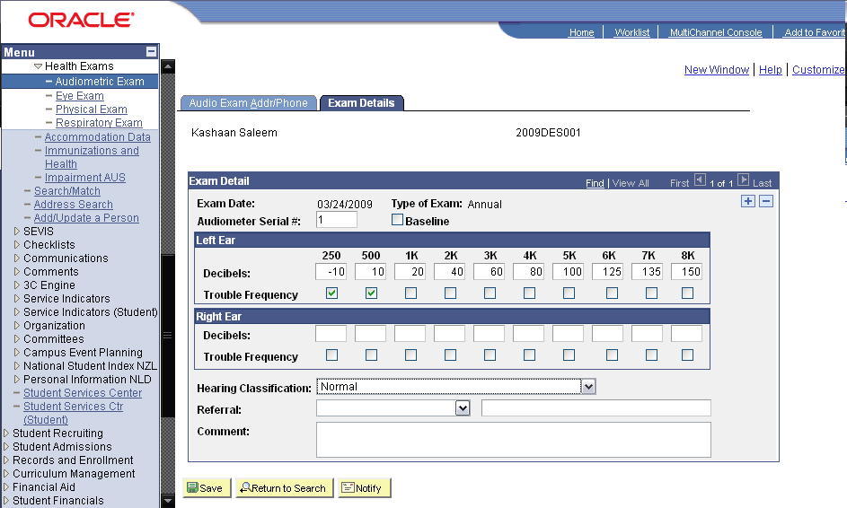

Step | Action
 | Click the Save button.

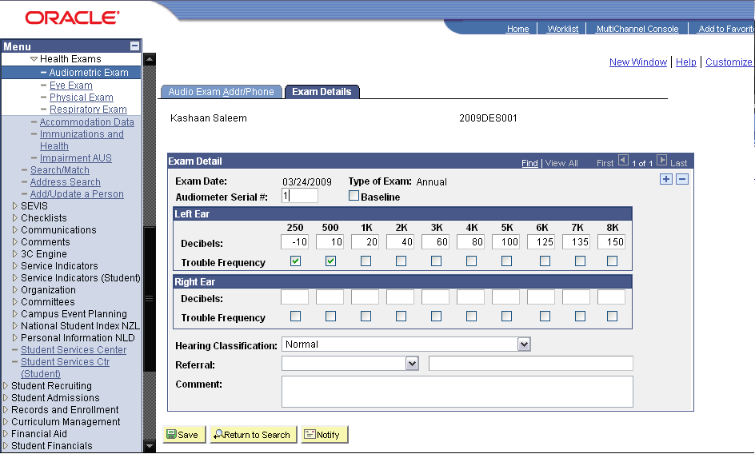

Step | Action
 | Click the Eye Exam link.

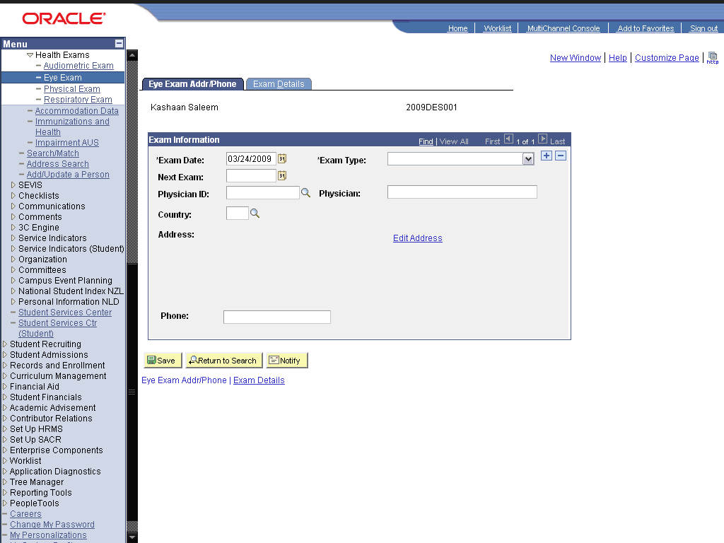

Step | Action
 | Click the cell.

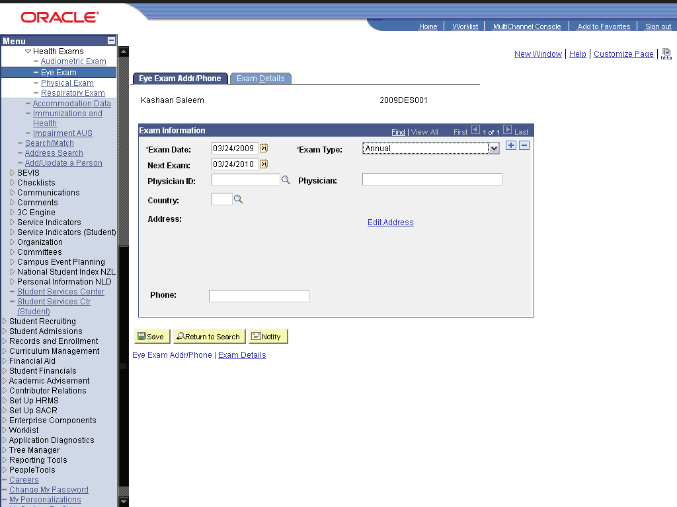

Step | Action
 | Enter the desired information into the Physician ID: field. Enter "00001924003".
 | Click the Exam Details link.
 | Enter the desired information into the Uncorrected: field. Enter "2".
 | Enter the desired information into the field. Enter "2".
 | Click the Save button.
 | Click the Physical Exam link.

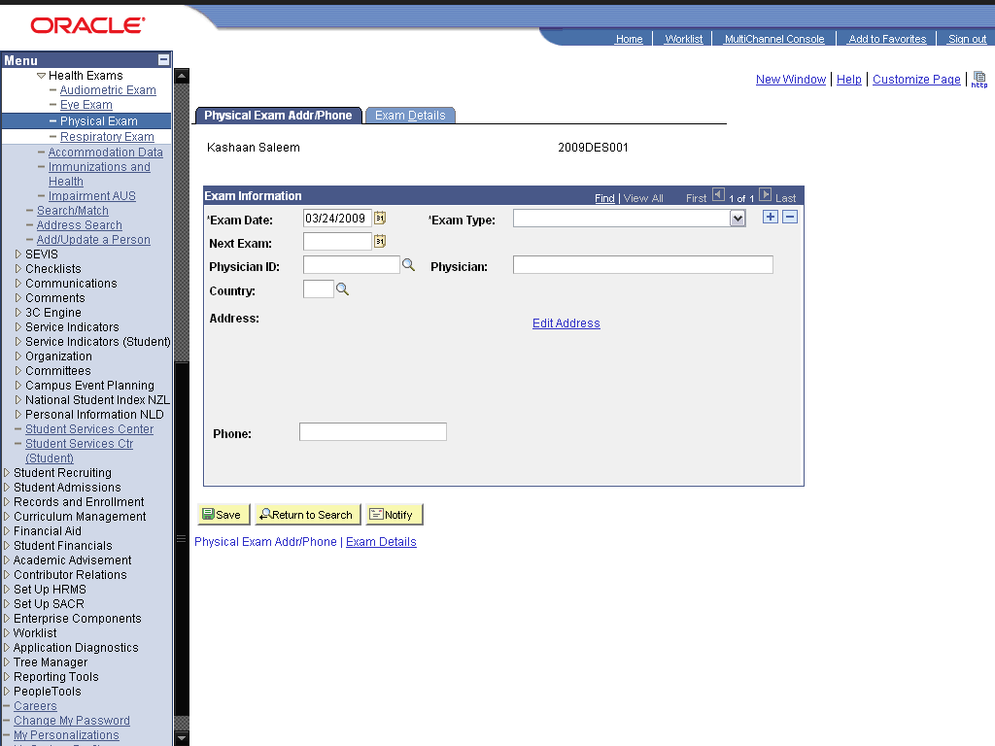

Step | Action
 | Click the cell.

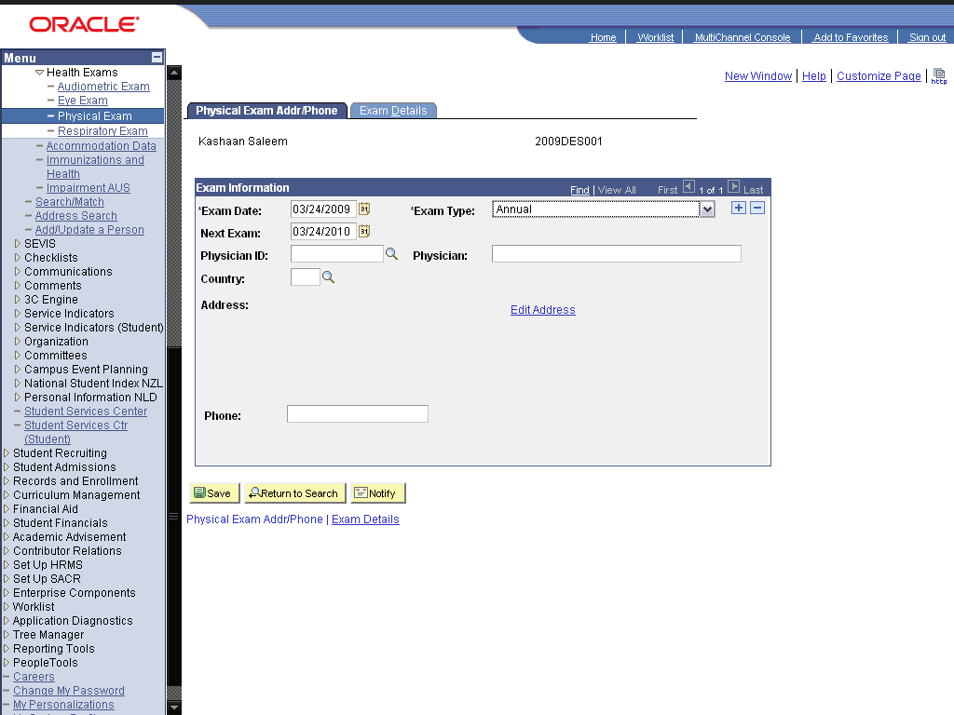

Step | Action
 | Enter the desired information into the Physician ID: field. Enter "00001924003".
 | Click the Exam details link.
 | Click the Blood Donor option.

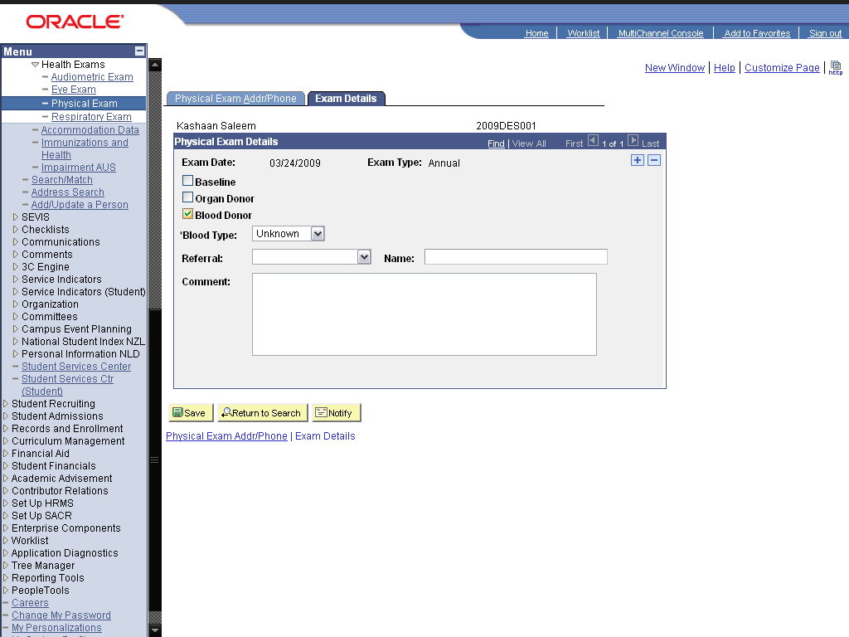

Step | Action
 | Click in the Blood Type: field.

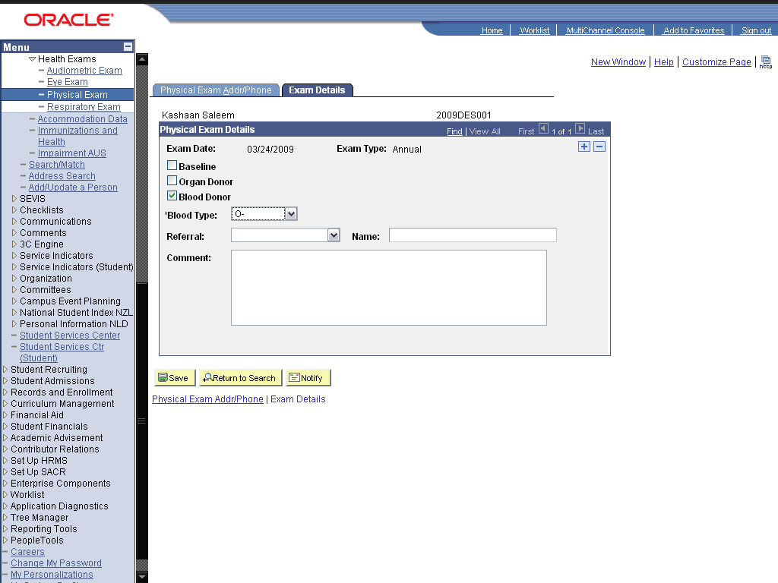

Step | Action
 | Click the Save button.
 | Click the Respiratory Exam link.

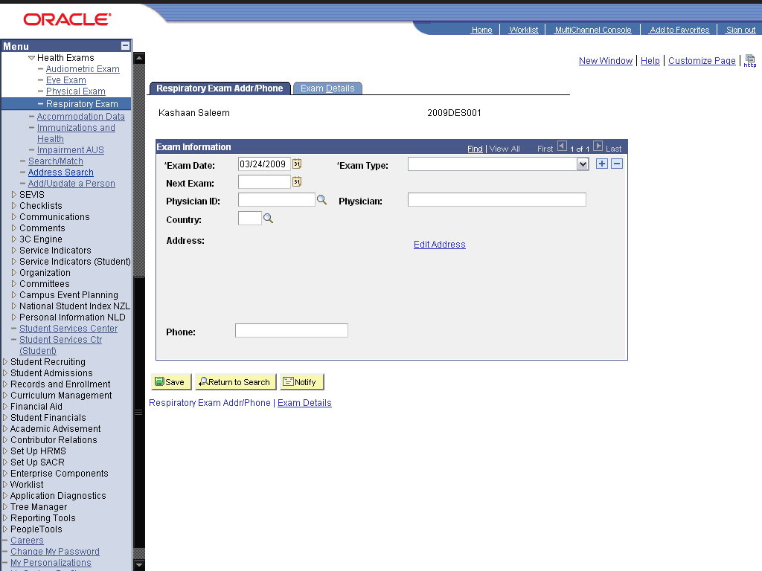

Step | Action
 | Click the cell.

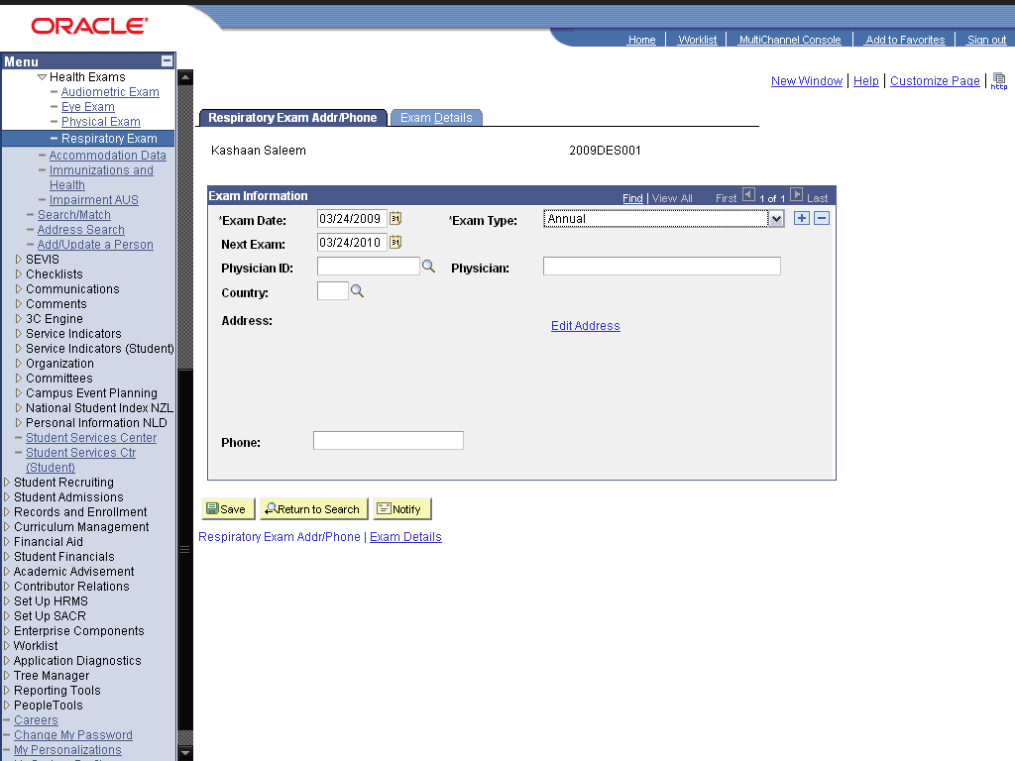

Step | Action
 | Enter the desired information into the Physician ID: field. Enter "00001924003".
 | Click the Exam Details link.

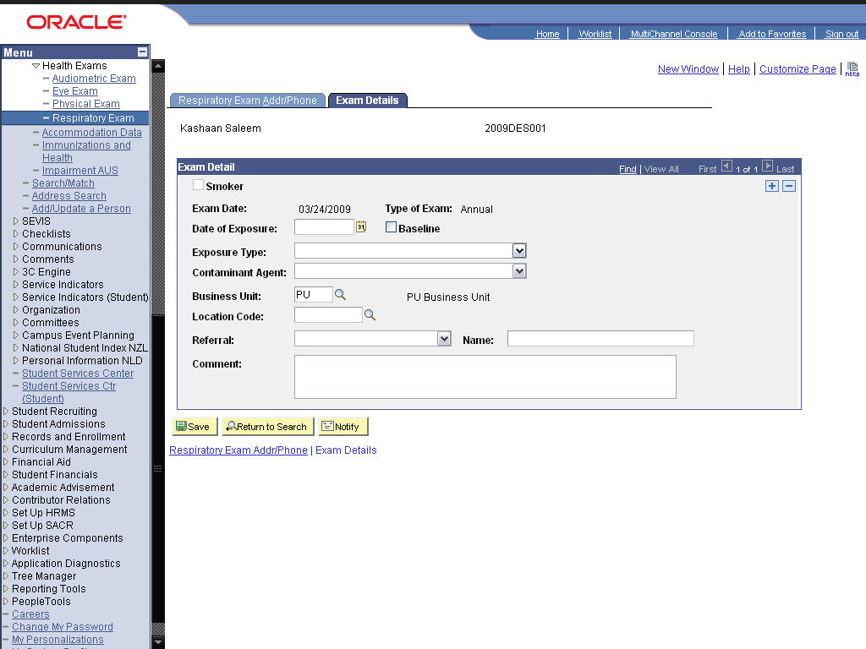

Step | Action
 | Click in the Exposure Type: field.
 | Click the Look up Business Unit (Alt+5) graphic.

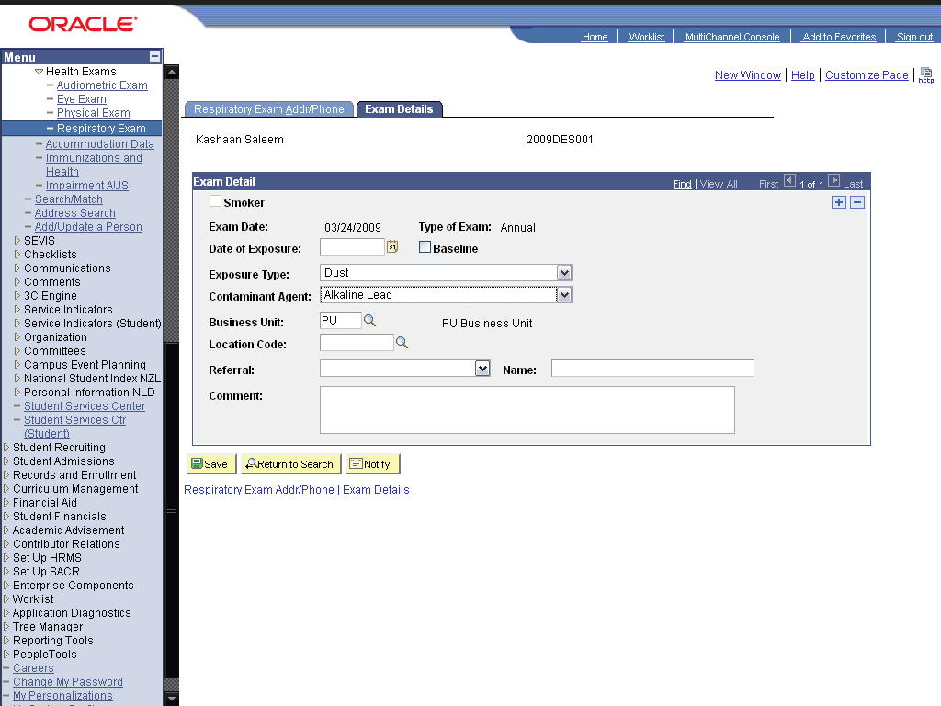

Step | Action
 | Click the Save button.
 | End of Procedure.

Maintaining Checklist Information

Create Checklist

Procedure

Step | Action
 | Click the Campus Community link.

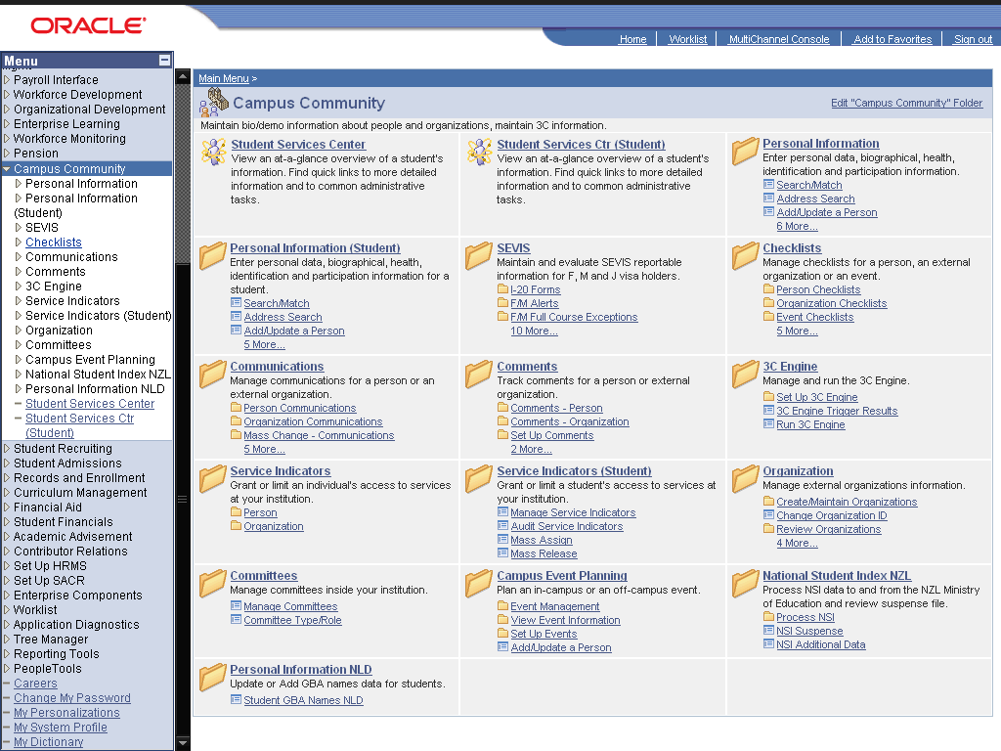

Step | Action
 | Click the Checklists link.
 | Click the Set up Checklists link.
 | Click the Checklist Item Table link.

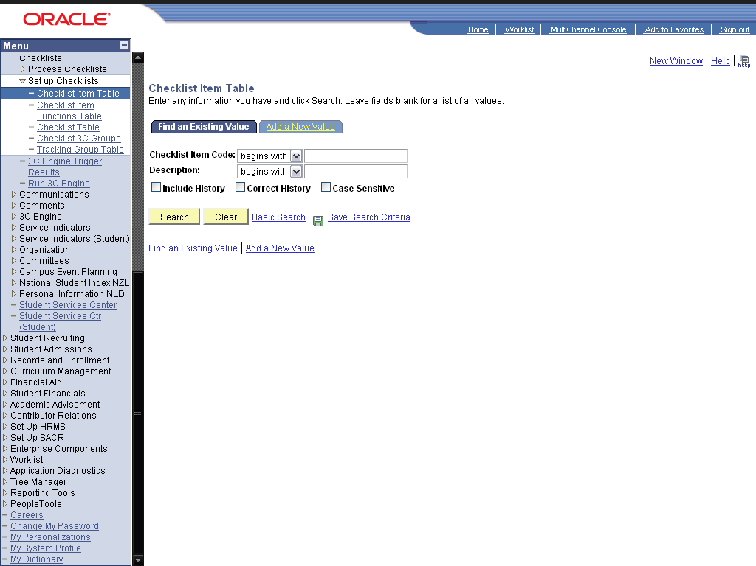

Step | Action
 | Click the dd a New Value link.
 | Enter the desired information into the Checklist Item Code: field. Enter "BABSC".
 | Click the Add button.
 | Enter the desired information into the *Effective Date: field. Enter "01/01/1900".
 | Enter the desired information into the *Checklist Code Descr: field. Enter "BA/ BSC Equivalent".
 | Enter the desired information into the Short Description: field. Enter "BA/ BSC".
 | Click the Item Association list.

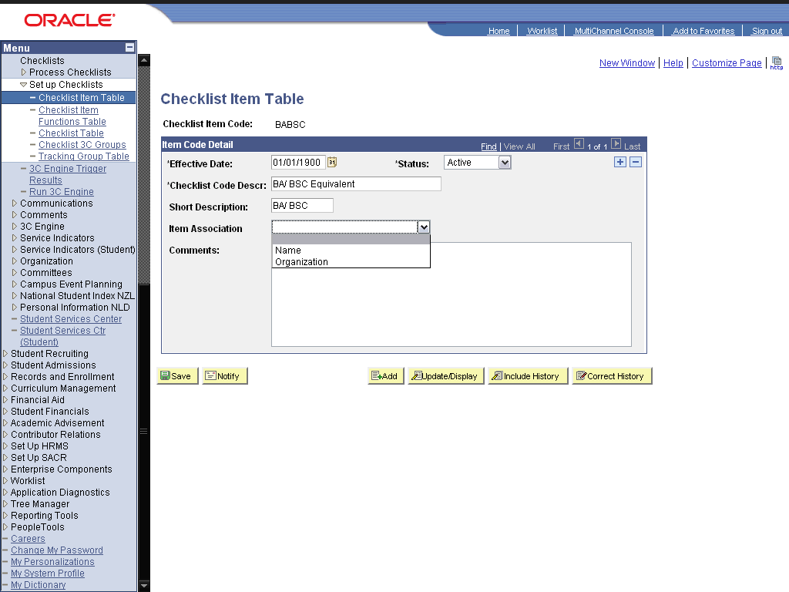

Step | Action
 | Click in the Name: field.

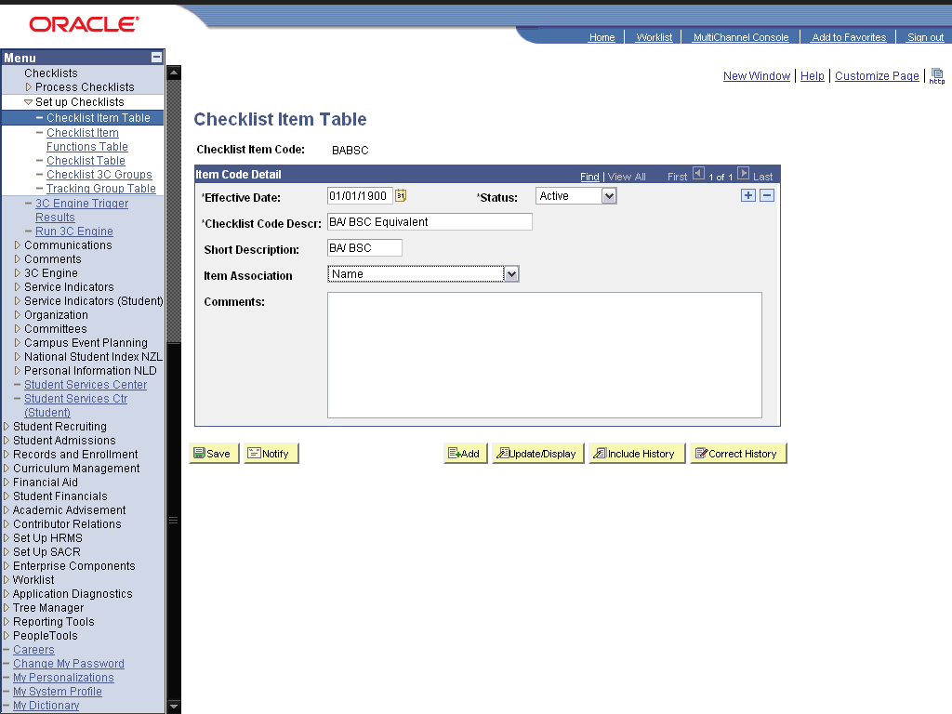

Step | Action
 | Click the Save button.
 | Click the Checklist Item Functions Table link.

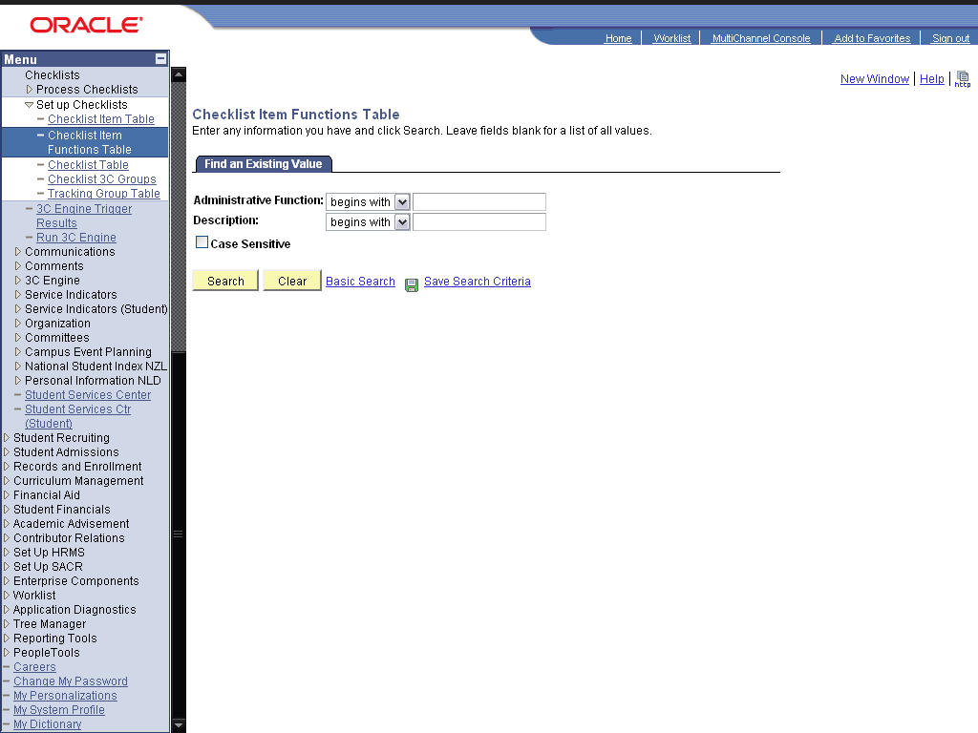

Step | Action
 | Click the Search button.
 | Click the ADMA link.
 | Click the Look up Item Code (Alt+5) graphic.
 | Click the BABSC link.
 | Click the Add a new row at row 1 (Alt+7) graphic.
 | Enter the desired information into the field. Enter "NICARD".
 | Click the Add a new row at row 2 (Alt+7) graphic.
 | Enter the desired information into the field. Enter "PHOTO".
 | Click the Add a new row at row 3 (Alt+7) graphic.
 | Enter the desired information into the field. Enter "DOMC".
 | Click the Save button.
 | Click the Checklist Table link.

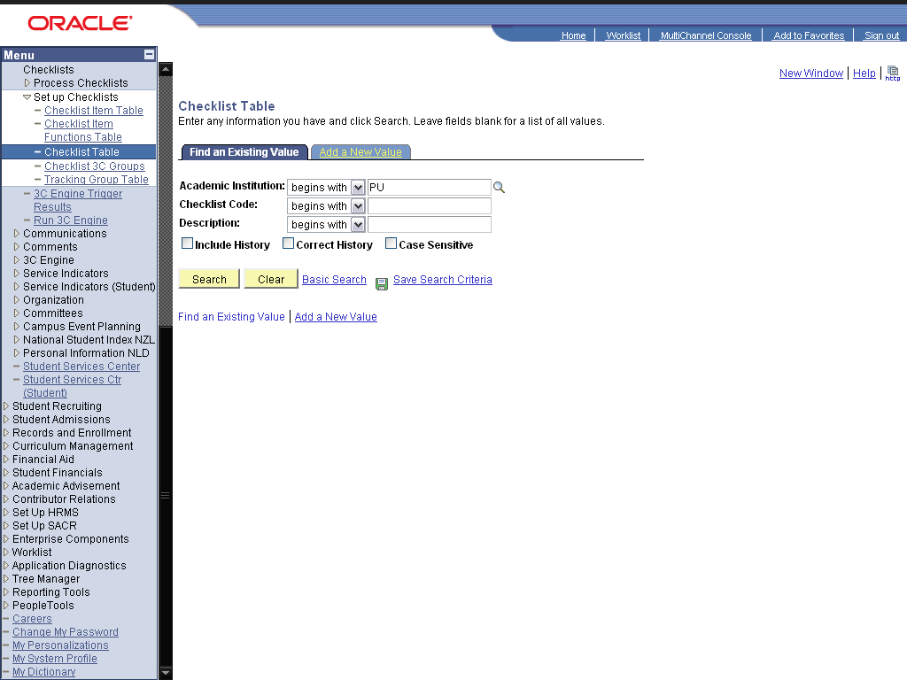

Step | Action
 | Click the dd a New Value link.
 | Enter the desired information into the Checklist Code: field. Enter "ADMIS".
 | Click the Add button.
 | Enter the desired information into the field. Enter "01/01/1900".
 | Enter the desired information into the *Description: field. Enter "Admission Checklist".
 | Enter the desired information into the Short Description: field. Enter "Admission".
 | Enter the desired information into the *Function: field. Enter "ADMA".
 | Click the Checklist Type: list.

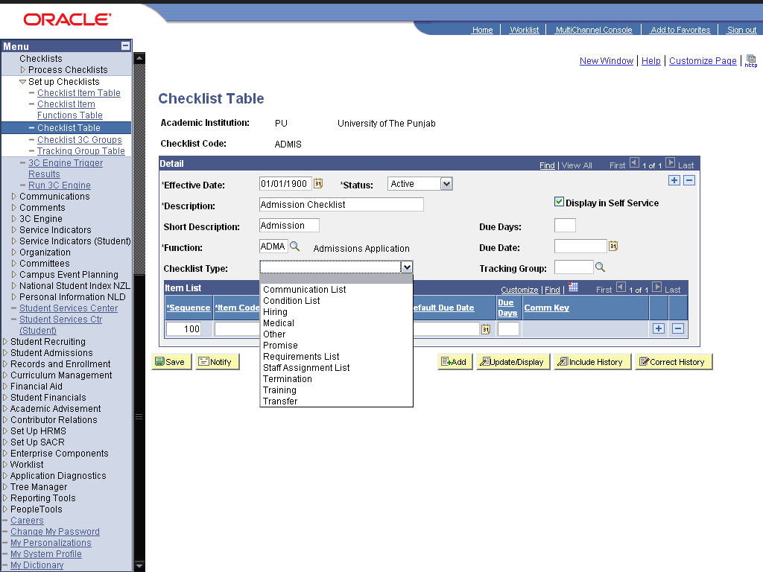

Step | Action
 | Click the Condition List link.

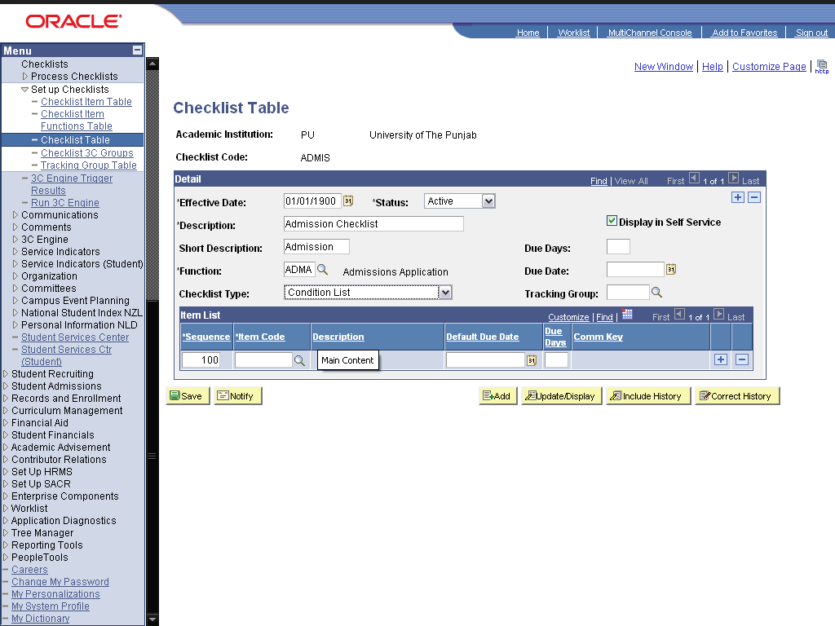

Step | Action
 | Enter the desired information into the Due Days: field. Enter "15".
 | Click the Look up Item Code (Alt+5) graphic.
 | Click the BABSC link.
 | Click the Add a new row at row 1 (Alt+7) graphic.
 | Enter the desired information into the field. Enter "DOMC".
 | Click the Save button.
 | Click the Checklist 3C Groups link.

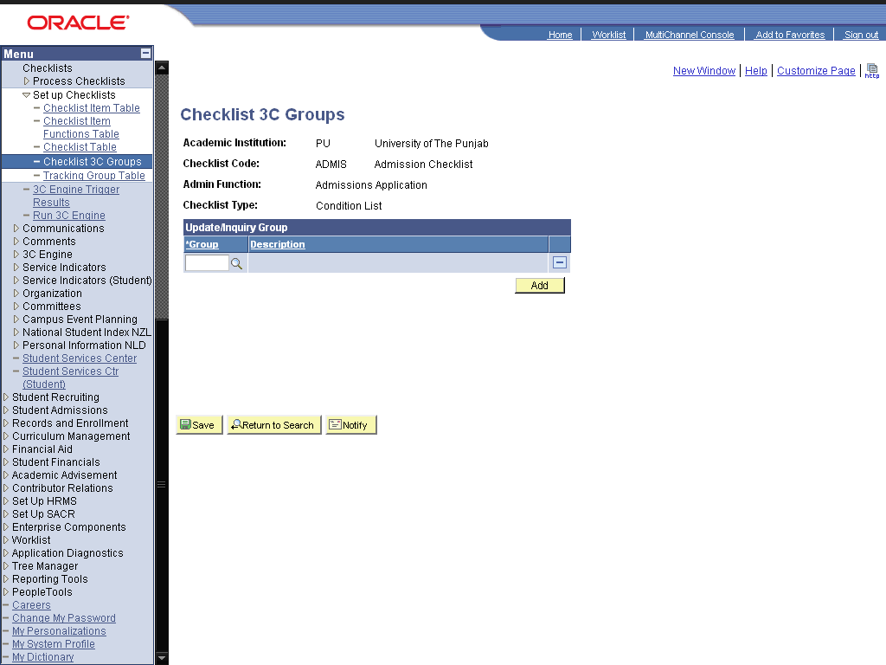

Step | Action
 | Click the Look up Group (Alt+5) graphic.
 | Click the Comment/Communication Security link.
 | Click the Save button.
 | End of Procedure.

Assign Checklist

Procedure

Step | Action
 | Click the Campus Community link.

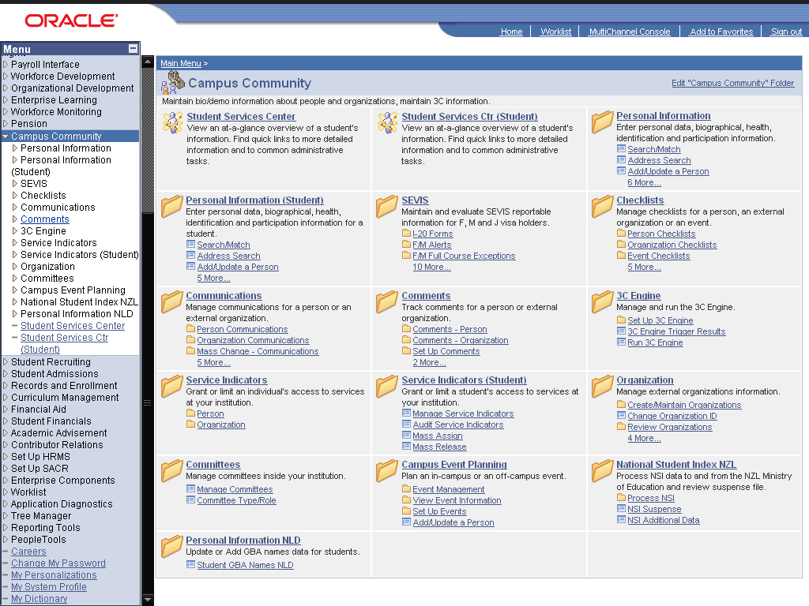

Step | Action
 | Click the Checklists link.
 | Click the Person Checklists link.
 | Click the Checklist Management - Person link.

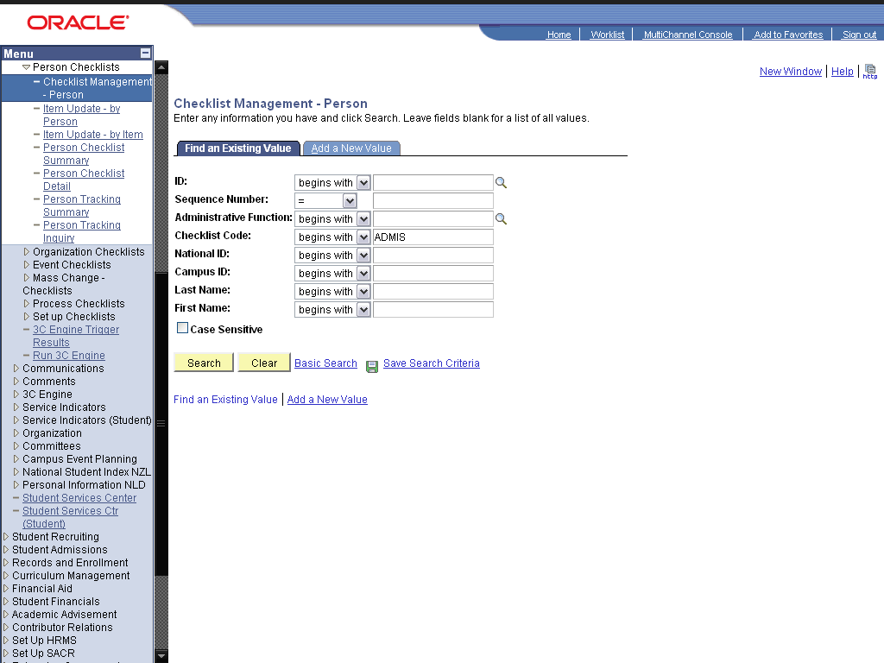

Step | Action
 | Click the dd a New Value link.
 | Enter the desired information into the ID: field. Enter "2009des001".
 | Click the Add button.
 | Enter the desired information into the *Administrative Function: field. Enter "ADMA".
 | Enter the desired information into the *Checklist Code: field. Enter "ADMIS".
 | Enter the desired information into the Due Date: field. Enter "04/08/2009".
 | Click the Checklist Management 2 link.
 | Click the cell.
 | Click the Variable Data button.
 | Enter the desired information into the field. Enter "GRAD".
 | Click the Look up Application Nbr (Alt+5) graphic.
 | Click the 00028732 link.
 | Click the OK button.
 | Click the Save button.
 | Click the Item Update - by Person link.

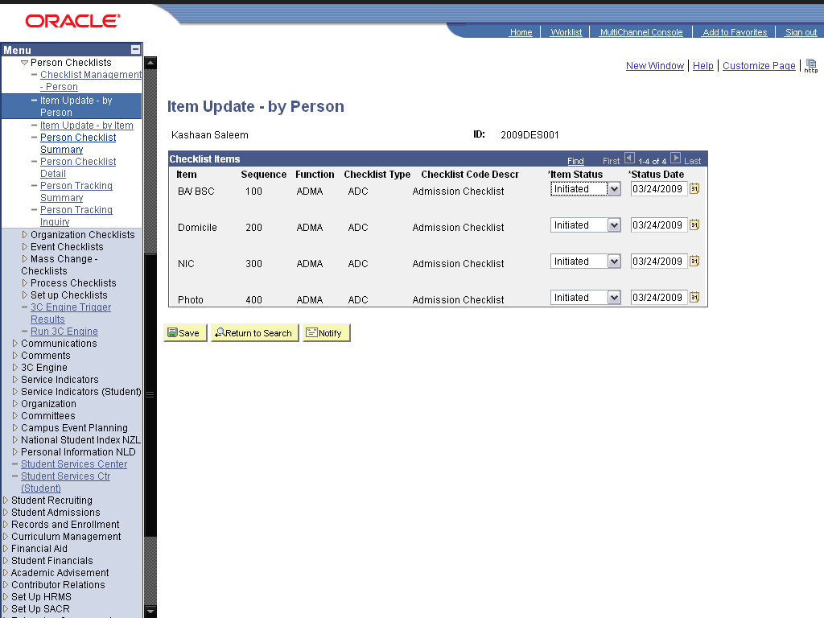

Step | Action
 | Click the list.

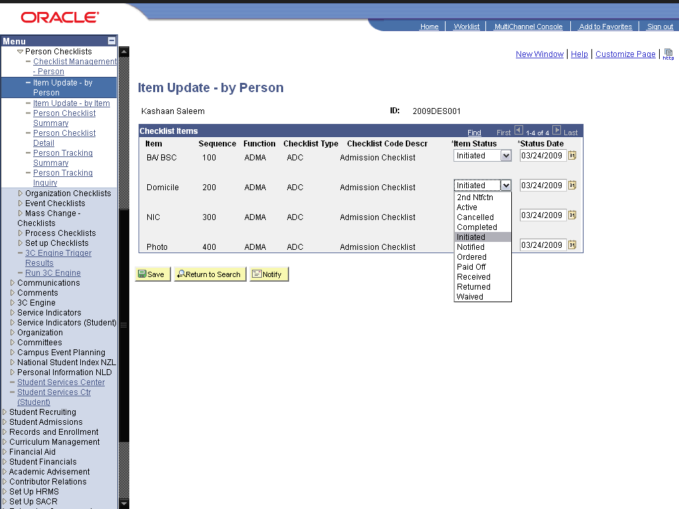

Step | Action
 | Click the cell.

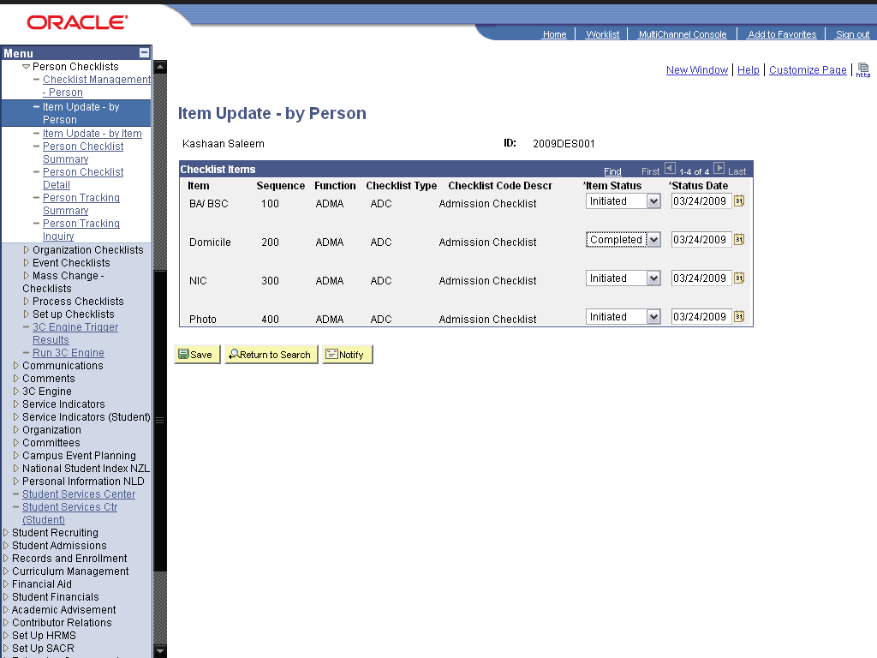

Step | Action
 | Click the Save button.

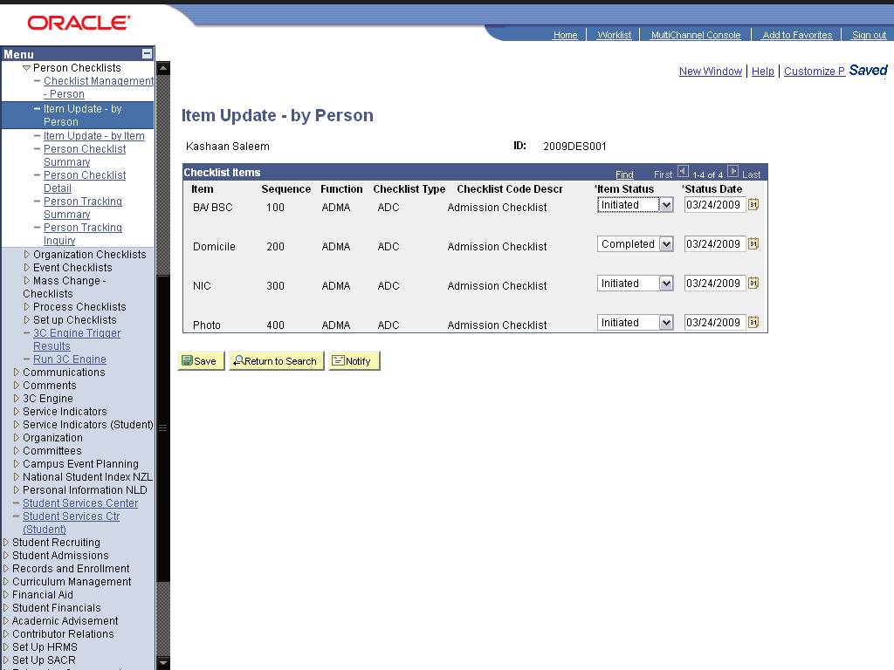

Step | Action
 | Click the Item Update - by Item link.
 | Click the Add a New Value link.
 | Click the Look up Checklist Item Code (Alt+5) graphic.
 | Click the PHOTO link.
 | Click the Add button.
 | Click the Look up ID (Alt+5) graphic.
 | Click the 2002GBW229 link.
 | Click the Add a new row at row 1 (Alt+7) graphic.
 | Click the Look up ID (Alt+5) graphic.
 | Click the 2002IWG28 link.
 | Click the Save button.
 | Click the Person Checklist Summary link.

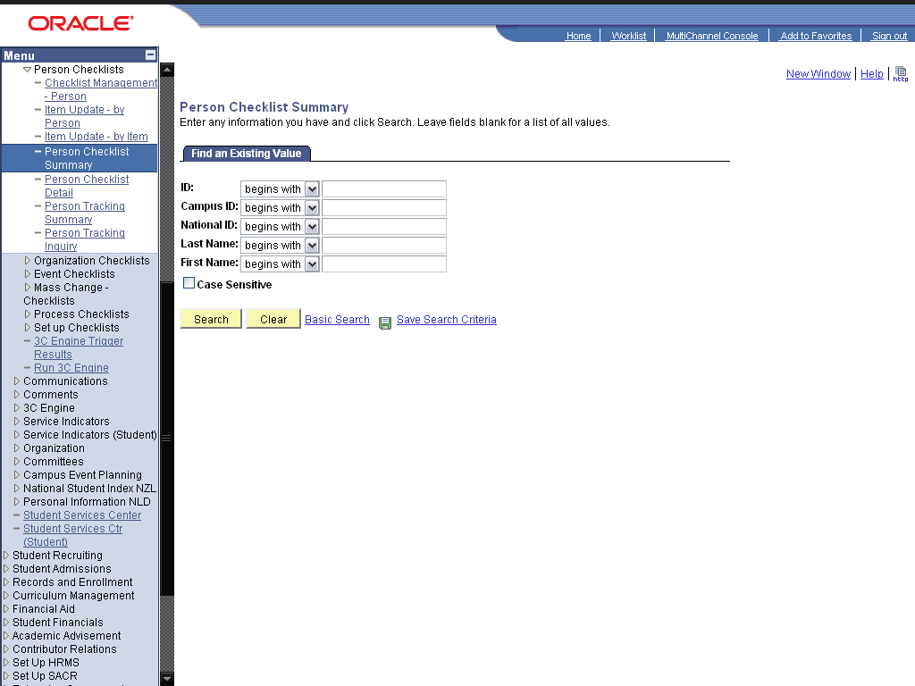

Step | Action
 | Click the Search button.
 | Enter the desired information into the Function field. Enter "ADMA".
 | Click the Search graphic.
 | Click the Save button.
 | End of Procedure.

Maintaining Comments

Create Comment

Procedure

Step | Action
 | Click the Campus Community link.

Step | Action
 | Click the Comments link.
 | Click the Set Up Comments link.
 | Click the Comment Category Table link.

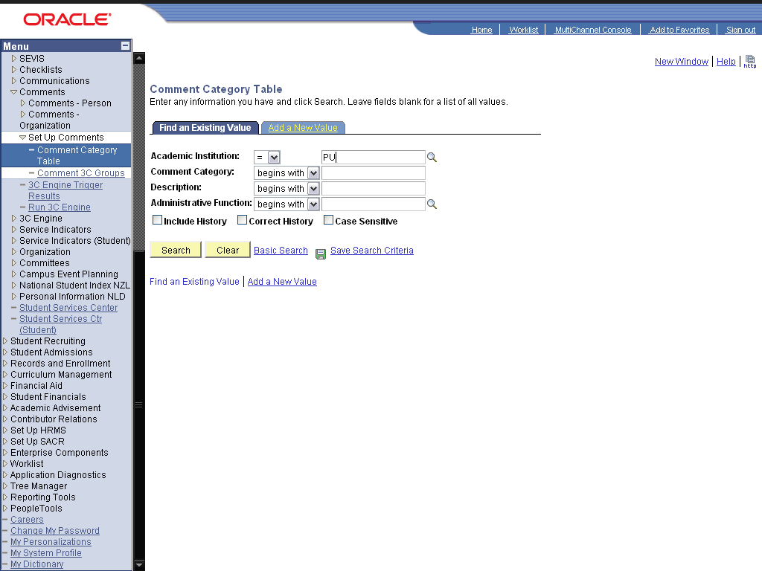

Step | Action
 | Click the dd a New Value link.
 | Enter the desired information into the Comment Category: field. Enter "ADM".
 | Click the Add button.
 | Enter the desired information into the *Effective Date: field. Enter "01/01/1900".
 | Enter the desired information into the *Description: field. Enter "Administrative Comment".
 | Enter the desired information into the Short Description: field. Enter "Admin".
 | Enter the desired information into the *Administrative Function: field. Enter "GEN".
 | Enter the desired information into the field. Enter "Need to Improve.".
 | Click the Save button.
 | Click the Comment 3C Groups link.

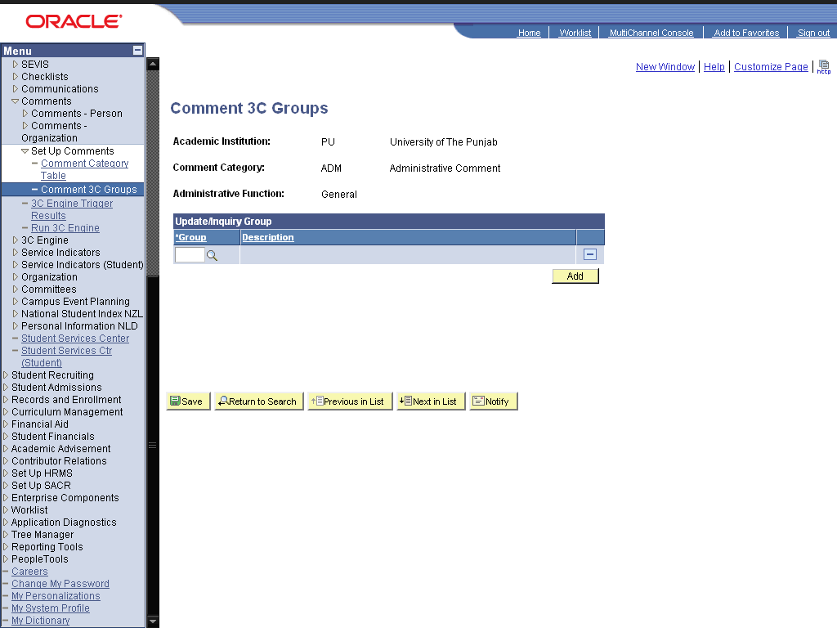

Step | Action
 | Enter the desired information into the field. Enter "SEC".
 | Click the Save button.
 | End of Procedure.

Assign Comment

Procedure

Step | Action
 | Click the Campus Community link.

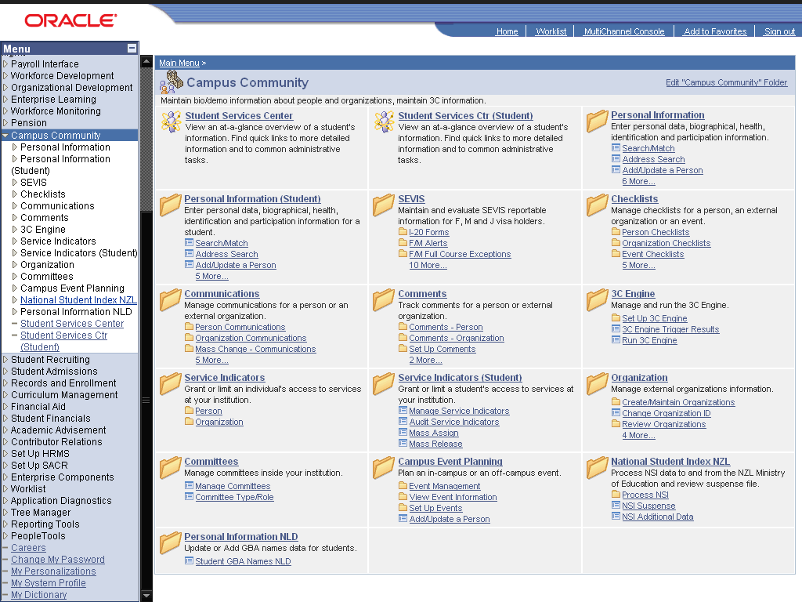

Step | Action
 | Click the Comments link.
 | Click the Comments - Person link.
 | Click the Person Comment Entry link.

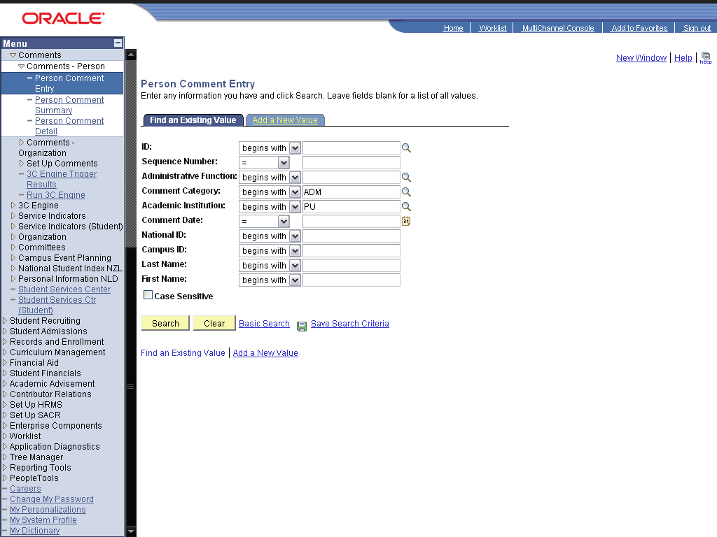

Step | Action
 | Click the dd a New Value link.
 | Enter the desired information into the ID: field. Enter "2009des001".
 | Click the Add button.
 | Enter the desired information into the *Administrative Function: field. Enter "GEN".
 | Enter the desired information into the *Comment Category: field. Enter "ADM".
 | Click the Look up Department (Alt+5) graphic.
 | Click the ADMIN link.
 | Click the Save button.
 | Click the Person Comment Summary link.

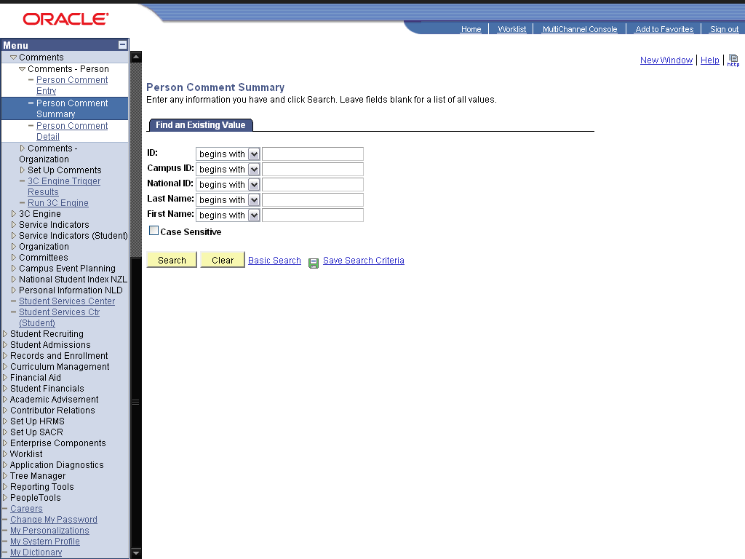

Step | Action
 | Press [Enter].
 | Enter the desired information into the Function: field. Enter "GEN".
 | Click the Fetch graphic.
 | Click the View link.
 | End of Procedure.

Maintaining Service Indicators

Assign and Manage Service Indicators

Procedure

Step | Action
 | Click the Campus Community link.

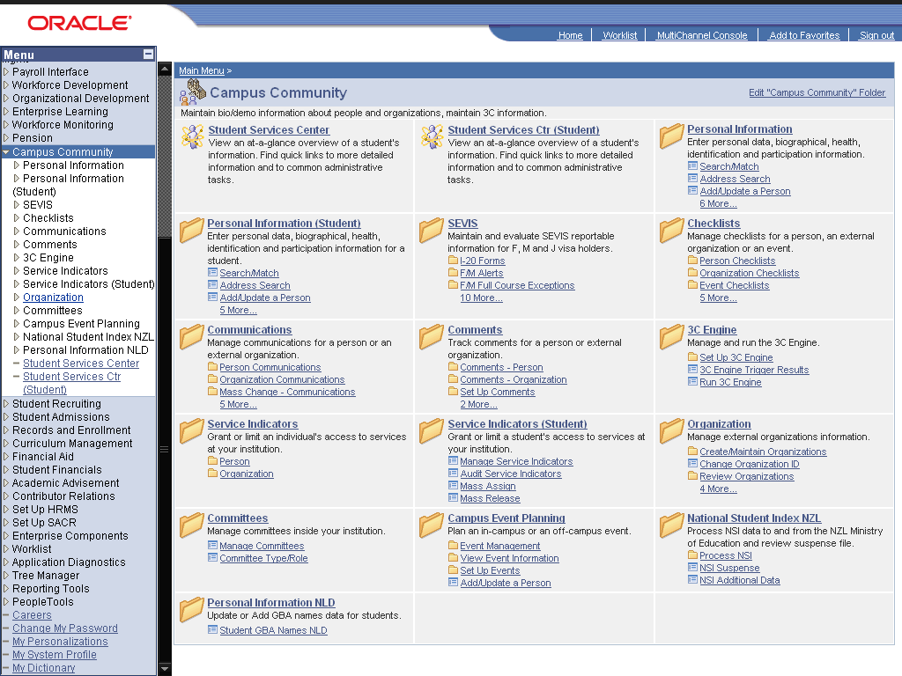

Step | Action
 | Click the Committees link.
 | Click the Manage Service Indicators link.

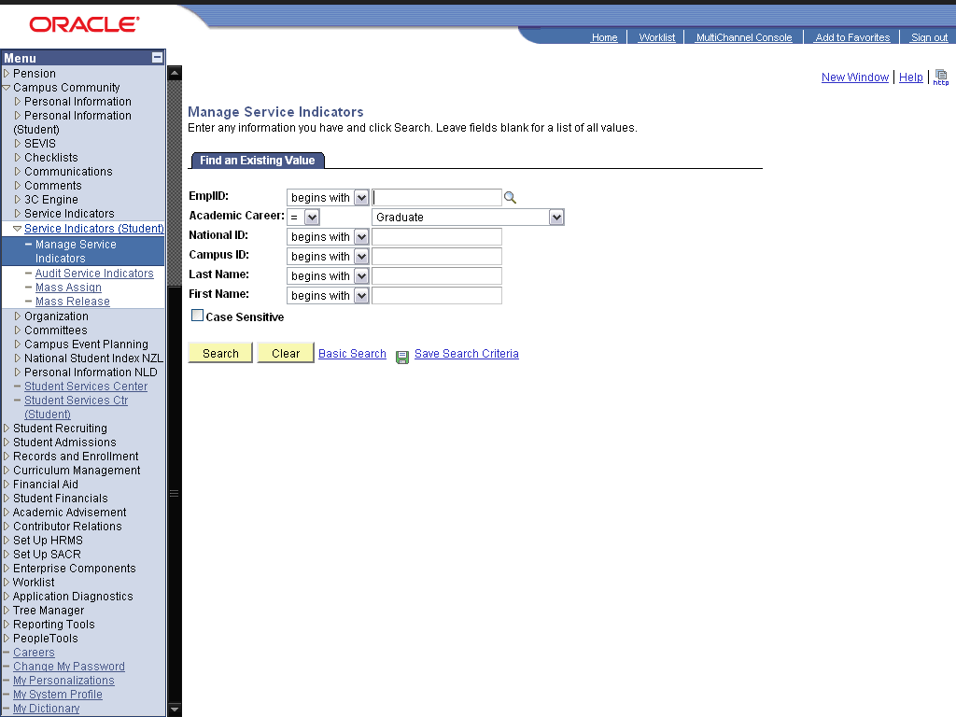

Step | Action
 | Click the Search button.
 | Click the 2009DES001 link.
 | Click the Effect list.

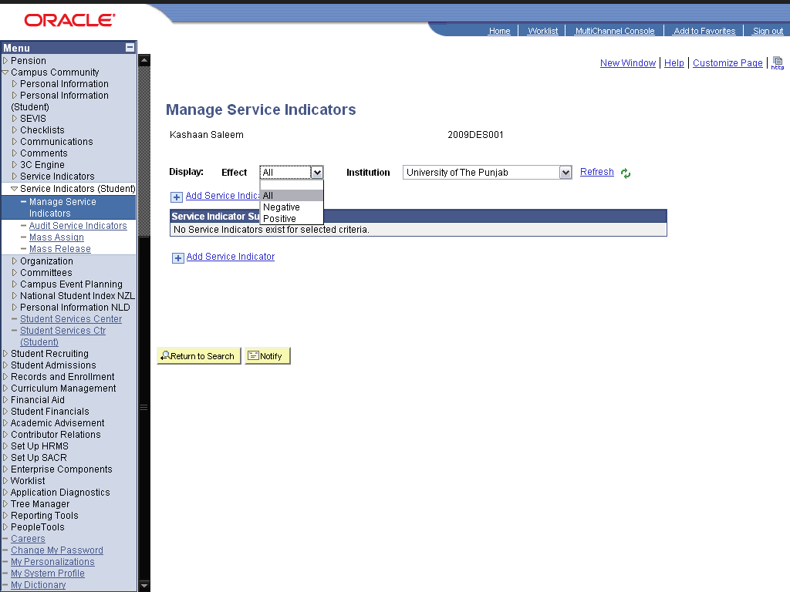

Step | Action
Click in the Negative field.
Select the effect of the service indicator

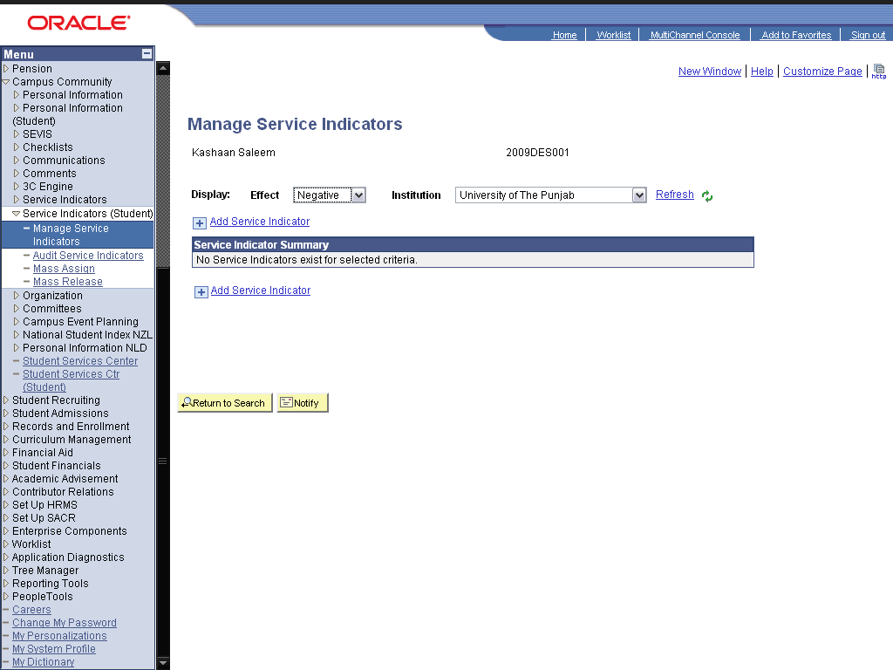

Step | Action
 | Click the Add Service Indicator link.
 | Click the Late Fee Service Indicator link.
 | Click the Look up Service Ind Reason Code (Alt+5) graphic.
 | Click the Unpaid Fee link.
 | Enter the desired information into the Start Term: field. Enter "0091".
Enter the desired information into the End Date: field. Enter "04/25/2009".
This is the date after which, the service indicator will remain no longer effective.
Click the cell.
The impacts of this service indicator: This specific service indicator blocks all sorts of enrollments.
 | Click the OK button.
 | Click the Return to Search button.
Click the Personal Information (Student) link.
Now to view how the service indicator is visible to the user.

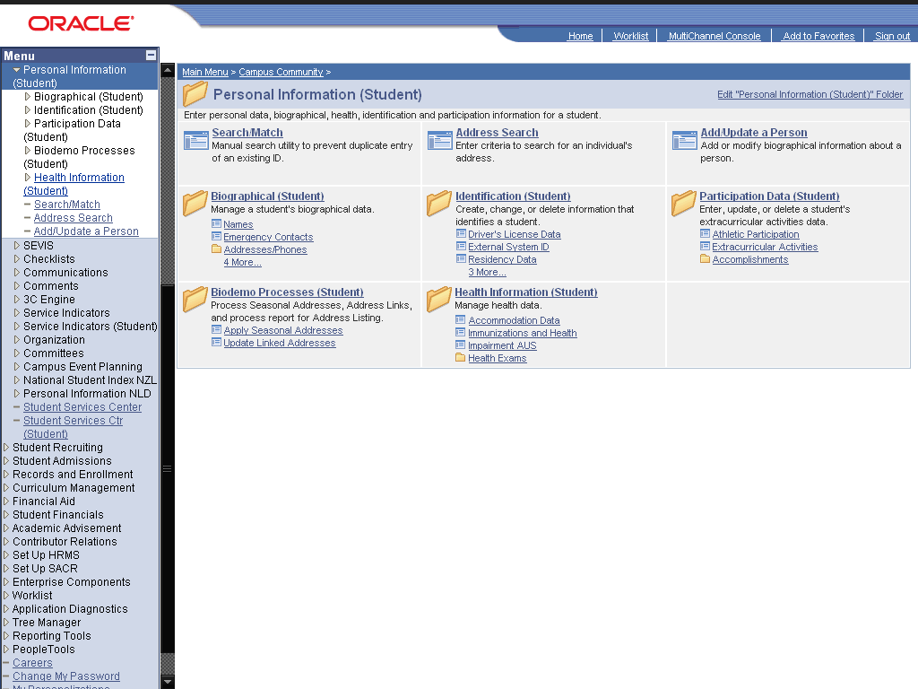

Step | Action
 | Click the Addresses/Phones link.
 | Click the Addresses link.

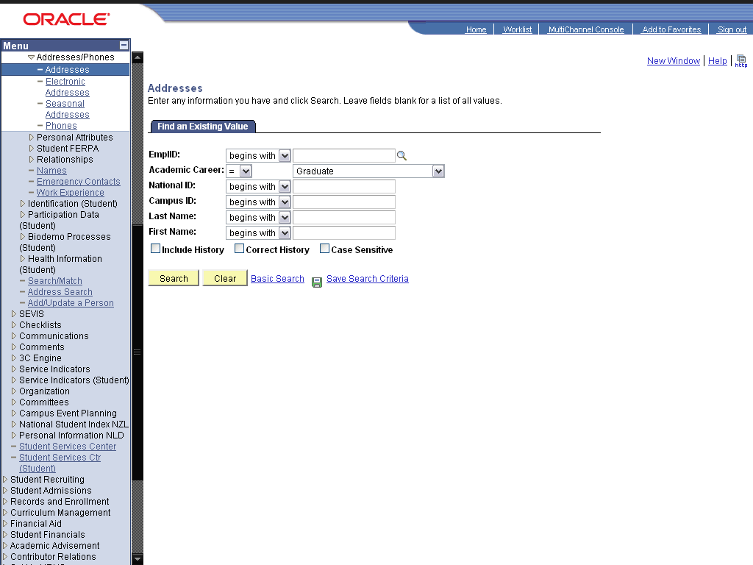

Step | Action
 | Click the Search button.
 | Click the 2009DES001 link.
Click the Negative Service Indicators graphic.
This indicates a negative indicator. For positive indicator "star" is used.
 | Click the FEE link.
Click the Release button.
to release the service indicator before its end date, click this button.
 | Click the OK button.
 | End of Procedure.

Mass Assign and Mass Release

Procedure

Step | Action
 | Click the Campus Community link.

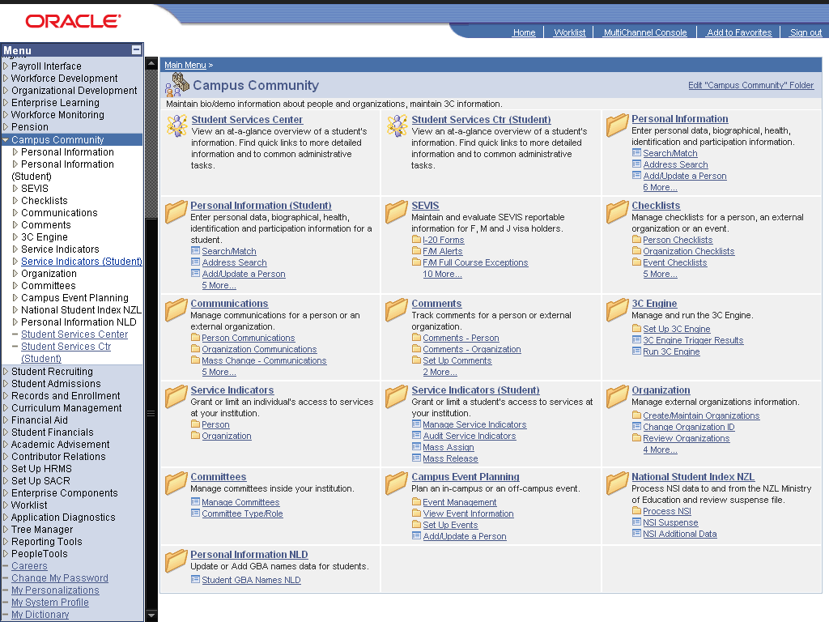

Step | Action
 | Click the Service Indicators (Student) link.
 | Click the Mass Assign link.

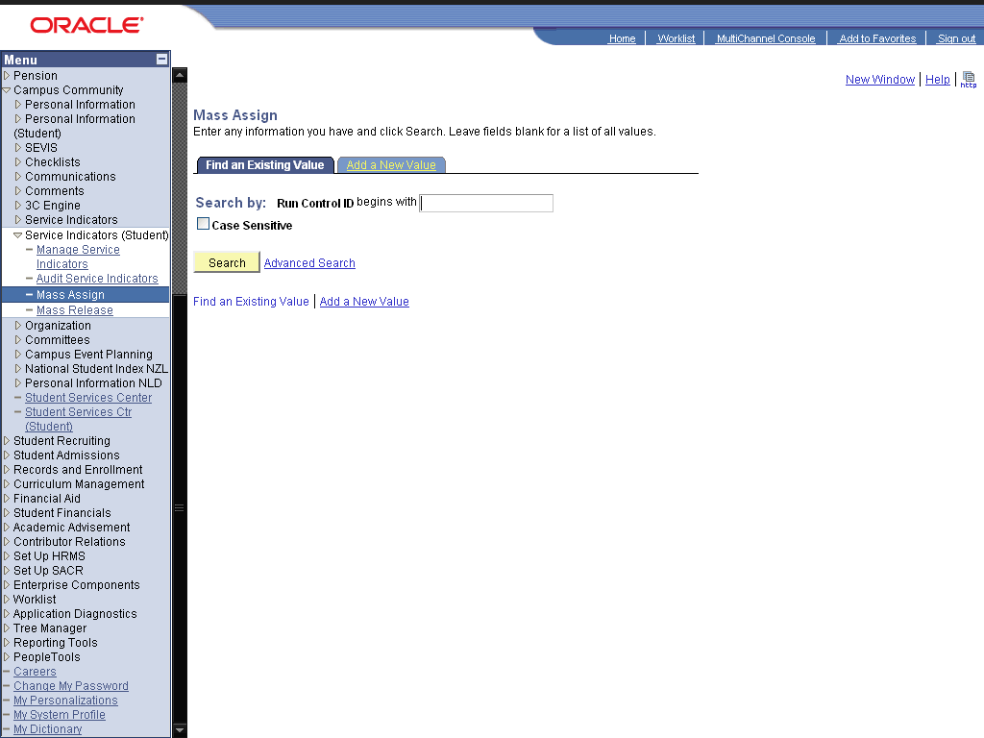

Step | Action
 | Click the Add a New Value link.
 | Enter the desired information into the Run Control ID: field. Enter "Mass_Assign".
 | Click the Add button.

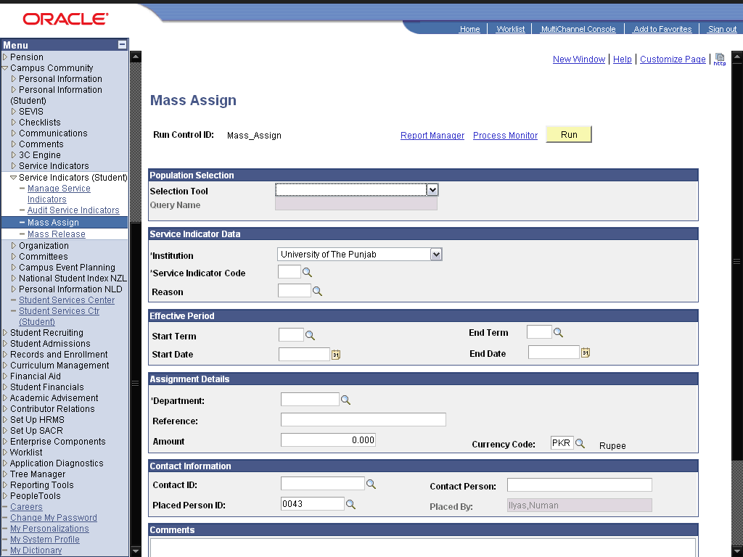

Step | Action
Click an entry in the list.
This is the Student's Selection Query. This query selects the students on which you want to apply the service indicator.

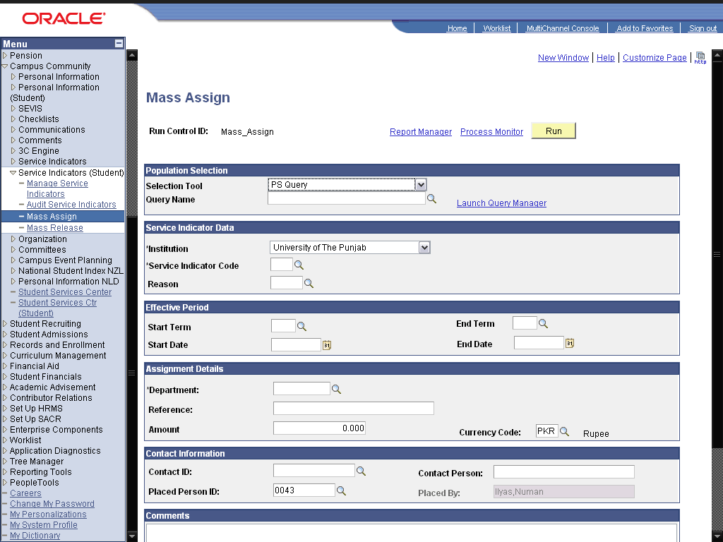

Step | Action
 | Click the Look up Query Name (Alt+5) graphic.
 | Click the QA_CS_CC_PS_SRVCIND_PERS link.
Click the Preview Selection Results link.
Click to see the list of students selected by the query, on which the service indicator will be applied.
 | Click the Return button.
 | Enter the desired information into the *Service Indicator Code field. Enter "FEE".
 | Enter the desired information into the Reason field. Enter "1".
 | Enter the desired information into the Start Term field. Enter "0091".
 | Click the Run button.
 | Click the OK button.
 | Click the Process Monitor link.
 | Click the Refresh button.
 | Click the Mass Release link.

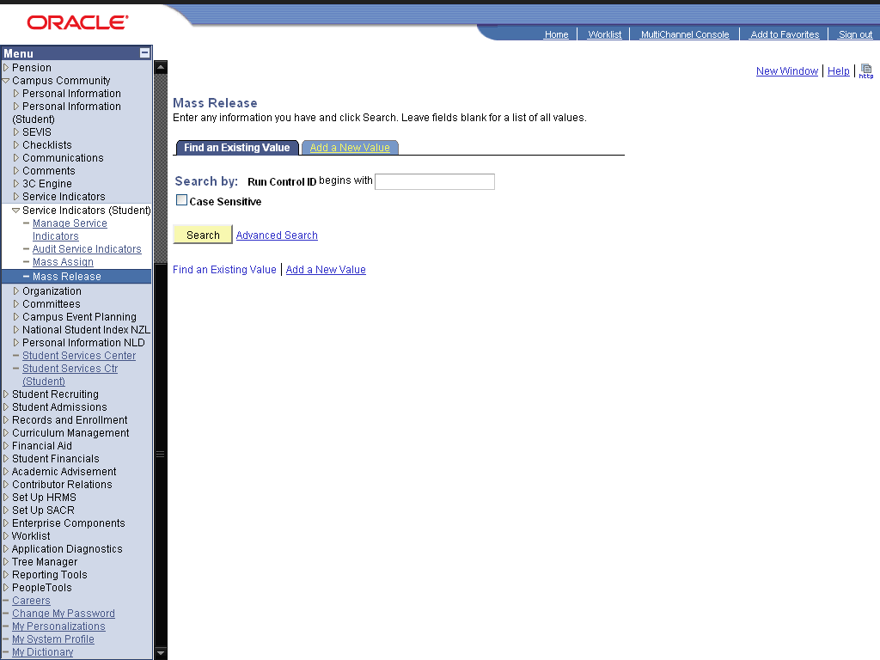

Step | Action
 | Click the Add a New Value link.
 | Enter the desired information into the field. Enter "Mass_Release".

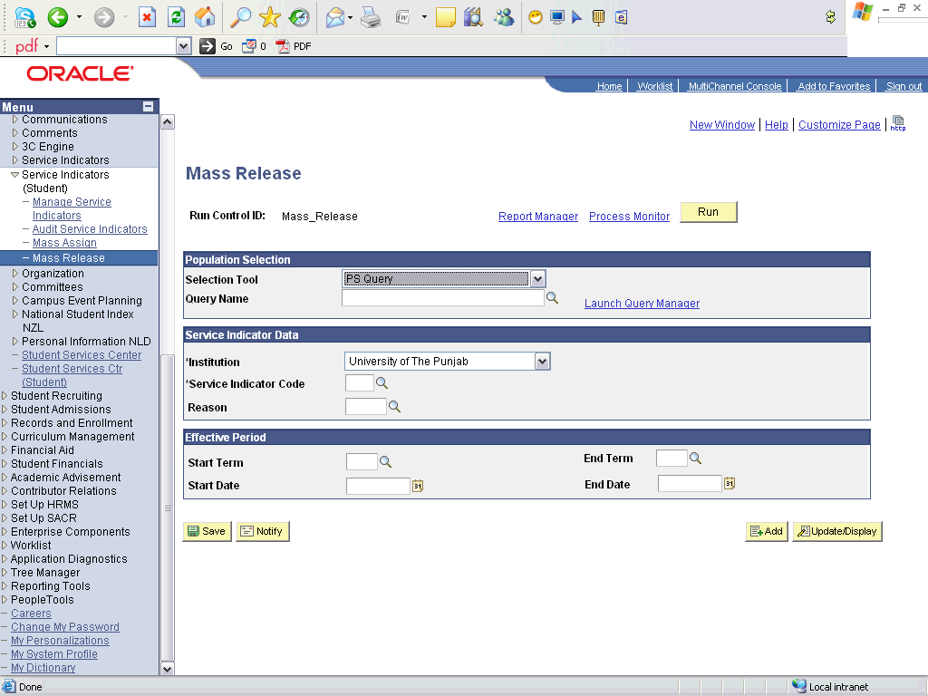

Step | Action
 | Click the Look up Query Name (Alt+5) button.
 | Click an entry in the Query Name column.
 | Enter the desired information into the Service Indicator Code field. Enter "Fee".
 | Enter the desired information into the Reason field. Enter "1".
 | Enter the desired information into the Start Term field. Enter "0091".
 | Click the Run button.

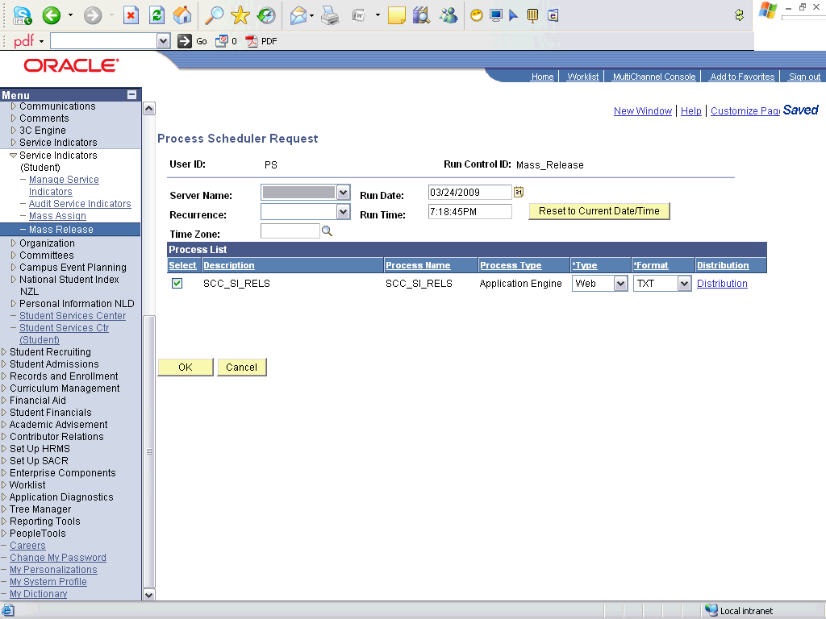

Step | Action
 | Click the OK button.

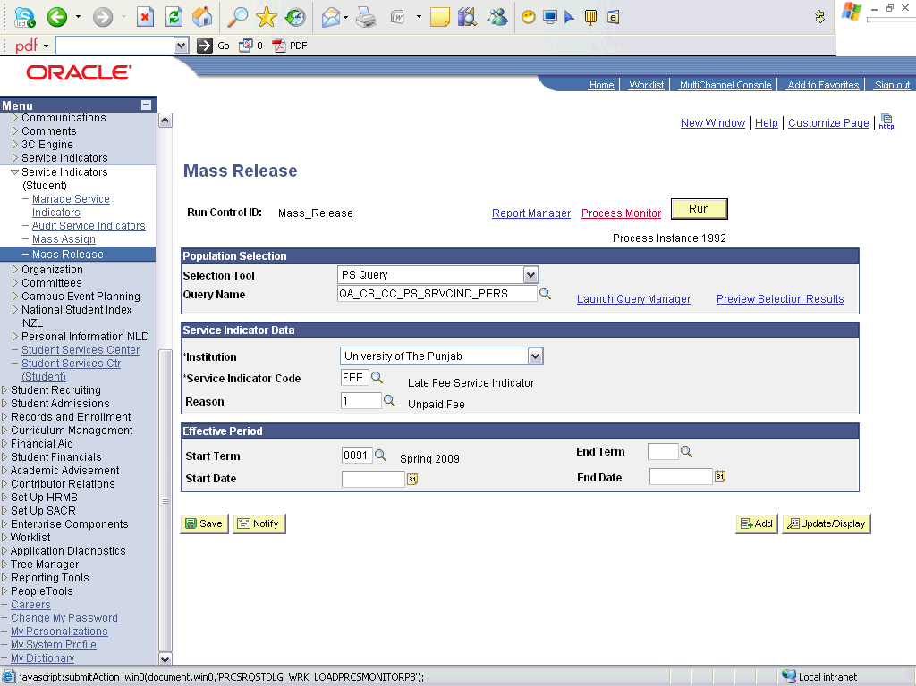

Step | Action
 | Click the Process Monitor link.

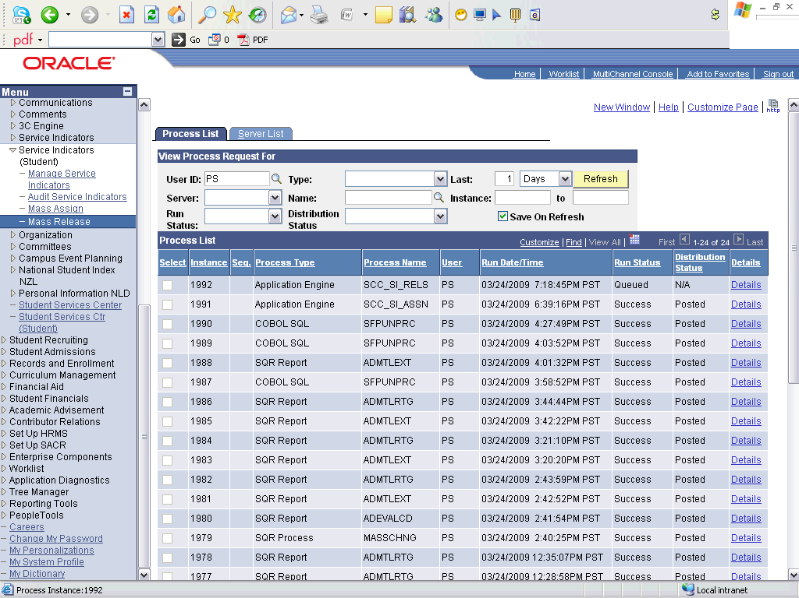

Step | Action
 | Click the Refresh button.
 | End of Procedure.

