Hostel Management
Created on Thursday, July 02, 2009
Copyright & Trademarks
Copyright © 2003, 2007, Oracle. All rights reserved. Powered by OnDemand Software. Distributed by Oracle under license from Global Knowledge Software LLC. © 1998-2007. All rights reserved.

The information contained in this document is subject to change without notice. If you find any problems in the documentation, please report them to us in writing. This document is not warranted to be error-free. Except as may be expressly permitted in your license agreement for these Programs, no part of these Programs may be reproduced or transmitted in any form or by any means, electronic or mechanical, for any purpose.

If this documentation is delivered to the United States Government or anyone using the documentation on behalf of the United States Government, the following notice is applicable:

U.S. GOVERNMENT RIGHTS
The U.S. Government’s rights to use, modify, reproduce, release, perform, display, or disclose these training materials are restricted by the terms of the applicable Oracle license agreement and/or the applicable U.S. Government contract.

Oracle, JD Edwards, PeopleSoft, and Siebel are registered trademarks of Oracle Corporation and/or its affiliates. Other names may be trademarks of their respective owners.

Table of Contents
Hostel Application 1
Creating a Hostel Application 1
Hostel Room Allotment 9
Alloting a Hostel Room to Student 9
Mess Enrollment 13
Mess Enrollment 13
Mess Attendance 15
Tracking Mess Attendance 15
Mess Billing 23
Create Mess Bill 23
Notice Board 29
Using the Notice board 29
Inventory 43
Managing Inventory 43
Misc. 53
Requests 53
Request Accepted/Rejected 58
Complaints 63
Clearance 70
Reports 79
Room Allotment Summary 79
Monthly Mess Billing Summary 83
Allotment Cards 90
Attendance Summary Report 93
List of Applicant 100
Issued Inventory 104
Recieved Inventory 107
Write off Inventory 111
Mess Attendace Summary 114
List of Hostel Rooms 119
Request/Complaint Summary 122
Current Balances 126

Hostel Application

Creating a Hostel Application

Procedure

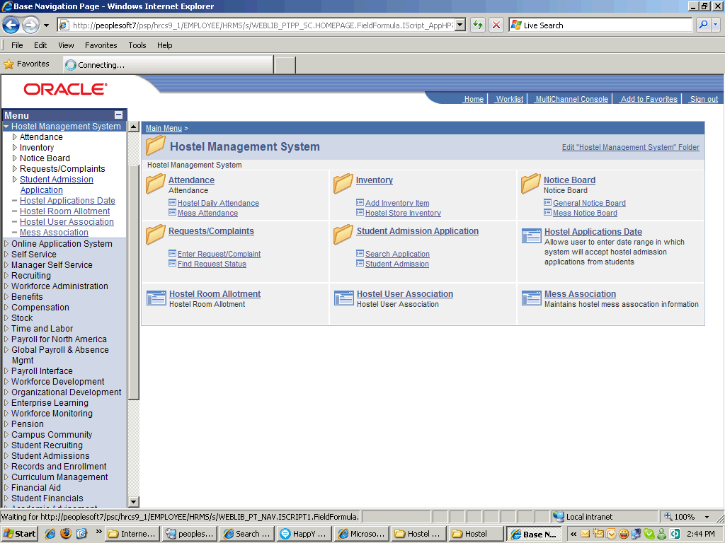

Step | Action
 | Click the Student Admission Application link.
 | Click the Student Admission link.

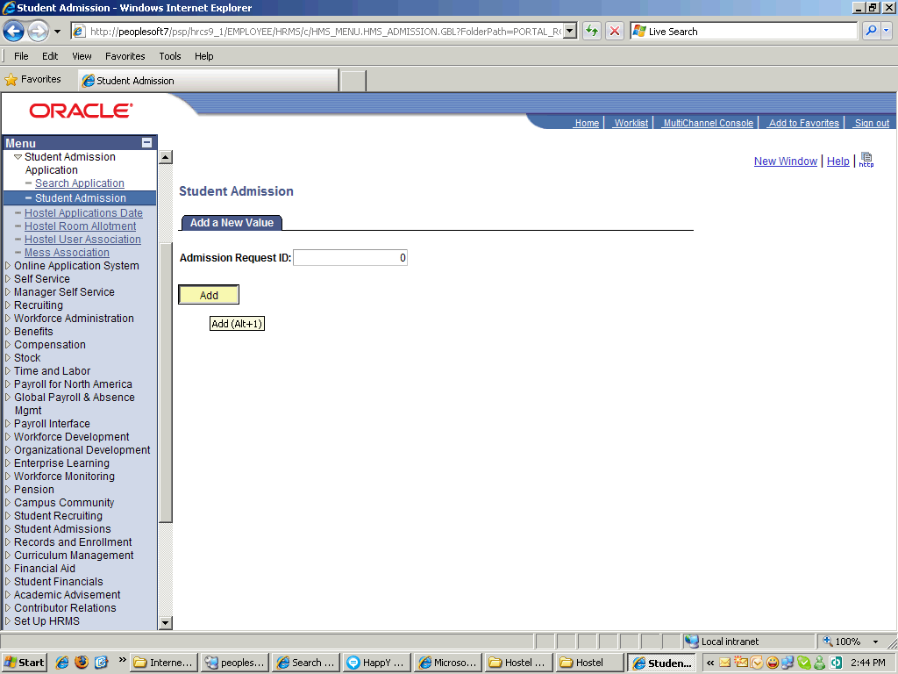

Step | Action
 | Click the Student Admission link.

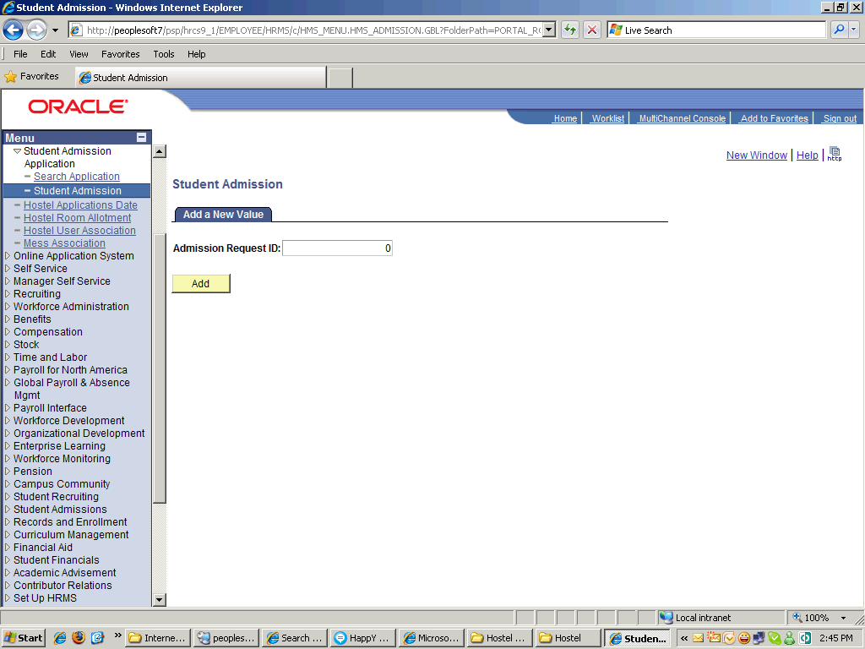

Step | Action
 | Click the Add button.

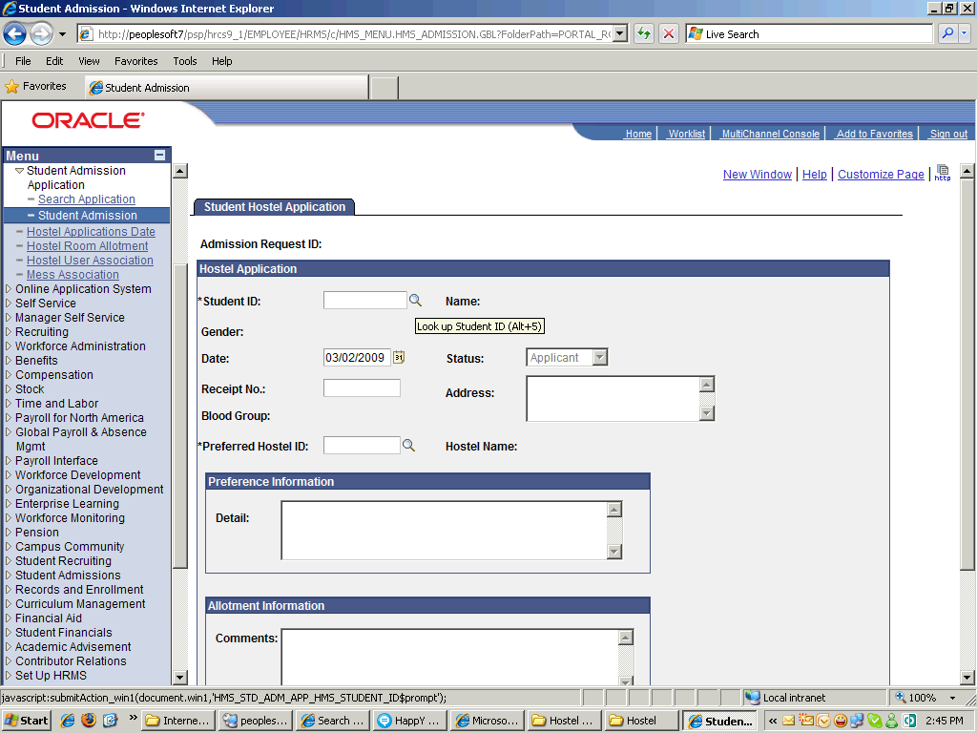

Step | Action
 | Click the Look up Student ID (Alt+5) button.
 | Click in the Receipt No. field.
 | Enter the desired information into the Receipt No. field. Enter "123456".
 | Click the Look up Preferred Hostel ID (Alt+5) button.
 | Click an entry in the Hostel ID column.
 | Enter the desired information into the Detail field. Enter "with my friend at room # 1".

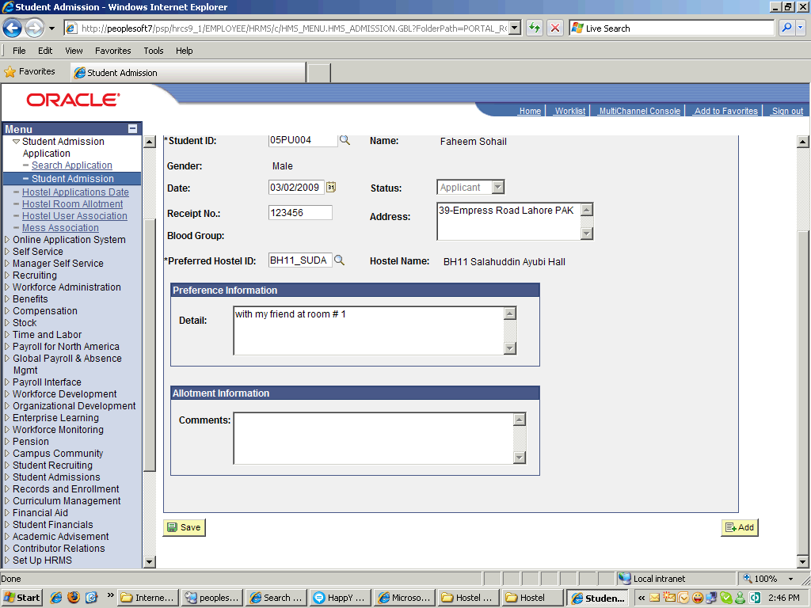

Step | Action
 | Scroll the object with the mouse wheel.

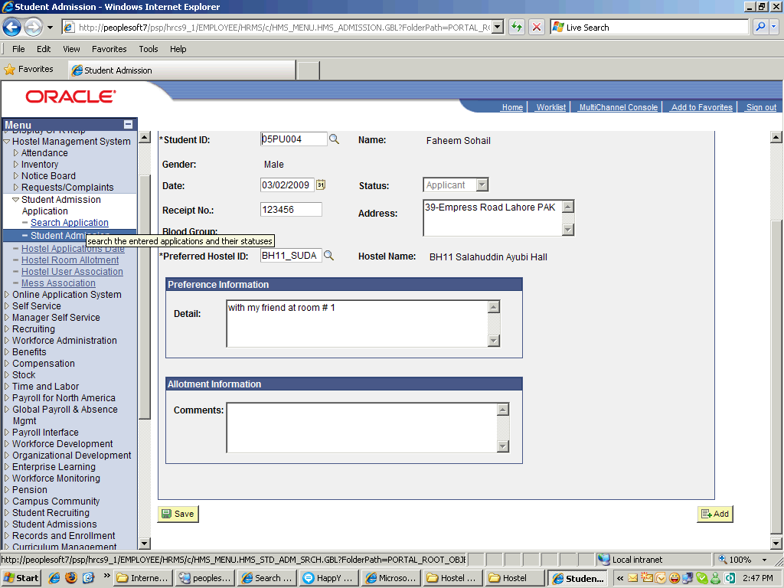

Step | Action
 | Click the Search Application link.

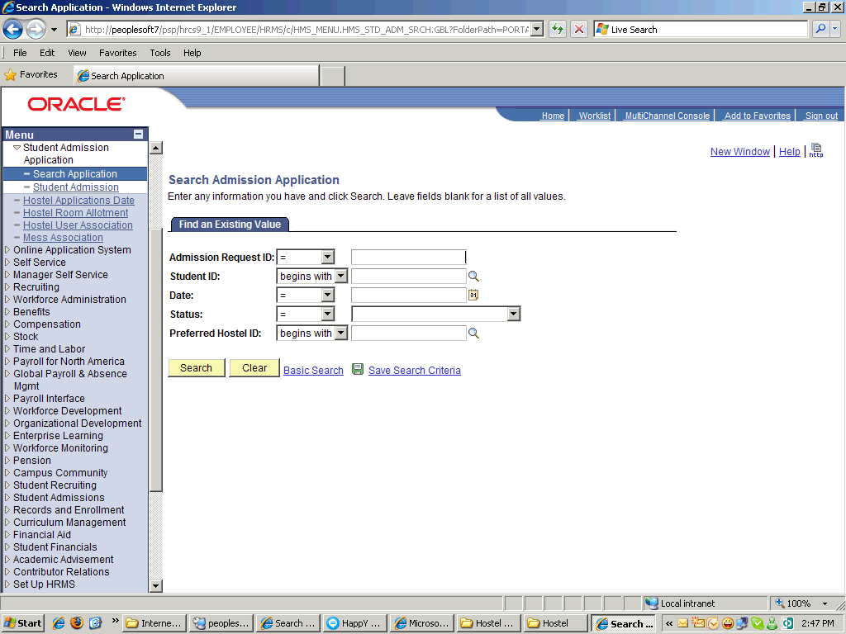

Step | Action
 | Point to the Search object.

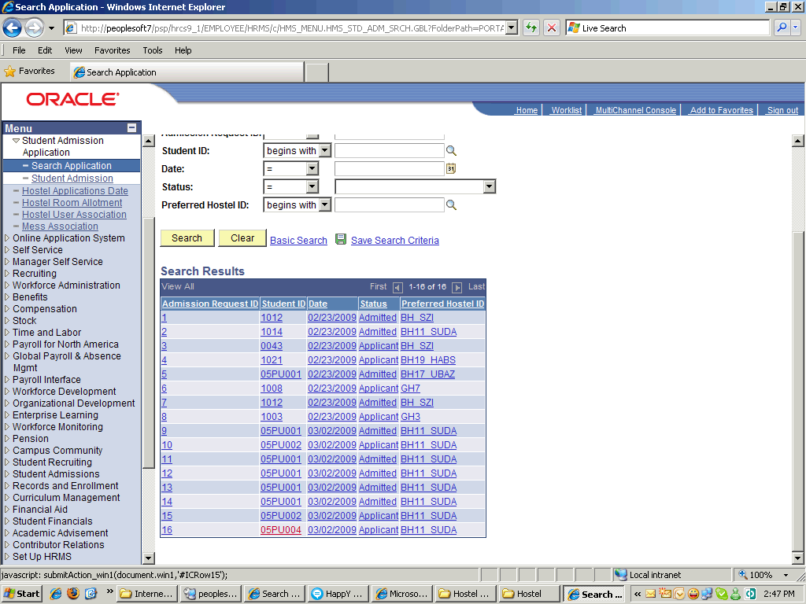

Step | Action
 | Scroll the Detail object with the mouse wheel.
 | Click the Return to Search button.
 | End of Procedure.

Hostel Room Allotment

Alloting a Hostel Room to Student

Procedure

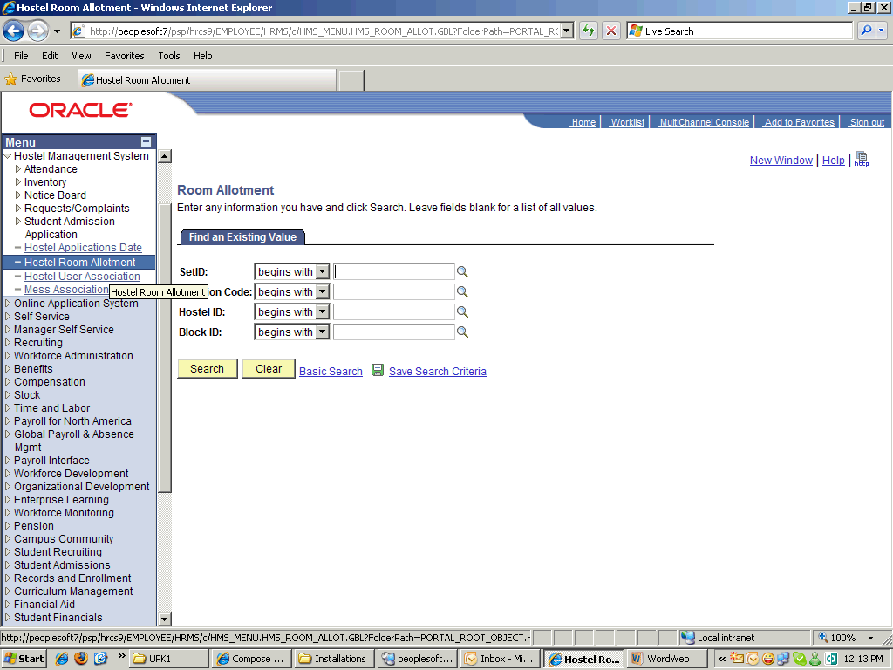

Step | Action
 | Click the Hostel Room Allotment link.
 | Click the Search button.
 | Click an entry in the Hostel ID column.

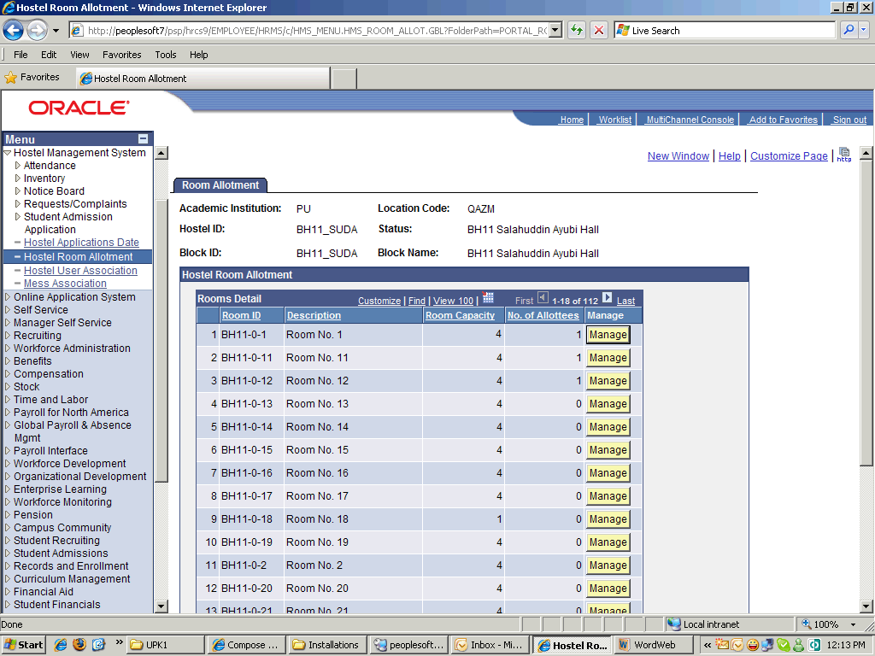

Step | Action
 | Scroll the object with the mouse wheel.

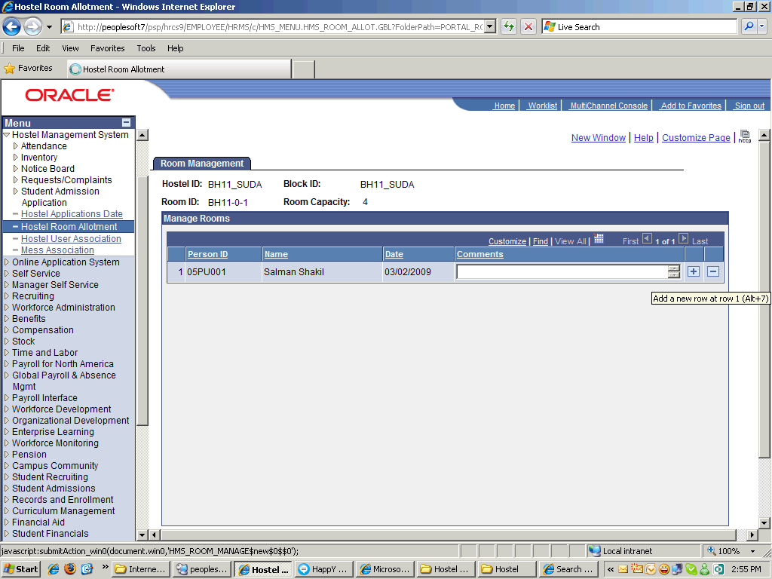

Step | Action
 | Click the Add a new row at row 1 (Alt+7) button.
 | Click the Person ID button.
 | Click in the Comments field.
 | Enter the desired information into the Comments field. Enter "Allotted with his Friend".
 | Click the Save button.

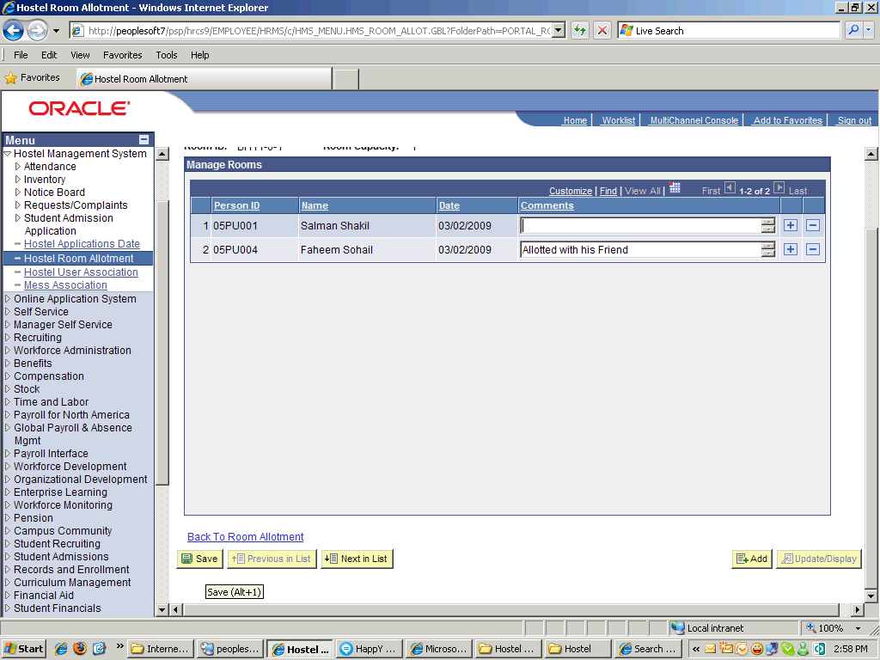

Step | Action
 | Click the object.
 | End of Procedure.

Mess Enrollment

Mess Enrollment

Procedure

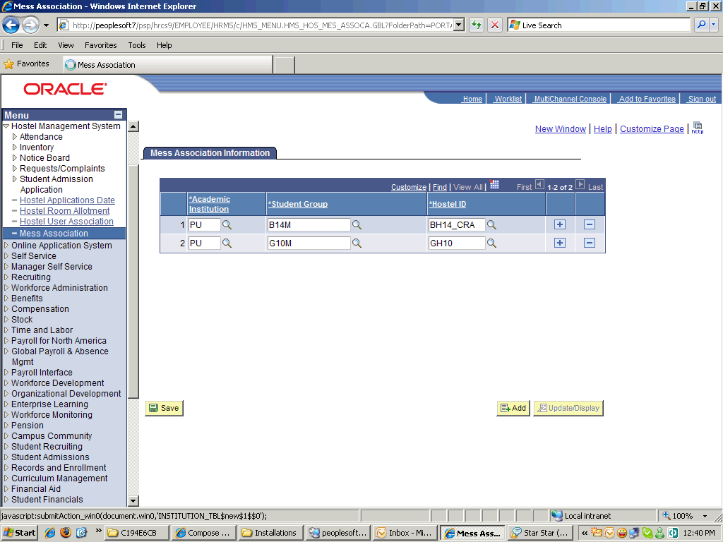

Step | Action
 | Click the Add a new row at row 2 (Alt+7) button.
 | Point to the Academic Institution object.
 | Click the Academic Institution button.
 | Click the Student Group button.
 | Point to the Student Group object.
 | Click the Hostel ID button.
 | Point to the Building object.
 | Click the Save button.
 | End of Procedure.

Mess Attendance

Tracking Mess Attendance

Procedure

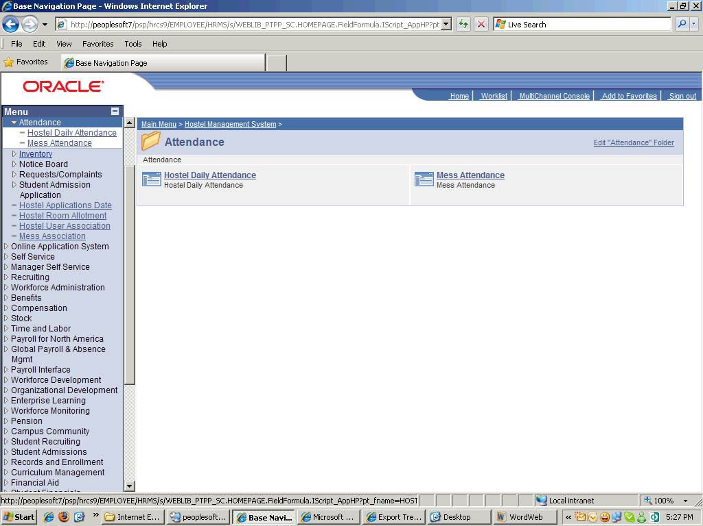

Step | Action
 | Point to the Mess Attendance object.

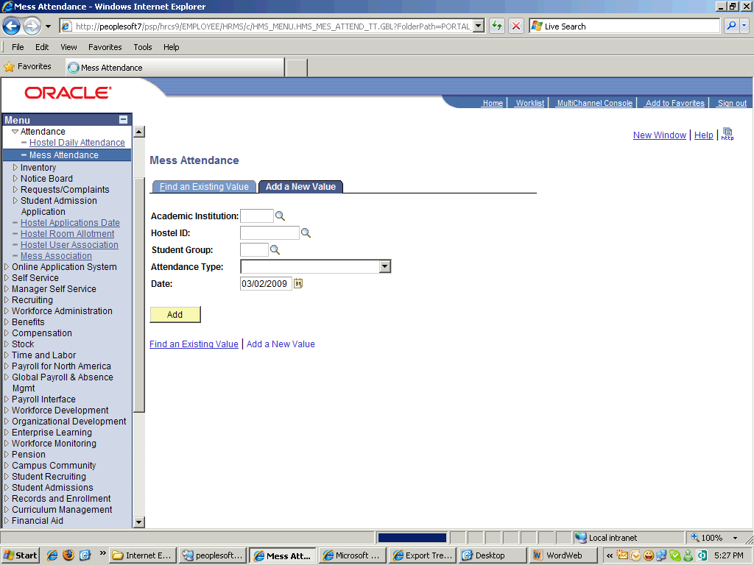

Step | Action
 | Click the Look up Academic Institution (Alt+5) button.
 | Click an entry in the Academic Institution column.
 | Click the Look up Hostel ID (Alt+5) button.
 | Click an entry in the Hostel ID column.
 | Point to the Look up Student Group (Alt+5) object.
 | Click an entry in the Student Group column.

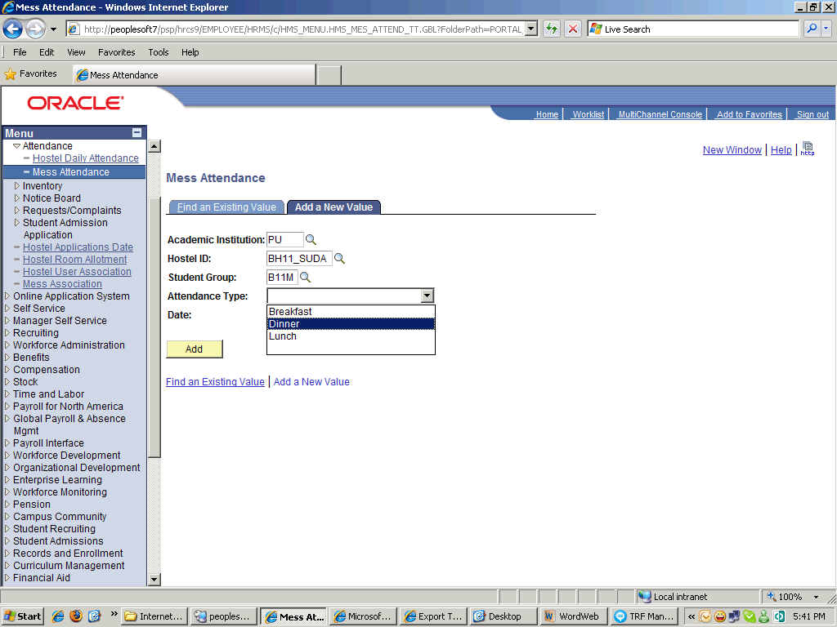

Step | Action
 | Click the Dinner list item.

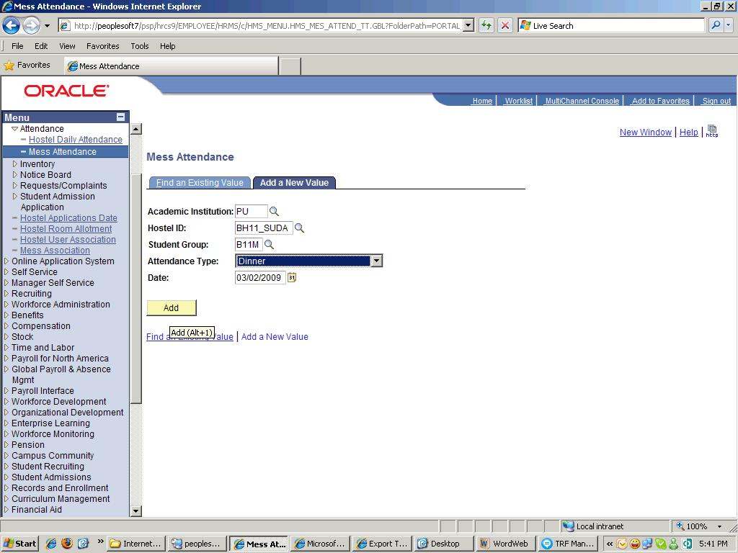

Step | Action
 | Click the Add button.

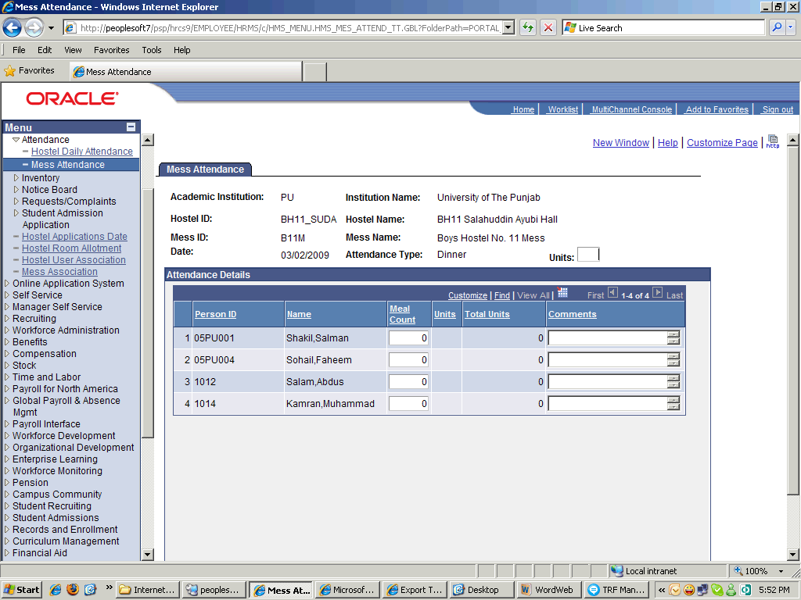

Step | Action
 | Enter the desired information into the Units field. Enter "2".
 | Click in the Meal Count field.
 | Enter the desired information into the Meal Count field. Enter "5".
 | Enter the desired information into the Meal Count field. Enter "4".
 | Click in the Meal Count field.

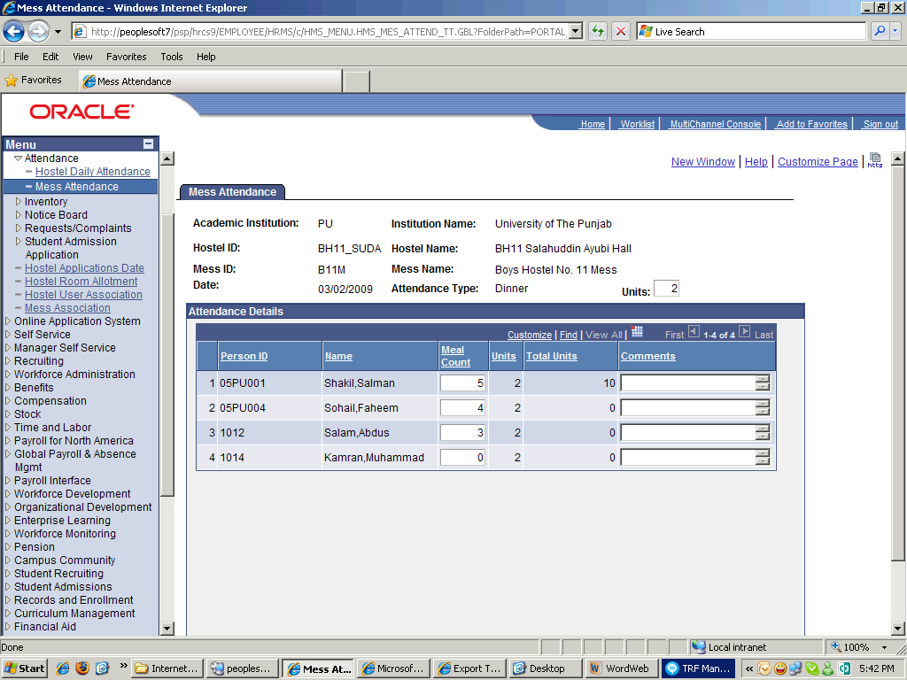

Step | Action
 | Release the mouse button.

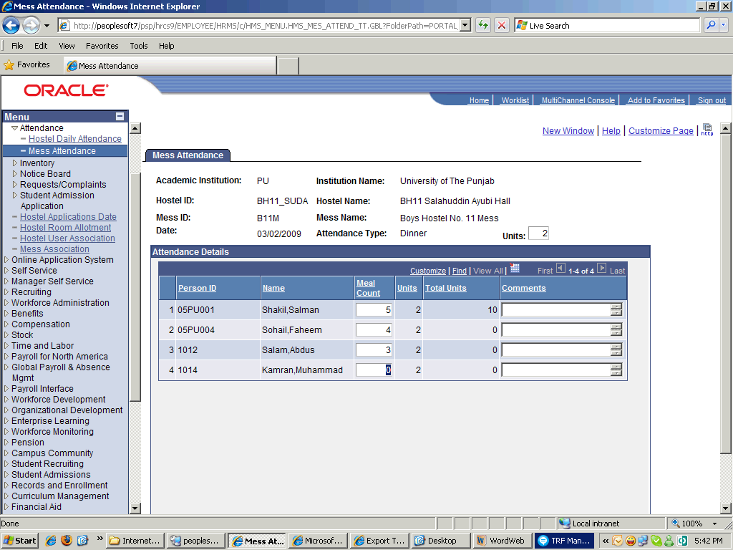

Step | Action
 | Enter the desired information into the Meal Count field. Enter "2".
 | Click in the Comments field.
 | Click the object.
 | Enter the desired information into the Comments field. Enter "Guest meals".

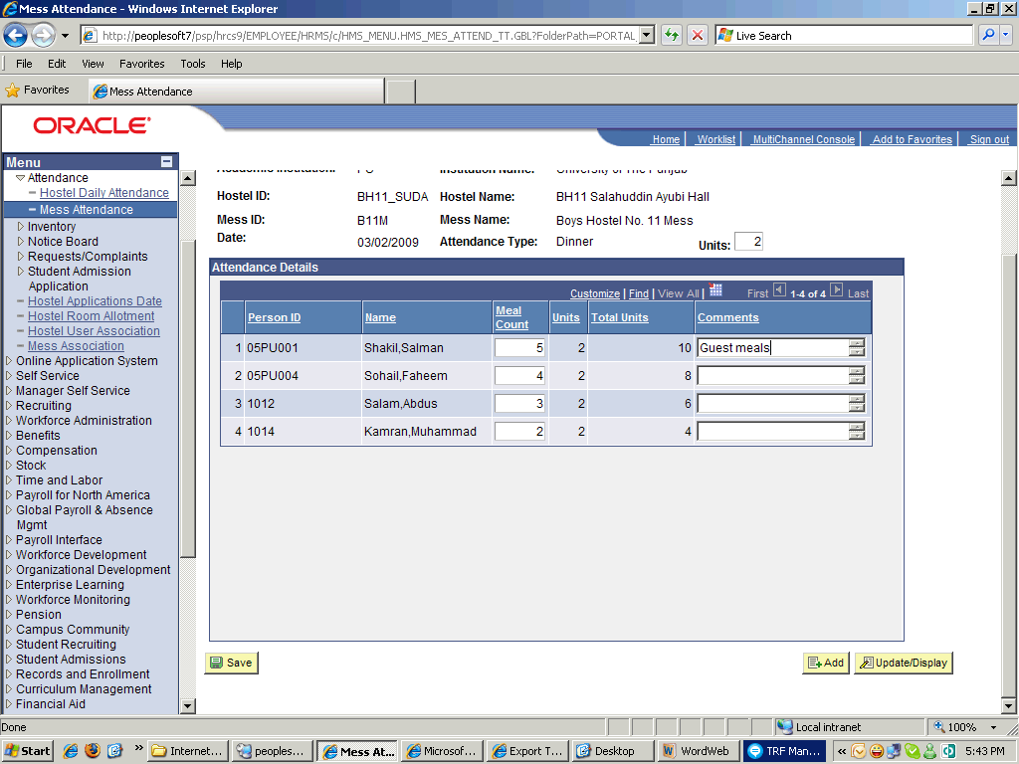

Step | Action
 | Scroll the object with the mouse wheel.
 | End of Procedure.

Mess Billing

Create Mess Bill

Procedure

Step | Action

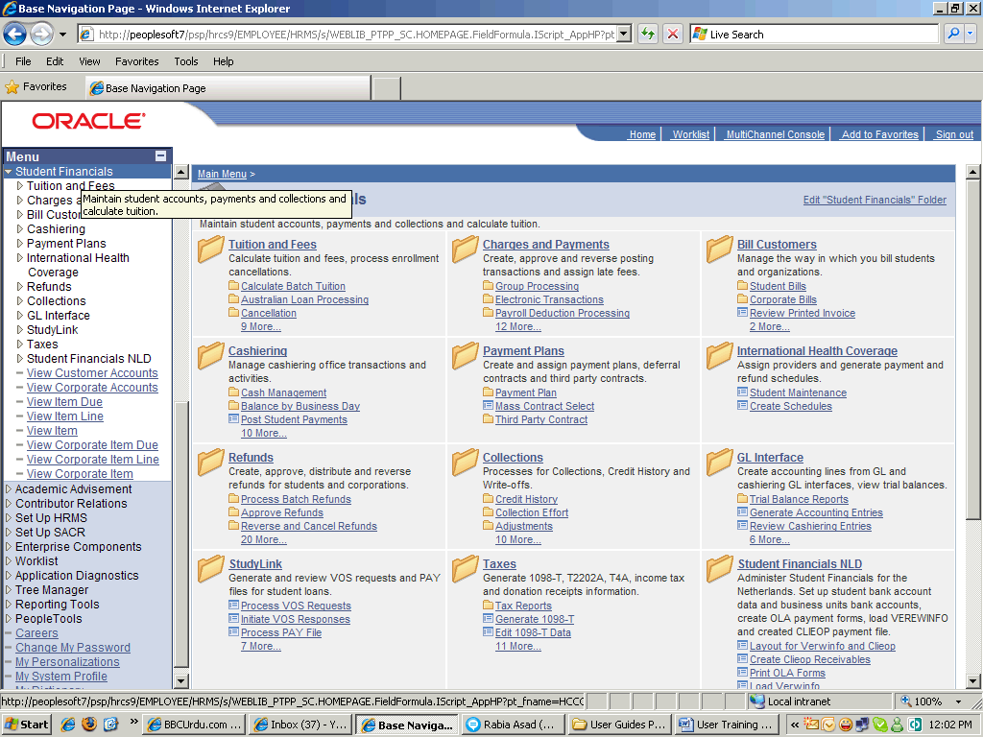

Step | Action
 | Click the Student Financials link.
 | Click the Charges and Payments link.
 | Click the Post Student Transaction link.

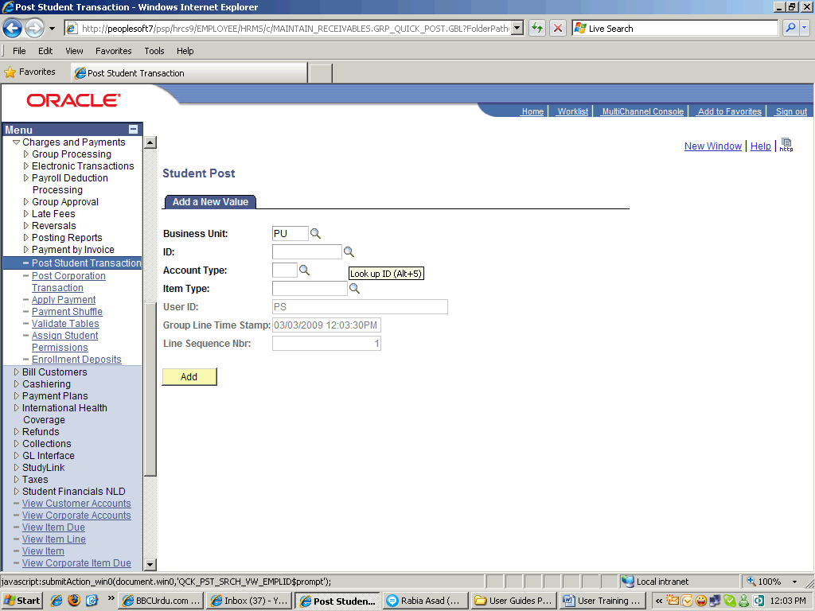

Step | Action
 | Point to the Look up ID (Alt+5) object.
 | Click an entry in the ID column.
 | Click the Look up Account Type (Alt+5) button.
 | Click an entry in the Account Type column.

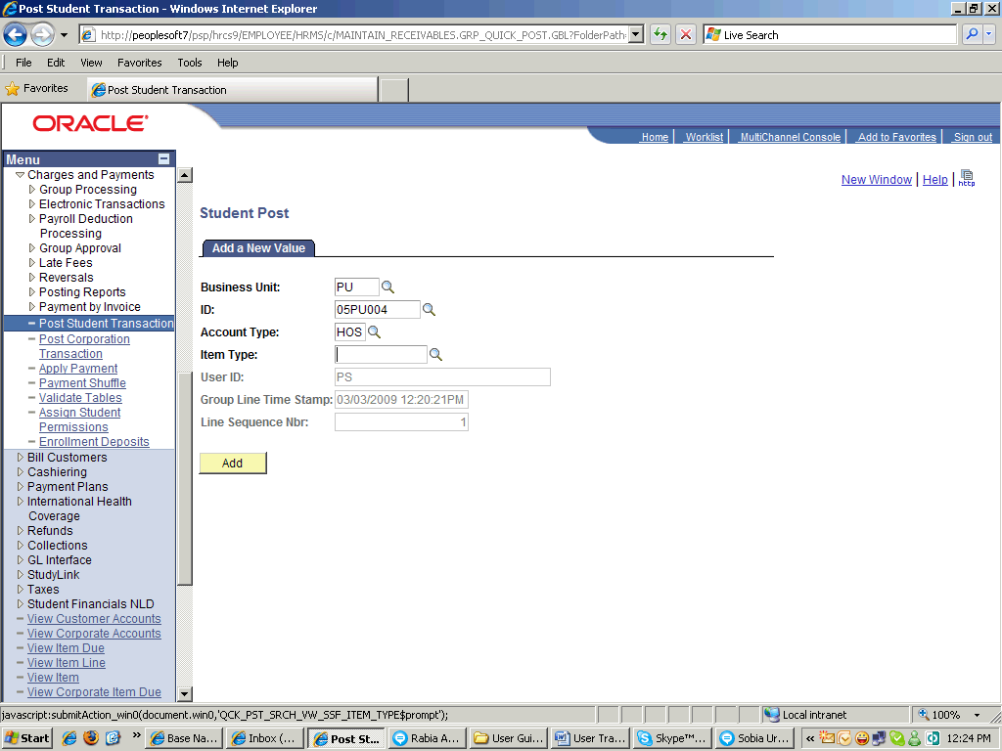

Step | Action
 | Scroll the object with the mouse wheel.
 | Release the mouse button.
 | Click the object.

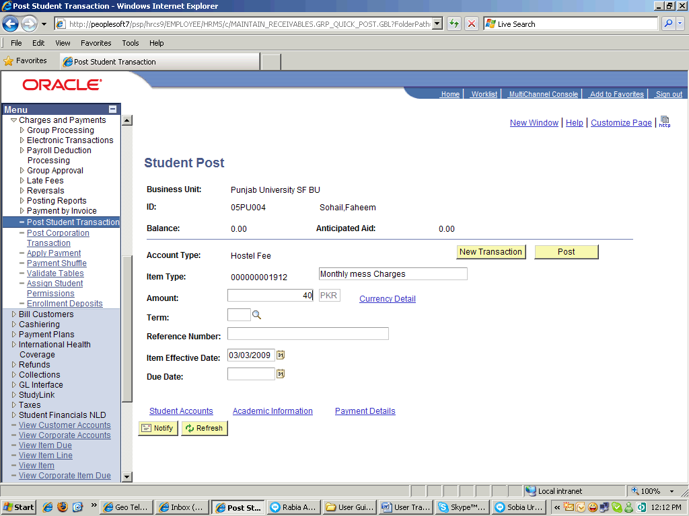

Step | Action
 | Enter the desired information into the Amount field. Enter "40".
 | Click the Look up Term (Alt+5) button.
 | Click in the Reference Number field.
 | Click the Choose a date (Alt+5) button.
 | Click the 16 link.
 | Click the Post button.
 | Click the Student Accounts link.

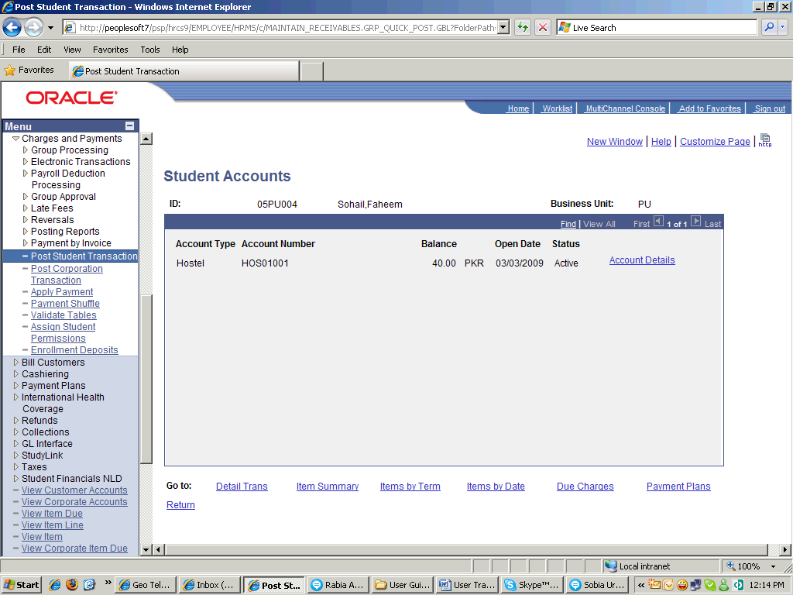

Step | Action
 | Point to the Account Details object.
 | Click an entry in the Account Details column.

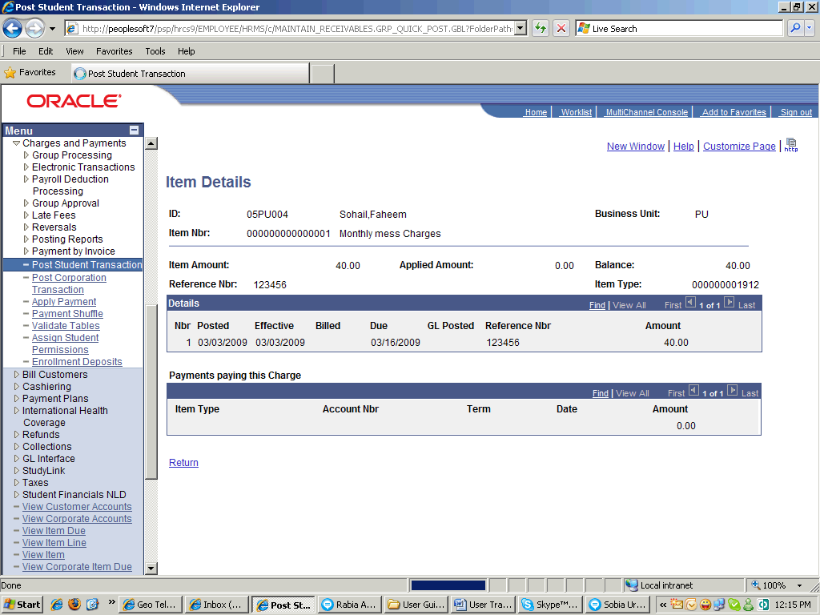

Step | Action
 | Click an entry in the Item Details column.
 | End of Procedure.

Notice Board

Using the Notice board

Procedure

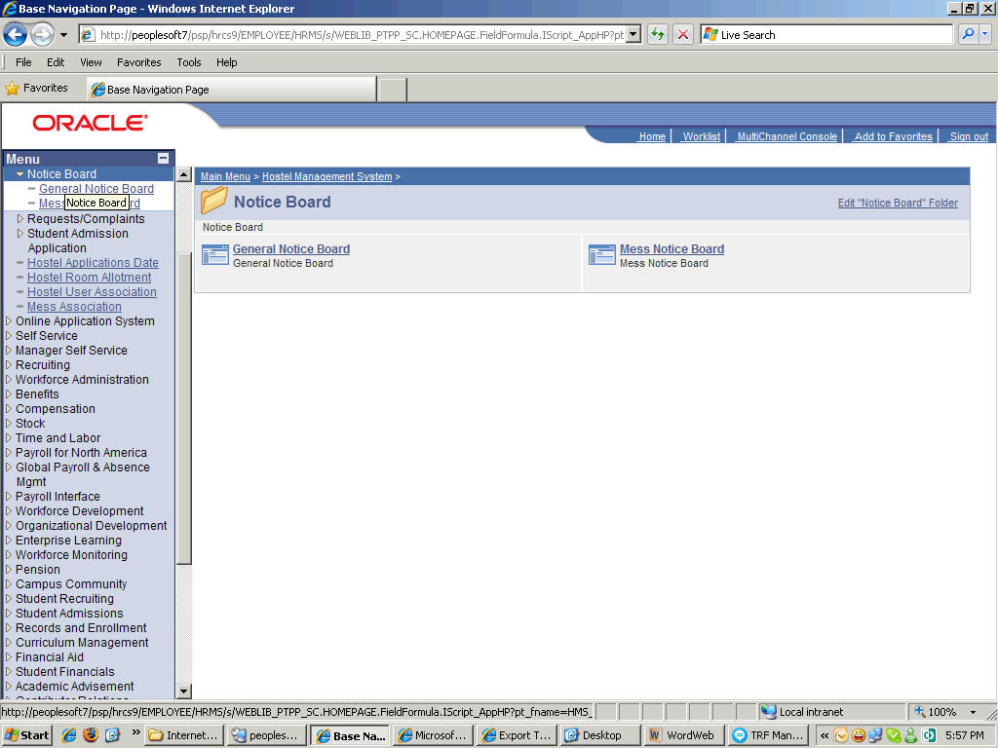

Step | Action
 | Point to the General Notice Board object.

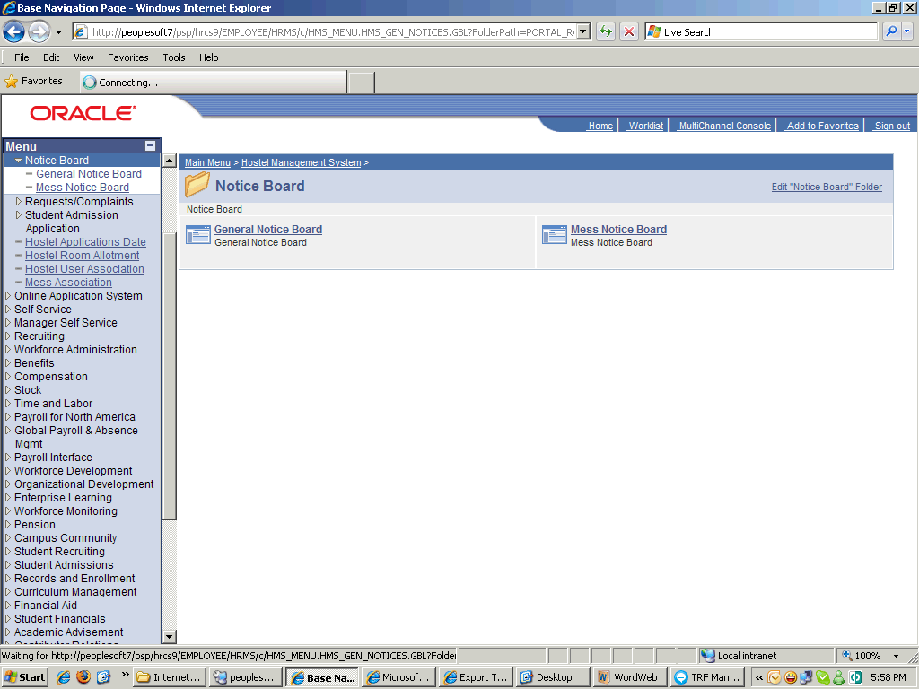

Step | Action
 | Press [Backspace].

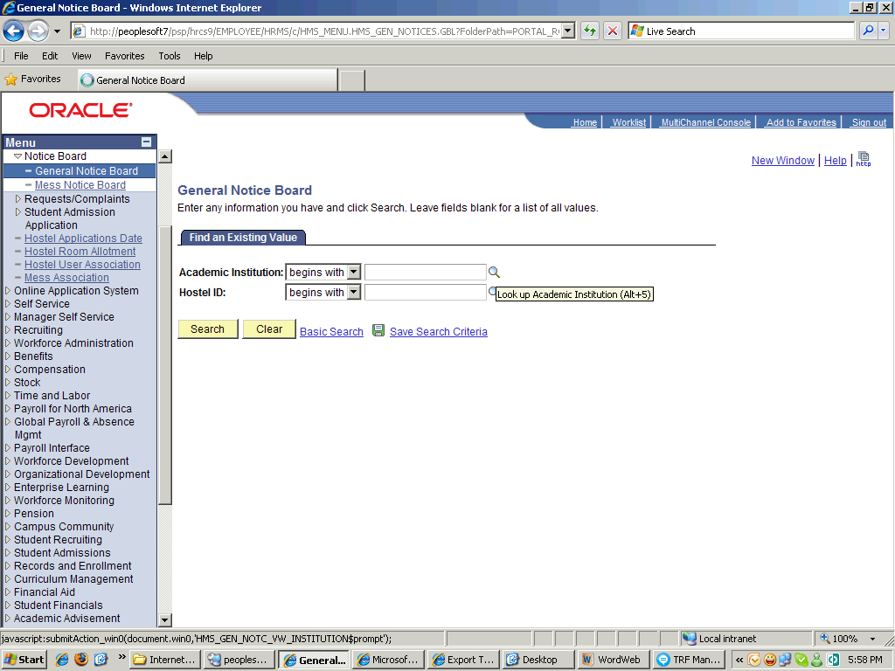

Step | Action
 | Click the Close button.

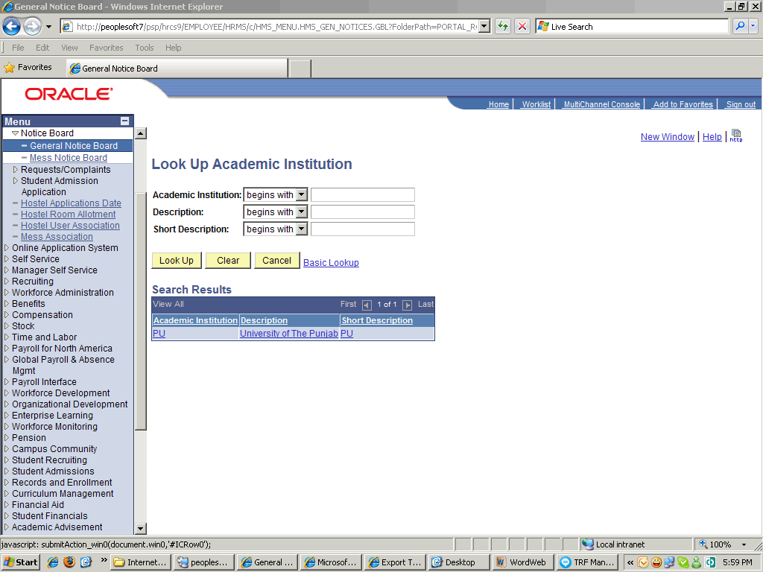

Step | Action
 | Click the object.

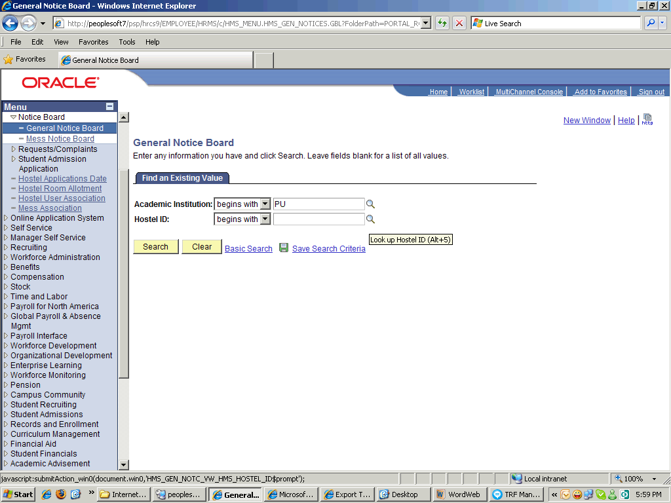

Step | Action
 | Click the Look up Hostel ID (Alt+5) button.
 | Click an entry in the Hostel ID column.
 | Click the Search button.

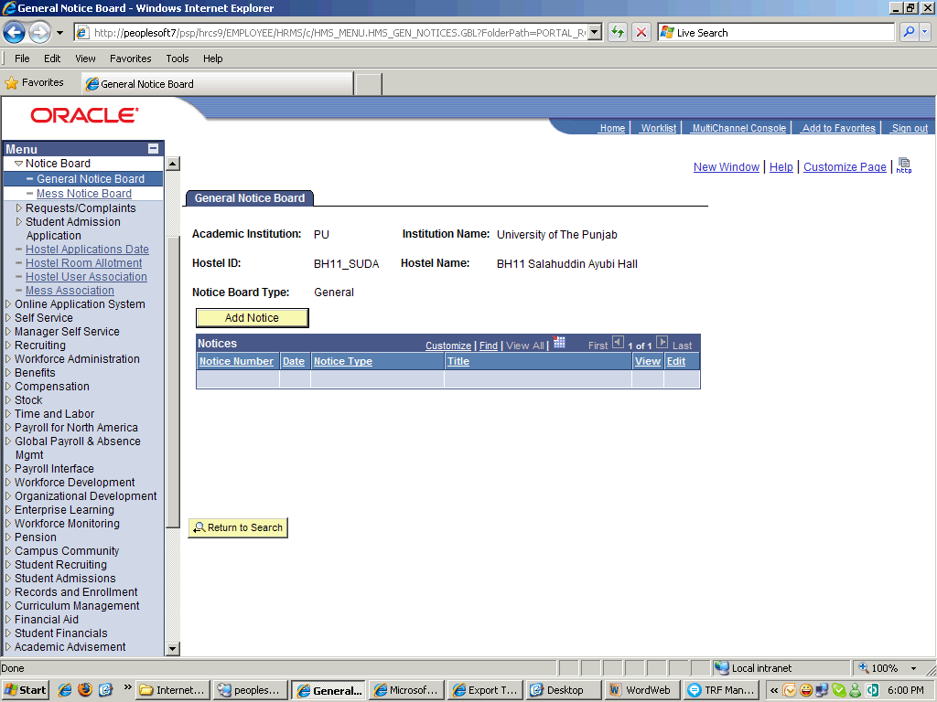

Step | Action
 | Click the Add Notice button.

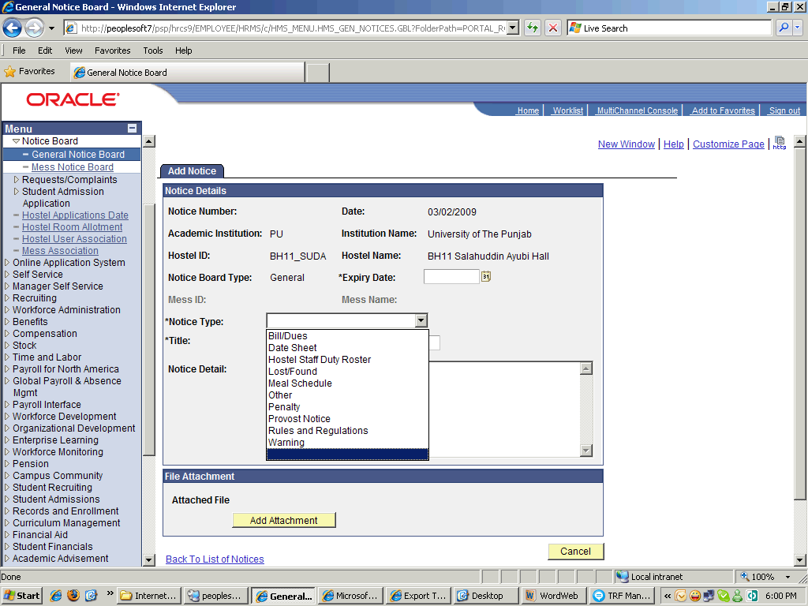

Step | Action
 | Click the Bill/Dues list item.

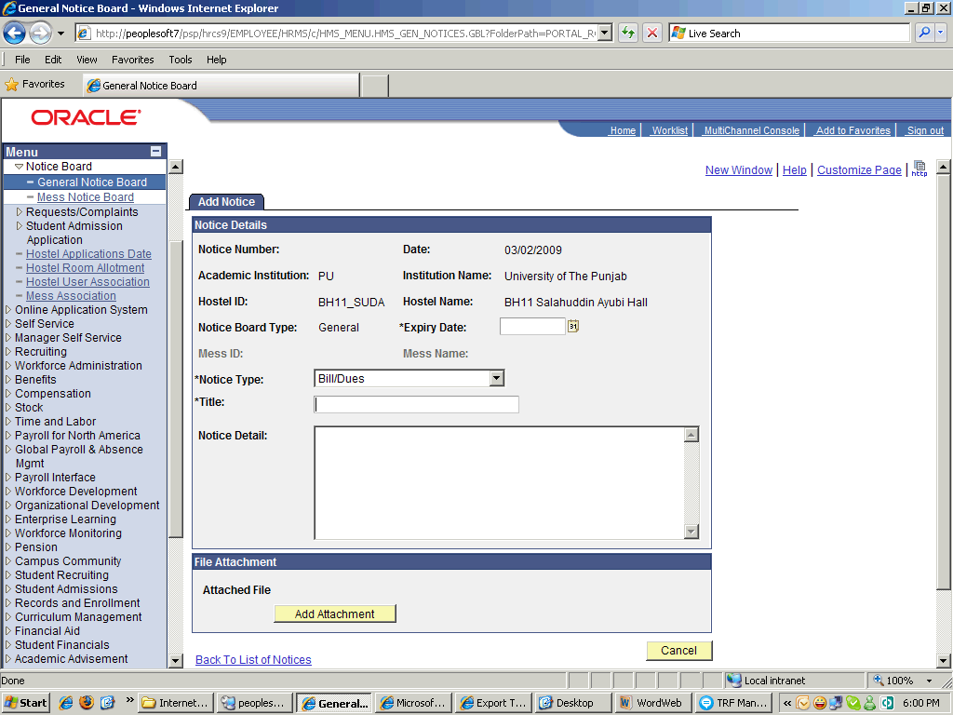

Step | Action
 | Enter the desired information into the Title field. Enter "Monthly Bill".
 | Enter the desired information into the Notice Detail field. Enter "please".
 | Enter the desired information into the Notice Detail field. Enter " submit mess dues before 01/03/2009.".
 | Click the Add Attachment button.

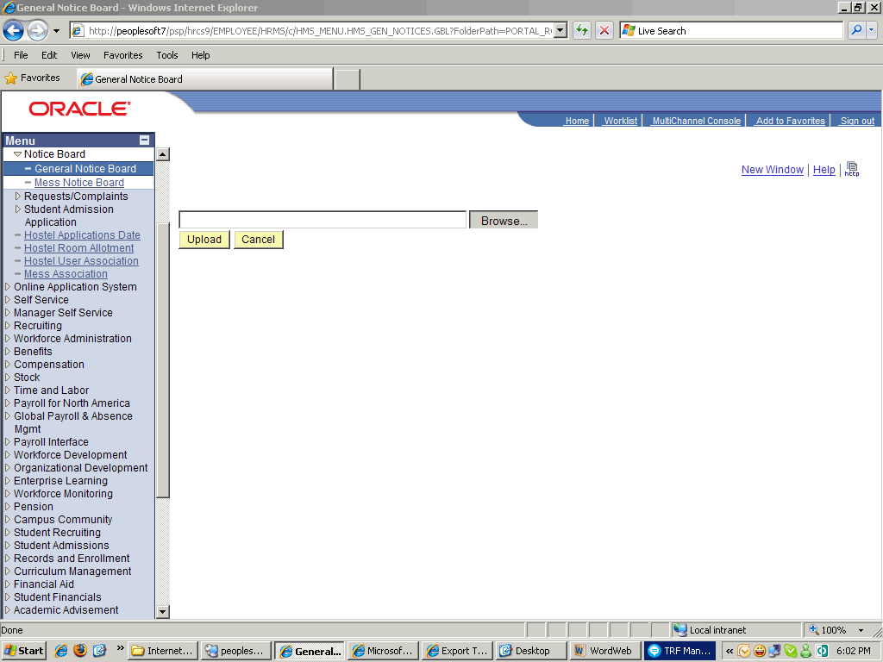

Step | Action
 | Click the Mess Dues list item.
 | Click the Open button.
or
Press [Alt+O].

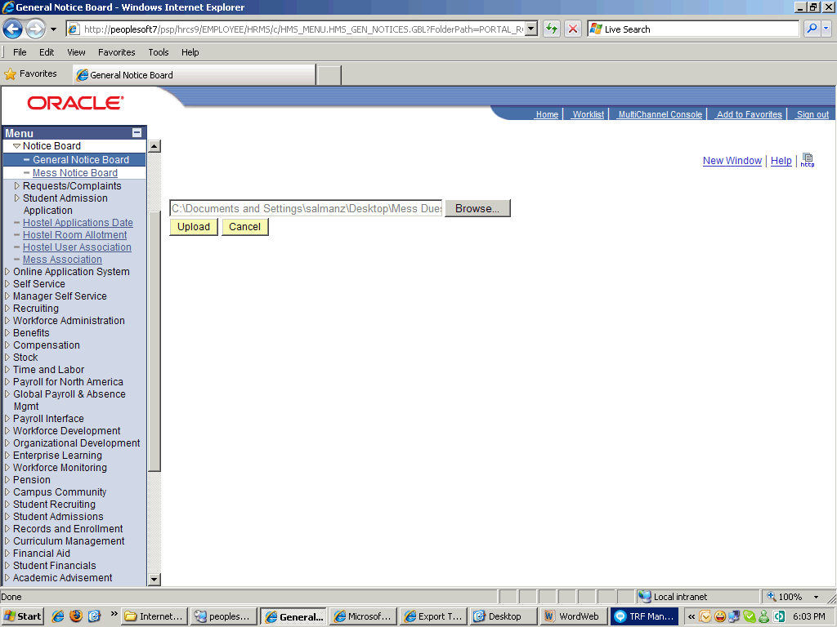

Step | Action
 | Point to the Upload object.
 | Point to the Choose a date (Alt+5) object.
 | Click the 24 link.

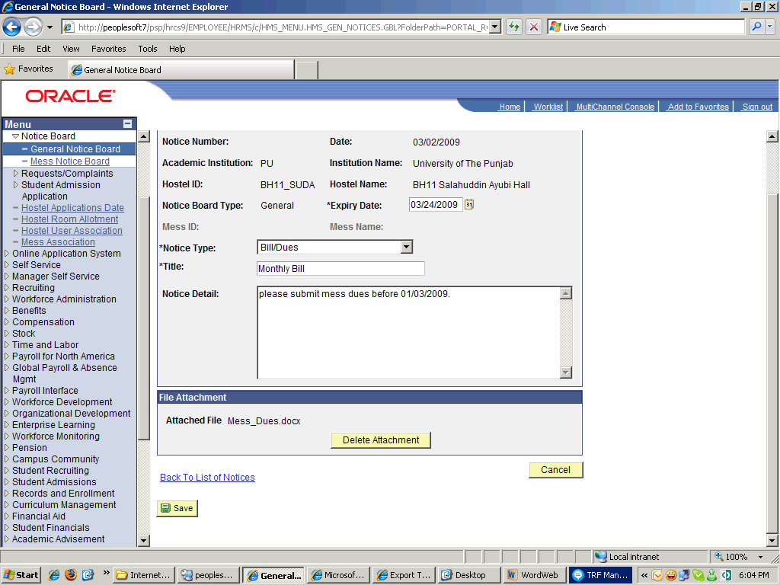

Step | Action
 | Point to the object.

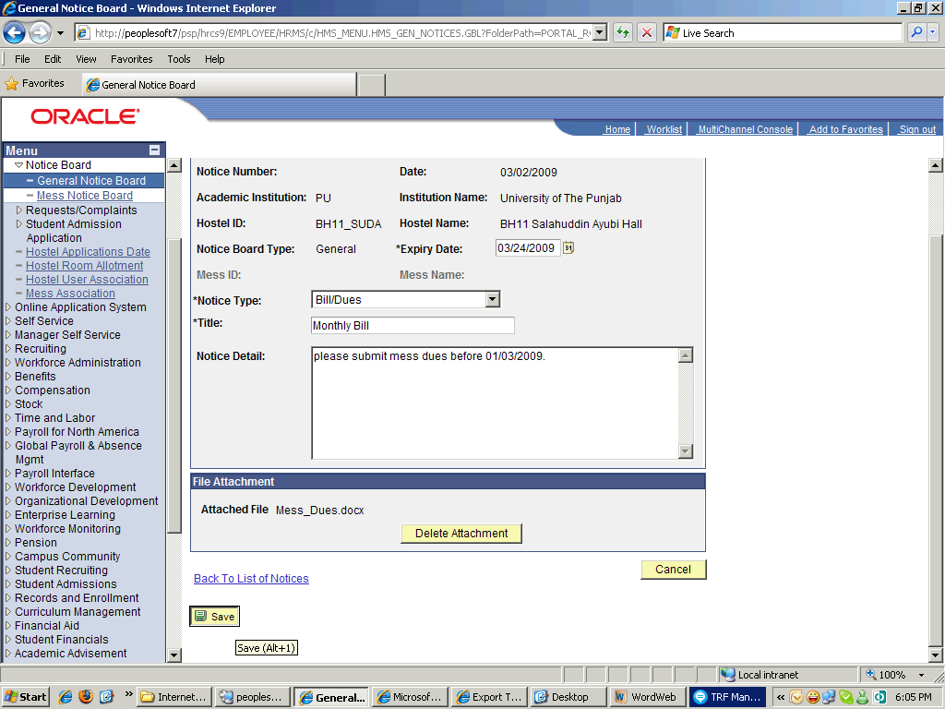

Step | Action
 | Click the Save button.

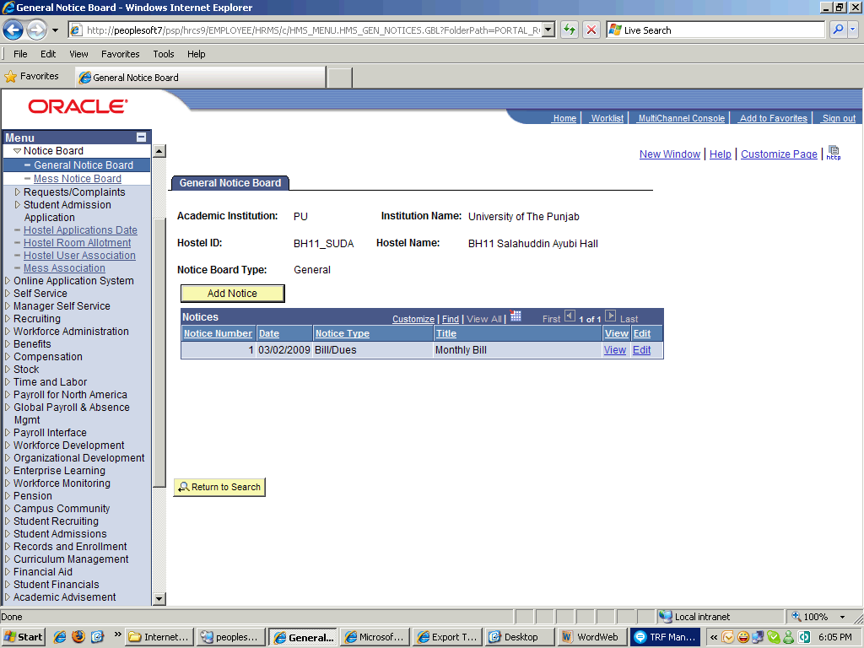

Step | Action
 | Point to the View object.

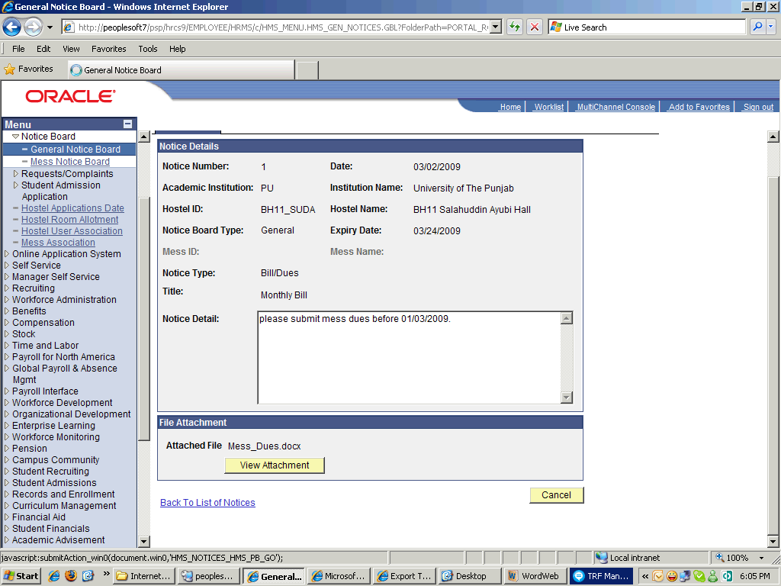

Step | Action
 | Click the Back To List of Notices link.
 | Enter the desired information into the Title field. Enter " report for Feb".
 | Click the Save button.
 | End of Procedure.

Inventory

Managing Inventory

Procedure

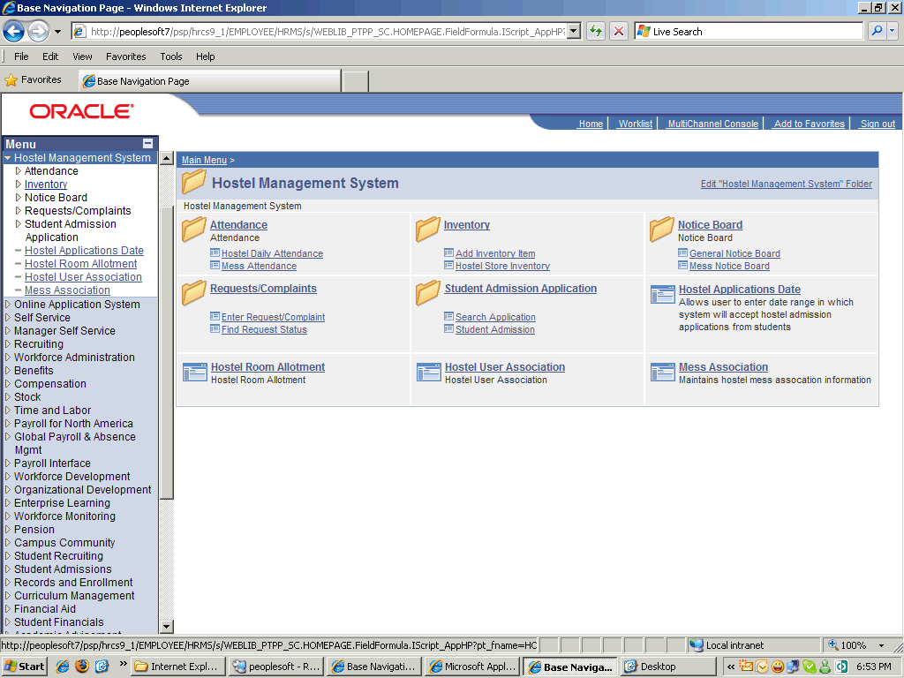

Step | Action
 | Point to the Inventory object.
 | Click the Add Inventory Item link.

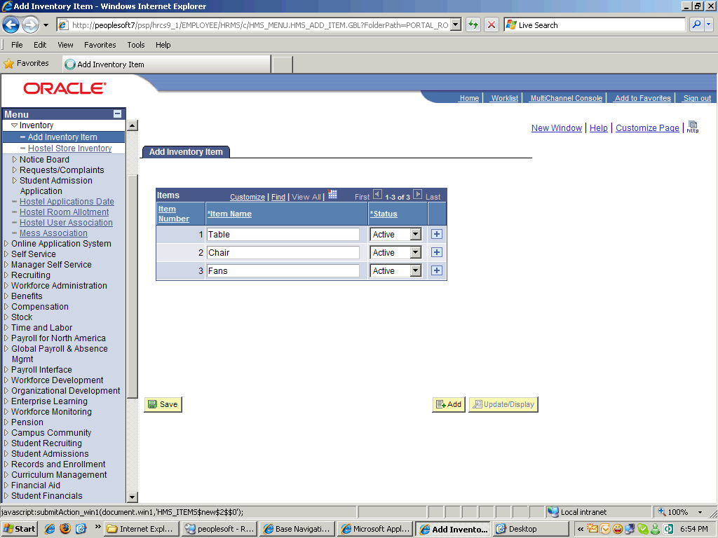

Step | Action
 | Click the Add a new row at row 3 (Alt+7) button.
 | Enter the desired information into the Item Name field. Enter "Beds".

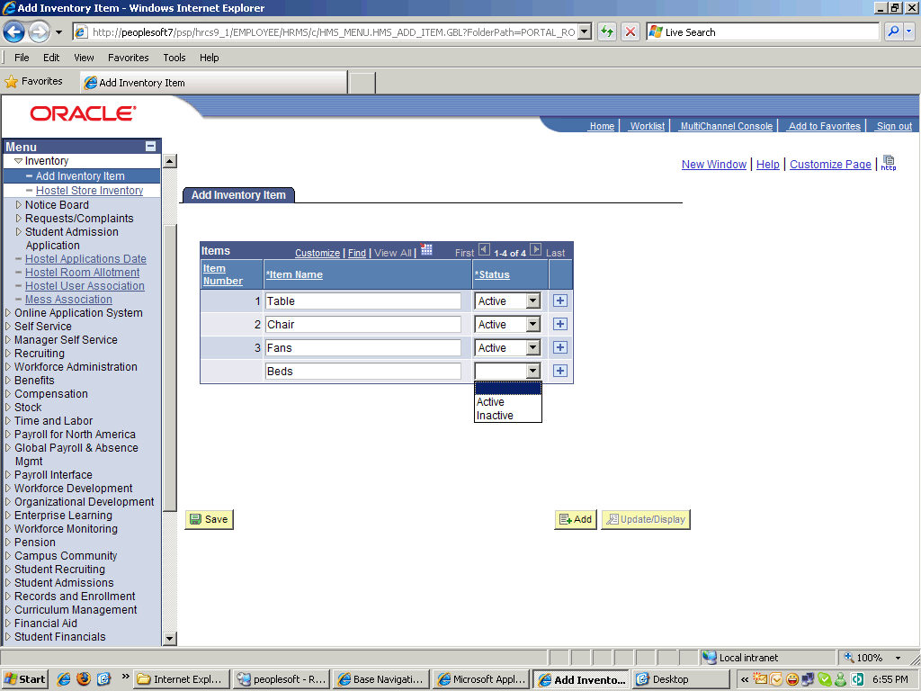

Step | Action
 | Click the Active list item.

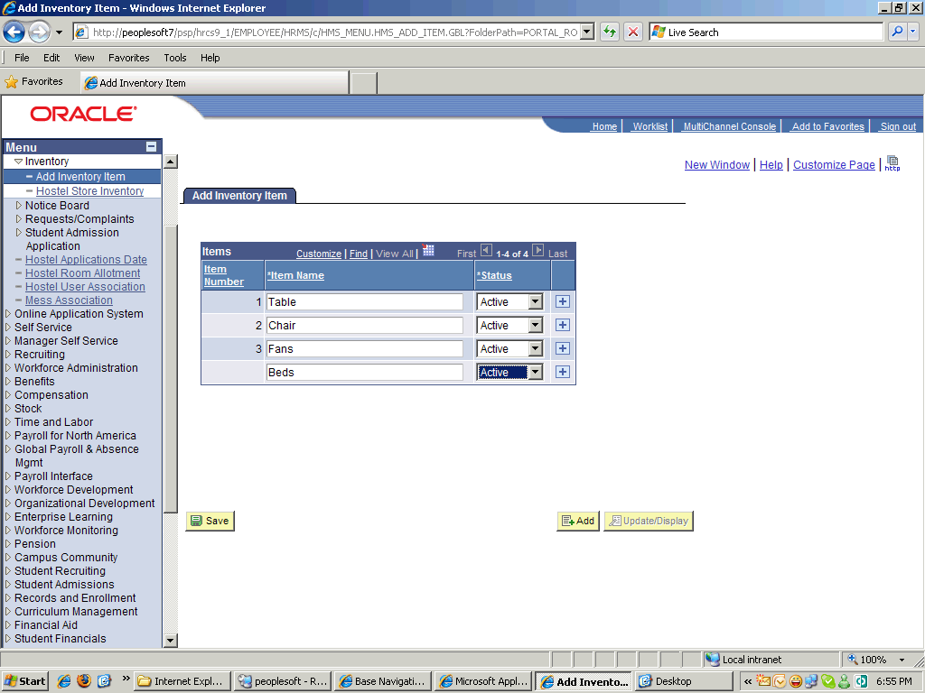

Step | Action
 | Point to the Save object.
 | Click the Save button.
 | Click the Hostel Store Inventory link.

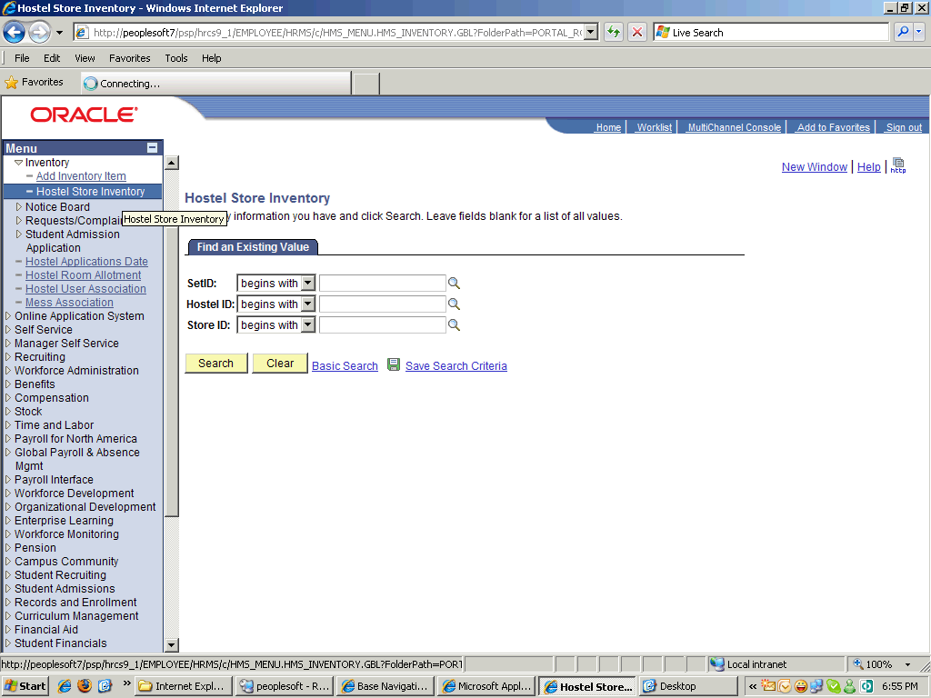

Step | Action
 | Click the Hostel Store Inventory link.
 | Point to the Look up SetID (Alt+5) object.
 | Click an entry in the Academic Institution column.
 | Point to the Look up Hostel ID (Alt+5) object.
 | Click an entry in the Hostel ID column.
 | Click the Look up Store ID (Alt+5) button.
 | Click the Search button.

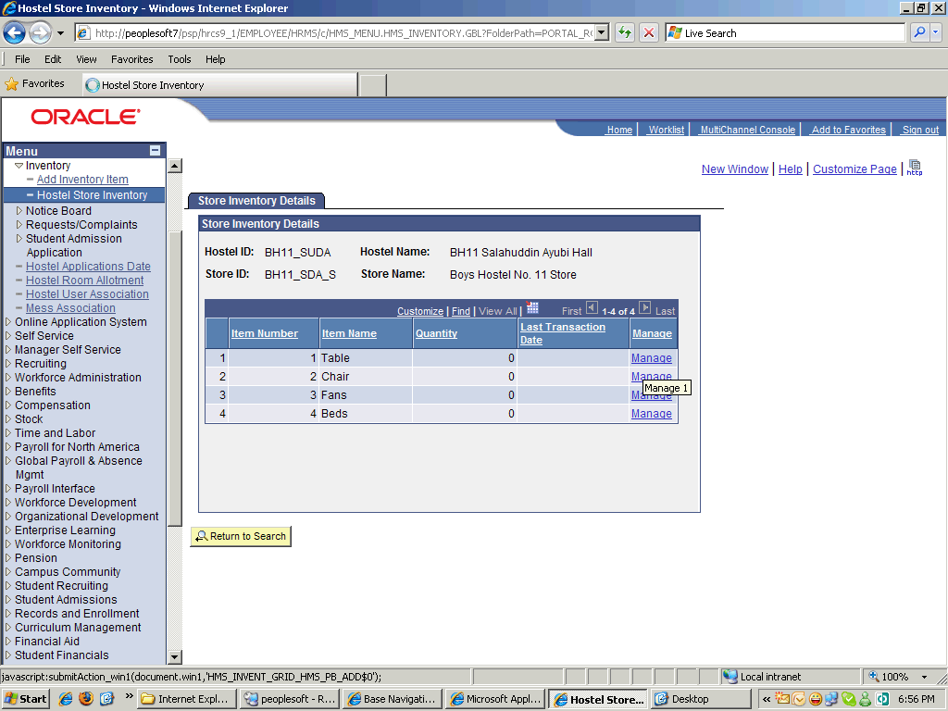

Step | Action
 | Click an entry in the Manage column.

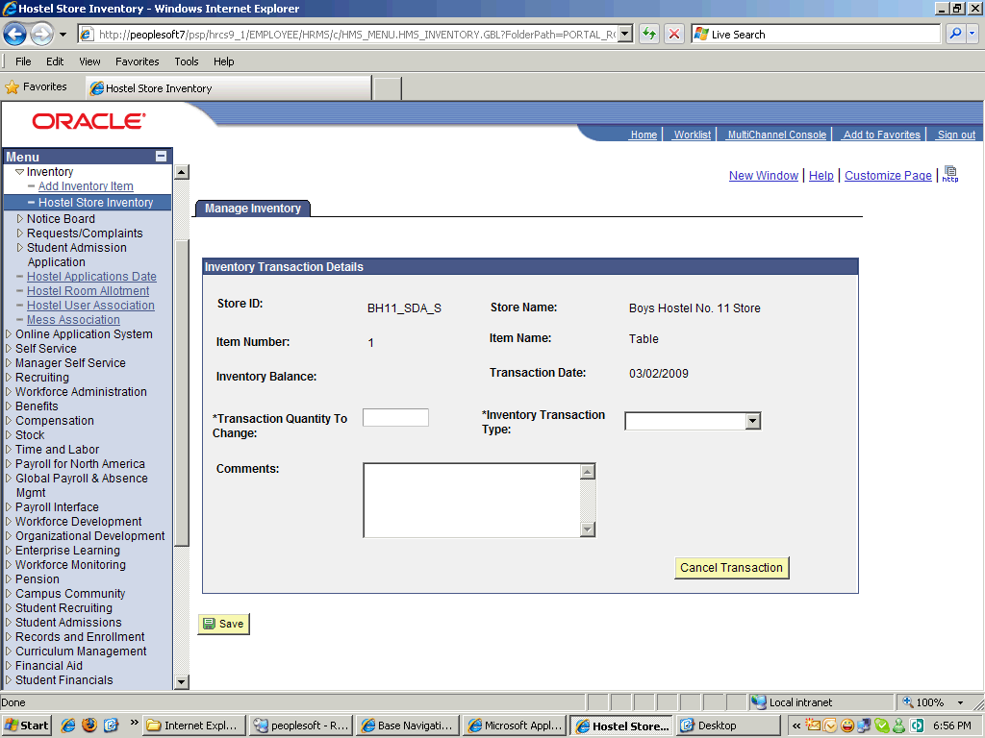

Step | Action
 | Enter the desired information into the Transaction Quantity To Change field. Enter "200".
 | Click the Inventory Transaction Type list.

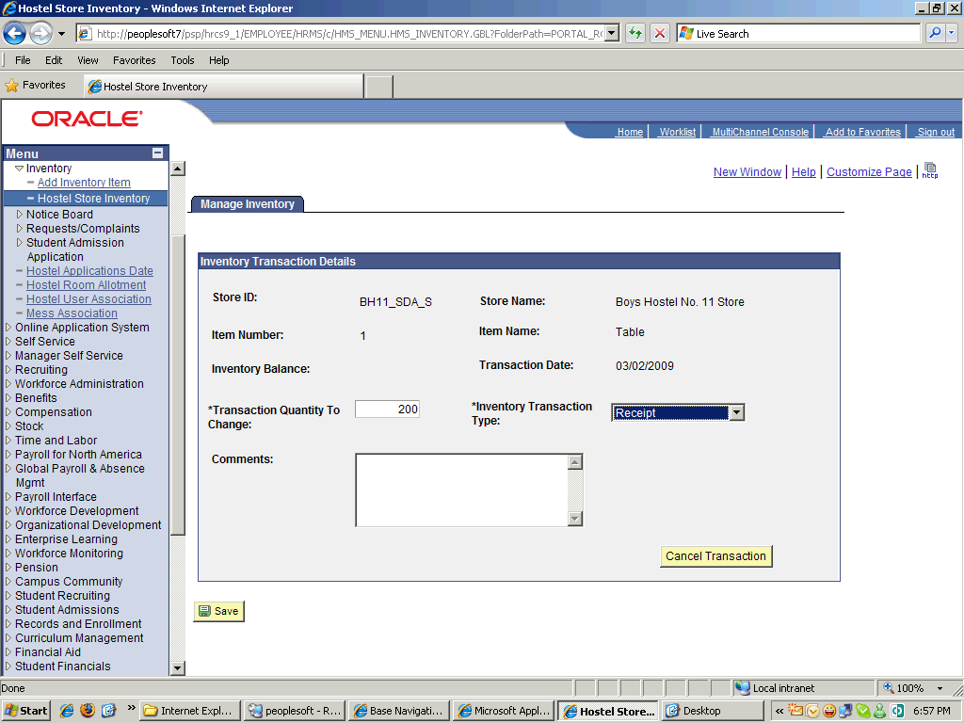

Step | Action
 | Click the Receipt list item.

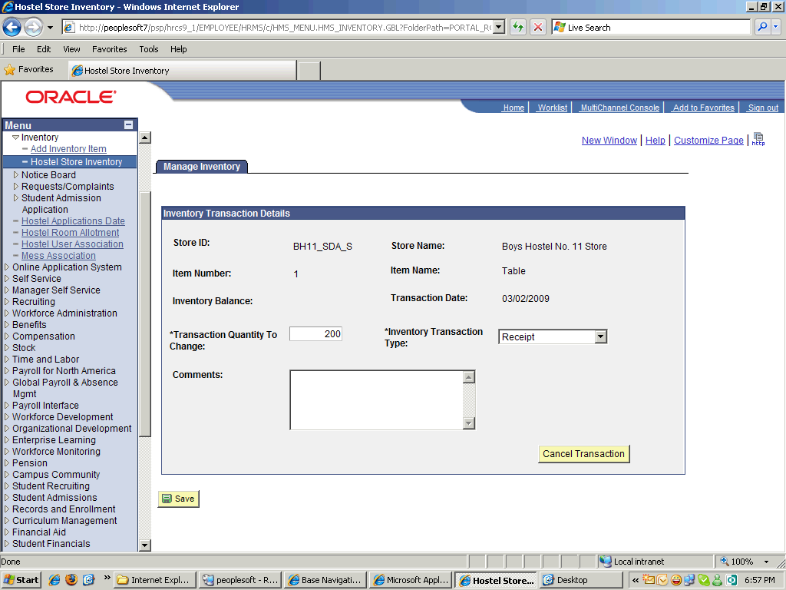

Step | Action
 | Enter the desired information into the Comments field. Enter "Add 200 tables in the inventory".
 | Click the Save button.
 | Click the Cancel Transaction button.
 | End of Procedure.

Misc.

Requests

Procedure

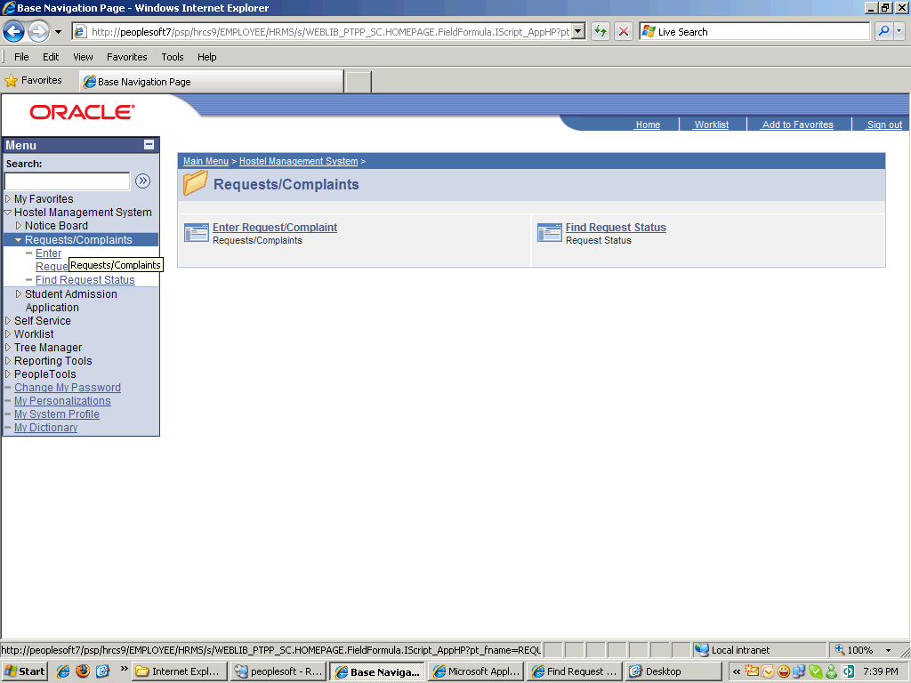

Step | Action
 | Click the Requests/Complaints link.
 | Click the Enter Request/Complaint link.

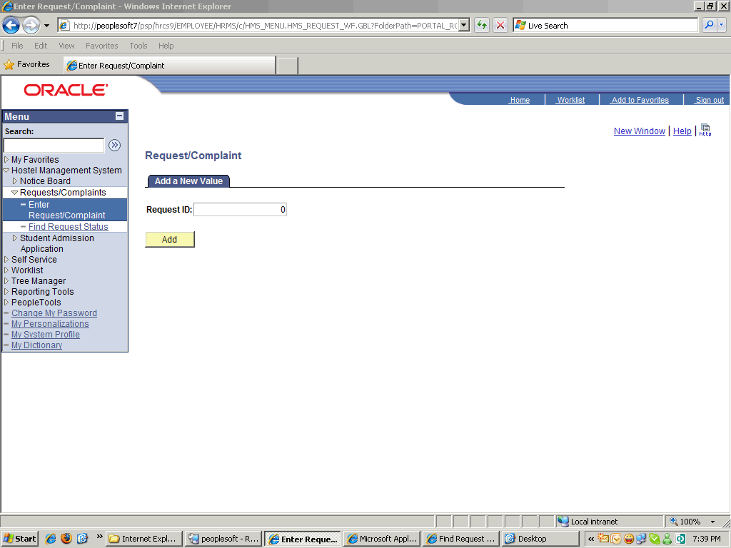

Step | Action
 | Point to the Add object.

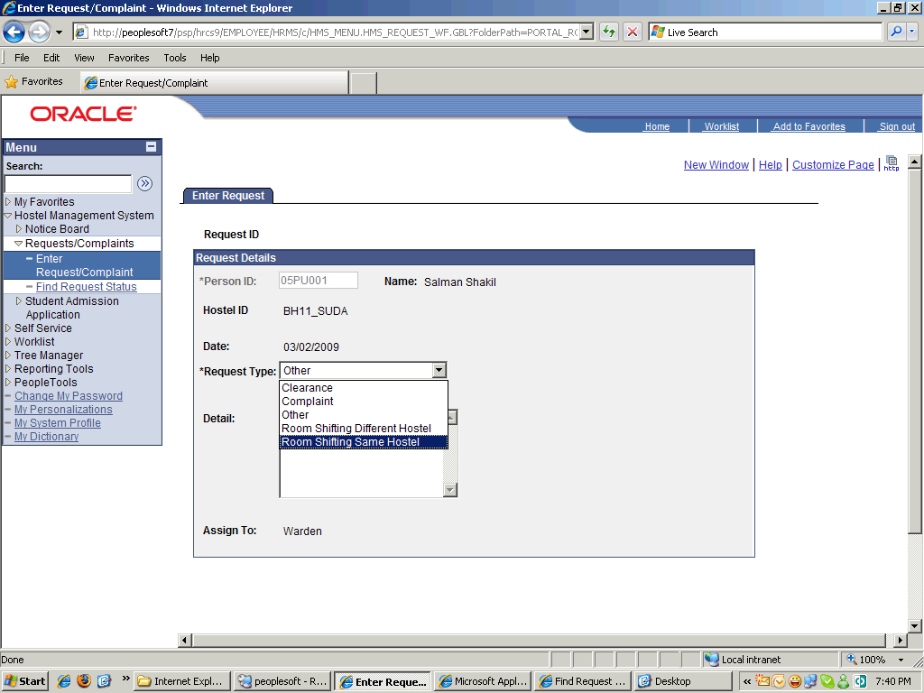

Step | Action
 | Click the Room Shifting Same Hostel list item.

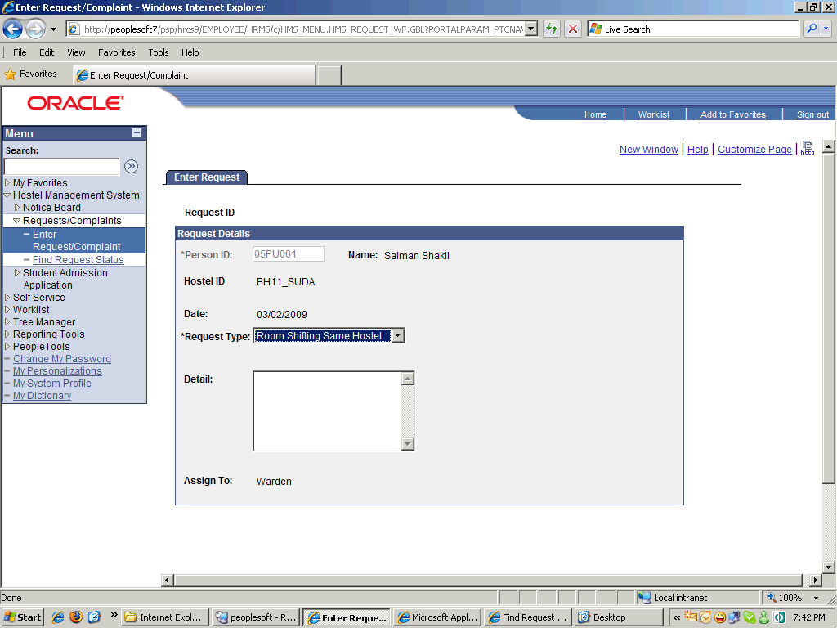

Step | Action
 | Enter the desired information into the Detail field. Enter "Room Shifting request from room #1 to Room Number 7.".
 | Click the Save button.

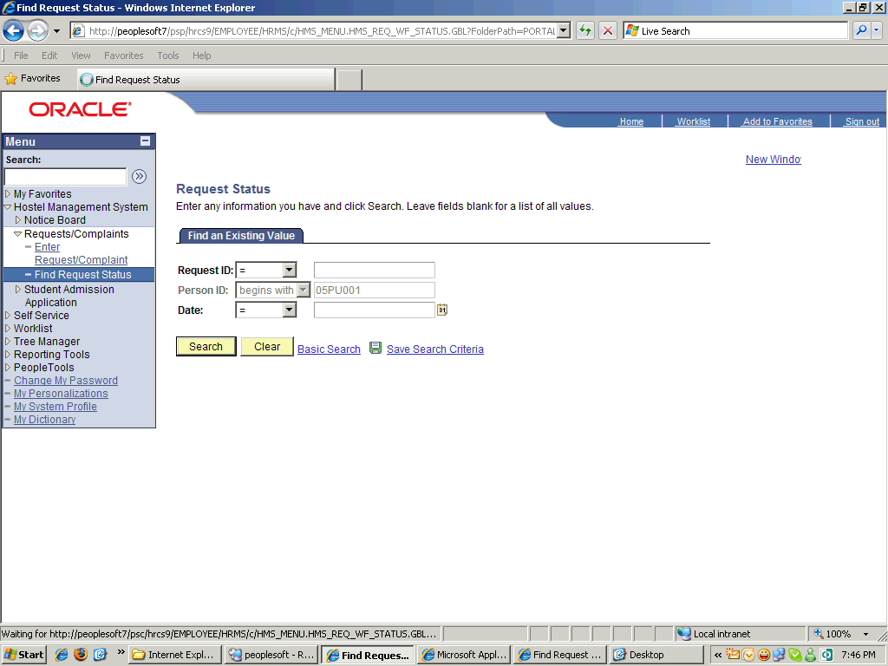

Step | Action
 | Click the Search button.
 | Point to the Request ID object.

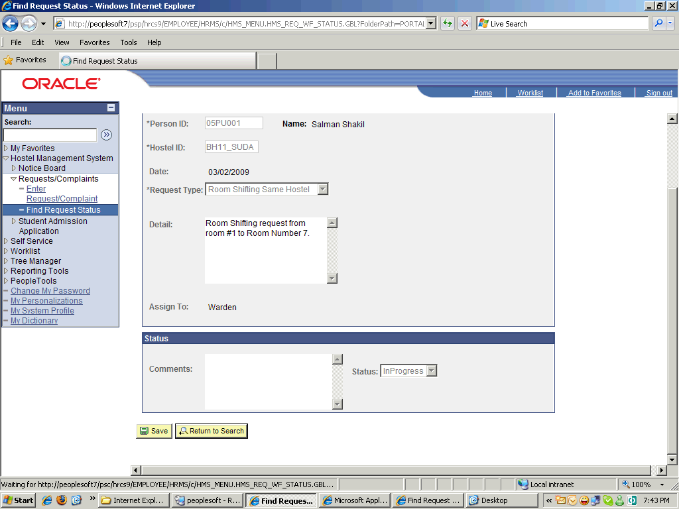

Step | Action
 | Click the Return to Search button.
 | End of Procedure.

Request Accepted/Rejected

Procedure

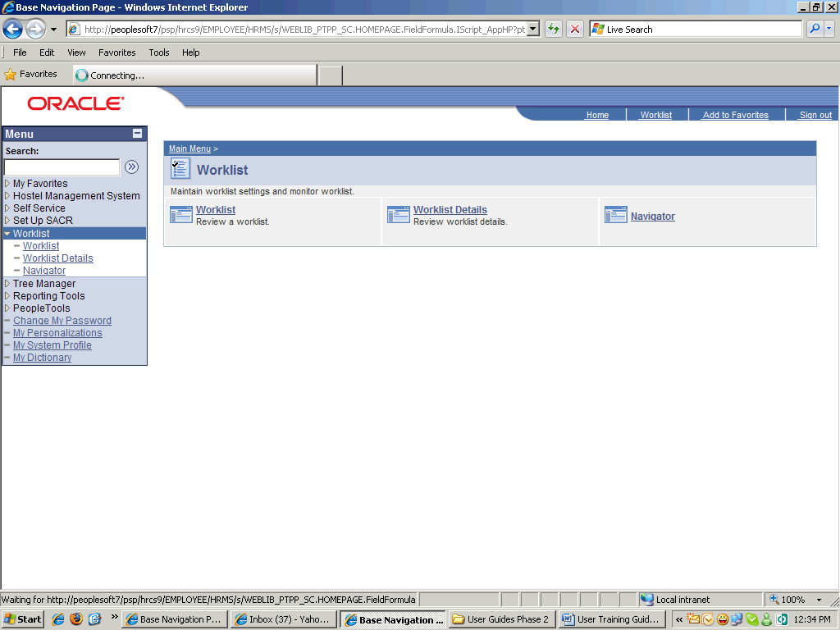

Step | Action
 | Click the Worklist link.
 | Click the Worklist link.

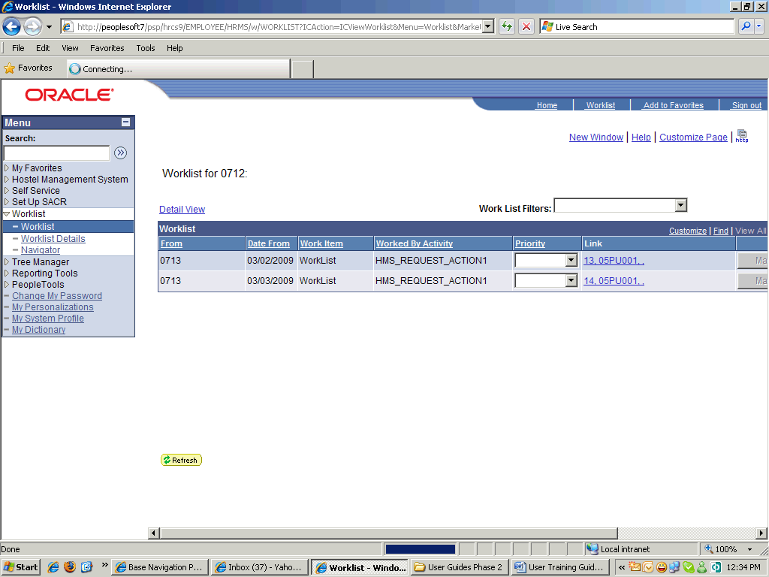

Step | Action
 | Click the Worklist link.

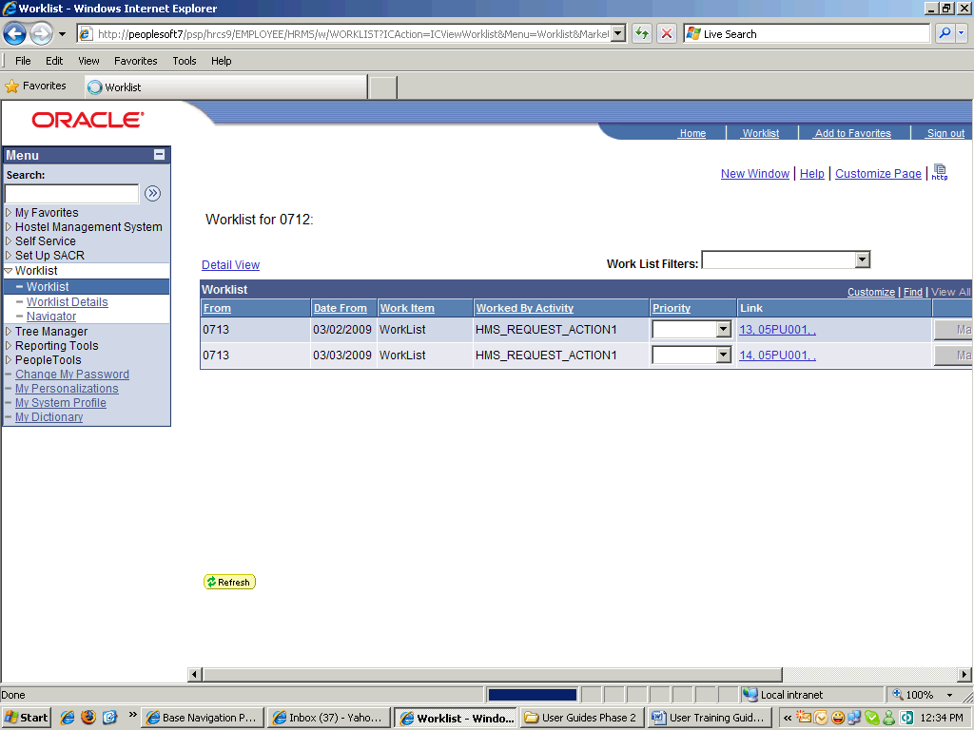

Step | Action
 | Release the mouse button.
 | Enter the desired information into the Comments field. Enter "your room shifting request has been accepted.".
 | Point to the Status object.

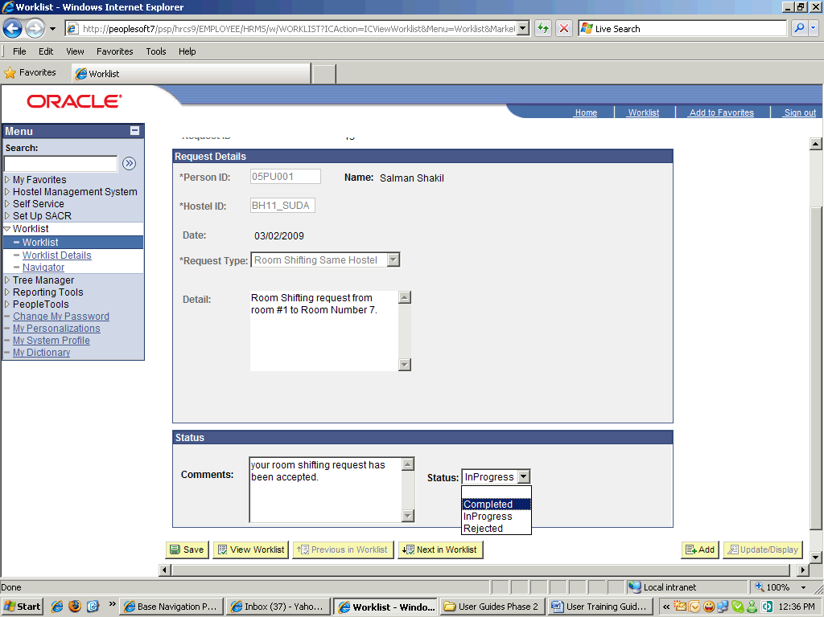

Step | Action
 | Point to the Completed object.

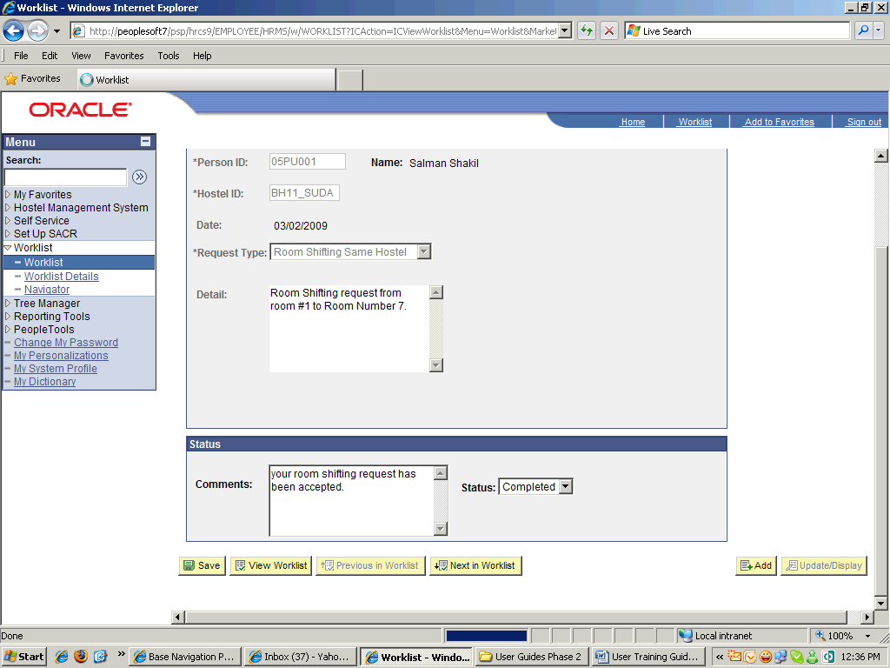

Step | Action
 | Click the Save button.
 | End of Procedure.

Complaints

Procedure

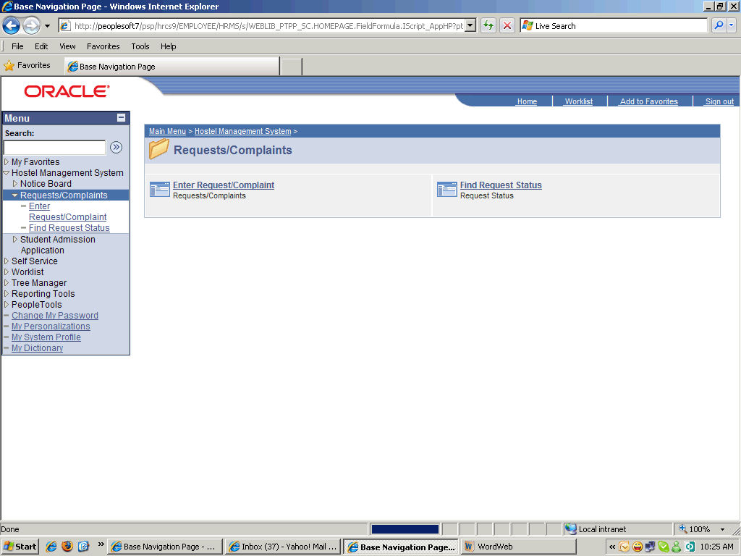

Step | Action
 | Click the Requests/Complaints link.
 | Click the Enter Request/Complaint link.

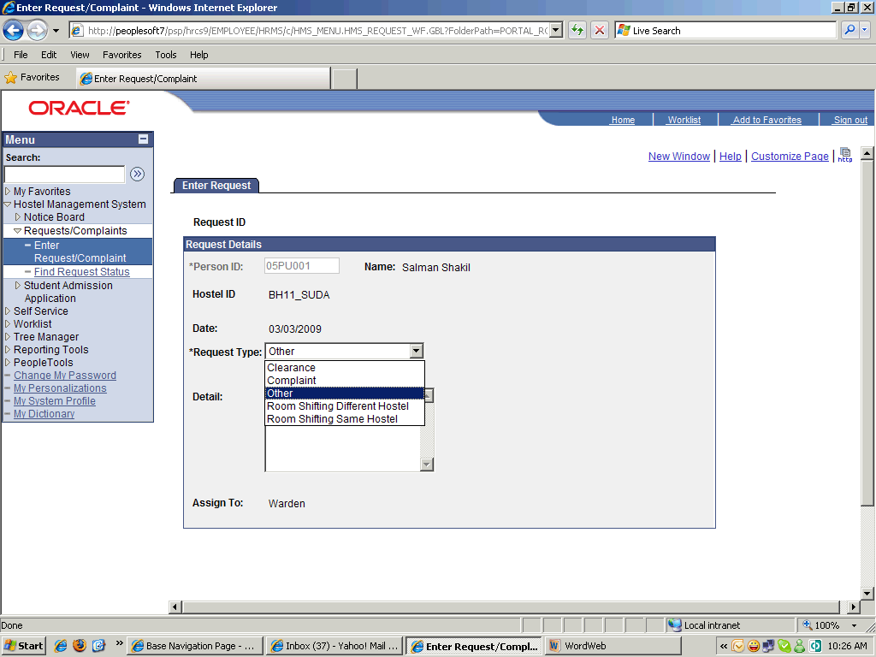

Step | Action
 | Click the Request Type list.
 | Enter the desired information into the Detail field. Enter ".".

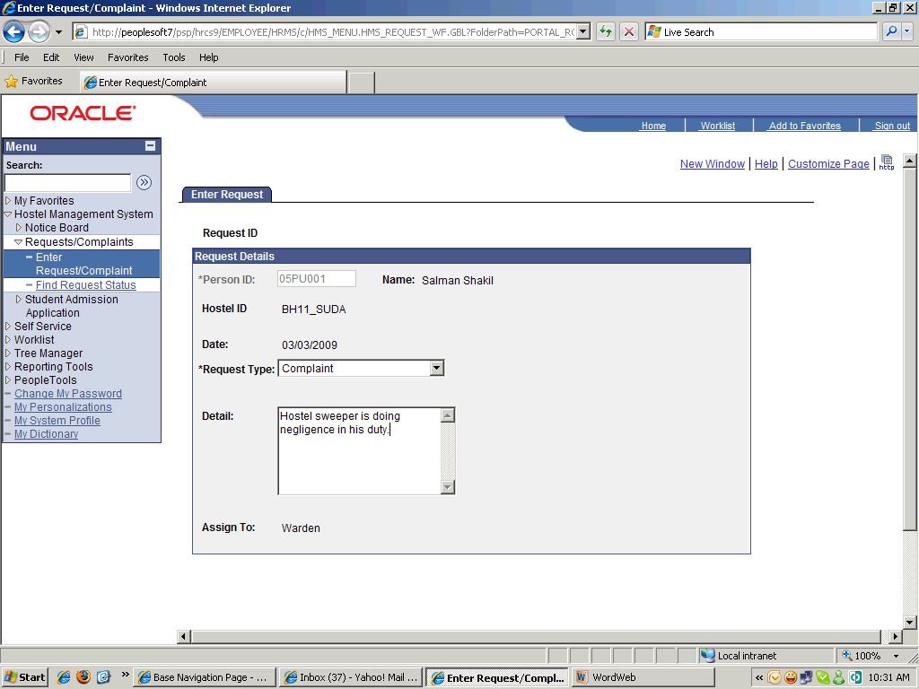

Step | Action
 | Scroll the object with the mouse wheel.

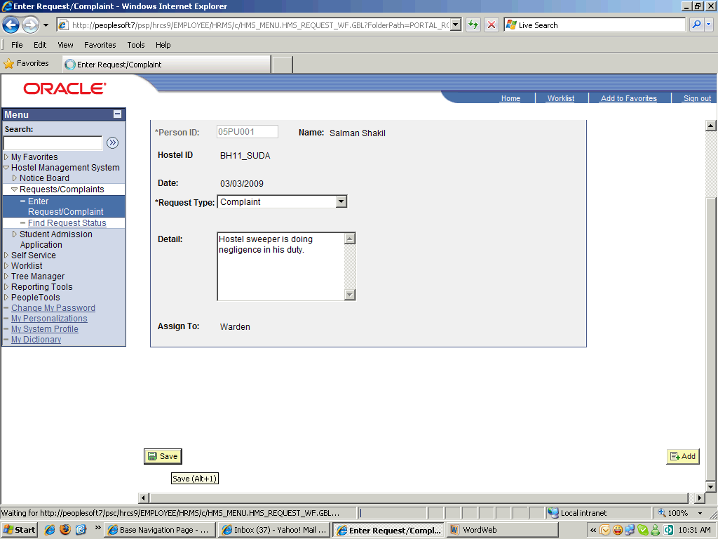

Step | Action
 | Click the Save button.
 | Point to the Find Request Status object.

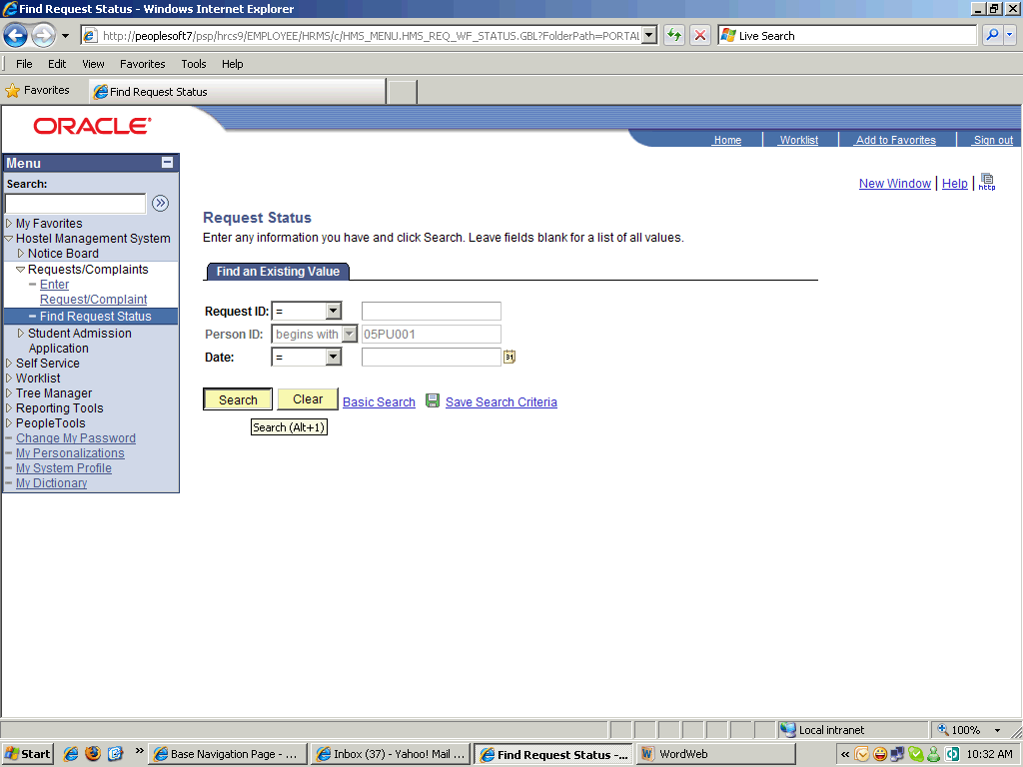

Step | Action
 | Click the Search button.

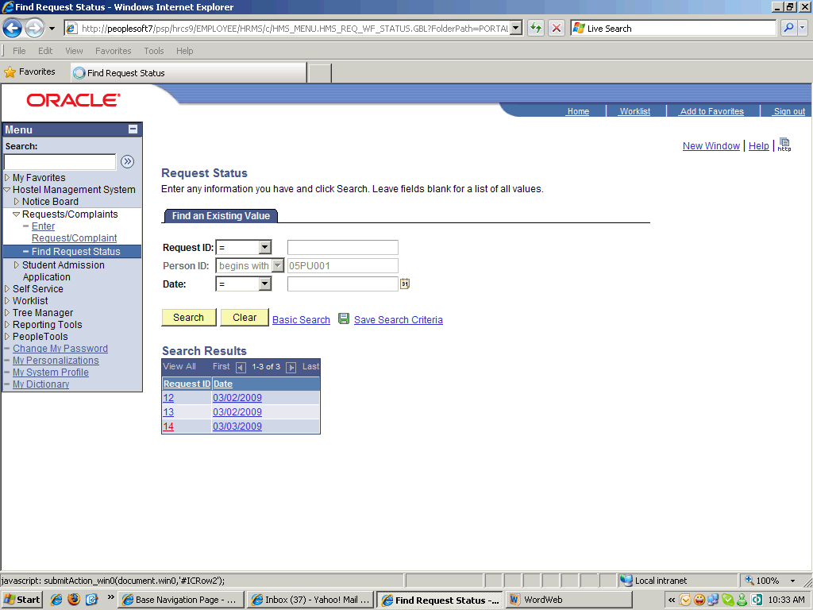

Step | Action
 | Scroll the object with the mouse wheel.

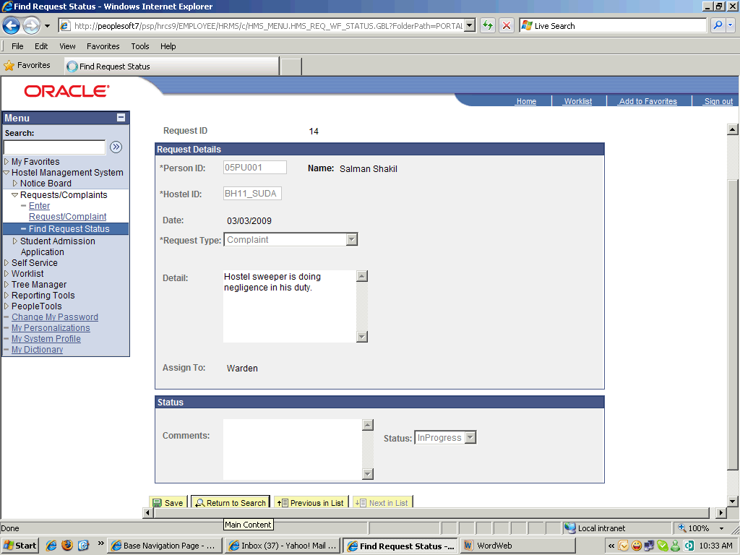

Step | Action
 | Scroll the Comments object with the mouse wheel.
 | End of Procedure.

Clearance

Procedure

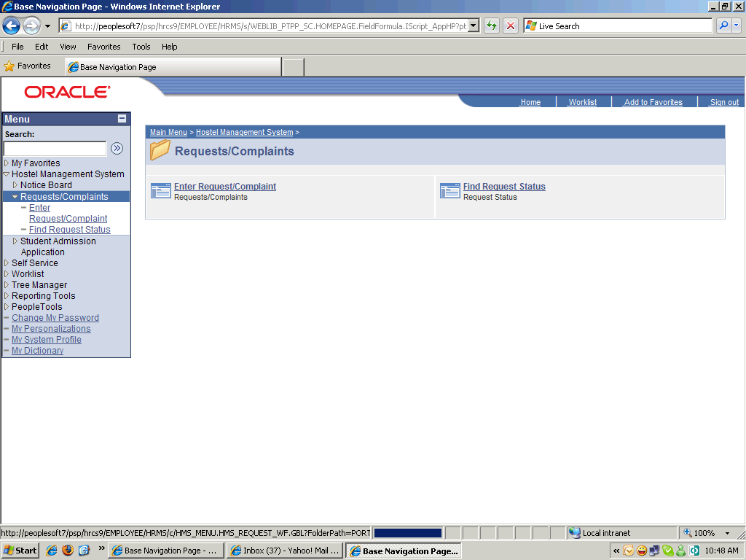

Step | Action
 | Click the Requests/Complaints link.
 | Click the Enter Request/Complaint link.

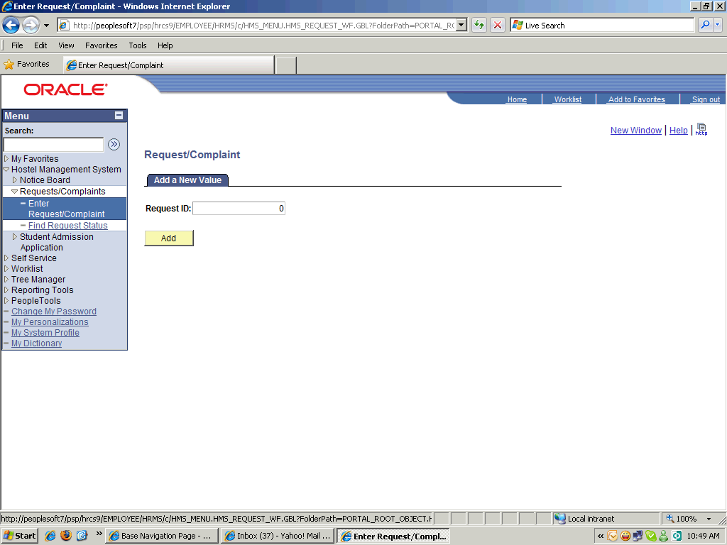

Step | Action
 | Point to the Add object.

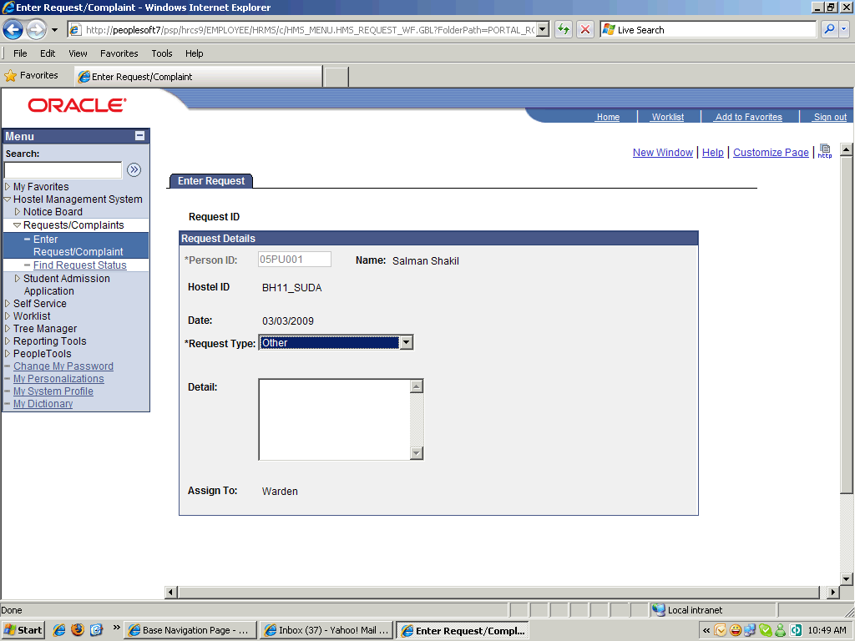

Step | Action
 | Click the Request Type list.

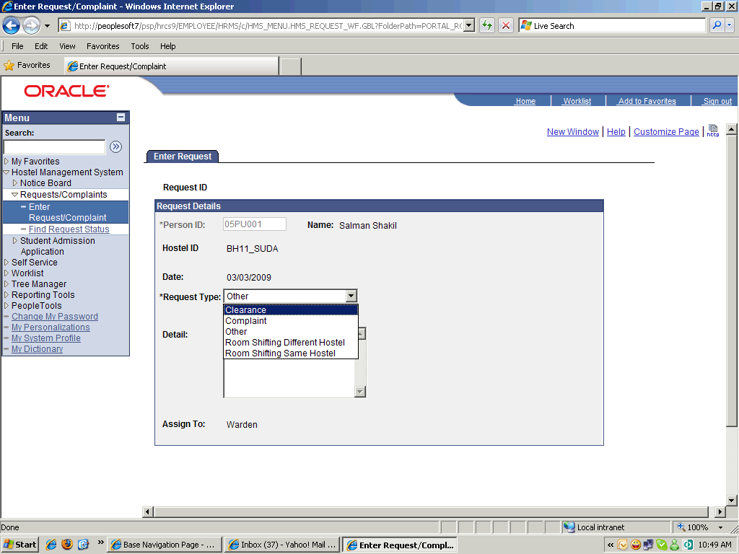

Step | Action
 | Click the Clearance list item.

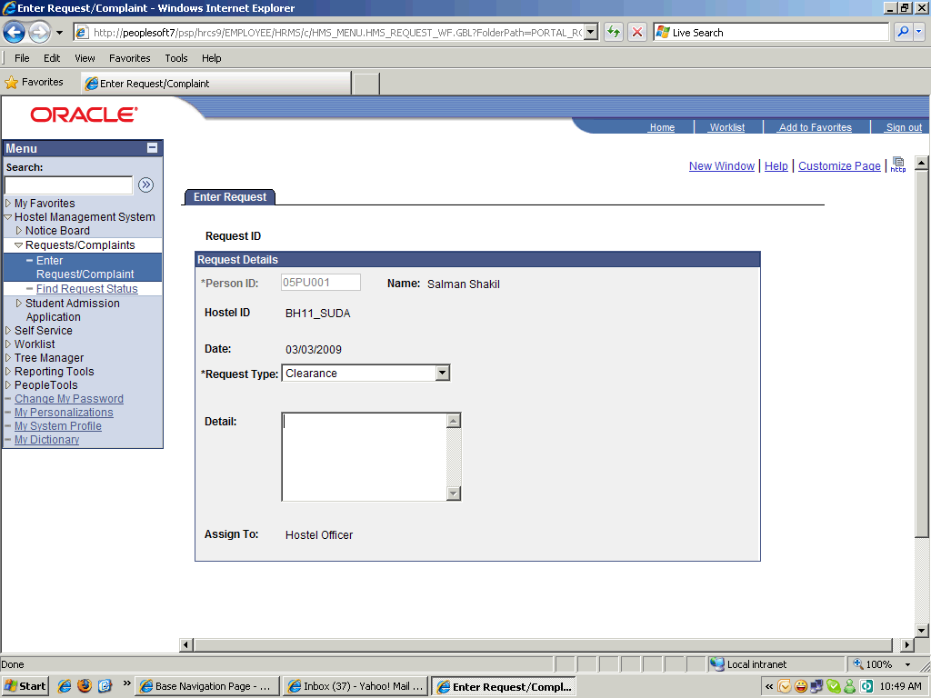

Step | Action
 | Enter the desired information into the Detail field. Enter "Degree".
 | Click the Save button.
 | Click the Find Request Status link.

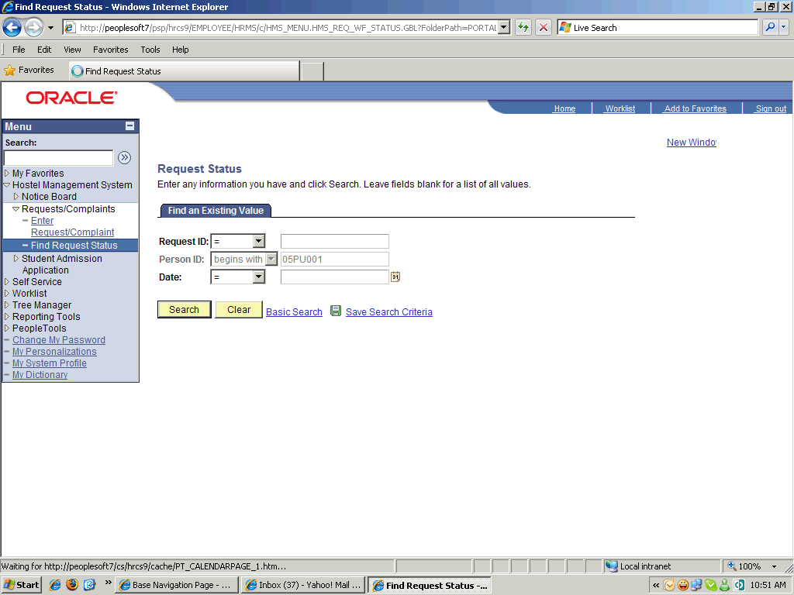

Step | Action
 | Click the Search button.

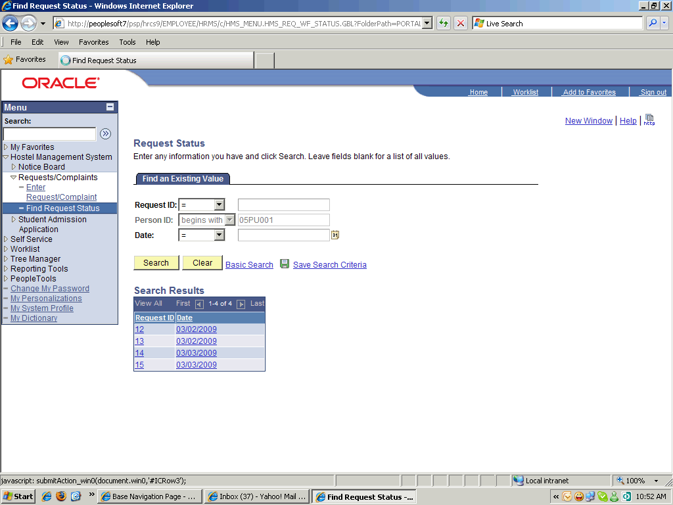

Step | Action
 | Scroll the object with the mouse wheel.

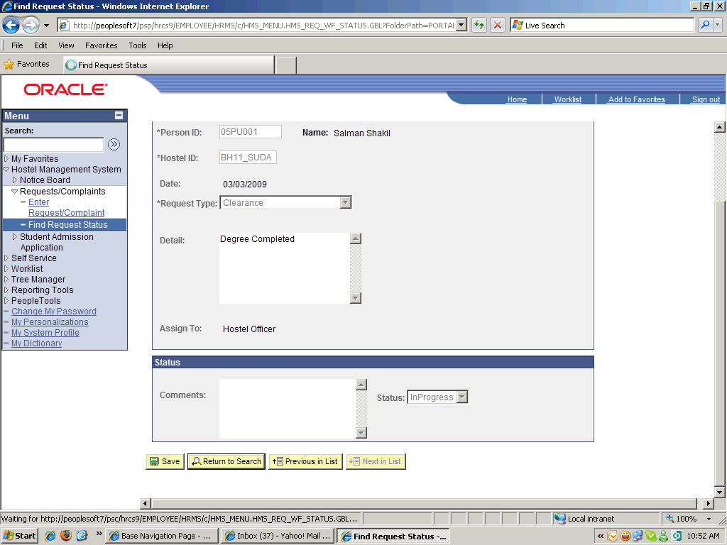

Step | Action
 | Click the Return to Search button.
 | End of Procedure.

Reports

Room Allotment Summary

Procedure

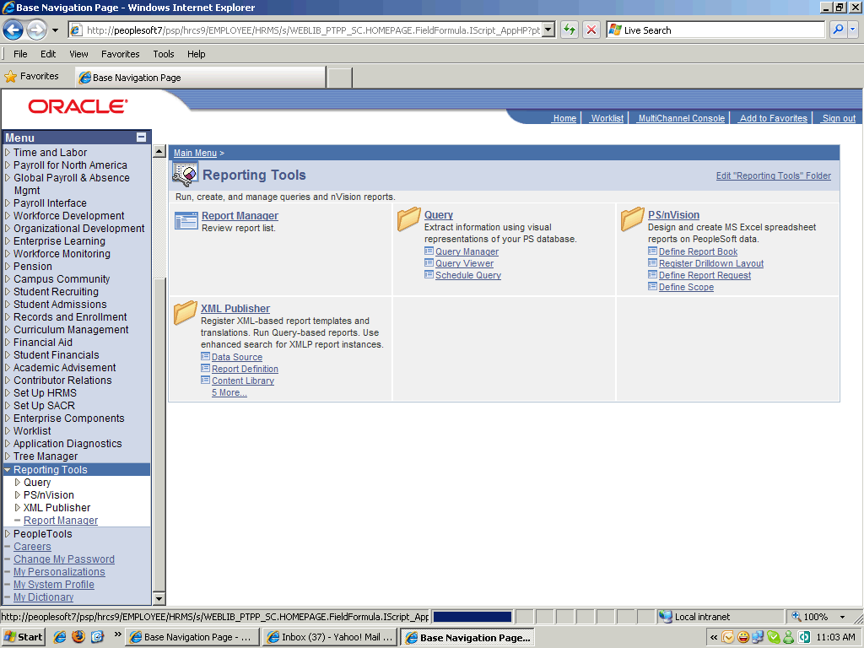

Step | Action
 | Point to the XML Publisher object.
 | Point to the Query Report Viewer object.

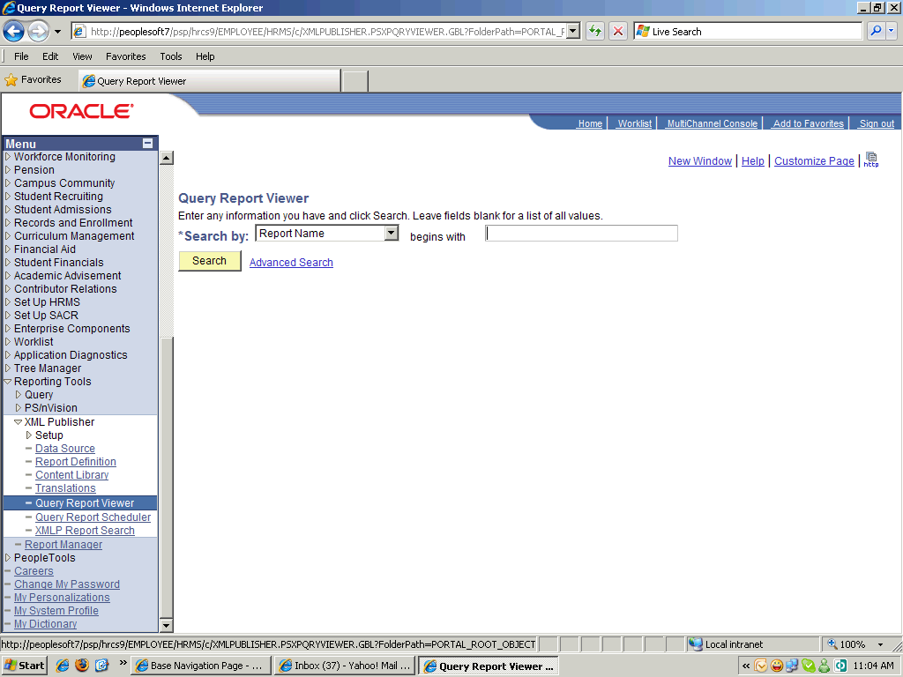

Step | Action
 | Enter the desired information into the Enter any information you have and click Search. Leave fields bl field. Enter "hms".
 | Click the Search button.
 | Click an entry in the View Report column.
 | Click the Look up SetID (Alt+5) button.
 | Click an entry in the Academic Institution column.

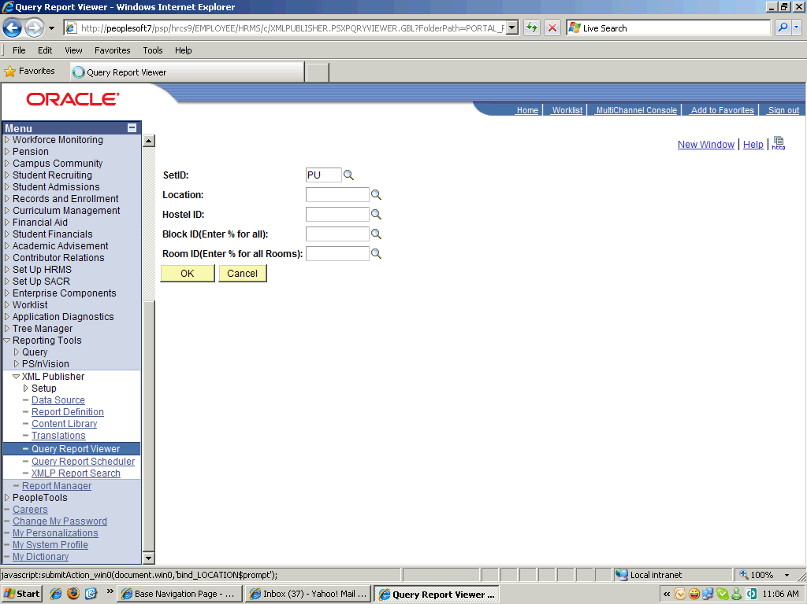

Step | Action
 | Scroll the object with the mouse wheel.

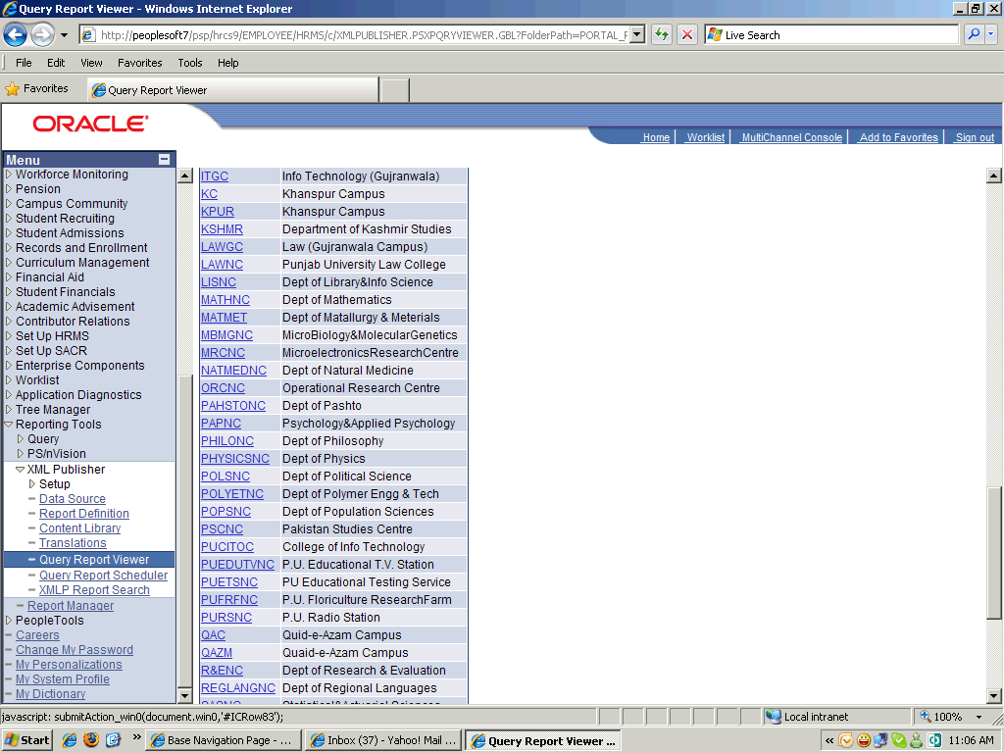

Step | Action
 | Click an entry in the Location Code column.
 | Click the Look up Hostel ID (Alt+5) button.
 | Click an entry in the Hostel ID column.
 | Enter the desired information into the Block ID(Enter % for all) field. Enter "%".
 | Enter the desired information into the Room ID(Enter % for all Rooms) field. Enter "%".
 | Point to the OK object.
 | End of Procedure.

Monthly Mess Billing Summary

Procedure

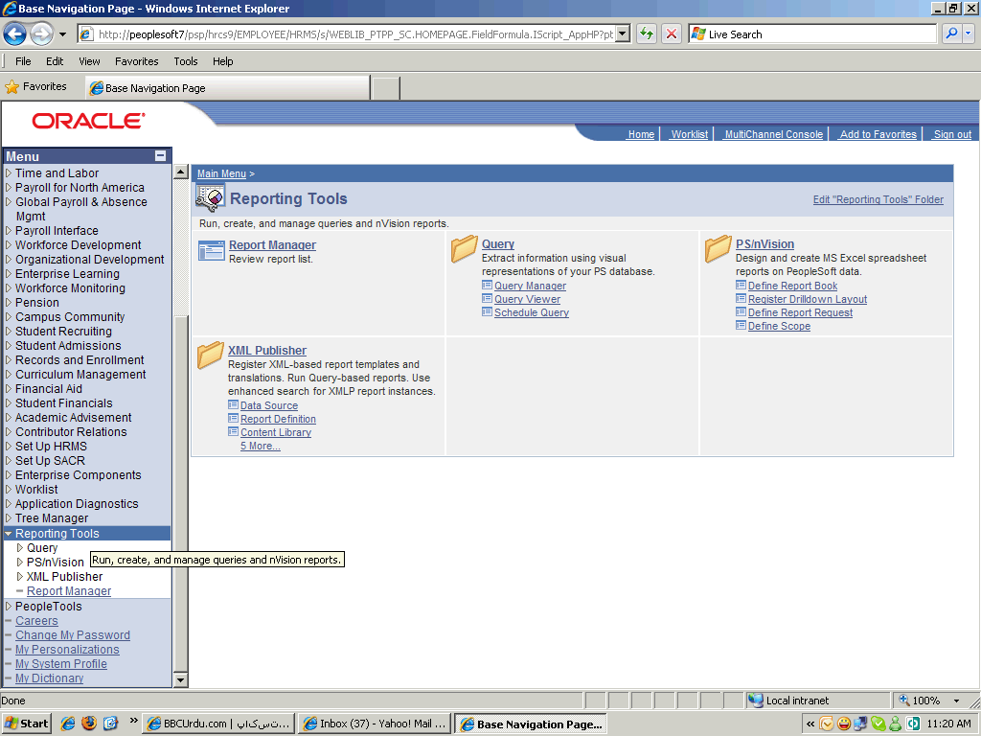

Step | Action
 | Point to the Reporting Tools object.
 | Point to the XML Publisher object.
 | Click the Query Report Viewer link.

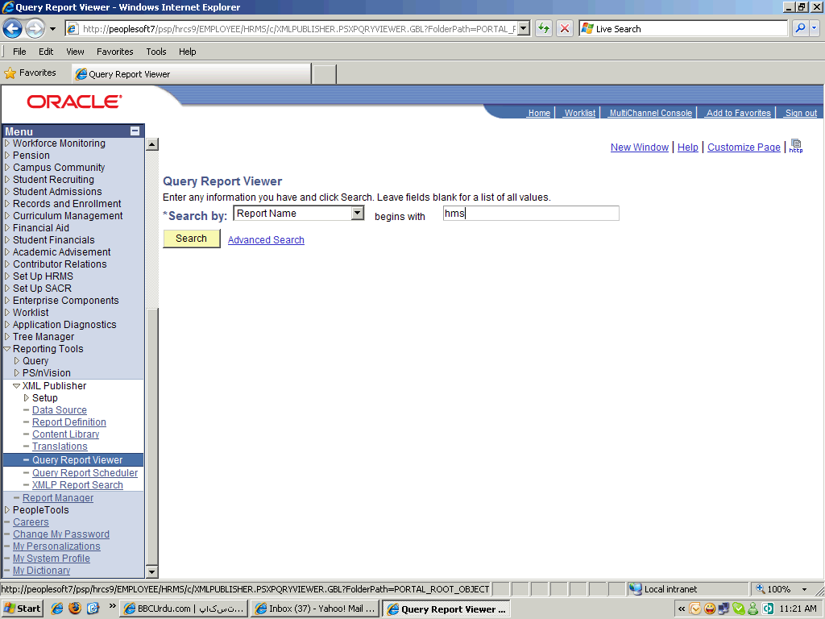

Step | Action
 | Enter the desired information into the Enter any information you have and click Search. Leave fields bl field. Enter "hms".

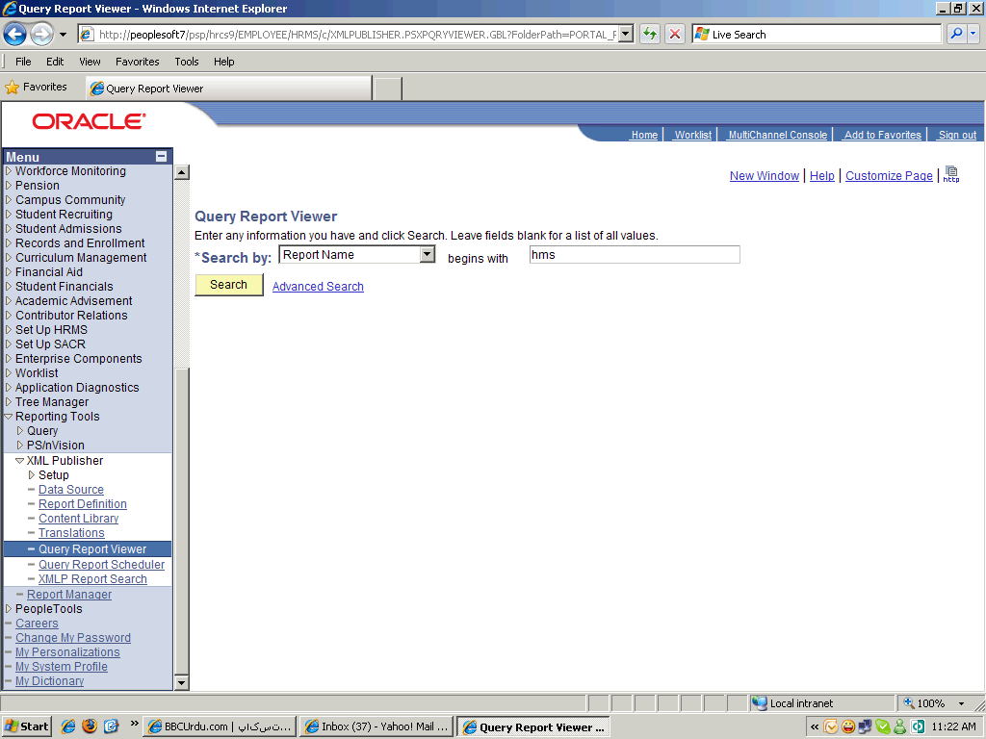

Step | Action
 | Scroll the object with the mouse wheel.

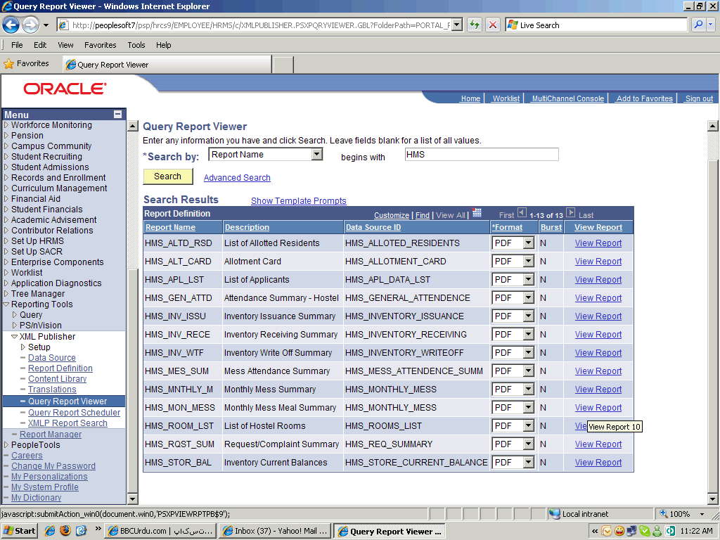

Step | Action
 | Click an entry in the View Report column.
 | Click the Look up Institution (Alt+5) button.
 | Click an entry in the Academic Institution column.
 | Click the Look up Hostel ID (Alt+5) button.
 | Click an entry in the Hostel ID column.
 | Click the Look up Mess ID (Alt+5) button.
 | Click in the Student ID(Enter % for all) field.
 | Enter the desired information into the Student ID(Enter % for all) field. Enter "%".
 | Click the list.

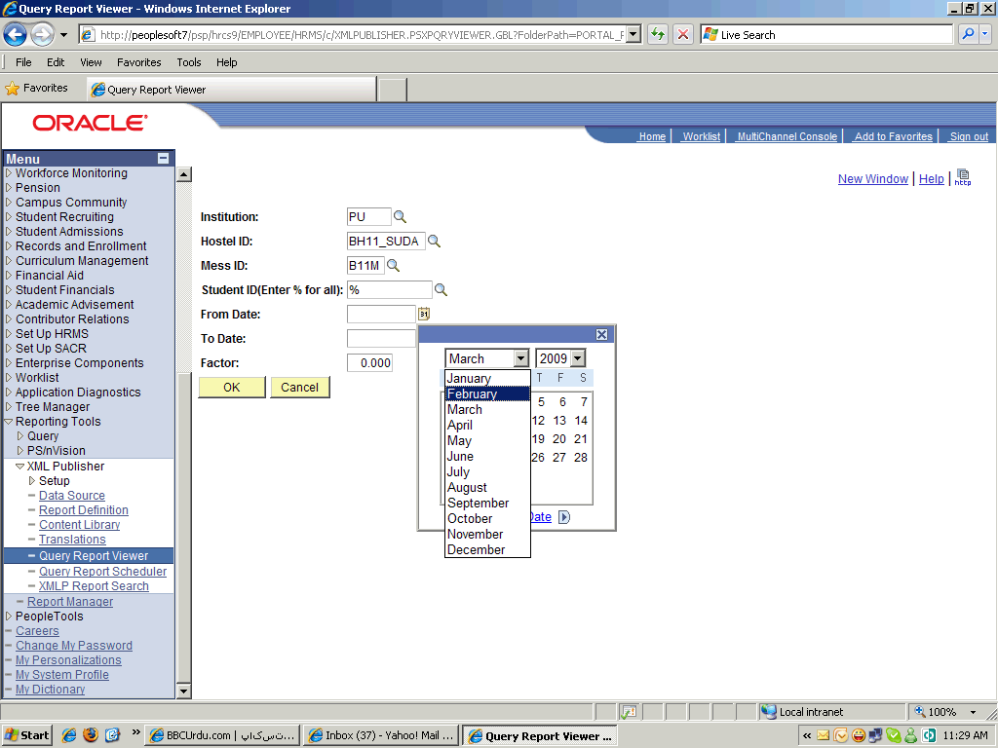

Step | Action
 | Click the February list item.

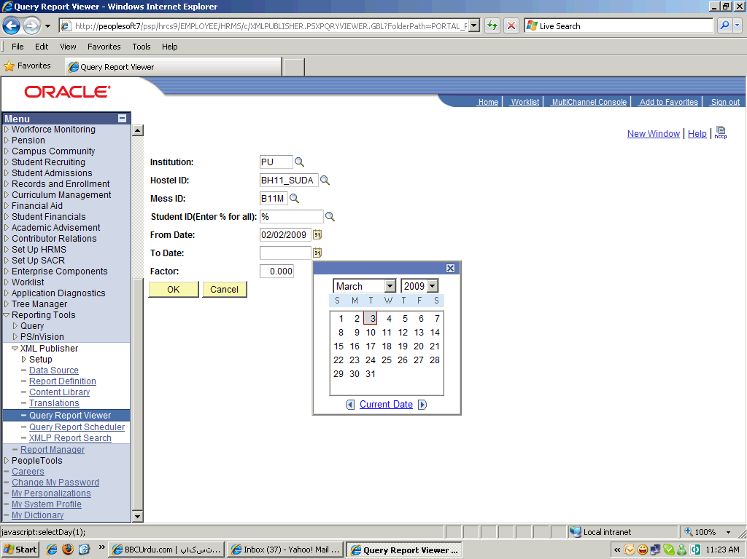

Step | Action
 | Click the 2 link.
 | Enter the desired information into the Factor field. Enter "2".

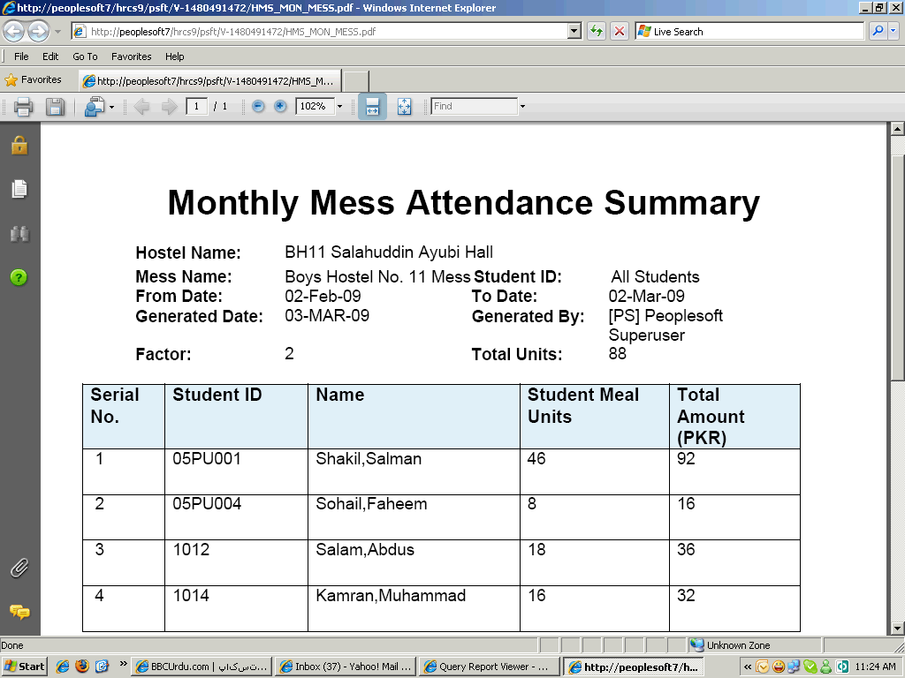

Step | Action
 | Scroll the AVPageView object with the mouse wheel.
 | End of Procedure.

Allotment Cards

Procedure

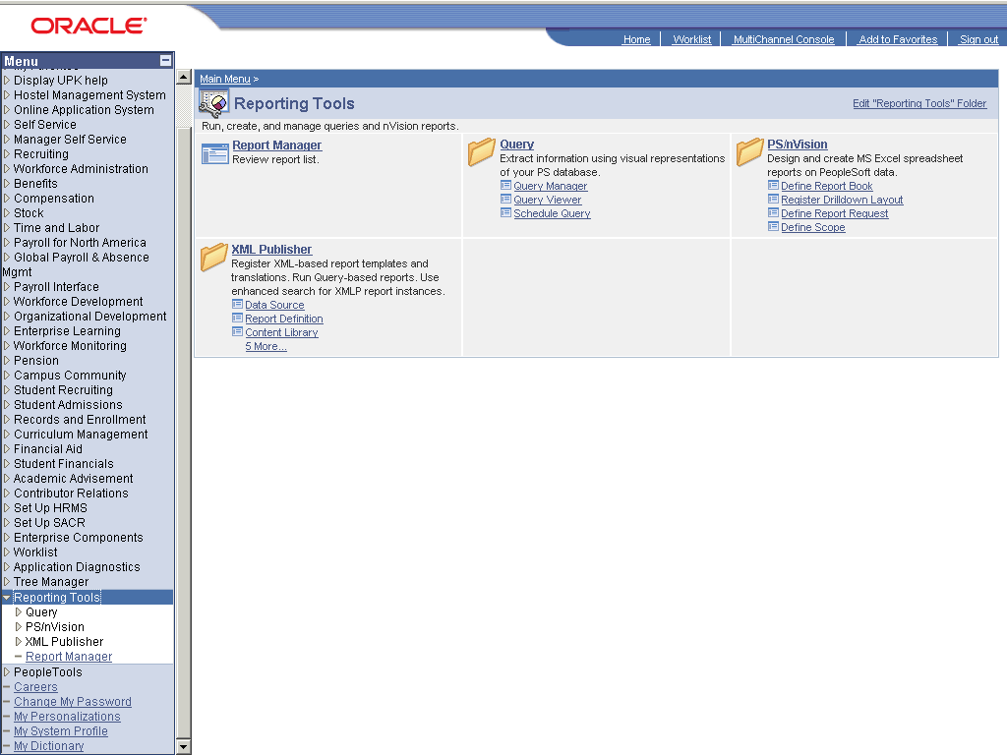

Step | Action
 | Click the Reporting Tools link.
 | Click the XML Publisher link.
 | Click the Query Report Viewer link.

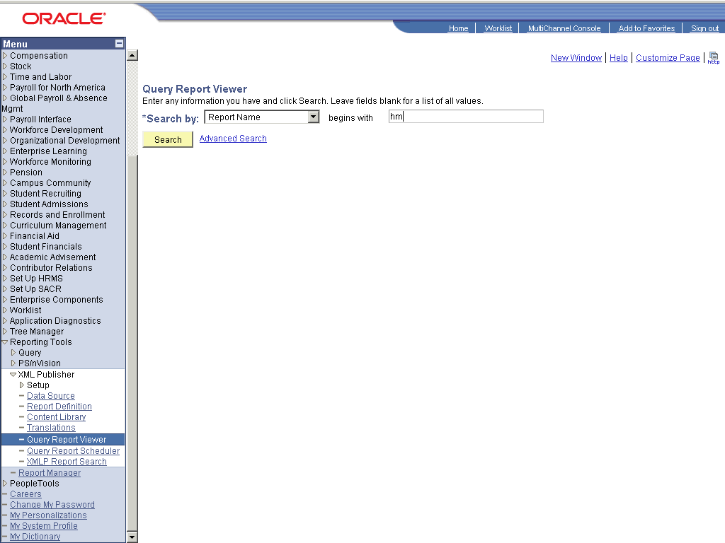

Step | Action
 | Enter the desired information into the field. Enter "hms".
 | Click the Search button.
 | Click the View Report link.
 | Click the Look up SetID (Alt+5) graphic.
 | Click the PU link.
 | Scroll the object with the mouse wheel.
 | Click the QAZM link.
 | Click the desired object.
 | Click in the Resident ID (Enter % for all): field.
 | Enter the desired information into the Resident ID (Enter % for all): field. Enter "%".

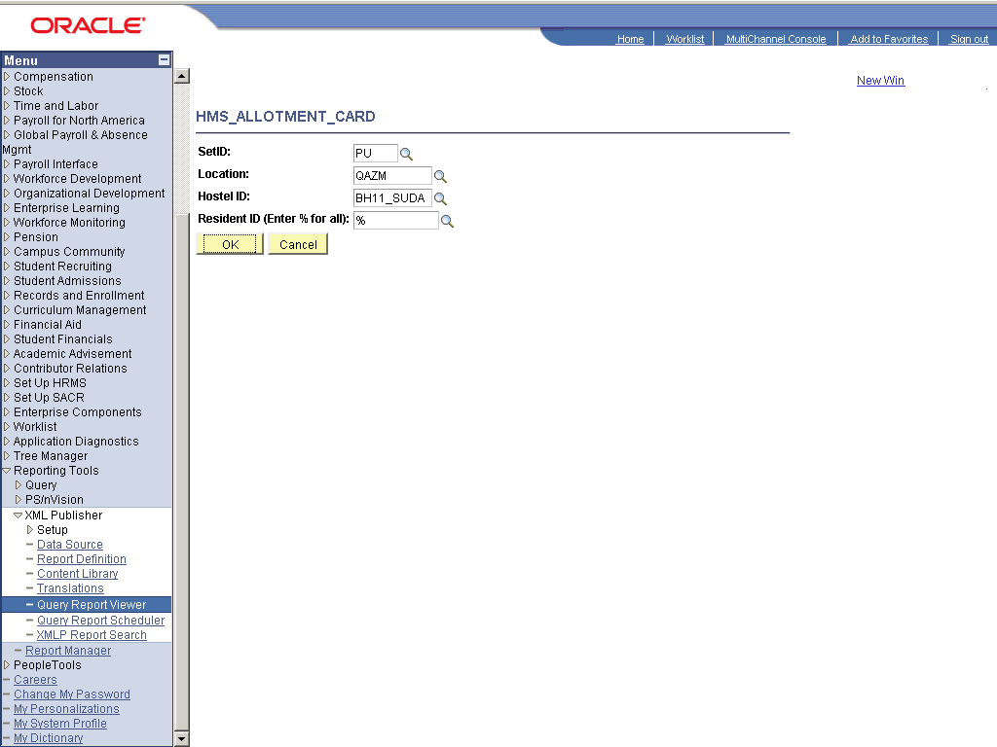

Step | Action
 | Scroll the AVPageView object with the mouse wheel.
 | Scroll the AVPageView object with the mouse wheel.
 | End of Procedure.

Attendance Summary Report

Procedure

Step | Action
 | Click the Reporting Tools link.
 | Click the XML Publisher link.
 | Click the Query Report Viewer link.

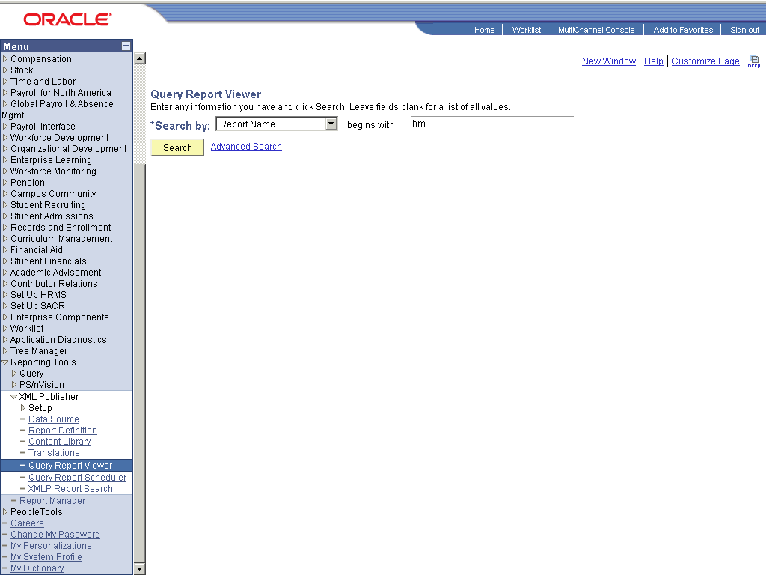

Step | Action
 | Enter the desired information into the field. Enter "hms".
 | Click the Search button.
 | Click the View Report link.
 | Click the Look up Hostel ID (Alt+5) graphic.
 | Click the BH11_SUDA link.
 | Click the Choose a date (Alt+5) graphic.

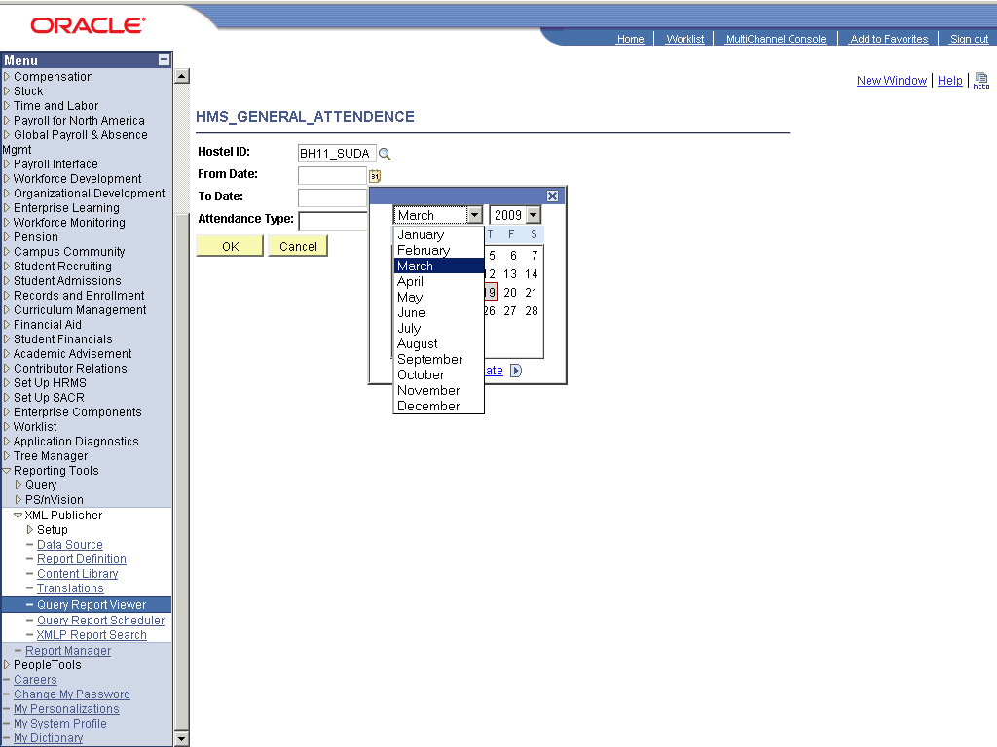

Step | Action
 | Click the http://peoplesoft7/cs/hrcs9/cache/PT_CALENDARPAGE_1.htm object.

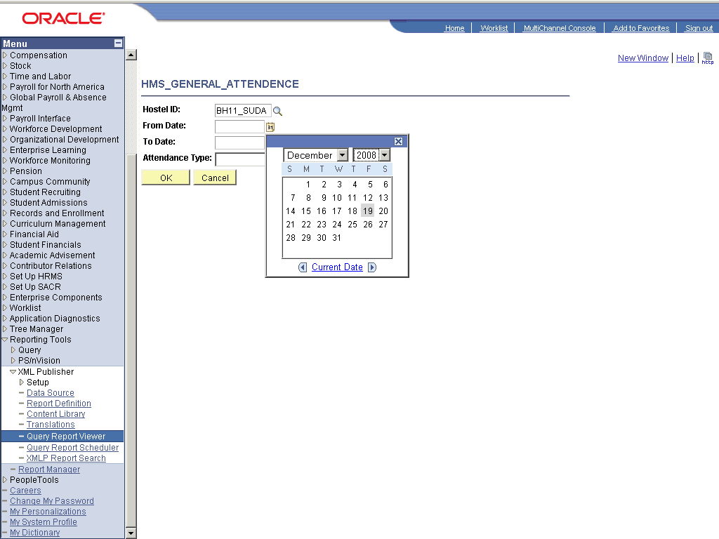

Step | Action
 | Point to the 19 object.
 | Click the Choose a date (Alt+5) graphic.
 | Click the Attendance Type: list.

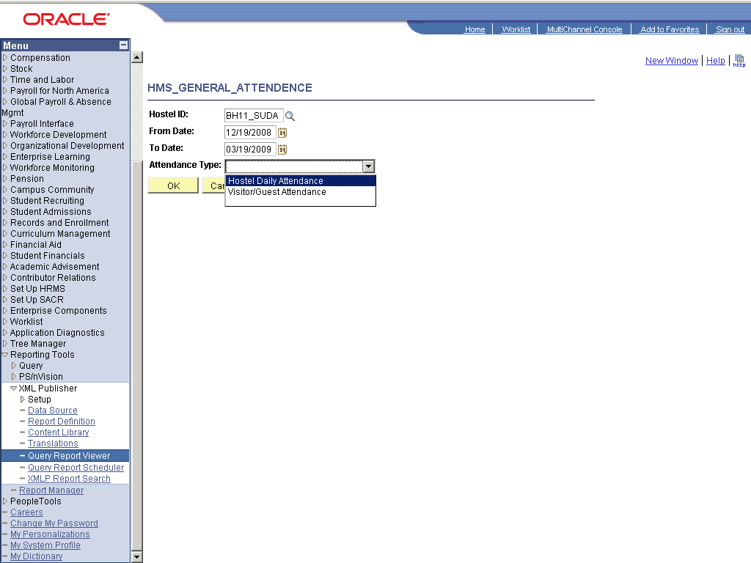

Step | Action
 | Click the object.

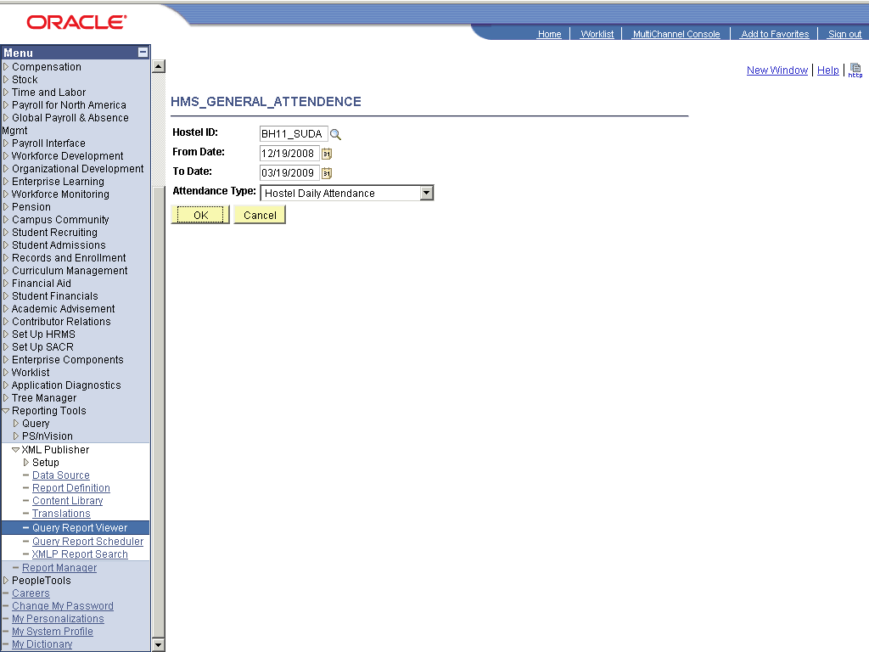

Step | Action
 | Click the OK button.

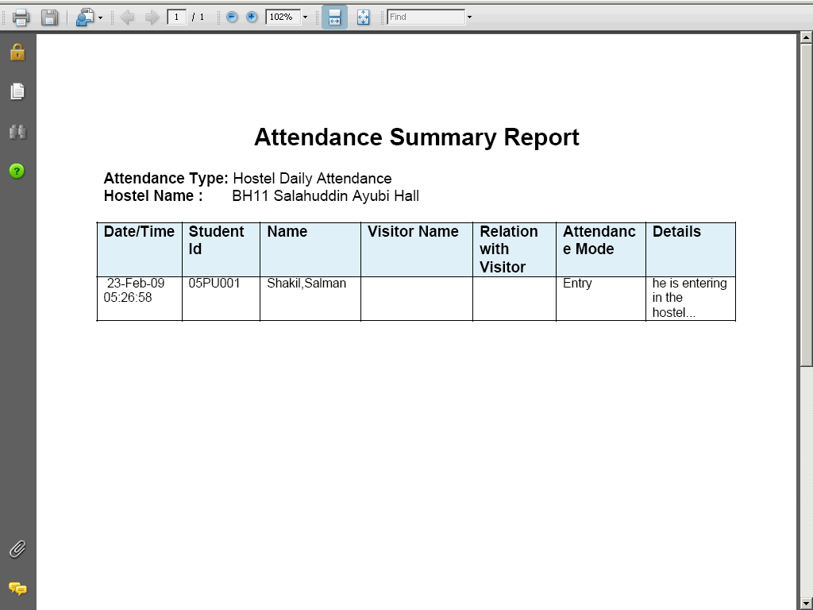

Step | Action
 | Scroll the AVPageView object with the mouse wheel.
 | End of Procedure.

List of Applicant

Procedure

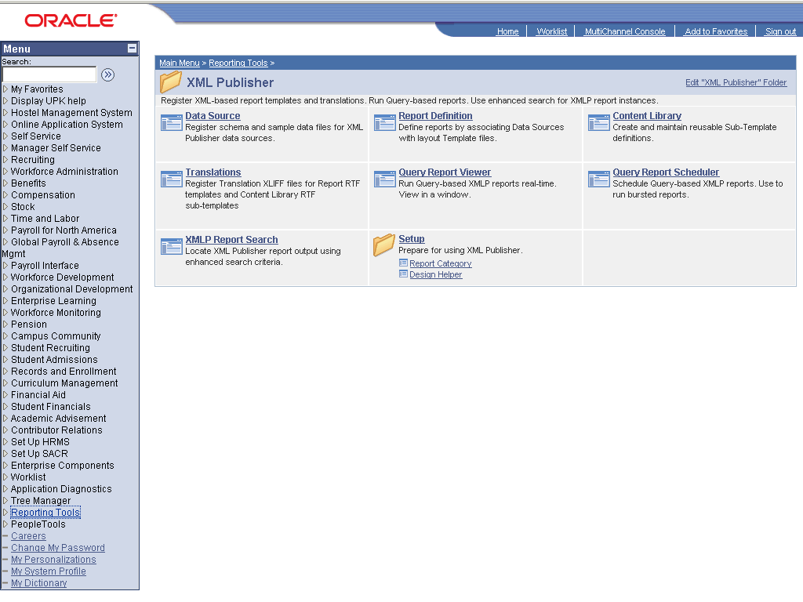

Step | Action
 | Click the Reporting Tools link.
 | Click the XML Publisher link.
 | Click the Query Report Viewer link.

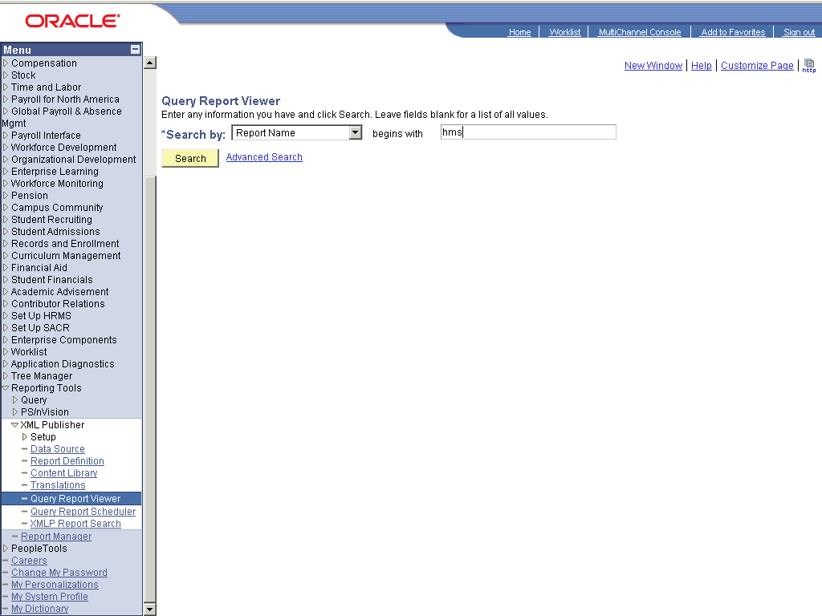

Step | Action
 | Enter the desired information into the field. Enter "hms".
 | Click the Search button.
 | Click the View Report link.
 | Click the Look up SetID (Alt+5) graphic.
 | Point to the PU object.
 | Scroll the object with the mouse wheel.
 | Point to the QAZM object.
 | Click the Look up Hostel ID (Alt+5) graphic.

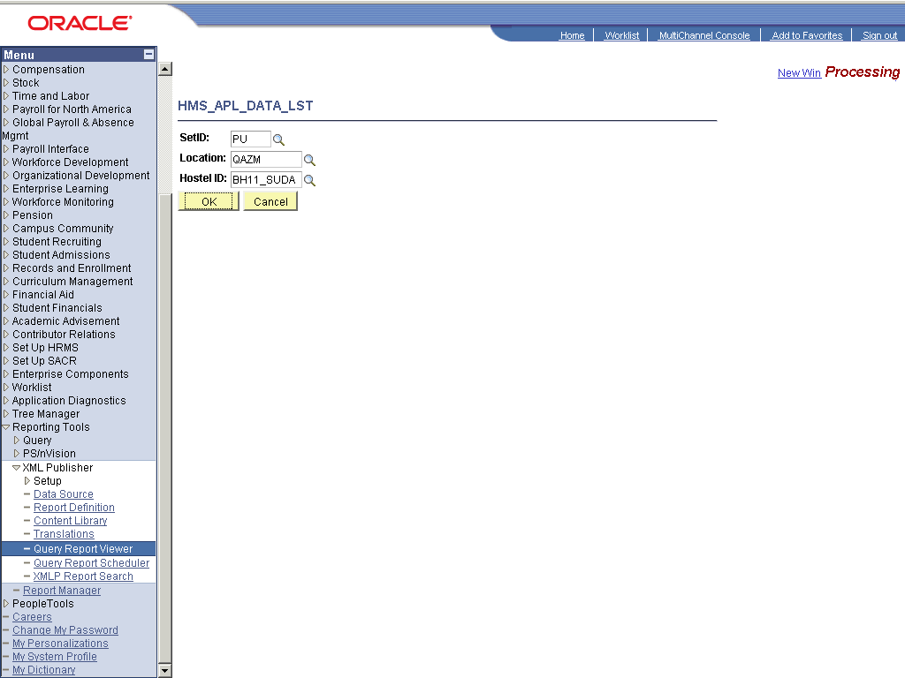

Step | Action
 | Scroll the AVPageView object with the mouse wheel.
 | End of Procedure.

Issued Inventory

Procedure

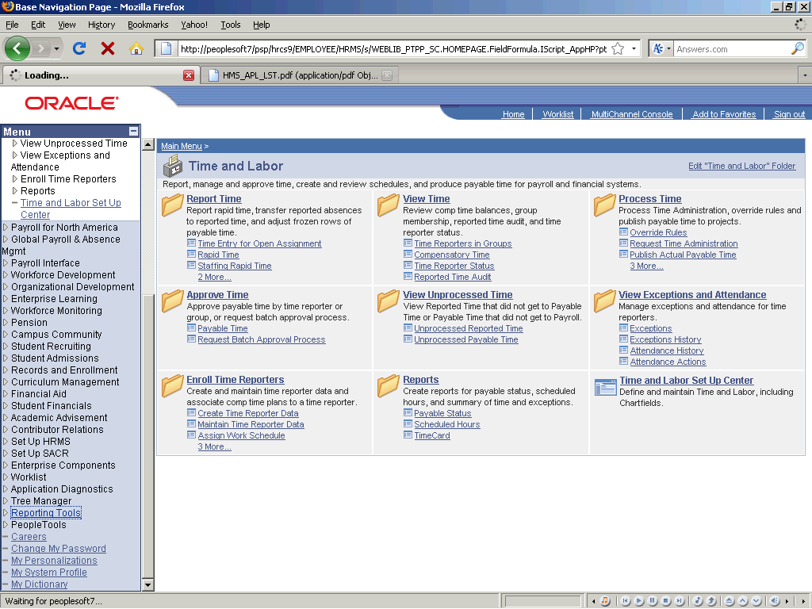

Step | Action
 | Click the Reporting Tools link.
 | Click the XML Publisher link.
 | Click the Query Report Viewer link.

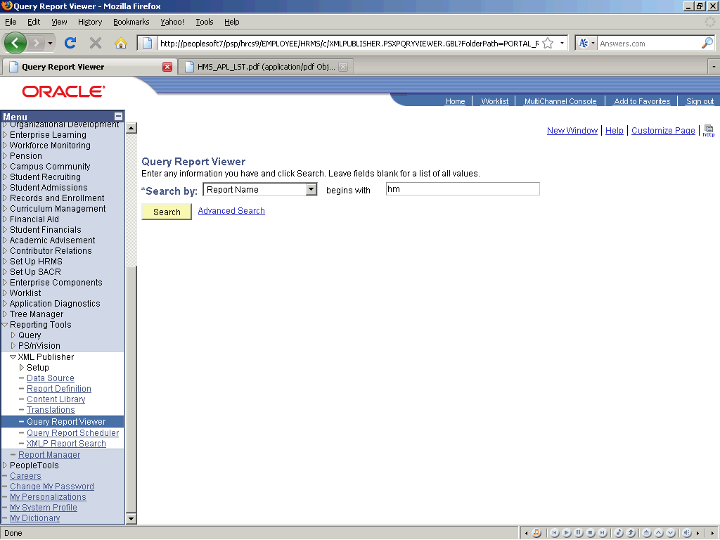

Step | Action
 | Enter the desired information into the field. Enter "hms".
 | Click the Search button.
 | Click the Cancel button.
 | Click the Look up SetID (Alt+5) graphic.
 | Click the PU link.
 | Click the Look up Hostel ID (Alt+5) graphic.
 | Click the BH11_SUDA link.
 | Click the Look up Store ID (Alt+5) graphic.
 | Click the BH11_SDA_S link.

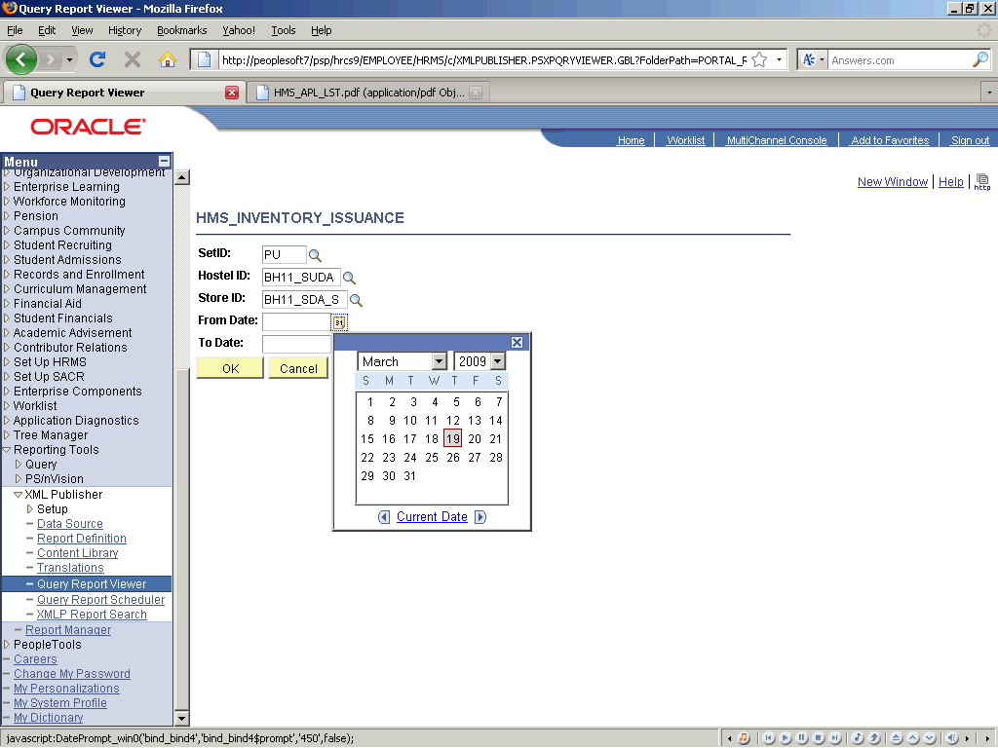

Step | Action
 | Click the http://peoplesoft7/cs/hrcs9/cache/PT_CALENDARPAGE_1.htm object.

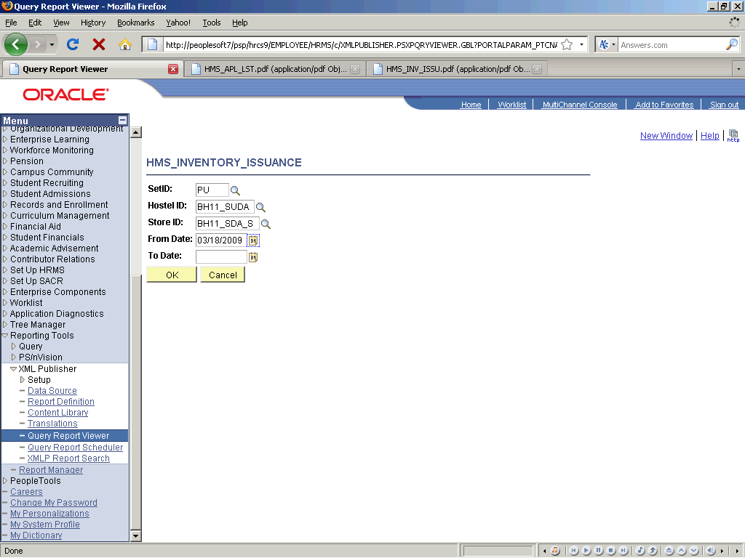

Step | Action
 | Click the 18 link.
 | Click the OK button.
 | End of Procedure.

Recieved Inventory

Procedure

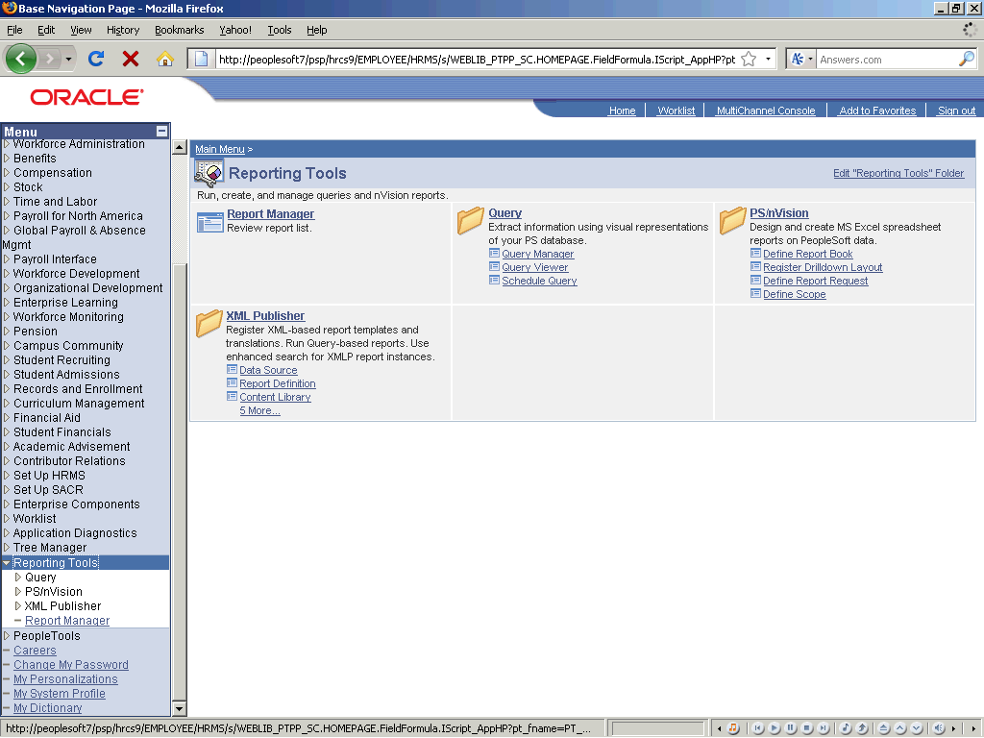

Step | Action
 | Click the Reporting Tools link.
 | Click the XML Publisher link.
 | Click the Query Report Viewer link.

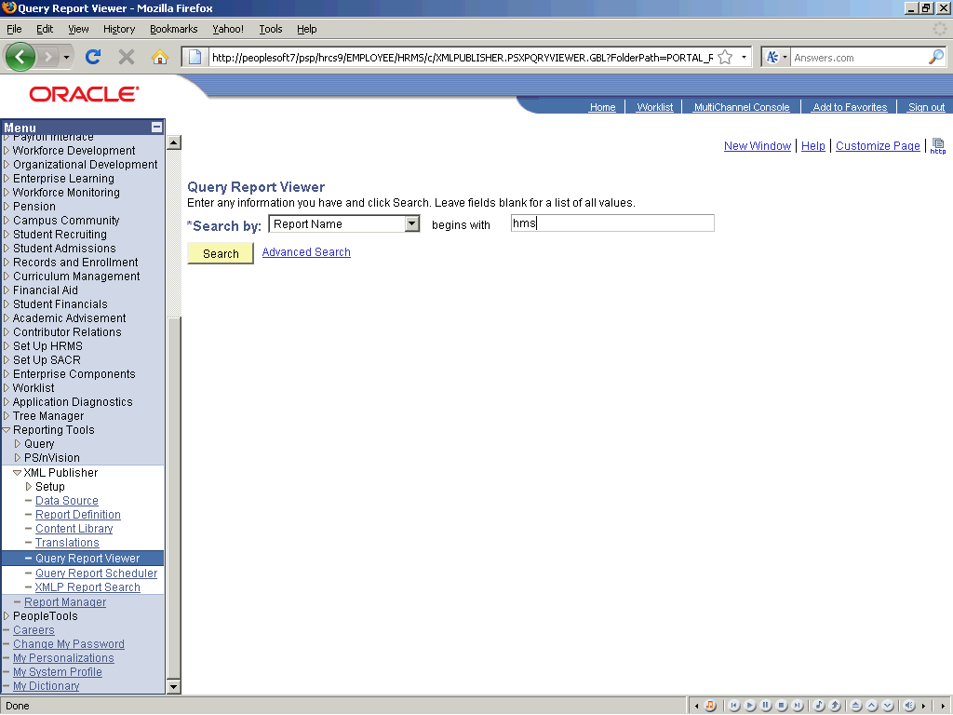

Step | Action
 | Enter the desired information into the field. Enter "hms".
 | Click the Search button.
 | Click the View Report link.
 | Click the Look up SetID (Alt+5) graphic.
 | Click the PU link.
 | Click the Look up Hostel ID (Alt+5) graphic.
 | Click the BH11_SUDA link.
 | Press [F11].
 | Click the BH11_SDA_S link.
 | Click the Choose a date (Alt+5) graphic.
 | Click the Choose a date (Alt+5) graphic.
 | Click the OK button.

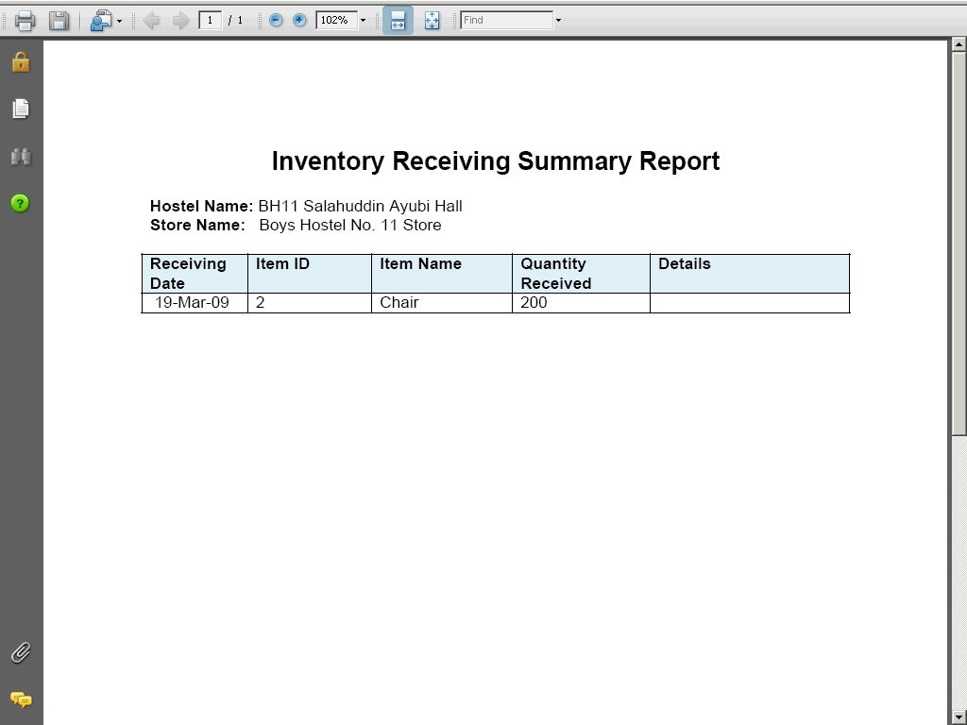

Step | Action
 | Click the object.
 | End of Procedure.

Write off Inventory

Procedure

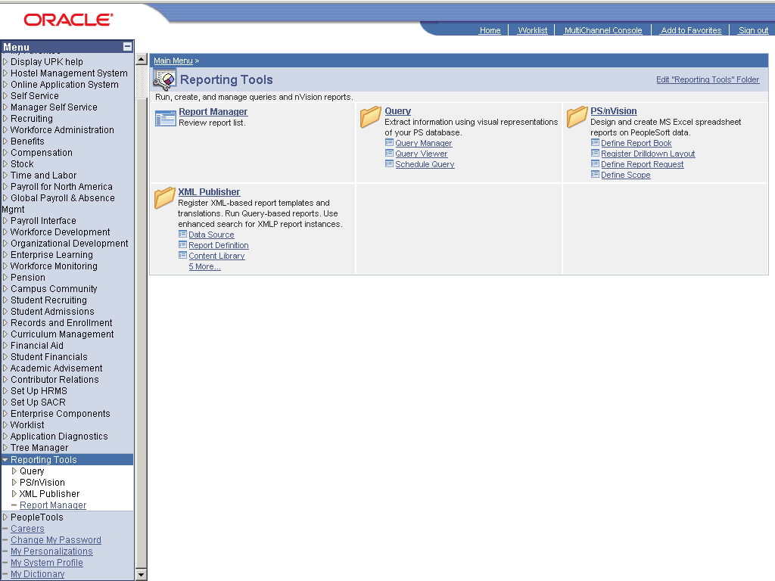

Step | Action
 | Click the Reporting Tools link.
 | Double-click the XML Publisher object.

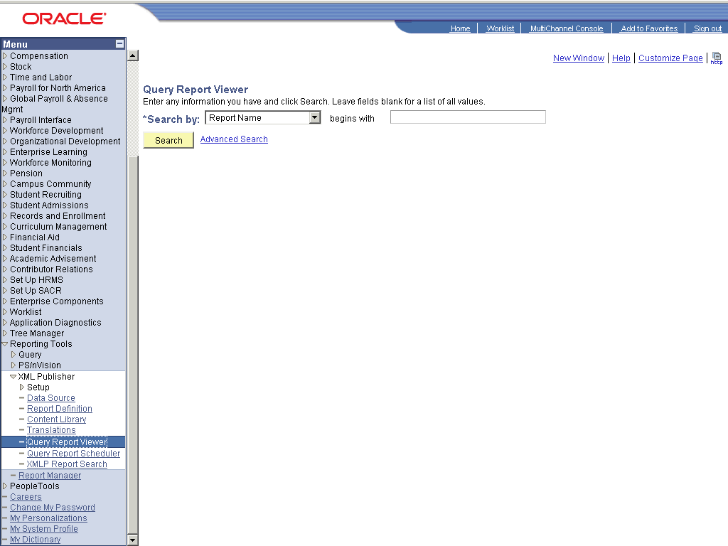

Step | Action
 | Click the Query Report Viewer link.
 | Enter the desired information into the field. Enter "hms".
 | Click the Search button.
 | Click the View Report link.
 | Click the Look up SetID (Alt+5) graphic.
 | Click the PU link.
 | Click the Look up Hostel ID (Alt+5) graphic.
 | Click the BH11_SUDA link.
 | Click the Look up Store ID (Alt+5) graphic.
 | Click the BH11_SDA_S link.
 | Click the Choose a date (Alt+5) graphic.
 | Click the Choose a date (Alt+5) graphic.
 | Click the 18 link.
 | Click the Choose a date (Alt+5) graphic.
 | Click the OK button.
 | End of Procedure.

Mess Attendace Summary

Procedure

Step | Action
 | Click the Reporting Tools link.
 | Click the XML Publisher link.
 | Click the Query Report Viewer link.

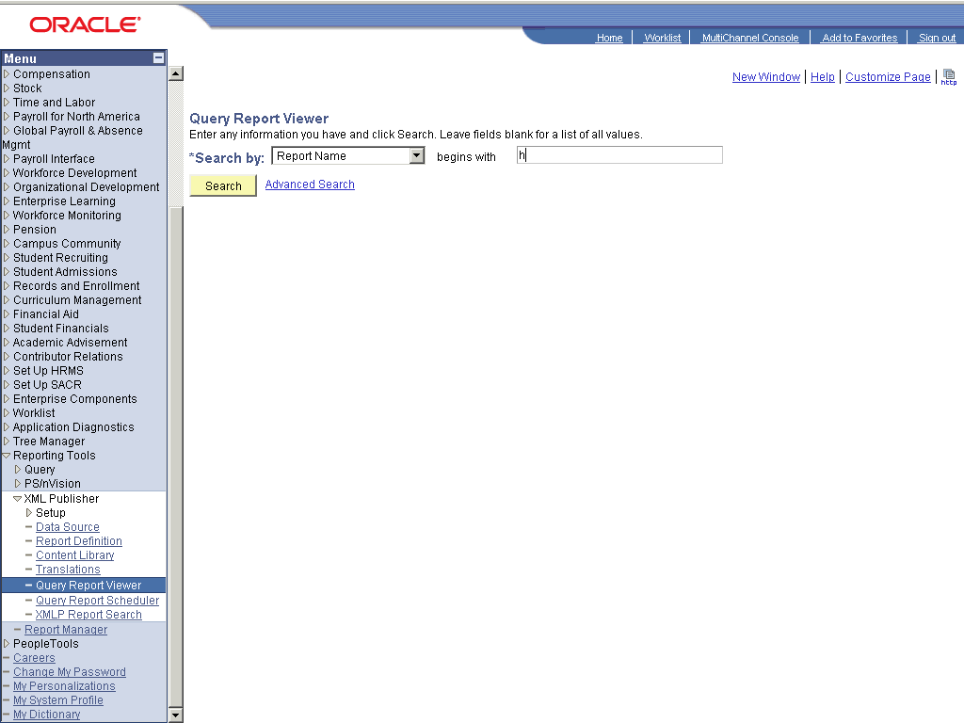

Step | Action
 | Enter the desired information into the field. Enter "hms".
 | Click the Search button.
 | Click the View Report link.
 | Click the Look up Institution (Alt+5) graphic.
 | Click the PU link.
 | Click the Look up Hostel ID (Alt+5) graphic.
 | Point to the BH11_SUDA object.
 | Point to the Look up Mess ID (Alt+5) object.
 | Click the B11M link.

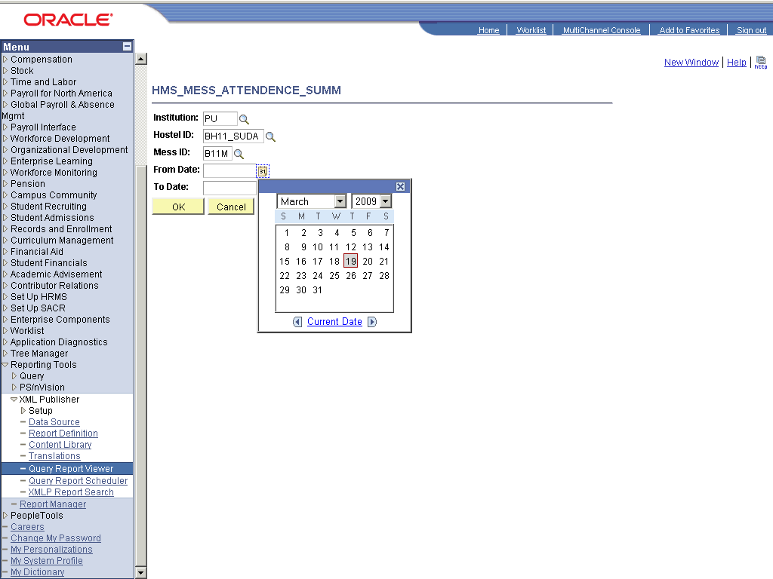

Step | Action
 | Click the 13 link.

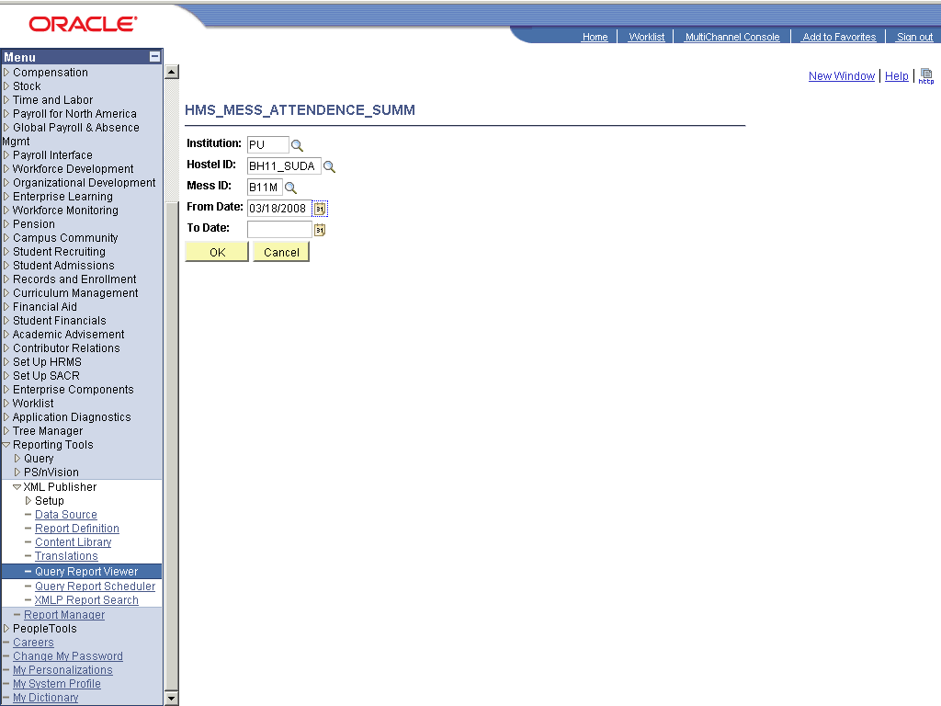

Step | Action
 | Click the 18 link.
 | Click the Choose a date (Alt+5) graphic.

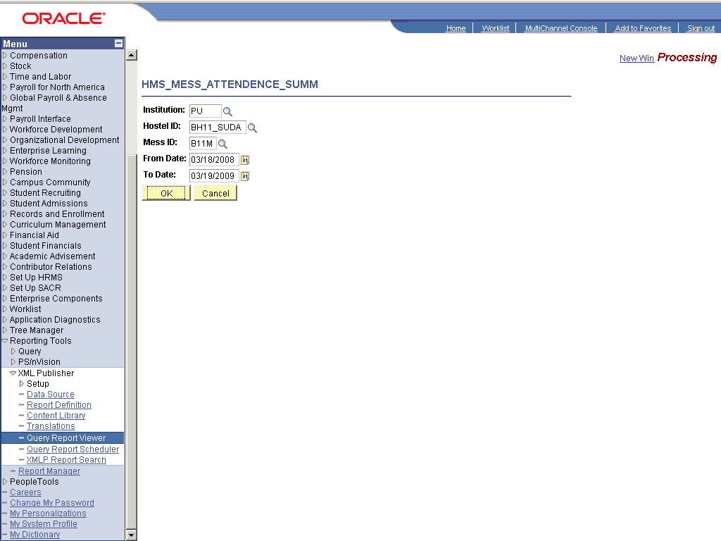

Step | Action
 | Scroll the AVPageView object with the mouse wheel.
 | End of Procedure.

List of Hostel Rooms

Procedure

Step | Action
 | Click the Reporting Tools link.
 | Click the XML Publisher link.
 | Click the Query Report Viewer link.

Step | Action
 | Enter the desired information into the field. Enter "hms".
 | Click the Search button.
 | Click the View Report link.
 | Click the Look up SetID (Alt+5) graphic.
 | Click the PU link.
 | Scroll the SASNC object with the mouse wheel.
 | Click the QAZM link.
 | Click the Look up Hostel ID (Alt+5) graphic.
 | Click the BH11_SUDA link.
 | Click the Look up Block ID (Alt+5) graphic.
 | Click the BH11_SUDA link.
 | Click the OK button.
 | End of Procedure.

Request/Complaint Summary

Procedure

Step | Action
 | Click the Reporting Tools link.
 | Click the XML Publisher link.
 | Click the Query Report Viewer link.

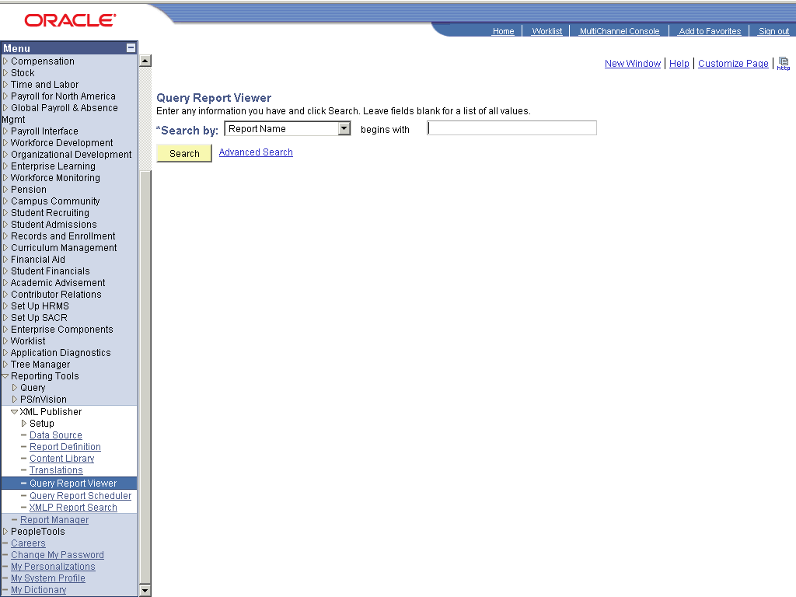

Step | Action
 | Point to the object.
 | Click the Search button.
 | Click the View Report link.
 | Click the Look up Hostel ID (Alt+5) graphic.
 | Click the BH11_SUDA link.

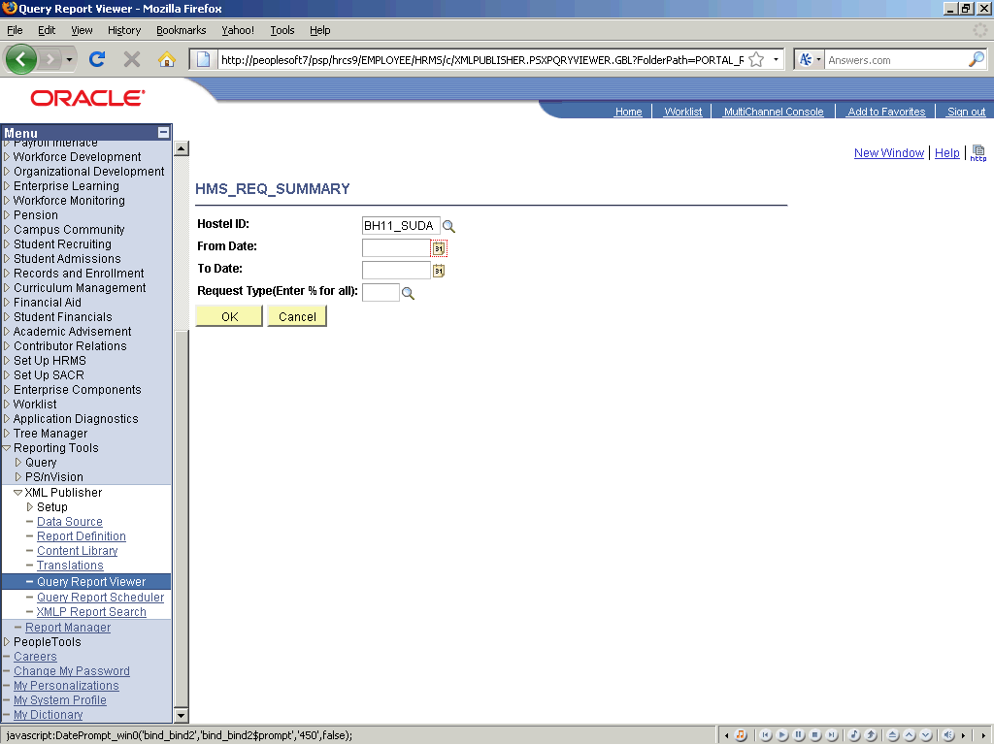

Step | Action
 | Click the cell.

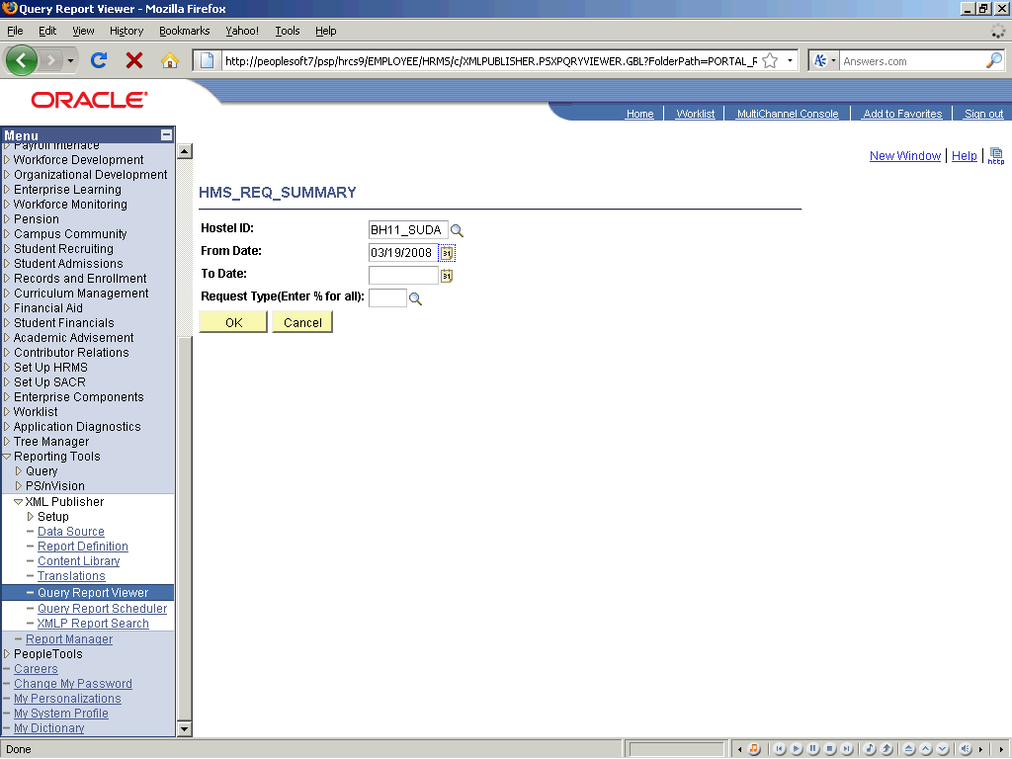

Step | Action
 | Click the 19 link.
 | Click the Choose a date (Alt+5) graphic.
 | Enter the desired information into the Request Type(Enter % for all): field. Enter "%".
 | Click the OK button.
 | End of Procedure.

Current Balances

Procedure

Step | Action
 | Click the Reporting Tools link.
 | Click the XML Publisher link.
 | Click the Query Report Viewer link.

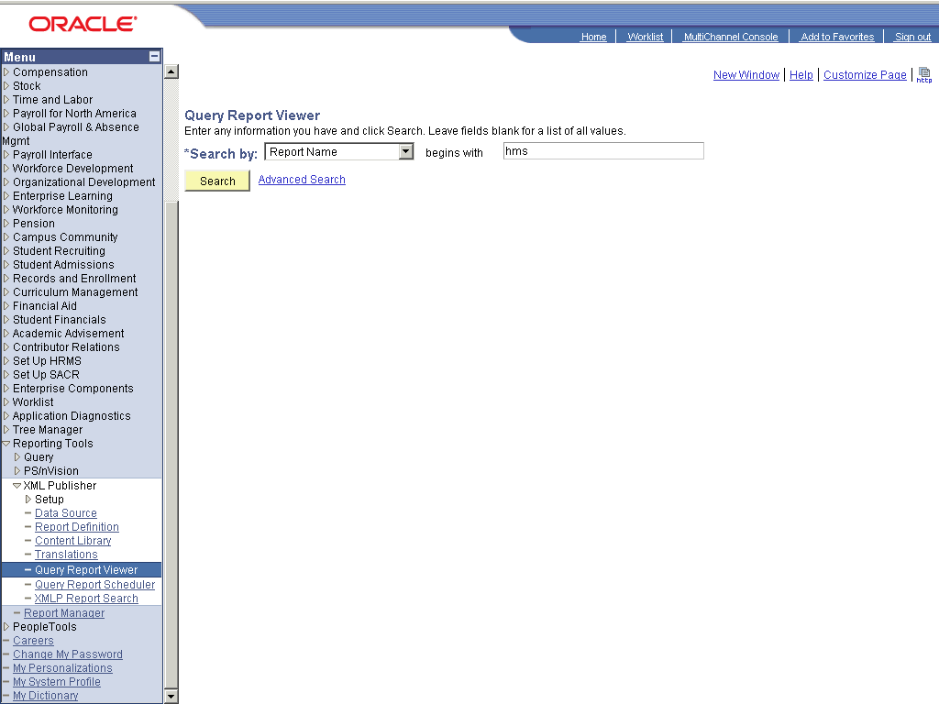

Step | Action
 | Enter the desired information into the field. Enter "hms".
 | Click the Search button.
 | Click the View Report link.
 | Click the Look up SetID (Alt+5) graphic.
 | Click the PU link.
 | Click the Look up Hostel ID (Alt+5) graphic.
 | Point to the BH11_SUDA object.
 | Click the Look up Store ID (Alt+5) graphic.
 | Click the BH11_SDA_S link.
 | Click the OK button.
 | Click the OK button.
 | End of Procedure.

