Pre Admission Setups
Created on Thursday, July 02, 2009
Copyright & Trademarks
Copyright © 2003, 2007, Oracle. All rights reserved. Powered by OnDemand Software. Distributed by Oracle under license from Global Knowledge Software LLC. © 1998-2007. All rights reserved.

The information contained in this document is subject to change without notice. If you find any problems in the documentation, please report them to us in writing. This document is not warranted to be error-free. Except as may be expressly permitted in your license agreement for these Programs, no part of these Programs may be reproduced or transmitted in any form or by any means, electronic or mechanical, for any purpose.

If this documentation is delivered to the United States Government or anyone using the documentation on behalf of the United States Government, the following notice is applicable:

U.S. GOVERNMENT RIGHTS
The U.S. Government’s rights to use, modify, reproduce, release, perform, display, or disclose these training materials are restricted by the terms of the applicable Oracle license agreement and/or the applicable U.S. Government contract.

Oracle, JD Edwards, PeopleSoft, and Siebel are registered trademarks of Oracle Corporation and/or its affiliates. Other names may be trademarks of their respective owners.

Table of Contents
General Setups 1
Setup Seat Division 1
Setup Seat Distribution 3
Setup Application Closing Date 7
Setup Programs for Preferences 10
Setup for Evaluation Processes 15
Setup Mass Change 15
Setup Mass Change Group 26
Setup for Run Mass Change 29
Setup for Assign Evaluation Codes 31
Setup for Material Extracts 34
Setup for Evaluation Calculation 38
Setup Jobset for Evaluation 41

General Setups

Setup Seat Division

Procedure

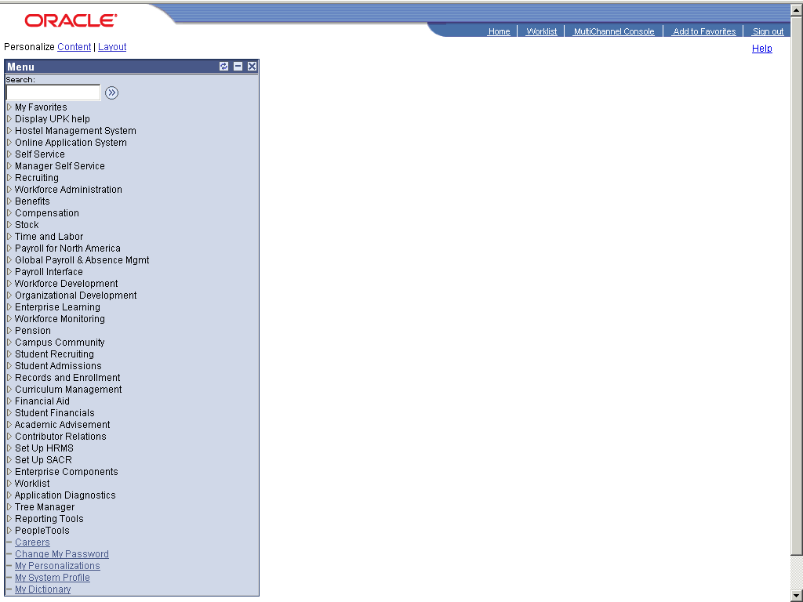

Step | Action
 | Click the Student Admissions link.

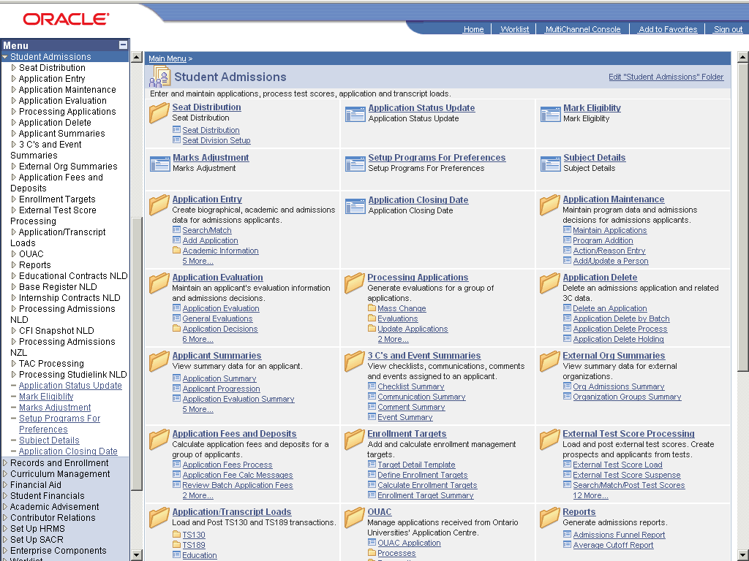

Step | Action
 | Click the Seat Distribution link.
 | Click the Seat Division Setup link.

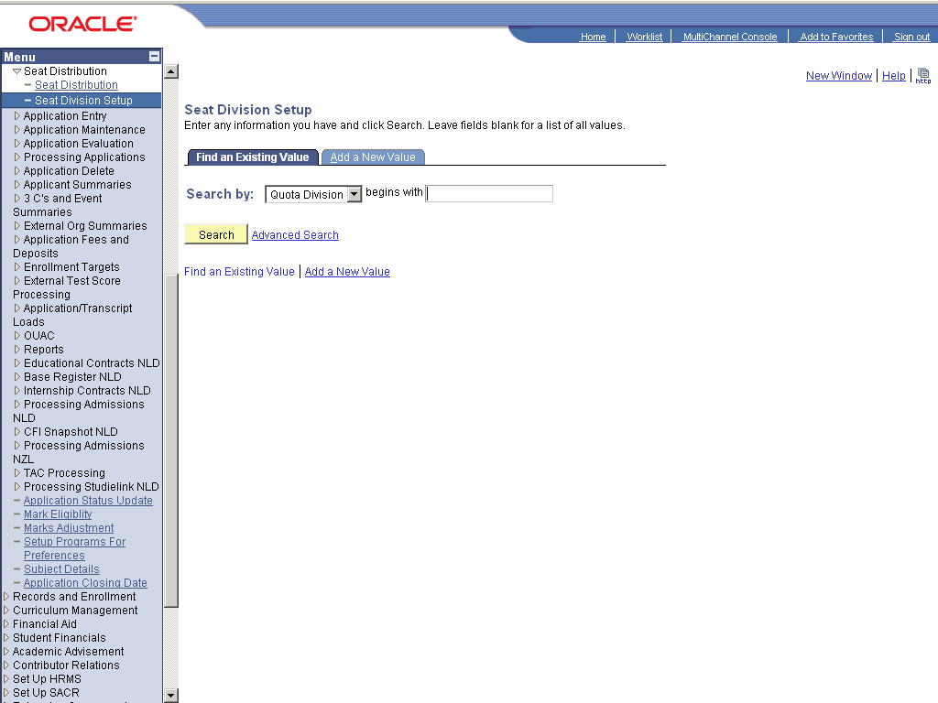

Step | Action
 | Click the dd a New Value link.
 | Enter the desired information into the Quota Division: field. Enter "ICOM".
 | Click the Add button.
 | Enter the desired information into the field. Enter "I.Com".
 | Click the Save button.
 | End of Procedure.

Setup Seat Distribution

Procedure

Step | Action
 | Click the Student Admissions link.

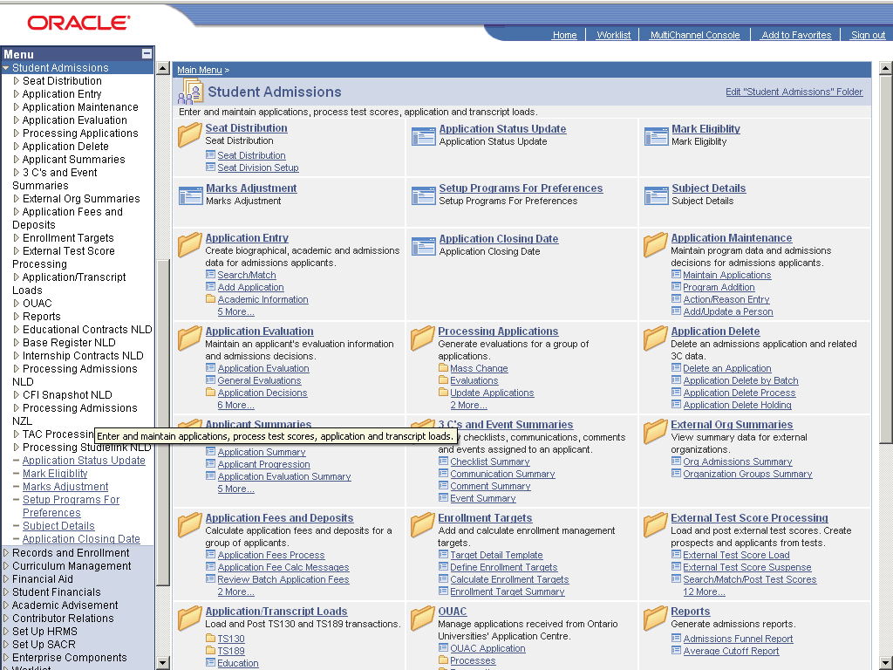

Step | Action
 | Click the Seat Distribution link.
 | Click the Seat Distribution link.

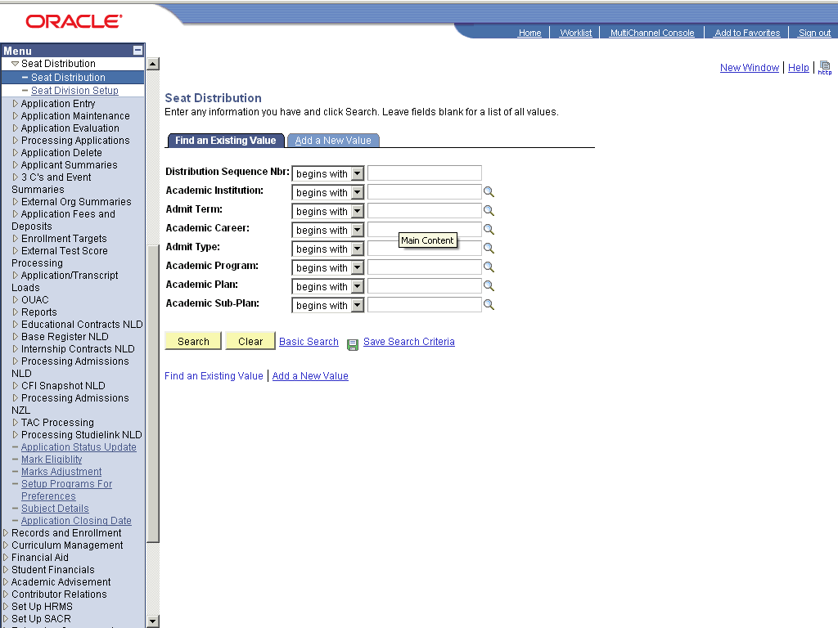

Step | Action
 | Click the dd a New Value link.
 | Click the Add button.
 | Enter the desired information into the *Academic Institution: field. Enter "PU".
 | Enter the desired information into the *Academic Career: field. Enter "GRAD".
 | Enter the desired information into the *Admit Term: field. Enter "0913".
 | Enter the desired information into the *Admit Type: field. Enter "OPN".
 | Enter the desired information into the *Academic Program: field. Enter "MSCIT".
 | Enter the desired information into the *Academic Plan: field. Enter "MSCIT".
 | Enter the desired information into the *Academic Sub-Plan: field. Enter "MORN".
 | Enter the desired information into the Total Seats: field. Enter "45".
 | Click the Save button.
 | End of Procedure.

Setup Application Closing Date

Procedure

Step | Action
 | Click the Student Admissions link.

Step | Action
 | Click the Application Closing Date link.

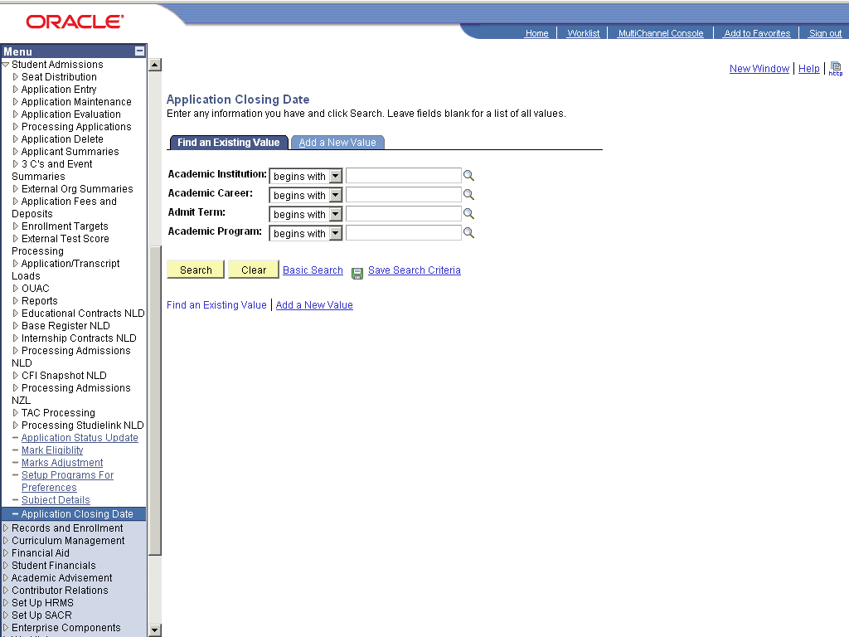

Step | Action
 | Click the dd a New Value link.
 | Enter the desired information into the field. Enter "PU".
 | Enter the desired information into the Academic Career: field. Enter "GRAD".
 | Enter the desired information into the Admit Term: field. Enter "0913".
 | Enter the desired information into the Academic Program: field. Enter "MSCIT".
 | Click the Add button.
Enter the desired information into the Application Closing Date: field. Enter "09/30/2009".
Format:
Month/Day/Year
 | Click the Save button.
 | End of Procedure.

Setup Programs for Preferences

Procedure

Step | Action
 | Click the Student Admissions link.

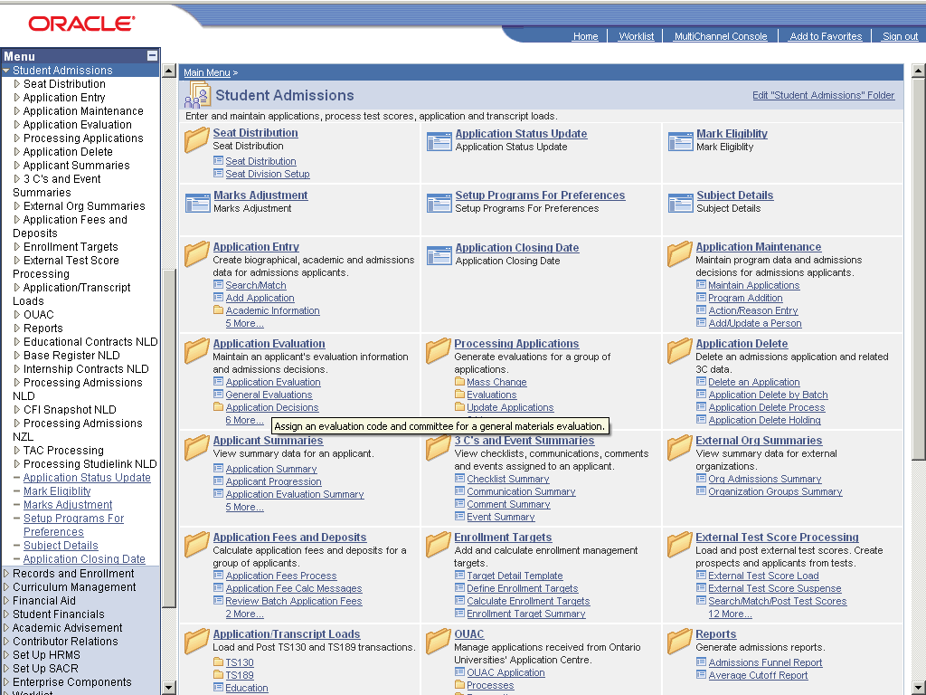

Step | Action
 | Click the Setup Programs For Preferences link.

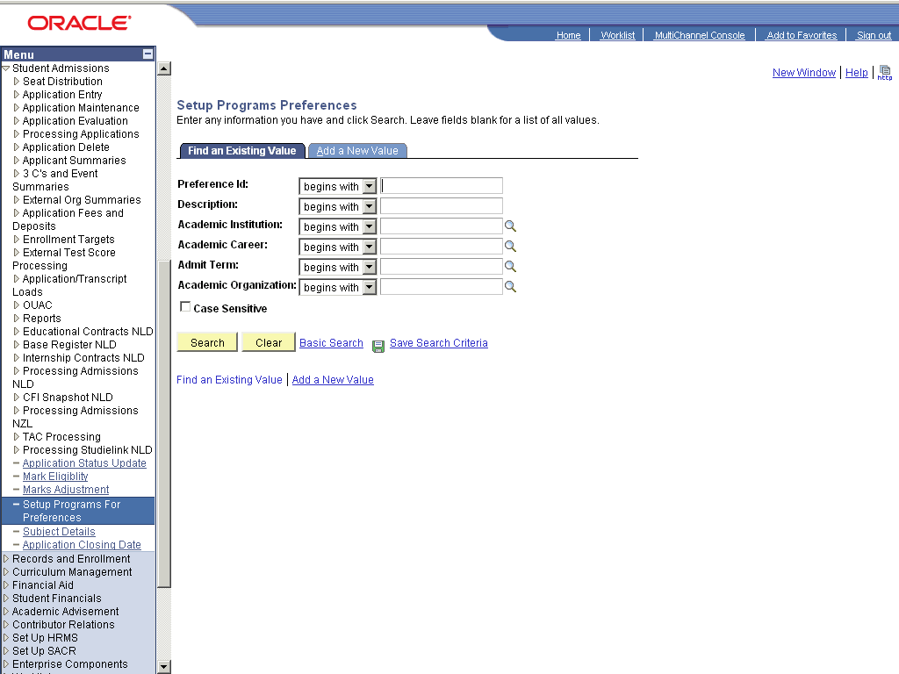

Step | Action
 | Click the dd a New Value link.
 | Enter the desired information into the Preference Id: field. Enter "PUCIT_PREF".
 | Enter the desired information into the Description: field. Enter "PUCIT-Programs for Preferences".
 | Enter the desired information into the Academic Institution: field. Enter "PU".
 | Enter the desired information into the Academic Career: field. Enter "UGRD".
 | Enter the desired information into the Admit Term: field. Enter "0913".
 | Click the Look up Academic Organization (Alt+5) graphic.
 | Click the SCIENCE link.
 | Click the Add button.
 | Enter the desired information into the field. Enter "BSCS".
 | Click the Add a new row at row 1 (Alt+7) graphic.
 | Enter the desired information into the field. Enter "BSIT".
 | Click the Add a new row at row 2 (Alt+7) graphic.
 | Enter the desired information into the field. Enter "BSSE".
 | Click the Add a new row at row 3 (Alt+7) graphic.
 | Enter the desired information into the field. Enter "BSIF".
 | Click the Save button.
 | End of Procedure.

Setup for Evaluation Processes

Setup Mass Change

Procedure

Step | Action
 | Click the Student Admissions link.

Step | Action
 | Click the Processing Applications link.
 | Click the Mass Change link.
 | Click the Mass Change Definition link.

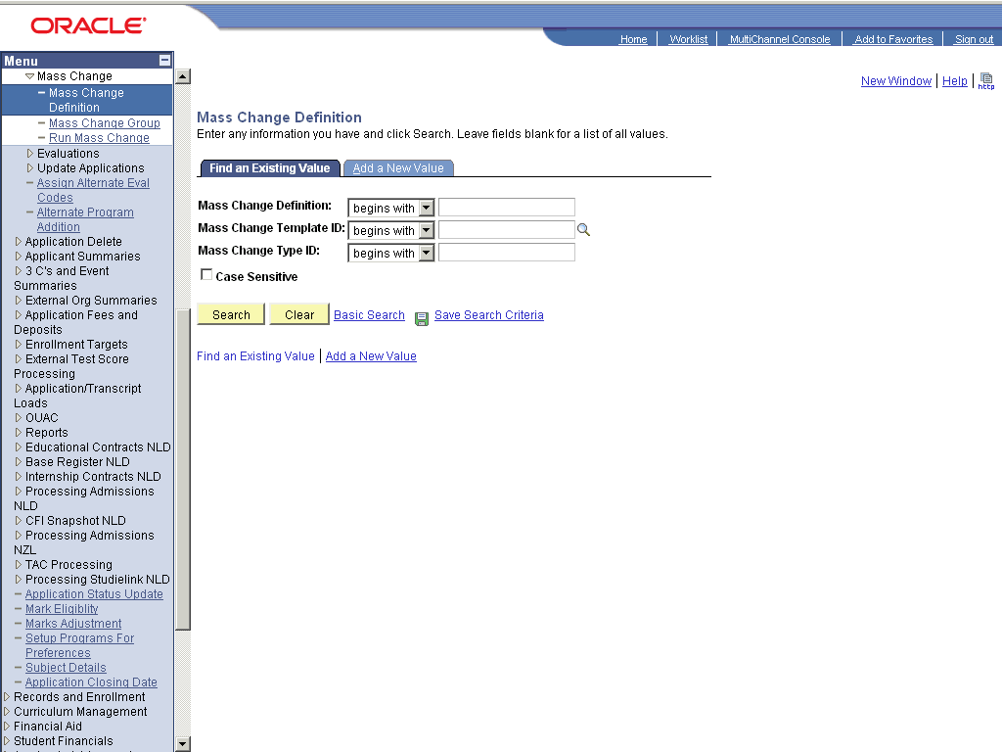

Step | Action
 | Click the dd a New Value link.
 | Enter the desired information into the Mass Change Definition: field. Enter "MC_PUCIT_MSCIT".
 | Click the Add button.
 | Click the Look up Mass Change Template (Alt+5) graphic.
 | Click the Evaluation Assignment Criteria link.
 | Click the tudent Administration link.
 | Enter the desired information into the Academic Career: field. Enter "GRAD".
 | Click the riteria and Defaults link.
 | Click the Show next row (Alt+.) graphic.
 | Click the View All link.
 | Click the list.

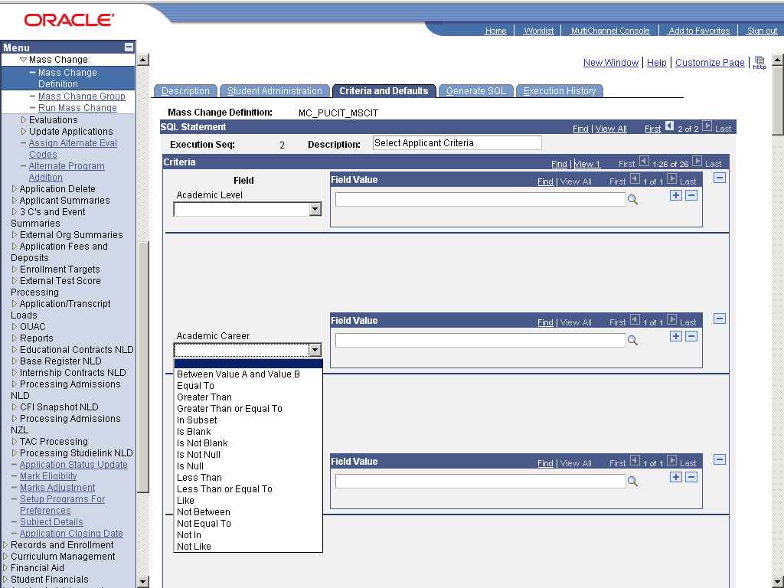

Step | Action
 | Click the cell.

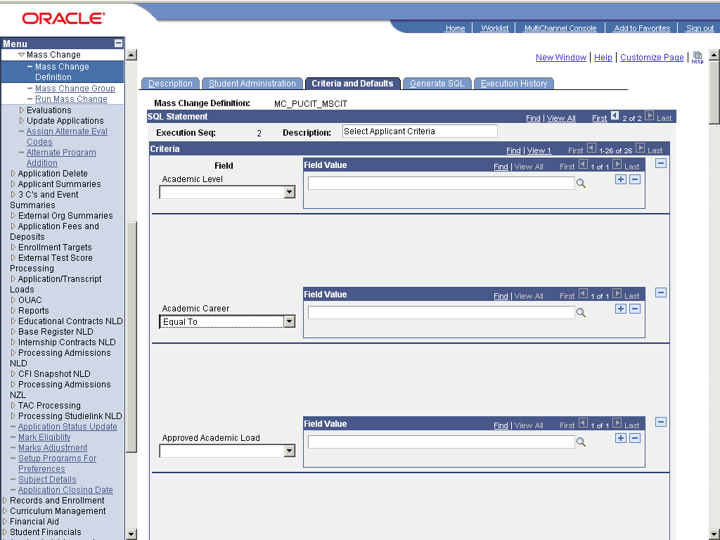

Step | Action
 | Enter the desired information into the field. Enter "GRAD".
 | Click the list.

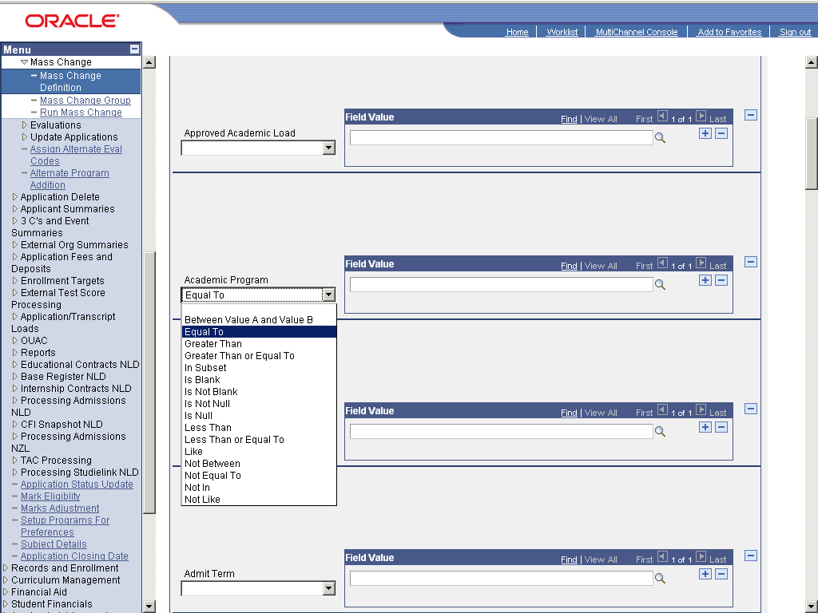

Step | Action
 | Click the cell.

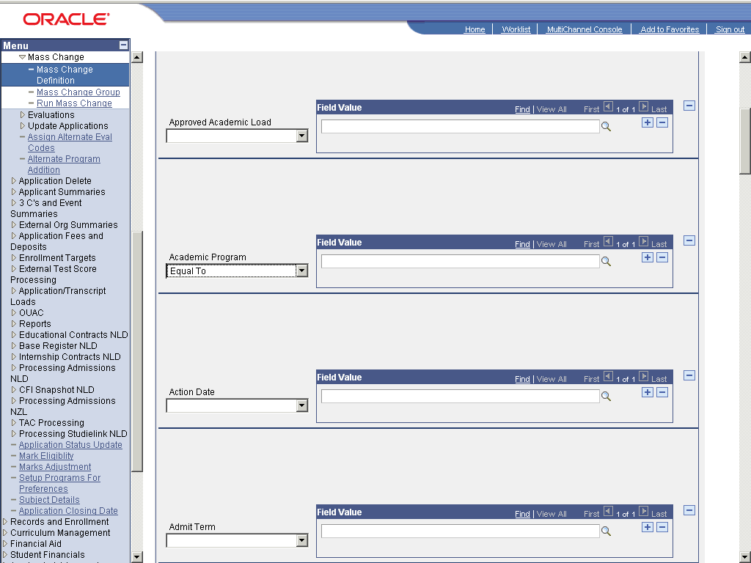

Step | Action
 | Enter the desired information into the field. Enter "MSCIT".
 | Click the list.

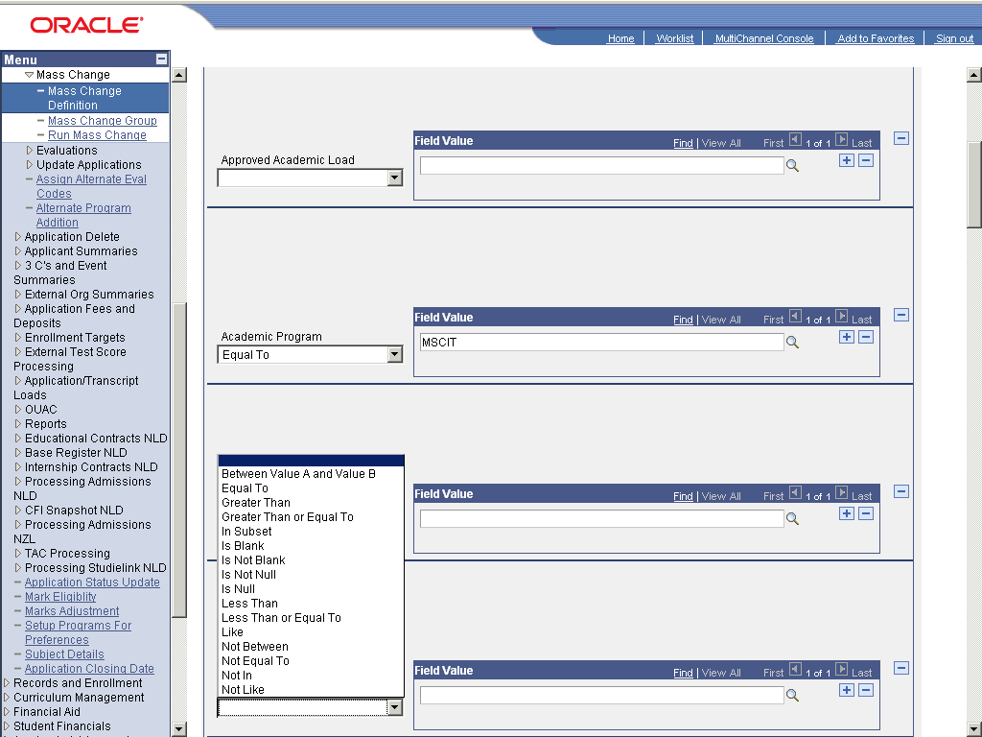

Step | Action
 | Click the cell.

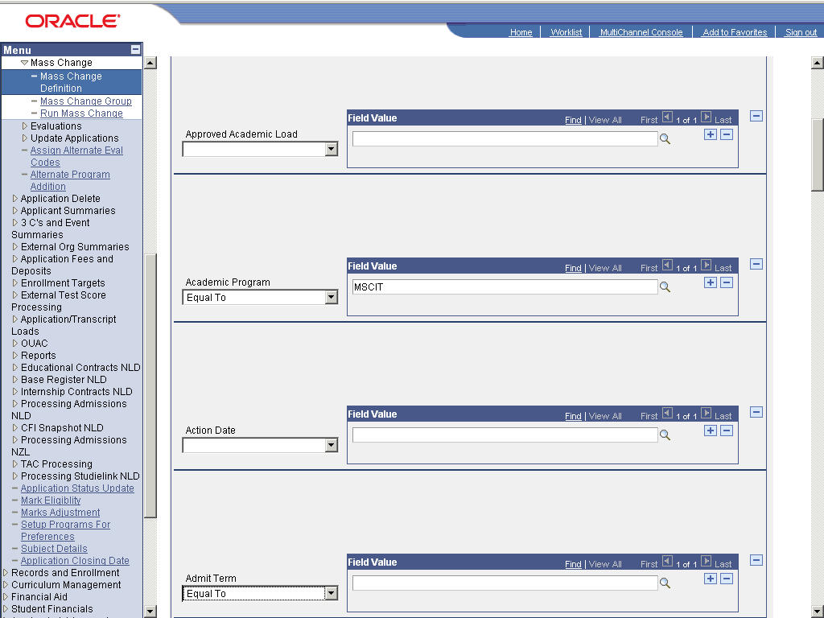

Step | Action
 | Enter the desired information into the field. Enter "0913".
 | Click the list.

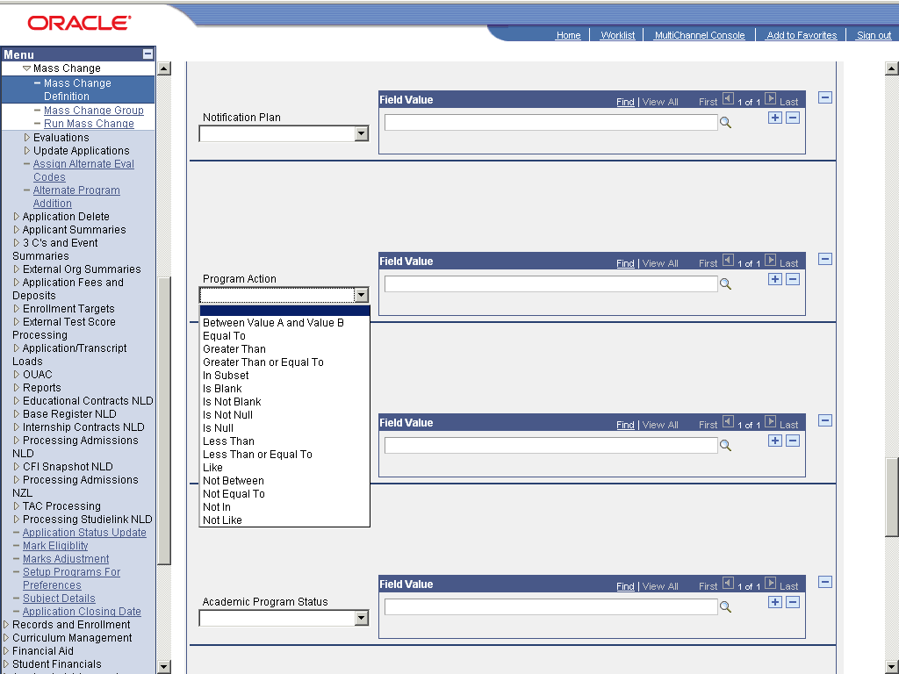

Step | Action
 | Click the cell.

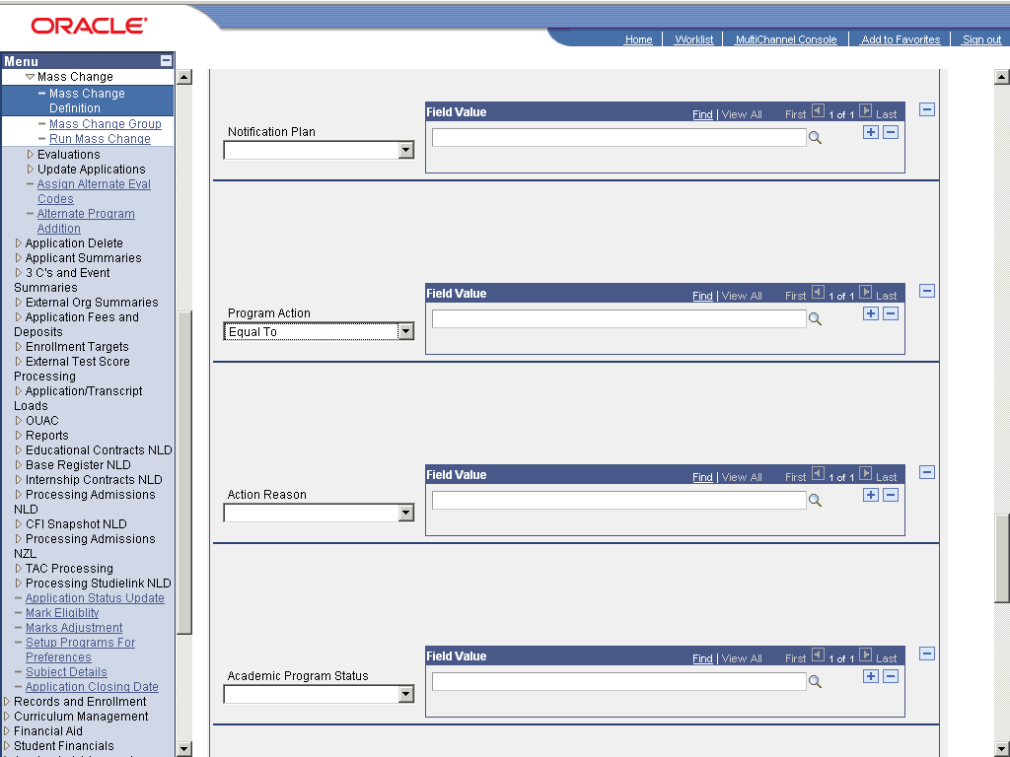

Step | Action
 | Enter the desired information into the field. Enter "APPL".
 | Click the Delete row 1 (Alt+8) graphic.
 | Click the Look up Mass Change Field Value (Alt+5) graphic.
 | Click the Graduate Evaluation link.
 | Click the enerate SQL link.
 | Click the Generate button.
 | Click the Save button.
 | End of Procedure.

Setup Mass Change Group

Procedure

Step | Action
 | Click the Student Admissions link.

Step | Action
 | Click the Processing Applications link.
 | Click the Mass Change link.
 | Click the Mass Change Group link.

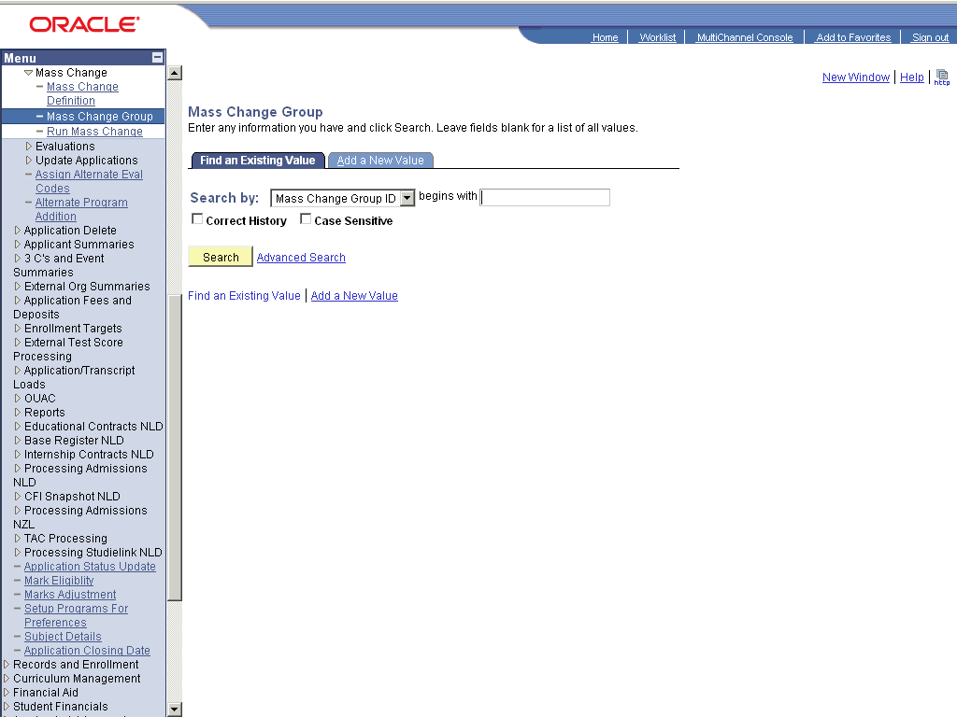

Step | Action
 | Click the dd a New Value link.
 | Enter the desired information into the Mass Change Group ID: field. Enter "MCG_PUCIT_MSCIT".
 | Click the Add button.
 | Enter the desired information into the field. Enter "SA".
 | Enter the desired information into the Execution Sequence field. Enter "10".
 | Enter the desired information into the *Mass Change Definition field. Enter "MC_PUCIT_MSCIT".
 | Enter the desired information into the field. Enter "20".
 | Click the Look up Mass Change Definition (Alt+5) graphic.
 | Click the Evaluation Duplicate Check link.
 | Click the Save button.
 | End of Procedure.

Setup for Run Mass Change

Procedure

Step | Action
 | Click the Student Admissions link.

Step | Action
 | Click the Processing Applications link.
 | Click the Mass Change link.
 | Click the Run Mass Change link.

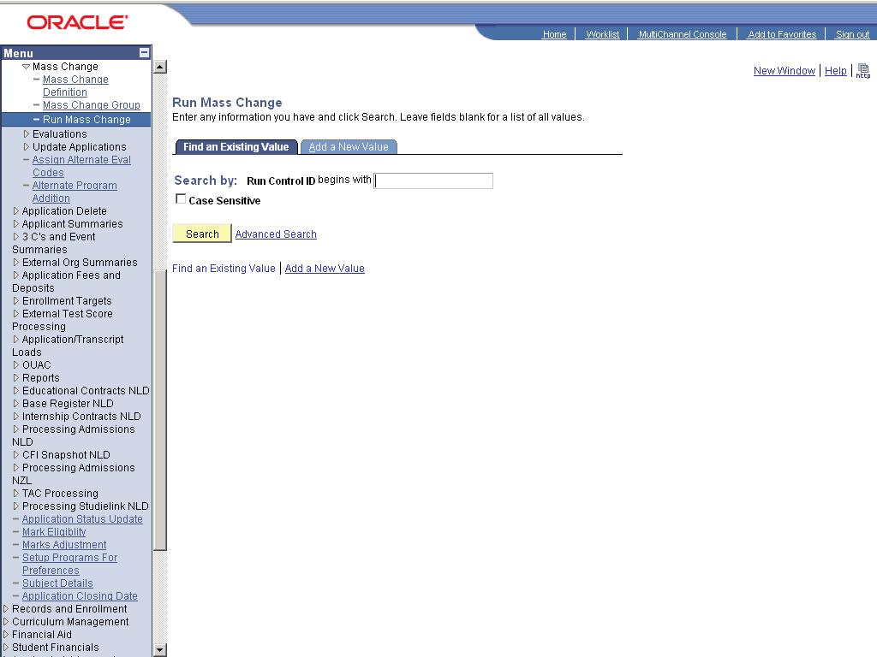

Step | Action
 | Click the dd a New Value link.
 | Enter the desired information into the Run Control ID: field. Enter "RMC_PUCIT_MSCIT".
 | Click the Add button.
 | Click the Execute Mass Change Group option.
 | Enter the desired information into the Mass Change Group ID: field. Enter "MCG_PUCIT_MSCIT".
 | Click the Save button.
 | End of Procedure.

Setup for Assign Evaluation Codes

Procedure

Step | Action
 | Click the Student Admissions link.

Step | Action
 | Click the Processing Applications link.
 | Click the Evaluations link.
 | Click the Assign Evaluation Codes link.

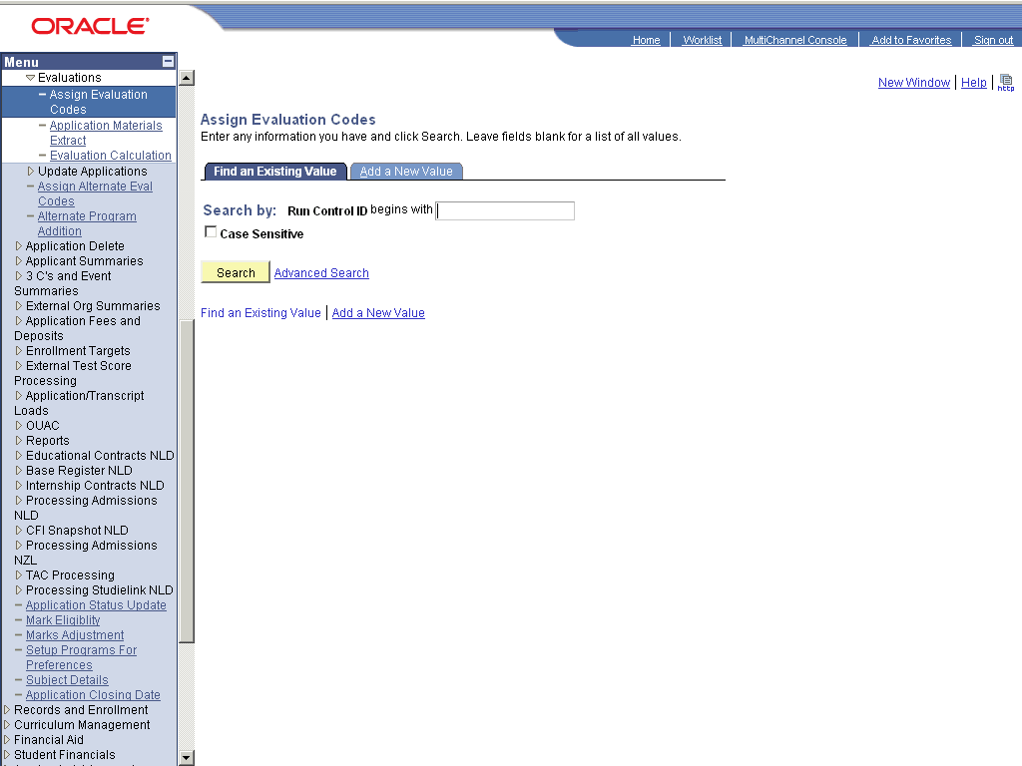

Step | Action
 | Click the dd a New Value link.
 | Enter the desired information into the Run Control ID: field. Enter "AEC_PUCIT_MSCIT".
 | Click the Add button.
 | Enter the desired information into the *Evaluation Status: field. Enter "IP".
 | Enter the desired information into the *Evaluation Status: field. Enter "IP".
 | Enter the desired information into the *Evaluation Status: field. Enter "IP".
 | Click the Save button.
 | End of Procedure.

Setup for Material Extracts

Procedure

Step | Action
 | Click the Student Admissions link.

Step | Action
 | Click the Processing Applications link.
 | Click the Evaluations link.
 | Click the Application Materials Extract link.

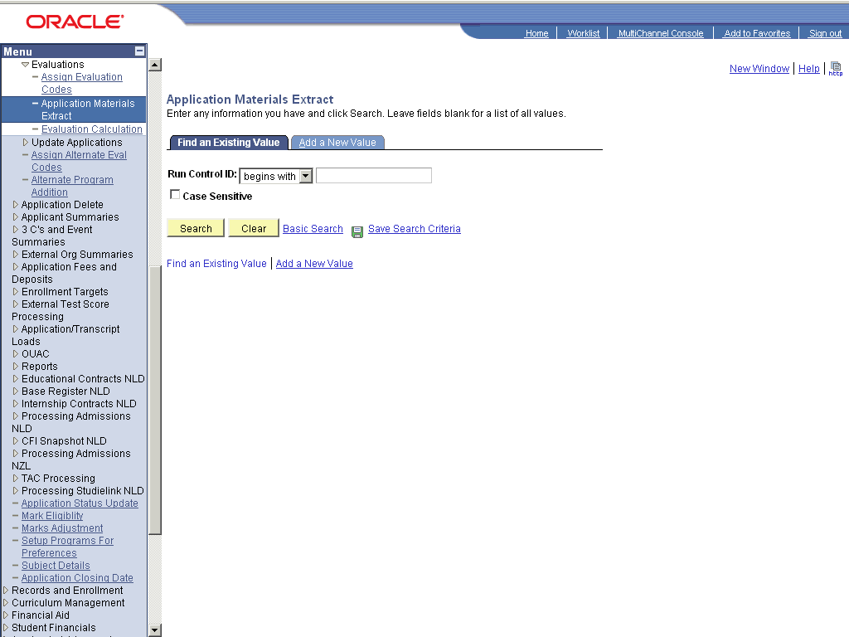

Step | Action
 | Click the dd a New Value link.
 | Enter the desired information into the Run Control ID: field. Enter "AME_PUCIT_MSCIT".
 | Click the Add button.
 | Click the Look up Evaluation Code (Alt+5) graphic.
 | Click the Graduate Evaluation link.
 | Enter the desired information into the *Admit Term: field. Enter "0913".
 | Enter the desired information into the *Evaluation Status: field. Enter "IP".
 | Click the Save button.
 | End of Procedure.

Setup for Evaluation Calculation

Procedure

Step | Action
 | Click the Student Admissions link.

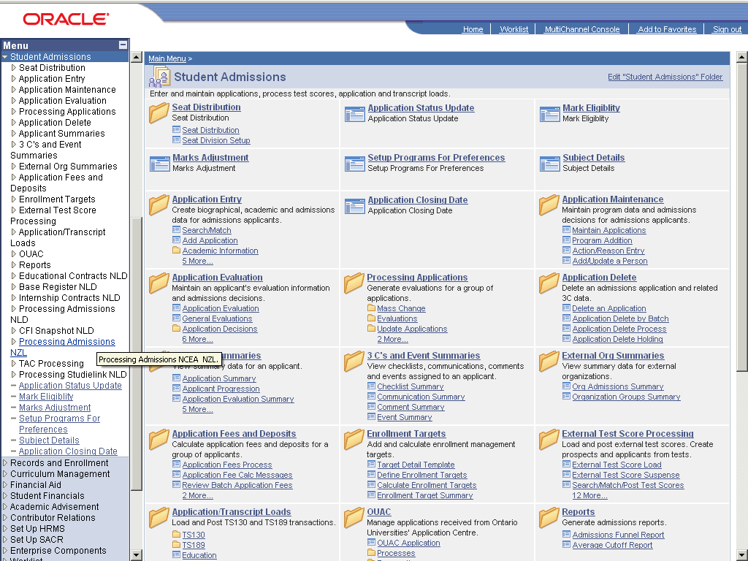

Step | Action
 | Click the Processing Applications link.
 | Click the Evaluations link.
 | Click the Evaluation Calculation link.

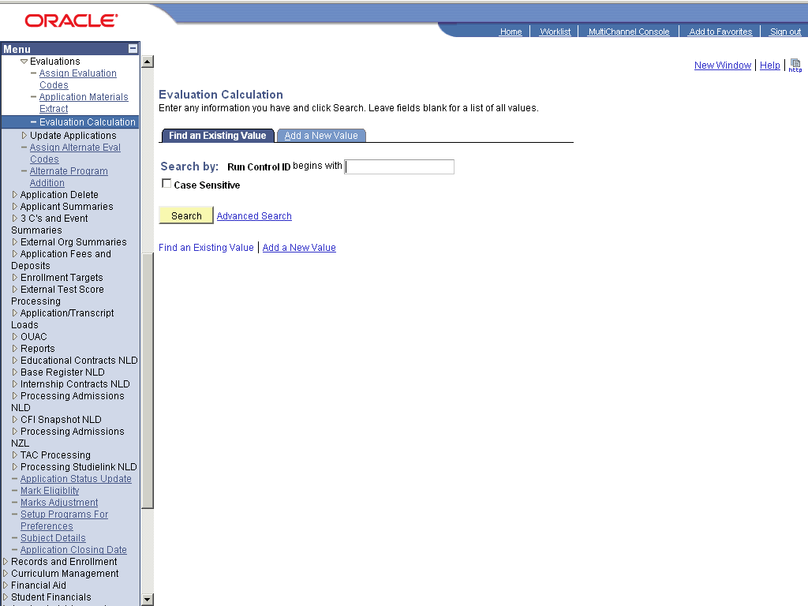

Step | Action
 | Click the dd a New Value link.
 | Enter the desired information into the Run Control ID: field. Enter "EC_PUCIT_MSCIT".
 | Click the Add button.
 | Enter the desired information into the *Evaluation Code: field. Enter "GRAD_EVAL".
 | Enter the desired information into the *Admit Term: field. Enter "0913".
 | Enter the desired information into the field. Enter "IP".
 | Enter the desired information into the field. Enter "IP".
 | Click the Save button.
 | End of Procedure.

Setup Jobset for Evaluation

Procedure

Step | Action
 | Click the PeopleTools link.

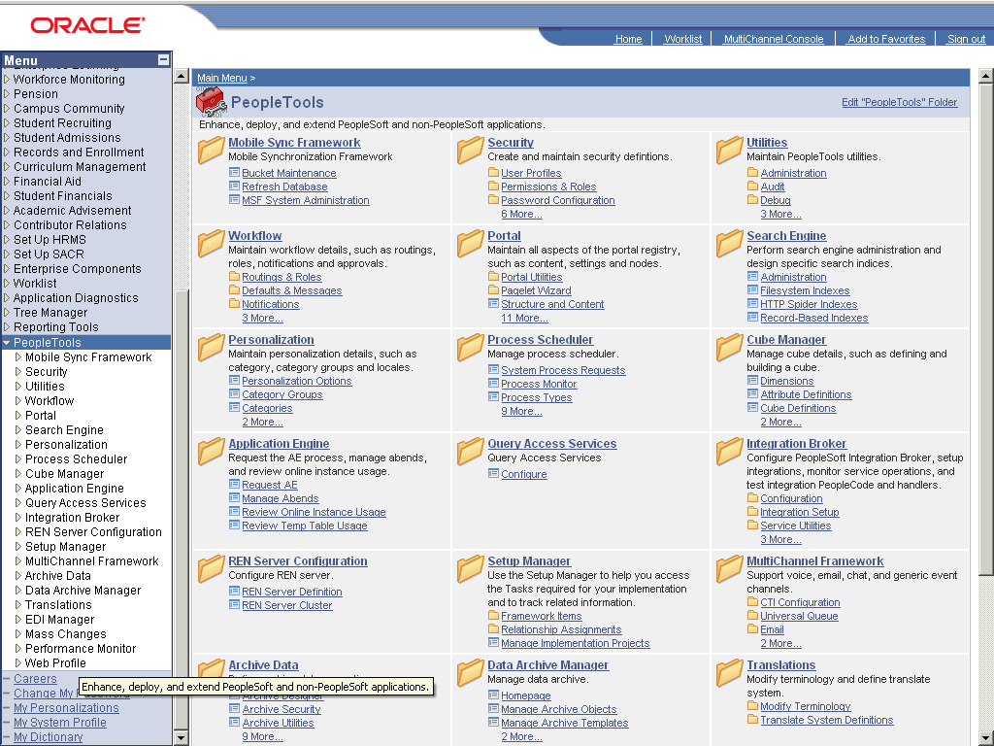

Step | Action
 | Click the Process Scheduler link.
 | Click the Schedule JobSet Definitions link.

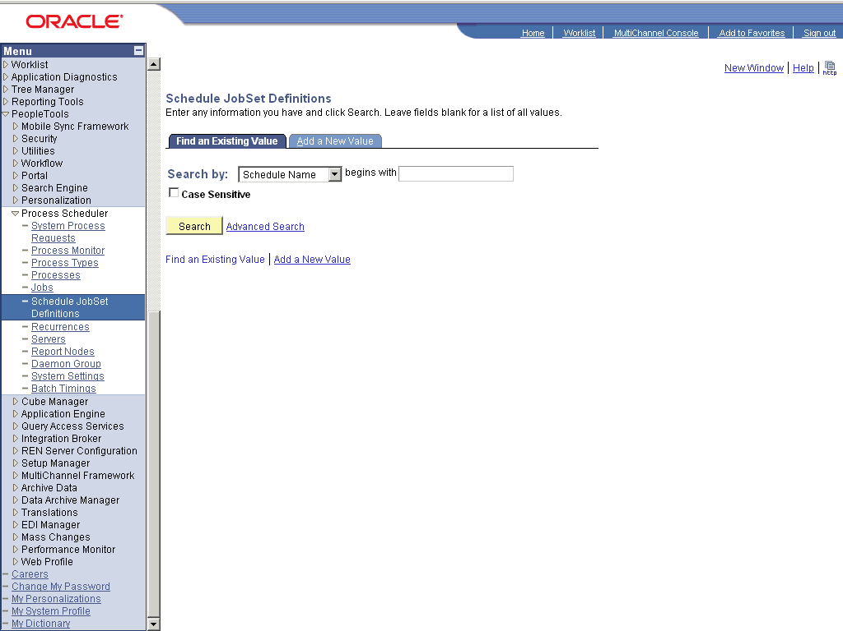

Step | Action
 | Click the dd a New Value link.
 | Enter the desired information into the Schedule Name: field. Enter "PU_MSCIT_EVAL".
 | Enter the desired information into the Job Name: field. Enter "PU_EVAL".
 | Click the Add button.
 | Enter the desired information into the *Run Control ID: field. Enter "PU_MSCIT_EVAL".
 | Click the *Status: list.

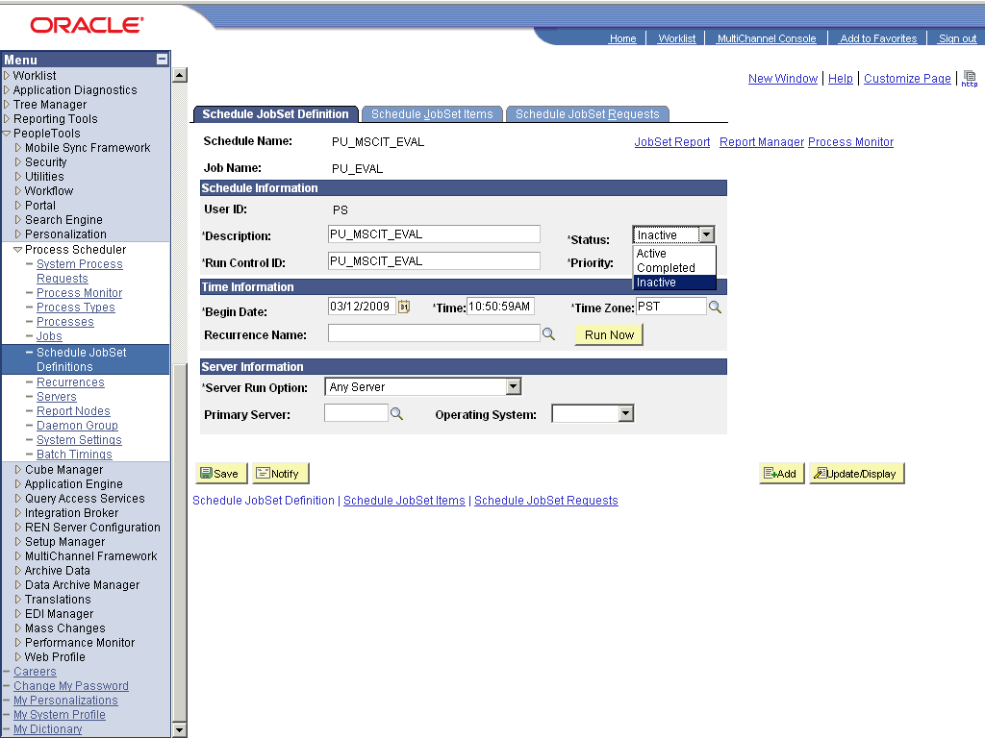

Step | Action
 | Click the cell.

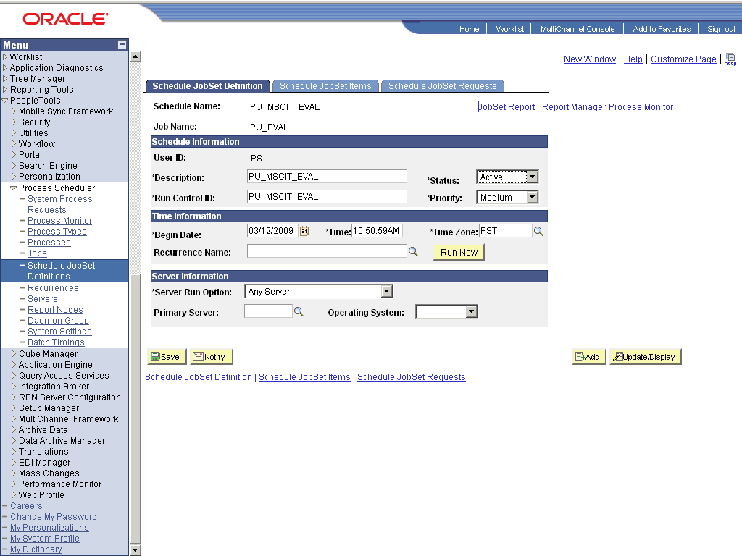

Step | Action
 | Click the obSet Items link.
 | Enter the desired information into the field. Enter "PU_MSCIT_EVAL".
 | Click the PU_EVAL link.
 | Enter the desired information into the field. Enter "RMC_PUCIT_MSCIT".
 | Enter the desired information into the field. Enter "AEC_PUCIT_MSCIT".
 | Enter the desired information into the field. Enter "AME_PUCIT_MSCIT".
 | Enter the desired information into the field. Enter "EC_PUCIT_MSCIT".
 | Click the Show all columns graphic.
 | Click the Parameters link.
 | Enter the desired information into the field. Enter "RMC_PUCIT_MSCIT".
 | Click the OK button.
 | Click the Save button.
 | End of Procedure.

