Recruitment and Admissions
Created on Thursday, July 02, 2009
Copyright & Trademarks
Copyright © 2003, 2007, Oracle. All rights reserved. Powered by OnDemand Software. Distributed by Oracle under license from Global Knowledge Software LLC. © 1998-2007. All rights reserved.

The information contained in this document is subject to change without notice. If you find any problems in the documentation, please report them to us in writing. This document is not warranted to be error-free. Except as may be expressly permitted in your license agreement for these Programs, no part of these Programs may be reproduced or transmitted in any form or by any means, electronic or mechanical, for any purpose.

If this documentation is delivered to the United States Government or anyone using the documentation on behalf of the United States Government, the following notice is applicable:

U.S. GOVERNMENT RIGHTS
The U.S. Government’s rights to use, modify, reproduce, release, perform, display, or disclose these training materials are restricted by the terms of the applicable Oracle license agreement and/or the applicable U.S. Government contract.

Oracle, JD Edwards, PeopleSoft, and Siebel are registered trademarks of Oracle Corporation and/or its affiliates. Other names may be trademarks of their respective owners.

Table of Contents
Create Application 1
Add Applicant's Biographical Information 1
Add Applicant's Programs Information 11
Add Applicant Relations 15
Add Applicant's Father's Name 15
Add Previous Education 23
Add Previous Education of an Applicant 23
Add Test Results 47
Add Test Results of an Applicant 47
Add Publications (If Program's Requirement) 51
Add Publications of an Applicant 51
Mark Relevant Publications of an Applicant 57
Add Work Experience (If Program's Requirement) 63
Add Work Experience of an Applicant 63
Mark Relevant Experience of an Applicant 65
Evaluating Applicants 69
Determine Eligibility Report 69
Mark Ineligible Applicants 72
Ineligible Applicants Report 75
Adding Positive and Negative Adjustments of Applicants 79
Run Jobset to Evaluate Applicants 83
Merit List 87
Generate General Merit List Report 87
Finalize Seat Allocation 90
Generate Merit List Report 95
Reverse Merit List (If Required) 98
Generate Waiting List 102
Freeze Merit List Iteration 105
Seat Allocation With Preference 109
Matriculate Individual Applicant (Make applicant a student) 113
Matriculate Individual Applicant 113
Matriculate Applicants in Batch 117
Create Mass Change to Select Applicants 117
Create Mass Change Group 127
Run Mass Change Process 131
Run Application Program Update Process 134
Run Activate Applicants Process 137
Application Status Report 141
Application Status Report 141

Create Application

Add Applicant's Biographical Information

Procedure

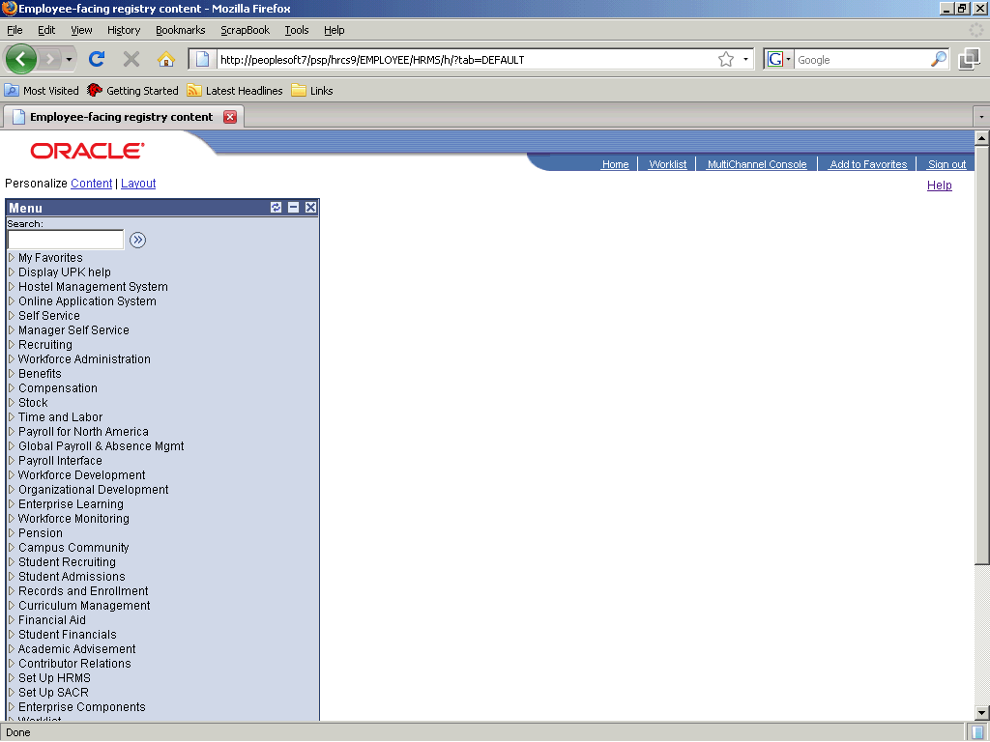

Step | Action
 | Click the Student Admissions link.

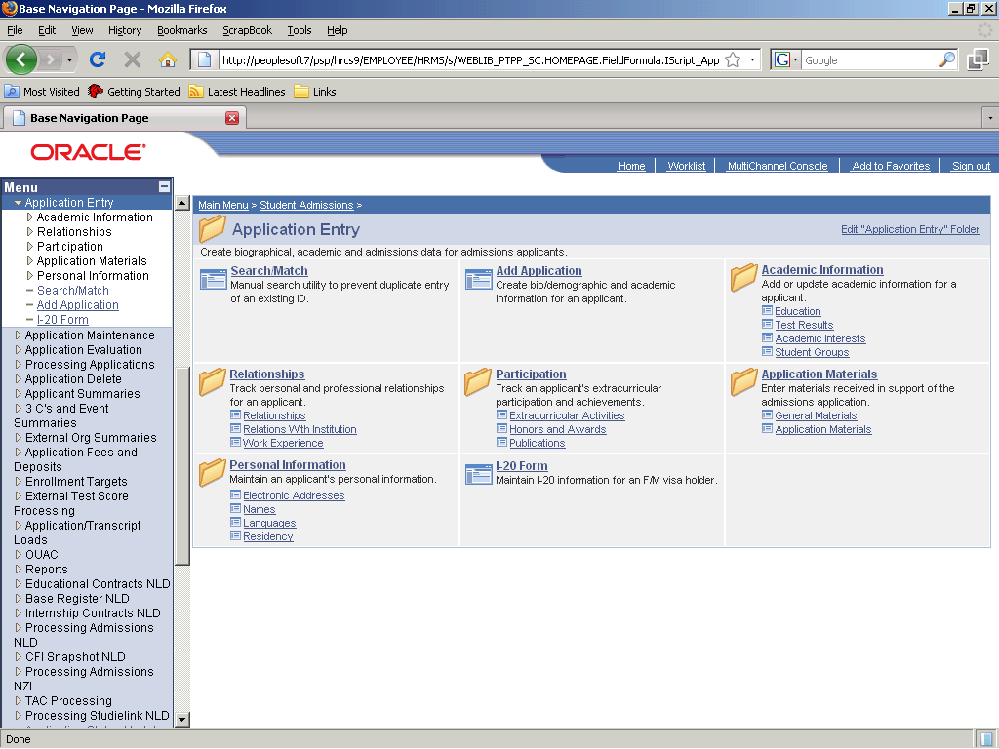

Step | Action
 | Click the Application Entry link.
 | Click the Add Application link.

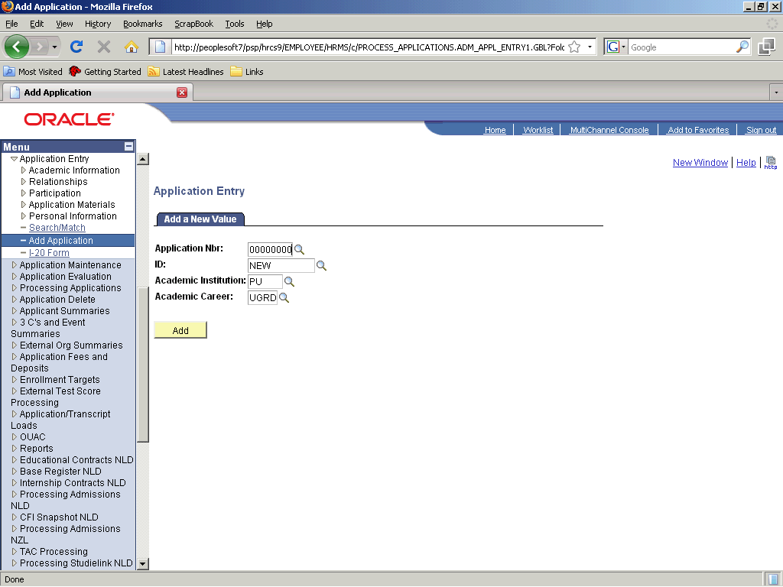

Step | Action
Enter the desired information into the ID: field. Enter "3424".

If applicant already exists in the system then just select the ID from lookup and add another application for that applicant.

This ID field is used to enter Application Form Number.

Note:
To ensure uniqueness in the system, use the following format;
Format : XXXYYTZZZZZ
XXX : Departmental/Faculty Code
YY : Year
T : Session (Spring, Fall, etc)
ZZZZZ : serial number
Example:
UCS09F00001
Enter the desired information into the Academic Career: field. Enter "GRAD".
Click lookup to view all possible values of Academic Career.
Possible values are;
1. UGRD
2. GRAD
3. PGRD
4. CNED
 | Click the Add button.
 | Click the Prefix: list.

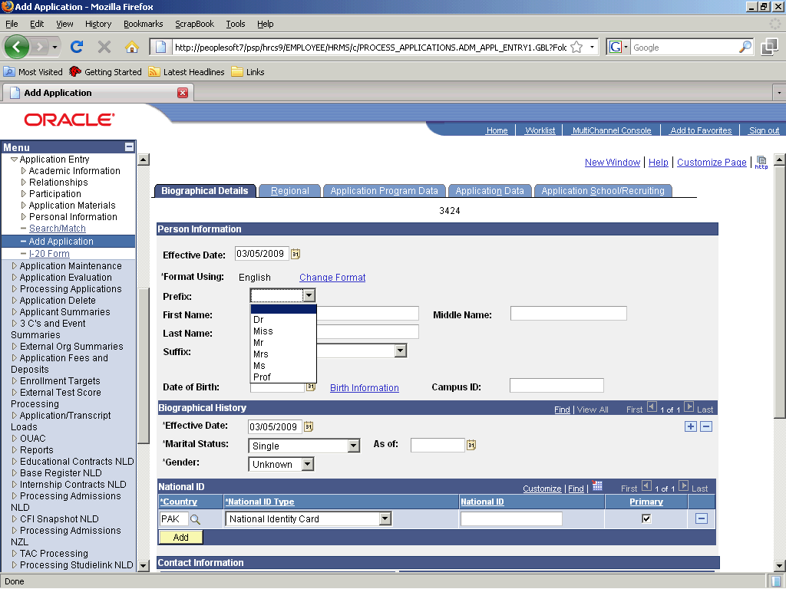

Step | Action
 | Click the cell.

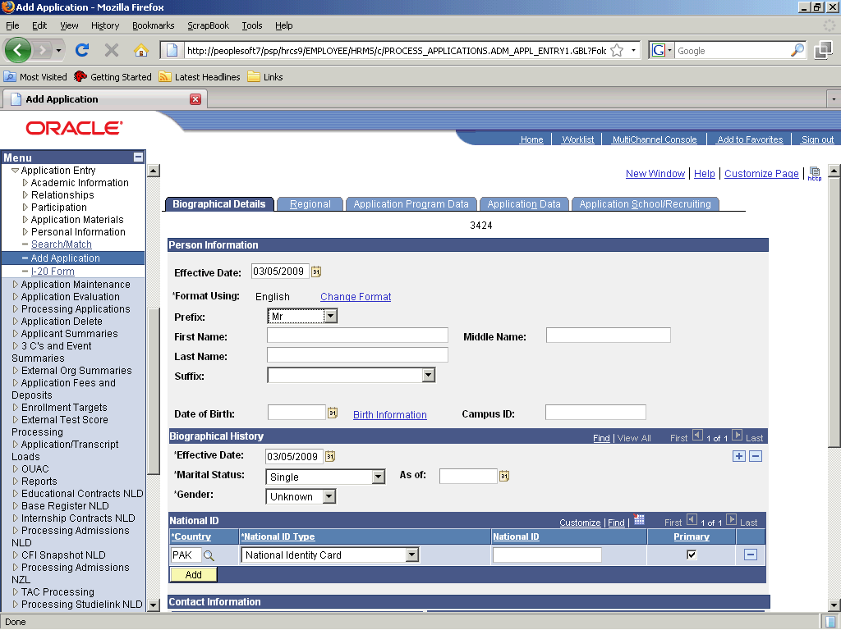

Step | Action
 | Enter the desired information into the First Name: field. Enter "Imran".
 | Enter the desired information into the Middle Name: field. Enter "Ahmad".
 | Enter the desired information into the Last Name: field. Enter "Khan".
Enter the desired information into the Date of Birth: field. Enter "02/26/1985".
In format month/day/year.
 | Click the *Gender: list.

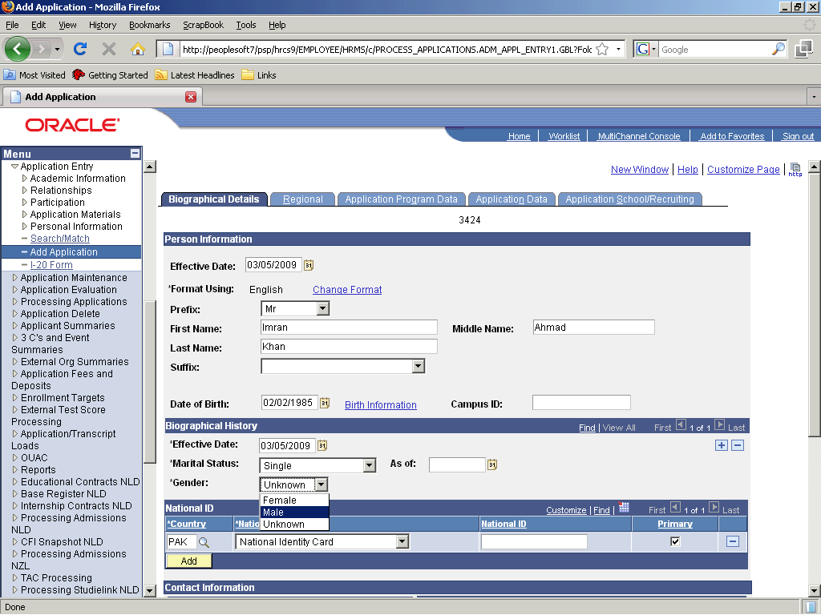

Step | Action
 | Click the cell.

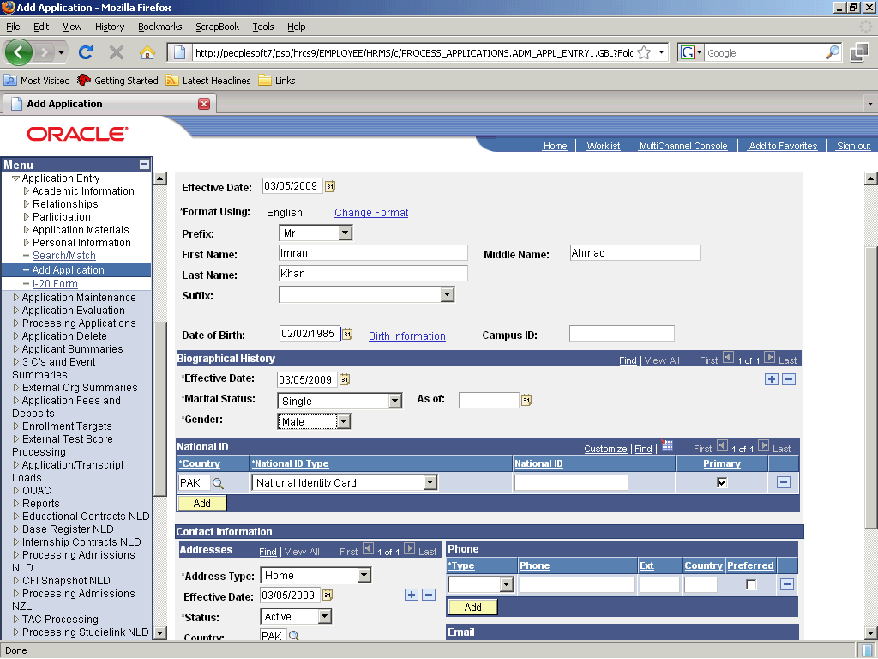

Step | Action
 | Enter the desired information into the field. Enter "35201-1234567-9".
 | Click the Edit Address link.
 | Enter the desired information into the Address 1: field. Enter "39 Empress Road".
 | Enter the desired information into the City: field. Enter "Lahore".
 | Enter the desired information into the State: field. Enter "PUNJAB".
 | Enter the desired information into the Postal: field. Enter "54000".
 | Click the OK graphic.

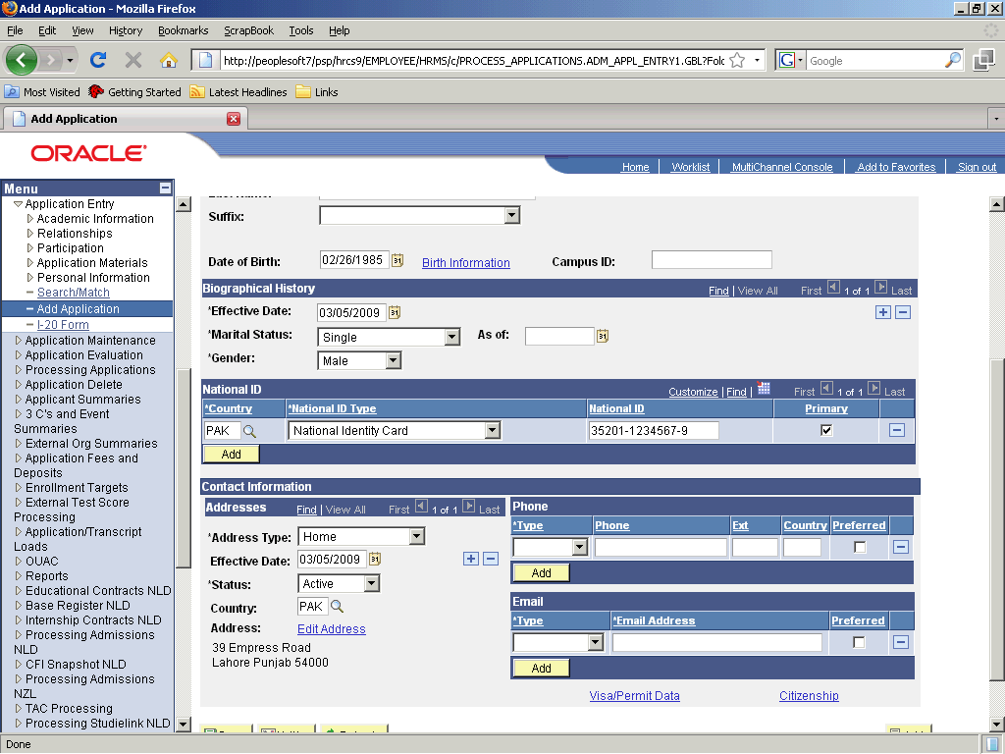

Step | Action
 | Click the list.
 | Click the list.

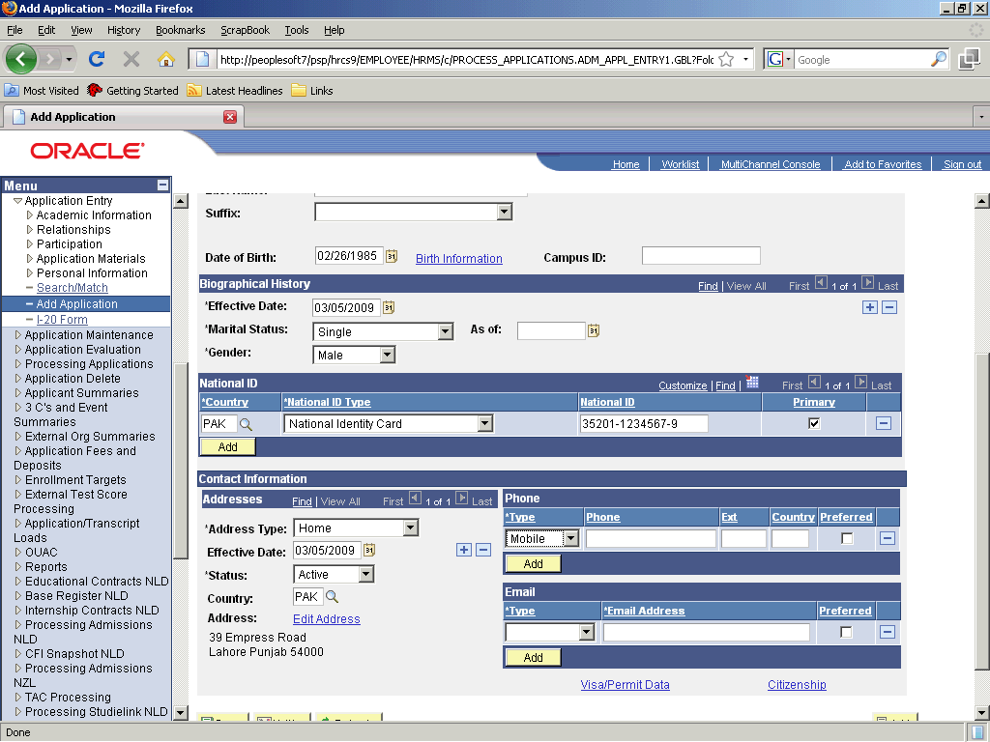

Step | Action
 | Enter the desired information into the field. Enter "03341234567".
 | Click the list.

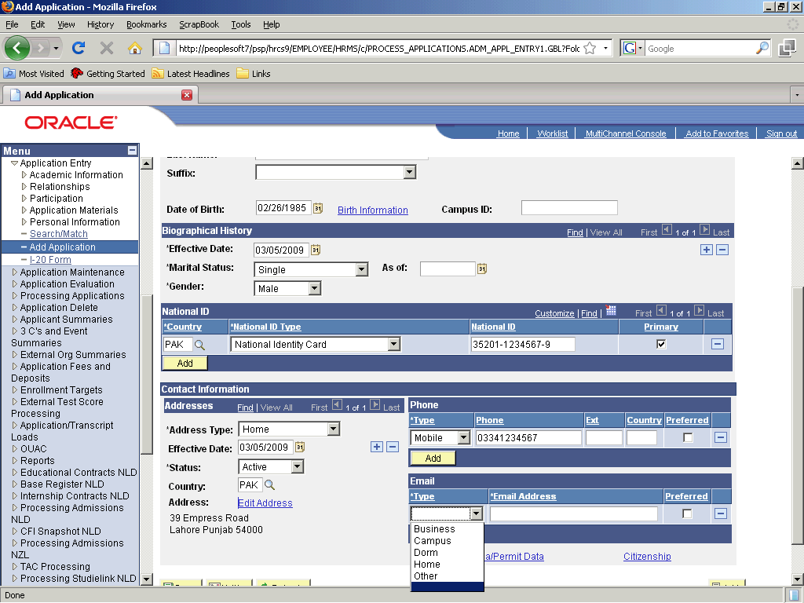

Step | Action
 | Click the Add a new row at row 1 (Alt+7) graphic.

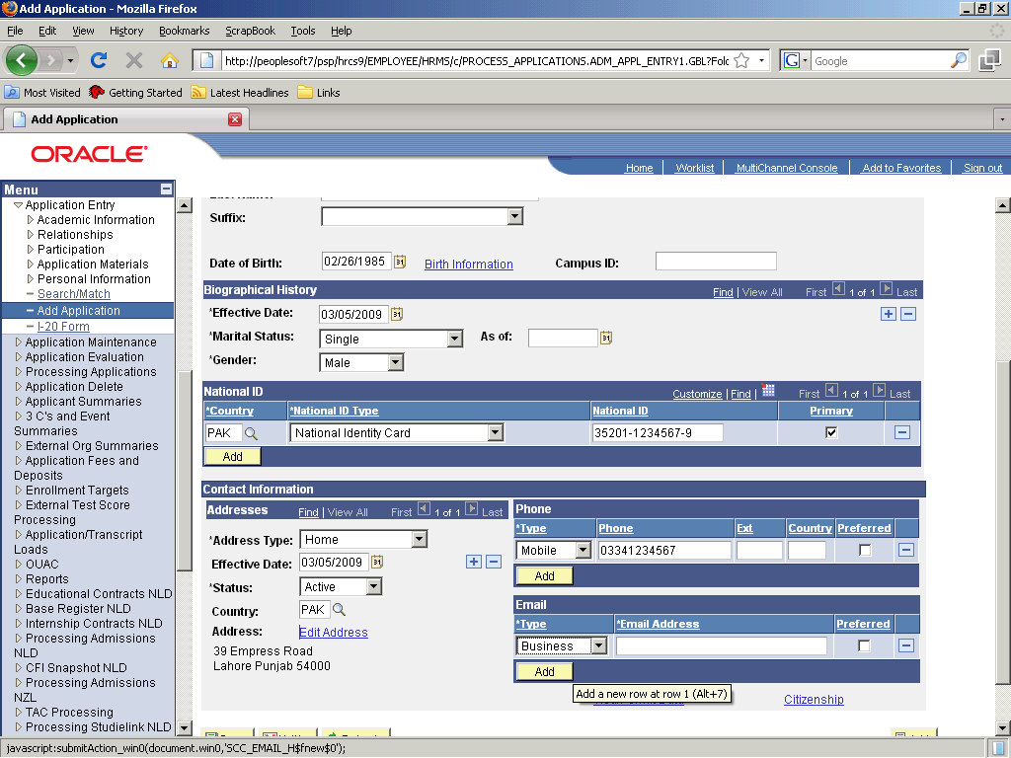

Step | Action
 | Enter the desired information into the field. Enter "xyz@company.com".
 | End of Procedure.

Add Applicant's Programs Information

Procedure

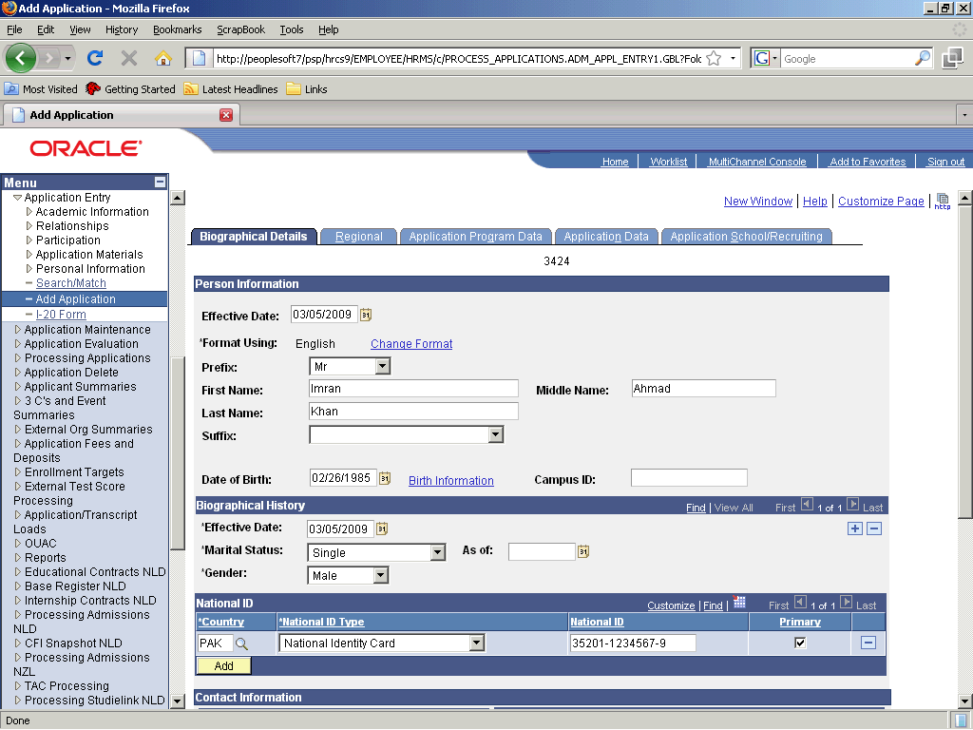

Step | Action
 | Click the Application Pro link.
Enter the desired information into the *Admit Term: field. Enter "0913".
Term represents session, i.e., current admission session.
 | Enter the desired information into the *Academic Program: field. Enter "MSCIT".
 | Enter the desired information into the *Campus: field. Enter "AIQBL".
Enter the desired information into the *Academic Plan: field. Enter "MSCIT".
Note:
Academic Plan represents specializations of the program. Enter same value as program code in this field.
Enter the desired information into the *Sub-Plan: field. Enter "MORN".
Sub-Plan represents offering time of program and its possible values are
1. Morning
2. Afternoon
3. Evening
Click the Add a new row at row 1 (Alt+7) graphic.
Note:
Click '+' to add multiple programs.
 | Enter the desired information into the field. Enter "MSCGI".
Enter the desired information into the *Academic Plan: field. Enter "MSCGI".
Note:
Academic Plan represents specializations of the program. Enter same value as program code in this field.
 | Enter the desired information into the *Sub-Plan: field. Enter "MORN".
 | Click the Applicatio link.
 | Enter the desired information into the *Admit Type: field. Enter "OPN".
 | Click the Save button.
 | End of Procedure.

Add Applicant Relations

Add Applicant's Father's Name

Procedure

Step | Action
 | Click the Student Admissions link.

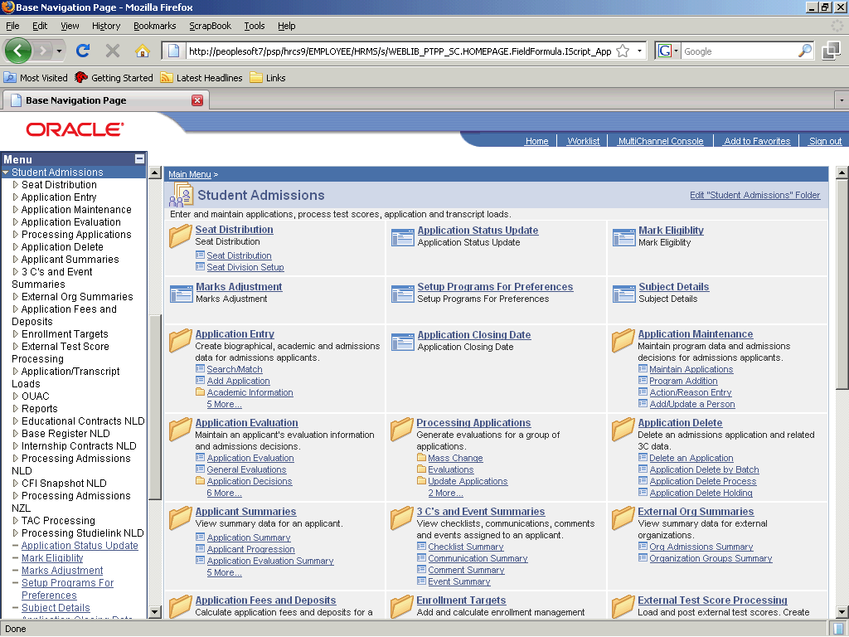

Step | Action
 | Click the Application Entry link.
 | Click the Relationships link.
 | Click the Relationships link.

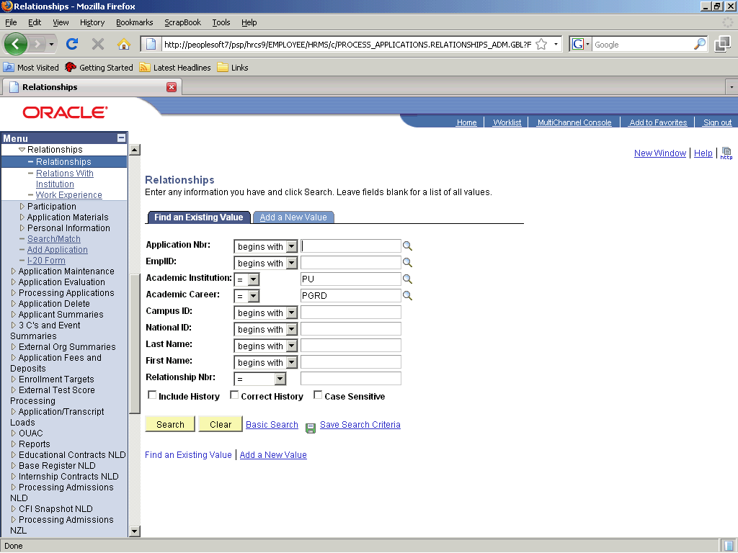

Step | Action
 | Click the dd a New Value link.
 | Enter the desired information into the ID: field. Enter "3424".
 | Enter the desired information into the Academic Career: field. Enter "GRAD".
 | Click the Add button.
 | Click the *Relationship: list.

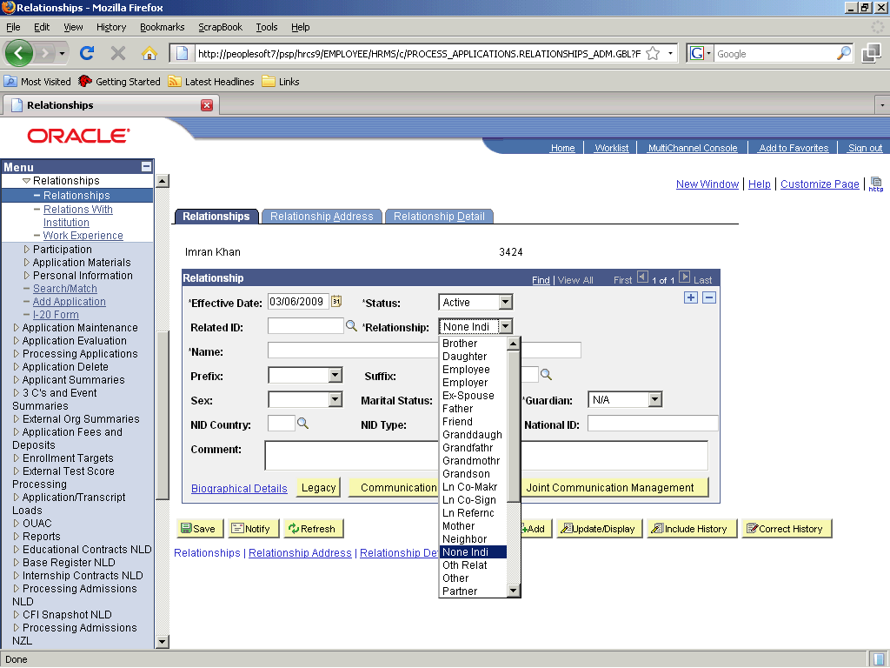

Step | Action
 | Click the Relationship list.

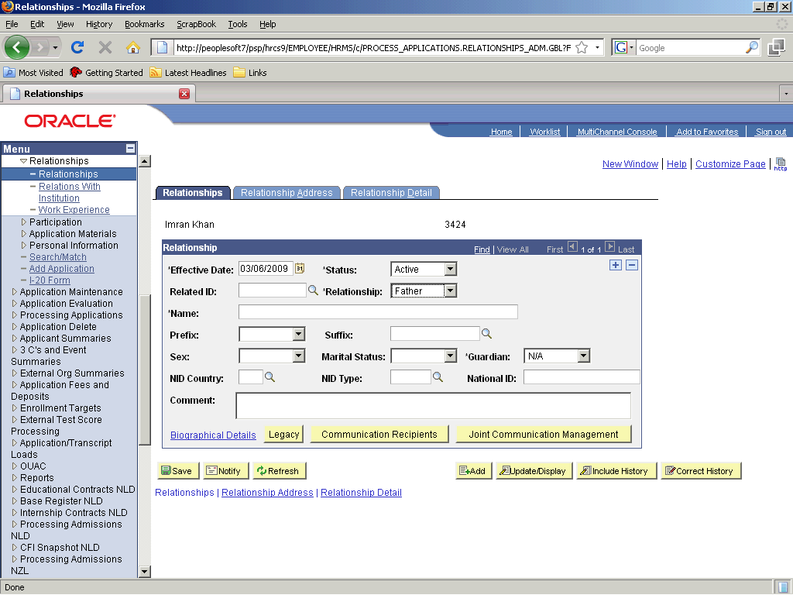

Step | Action
Enter the desired information into the *Name: field. Enter "Khan,Dilshad".
Format:
last name, first name
 | Click the *Guardian: list.

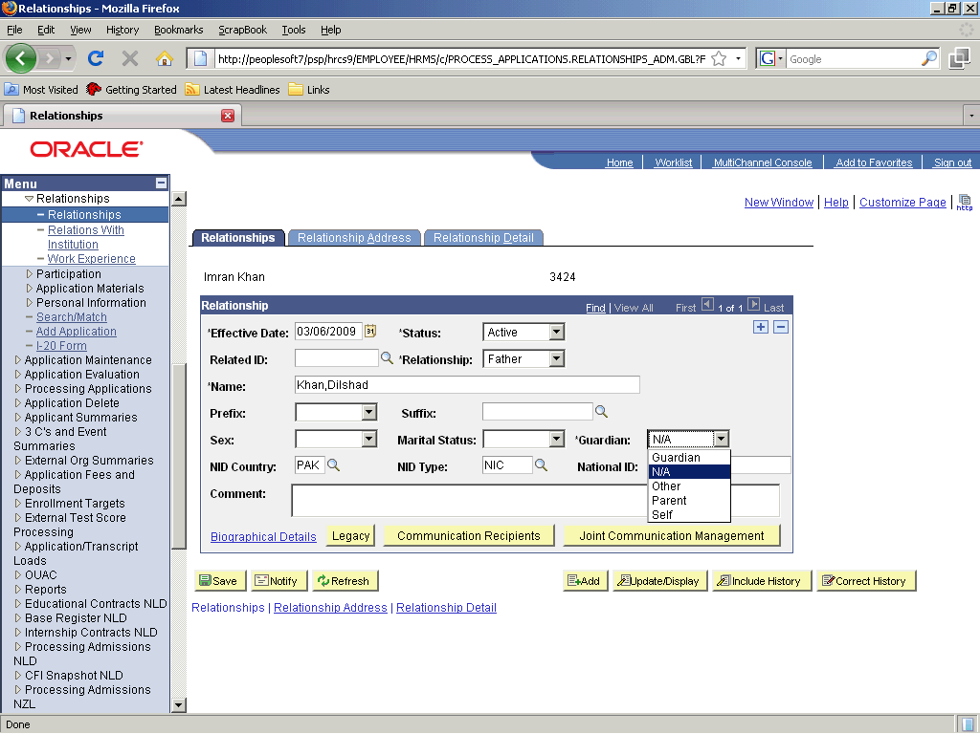

Step | Action
 | Click in the Guardian field.

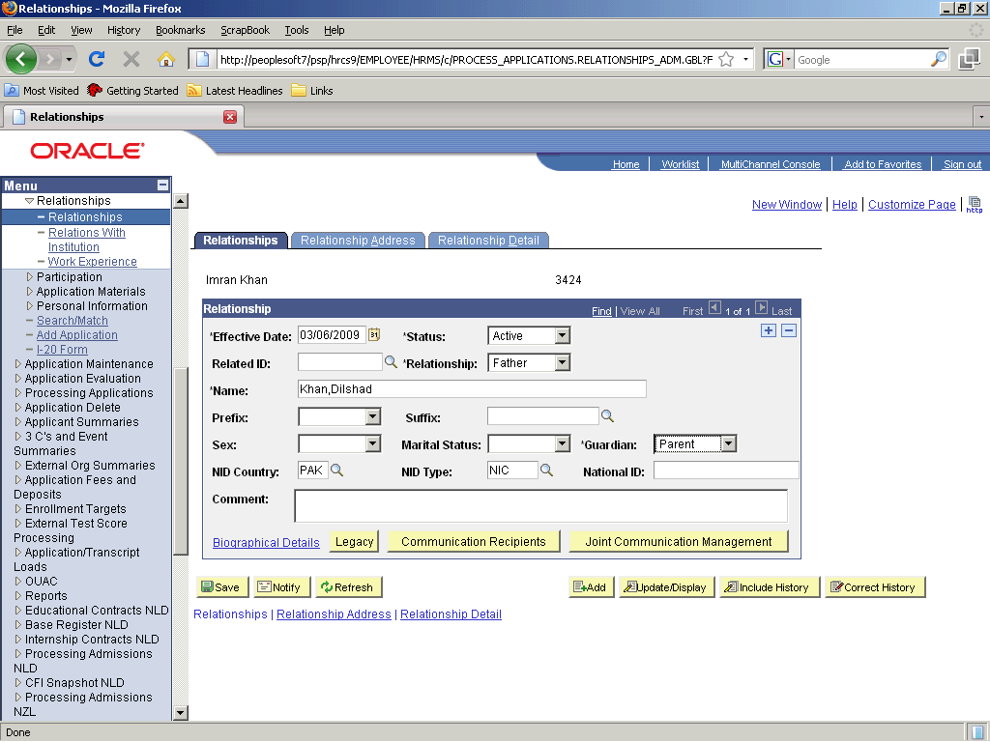

Step | Action
 | Click the Save button.
 | End of Procedure.

Add Previous Education

Add Previous Education of an Applicant

Procedure

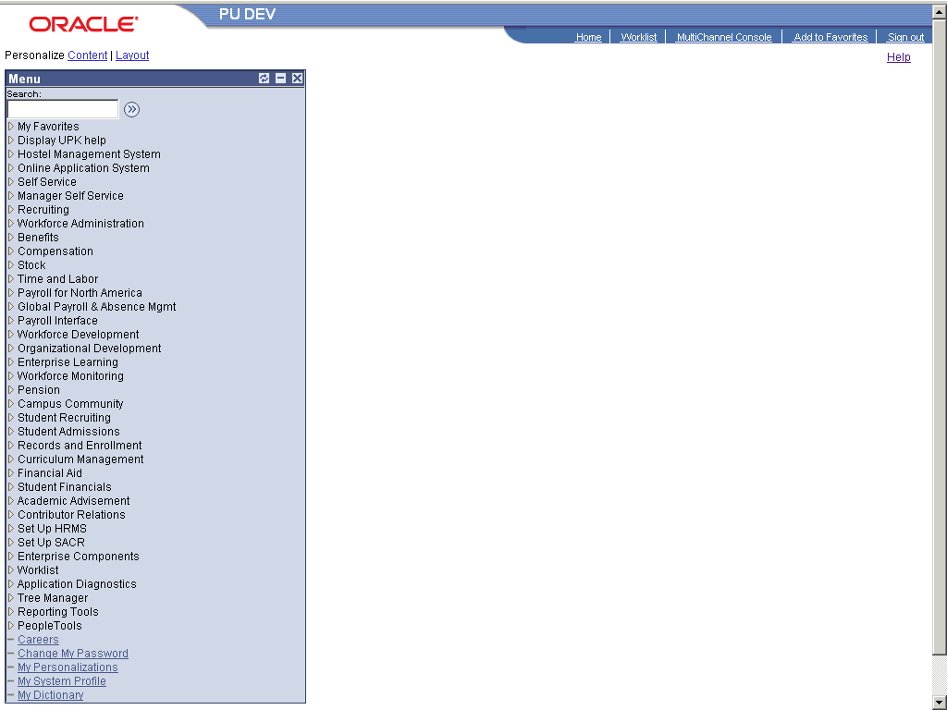

Step | Action
 | Click the Student Admissions link.

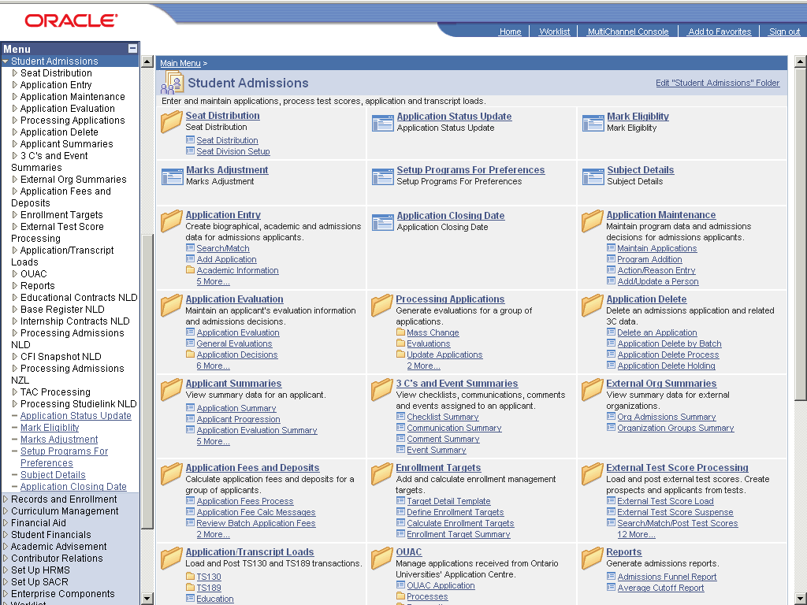

Step | Action
 | Click the Application Entry link.
 | Click the Academic Information link.
 | Click the Education link.

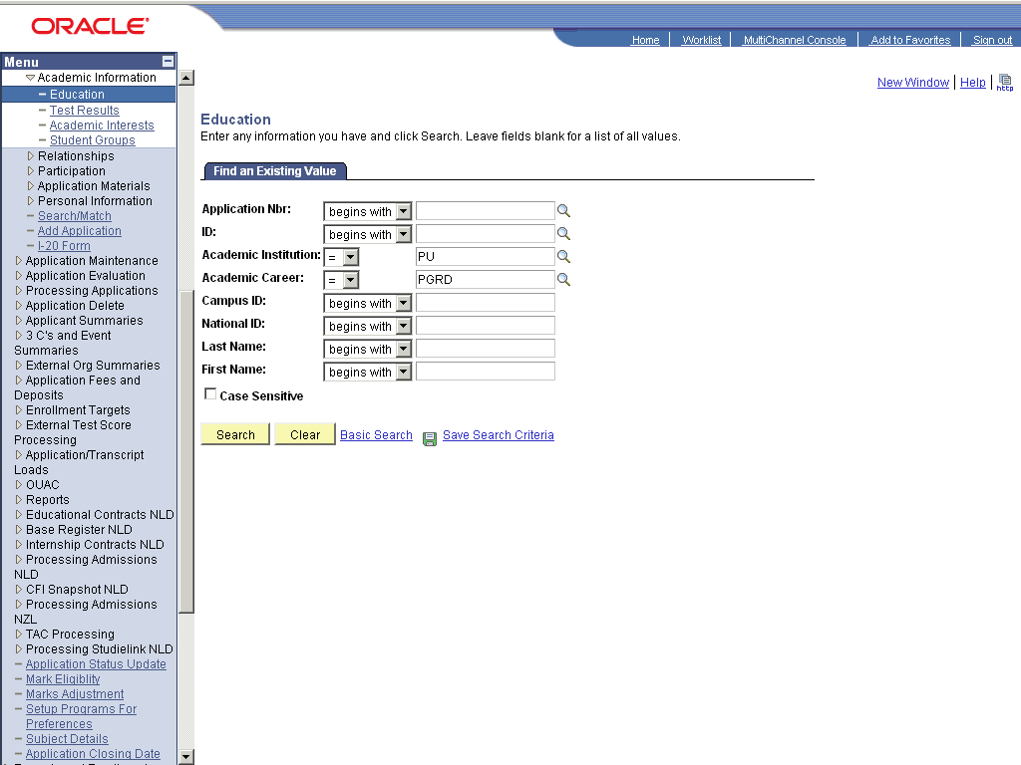

Step | Action
 | Enter the desired information into the ID: field. Enter "3424".
 | Enter the desired information into the Academic Career: field. Enter "GRAD".
 | Click the Search button.
Enter the desired information into the *External Org ID: field. Enter "SS".
Choose Secondary School (SS) for entering Matric qualification.
 | Click the *Career: list.

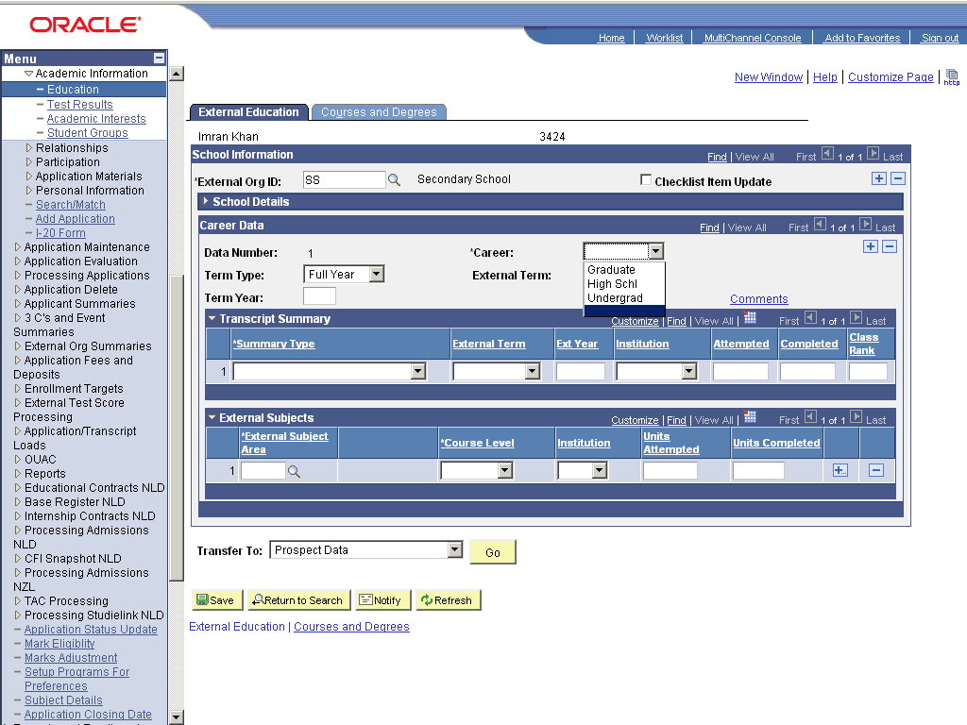

Step | Action
 | Click the cell.

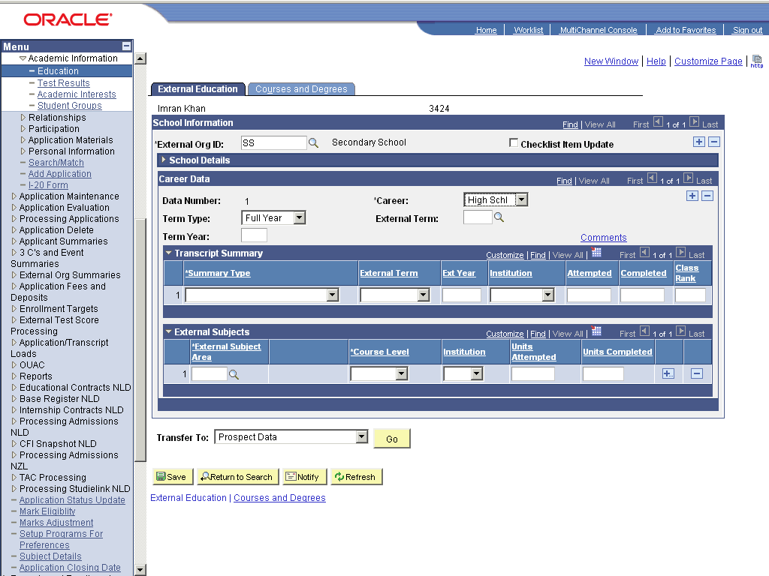

Step | Action
 | Click the Look up External Term (Alt+5) graphic.
 | Click the Annual link.
 | Enter the desired information into the Term Year: field. Enter "2001".
 | Click the list.

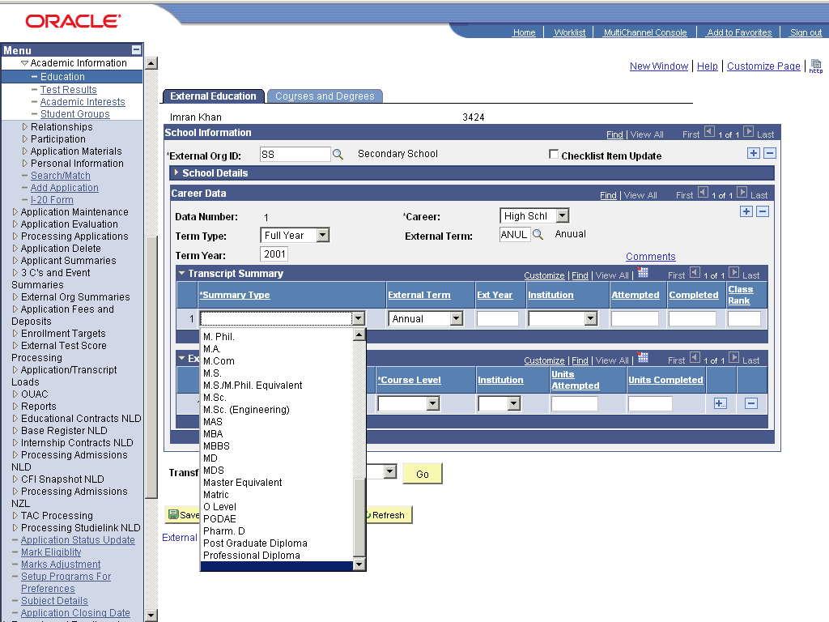

Step | Action
 | Click the cell.

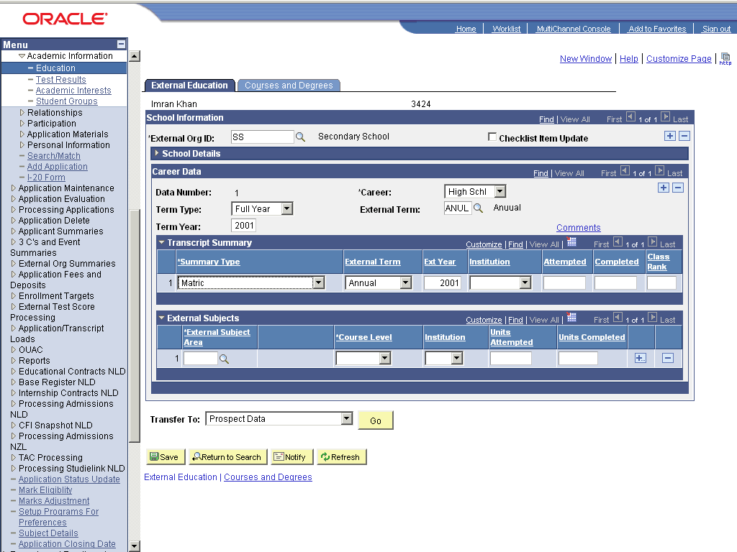

Step | Action
Enter the desired information into the field. Enter "770".
Enter Obtained Marks.
Enter the desired information into the field. Enter "850".
Enter Total Marks.
Enter the desired information into the field. Enter "1".
This field is used to enter Division.
 | Click the Add a new row at row 1 (Alt+7) graphic.
Enter the desired information into the *External Org ID: field. Enter "HSS".
Choose Higher Secondary School (HSS) for entering Intermediate qualification.
 | Click the *Career: list.

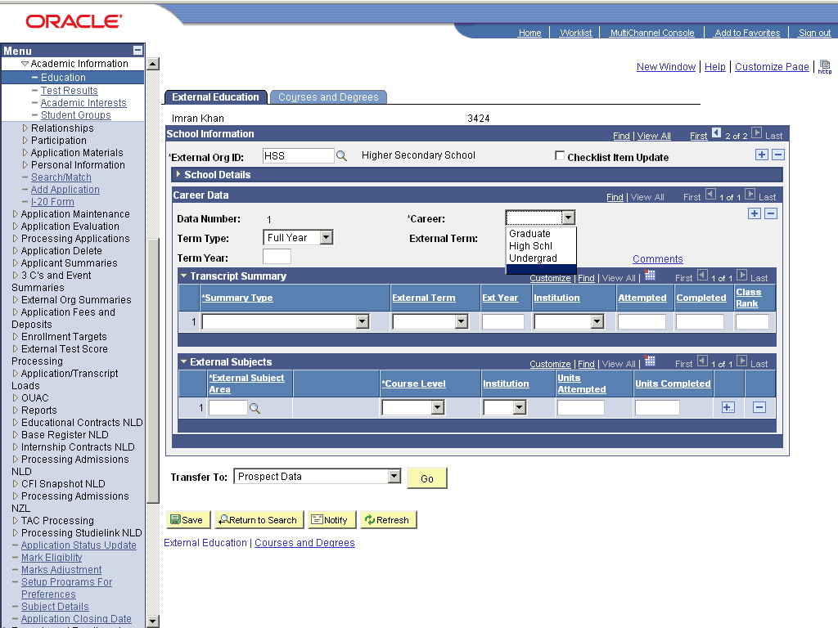

Step | Action
 | Click the cell.

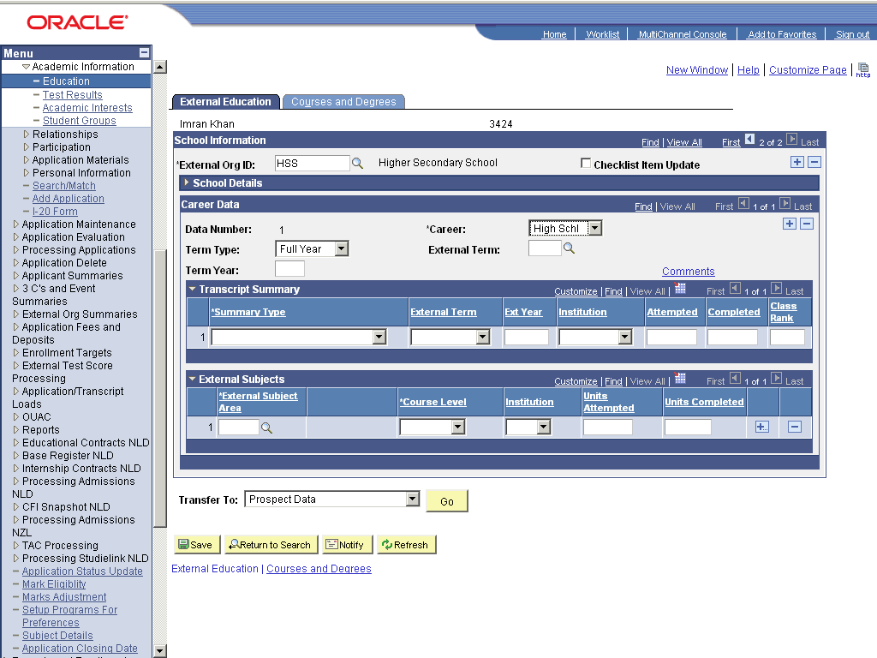

Step | Action
 | Click the Look up External Term (Alt+5) graphic.
 | Click the Annual link.
 | Enter the desired information into the Term Year: field. Enter "2003".
 | Click the list.

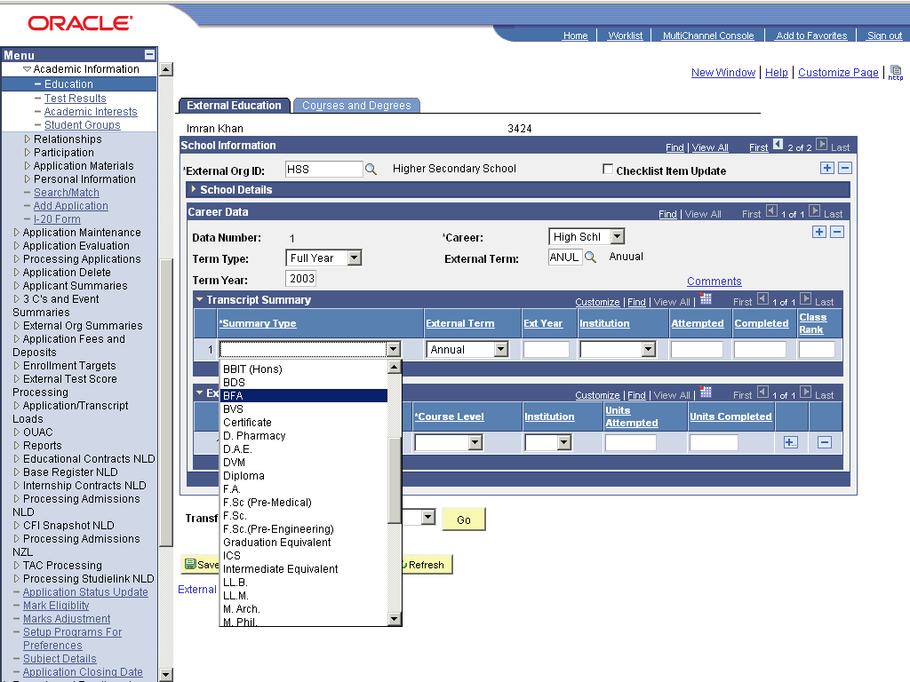

Step | Action
 | Click the Return to Search button.

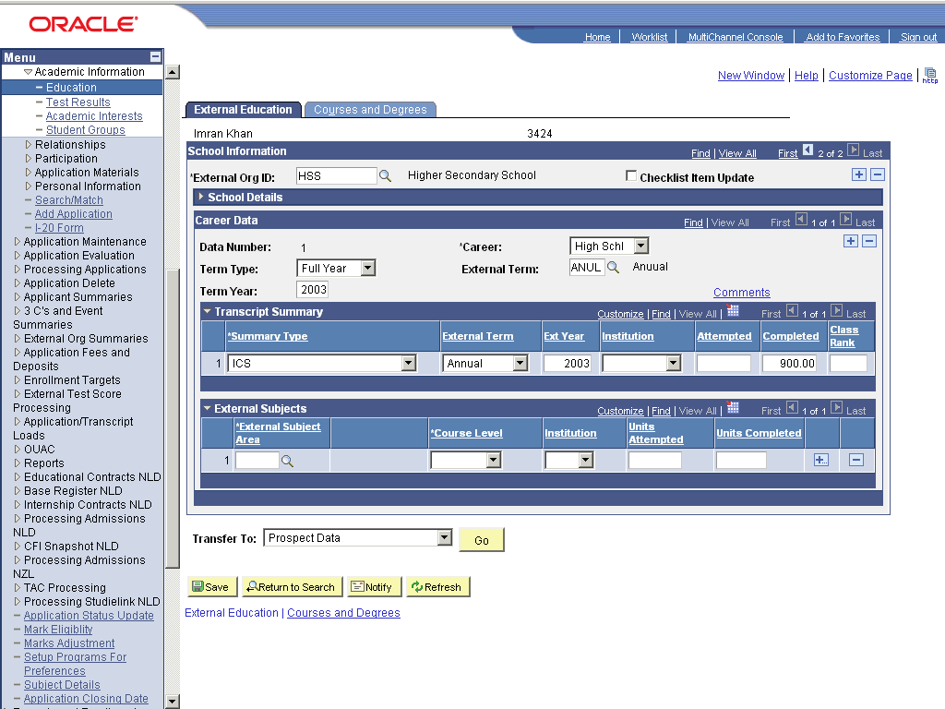

Step | Action
Enter the desired information into the field. Enter "900".
Enter Obtained Marks.
Enter the desired information into the field. Enter "1100".
Enter Total Marks.
Enter the desired information into the field. Enter "1".
This field is used to enter Division.
 | Click the Add a new row at row 2 (Alt+7) graphic.
Enter the desired information into the *External Org ID: field. Enter "HEC".
Choose Higher Education Commission (HEC) for entering graduation and onwards qualifications.
 | Click the *Career: list.

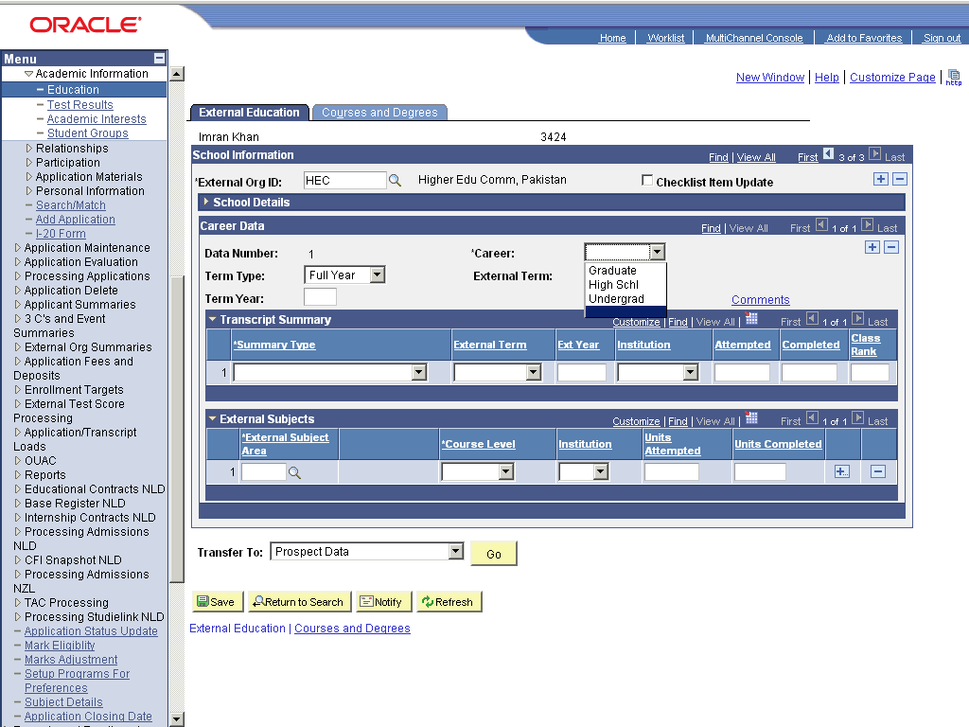

Step | Action
 | Click the cell.

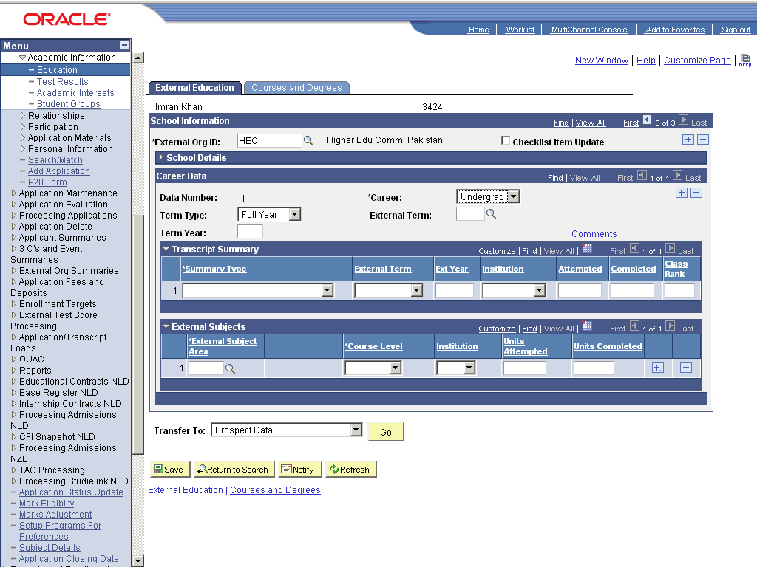

Step | Action
 | Click the Look up External Term (Alt+5) graphic.
 | Click the Annual link.
 | Enter the desired information into the Term Year: field. Enter "2007".
 | Click the list.

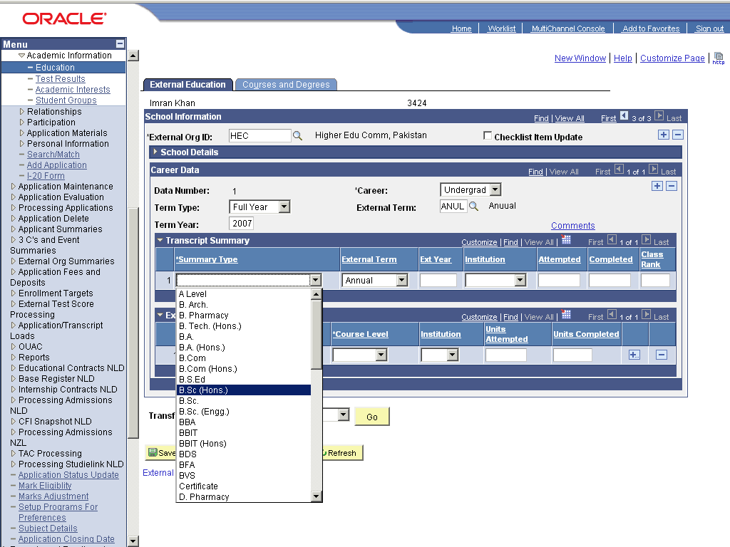

Step | Action
 | Click the cell.

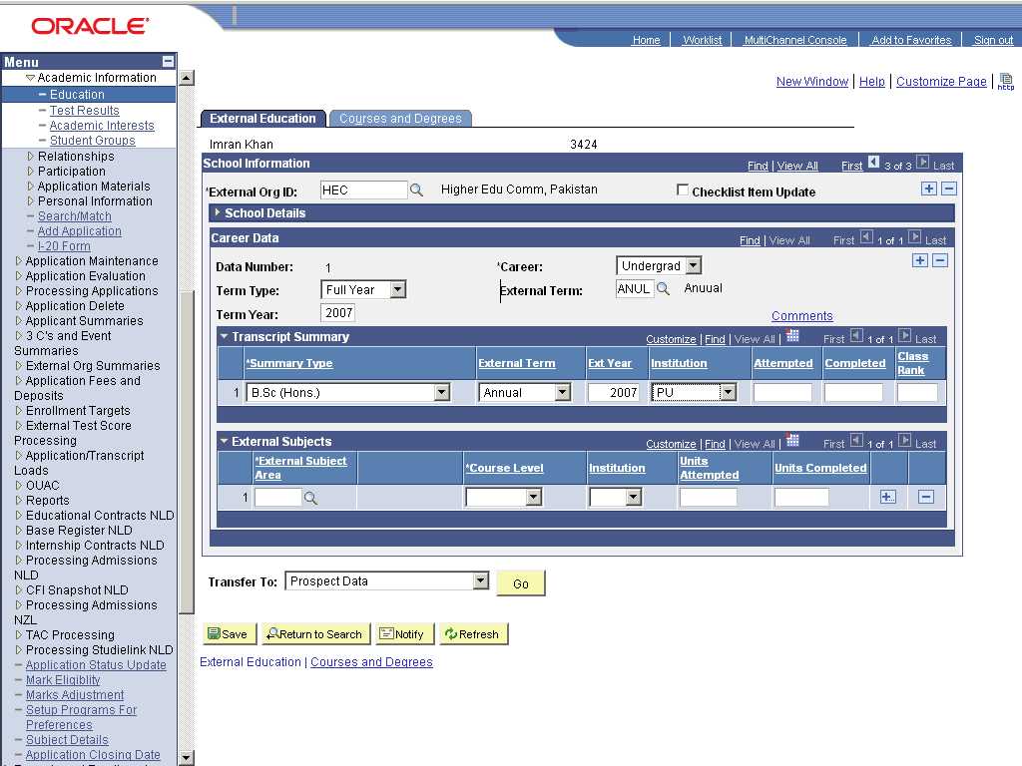

Step | Action
Click the list.
Select PU if applicant has completed degree from PU.

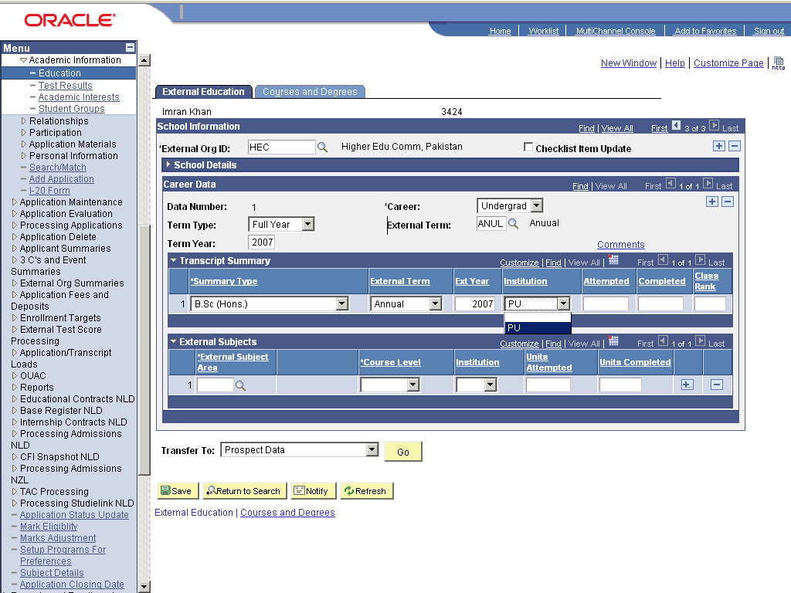

Step | Action
Click the cell.
Select PU if applicant has completed degree from PU.

Step | Action
Enter the desired information into the field. Enter "600".
Enter Obtained Marks.
Enter the desired information into the field. Enter "800".
Enter Total Marks.
Enter the desired information into the field. Enter "1".
This field is used to enter Division.
 | Enter the desired information into the field. Enter "CS".
 | Click the list.

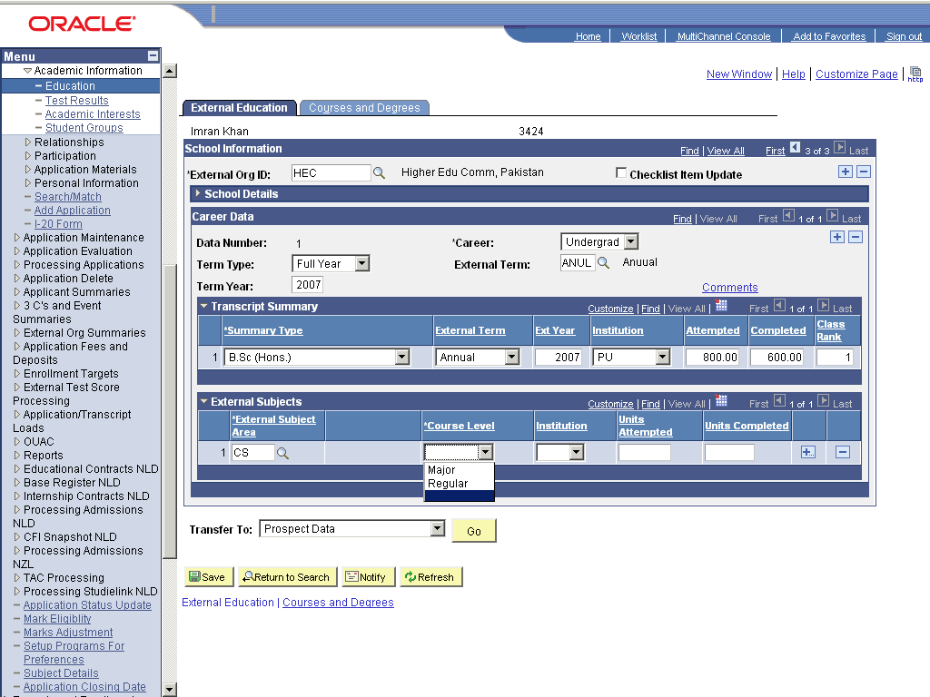

Step | Action
Click the cell.
Note:
Course level has two possible values: Major and Regular
Major: Major is used to complete degree information.
e.g., In Degree B.Sc (Hons.) Computer Science
"Computer Science" should be added as major subjet to completely describe the degree name.
Regular: Regular indicates subjects that are studied in above selected degree.

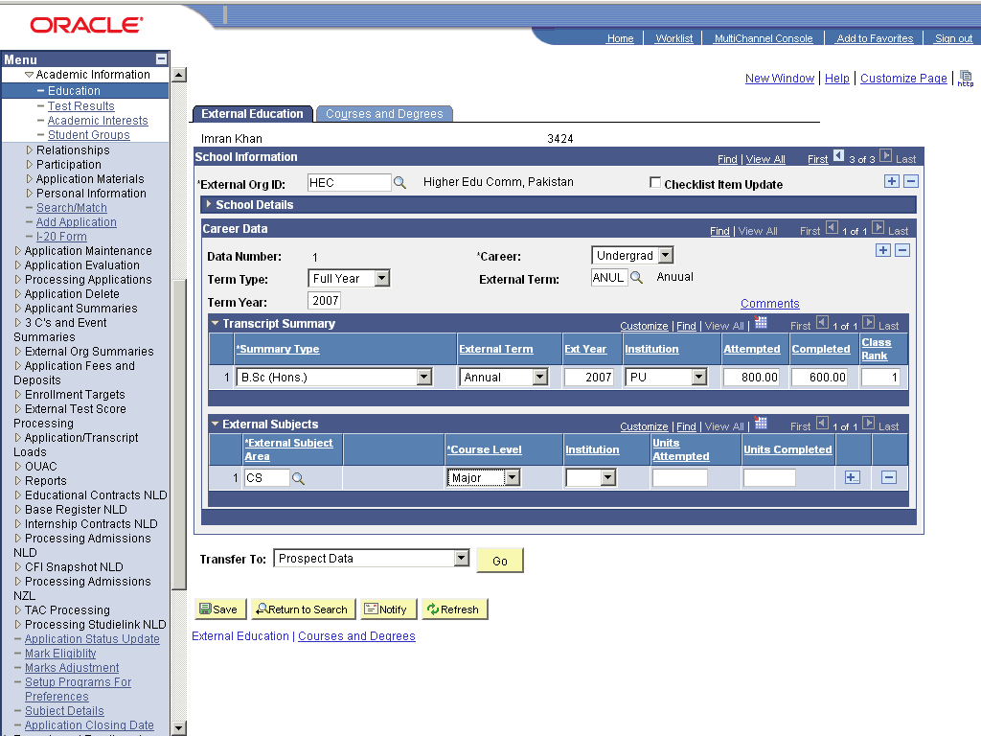

Step | Action
 | Click the Add multiple new rows at row 1 (Alt+7) graphic.

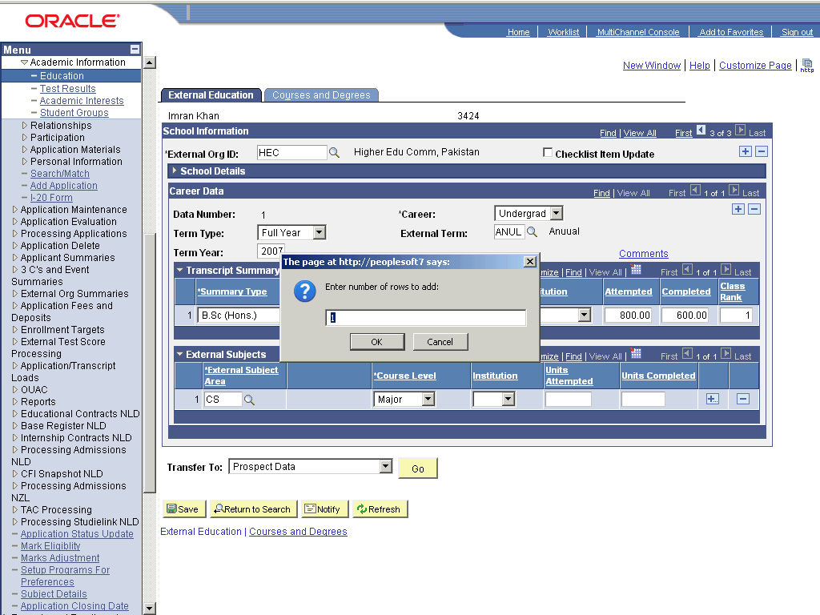

Step | Action
 | Click the OK button.

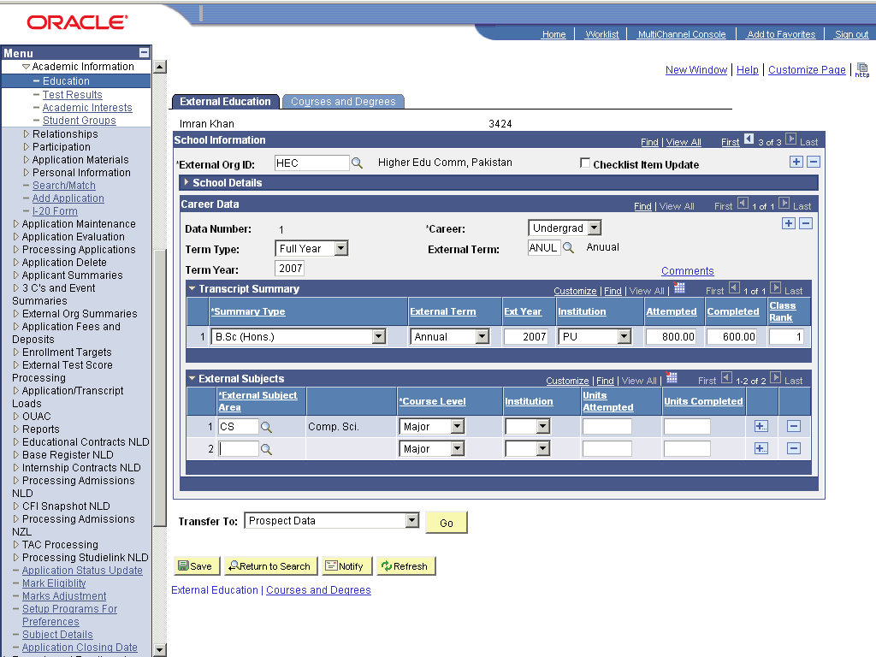

Step | Action
 | Enter the desired information into the field. Enter "STAT".
 | Click the list.

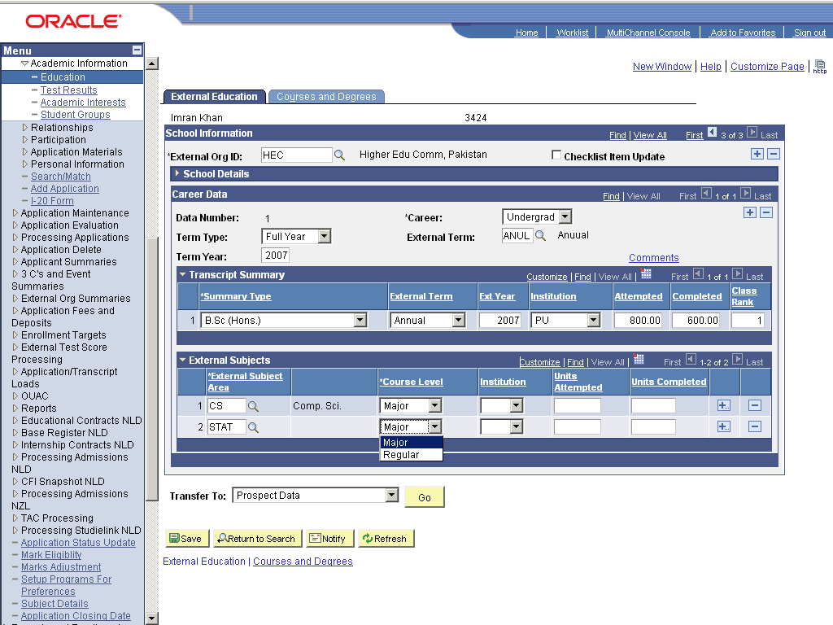

Step | Action
 | Click the cell.

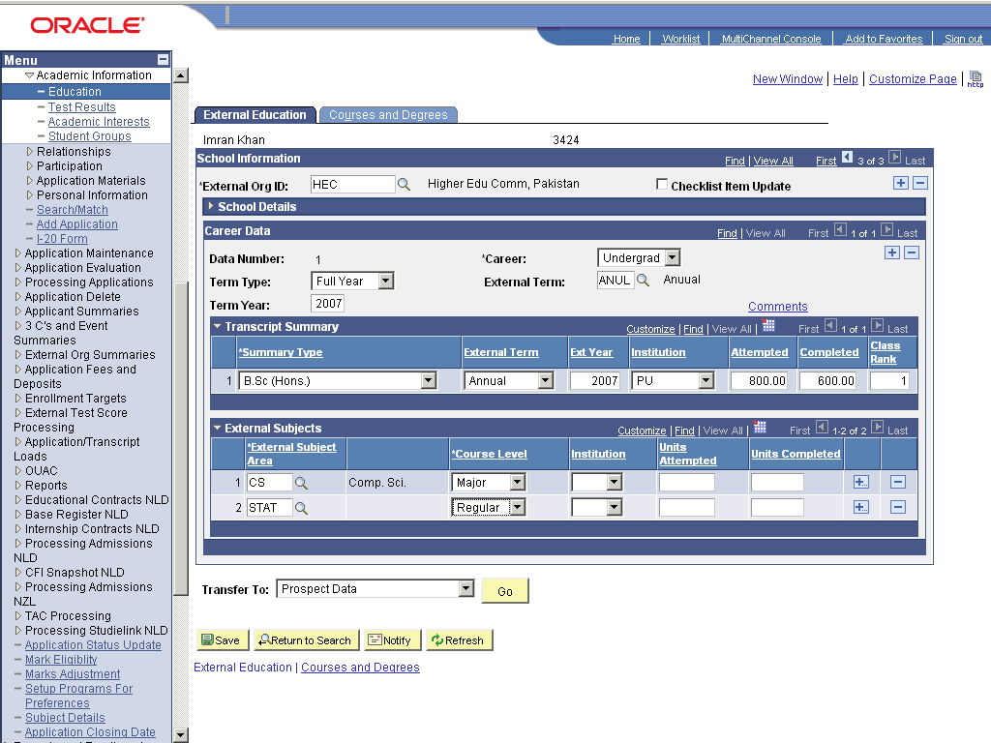

Step | Action
Enter the desired information into the field. Enter "80".
Enter Obtained Marks.
Enter the desired information into the field. Enter "100".
Enter Total Marks.
 | Click the Save button.
 | End of Procedure.

Add Test Results

Add Test Results of an Applicant

Procedure

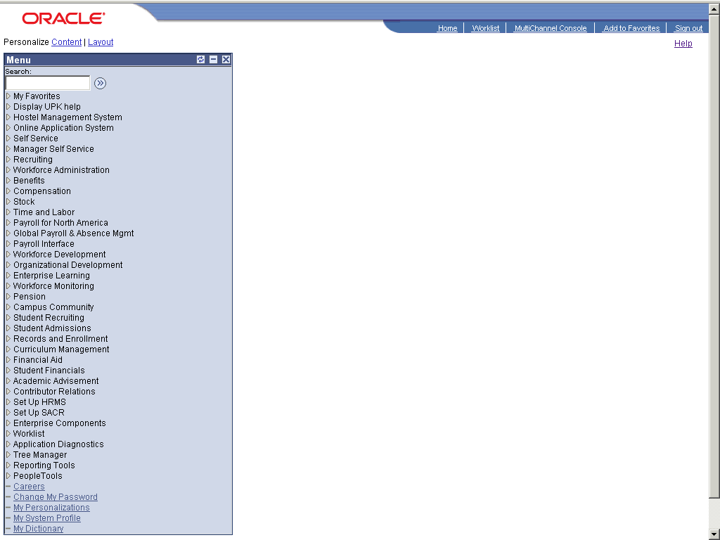

Step | Action
 | Click the Student Admissions link.

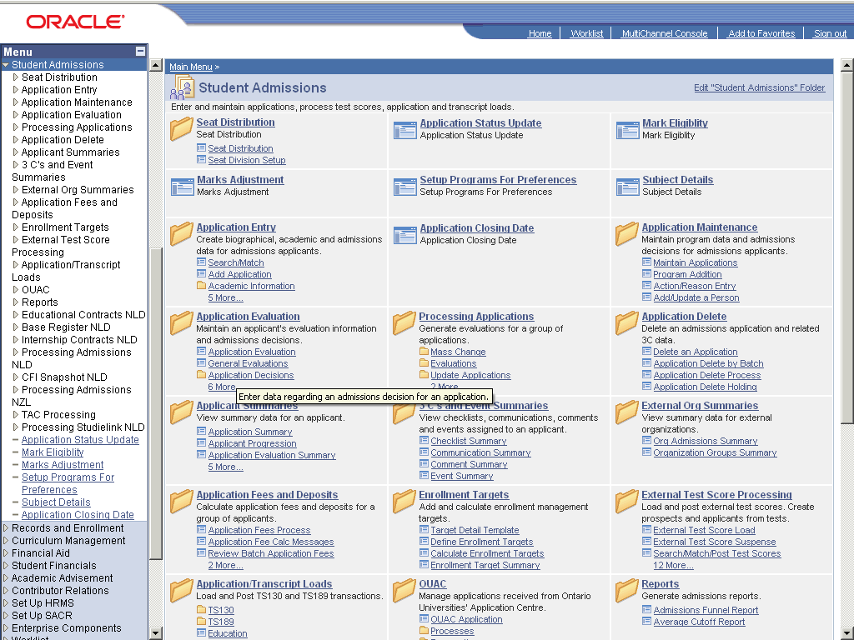

Step | Action
 | Click the Application Entry link.
 | Click the Academic Information link.
 | Click the Test Results link.

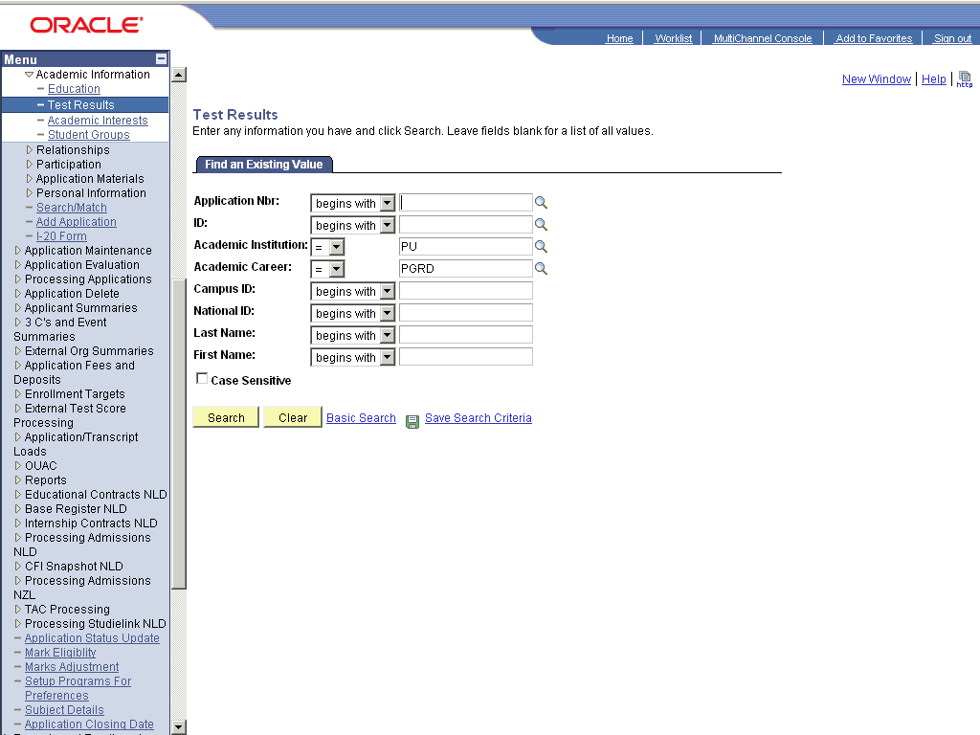

Step | Action
 | Enter the desired information into the ID: field. Enter "3424".
 | Enter the desired information into the Academic Career: field. Enter "GRAD".
 | Click the Search button.
Enter the desired information into the field. Enter "MSCIT".
Note:
Enter Test ID same as Program's Code.
 | Enter the desired information into the Test Date: field. Enter "03/12/2009".
 | Click the Look up Component (Alt+5) graphic.
 | Click the ENTST link.
 | Enter the desired information into the field. Enter "70".
 | Click the Add a new row at row 1 (Alt+7) graphic.
 | Click the HAFIZ link.
 | Enter the desired information into the field. Enter "20".
 | Click the Save button.
 | End of Procedure.

Add Publications (If Program's Requirement)

Add Publications of an Applicant

Procedure

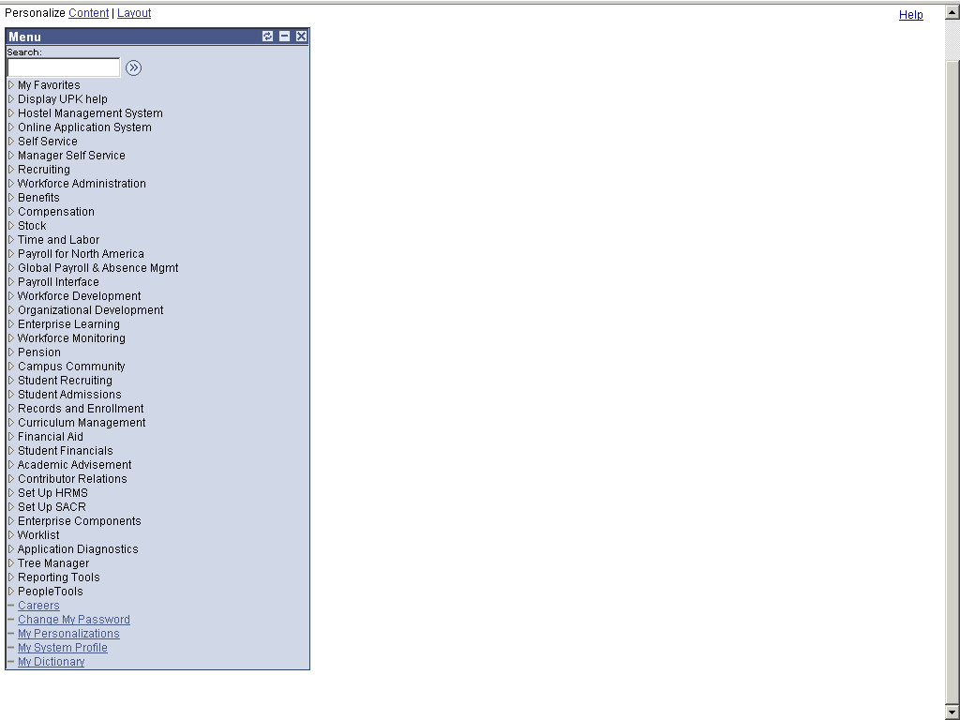

Step | Action
 | Click the Student Admissions link.

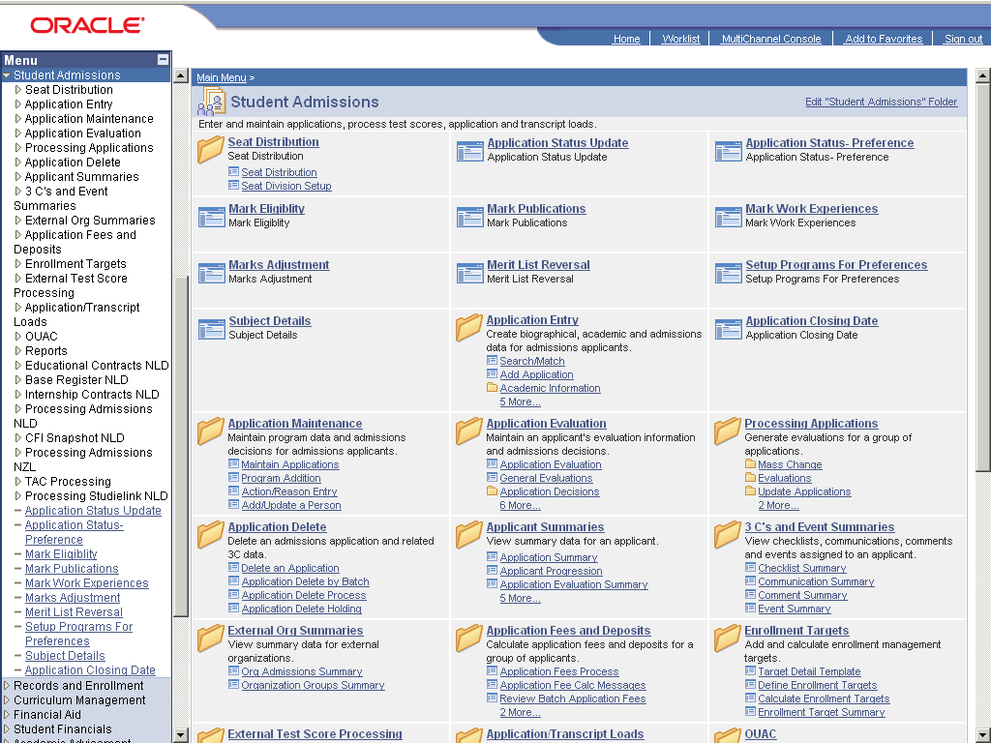

Step | Action
 | Click the Application Entry link.
 | Click the Participation link.
 | Click the Publications link.

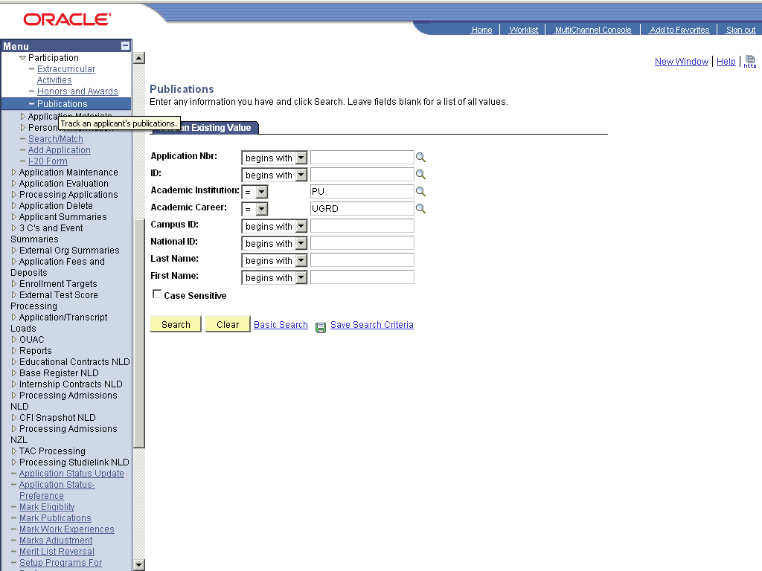

Step | Action
 | Enter the desired information into the ID: field. Enter "3424".
 | Click the Search button.
 | Click the Publication Type: list.

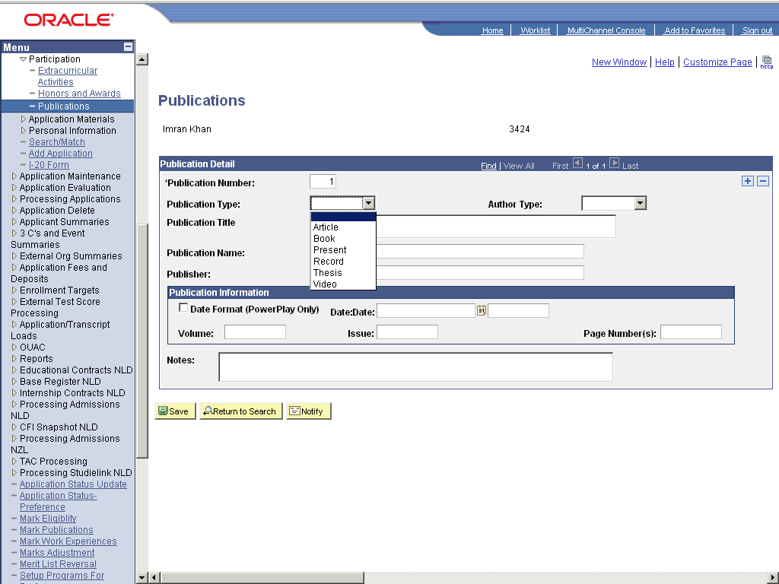

Step | Action
 | Click in the Publisher: field.

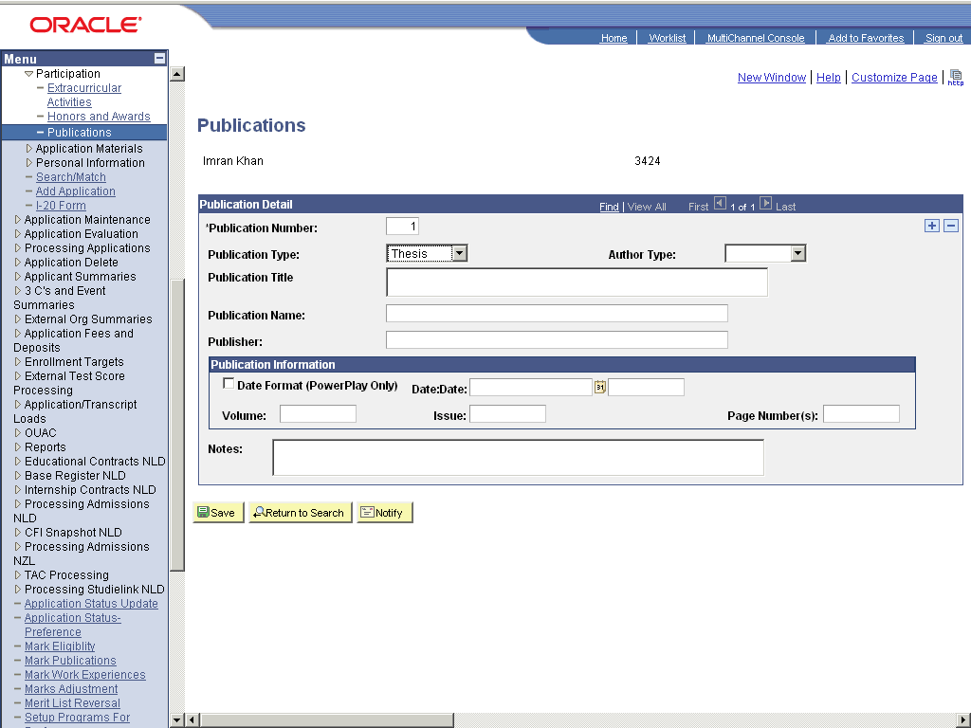

Step | Action
 | Click the Author Type: list.

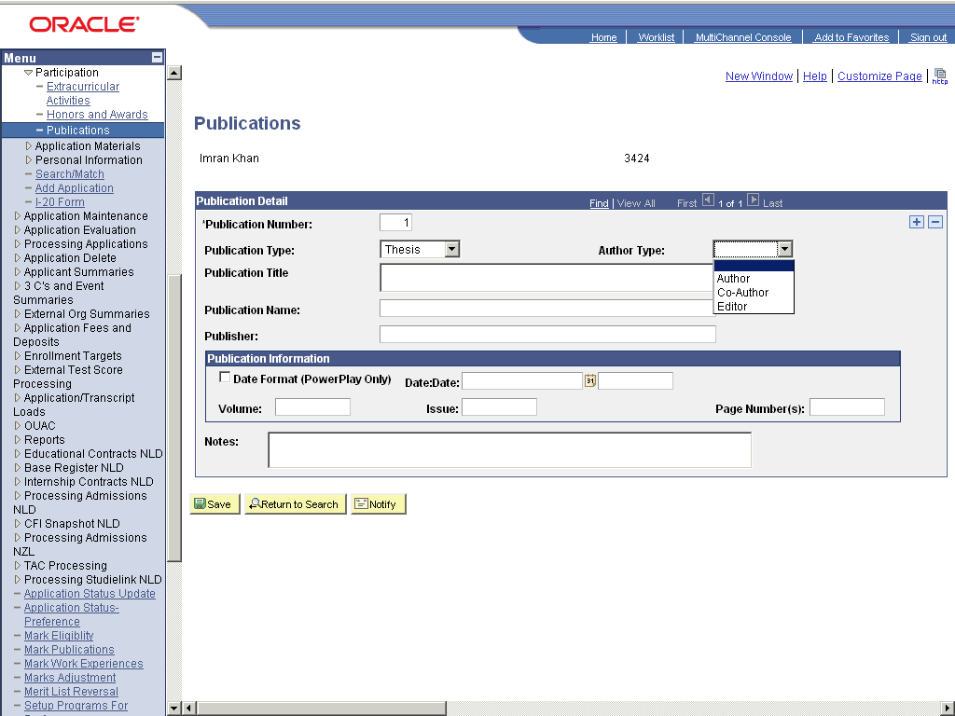

Step | Action
 | Click the cell.

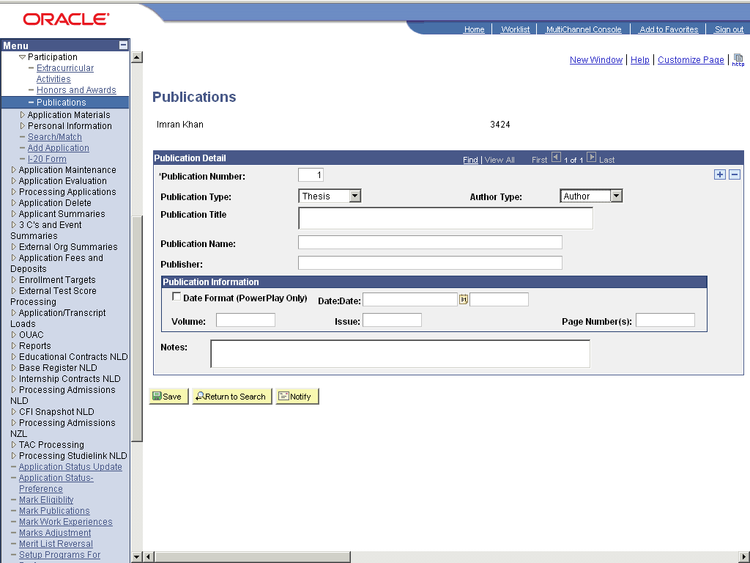

Step | Action
 | Enter the desired information into the Publication Title field. Enter "Support Vector Machine".
 | Enter the desired information into the Publication Name: field. Enter "Support Vector Machine".
 | Enter the desired information into the Publisher: field. Enter "Imran Khan".
 | Click the Save button.
 | End of Procedure.

Mark Relevant Publications of an Applicant

Procedure

Note:
Its mandatory to mark publications relevant, as only relevant publications are considered in merit calculation.

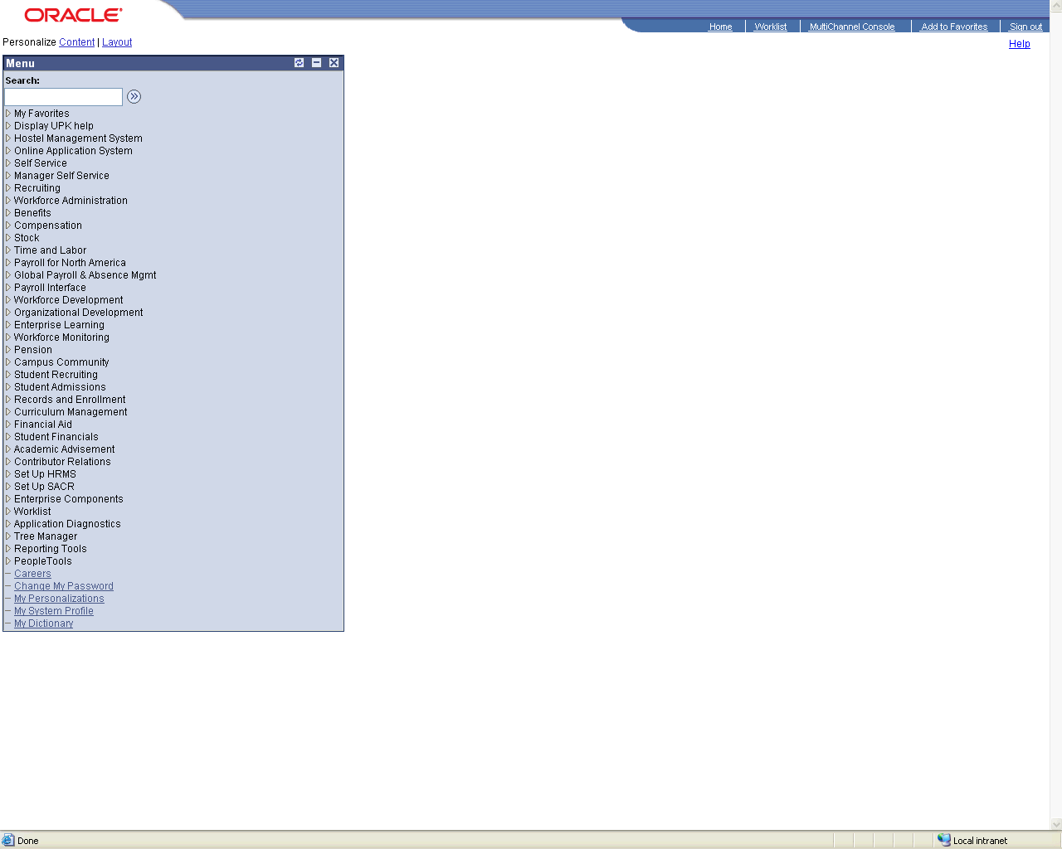

Step | Action
 | Click the Student Admissions link.

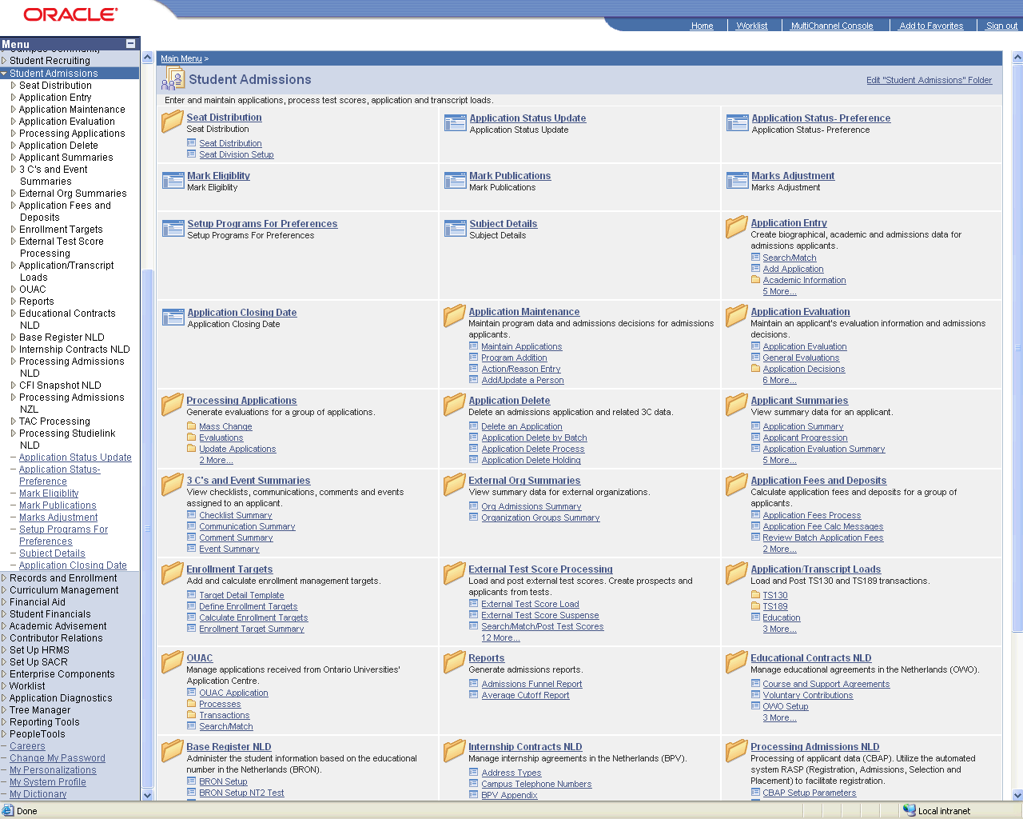

Step | Action
 | Click the Mark Publications link.

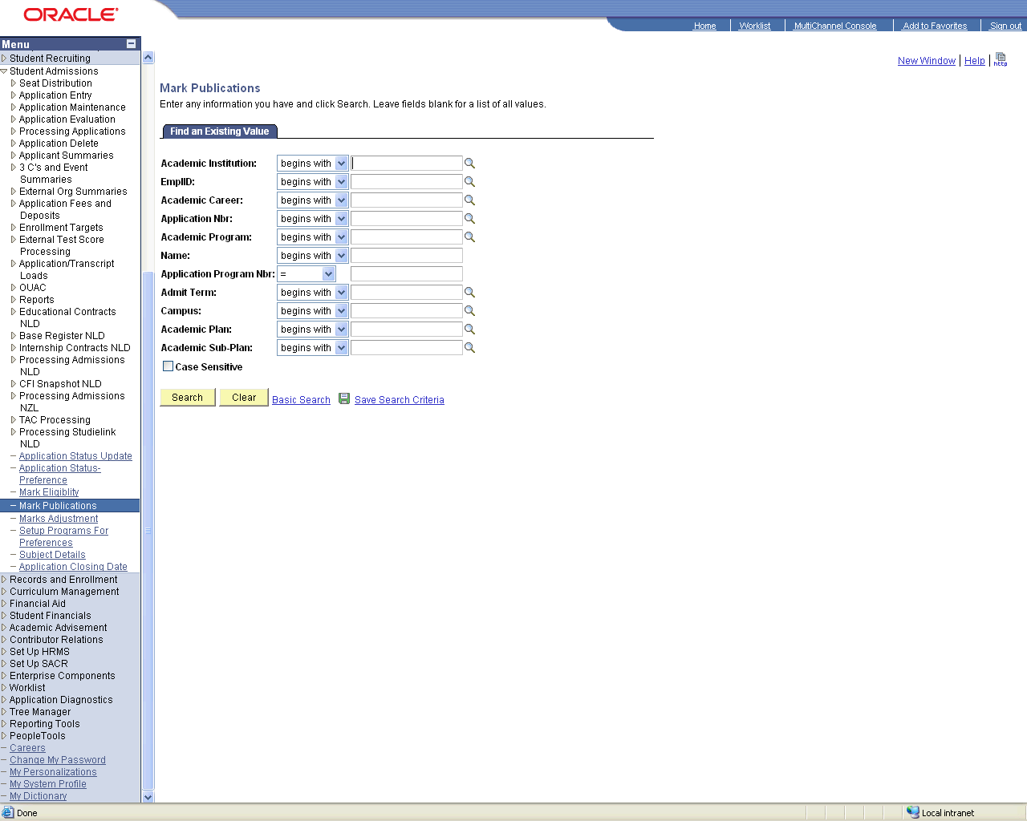

Step | Action
 | Enter the desired information into the EmplID field. Enter "3424".
 | Click the Search button.
 | Click an entry in the Name column.

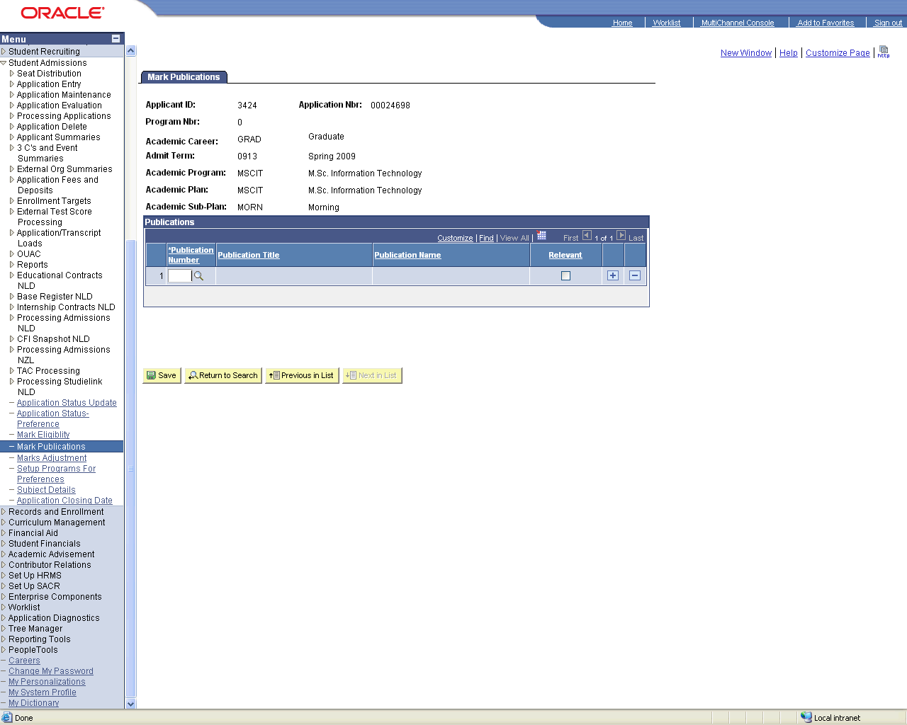

Step | Action
 | Click the Publication Number button.
 | Click an entry in the EmplID column.
 | Click the Relevant option.
 | Click the Save button.
 | End of Procedure.

Add Work Experience (If Program's Requirement)

Add Work Experience of an Applicant

Procedure

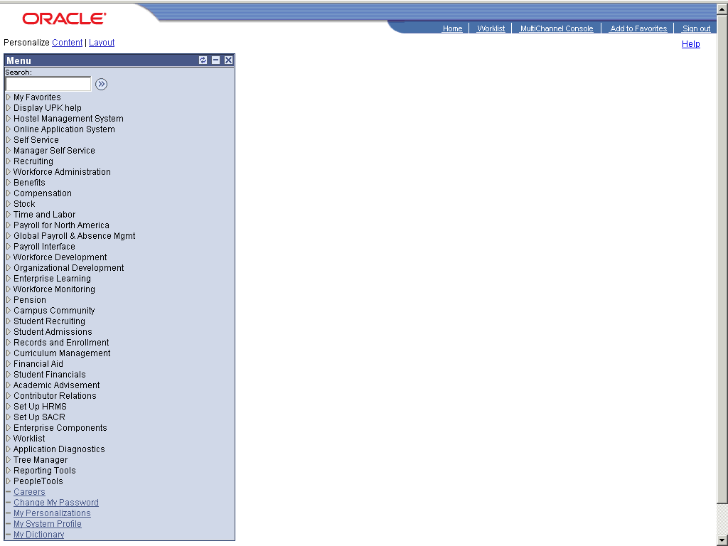

Step | Action
 | Click the Student Admissions link.

Step | Action
 | Click the Application Entry link.
 | Click the Relationships link.
 | Click the Work Experience link.

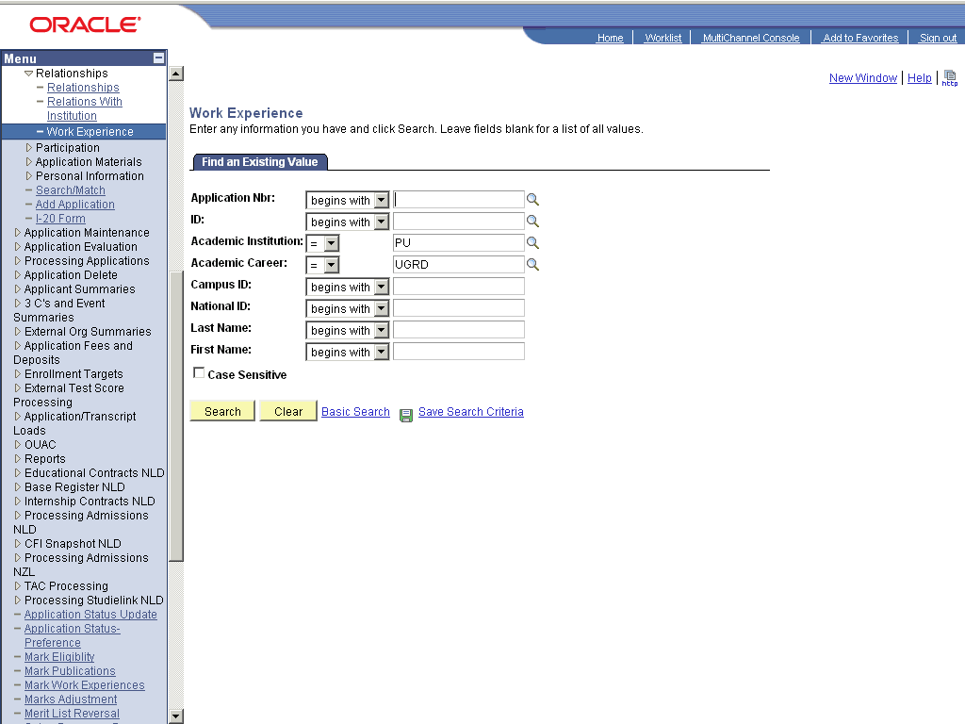

Step | Action
 | Enter the desired information into the ID: field. Enter "3424".
 | Click the Search button.
 | Enter the desired information into the field. Enter "Techlogix Pvt. Limited".
 | Enter the desired information into the *Start Date: field. Enter "02/25/2008".
 | Enter the desired information into the *End Date: field. Enter "06/25/2009".
 | Enter the desired information into the field. Enter "Software Engineer".
 | Click the Save button.
 | End of Procedure.

Mark Relevant Experience of an Applicant

Procedure

Note:
Its mandatory to mark work experience relevant, as only relevant work experiences are considered in merit calculation.

Step | Action
 | Click the Student Admissions link.

Step | Action
 | Click the Mark Work Experiences link.

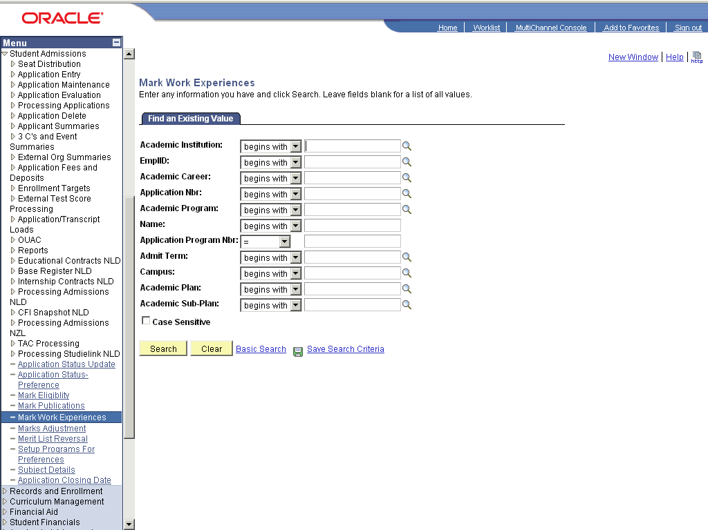

Step | Action
 | Enter the desired information into the EmplID: field. Enter "3424".
 | Press [Enter].
 | Click the MSCIT link.
 | Click the Look up Seq. Number (Alt+5) graphic.
 | Click the Techlogix Pvt. Limited link.
 | Click the option.
 | Click the Save button.
 | End of Procedure.

Evaluating Applicants

Determine Eligibility Report

Procedure

This report assists in identifying ineligible applicants.
Note:
Age of each applicant is calculated by taking difference of date of birth of applicant with application closing date.

If no date of birth of applicant or application closing date for the program is not set in system, then report will show -1 in age column.

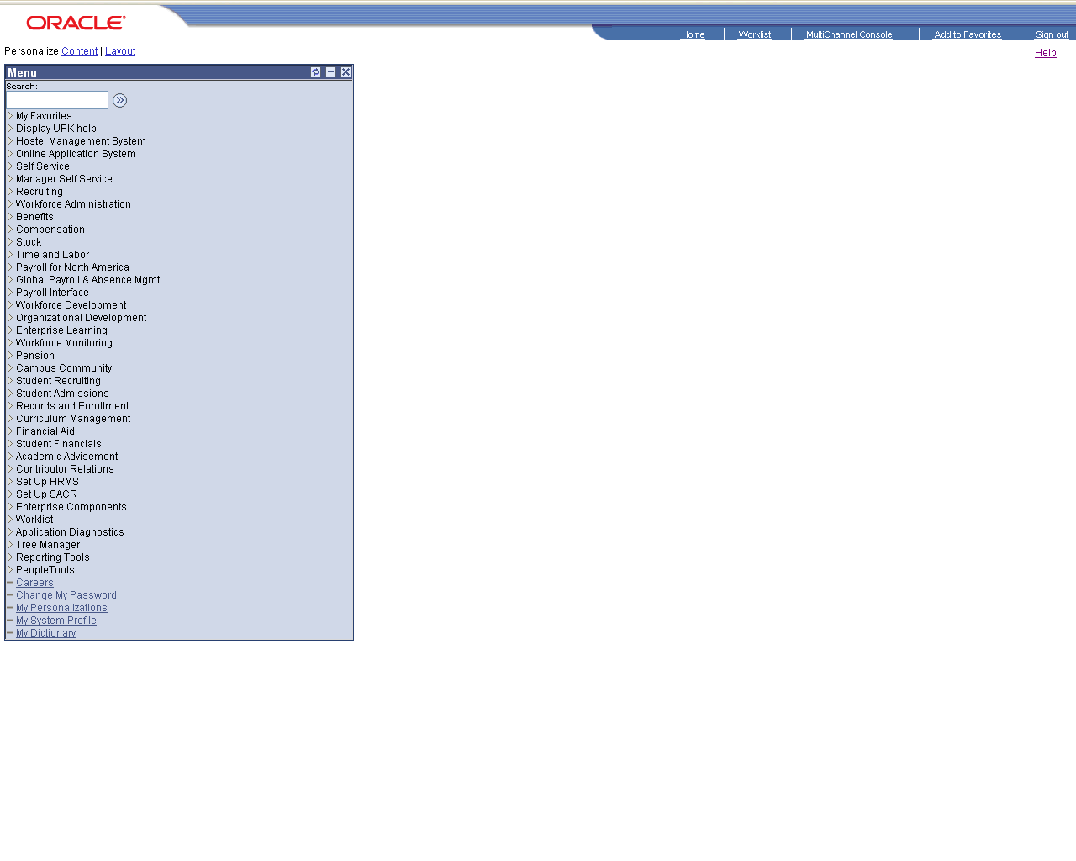

Step | Action
 | Click the Reporting Tools link.

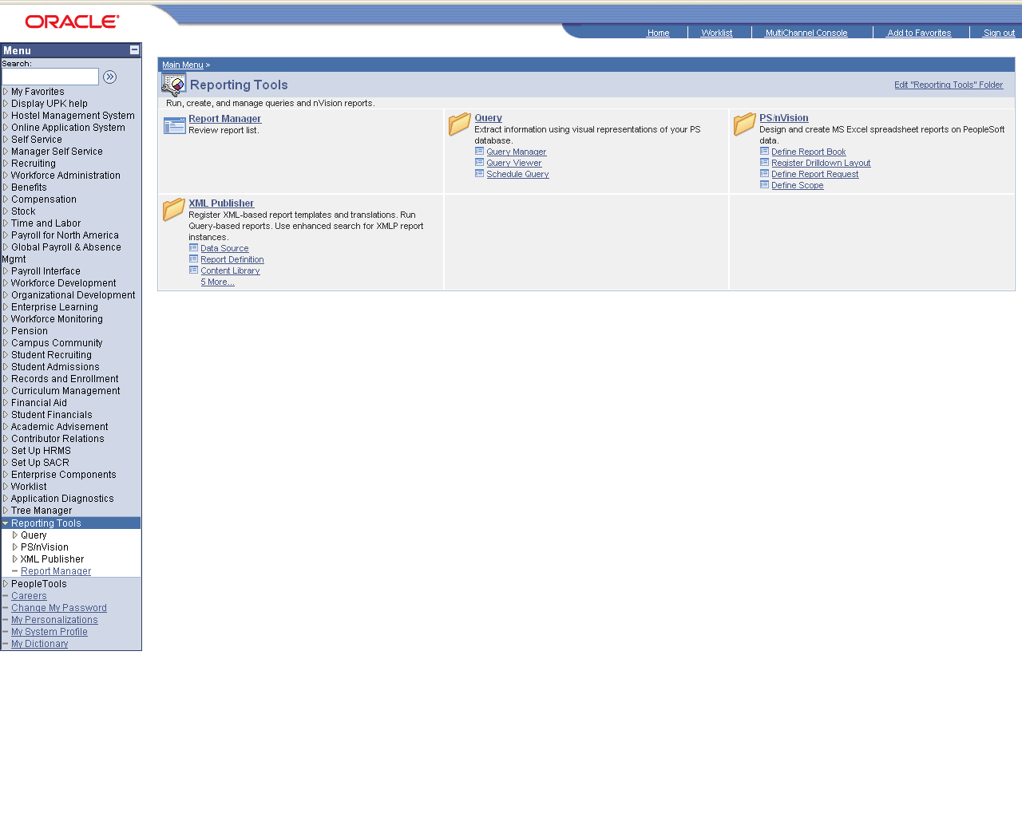

Step | Action
 | Click the XML Publisher link.
 | Click the Query Report Viewer link.

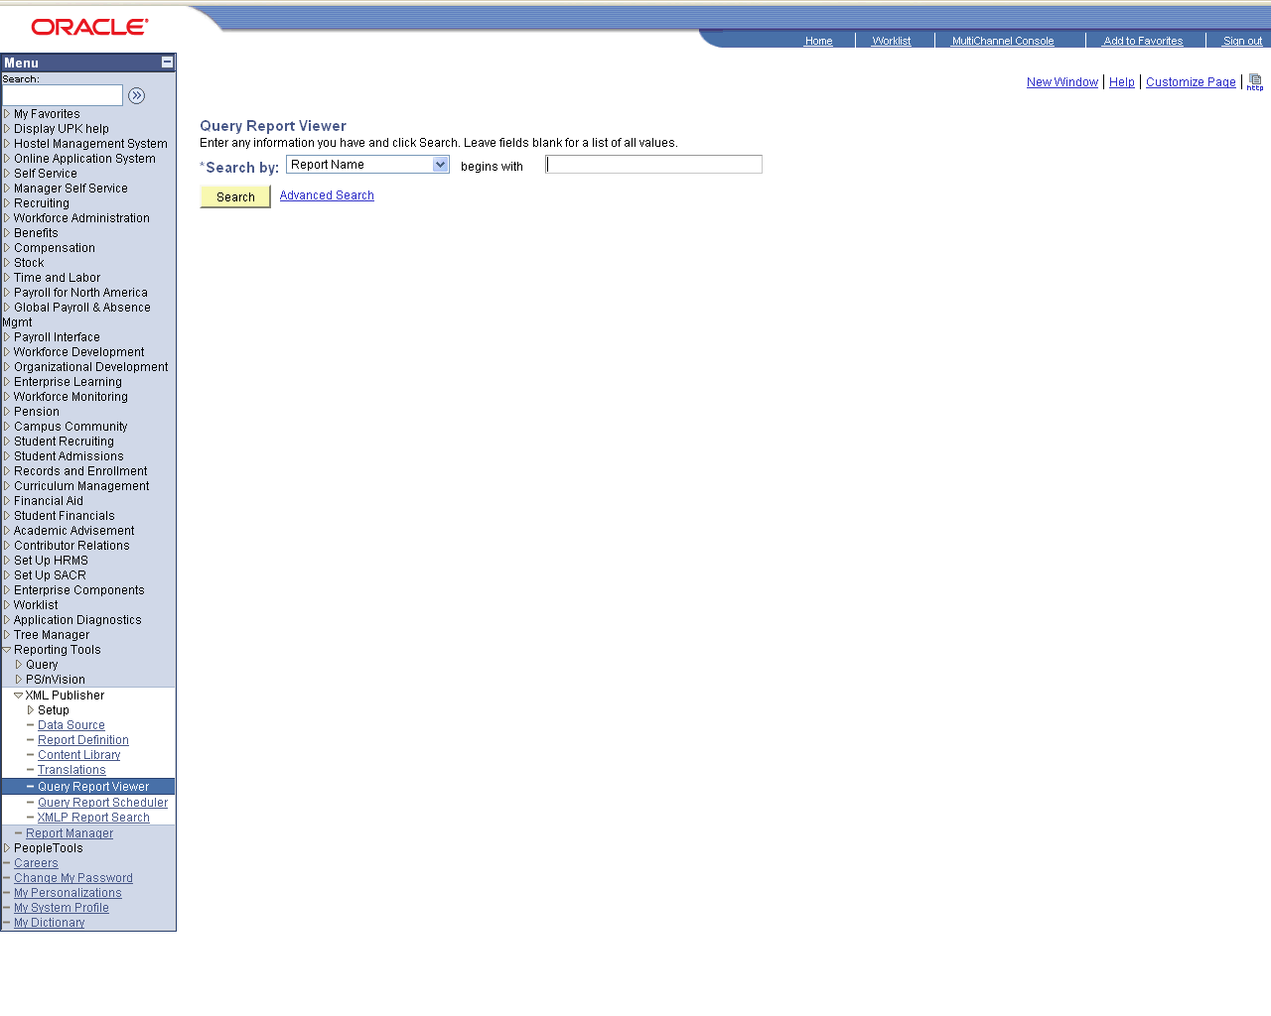

Step | Action
 | Enter the desired information into the field. Enter "PU_DET_ELIG".
 | Click the Search button.
 | Click the View Report link.
 | Enter the desired information into the field. Enter "PU".
 | Enter the desired information into the Career: field. Enter "GRAD".
 | Enter the desired information into the Admit Term: field. Enter "0913".
 | Enter the desired information into the Program: field. Enter "MSCIT".
 | Enter the desired information into the Campus: field. Enter "AIQBL".
 | Enter the desired information into the Academic Plan: field. Enter "MSCIT".
 | Enter the desired information into the Academic Sub-Plan: field. Enter "MORN".
 | Enter the desired information into the Admit Type: field. Enter "OPN".
 | Click the OK button.
 | Click the object.

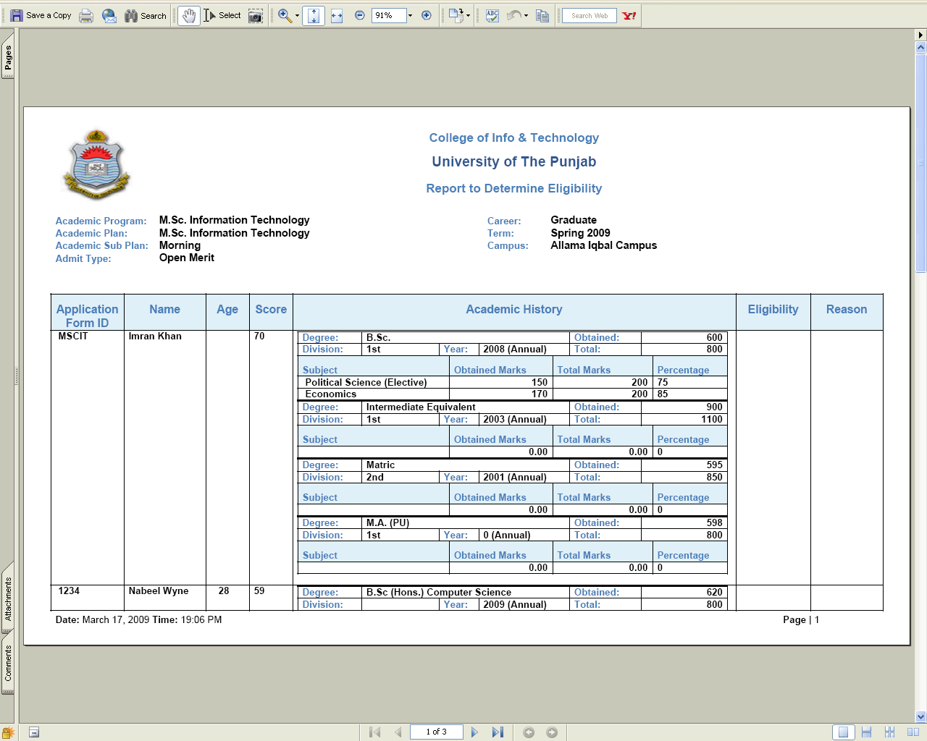

Step | Action
 | Press [Page Down].
 | Press [Page Down].
 | End of Procedure.

Mark Ineligible Applicants

Procedure

Note:
By default all applicants are eligible.
After taking decision of ineligible applicants from "Determine Eligibility Report", mark ineligible applicants. The applicants marked ineligible will not be considered in the merit list evaluation process.

Step | Action
 | Click the Student Admissions link.

Step | Action
 | Click the Mark Eligiblity link.

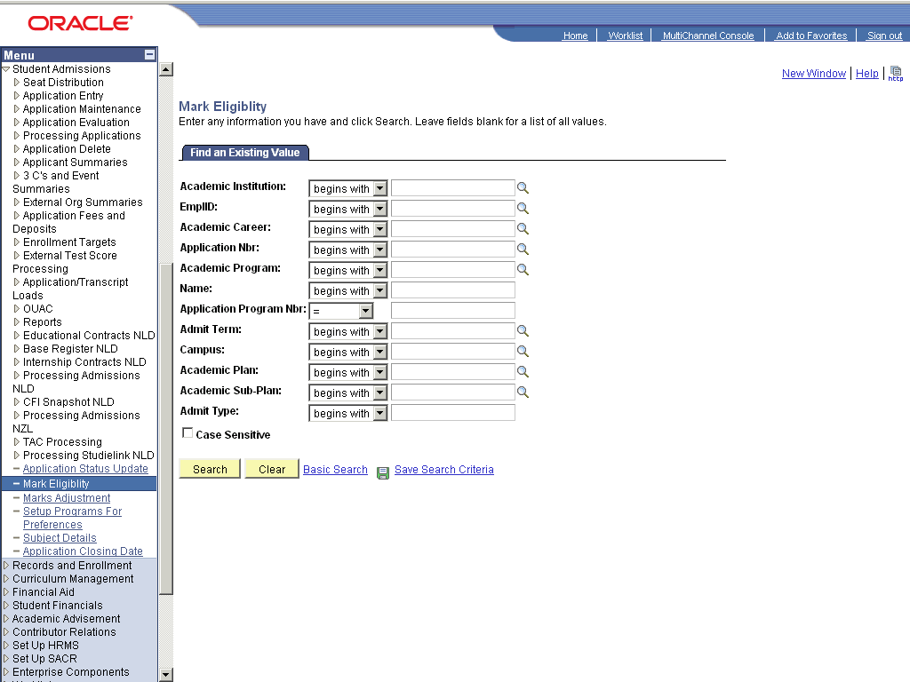

Step | Action
 | Enter the desired information into the EmplID: field. Enter "0050".
 | Click the Search button.
 | Click the option.
 | Click the Save button.
 | End of Procedure.

Ineligible Applicants Report

Procedure

This report shows the list of ineligible applicants.

Step | Action
 | Click the Reporting Tools link.

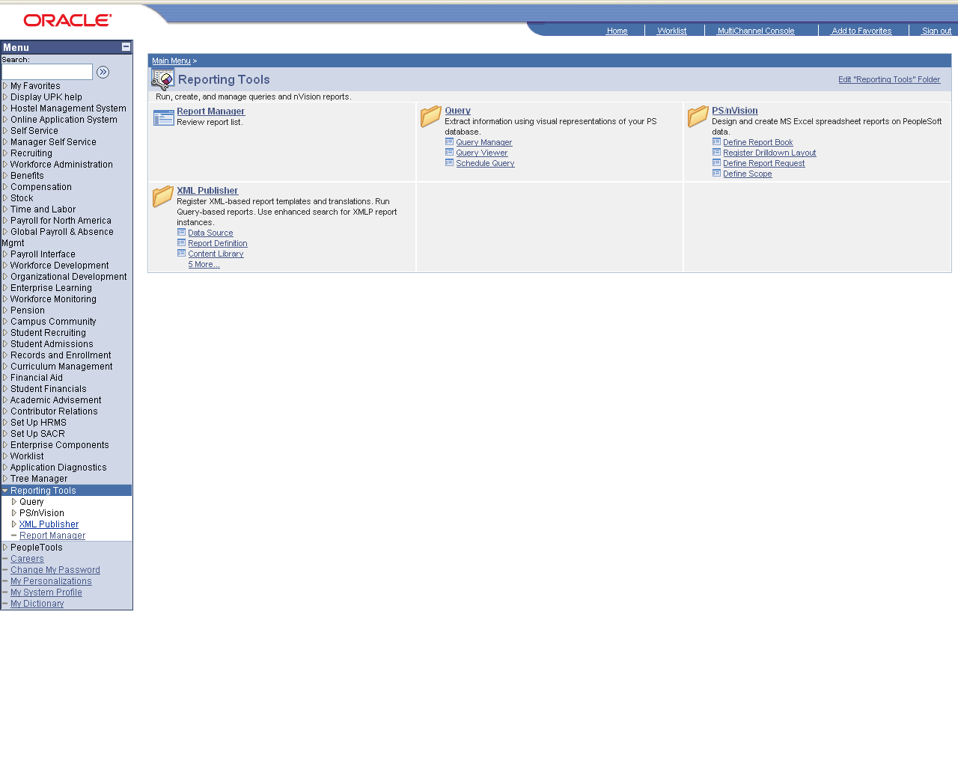

Step | Action
 | Click the XML Publisher link.
 | Click the Query Report Viewer link.

Step | Action
 | Enter the desired information into the field. Enter "PU_INELIG_CA".
 | Click the Search button.
 | Click the View Report link.
 | Enter the desired information into the Institution: field. Enter "PU".
 | Enter the desired information into the Career: field. Enter "GRAD".
 | Enter the desired information into the Admit Term: field. Enter "0913".
 | Enter the desired information into the Acad Prog: field. Enter "MSCIT".
 | Enter the desired information into the Campus: field. Enter "AIQBL".
 | Enter the desired information into the Acad Plan: field. Enter "MSCIT".
 | Enter the desired information into the Sub-Plan: field. Enter "MORN".
 | Enter the desired information into the Admit Type: field. Enter "OPN".
 | Click the OK button.

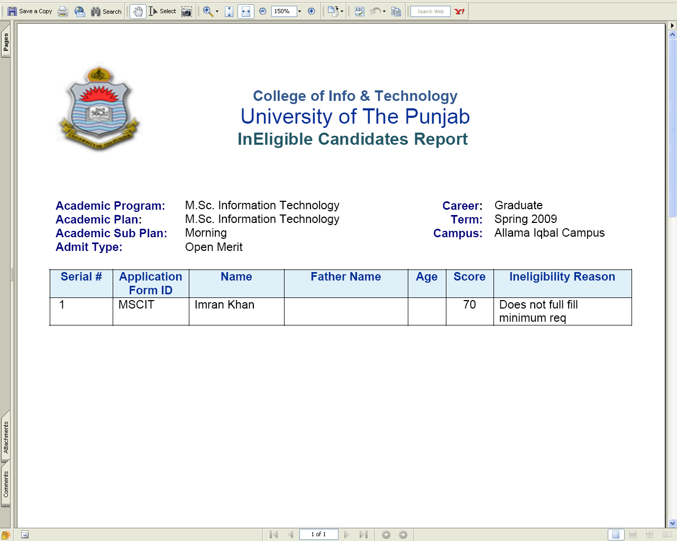

Step | Action
 | Point to the AVPageView object.
 | End of Procedure.

Adding Positive and Negative Adjustments of Applicants

Procedure

There are two types of adjustments
1. Positive:
Additional marks are given as positive adjustments. e.g., 20 additional marks if an applicant has studied specific subject in previous education.
2. Negative:
Deductions are given as negative adjustments. e.g., There is 2 marks deduction from total merit with each year lost.

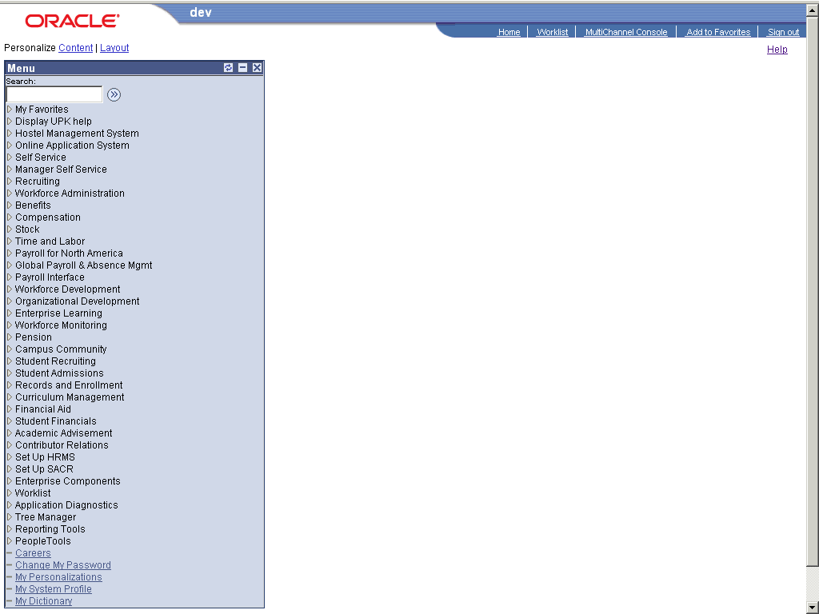

Step | Action
 | Click the Student Admissions link.

Step | Action
 | Click the Marks Adjustment link.

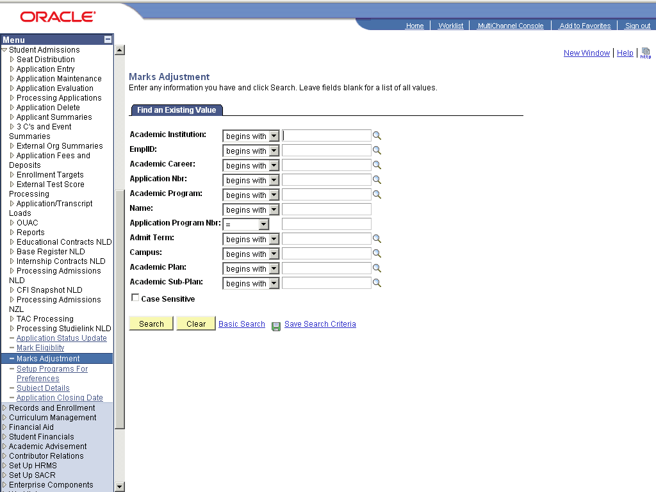

Step | Action
 | Enter the desired information into the EmplID: field. Enter "0053".
 | Click the Search button.
 | Click the option.
 | Enter the desired information into the field. Enter "40".
 | Enter the desired information into the field. Enter "Diploma in Graphic Design From UCAD".
 | Click the Add a new row at row 1 (Alt+7) graphic.
 | Click the option.
 | Enter the desired information into the field. Enter "2".
 | Enter the desired information into the field. Enter "1 Year Lost".
 | Click the Save button.
 | End of Procedure.

Run Jobset to Evaluate Applicants

Procedure

Pre-Requisite:
Create "JobSet" definition using Pre-Setup Admission tasks. All Evaluation Processes must be setup before running this jobset.

Step | Action
 | Click the PeopleTools link.

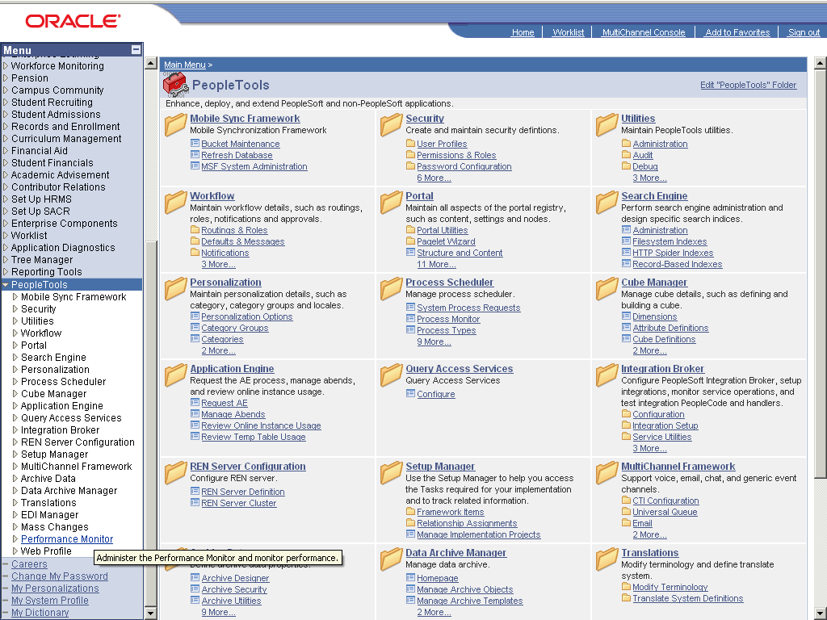

Step | Action
 | Click the Process Scheduler link.
 | Click the Schedule JobSet Definitions link.

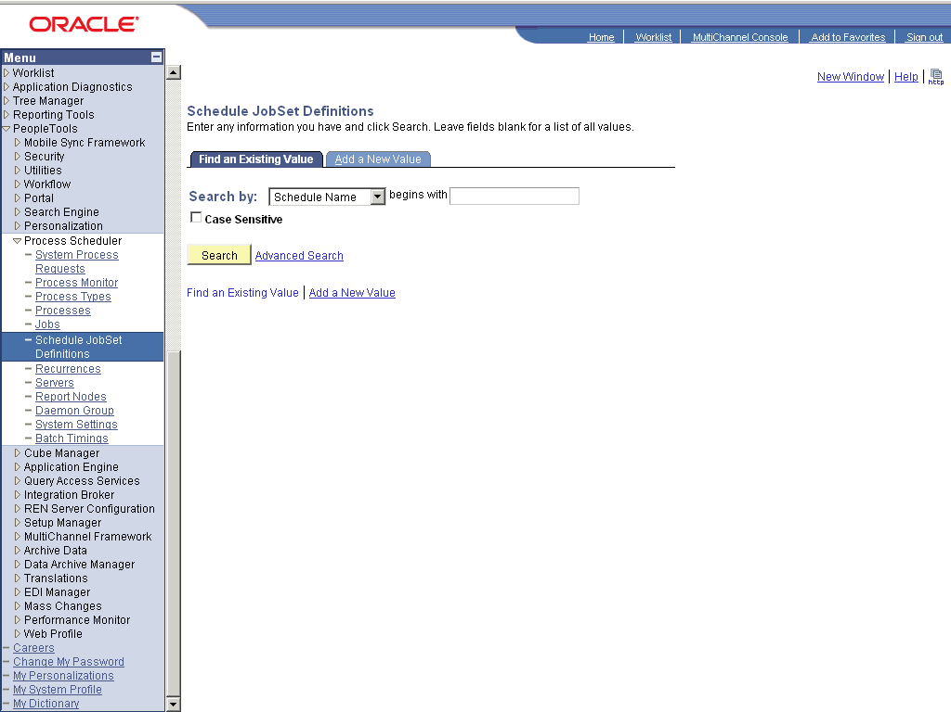

Step | Action
 | Enter the desired information into the field. Enter "PU_MSCIT_EVAL".
 | Click the Search button.
 | Click the Run Now button.
 | Click the Process Monitor link.
 | Click the Refresh button.
 | End of Procedure.

Merit List

Generate General Merit List Report

Procedure

Step | Action
 | Click the Reporting Tools link.

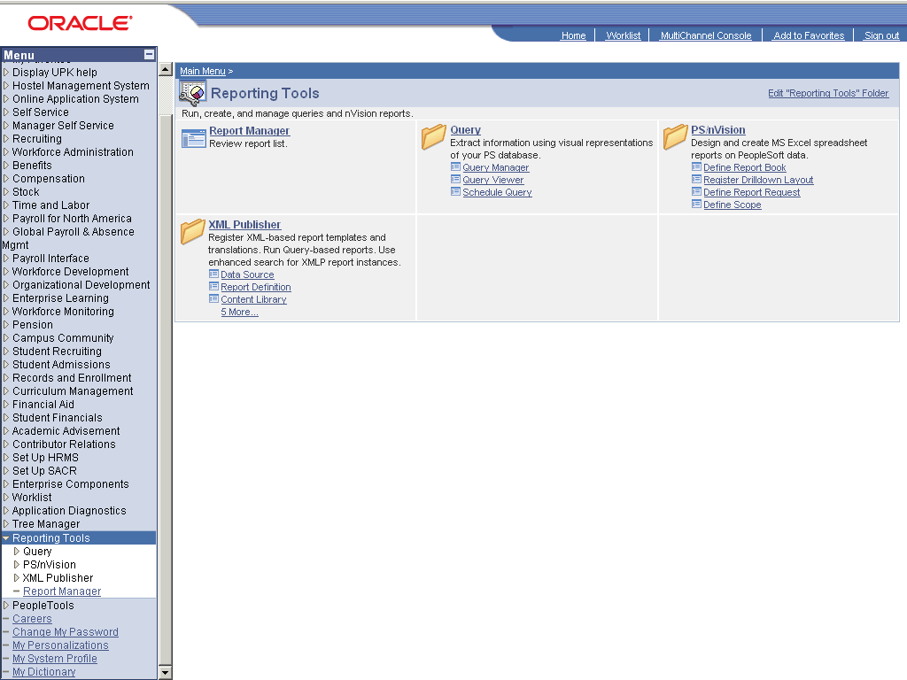

Step | Action
 | Click the XML Publisher link.
 | Click the Query Report Viewer link.

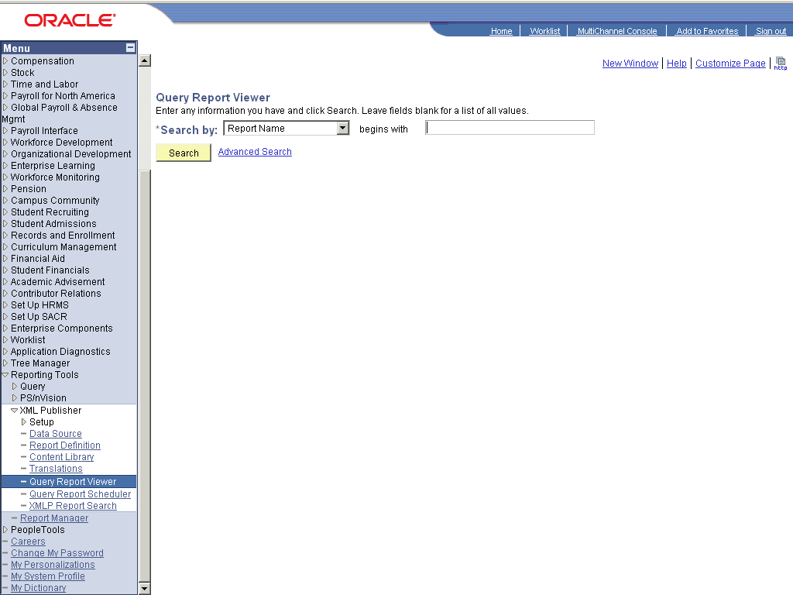

Step | Action
 | Enter the desired information into the field. Enter "PU_GMLST_GRD".
 | Click the Search button.
 | Click the View Report link.
 | Enter the desired information into the Institution: field. Enter "PU".
 | Enter the desired information into the Career: field. Enter "GRAD".
 | Enter the desired information into the Admit Term: field. Enter "0913".
 | Enter the desired information into the Program: field. Enter "MSCIT".
 | Enter the desired information into the Campus: field. Enter "AIQBL".
 | Click the OK button.
 | Scroll the object with the mouse wheel.
 | End of Procedure.

Finalize Seat Allocation

Procedure

All the applicants have ''APPL" status in the system. If you want to show applicant is the merit list report, you need to change his status from "APPL" to "COND".
Conditionally Admit (COND):
"COND" is the status that shows the admission offer to an applicant. Seat is not reserved on COND status.
If the candidate does not depsite admision dues, his/her admission will not be confirmed.

Step | Action
 | Click the Student Admissions link.

Step | Action
 | Click the Application Status Update link.

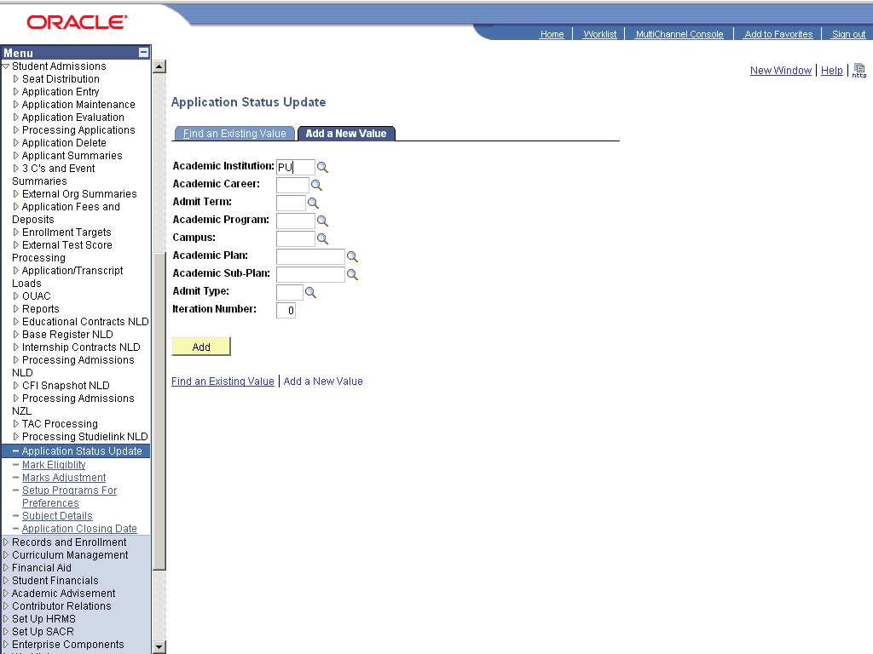

Step | Action
 | Enter the desired information into the Academic Career: field. Enter "GRAD".
 | Enter the desired information into the Admit Term: field. Enter "0913".
 | Enter the desired information into the Academic Program: field. Enter "MSCIT".
 | Enter the desired information into the Campus: field. Enter "AIQBL".
 | Enter the desired information into the Academic Plan: field. Enter "MSCIT".
 | Enter the desired information into the Academic Sub-Plan: field. Enter "MORN".
 | Enter the desired information into the Admit Type: field. Enter "OPN".
 | Click the Add button.
 | Click the Education link.
 | Click the View Subject(s) button.

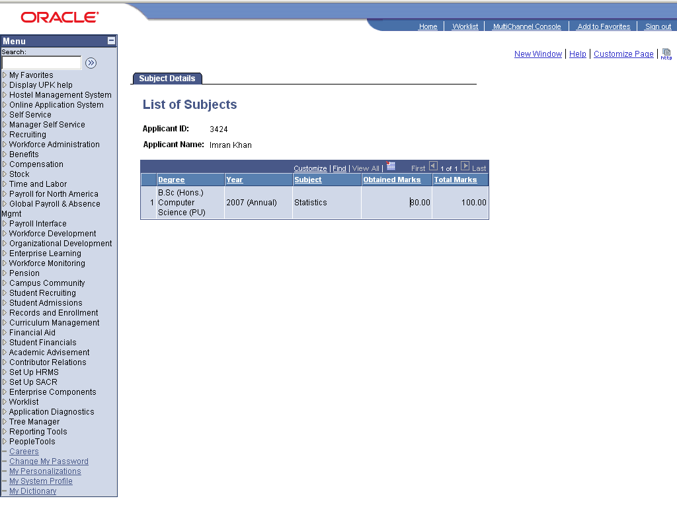

Step | Action
 | Point to the titlebar.

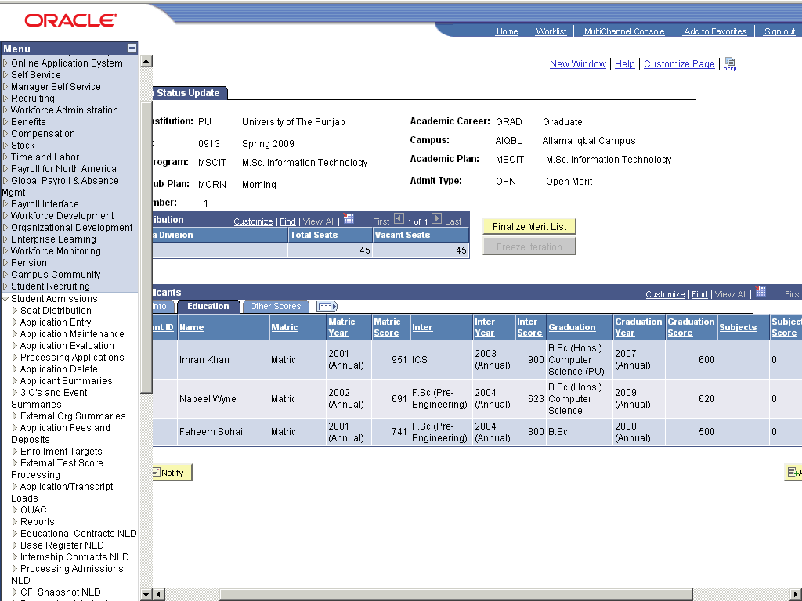

Step | Action
 | Click the Other Scores link.
 | Click the Show all columns graphic.
 | Click the Applicant Info link.
 | Enter the desired information into the field. Enter "COND".
 | Enter the desired information into the field. Enter "Give any remarks here.".
 | Enter the desired information into the field. Enter "COND".
 | Enter the desired information into the field. Enter "Give any remarks here.".
 | Click the Save button.
Click the Finalize Merit List button.
Note:
Click this button, if you have finalized seat allocation for applicants that should be in merit list report.
 | Click the OK button.
After Finalizing Seat Allocation, you can generate merit list report.
End of Procedure.

Generate Merit List Report

Procedure

Step | Action
 | Click the Reporting Tools link.

Step | Action
 | Click the XML Publisher link.
 | Click the Query Report Viewer link.

Step | Action
 | Enter the desired information into the field. Enter "PU_MLIST_GD".
 | Click the Search button.
 | Click the View Report link.
 | Enter the desired information into the Institution: field. Enter "PU".
 | Enter the desired information into the Career: field. Enter "GRAD".
 | Enter the desired information into the Admit Term: field. Enter "0913".
 | Enter the desired information into the Program: field. Enter "MSCIT".
 | Enter the desired information into the Campus: field. Enter "AIQBL".
 | Enter the desired information into the Academic Plan: field. Enter "MSCIT".
 | Enter the desired information into the Academic Sub Plan: field. Enter "MORN".
 | Enter the desired information into the Admit Type: field. Enter "OPN".
 | Enter the desired information into the Iteration Number: field. Enter "1".
 | Click the OK button.

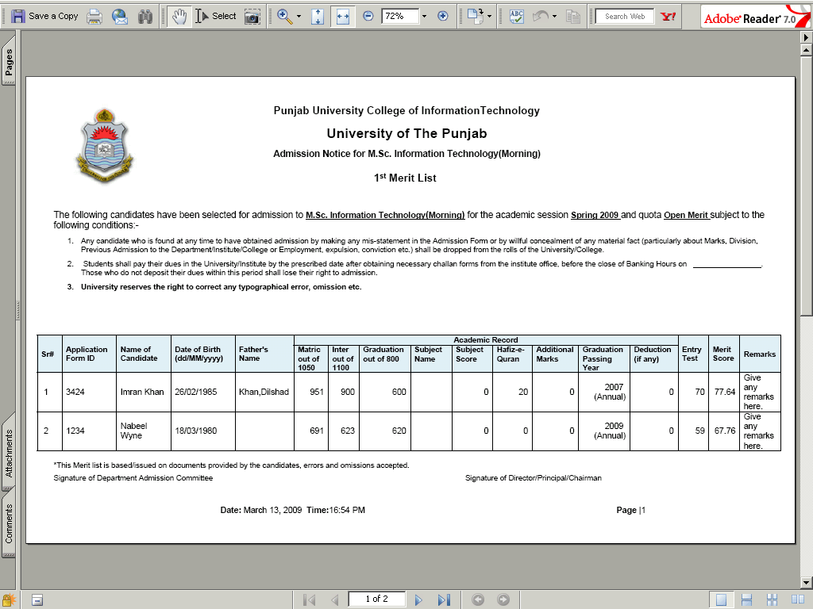

Step | Action
 | Click the AVPageView object.
 | End of Procedure.

Reverse Merit List (If Required)

Procedure

Note:
You can reverse current merit list iteration after finalizing merit list. But you cannot reverse it once it gets frozen.

Merit list can be reversed in the following scenario
1. If new applicant is added after finalizing seat allocation.
2. Educational or test marks of applicant(s) is updated.
3. If some applicant is considered in merit list by mistake.

Step | Action
 | Click the Student Admissions link.

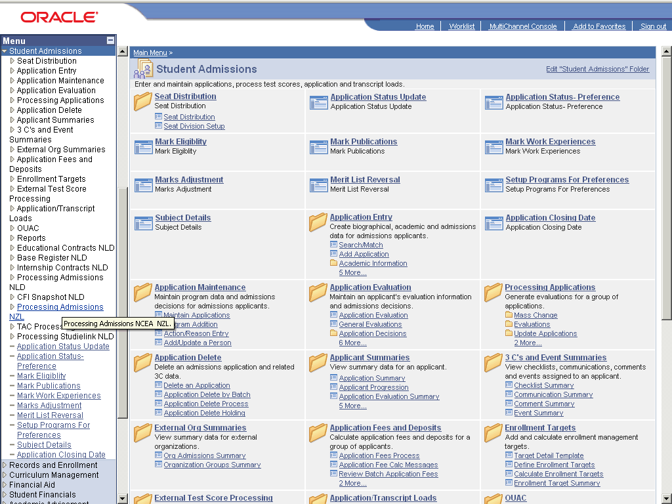

Step | Action
 | Click the Merit List Reversal link.

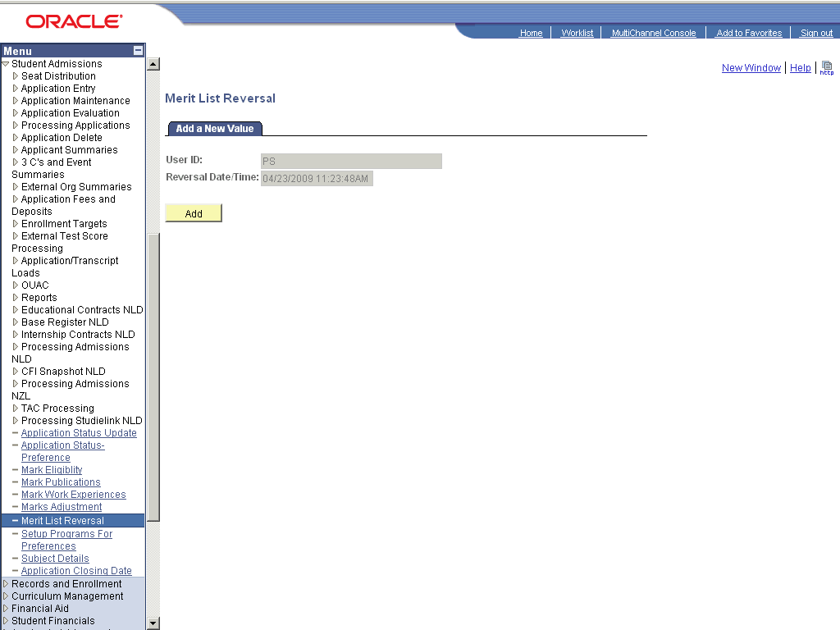

Step | Action
 | Click the Add button.
 | Enter the desired information into the *Academic Career: field. Enter "GRAD".
 | Enter the desired information into the *Admit Term: field. Enter "0913".
 | Enter the desired information into the *Admit Type: field. Enter "OPN".
 | Enter the desired information into the *Reason: field. Enter "Any Reason".
 | Enter the desired information into the Academic Program: field. Enter "MSCIT".
 | Enter the desired information into the field. Enter "AIQBL".
 | Enter the desired information into the Academic Plan: field. Enter "MSCIT".
 | Enter the desired information into the Academic Sub-Plan: field. Enter "MORN".
 | Click the Reverse button.
 | Click the OK button.
Note:
To reverse Preference based merit list iteration click on the check box as pointed by arrow in the picture.
End of Procedure.

Generate Waiting List

Procedure

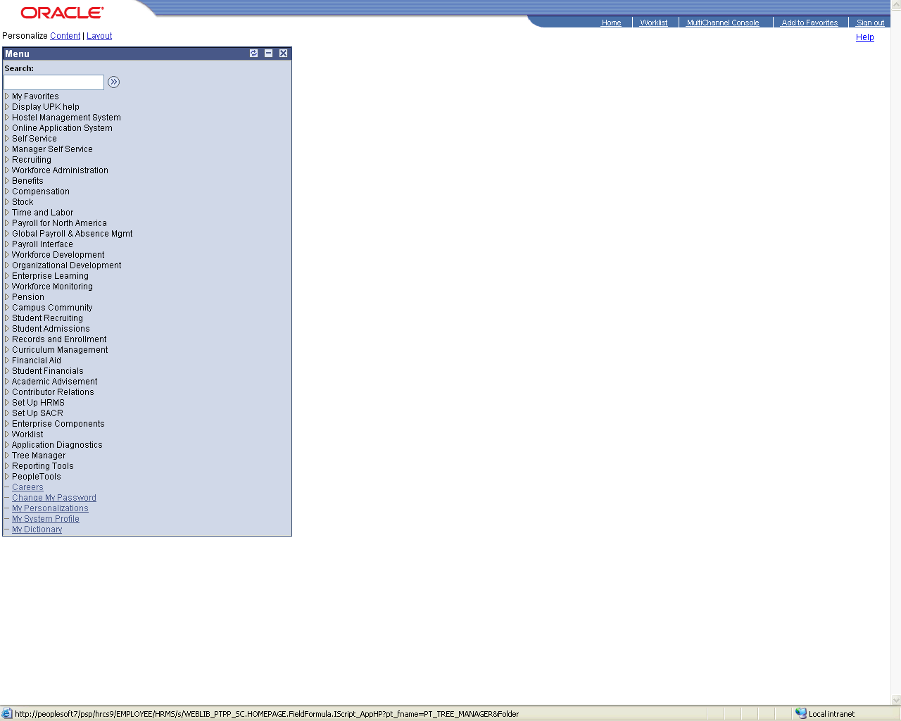

Step | Action
 | Click the Reporting Tools link.

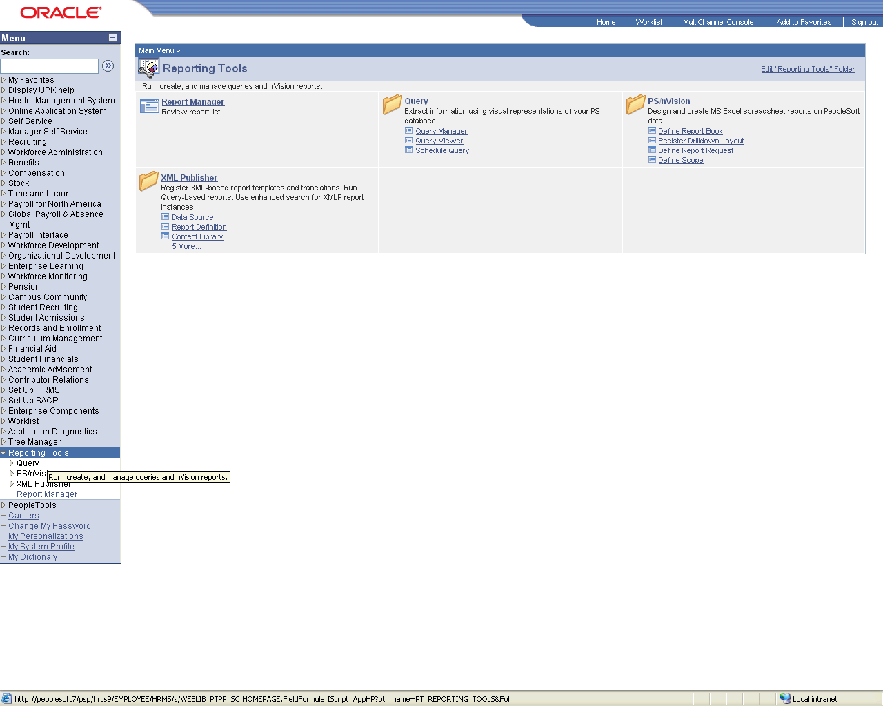

Step | Action
 | Click the XML Publisher link.
 | Click the Query Report Viewer link.

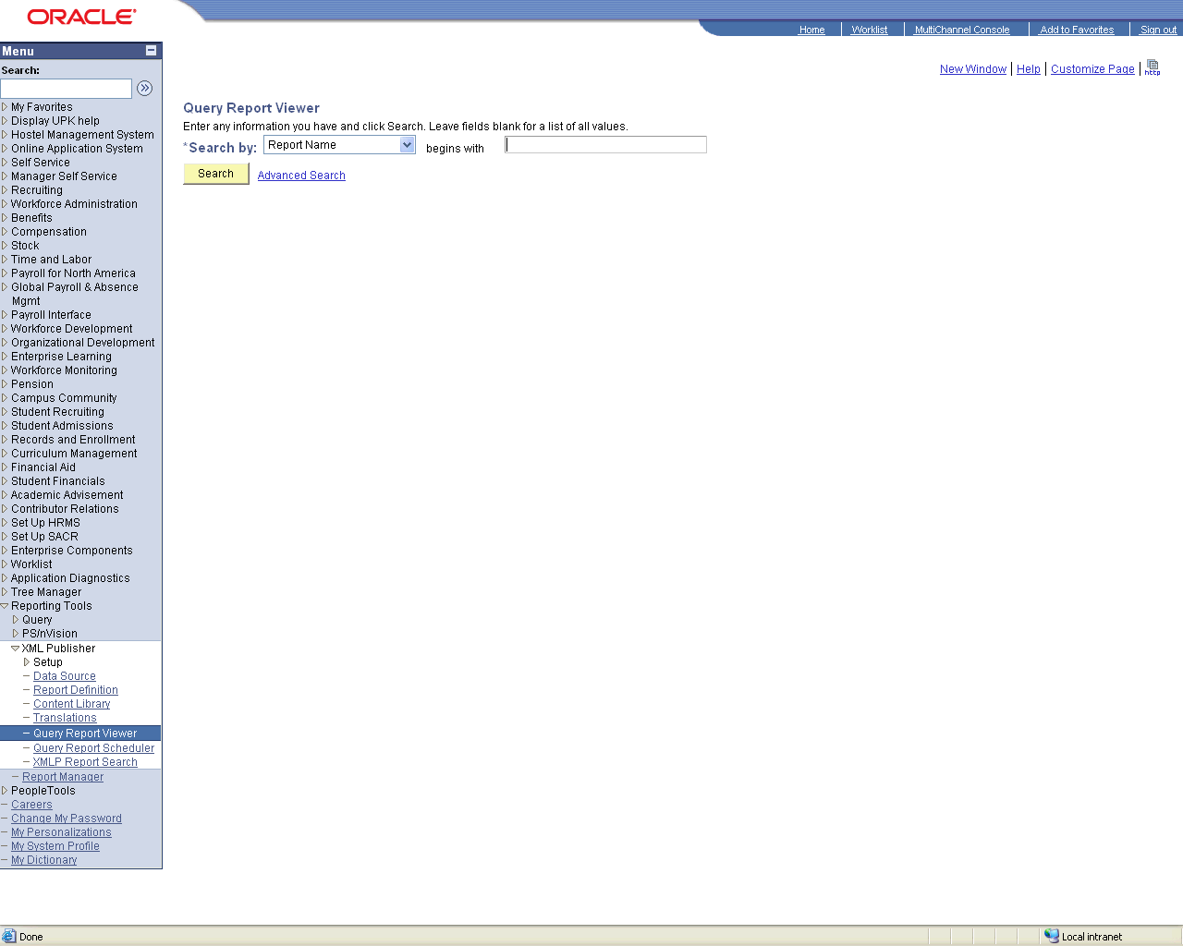

Step | Action
 | Enter the desired information into the Enter any information you have and click Search. Leave fields bl field. Enter "PU_WLIST_GRD".
 | Click the Search button.
 | Click an entry in the View Report column.
 | Enter the desired information into the Institution field. Enter "PU".
 | Enter the desired information into the Academic Career field. Enter "GRAD".
 | Enter the desired information into the Admit Term field. Enter "0913".
 | Enter the desired information into the Academic Program field. Enter "MSCIT".
 | Enter the desired information into the Campus field. Enter "AIQBL".
 | Enter the desired information into the Academic Plan field. Enter "MSCIT".
 | Enter the desired information into the Academic Sub Plan field. Enter "MORN".
 | Enter the desired information into the Admit Type field. Enter "OPN".
 | Enter the desired information into the Iteration Number field. Enter "1".
 | Click the OK button.

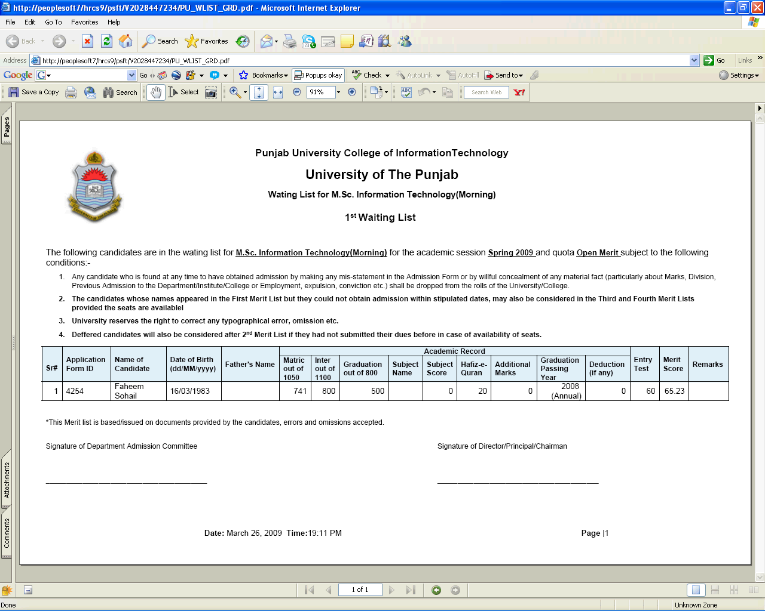

Step | Action
 | Press [F11].
 | End of Procedure.

Freeze Merit List Iteration

Procedure

Step | Action
 | Click the Student Admissions link.

Step | Action
 | Click the Application Status Update link.

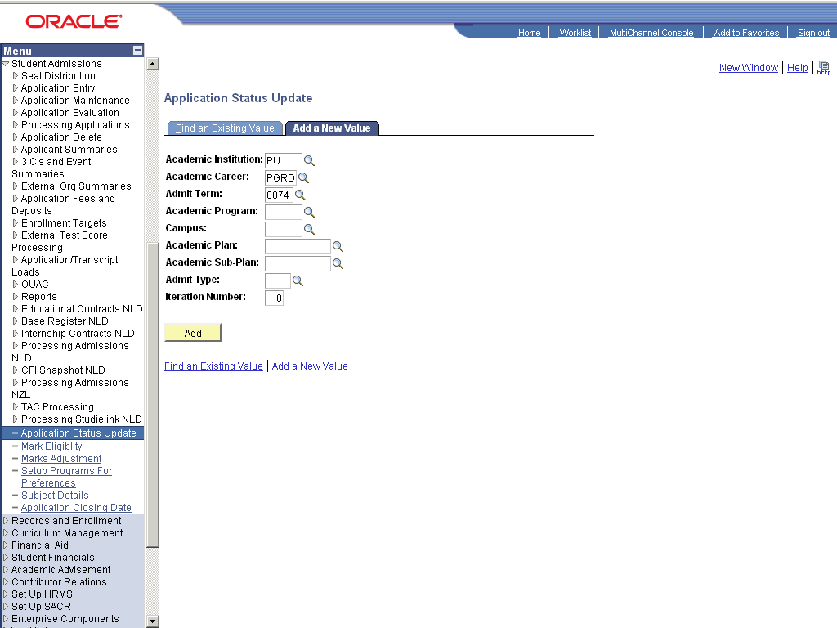

Step | Action
 | Click the ind an Existing Value link.
 | Enter the desired information into the Admit Term: field. Enter "0913".
 | Enter the desired information into the Academic Program: field. Enter "MSCIT".
 | Enter the desired information into the Academic Sub-Plan: field. Enter "MORN".
 | Enter the desired information into the Admit Type: field. Enter "OPN".
 | Enter the desired information into the Iteration Number: field. Enter "1".
 | Click the Search button.
Enter the desired information into the field. Enter "ADMT".
Change status of candidate from "COND" to "ADMT" if he/she deposits admission dues.
 | Enter the desired information into the field. Enter "Admission Fee Received.".
 | Click the Save button.
Click the Freeze Iteration button.
Note:
Once deadline to deposit admission dues for candidate closes, you have to feeze current merit list iteration, so the you can move to next iteration.
 | Click the OK button.
Point to the object.
Admission Fee for this applicant was not received, so his admission is deferred till 3rd and 4th Merit List.
Repeat same flow for 2nd, 3rd and 4th iteration.
End of Procedure.

Seat Allocation With Preference

Procedure

Step | Action
 | Click the Student Admissions link.

Step | Action
 | Click the Application Status- Preference link.

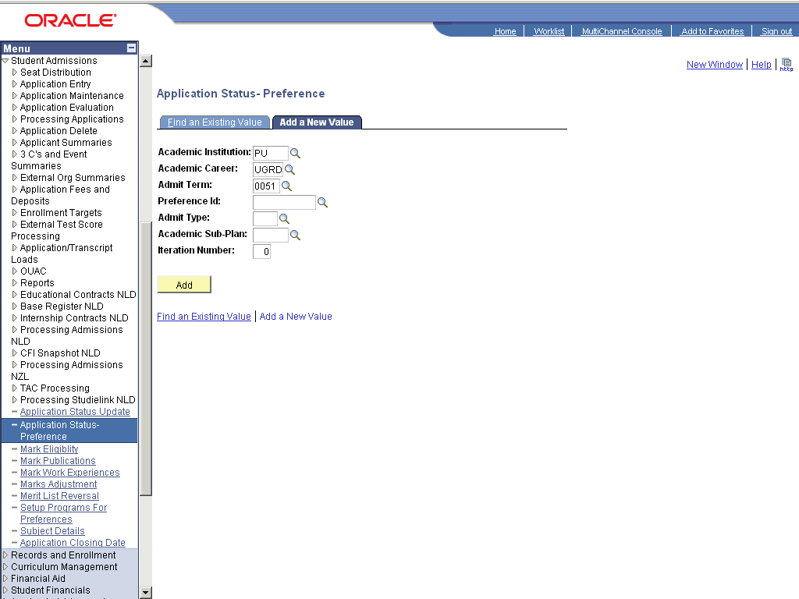

Step | Action
 | Click the Look up Preference Id (Alt+5) graphic.
 | Click the PUCIT_PREF link.
 | Enter the desired information into the Admit Type: field. Enter "OPN".
 | Click the Look up Academic Sub-Plan (Alt+5) graphic.
 | Click the ALL link.
 | Click the Add button.
 | Enter the desired information into the field. Enter "COND".
 | Click the Look up Quota Division (Alt+5) graphic.
 | Click the F.SC./ICS link.
Enter the desired information into the field. Enter ".".
In FSc Quota.
 | Click the Finalize Merit List button.
 | Click the OK button.
 | Enter the desired information into the field. Enter "ADMT".
 | Click the Freeze Iteration button.
 | Click the OK button.
 | End of Procedure.

Matriculate Individual Applicant (Make applicant a student)

Matriculate Individual Applicant

Procedure

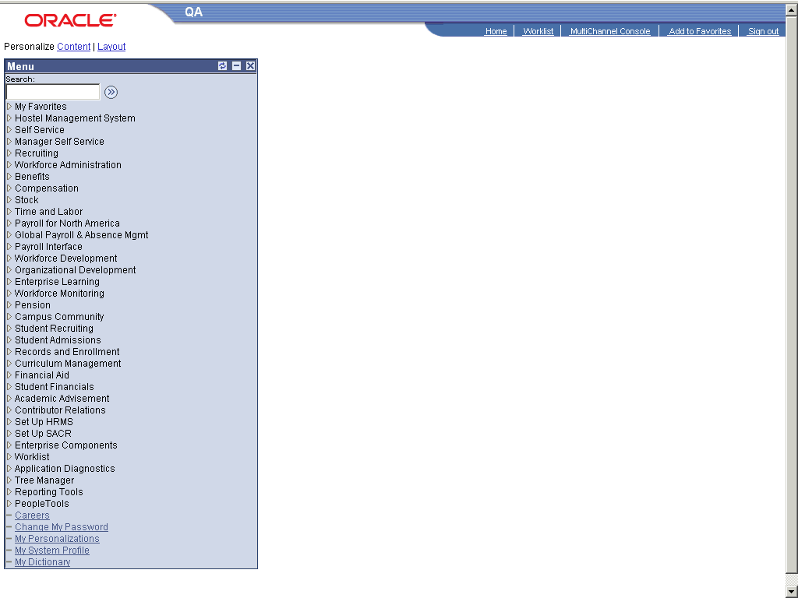

Step | Action
 | Click the Student Admissions link.

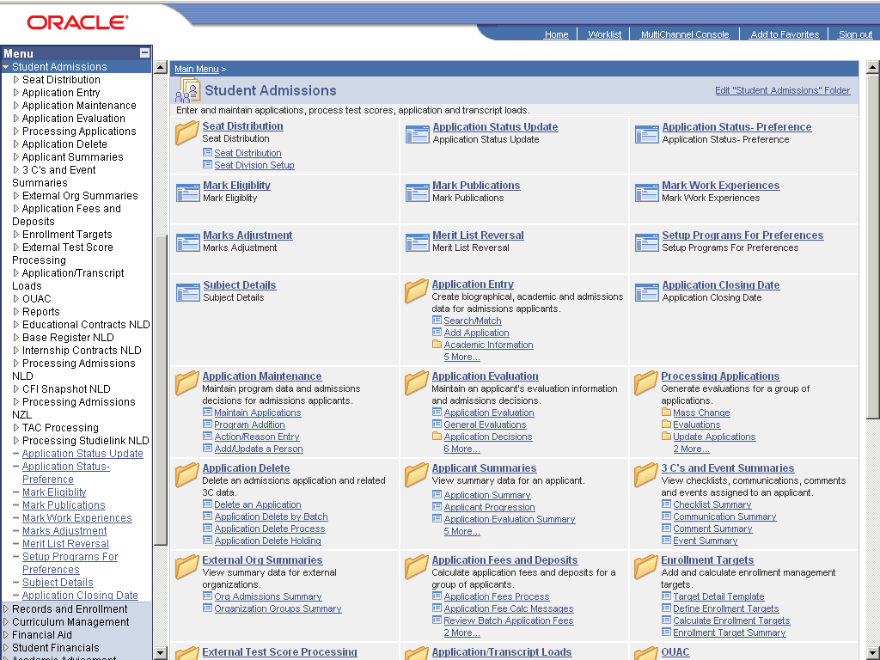

Step | Action
 | Click the Application Maintenance link.
 | Click the Maintain Applications link.

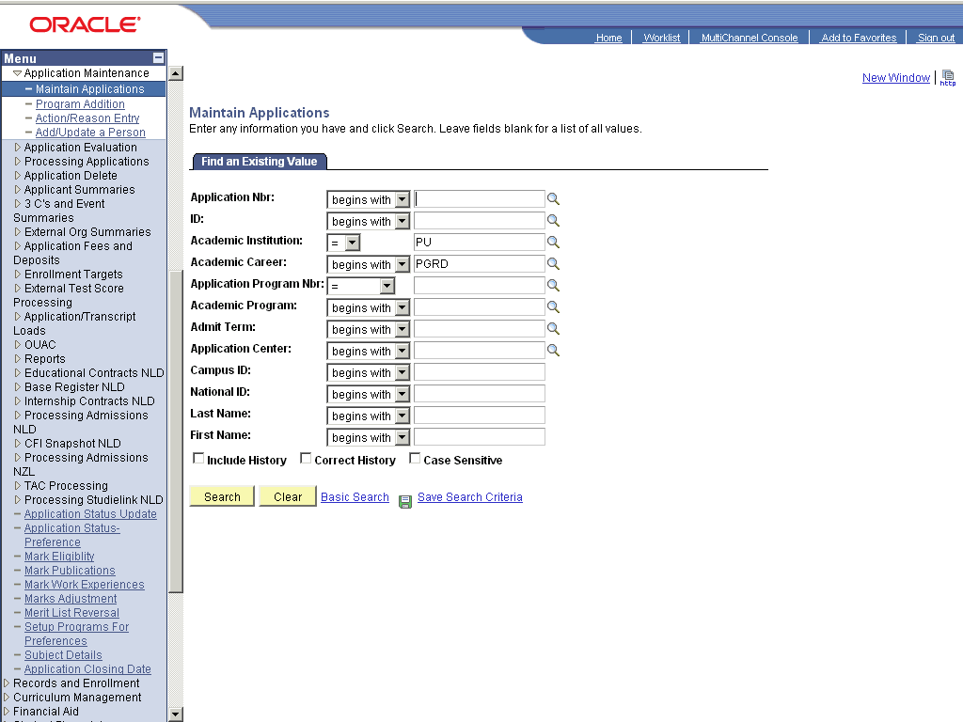

Step | Action
 | Enter the desired information into the ID: field. Enter "0044".
 | Click the Search button.
 | Click the Application Pro link.
 | Click the Correct History button.
 | Click the Add a new row at row 1 (Alt+7) graphic.
 | Enter the desired information into the *Program Action: field. Enter "MATR".
 | Press [Enter].
 | Click the Create Program button.
 | Click the Save button.
 | End of Procedure.

Matriculate Applicants in Batch

Create Mass Change to Select Applicants

Procedure

Step | Action
 | Click the Student Admissions link.

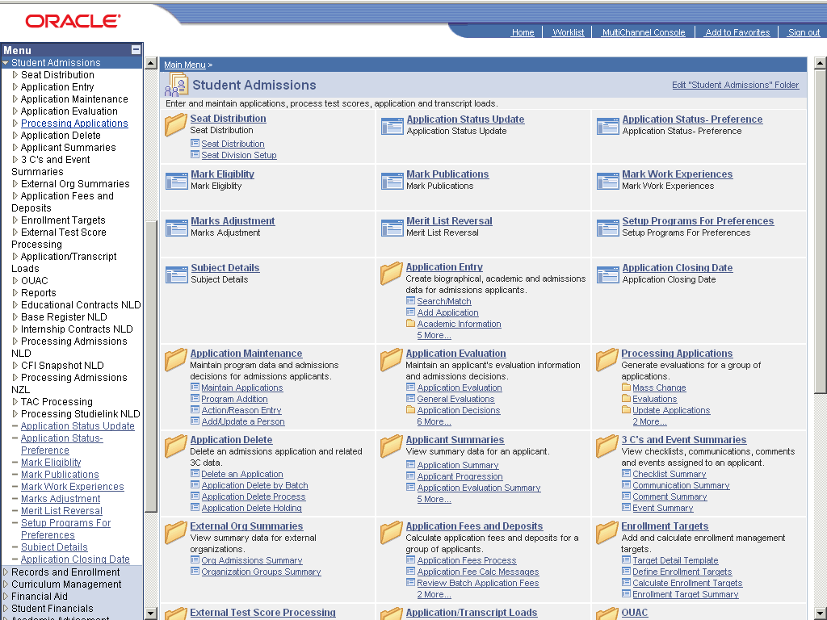

Step | Action
 | Click the Processing Applications link.
 | Click the Mass Change Definition link.

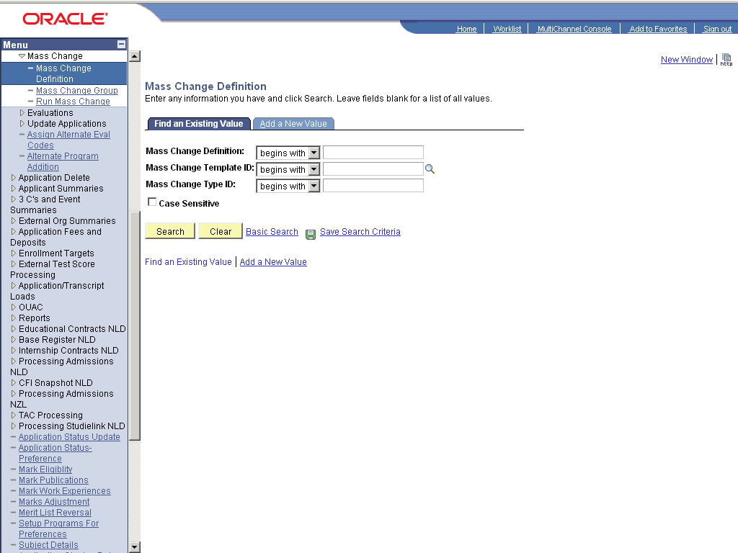

Step | Action
 | Click the dd a New Value link.
 | Enter the desired information into the Mass Change Definition: field. Enter "BSCS".
 | Click the Add button.
 | Enter the desired information into the *Mass Change Template: field. Enter "app".
 | Click the Look up Mass Change Template (Alt+5) graphic.
 | Click the Application Prog Update Select link.
 | Click the tudent Administration link.
 | Enter the desired information into the Academic Career: field. Enter "UGRD".
 | Click the riteria and Defaults link.
 | Enter the desired information into the field. Enter "MATR".
 | Click the View All link.
 | Click the list.

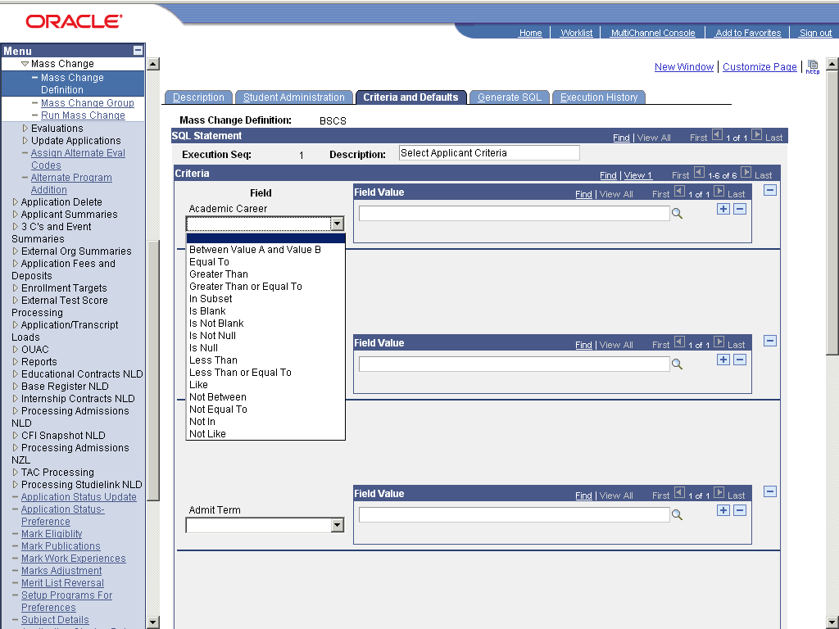

Step | Action
 | Click the cell.

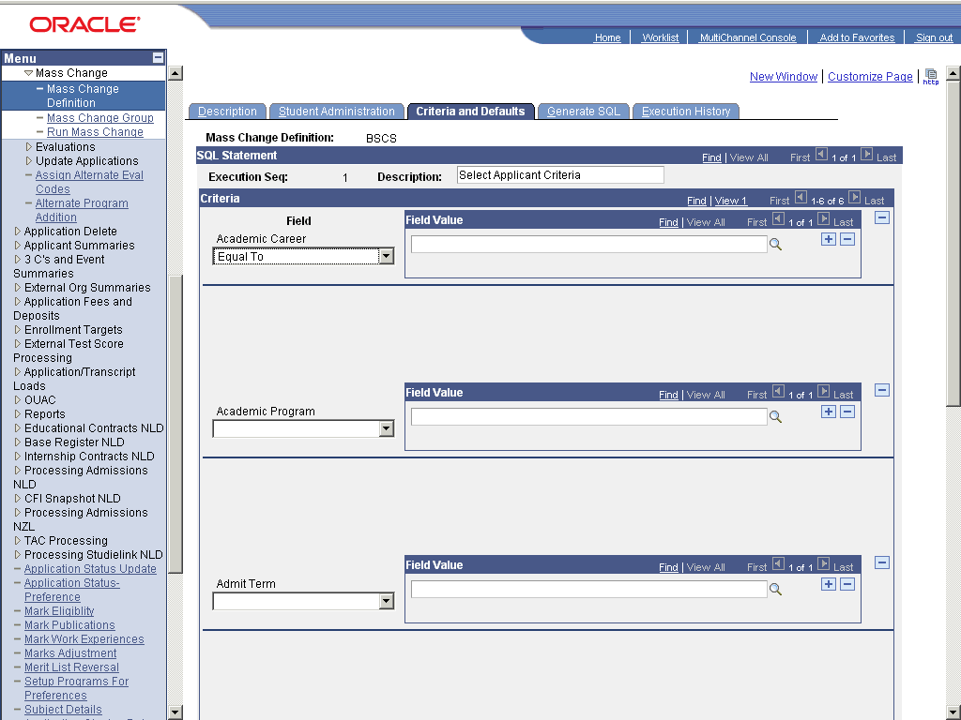

Step | Action
 | Enter the desired information into the field. Enter "UGRD".
 | Click the list.

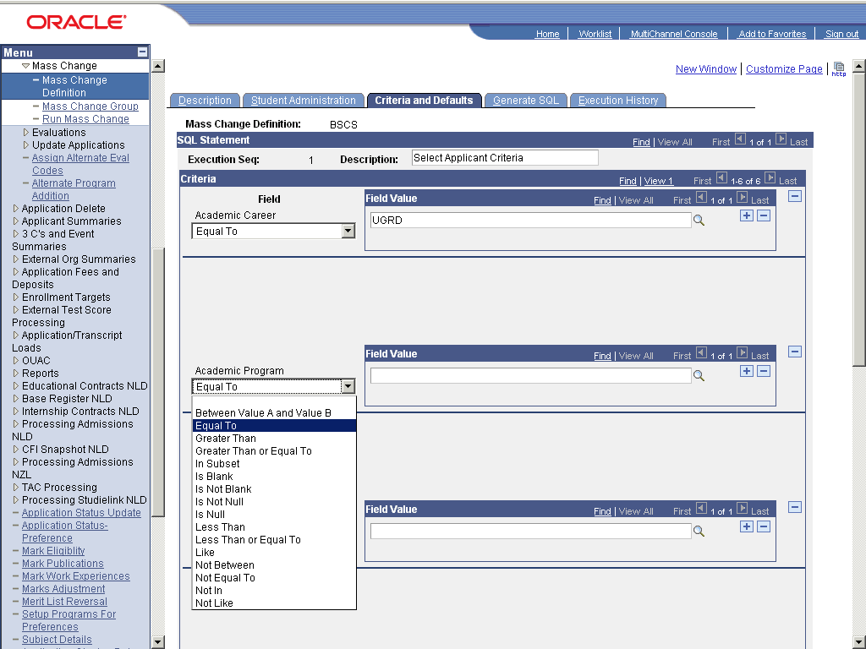

Step | Action
 | Click the cell.

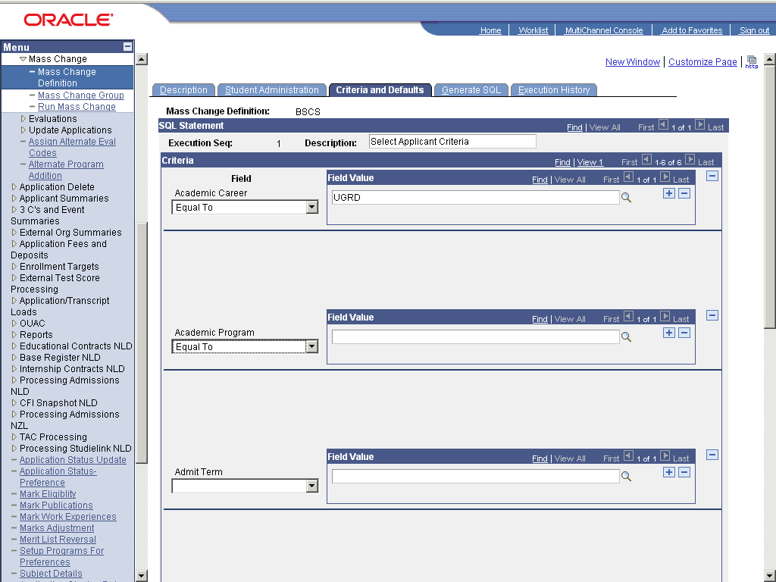

Step | Action
 | Enter the desired information into the field. Enter "BSCS".
 | Click the list.

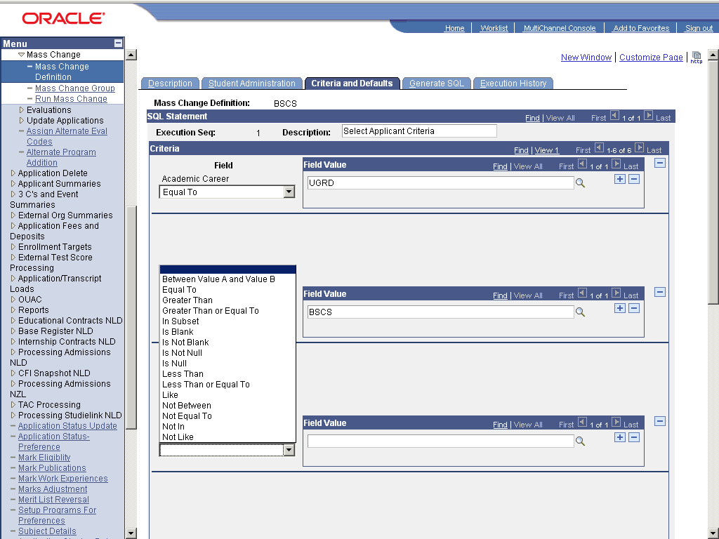

Step | Action
 | Click the cell.

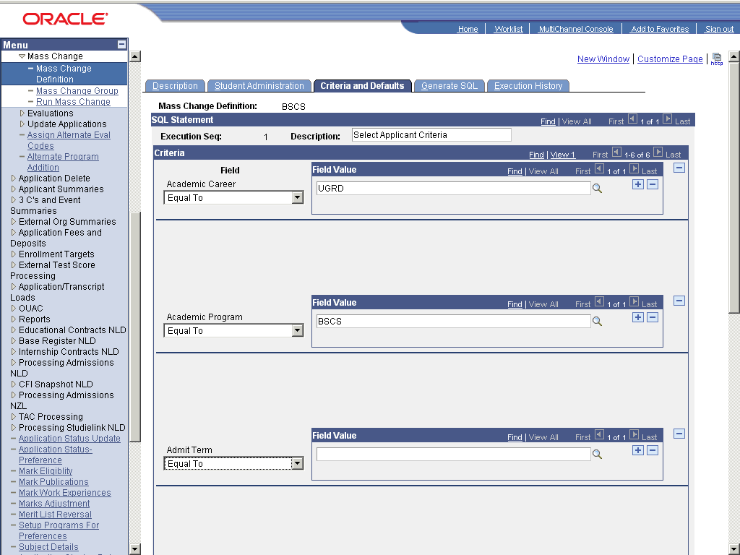

Step | Action
 | Enter the desired information into the field. Enter "0094".
 | Click the list.

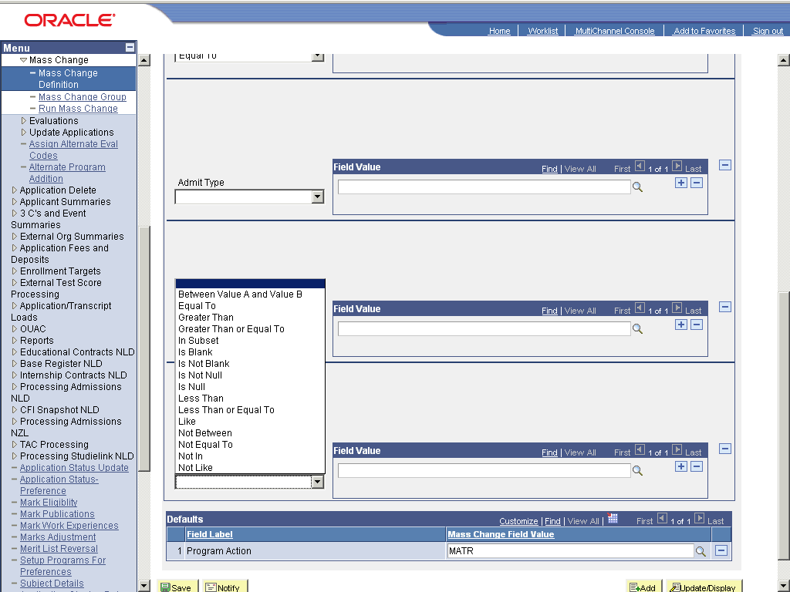

Step | Action
 | Click the cell.

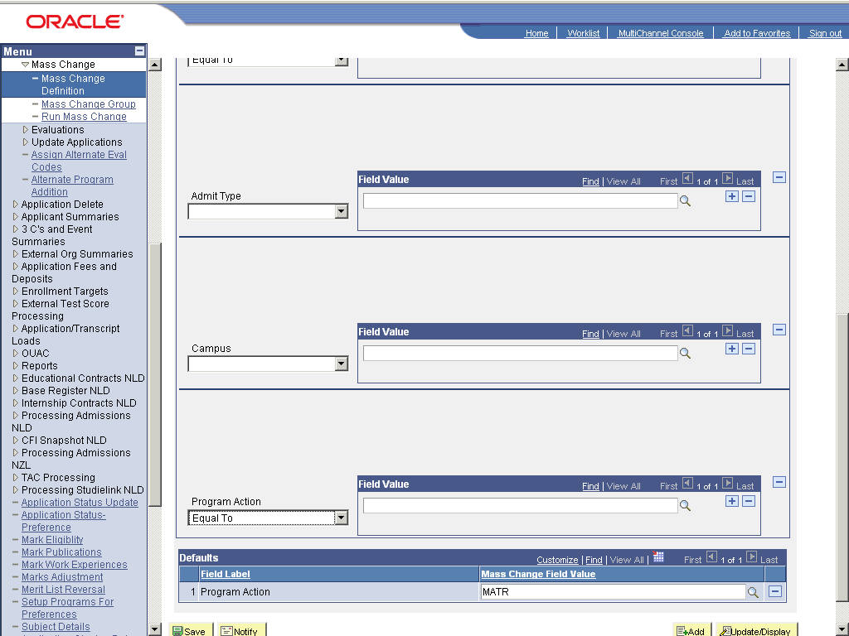

Step | Action
 | Enter the desired information into the field. Enter "ADMT".
 | Click the enerate SQL link.
 | Click the Generate button.
 | Click the Save button.
 | Click the OK button.
 | End of Procedure.

Create Mass Change Group

Procedure

Step | Action
 | Click the Student Admissions link.

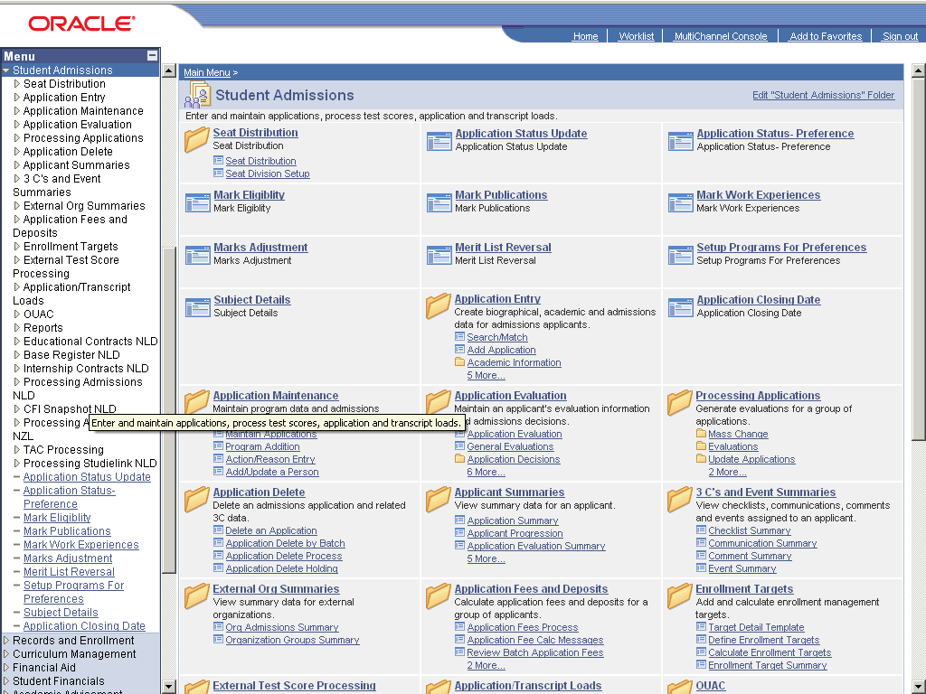

Step | Action
 | Click the Processing Applications link.
 | Click the Mass Change link.
 | Click the Mass Change Group link.

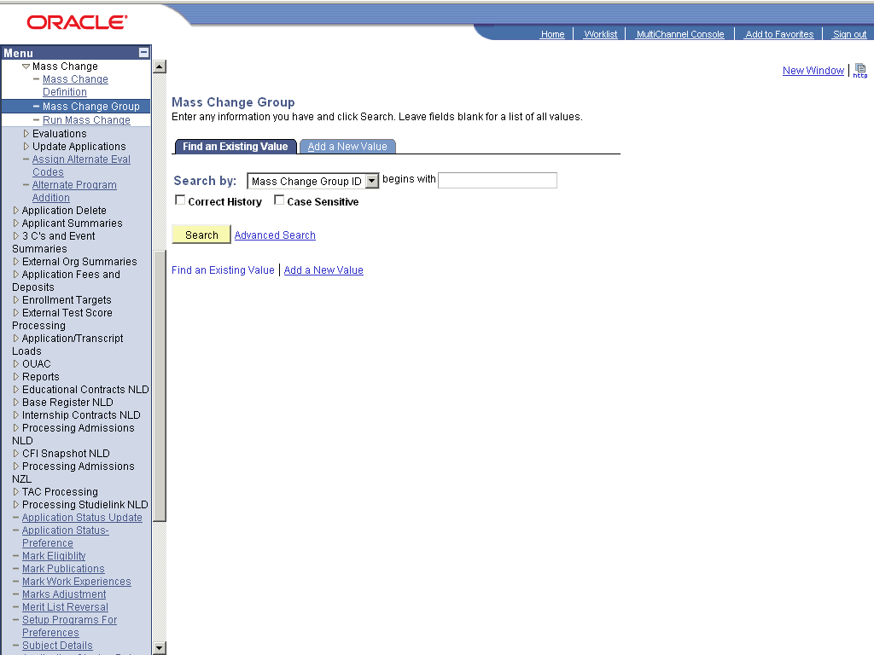

Step | Action
 | Click the dd a New Value link.
 | Enter the desired information into the Mass Change Group ID: field. Enter "UGRD_BSCS".
 | Click the Add button.
 | Enter the desired information into the field. Enter "SA".
 | Enter the desired information into the Execution Sequence field. Enter "10".
 | Enter the desired information into the *Mass Change Definition field. Enter "comm".
 | Click the Look up Mass Change Definition (Alt+5) graphic.
 | Click the Communication - Delete Temp link.
 | Click the Add a new row at row 1 (Alt+7) graphic.
 | Enter the desired information into the field. Enter "20".
 | Enter the desired information into the field. Enter "BSCS".
 | Click the Save button.
 | End of Procedure.

Run Mass Change Process

Procedure

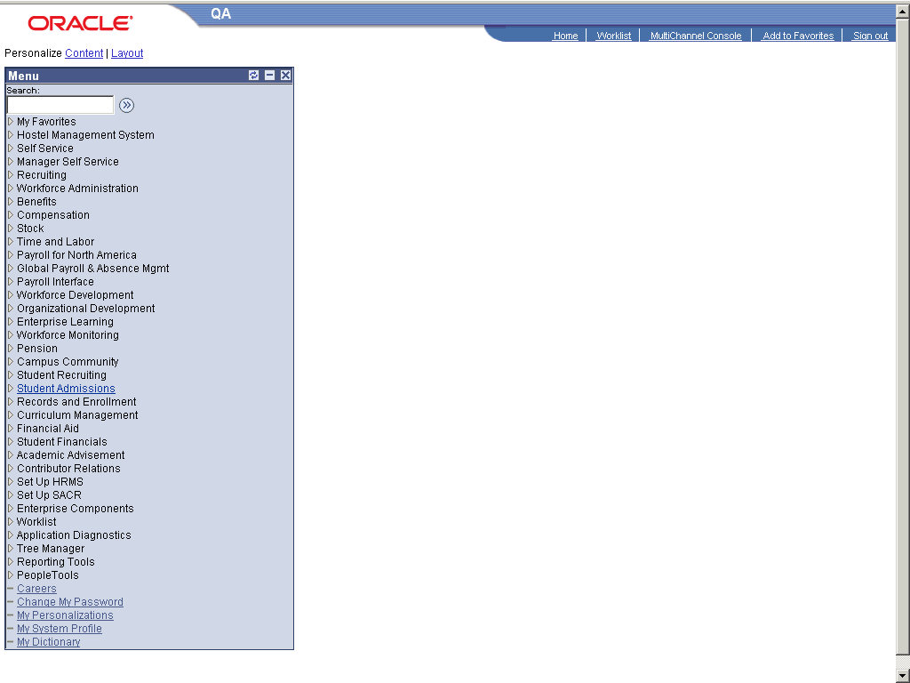

Step | Action
 | Click the Student Admissions link.

Step | Action
 | Click the Processing Applications link.
 | Click the Run Mass Change link.

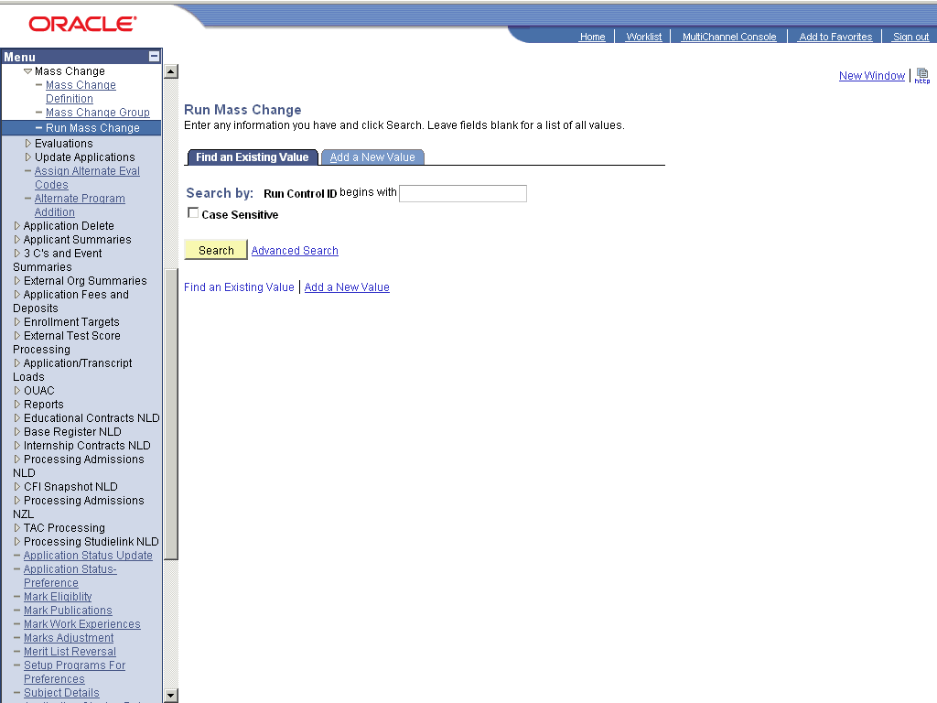

Step | Action
 | Click the dd a New Value link.
 | Enter the desired information into the Run Control ID: field. Enter "UGRD_BSCS".
 | Click the Add button.
 | Click the Execute Mass Change Group option.
 | Enter the desired information into the Mass Change Group ID: field. Enter "UGRD_BSCS".
 | Click the Save button.
 | Click the Run button.
 | Click the OK button.
 | Click the Process Monitor link.
 | Click the Refresh button.
 | End of Procedure.

Run Application Program Update Process

Procedure

Step | Action
 | Click the Student Admissions link.

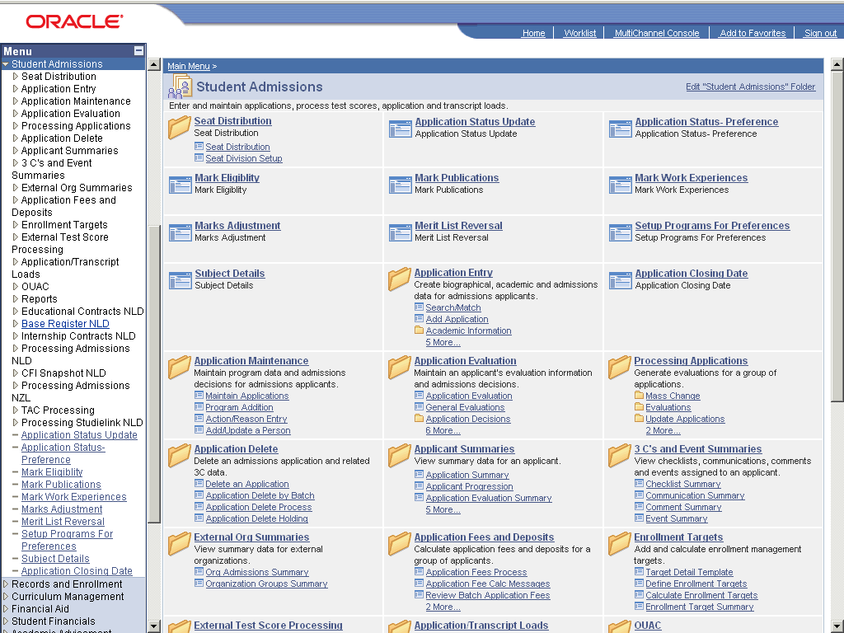

Step | Action
 | Click the Processing Applications link.
 | Click the Update Applications link.
 | Click the Application Program Update link.

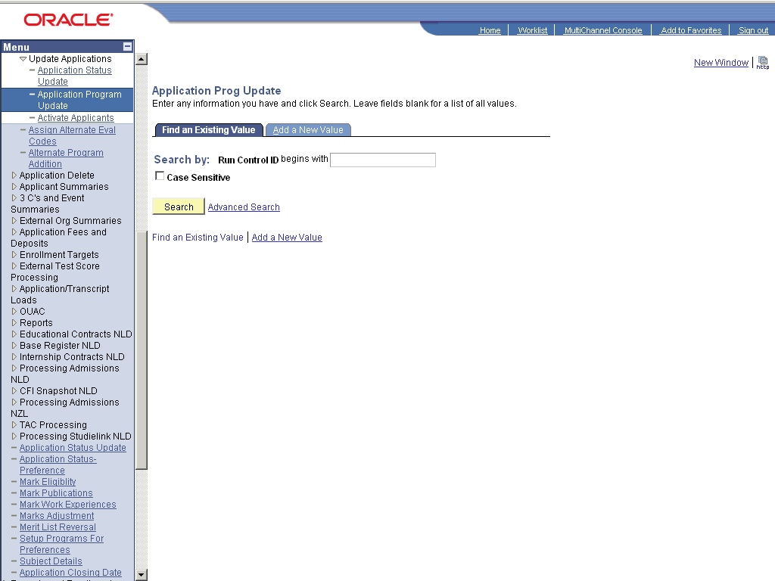

Step | Action
 | Click the dd a New Value link.
 | Enter the desired information into the Run Control ID: field. Enter "UGRD_BSCS".
 | Click the Add button.
 | Click the UGRD_BSCS link.
 | Click the Run button.
 | Click the OK button.
 | Click the Process Monitor link.
 | End of Procedure.

Run Activate Applicants Process

Procedure

Step | Action
 | Click the Student Admissions link.

Step | Action
 | Click the Processing Applications link.
 | Double-click the Update Applications object.
 | Click the Activate Applicants link.

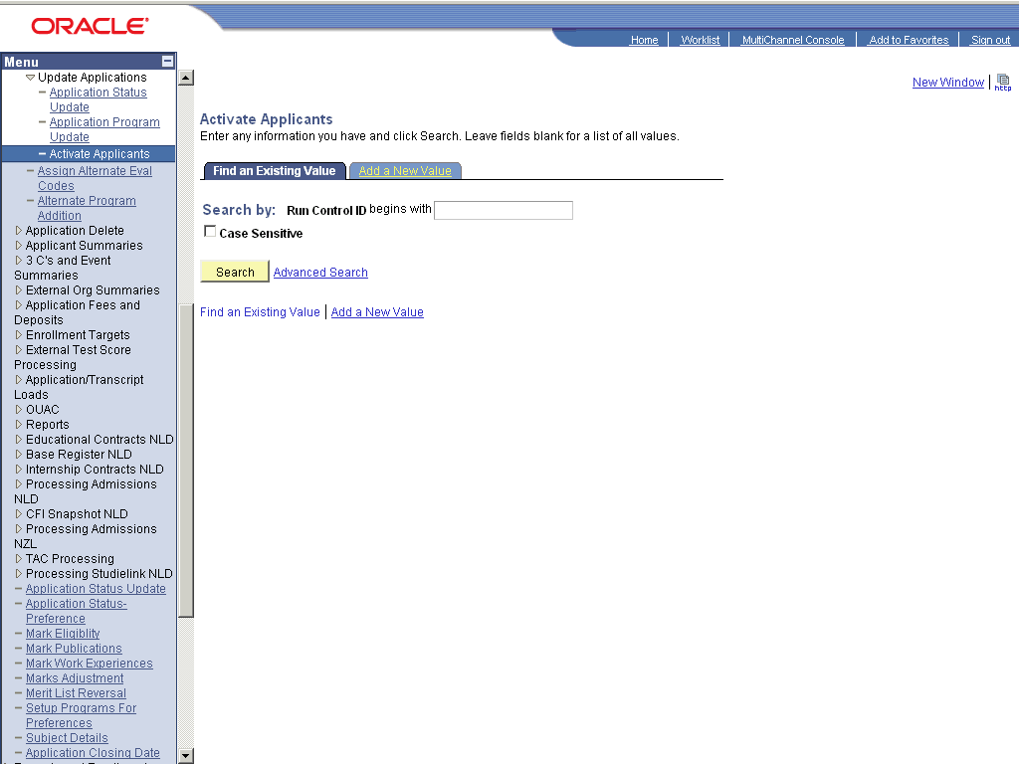

Step | Action
 | Click the dd a New Value link.
 | Enter the desired information into the Run Control ID: field. Enter "UGRD_BSCS".
 | Click the Add button.
 | Click the UGRD_BSCS link.
 | Enter the desired information into the *Career field. Enter "UGRD".
 | Enter the desired information into the Admit Term field. Enter "0094".
 | Enter the desired information into the Acad Prog field. Enter "BSCS".
 | Click the Save button.
 | Click the Run button.
 | Click the OK button.
 | Click the Process Monitor link.
 | End of Procedure.

Application Status Report

Application Status Report

Procedure

Application Status Report:
This report is used to show list of candidates with their specific statuses in sorted order on the basis of merit score.

This report can be use for multiple purposes;
e.g., At the time of roll number allocation, you can generate report of admitted candidates in sorted order on the basis of merit score.

Step | Action
 | Click the Reporting Tools link.

Step | Action
 | Click the XML Publisher link.
 | Click the Query Report Viewer link.

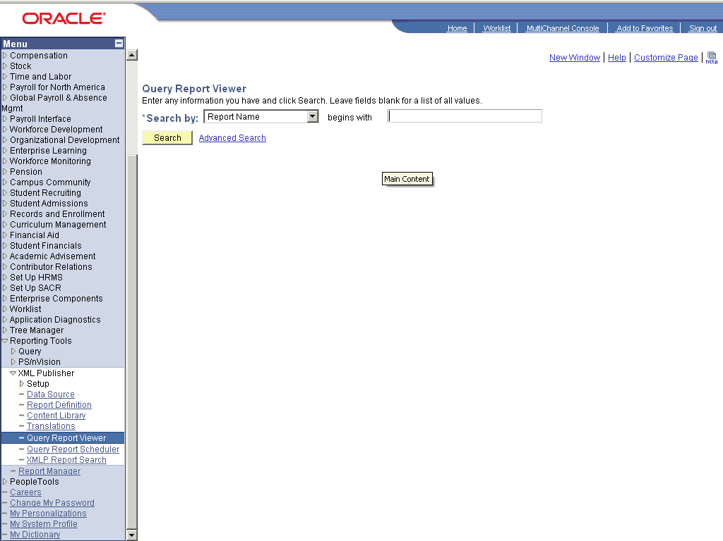

Step | Action
 | Enter the desired information into the field. Enter "PU_CAND_STAT".
 | Click the Search button.
 | Click the View Report link.
 | Enter the desired information into the field. Enter "PU".
 | Enter the desired information into the Career: field. Enter "GRAD".
 | Enter the desired information into the Admit Term: field. Enter "0094".
 | Enter the desired information into the Program: field. Enter "MSCST".
 | Enter the desired information into the Campus: field. Enter "QAZM".
 | Enter the desired information into the Plan: field. Enter "MSCST".
 | Enter the desired information into the Sub-Plan: field. Enter "MORN".
Enter the desired information into the Admit Type (% for All): field. Enter "%".
Enter % to generate report for all admit types.
 | Click the Look up Candidate Status (% for All) (Alt+5) graphic.
 | Click the Cancel button.
Enter the desired information into the Candidate Status (% for All): field. Enter "%".
Enter % to generate report for all status.
 | Click the OK button.

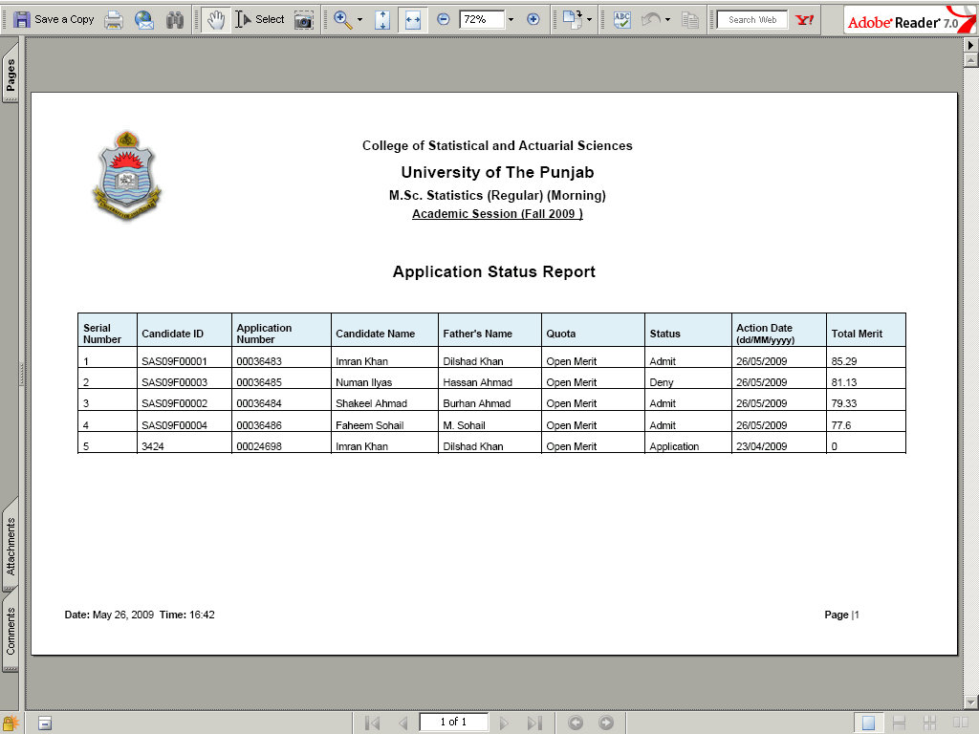

Step | Action
 | Click the AVPageView object.
 | End of Procedure.

