Student Financials
Created on Thursday, July 02, 2009
Copyright & Trademarks
Copyright © 2003, 2007, Oracle. All rights reserved. Powered by OnDemand Software. Distributed by Oracle under license from Global Knowledge Software LLC. © 1998-2007. All rights reserved.

The information contained in this document is subject to change without notice. If you find any problems in the documentation, please report them to us in writing. This document is not warranted to be error-free. Except as may be expressly permitted in your license agreement for these Programs, no part of these Programs may be reproduced or transmitted in any form or by any means, electronic or mechanical, for any purpose.

If this documentation is delivered to the United States Government or anyone using the documentation on behalf of the United States Government, the following notice is applicable:

U.S. GOVERNMENT RIGHTS
The U.S. Government’s rights to use, modify, reproduce, release, perform, display, or disclose these training materials are restricted by the terms of the applicable Oracle license agreement and/or the applicable U.S. Government contract.

Oracle, JD Edwards, PeopleSoft, and Siebel are registered trademarks of Oracle Corporation and/or its affiliates. Other names may be trademarks of their respective owners.

Table of Contents
Managing Admission Fee 1
Calculate Admission Fee - Individual 1
Calculate Admission Fee - Batch 4
Calculate Difference Fee amount 7
Generate Admission Fee invoice - Individual 11
Calculate Difference Fee invoice 15
Student Fee Payments 19
Viewing Account Information 25
Viewing Student Account Information 25
Calculating Term Fee 37
Tuition Calculation - Individual 37
Tuition Calculation - Batch 43
Applying Departmental Fee 53
Post Student Transactions for Departmental Charges 53
Generating Invoice 59
Creating Billing Request and Generating Invoice - Individual 59
Creating Billing Request and Generating Invoice - Batch 66
Creating Departmental Billing Request and Generating Invoice 72
Printing Invoices - Individual 78
Printing Invoices - Batch 92
Cancelling Invoices 105
Applying Payments 113
Applying Student Payments 113
Late Fee Calculation 121
Late Fee Calculation 121
Late Fee Service Indicator 133
Refunds 147
Performing a Refund 147
Reversals 155
Charge Reversal 155
Payment Reversal 161
Scholarships and Waivers 169
Applying Scholarhips 169
Applying Waivers - Automatically 179
Applying Waivers - Manually 187
Installments 195
Create Payment Plan 195
Assign Payment Plan 203

Managing Admission Fee

Calculate Admission Fee - Individual

Procedure

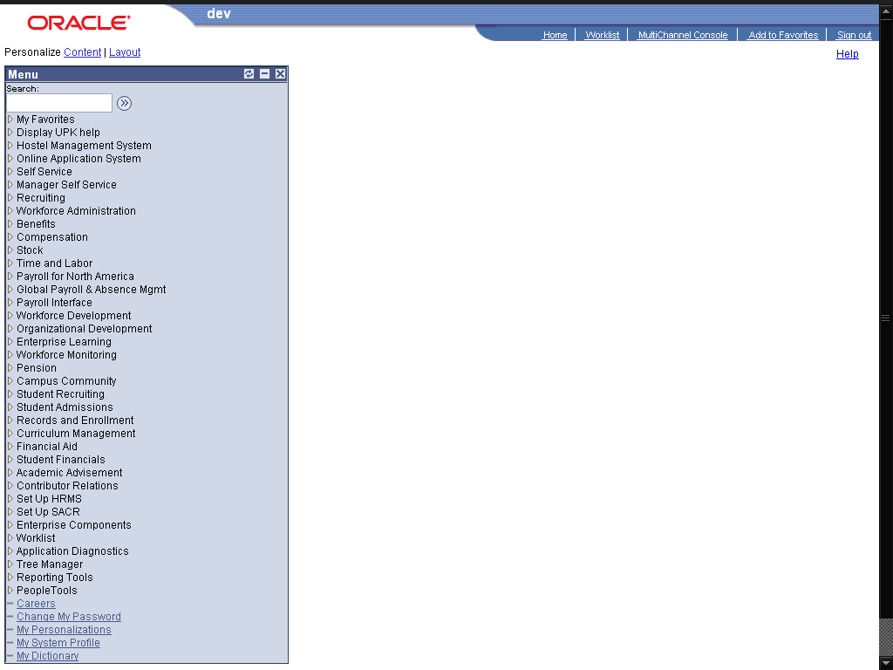

Step | Action
 | Click the Student Financials link.

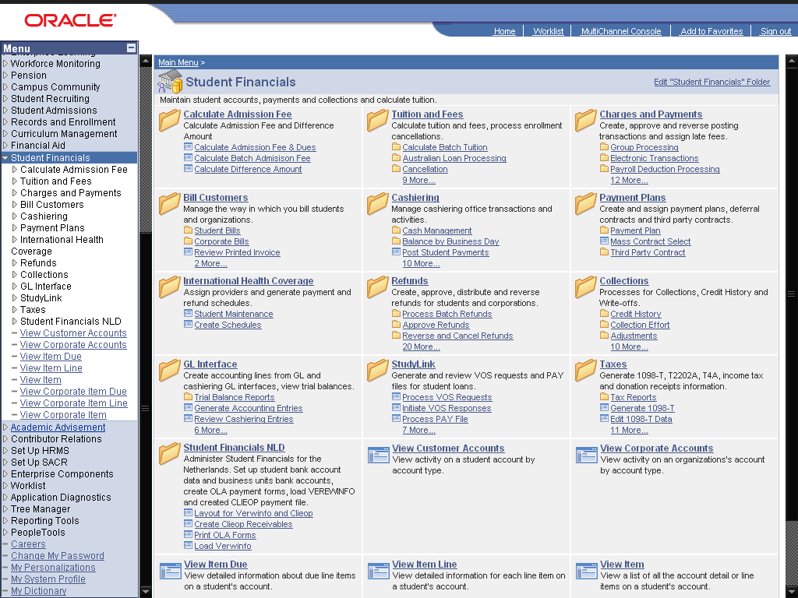

Step | Action
 | Click the Calculate Admission Fee link.
 | Click the Calculate Admission Fee & Dues link.

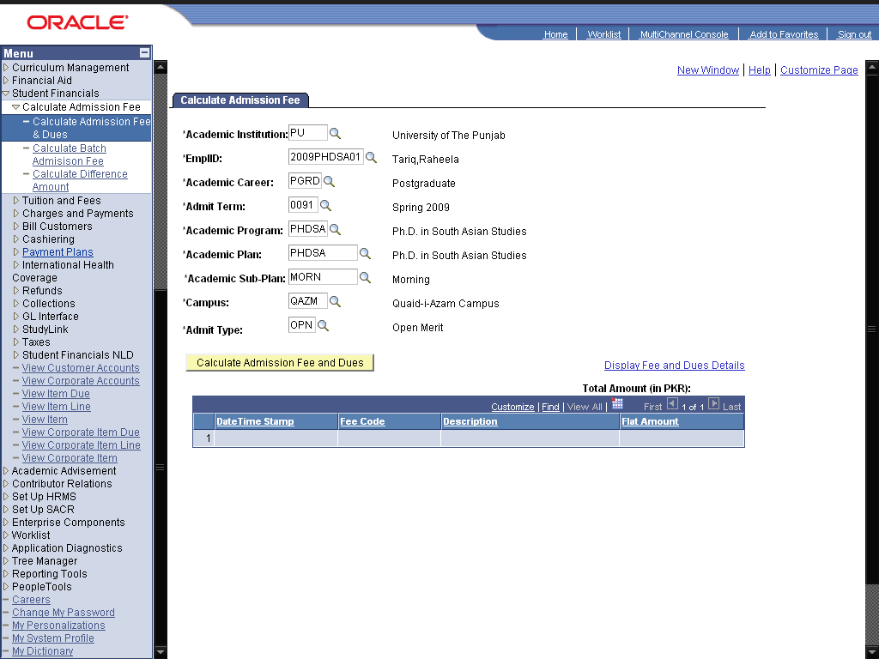

Step | Action
Enter the desired information into the *EmplID: field. Enter "2009PHDSA01".
Enter details in the other fields also, for the application and program to calculate fee for it.
The values in the fields would be already filled if these are set in Setup SACR -> User Defaults.
 | Click the Calculate Admission Fee and Dues button.
Click the OK button.
This message indicates that the fee is calculated successfully for the student.
Click the Display Fee and Dues Details link.
To view the calculated fee and its details
Point to the object.
Check the total fee amount calculated for this student. and also the details of the fee applied on this student in the grib below.
 | End of Procedure.

Calculate Admission Fee - Batch

Procedure

From this process, you can calculate the admission fee for all the conditionally admitted students for a given term and program.

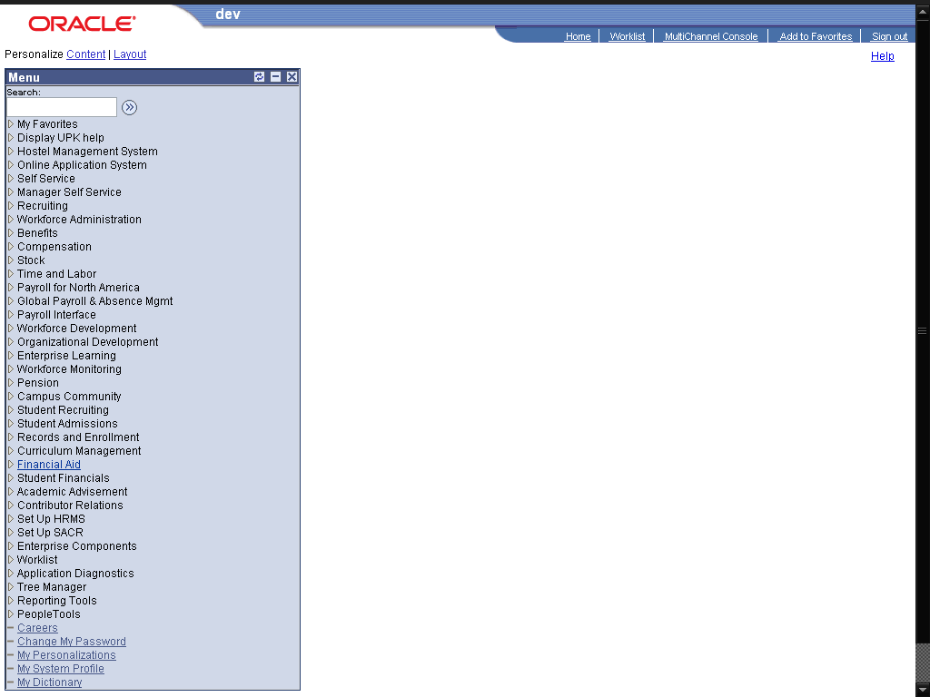

Step | Action
 | Click the Student Financials link.

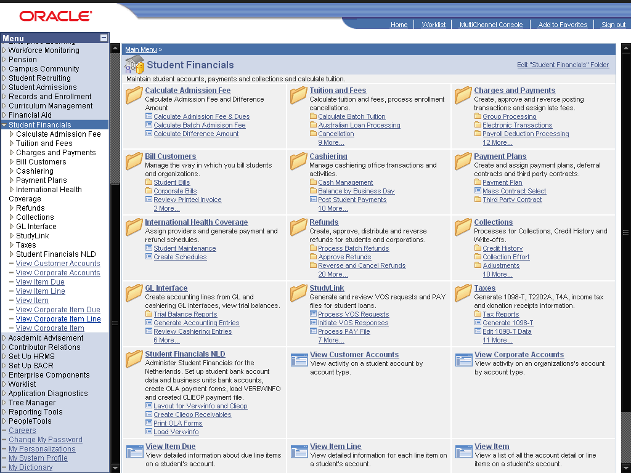

Step | Action
 | Click the Calculate Admission Fee link.
 | Click the Calculate Batch Admisison Fee link.

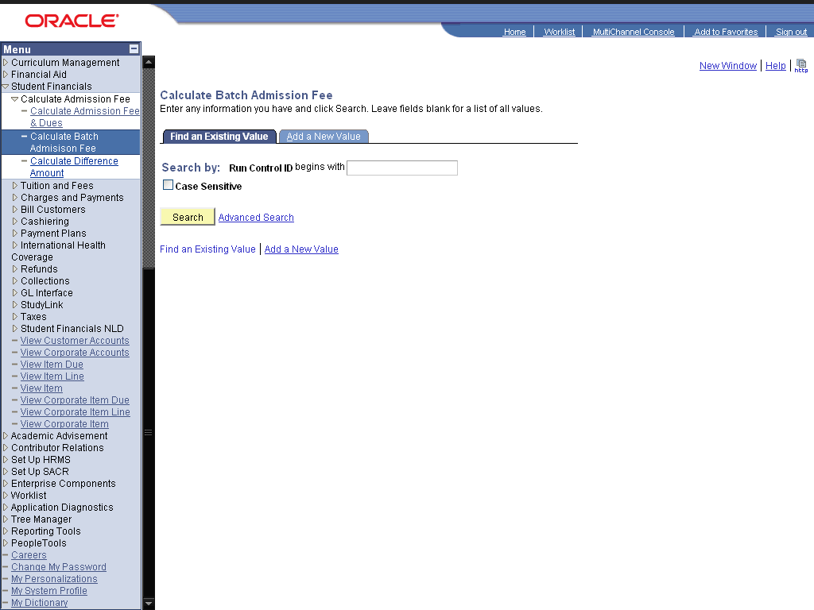

Step | Action
 | Click the Add a New Value link.
 | Enter the desired information into the Run Control ID: field. Enter "Calculate_admission_fee".
 | Click the Add button.
 | Enter the desired information into the *Academic Career: field. Enter "UGRD".
 | Enter the desired information into the *Admit Term: field. Enter "0091".
 | Enter the desired information into the *Academic Program: field. Enter "BCOM".
 | Click the Run button.
 | Click the OK button.
 | Click the Process Monitor link.
Click the Refresh button.
Refresh page untill the process is successful. Once the status is Success, the fee of all the conditionally admitted applicants will be calculated for the given term and program.
 | End of Procedure.

Calculate Difference Fee amount

Procedure

The difference of fee is calculated when a student gets admission offer in one department, and to reserve his/her seat he/she submits the fee, but in next merit lists, he/she gets admission in some other program of his/her desire, then to swap in the other department/ program, the fee to be submitted would be paid charges minus the new dues. Therefore, to calculate the new charges and calculating that how much more the student needs to pay , we need this page. (This page only calculates the difference of university dues).

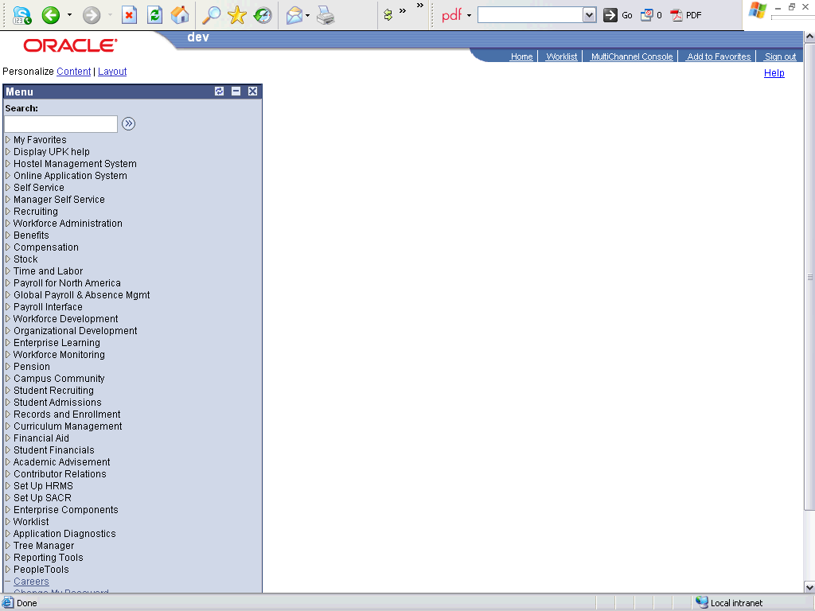

Step | Action
 | Click the Student Financials link.

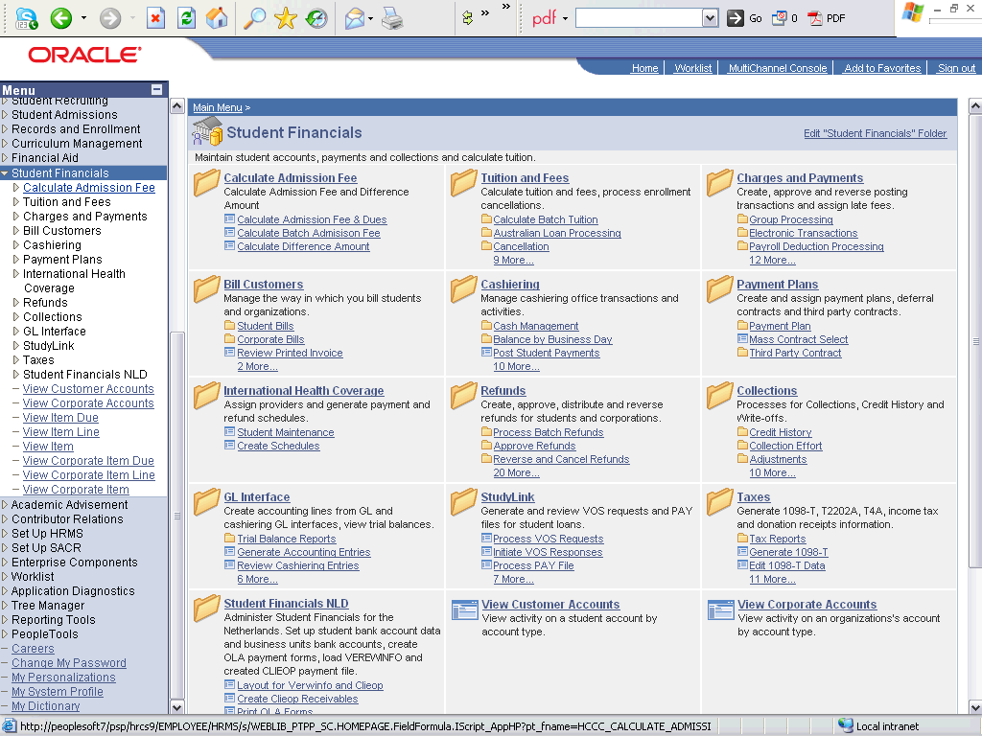

Step | Action
 | Click the Calculate Admission Fee link.
 | Click the Calculate Difference Amount link.

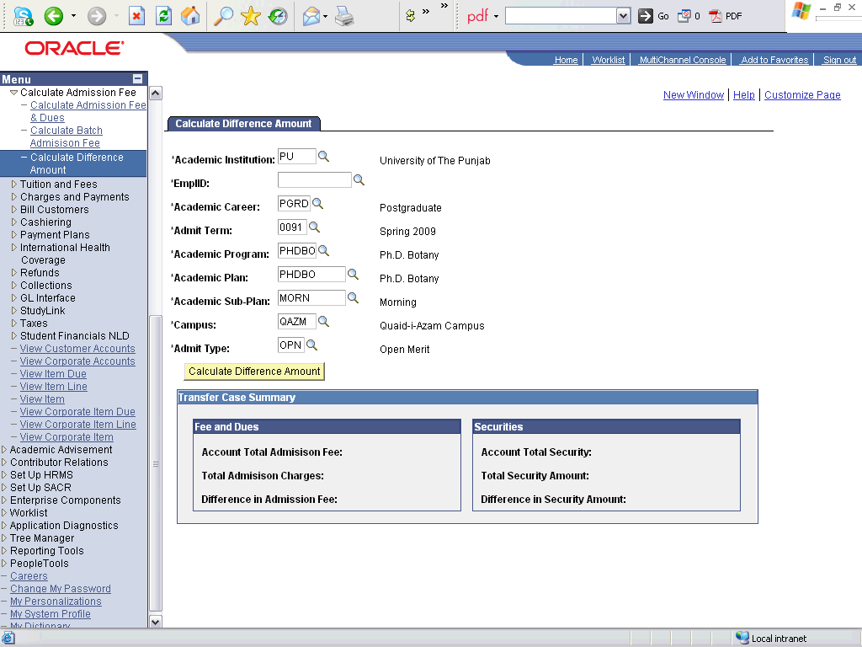

Step | Action
 | Enter the desired information into the EmplID field. Enter "2009PHD0001".
 | Click in the Academic Career field.
 | Click the Calculate Difference Amount button.

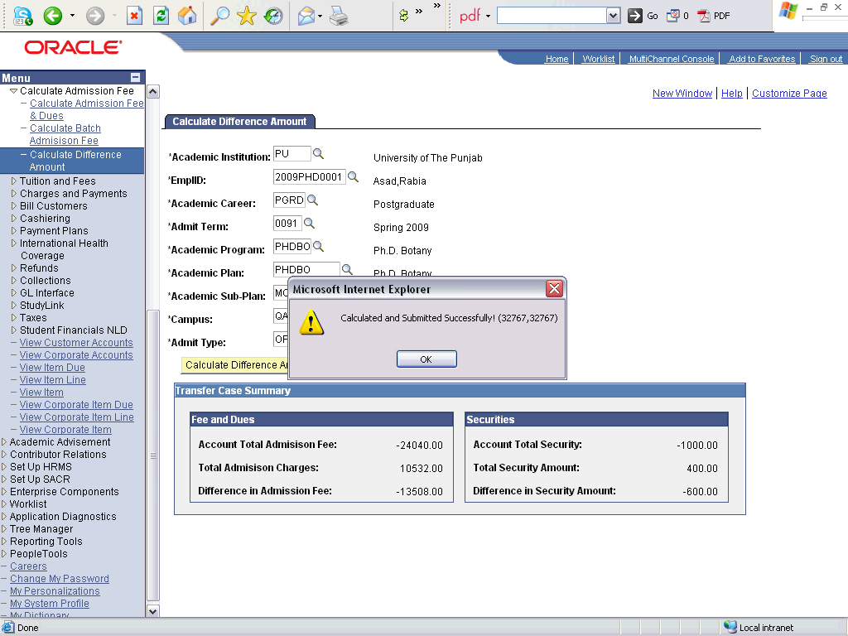

Step | Action
 | Click the OK button.

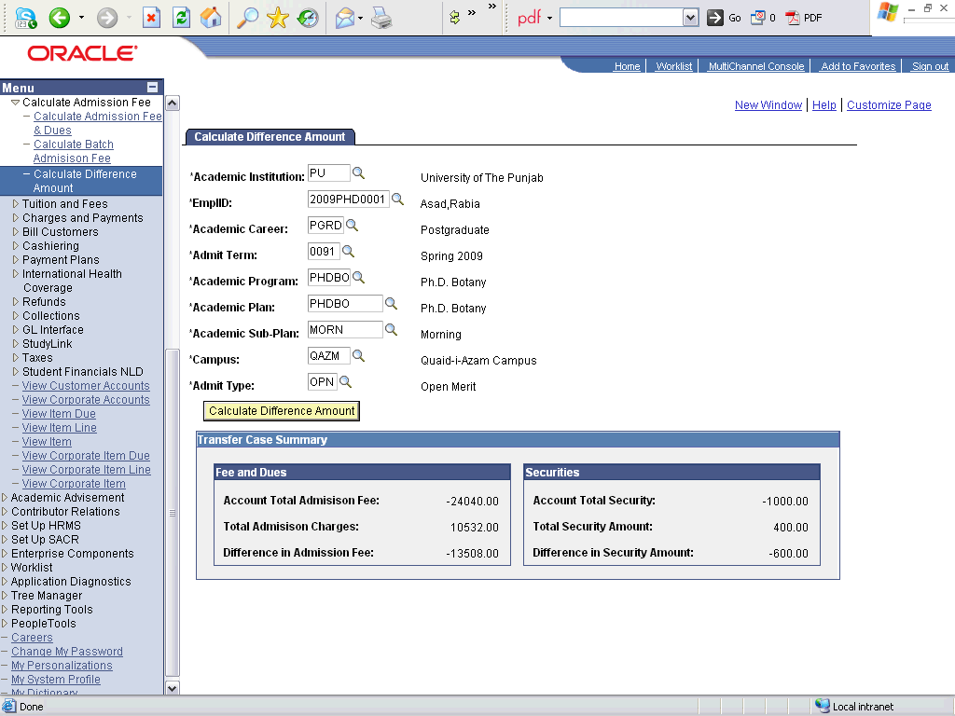

Step | Action
Click the object.
Check the fee details and difference of amount, separately for both university charges and securities.
 | End of Procedure.

Generate Admission Fee invoice - Individual

Procedure

Step | Action
 | Click the Reporting Tools link.

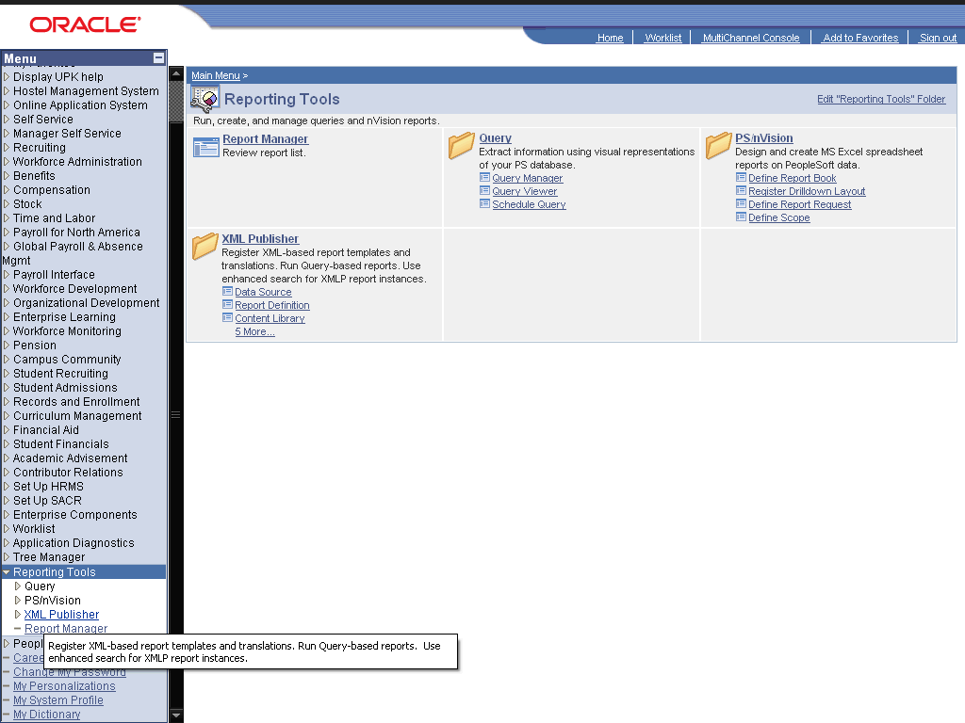

Step | Action
 | Click the XML Publisher link.
 | Click the Query Report Viewer link.

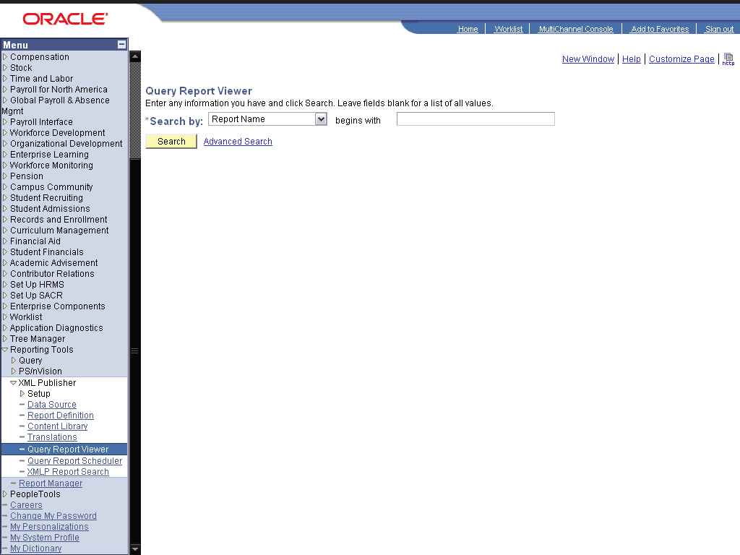

Step | Action
 | Enter the desired information into the field. Enter "ADM".
 | Click the Search button.
 | Click the View Report link.
 | Enter the desired information into the Institution: field. Enter "PU".
Enter the desired information into the Due Date: field. Enter "05/28/2009".
Enter all details for a respective applicant for whom you want to generate the report.
 | Click the OK button.

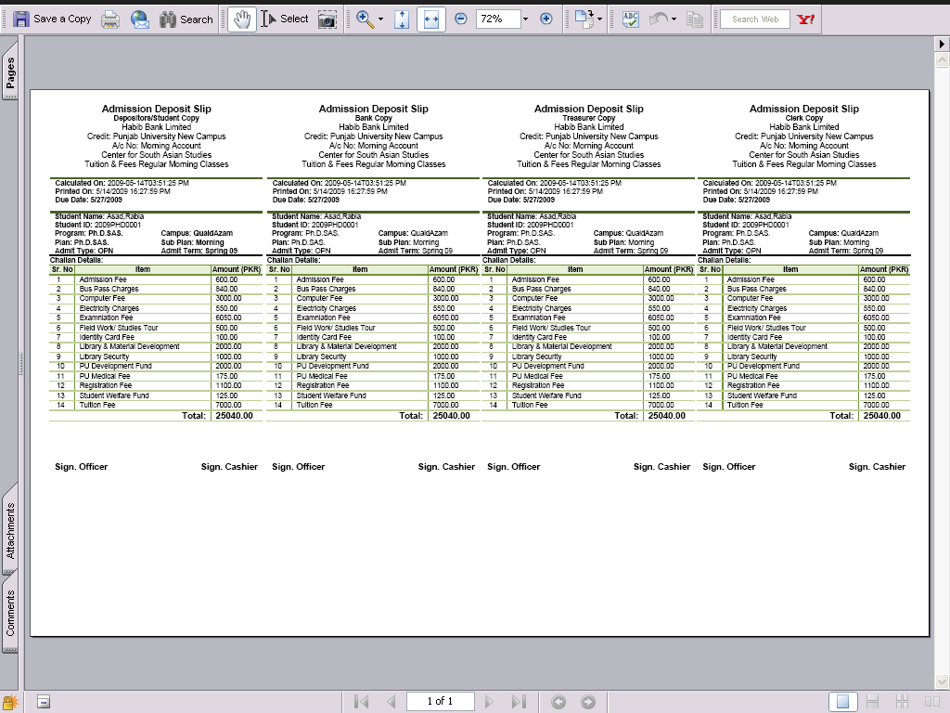

Step | Action
Click the Invoice object.
View the challan generated
 | End of Procedure.

Calculate Difference Fee invoice

Procedure

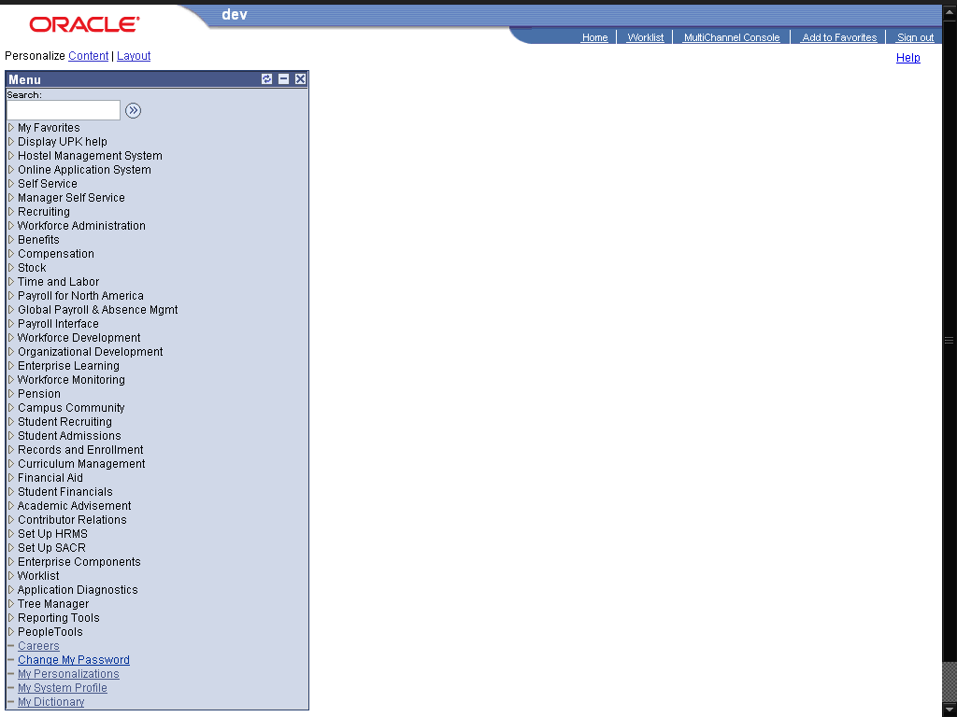

Step | Action
 | Click the Reporting Tools link.

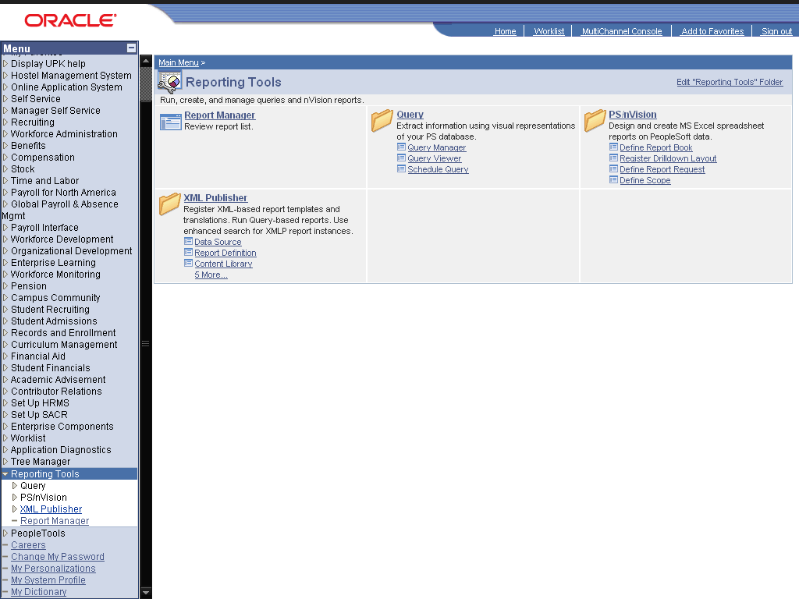

Step | Action
 | Click the XML Publisher link.
 | Click the Query Report Viewer link.

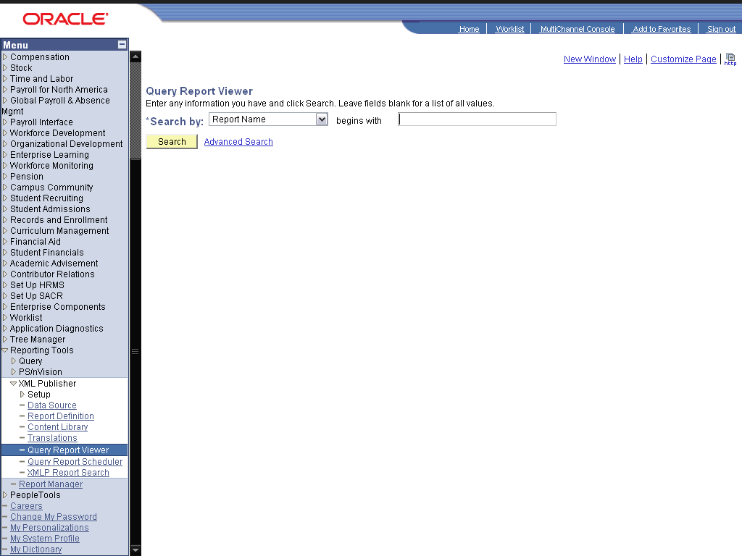

Step | Action
 | Enter the desired information into the field. Enter "diff".
 | Click the Search button.
 | Click the View Report link.
 | Enter the desired information into the Institution: field. Enter "PU".
Enter the desired information into the Career: field. Enter "PGRD".
Fill below fields with your required program, plans etc
 | Enter the desired information into the Due Date: field. Enter "05/27/2009".
 | Click the OK button.

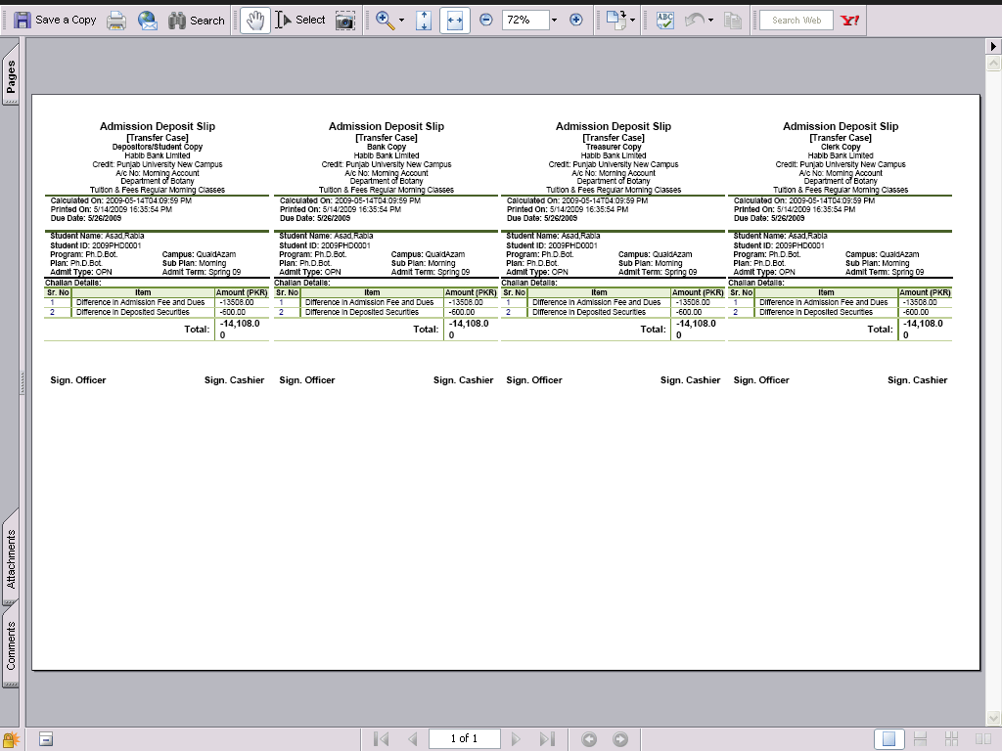

Step | Action
 | Click the Invoice object.
 | End of Procedure.

Student Fee Payments

Procedure

Step | Action
 | Click the Student Financials link.

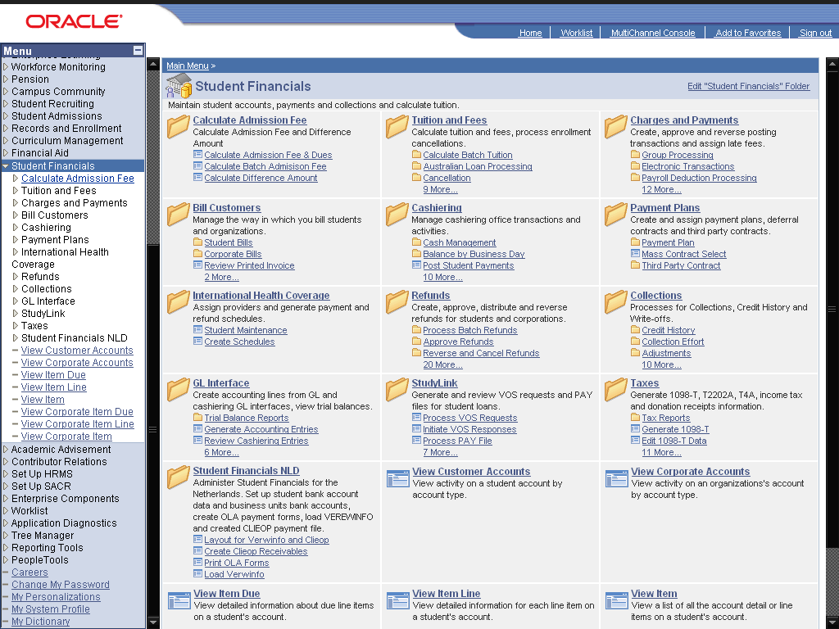

Step | Action
 | Click the Cashiering link.
 | Click the Post Student Payments link.

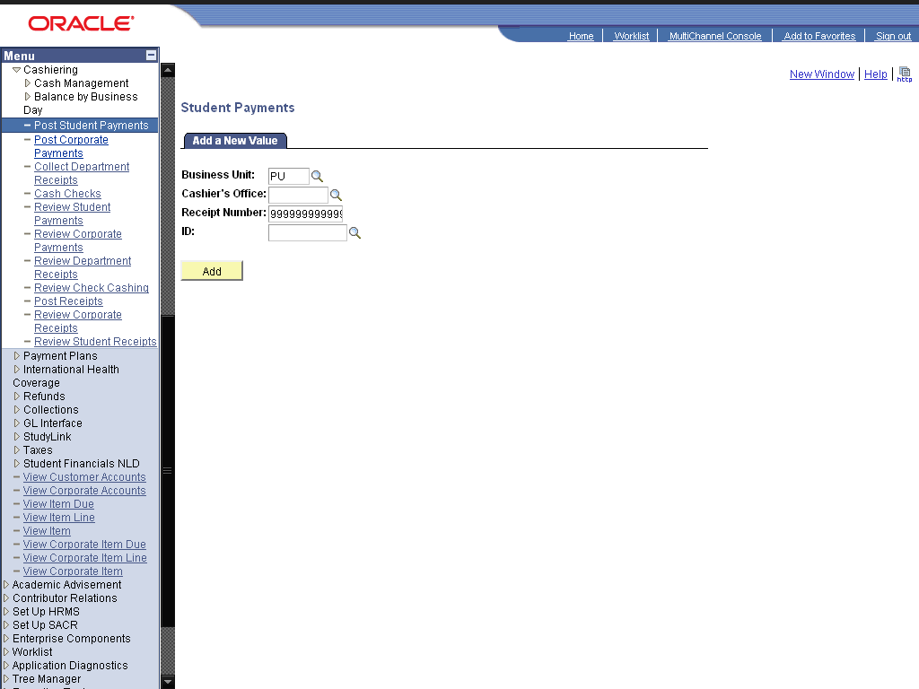

Step | Action
 | Enter the desired information into the Cashier's Office: field. Enter "AIQBLCO".
 | Enter the desired information into the ID: field. Enter "2009PHD0001".
 | Click the Add button.
 | Click the Look up Target (Alt+5) graphic.
 | Click the ADMISSION link.
 | Enter the desired information into the Term: field. Enter "0091".
Enter the desired information into the Amount: field. Enter "24050".
The Charges and Securities will be entered separately while making payment. 24050 are the charges out of 25050 total fee
 | Click the Add a new row at row 1 (Alt+7) graphic.
 | Click the Look up Target (Alt+5) graphic.
 | Click the LIBRARYSEC link.
 | Enter the desired information into the Term: field. Enter "0091".
Enter the desired information into the Amount: field. Enter "1000".
Enter the security amount againt the Target: LIBRARYSEC, if it is computer security then select the target of computer security and enter the security amount.
 | Enter the desired information into the *Tender: field. Enter "CASH".
 | Click the Create Receipt button.
Click in the -25,050.00 field.
The total fee has been paid.
Now when this applicant is matriculated by the admissions department, then his/her fee will be calculated using the "Fee Calculation" process. But invoices will not be generated and payment will not be entered in the system again for this student (since we have already did this through admission fee process). The admission fee will be used to calculate fee only for the 1st Semester or 1st Year.
 | End of Procedure.

Viewing Account Information

Viewing Student Account Information

Procedure

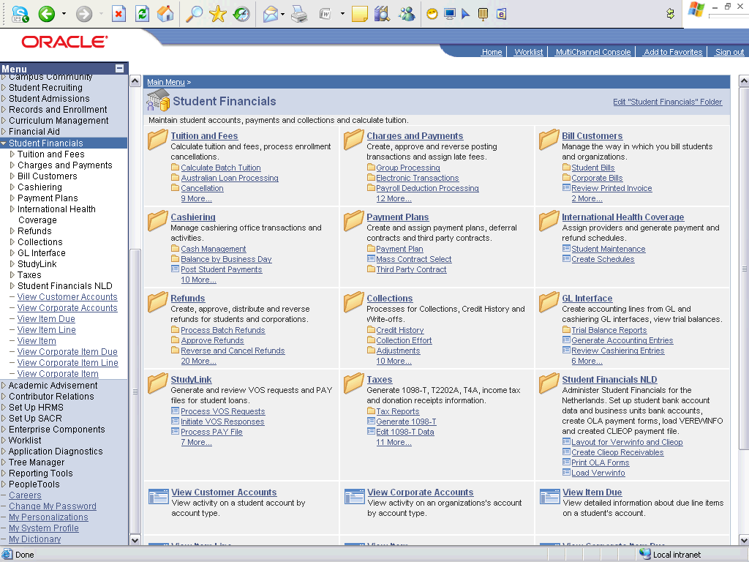

Step | Action
 | Click the View Customer Accounts link.

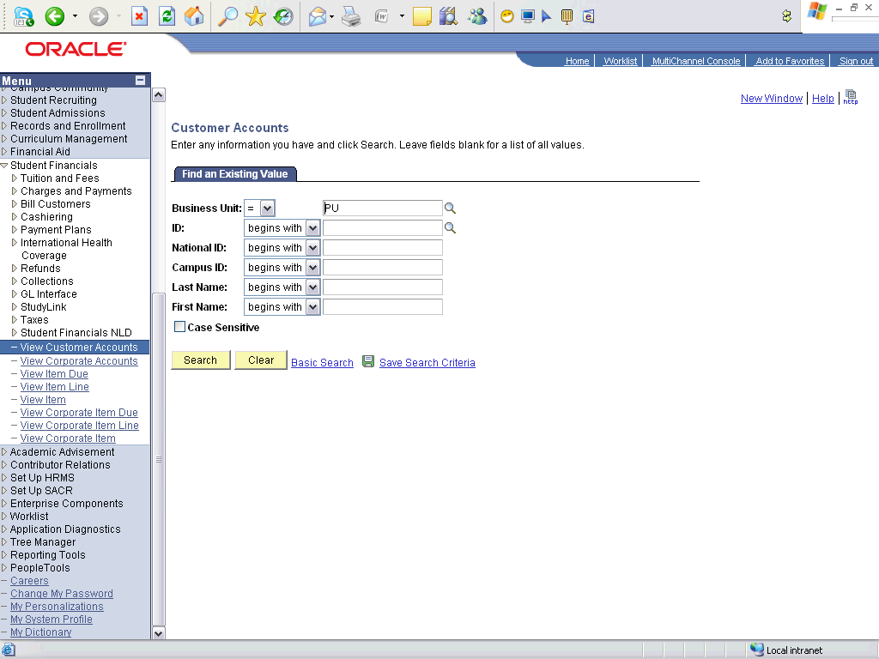

Step | Action
 | Click the Search button.
 | Click an entry in the ID column.

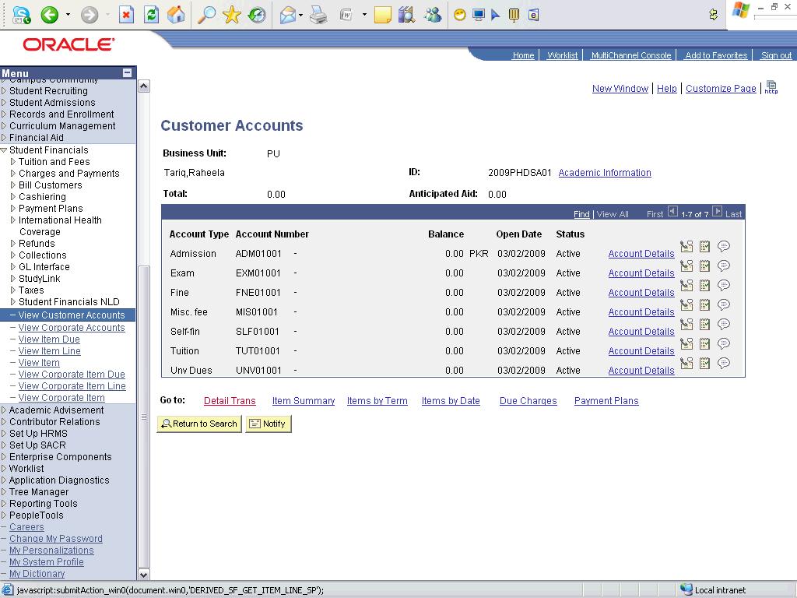

Step | Action
 | Click an entry in the Account Details column.

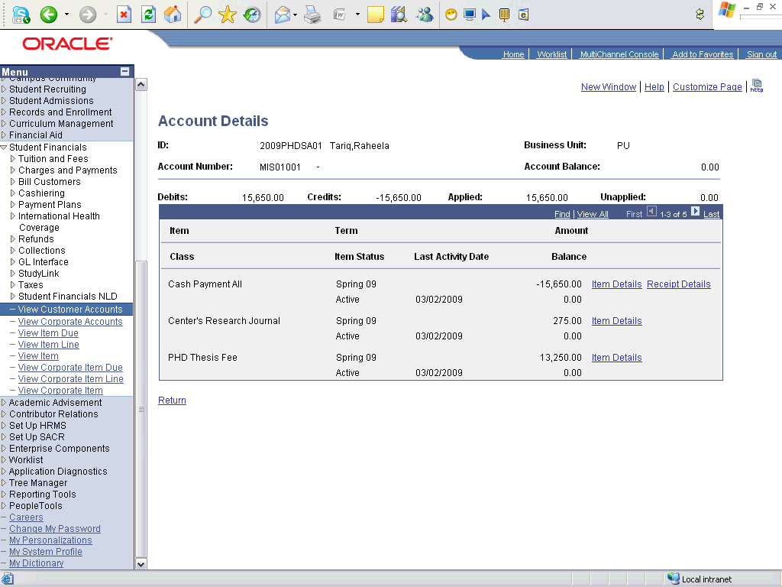

Step | Action
 | Click an entry in the Item Details column.

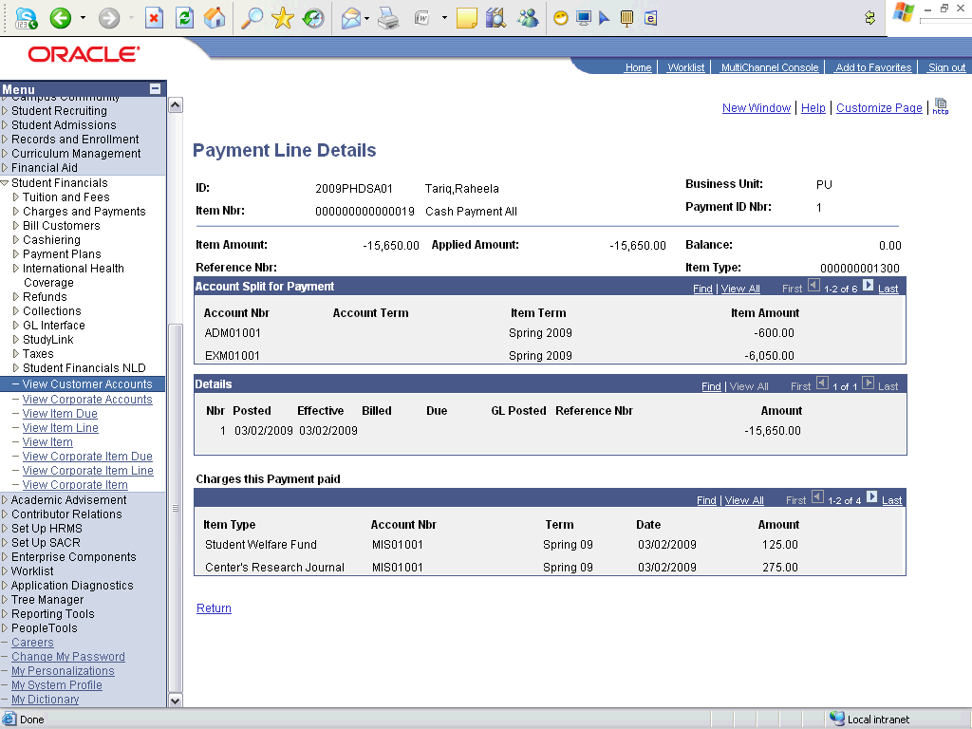

Step | Action
 | Click the View All link.

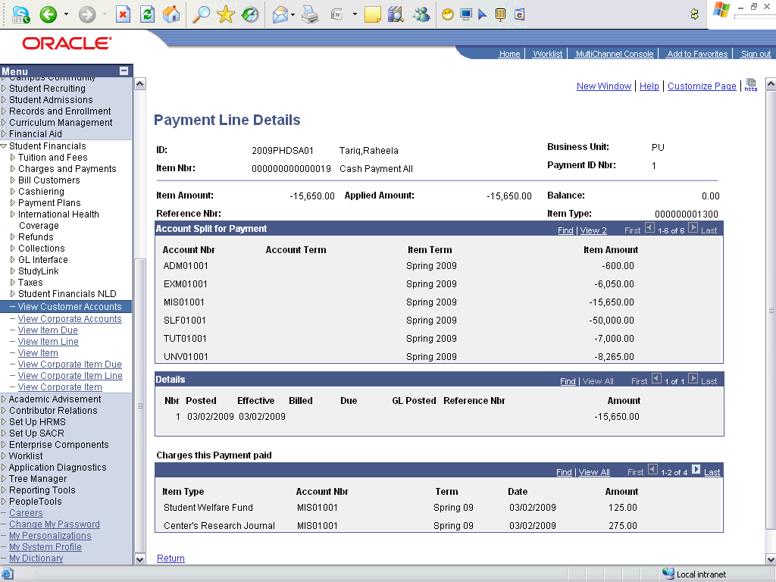

Step | Action
Point to the object.
View the details of Payments

Step | Action
 | Click the Return link.

Step | Action
 | Click an entry in the Item Details column.

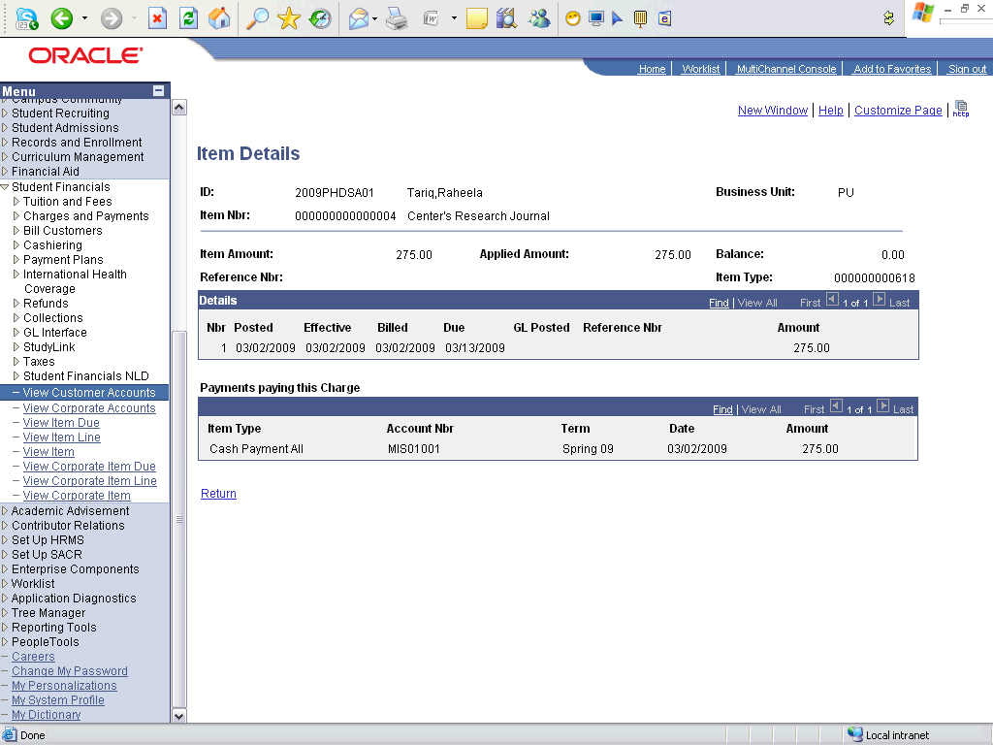

Step | Action
 | Click the Return link.

Step | Action
 | Click the Return link.

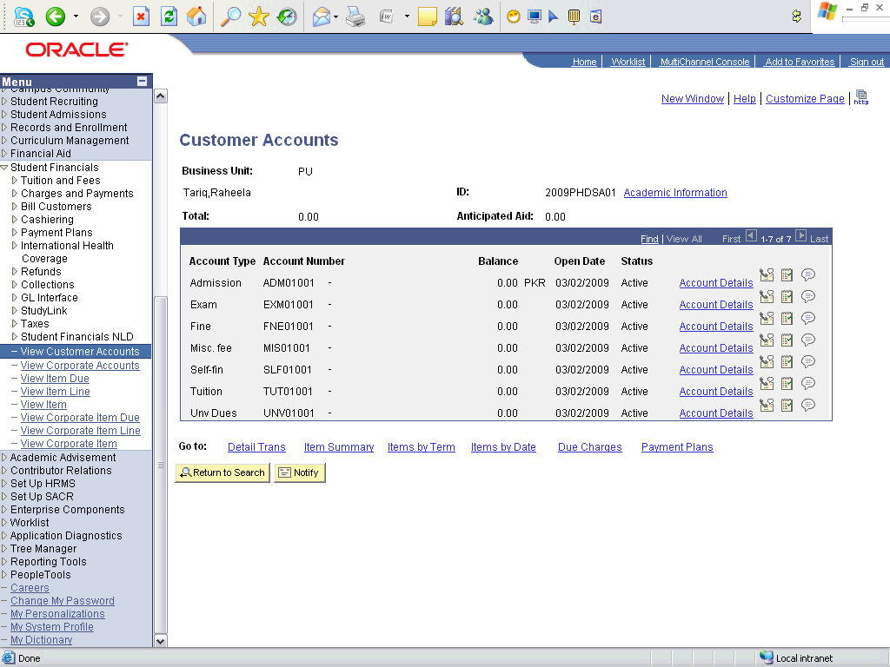

Step | Action
 | Click the Detail Trans link.

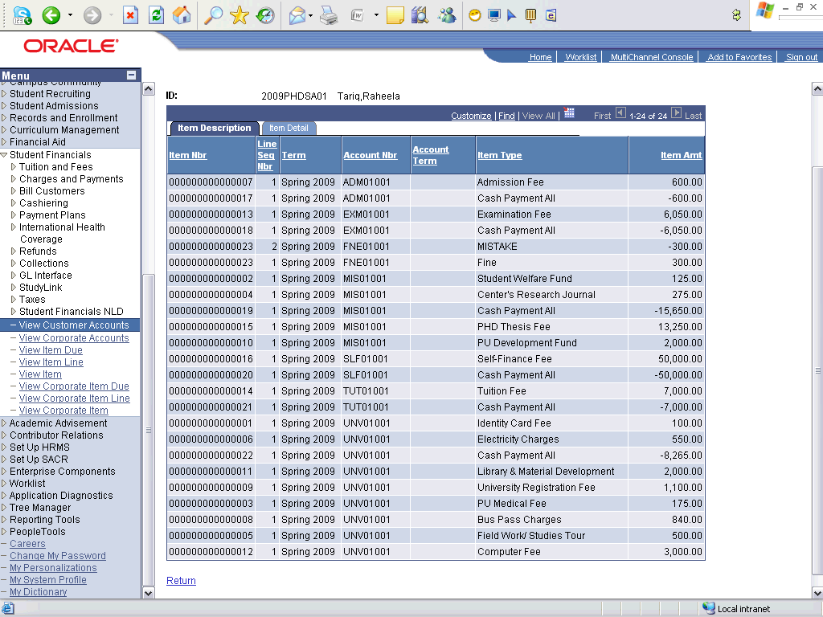

Step | Action
Point to the object.
View Details
 | Click the Return link.
 | End of Procedure.

Calculating Term Fee

Tuition Calculation - Individual

Procedure

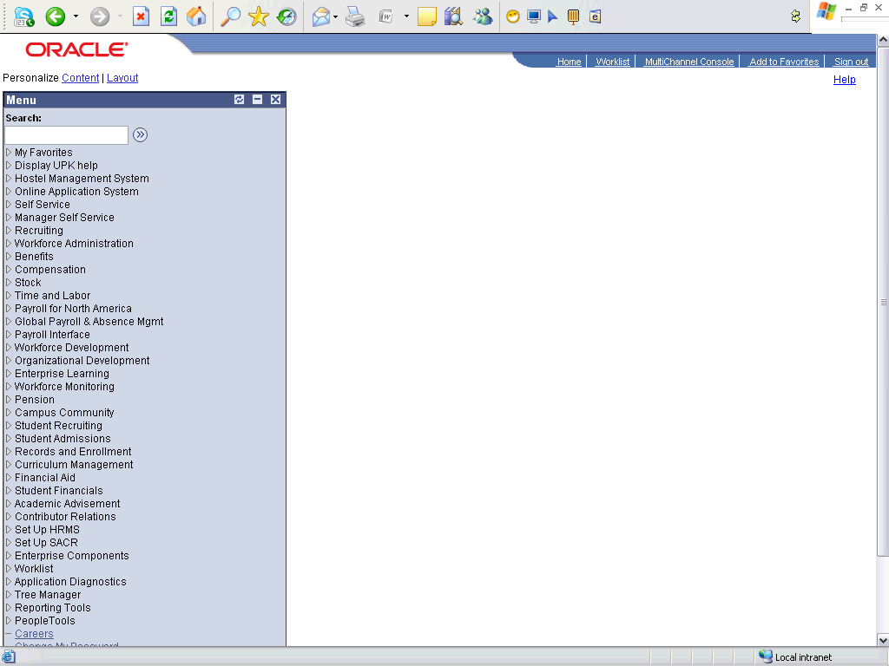

Step | Action
 | Click the Student Financials link.

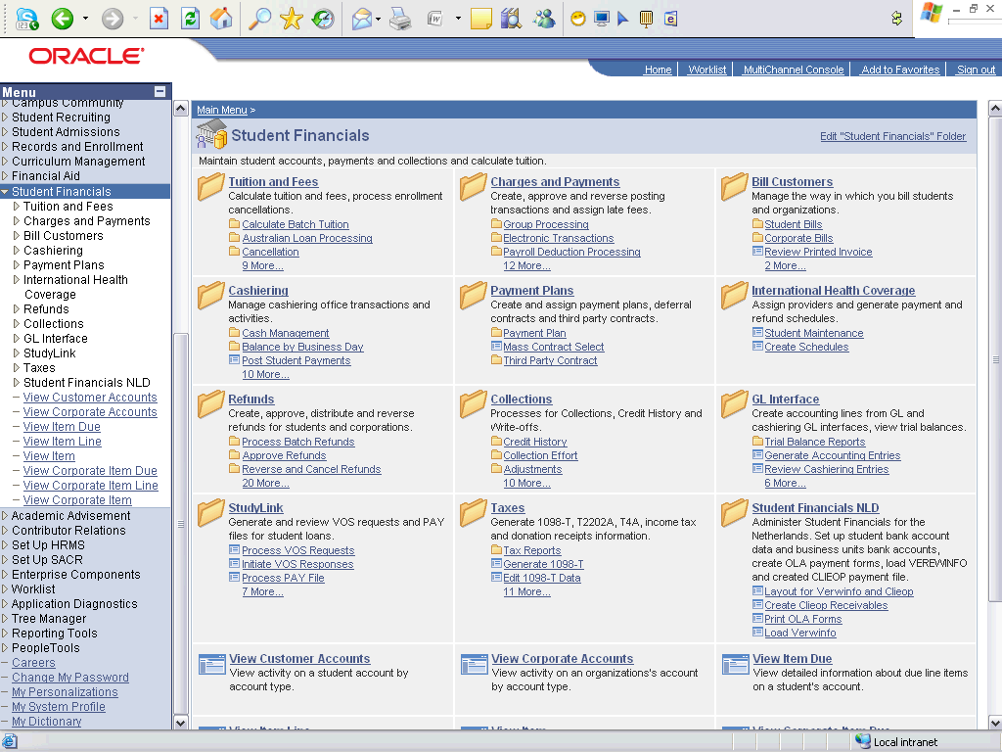

Step | Action
 | Click the Tuition and Fees link.
 | Click the Tuition Calculation link.

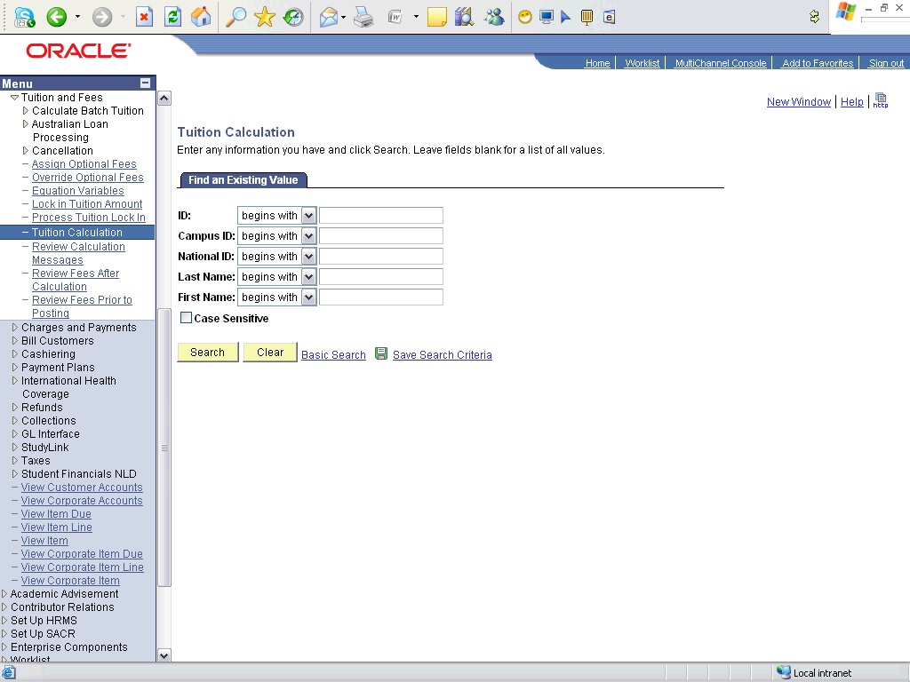

Step | Action
 | Click the Search button.
 | Click an entry in the ID column.

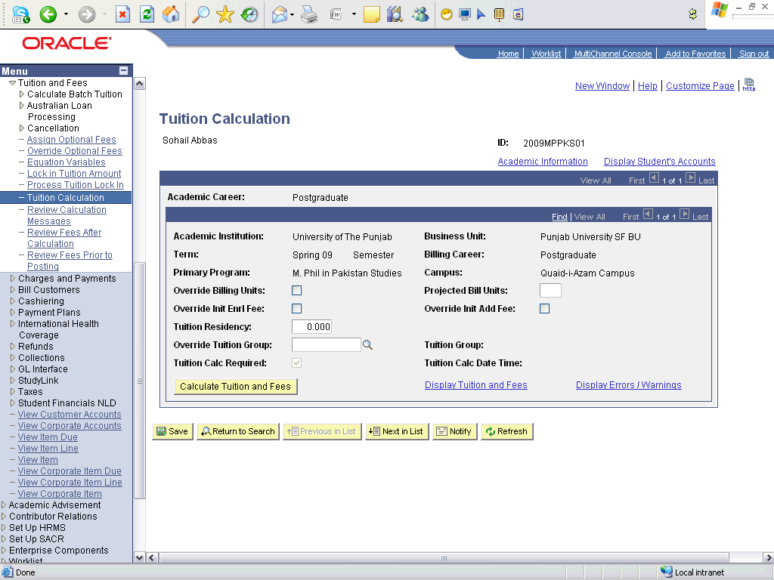

Step | Action
 | Click the Calculate Tuition and Fees button.
 | Click an entry in the Display Tuition and Fees column.

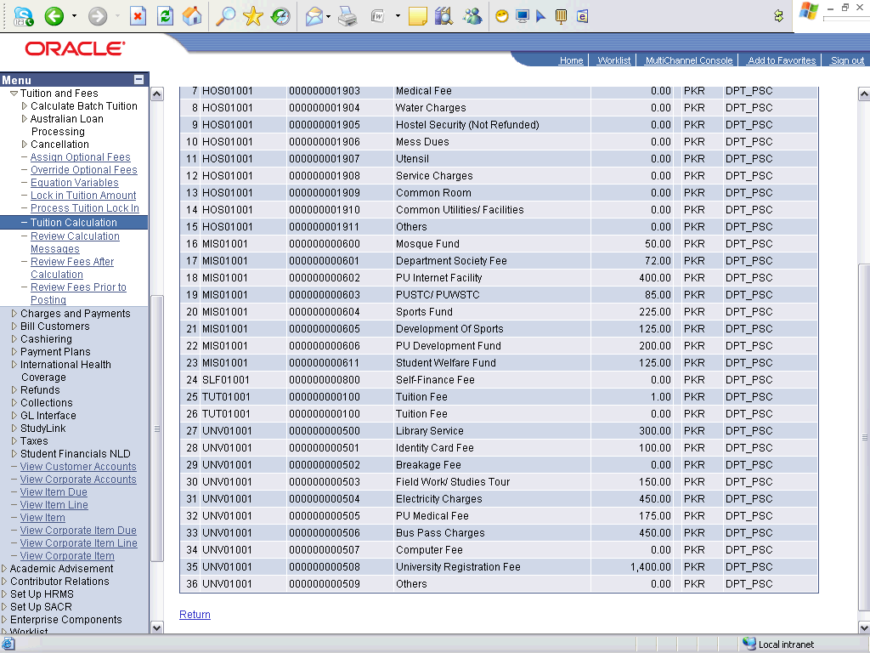

Step | Action
Point to the object.
View Applied Charges details
Point to the object.
Verify Total Fee

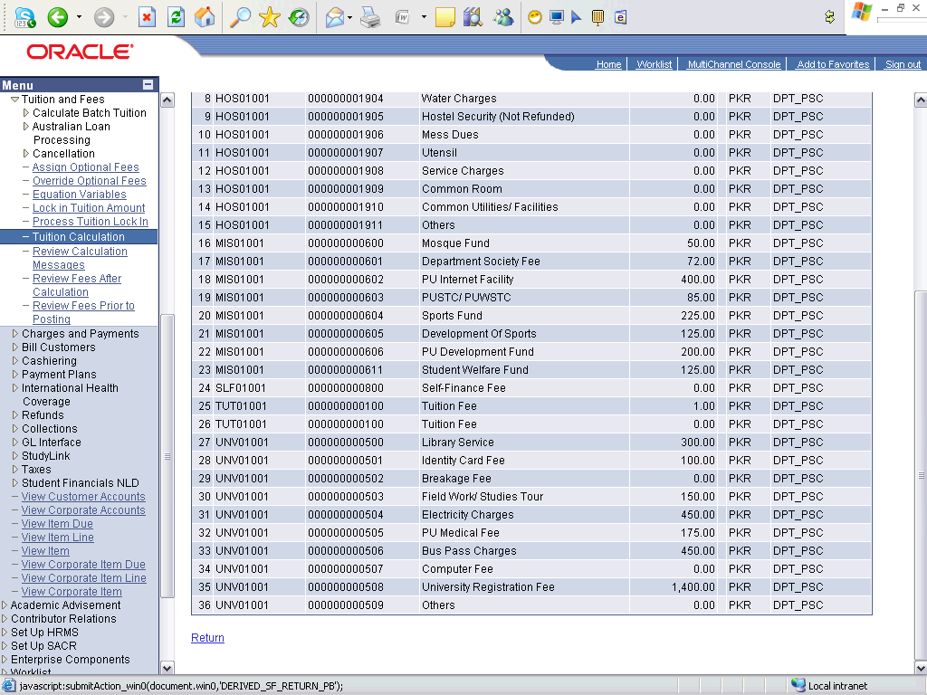

Step | Action
 | Click the Return link.

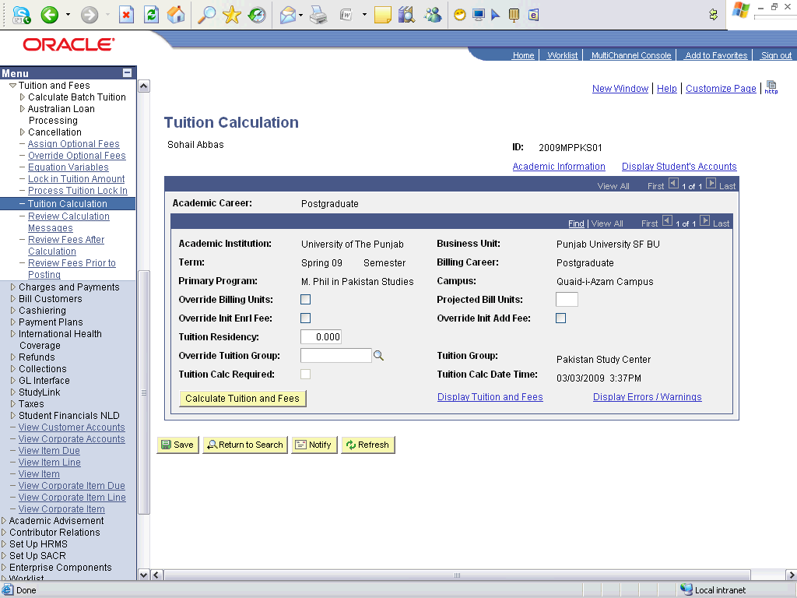

Step | Action
 | Click the Save button.
 | End of Procedure.

Tuition Calculation - Batch

Procedure

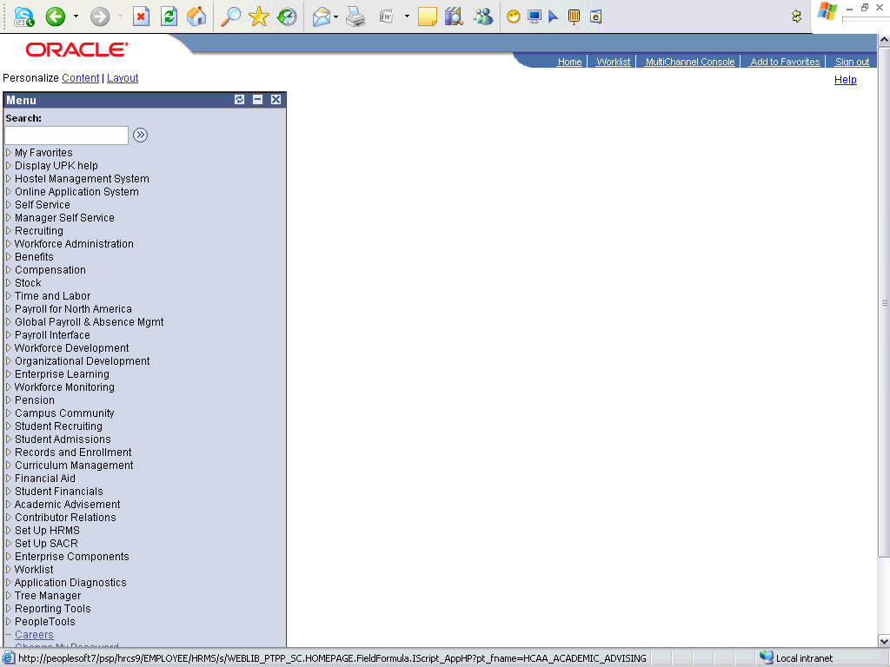

Step | Action
 | Click the Student Financials link.

Step | Action
 | Click the Tuition and Fees link.
 | Click the Calculate Batch Tuition link.
 | Click the Calculate Tuition link.

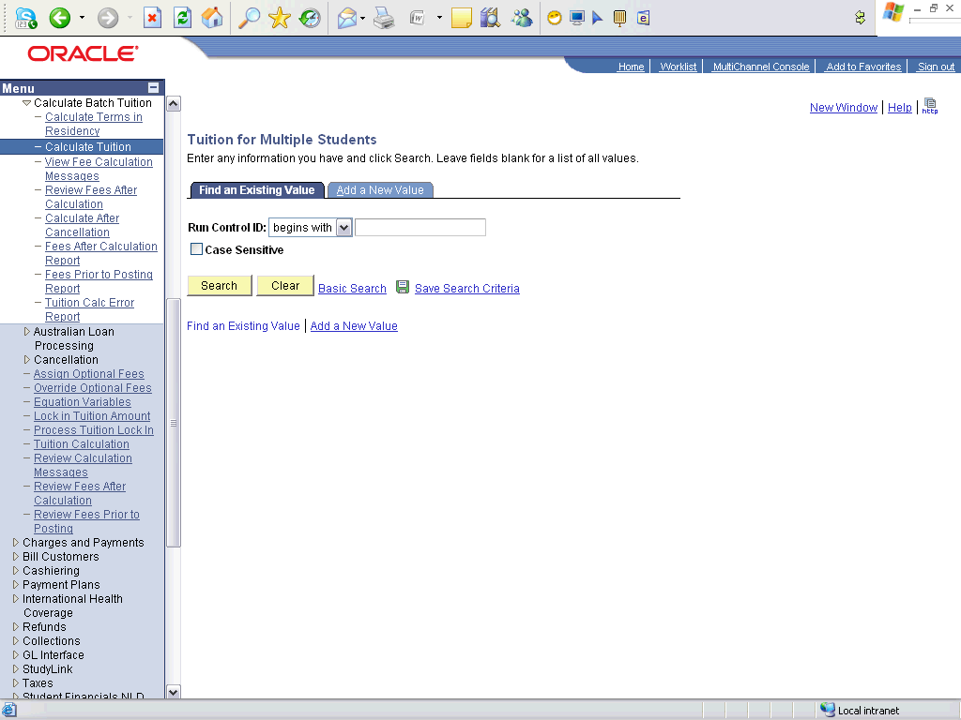

Step | Action
 | Click the Add a New Value tab.
 | Enter the desired information into the Run Control ID field. Enter "TC_ARCHITECTURE_MORN_2009".
 | Click the Add button.

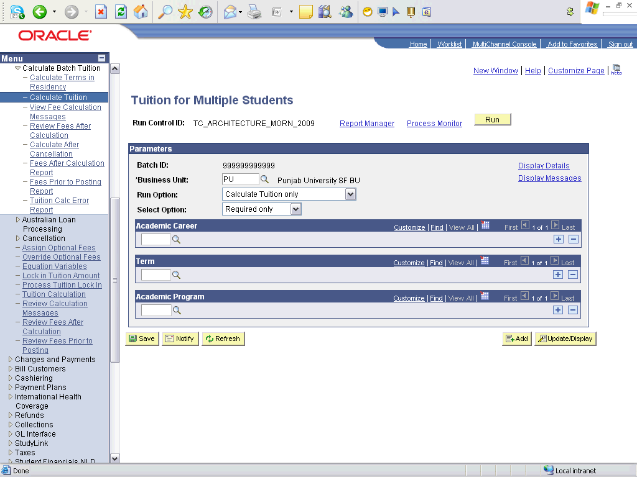

Step | Action
 | Click the Calc and Post Tuition, Waivers list item.
 | Enter the desired information into the Look up Career (Alt+5) field. Enter "UGRD".
 | Enter the desired information into the Look up Term (Alt+5) field. Enter "0913".
 | Enter the desired information into the Look up Acad Prog (Alt+5) field. Enter "BAR".
 | Click the Run button.

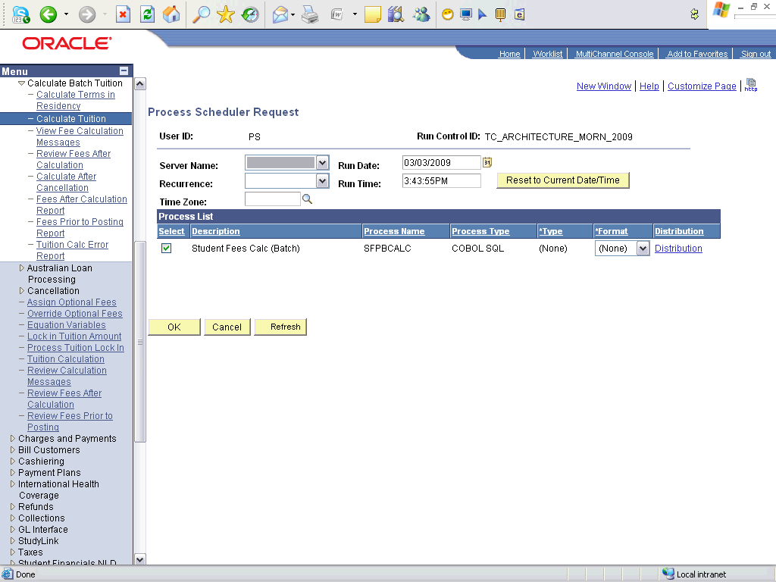

Step | Action
 | Click the OK button.

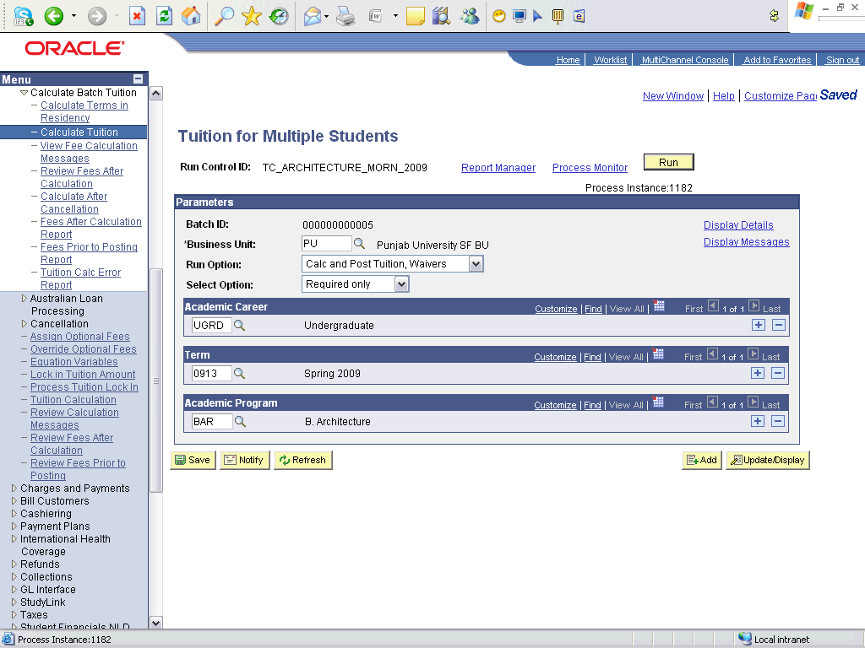

Step | Action
 | Click the Process Monitor link.

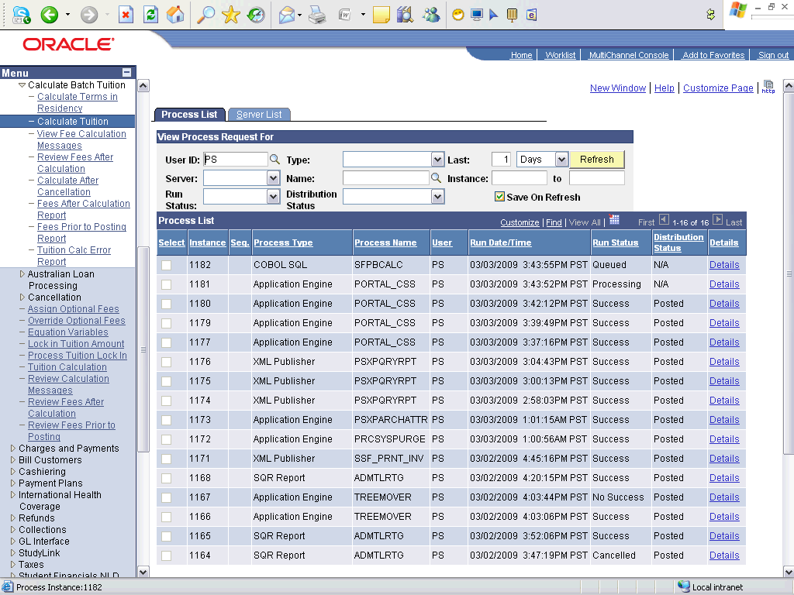

Step | Action
Point to the object.
Wait until the process's Run Status is Success.

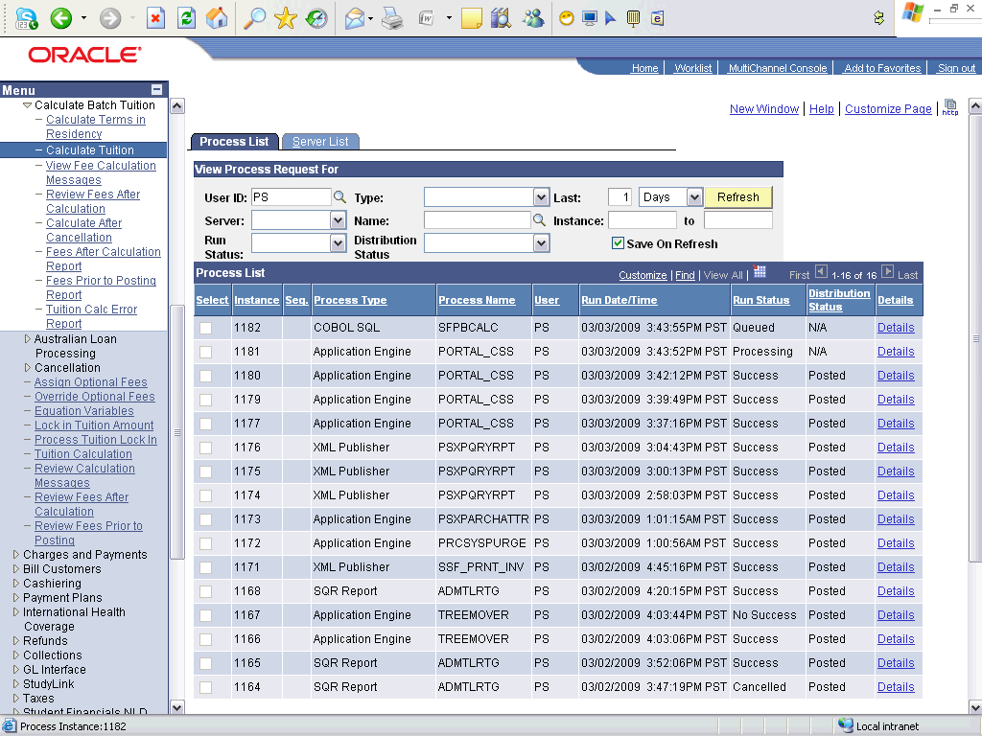

Step | Action
 | Click the Refresh button.
 | End of Procedure.

Applying Departmental Fee

Post Student Transactions for Departmental Charges

Procedure

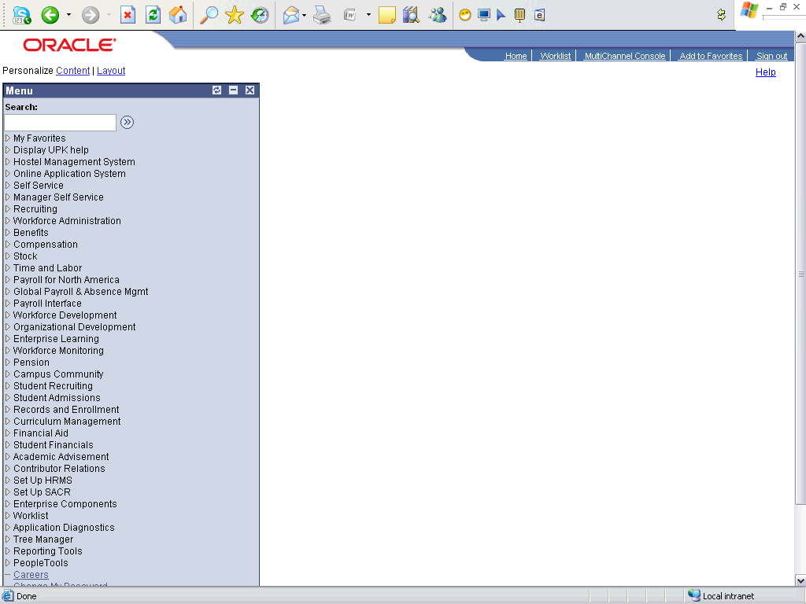

Step | Action
 | Click the Student Financials link.

Step | Action
 | Click the Charges and Payments link.
 | Click the Post Student Transaction link.

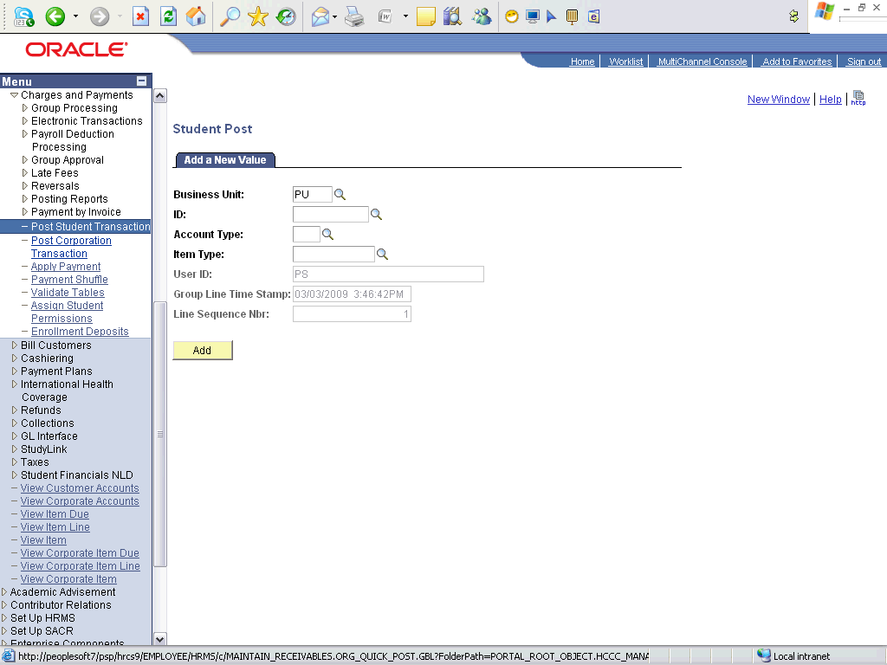

Step | Action
 | Enter the desired information into the ID field. Enter "2009MPPKS01".
 | Enter the desired information into the Account Type field. Enter "DPT".
 | Click the Look up Item Type (Alt+5) button.
 | Click an entry in the Description column.
 | Click the Add button.

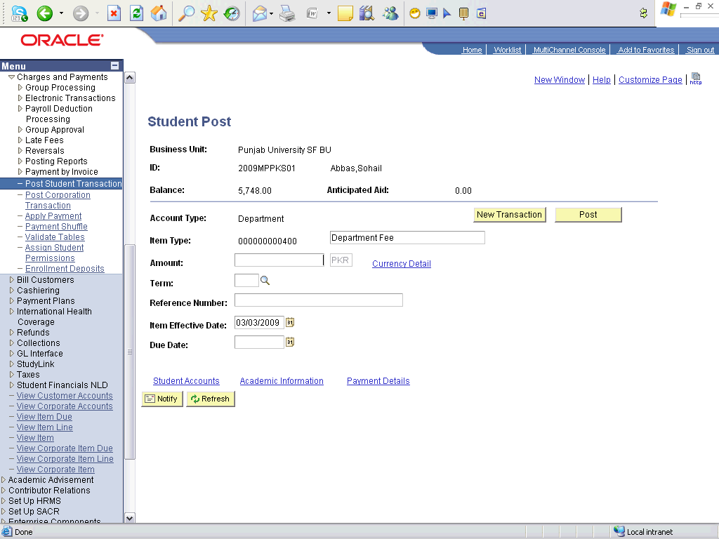

Step | Action
 | Enter the desired information into the Amount field. Enter "2500".
 | Enter the desired information into the Term field. Enter "0913".
 | Click the Choose a date (Alt+5) button.
 | Click the 30 link.
 | Click the Post button.
 | Click the Student Accounts link.

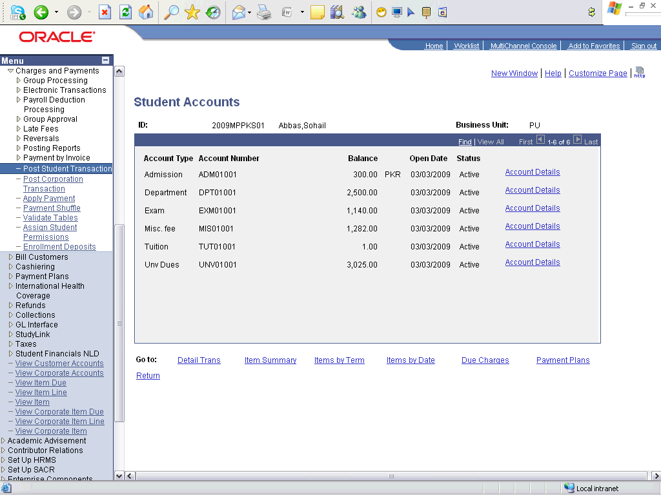

Step | Action
Point to the object.
Verify that the departmental charges are applied

Step | Action
 | Click the Return link.
 | End of Procedure.

Generating Invoice

Creating Billing Request and Generating Invoice - Individual

Procedure

Step | Action
 | Click the Student Financials link.

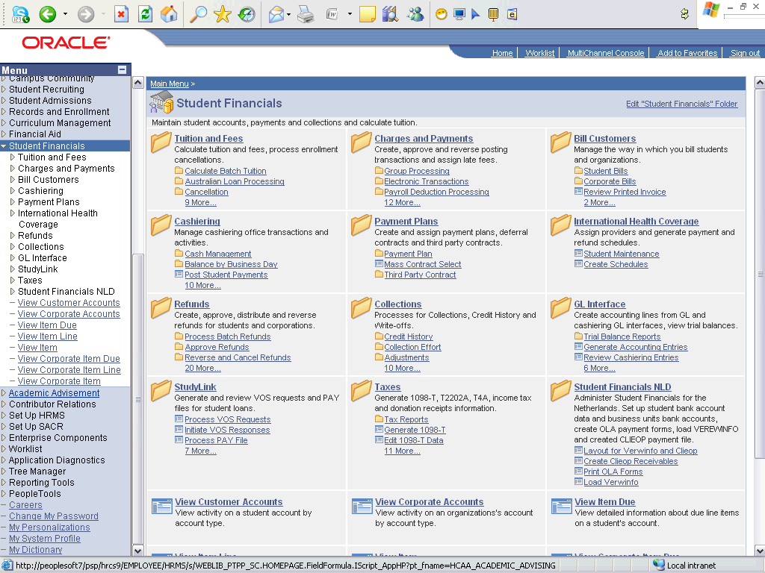

Step | Action
 | Click the Bill Customers link.
 | Click the Student Bills link.
 | Click the Create Billing Request link.

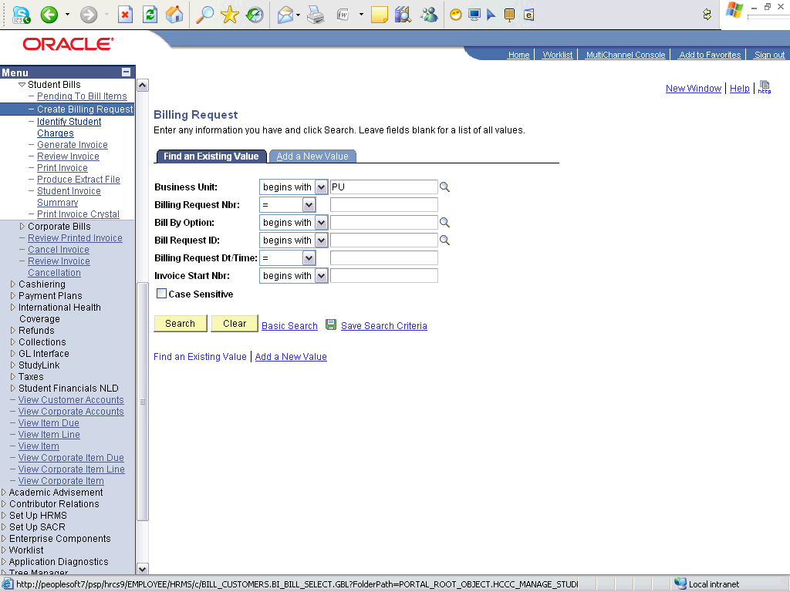

Step | Action
 | Click the Add a New Value tab.
 | Click the Look up Bill By Option (Alt+5) button.
 | Click an entry in the Description column.
 | Click the Add button.

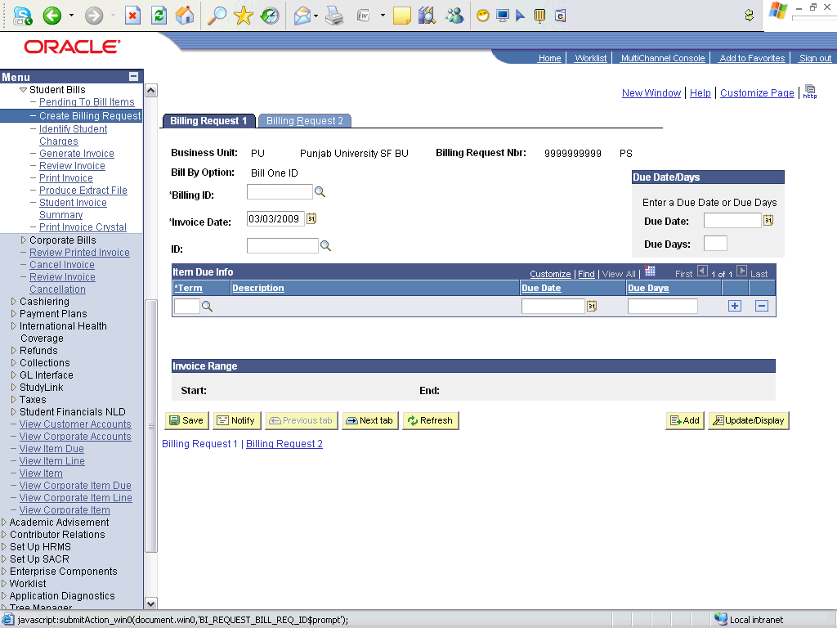

Step | Action
 | Click the Look up Billing ID (Alt+5) button.
 | Enter the desired information into the Bill Request ID field. Enter "B-P".
 | Click the Look Up button.
Click an entry in the Bill Request ID column.
Select Billing request for the desired department. Select the one ending with "-U", since it is for the university dues.
 | Enter the desired information into the ID field. Enter "2009MPPKS01".
 | Click the Choose a date (Alt+5) button.
 | Click the 24 link.
 | Click the Billing Request 2 tab.

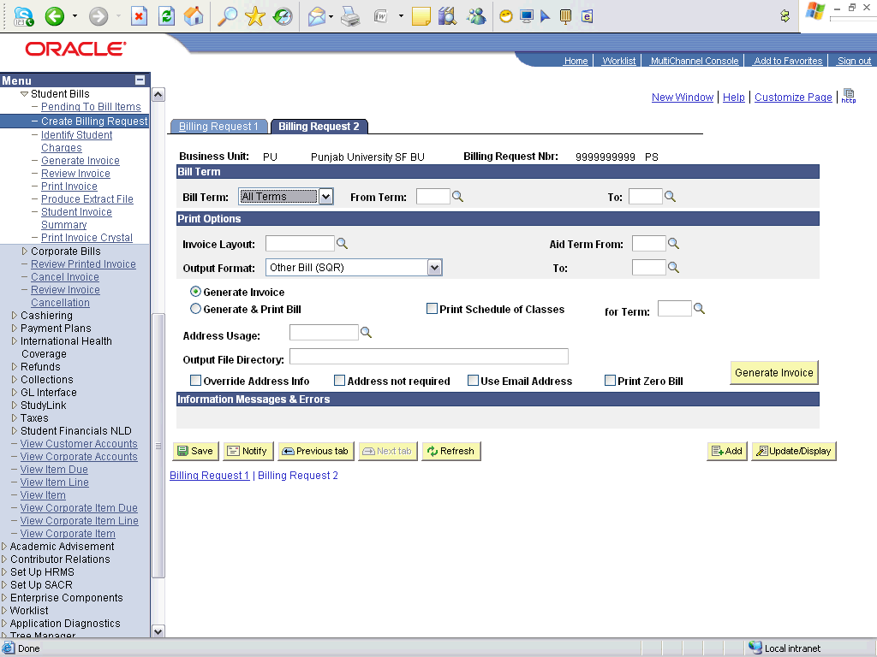

Step | Action
 | Click the One Term list item.
 | Enter the desired information into the Term field. Enter "0913".
 | Enter the desired information into the Invoice Layout field. Enter "PUINV".
 | Click the Address not required option.
 | Click the Generate Invoice button.

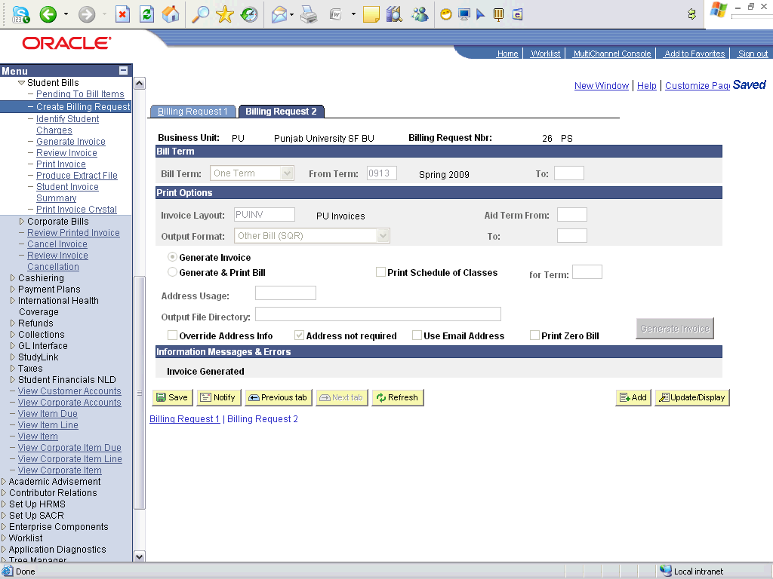

Step | Action
Point to the object.
The button is disabled and the invoice has been generated.

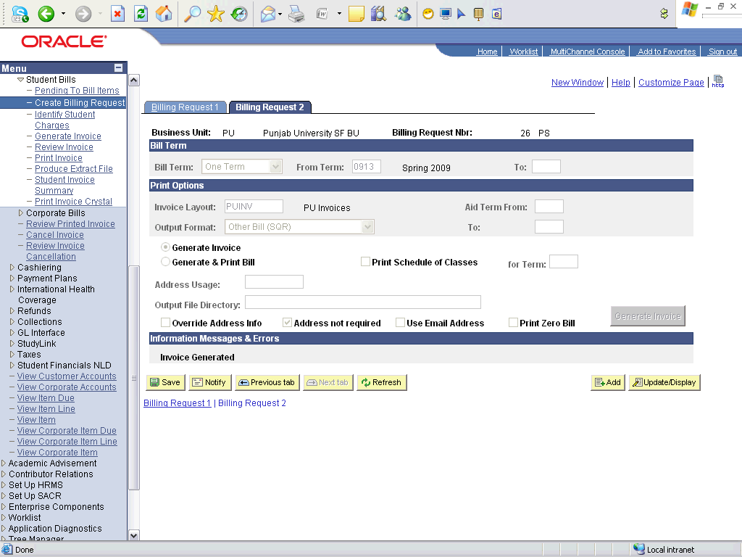

Step | Action
 | Click the Billing Request 1 tab.

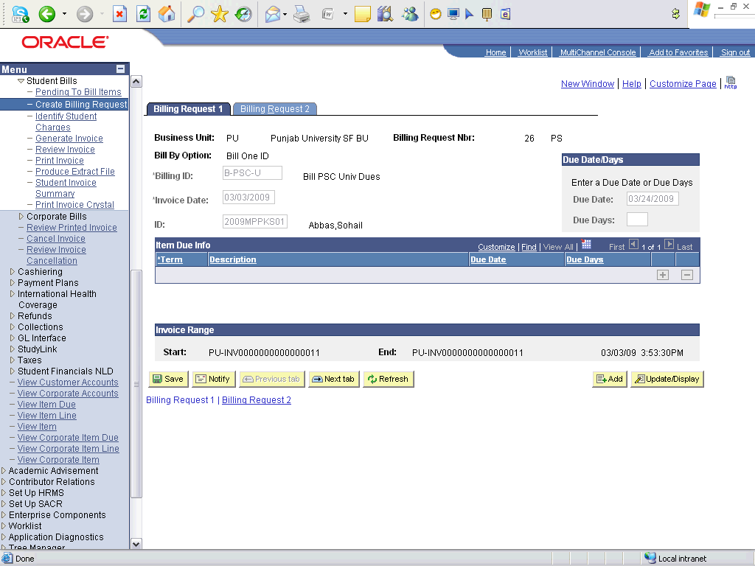

Step | Action
Point to the object.
This is the student's invoice number
 | End of Procedure.

Creating Billing Request and Generating Invoice - Batch

Procedure

Step | Action
 | Click the Student Financials link.

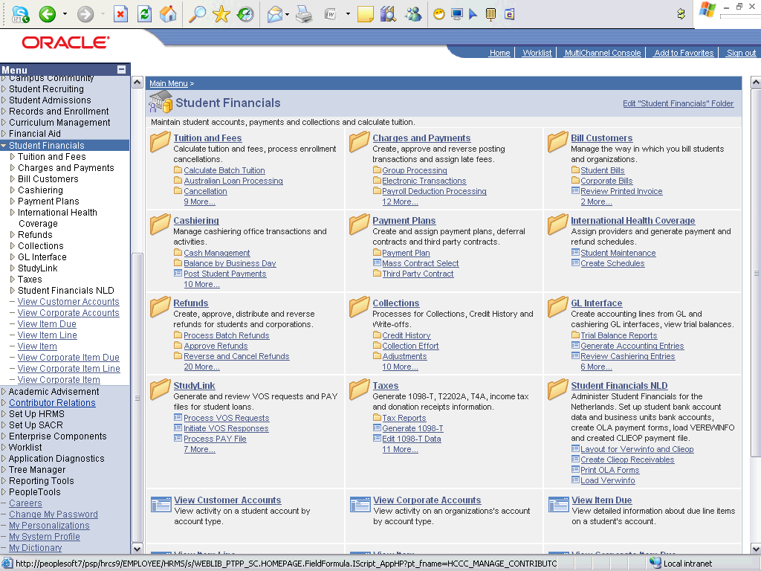

Step | Action
 | Click the Bill Customers link.
 | Click the Student Bills link.
 | Click the Create Billing Request link.

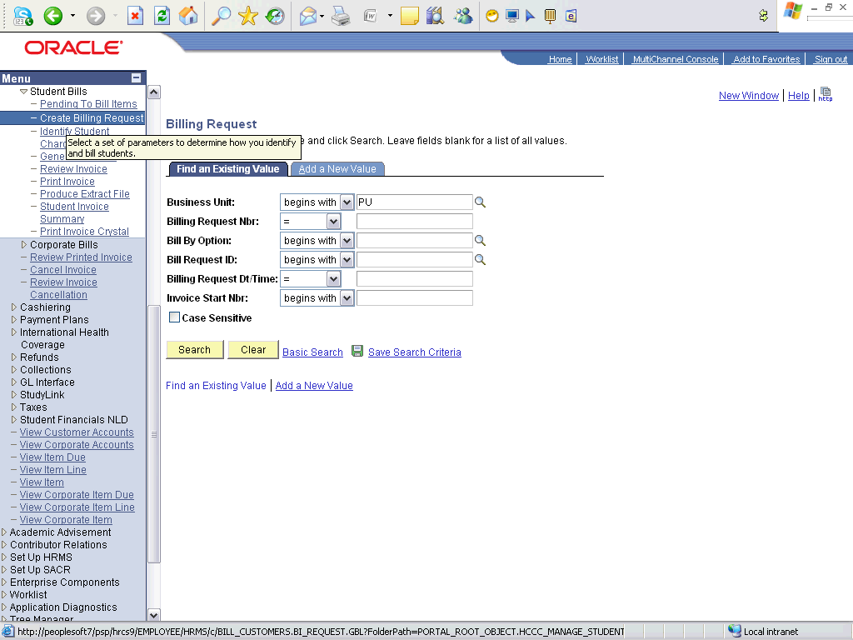

Step | Action
 | Click the Add a New Value tab.
 | Click the Look up Bill By Option (Alt+5) button.
 | Click an entry in the Description column.
 | Click the Add button.

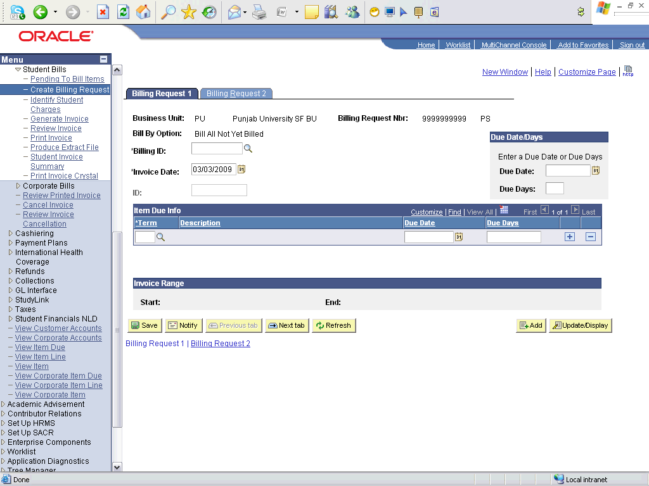

Step | Action
 | Click the Look Up button.
 | Click an entry in the Bill Request ID column.
 | Click the Choose a date (Alt+5) button.
 | Click the 24 link.
 | Click the Billing Request 2 tab.

Step | Action
 | Click the One Term list item.
 | Enter the desired information into the Term field. Enter "0913".
 | Enter the desired information into the Invoice Layout field. Enter "PUINV".
 | Click the Address not required option.
 | Click the Generate Invoice button.
 | Click the Billing Request 1 tab.

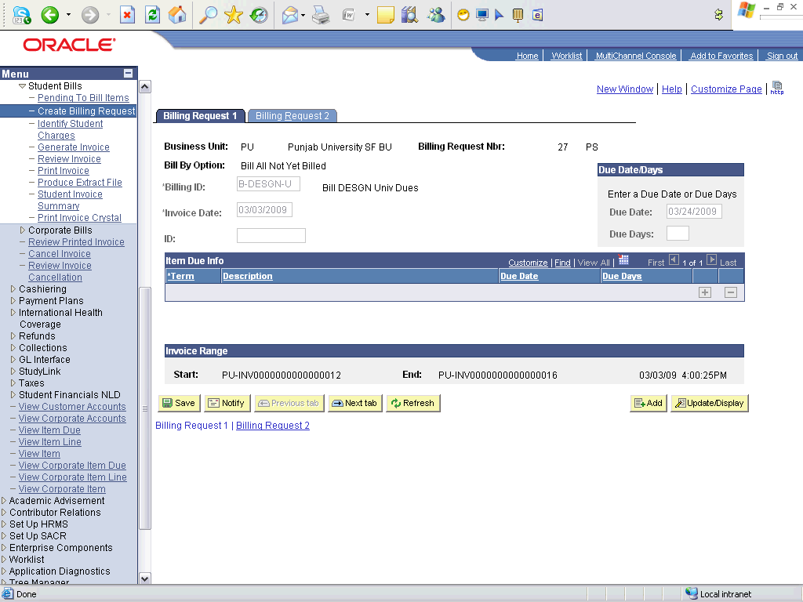

Step | Action
Point to the object.
Note the Range of the invoices generated for the students of that department.
 | End of Procedure.

Creating Departmental Billing Request and Generating Invoice

Procedure

Step | Action
 | Click the Student Financials link.

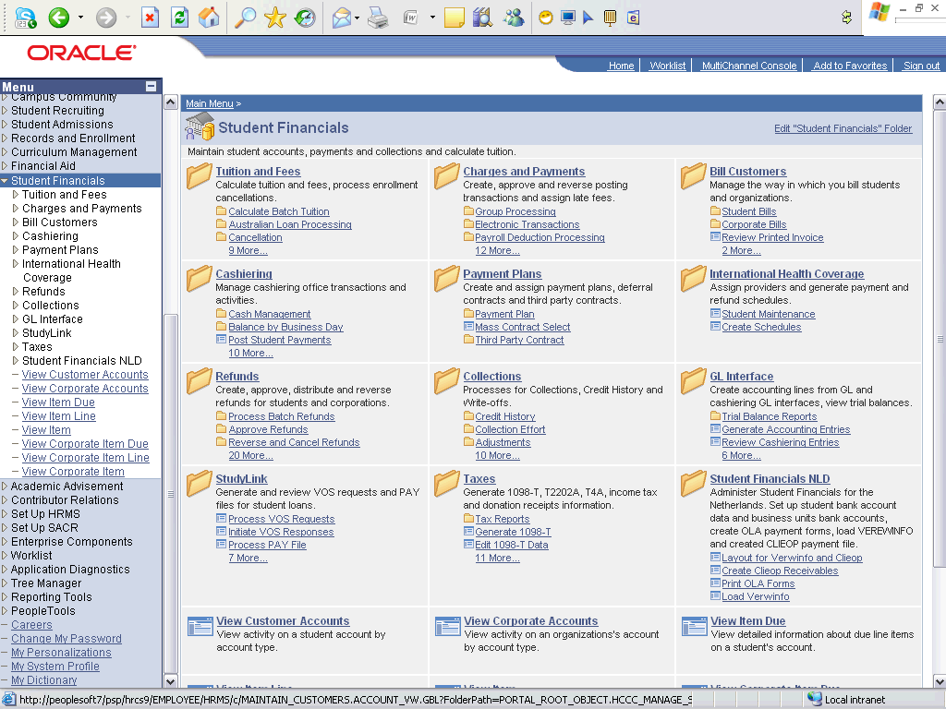

Step | Action
 | Click the Bill Customers link.
 | Click the Student Bills link.
 | Click the Create Billing Request link.

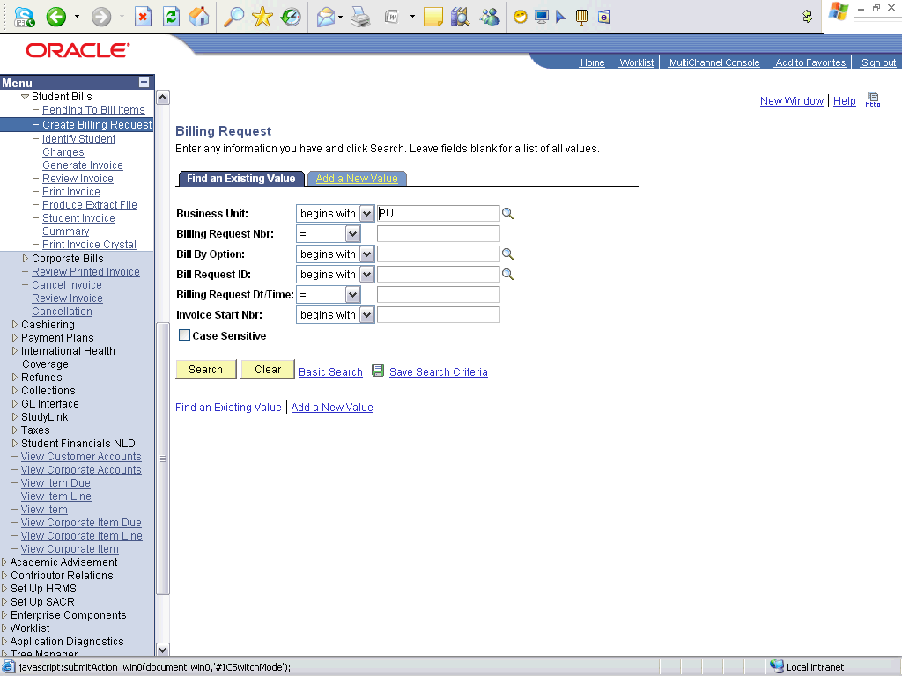

Step | Action
 | Click the Add a New Value tab.
 | Click the Look up Bill By Option (Alt+5) button.
Click an entry in the Description column.
Select A or Y depending upon your requirement.
 | Click the Add button.

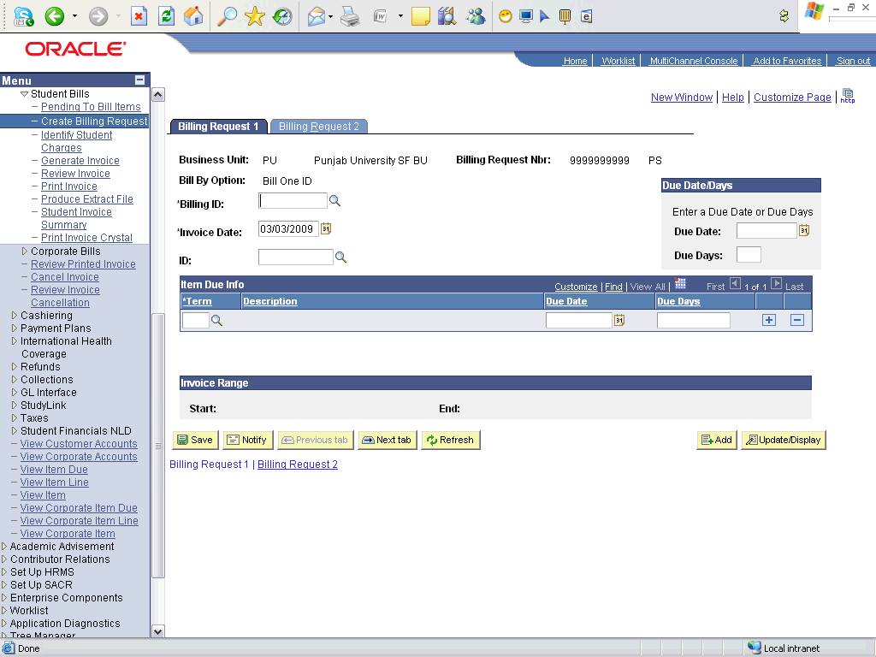

Step | Action
 | Click the Look up Billing ID (Alt+5) button.
 | Click the Look Up button.
Click an entry in the Bill Request ID column.
The billing Request ID ending with "-D" is for the departmental invoicing
 | Enter the desired information into the ID field. Enter "2009MPPKS01".
 | Click the Choose a date (Alt+5) button.
 | Click the 24 link.
 | Click the Billing Request 2 tab.

Step | Action
 | Click the One Term list item.
 | Enter the desired information into the Term field. Enter "0913".
 | Enter the desired information into the Invoice Layout field. Enter "PUINV".
 | Click the Address not required option.
 | Click the Generate Invoice button.
 | Click the Billing Request 1 tab.

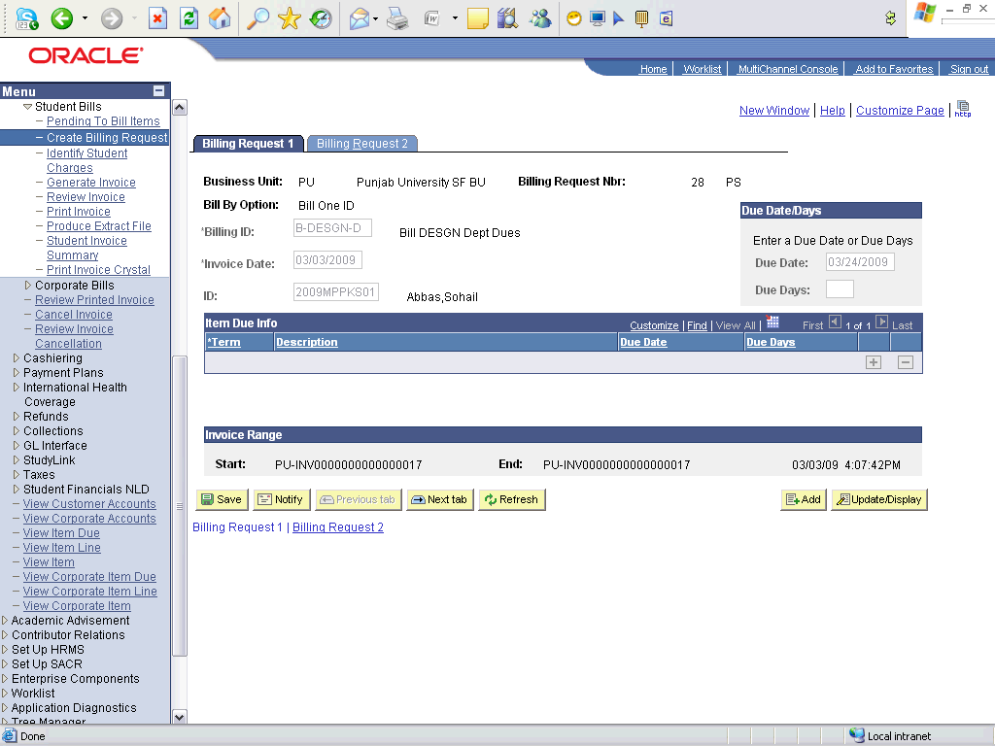

Step | Action
Point to the object.
The invoice number generated for departmental invoice.
 | End of Procedure.

Printing Invoices - Individual

Procedure

Step | Action
 | Click the Student Financials link.

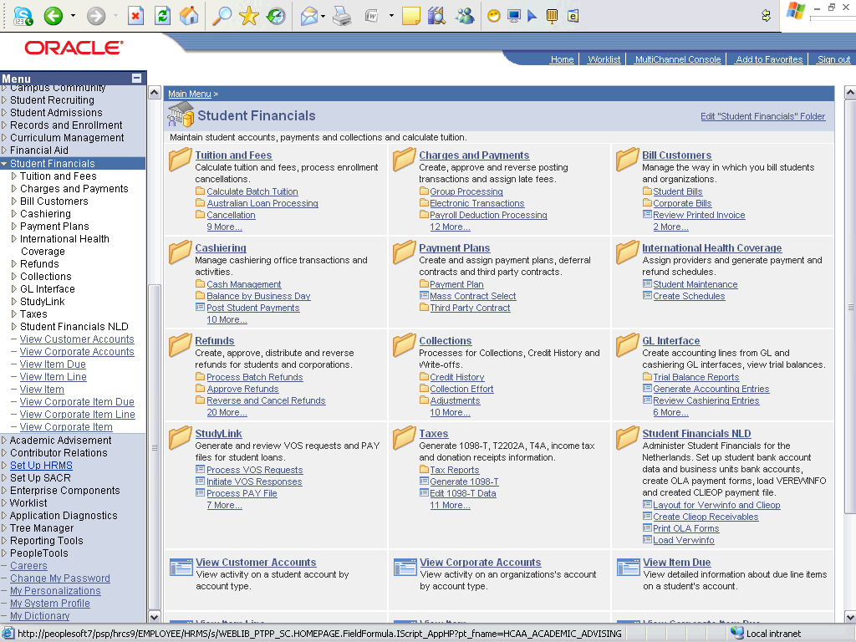

Step | Action
 | Click the Bill Customers link.
 | Click the Student Bills link.
 | Click the Print Invoice link.

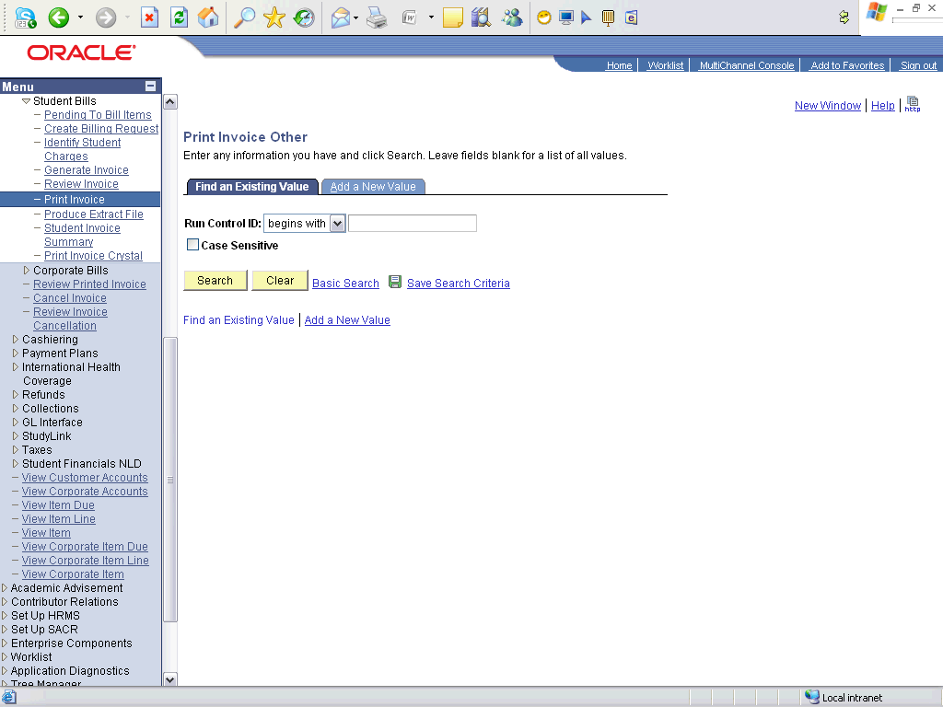

Step | Action
 | Click the Add a New Value tab.
 | Enter the desired information into the Run Control ID field. Enter "PRINT_INVOICES_2009".
 | Click the Add button.

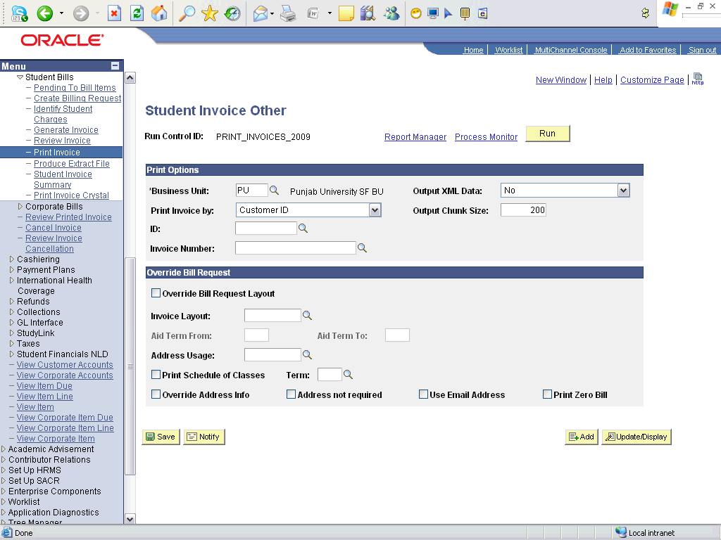

Step | Action
 | Click the Look up ID (Alt+5) button.
 | Click an entry in the ID column.
 | Click the Look up Invoice Number (Alt+5) button.
Click an entry in the Invoice Number column.
Select university dues invoice or department dues invoice number
 | Click the Run button.

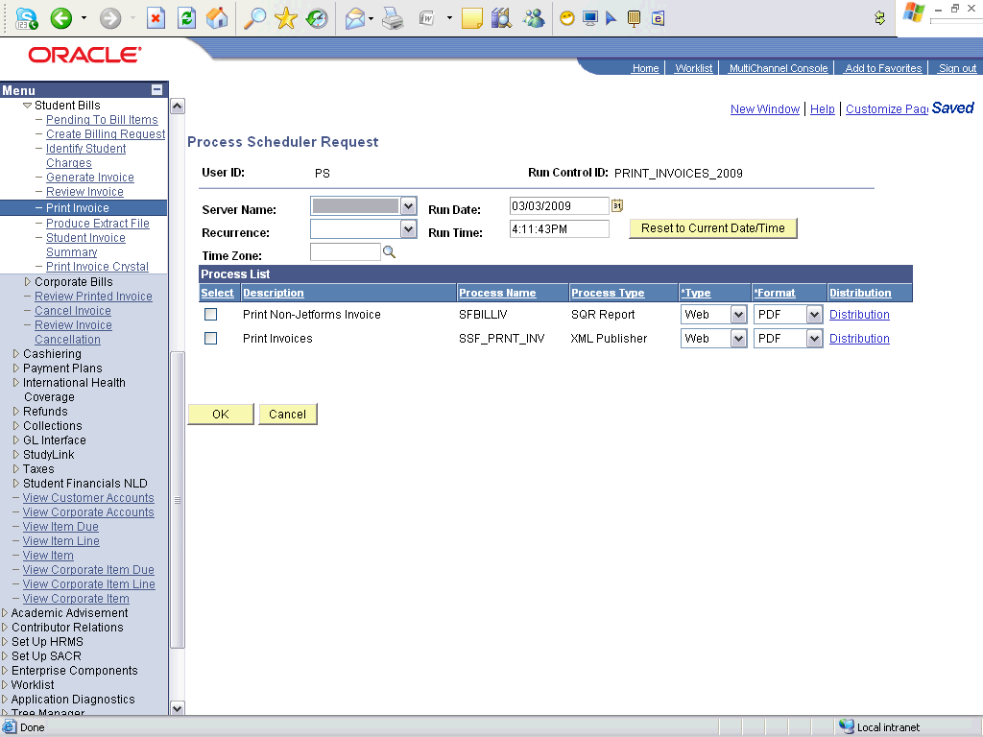

Step | Action
 | Click the Select option.
 | Click the OK button.

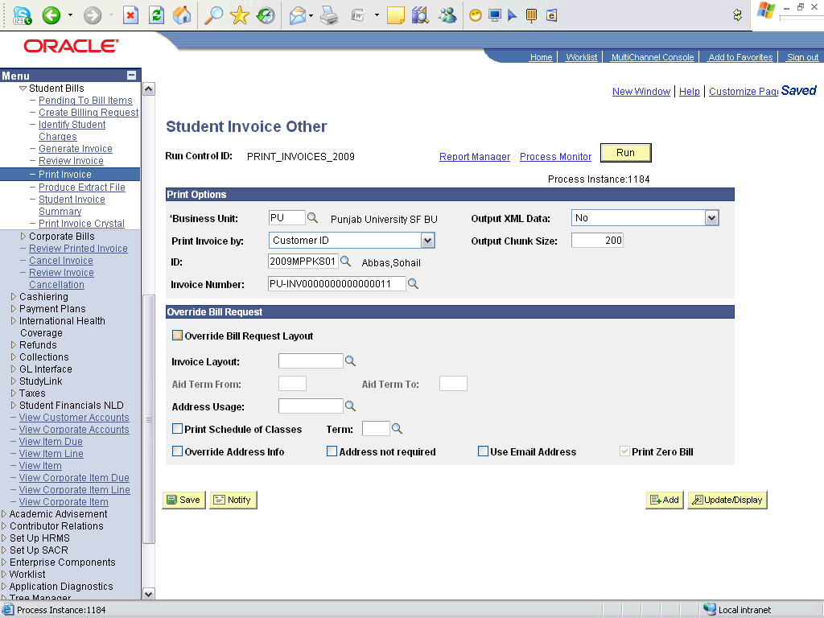

Step | Action
 | Click the Process Monitor link.

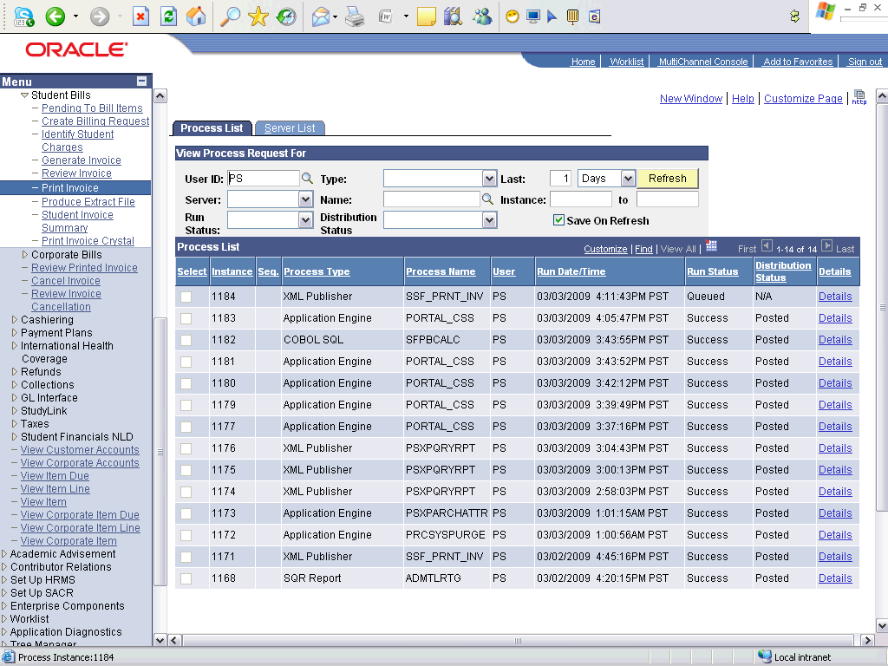

Step | Action
Point to the object.
Wait till the run status of this process is Success

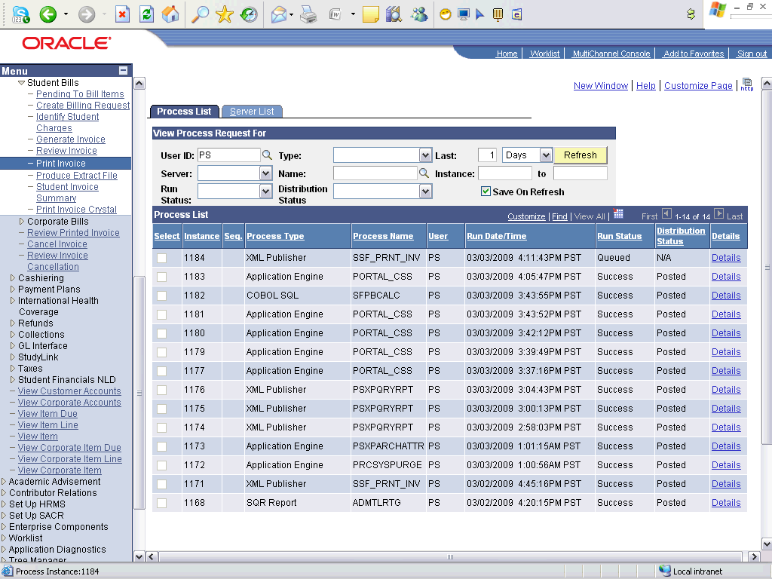

Step | Action
 | Click the Refresh button.

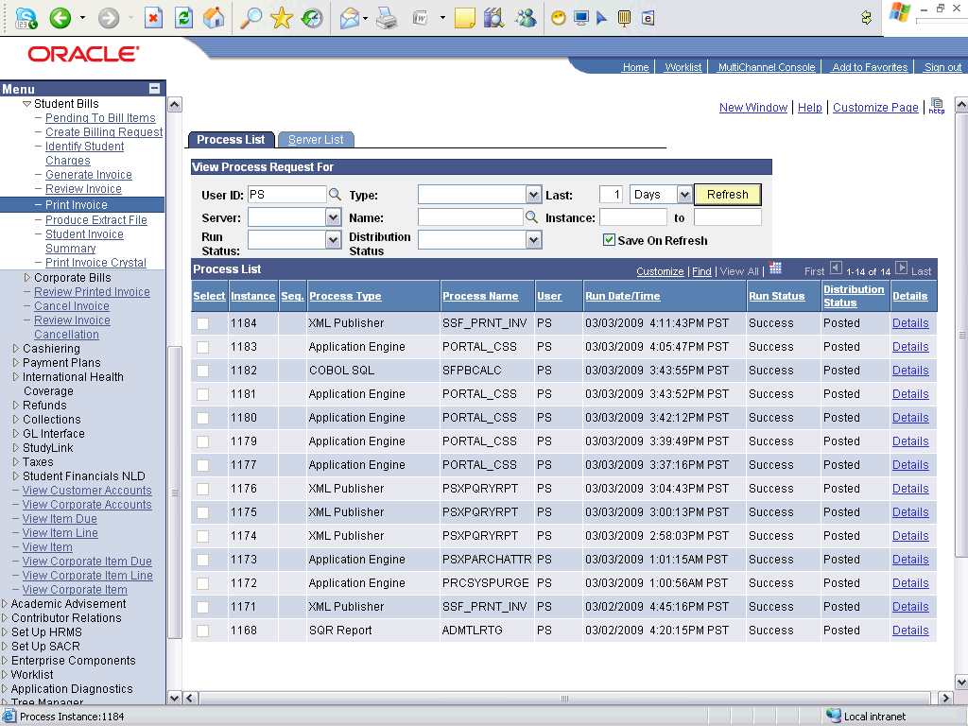

Step | Action
Point to the object.
The invoice has been printed

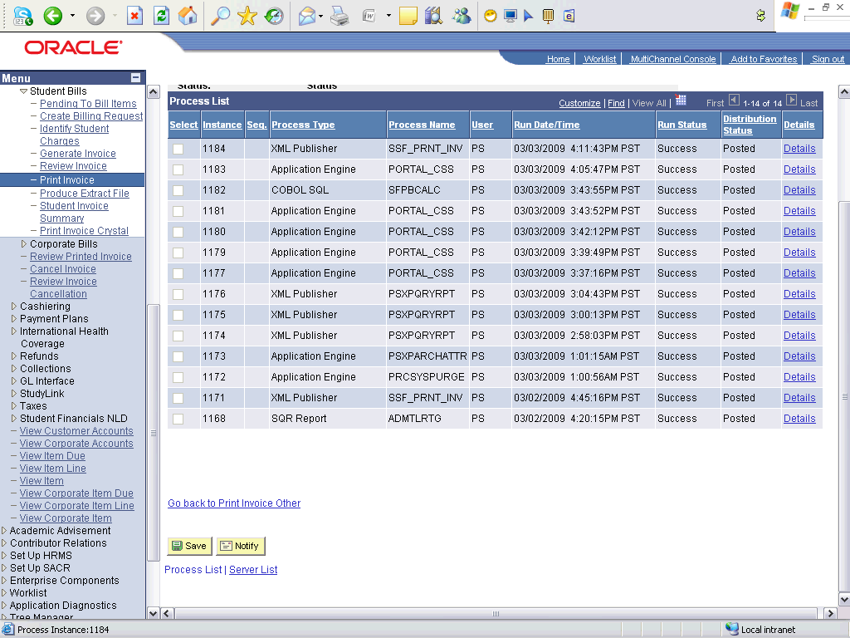

Step | Action
 | Click the Go back to Print Invoice Other link.

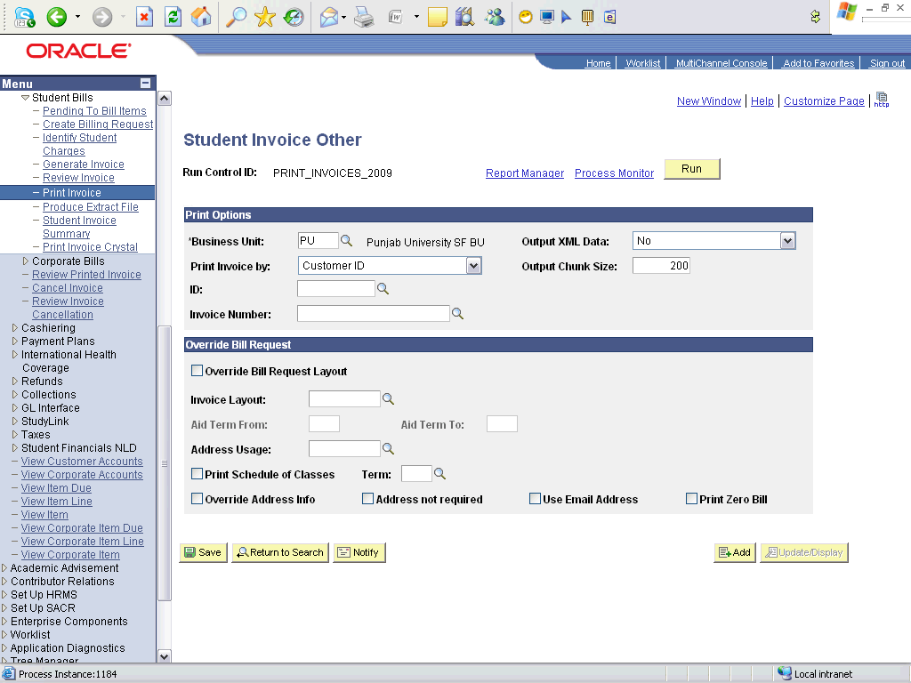

Step | Action
 | Click the Report Manager link.

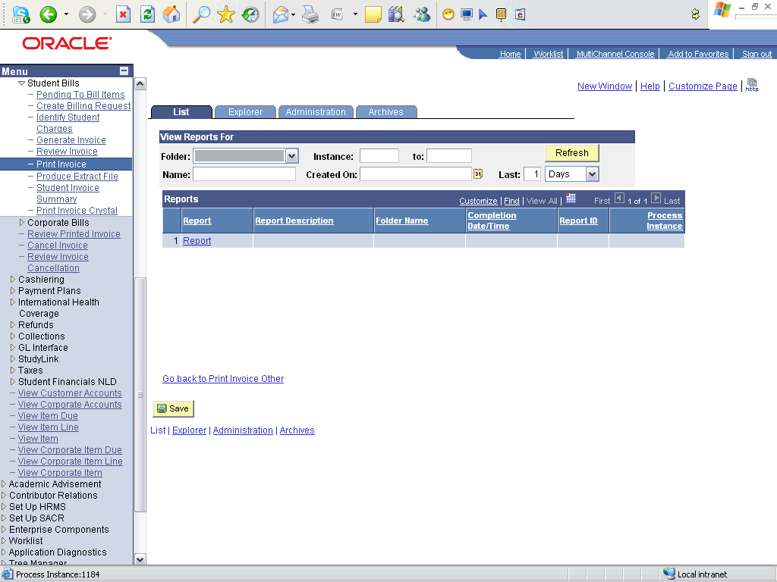

Step | Action
 | Click the Administration tab.

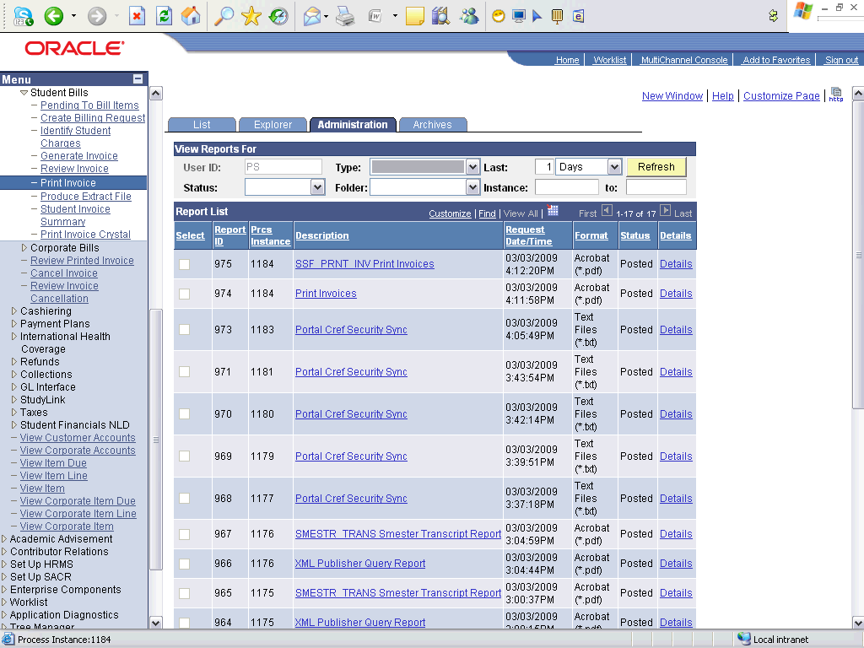

Step | Action
 | Click an entry in the Description column.

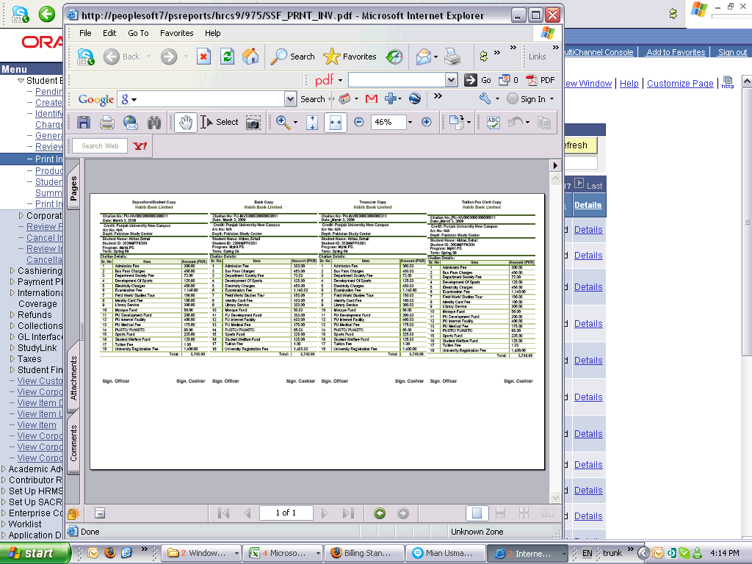

Step | Action
 | Click the AVPageView object.
 | End of Procedure.

Printing Invoices - Batch

Procedure

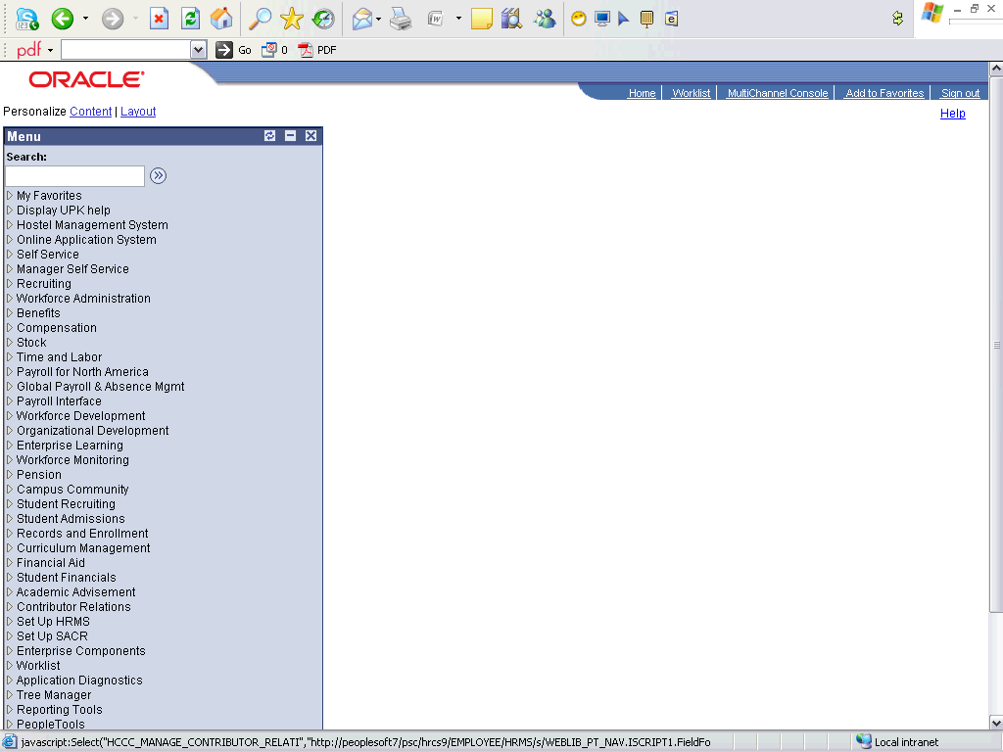

Step | Action
 | Click the Student Financials link.

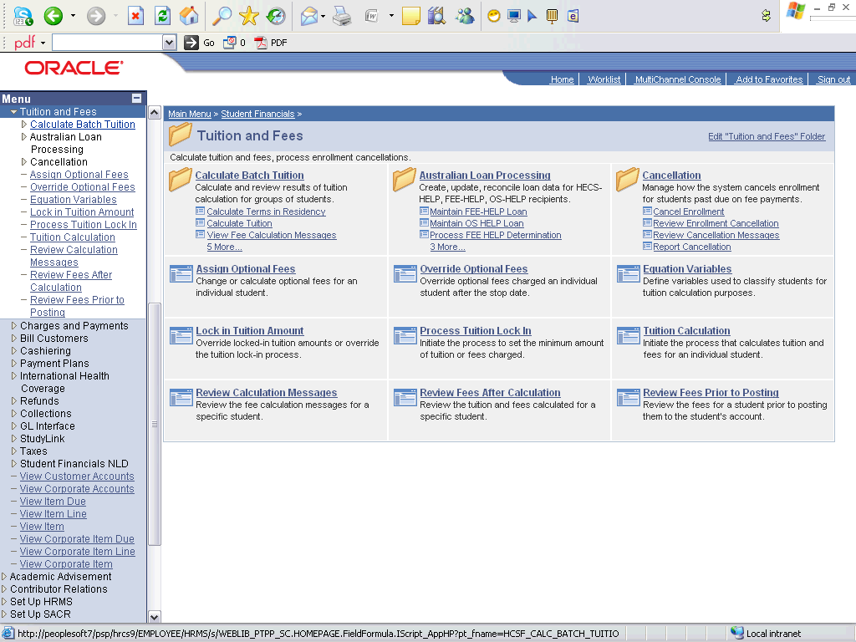

Step | Action
 | Click the Bill Customers link.
 | Click the Student Bills link.
 | Click the Print Invoice link.

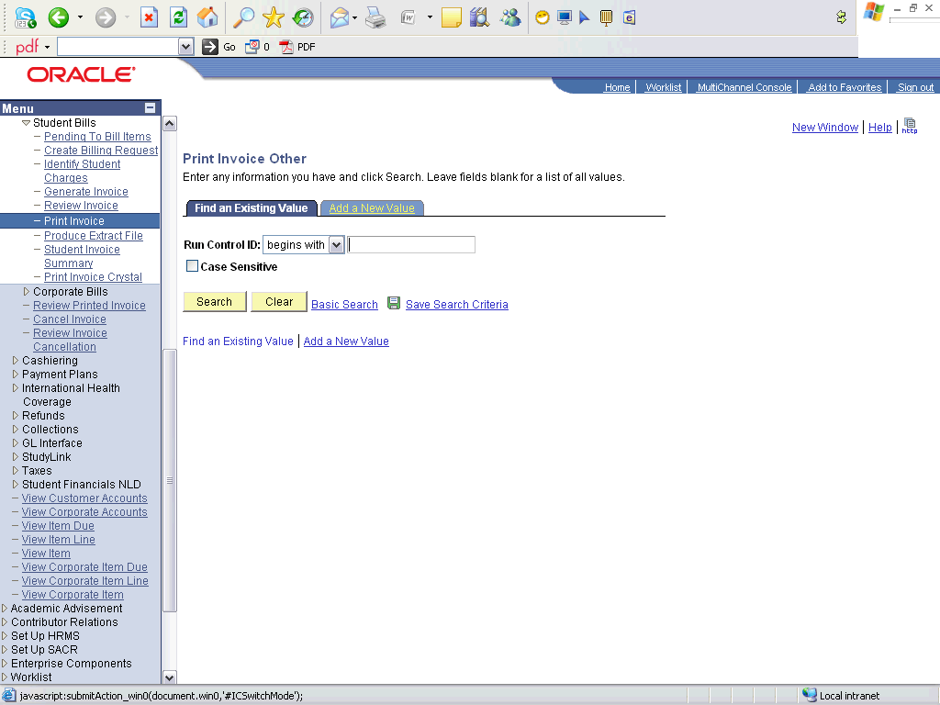

Step | Action
 | Click the Add a New Value tab.
 | Enter the desired information into the Run Control ID field. Enter "PRINT_INVOICES_BATCH".
 | Enter the desired information into the Run Control ID field. Enter "PRINT_INVOICES_DESGN_2009".
 | Click the Add button.

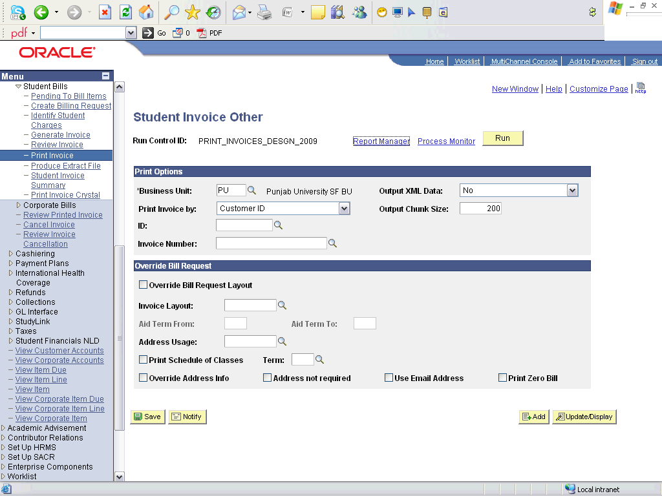

Step | Action
 | Click the Invoice Range list item.
 | Click the Look up Start (Alt+5) button.
 | Click an entry in the Invoice Start Nbr column.
 | Click the Look up End (Alt+5) button.
 | Click an entry in the Invoice Nbr End column.
 | Click the Run button.

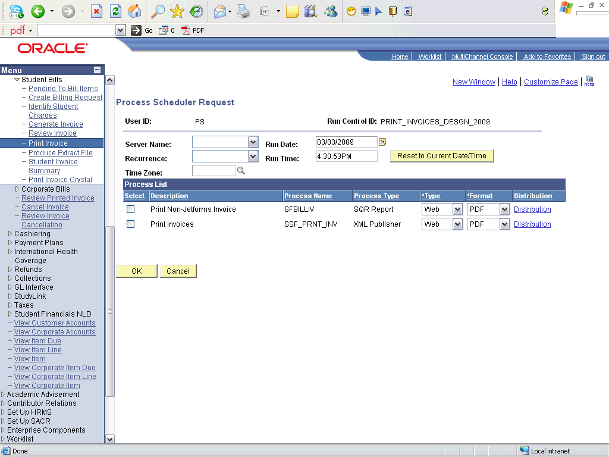

Step | Action
 | Click the Select option.
 | Click the OK button.

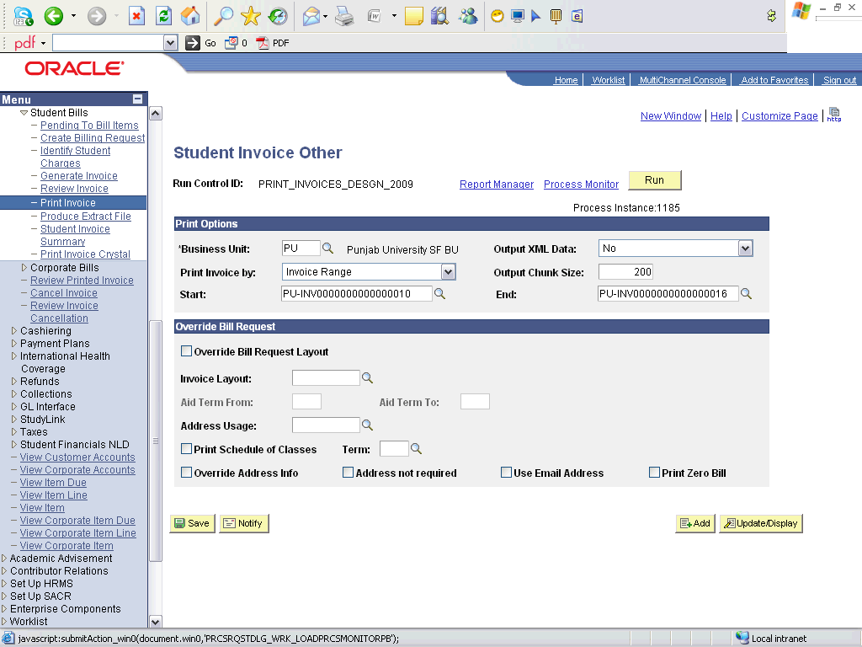

Step | Action
 | Click the Process Monitor link.

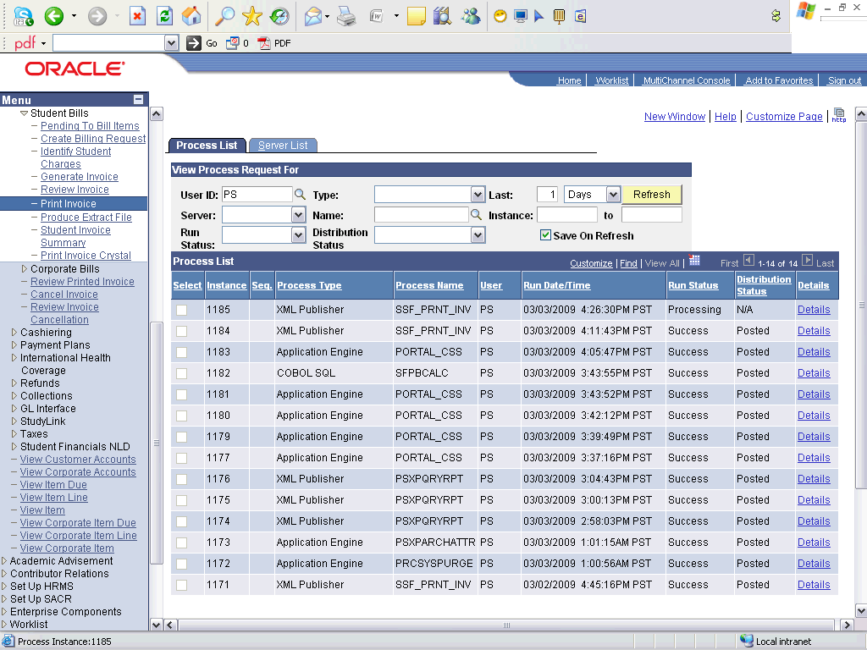

Step | Action
 | Click the Refresh button.

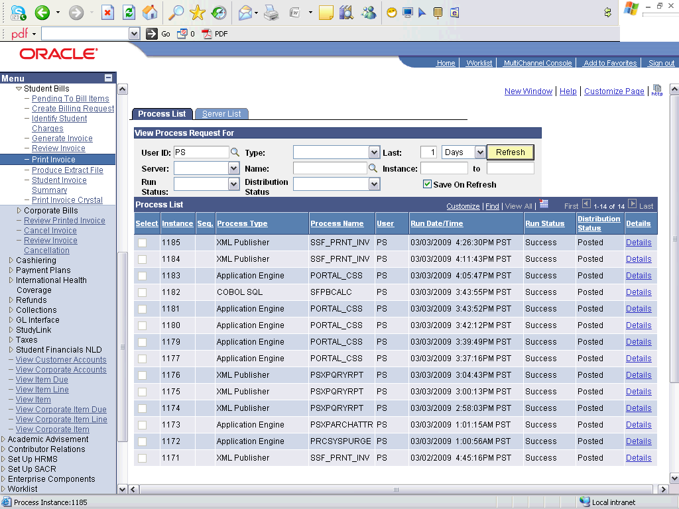

Step | Action
Point to the object.
Wait until the process is success

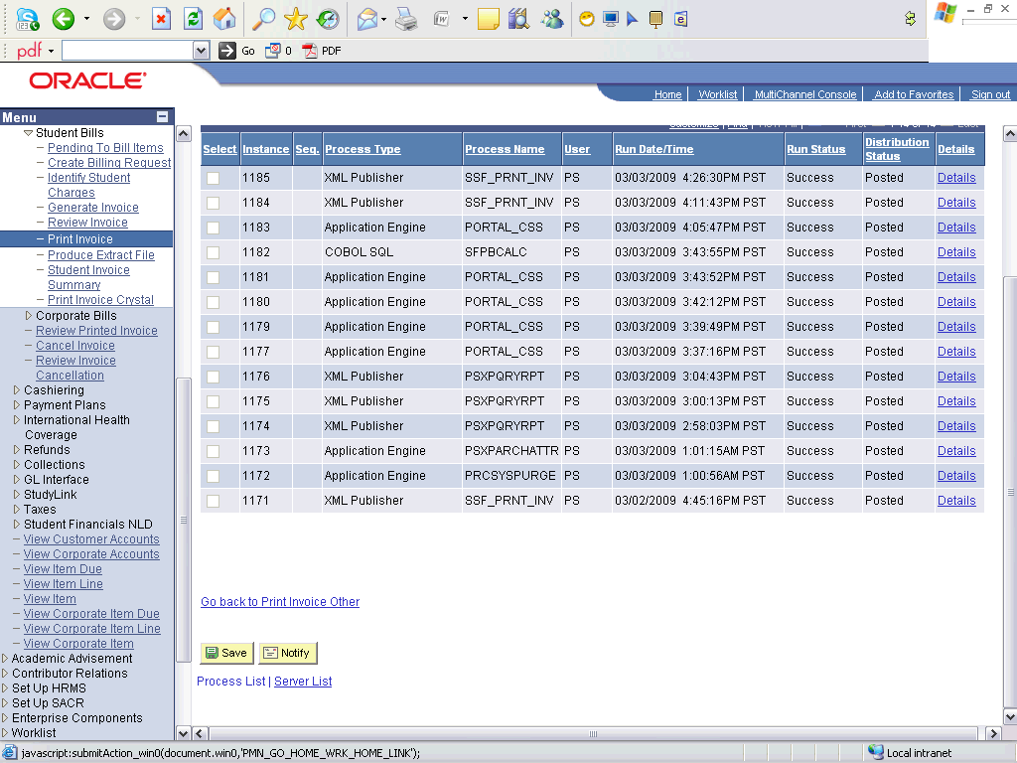

Step | Action
 | Click the Go back to Print Invoice Other link.

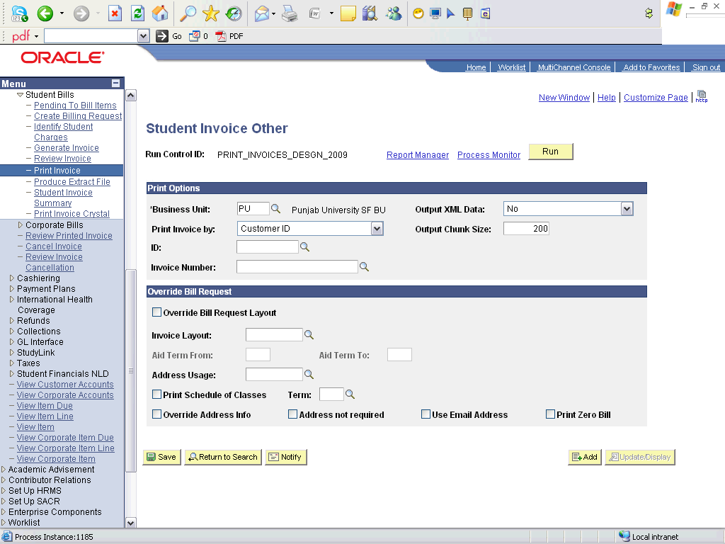

Step | Action
 | Click the Report Manager link.

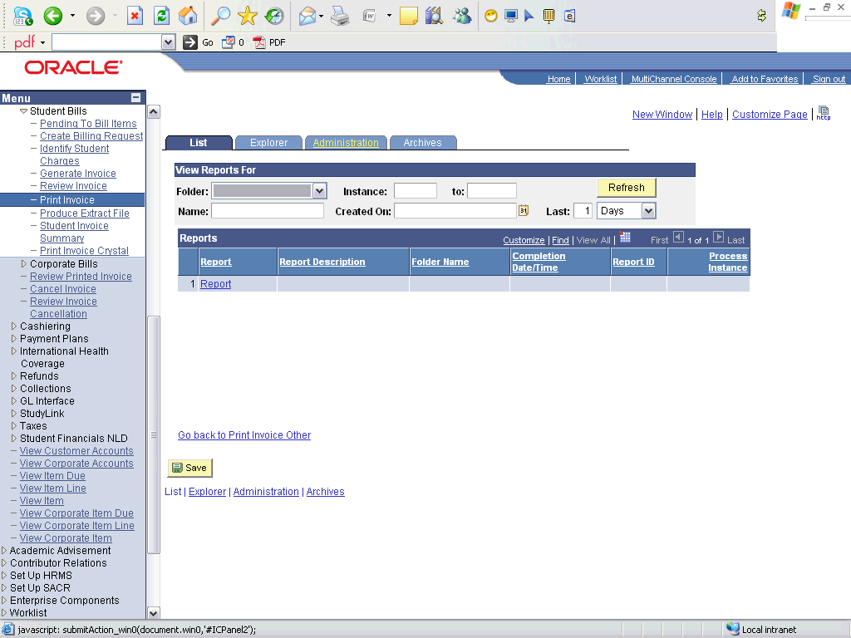

Step | Action
 | Click the Administration tab.

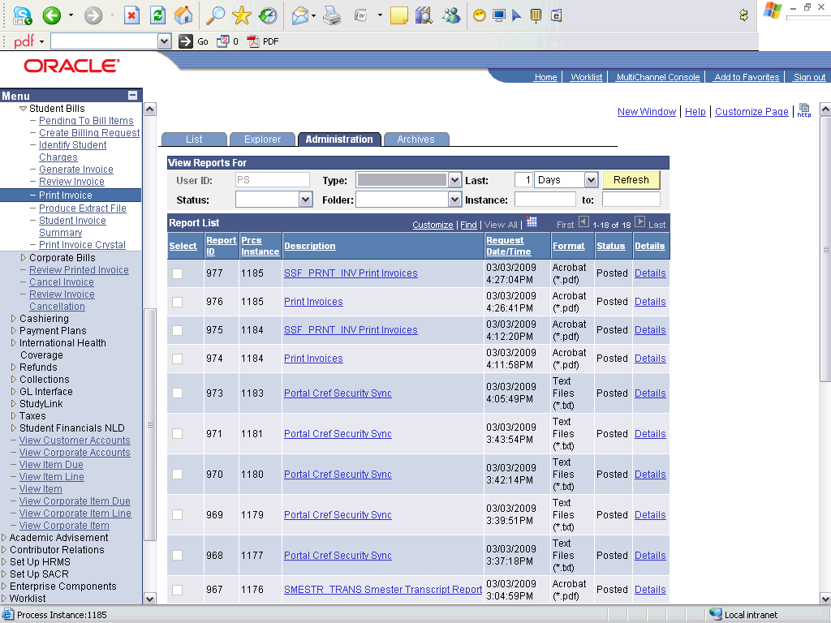

Step | Action
 | Click an entry in the Description column.

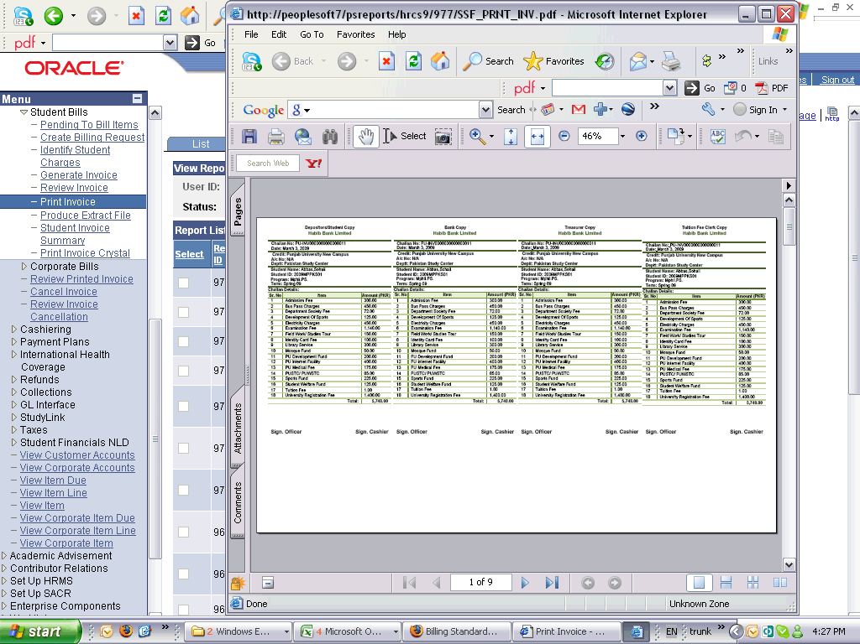

Step | Action
Point to the object.
The invoices in range are printed.
Click the scrollbar.
To view all the invoices.
 | End of Procedure.

Cancelling Invoices

Procedure

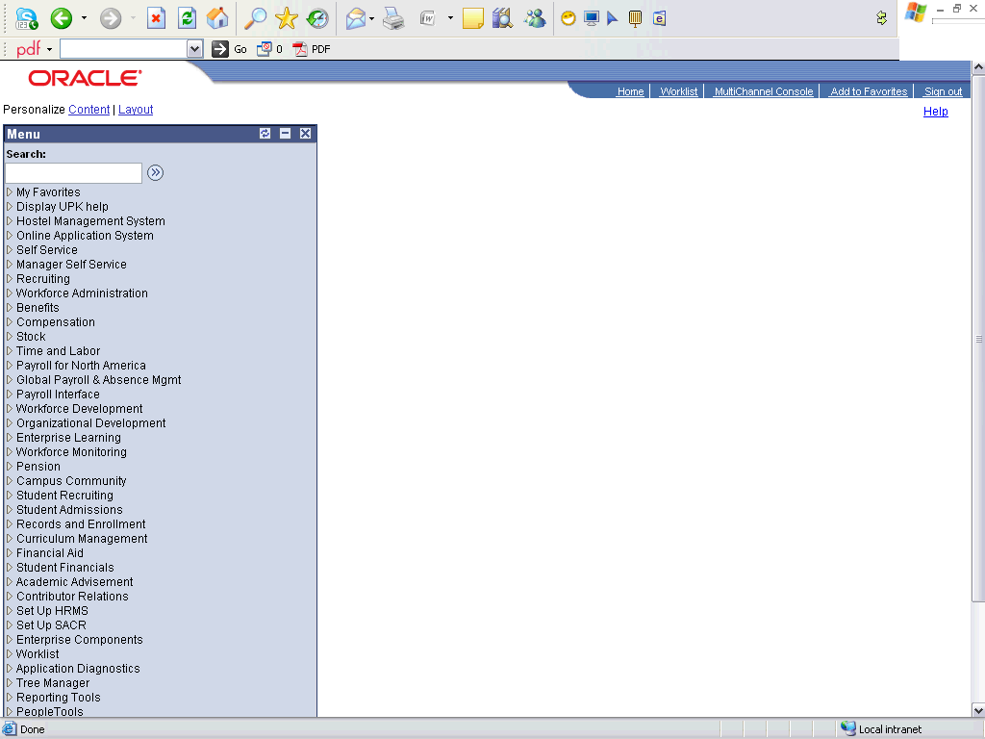

Step | Action
 | Click the Student Financials link.

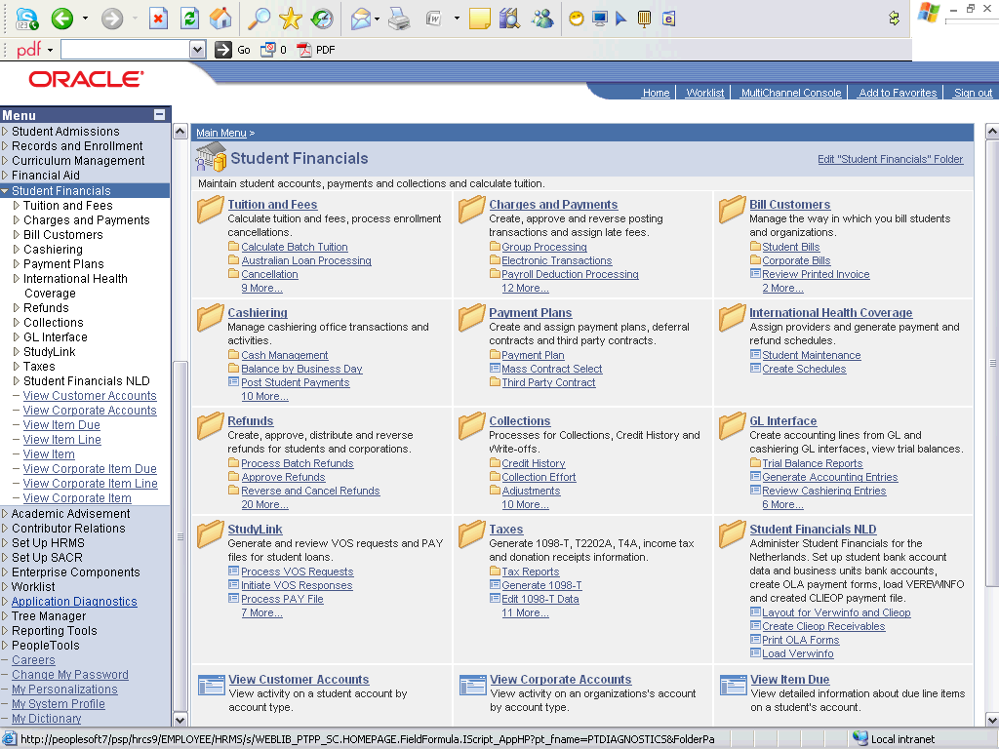

Step | Action
 | Click the Bill Customers link.
 | Click the Cancel Invoice link.

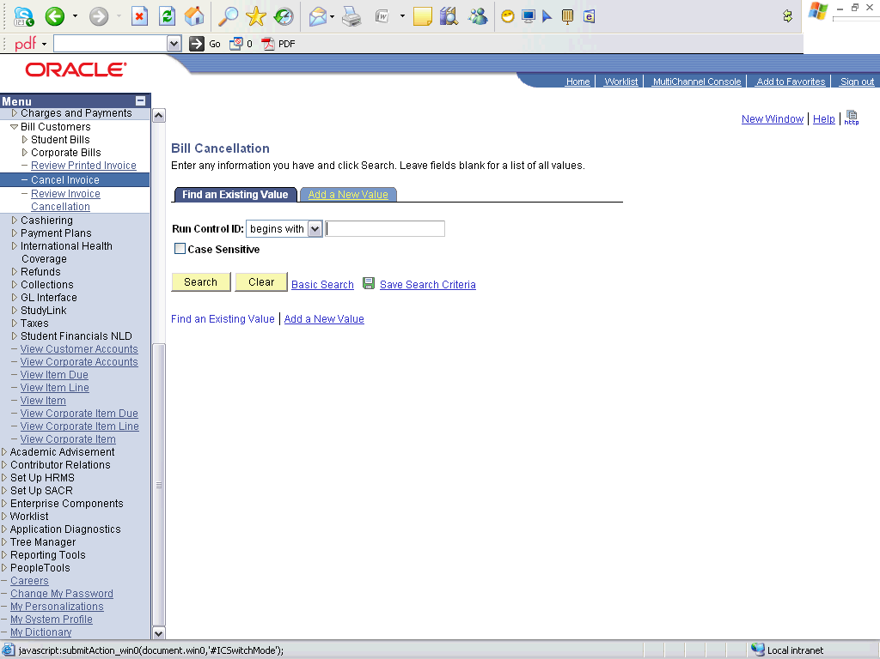

Step | Action
 | Click the Add a New Value tab.
 | Enter the desired information into the Run Control ID field. Enter "CANCEL_INVOICE_2009MPPKS01".
 | Click the Add button.

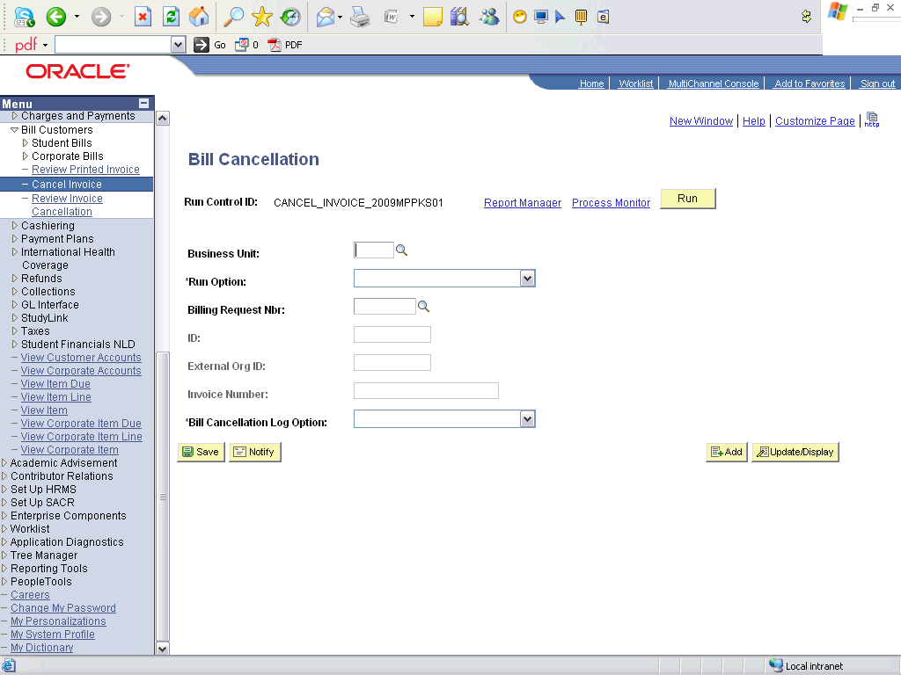

Step | Action
 | Click the Look up Business Unit (Alt+5) button.
 | Click an entry in the Description column.
 | Click the Invoice ID list item.
 | Click the Look up ID (Alt+5) button.
 | Click an entry in the ID column.
 | Click the None list item.
 | Click the Run button.

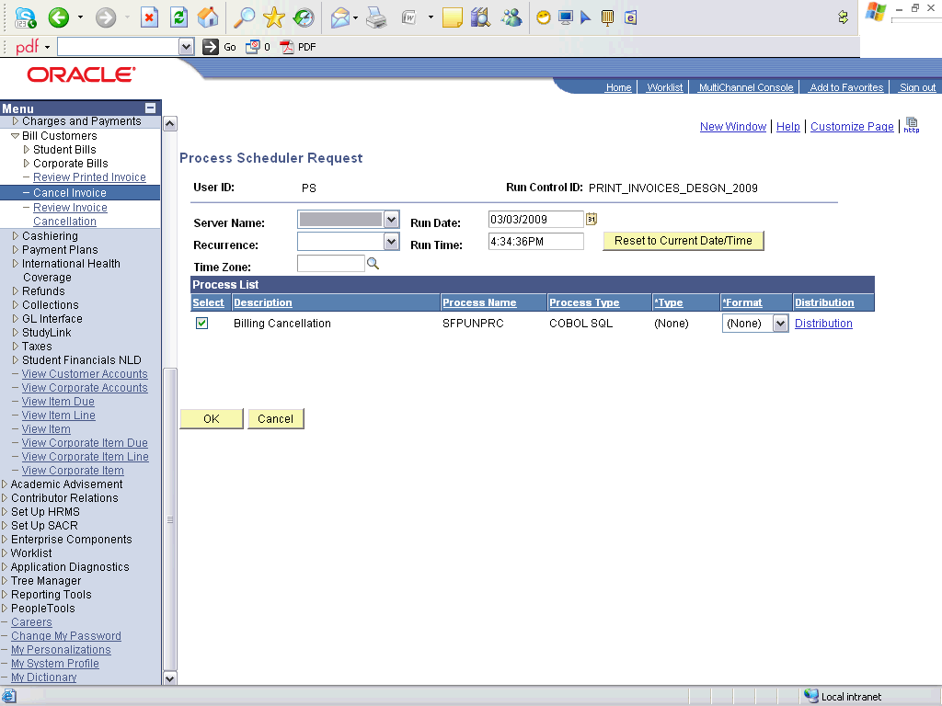

Step | Action
 | Click the OK button.

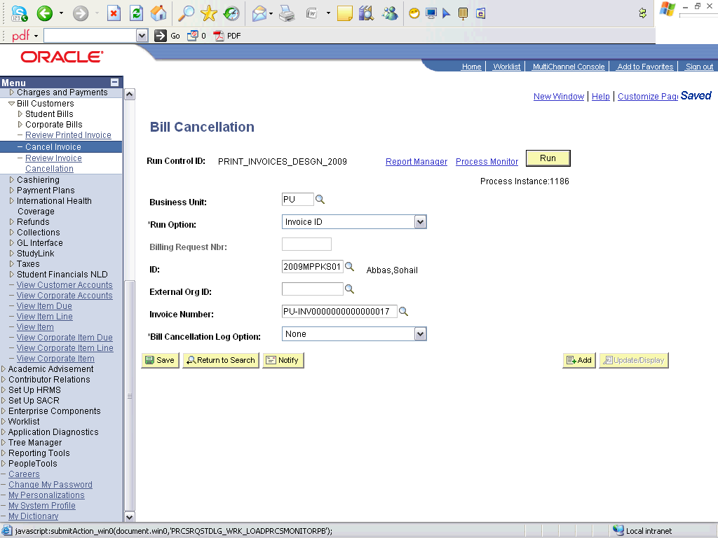

Step | Action
 | Click the Process Monitor link.

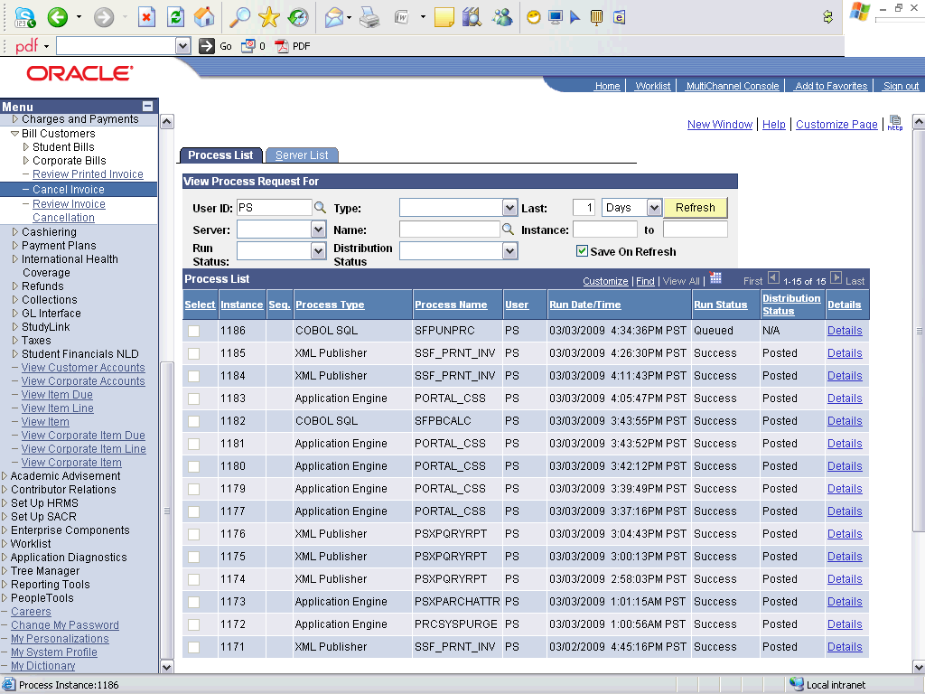

Step | Action
 | Click the Refresh button.
Point to the object.
Wait untill process is Success
 | End of Procedure.

Applying Payments

Applying Student Payments

Procedure

Step | Action
 | Click the Student Financials link.

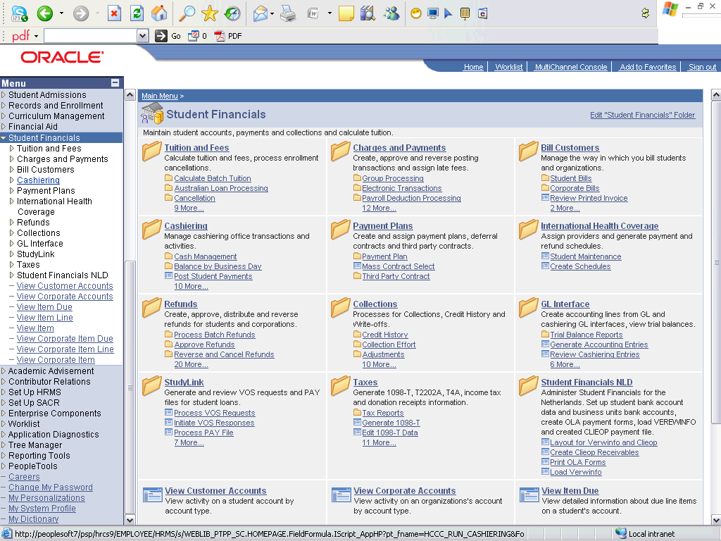

Step | Action
 | Click the Cashiering link.
 | Click the Post Student Payments link.

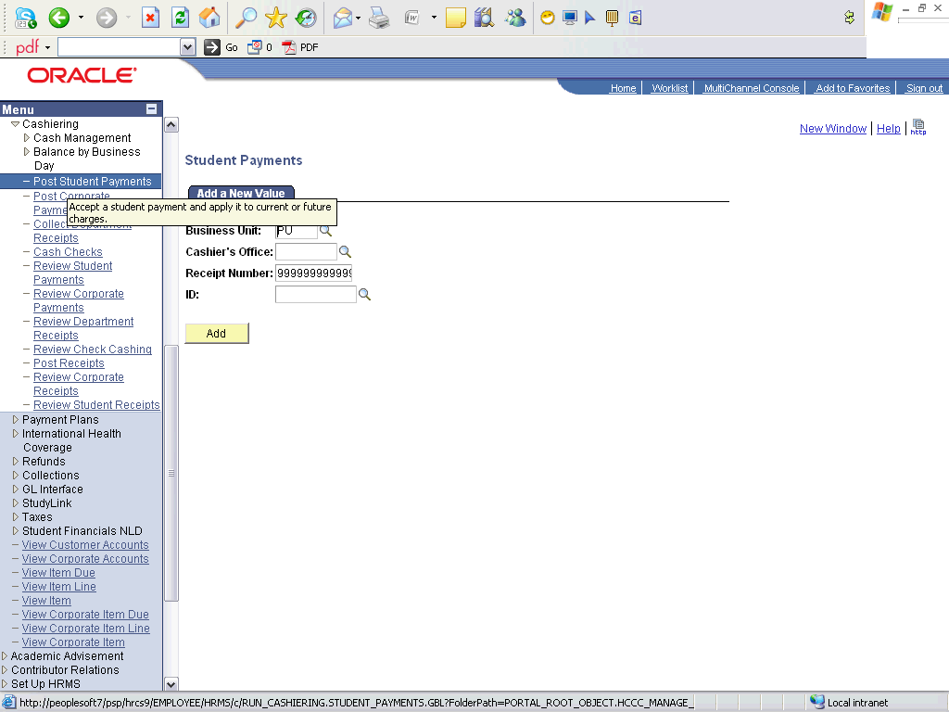

Step | Action
 | Click the Look up Cashier button.
 | Click an entry in the Cashier's Office column.
 | Enter the desired information into the ID field. Enter "2009MPPKS01".
 | Click the Add button.

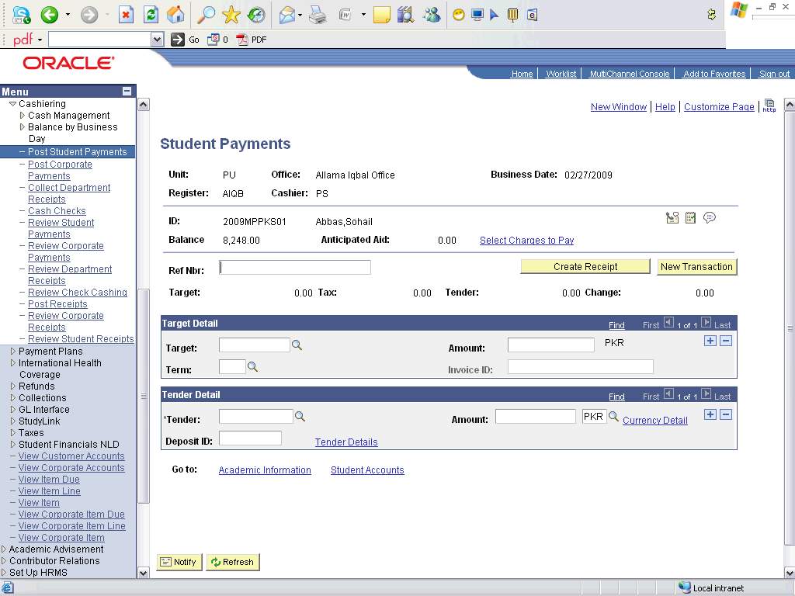

Step | Action
 | Click the Look up Target (Alt+5) button.
Click an entry in the Description column.
ADMISSION: is used to enter payments for the applicants paying to confirm their seats.
SECURITIES: is used to enter the deposits, like library securities, hostel securities etc.
ALLFEE: is used to enter all other payments
 | Enter the desired information into the Term field. Enter "0913".
 | Click the Look up Invoice ID (Alt+5) button.
 | Click an entry in the Invoice Number column.
 | Enter the desired information into the Tender field. Enter "CASH".
 | Enter the desired information into the Amount field. Enter "5748".
 | Enter the desired information into the Amount field. Enter "5748".
 | Click the Create Receipt button.
 | Click the Student Accounts link.

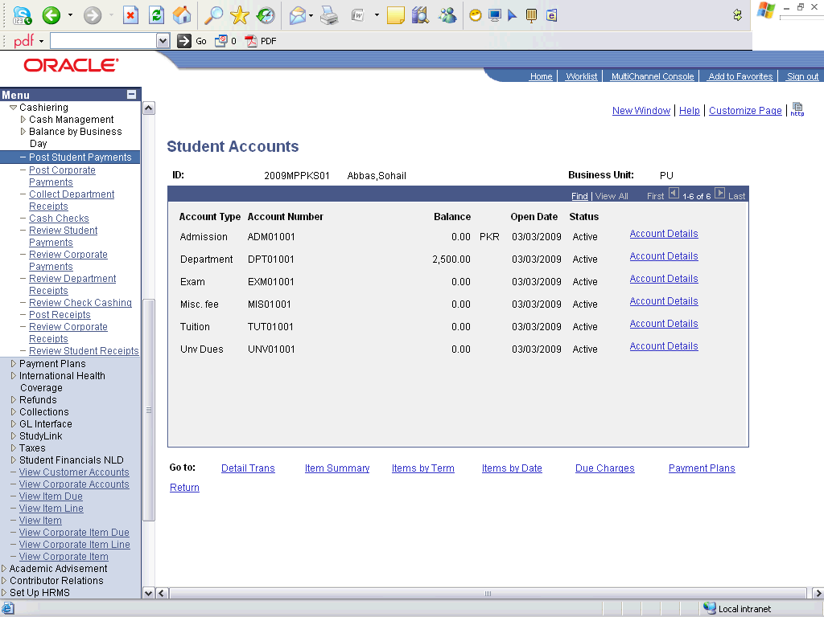

Step | Action
Point to the object.
The university dues are payed. The department dues are not paid since the invoice we selected was for the university dues. Make another transaction for the payment of department dues against its invoice to pay department dues.

Step | Action
 | Click an entry in the Account Details column.

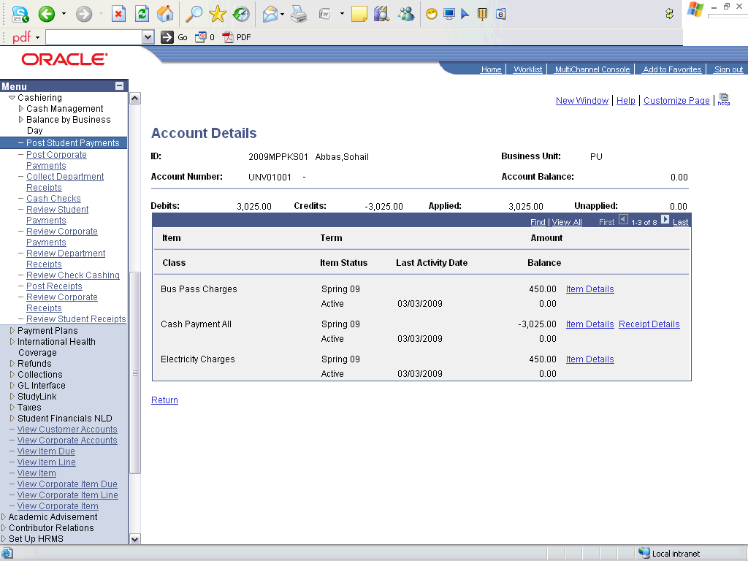

Step | Action
Point to the object.
Verify the payment details
 | End of Procedure.

Late Fee Calculation

Late Fee Calculation

Procedure

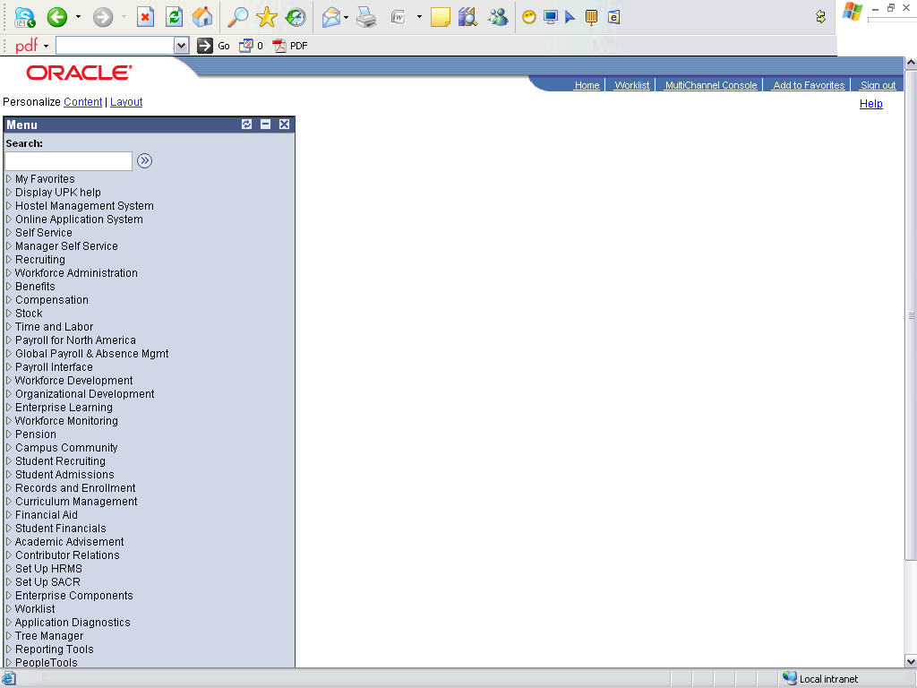

Step | Action
 | Click the Student Financials link.

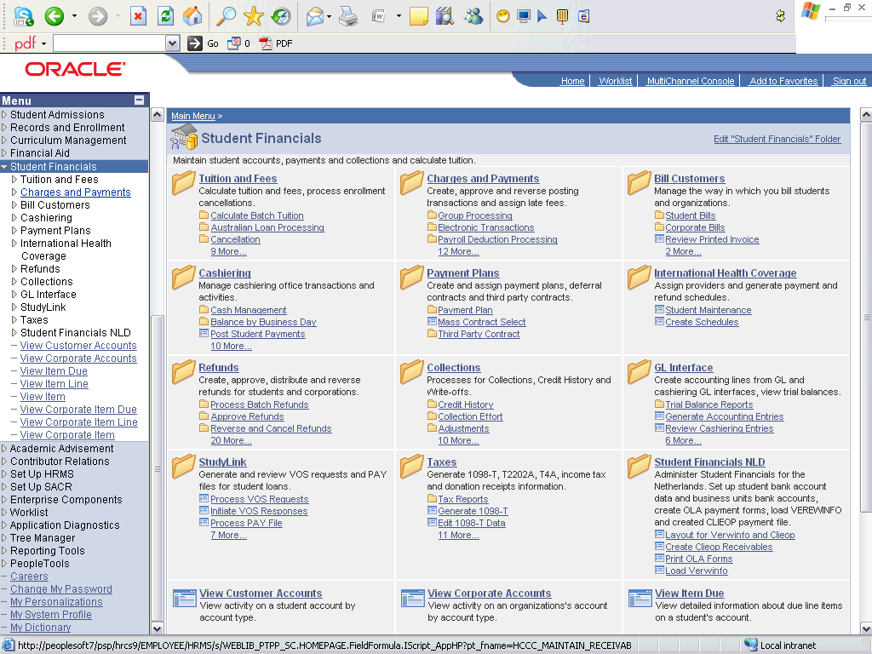

Step | Action
 | Click the Charges and Payments link.
 | Click the Late Fees link.
 | Click the Late Fees Processing link.

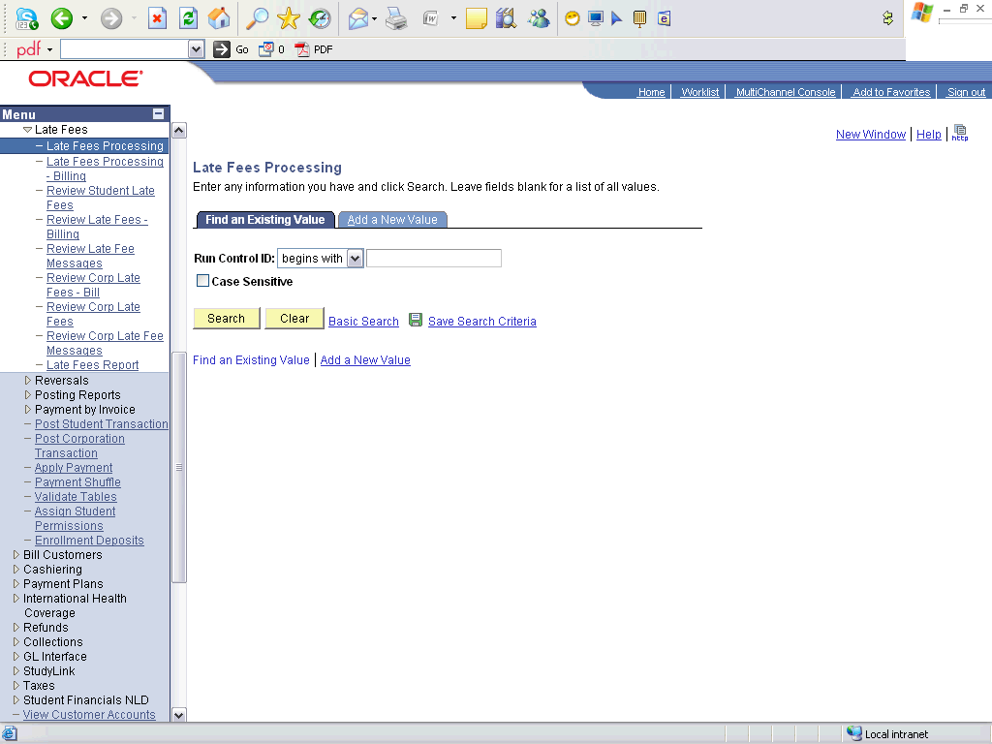

Step | Action
 | Click the Add a New Value tab.
 | Enter the desired information into the Run Control ID field. Enter "LATE_FEE_CALCULATION".
 | Click the Add button.

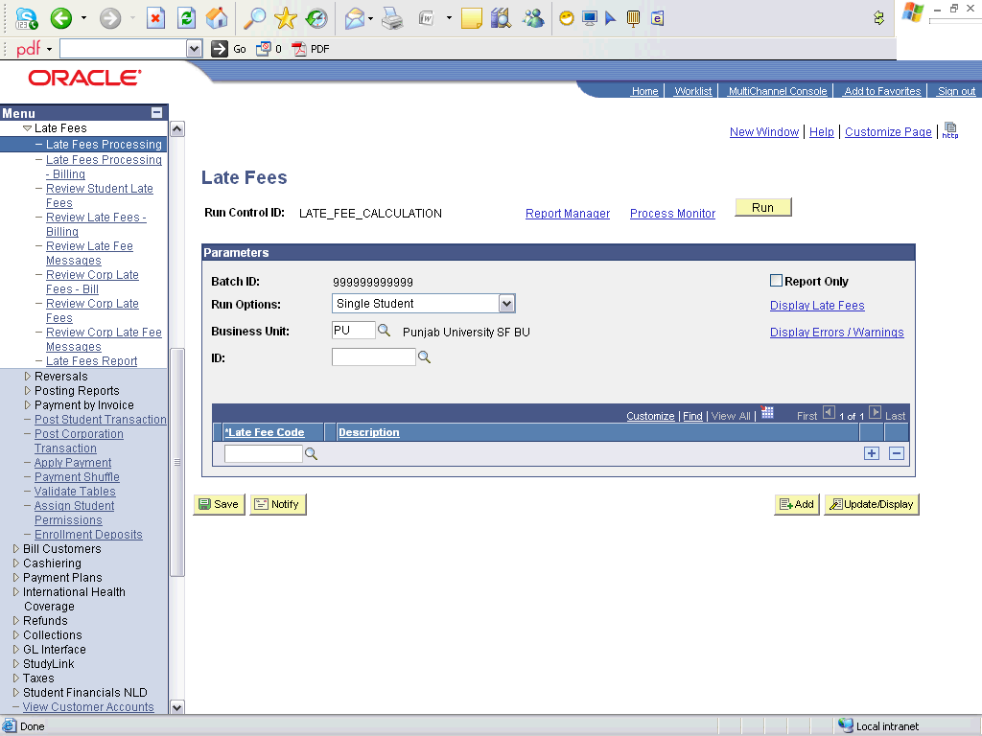

Step | Action
 | Click the Run Options list.
Click the Single Student list item.
Select "All Students" to calculate late fee for all students whose charges are due and still not paid yet.
 | Enter the desired information into the ID field. Enter "0050".
 | Click the Late Fee Code button.
 | Click an entry in the Description column.
 | Click the Run button.

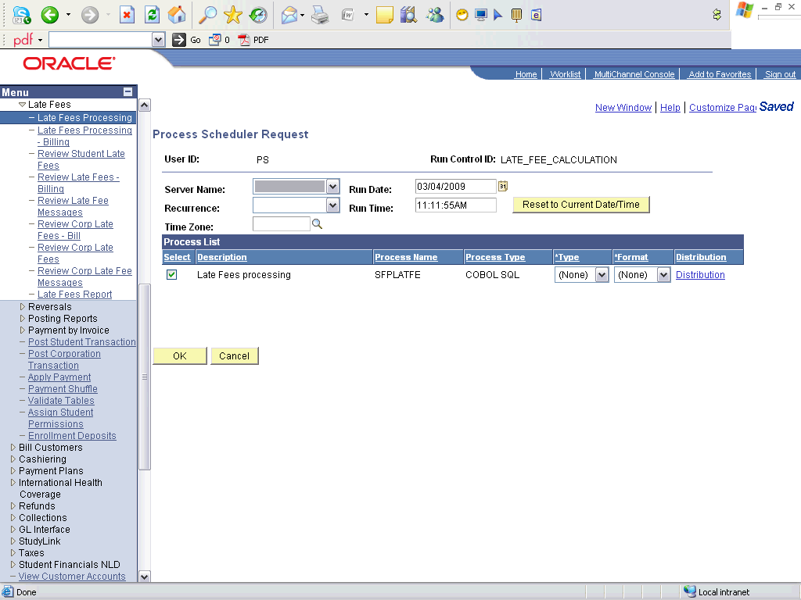

Step | Action
 | Click the OK button.

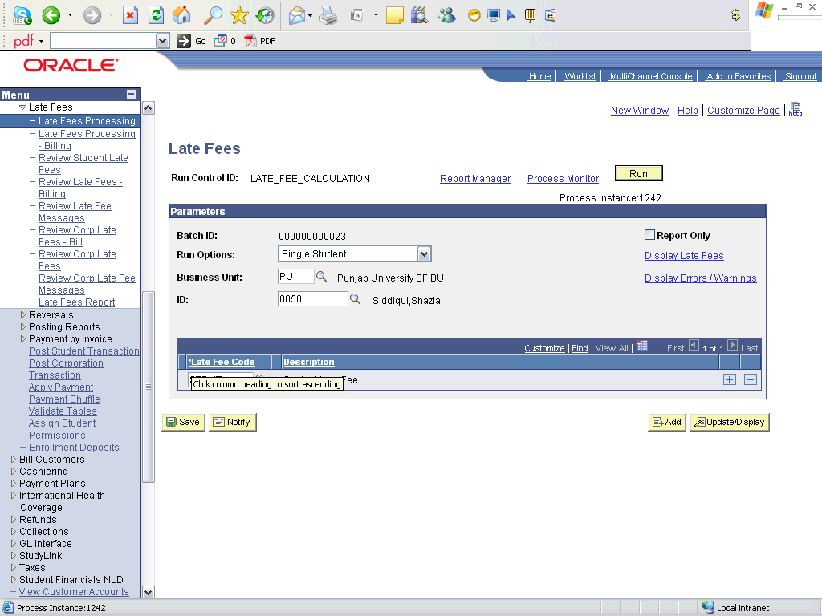

Step | Action
 | Click the Process Monitor link.

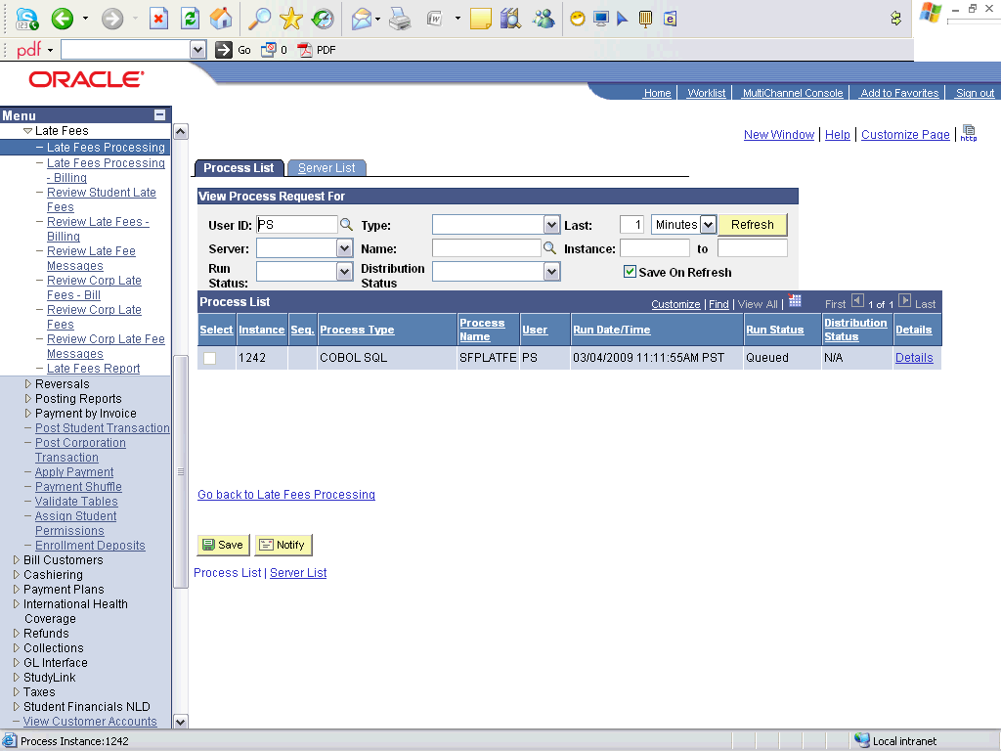

Step | Action
Click the Refresh button.
Wait until the process is success
 | Click the Go back to Late Fees Processing link.

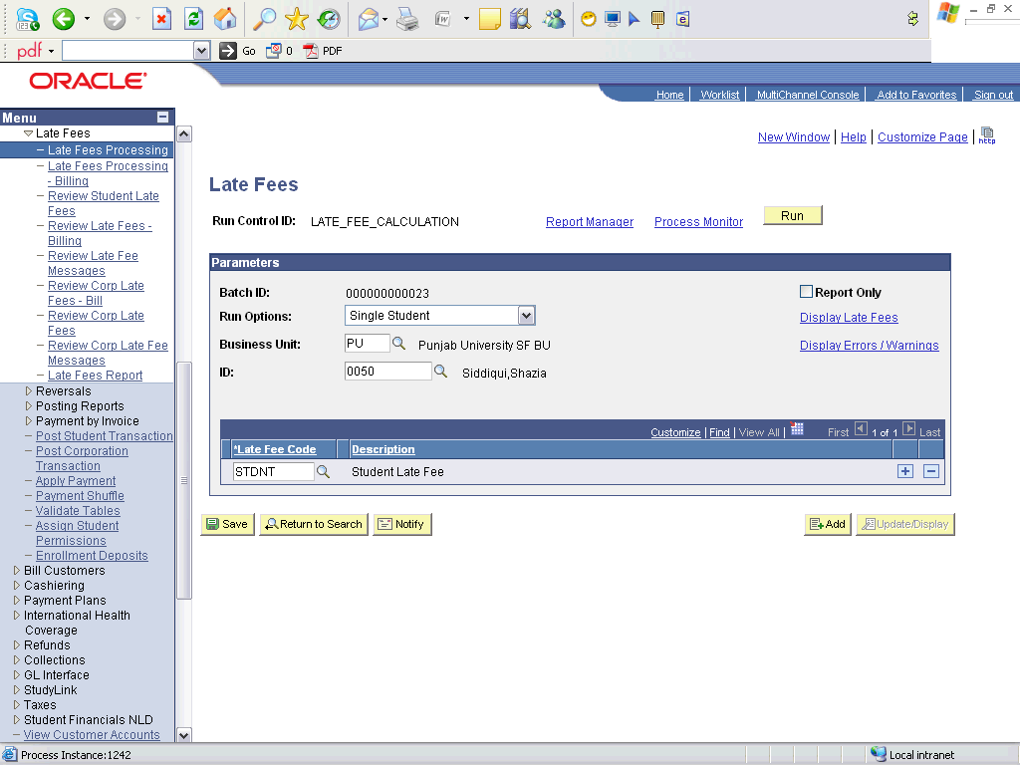

Step | Action
 | Click the Display Late Fees link.

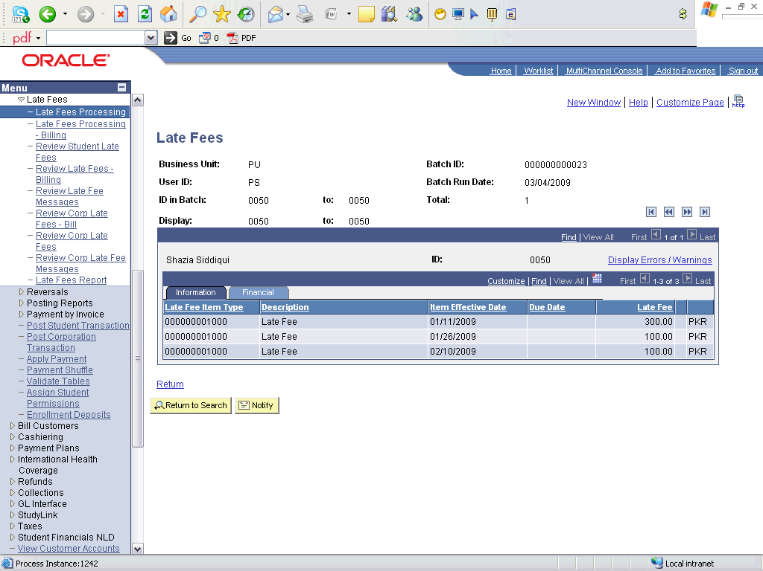

Step | Action
Point to the object.
Verify the late fee applied on the student

Step | Action
 | Click the Return link.

Step | Action
 | Click the View Customer Accounts link.

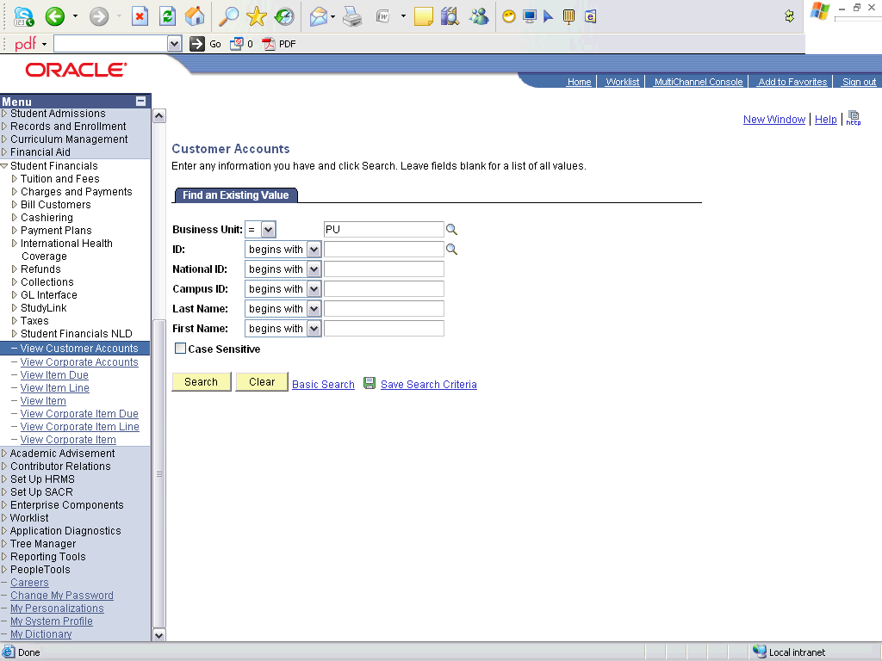

Step | Action
 | Enter the desired information into the ID field. Enter "0050".
 | Click the Search button.

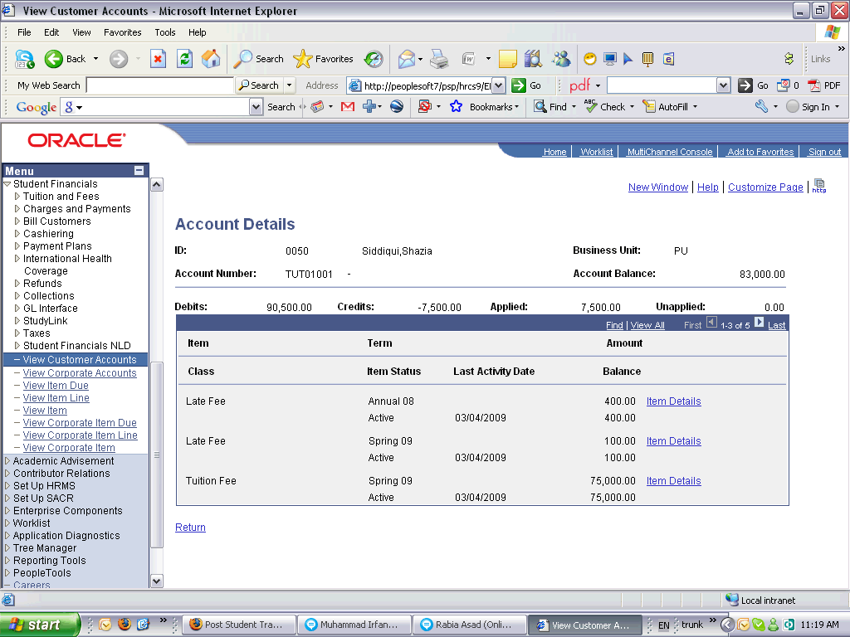

Step | Action
Point to the object.
Late fee charges have been applied to the student.
 | End of Procedure.

Late Fee Service Indicator

Procedure

Step | Action
 | Click the Student Financials link.

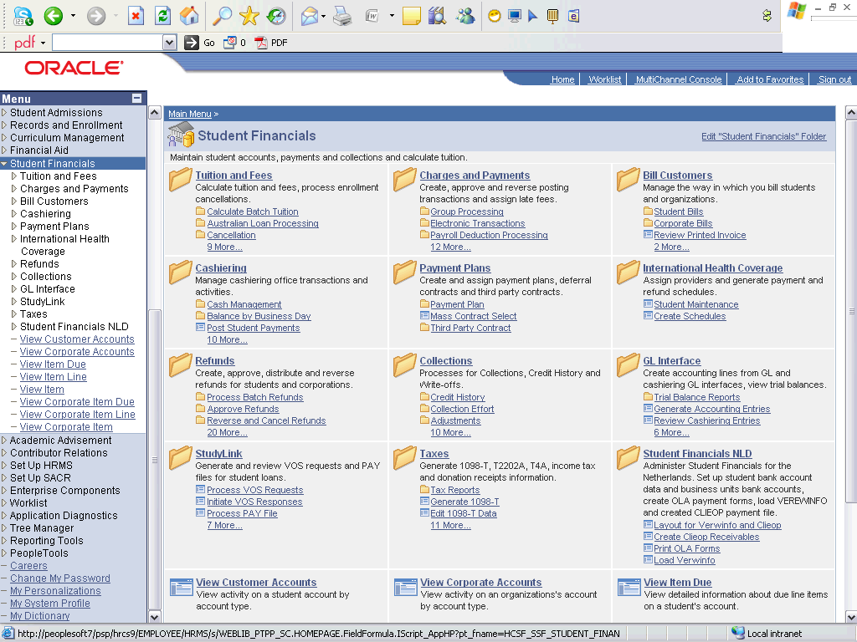

Step | Action
 | Click the Collections link.
 | Click the Credit History link.
 | Click the Process Credit History link.

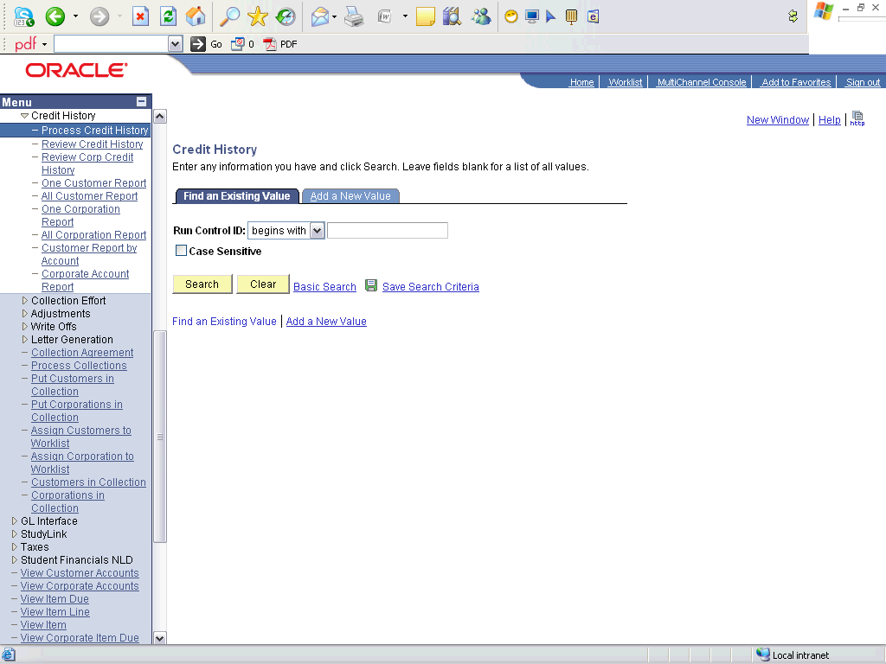

Step | Action
 | Click the Add a New Value tab.
 | Enter the desired information into the Run Control ID field. Enter "Apply_late_fee_servic_indicator".
 | Click the Add button.

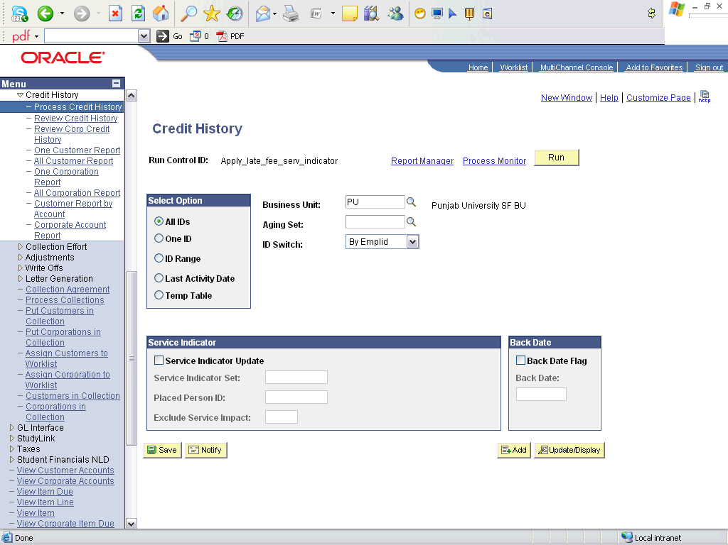

Step | Action
 | Click the Look up Aging Set (Alt+5) button.
 | Click an entry in the Description column.
 | Click the Service Indicator Update option.
 | Click the Look up Service Indicator Set (Alt+5) button.
 | Click an entry in the Service Indicator Set column.
 | Click the Run button.

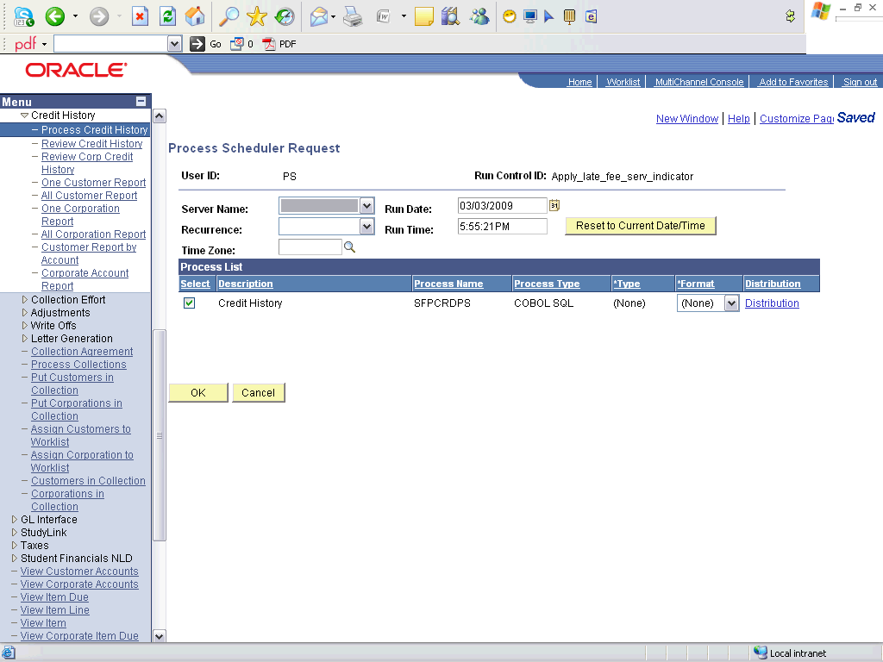

Step | Action
 | Click the OK button.

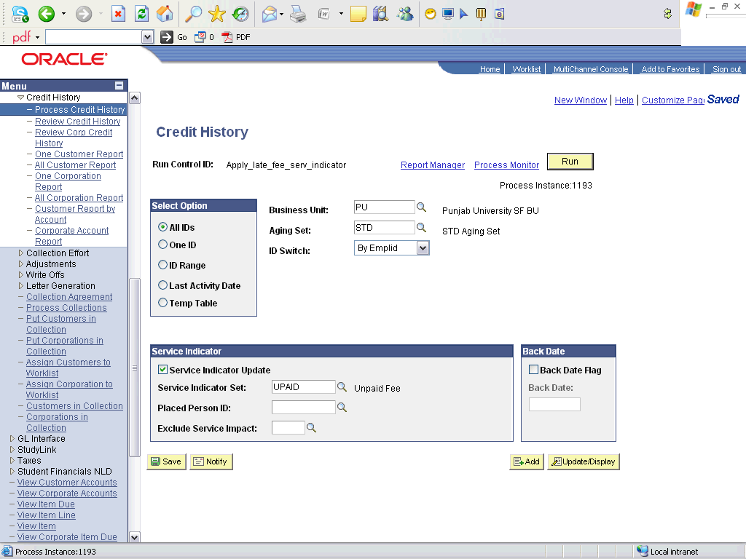

Step | Action
 | Click the Process Monitor link.

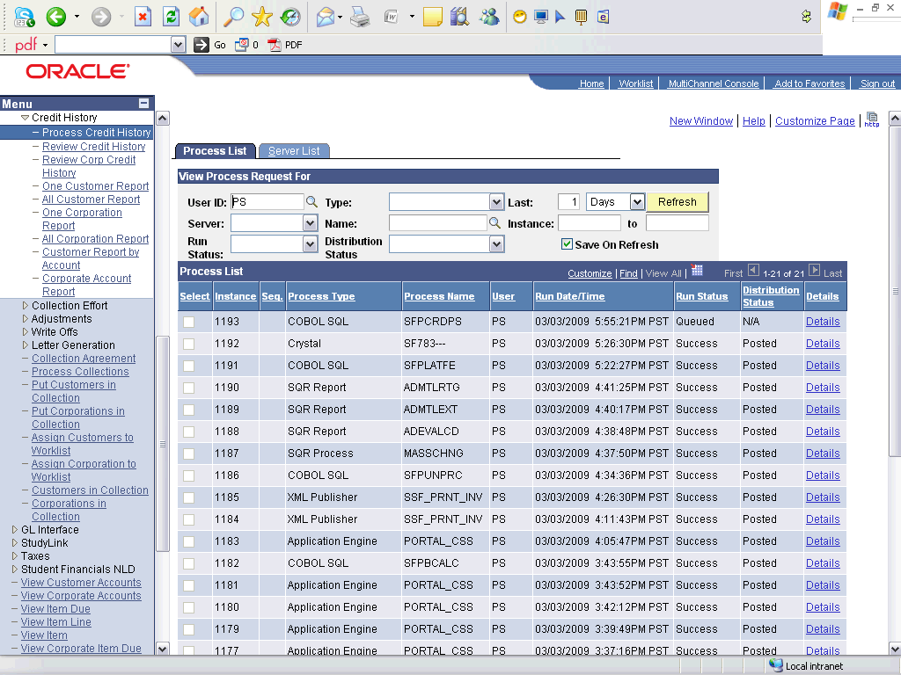

Step | Action
Point to the Refresh object.
Wait untill the process is Success
 | Click the View Customer Accounts link.

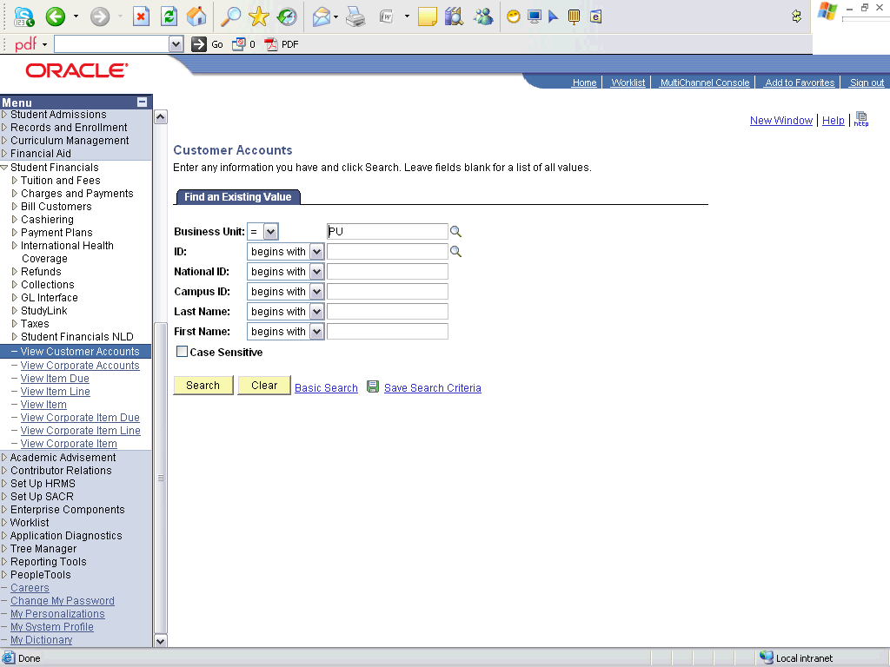

Step | Action
 | Enter the desired information into the ID field. Enter "08pu002".
 | Click the Search button.

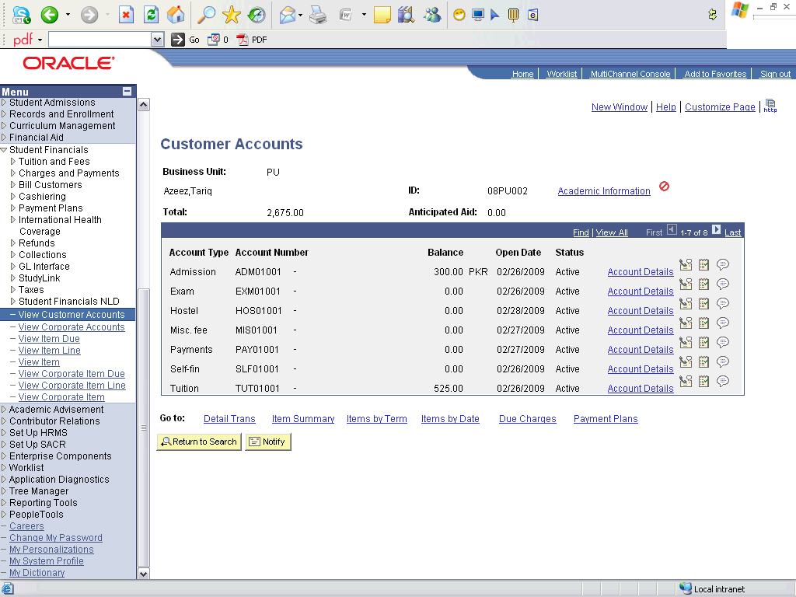

Step | Action
Click the Negative Service Indicators button.
This icon appears on students' pages who has not yet paid all charges

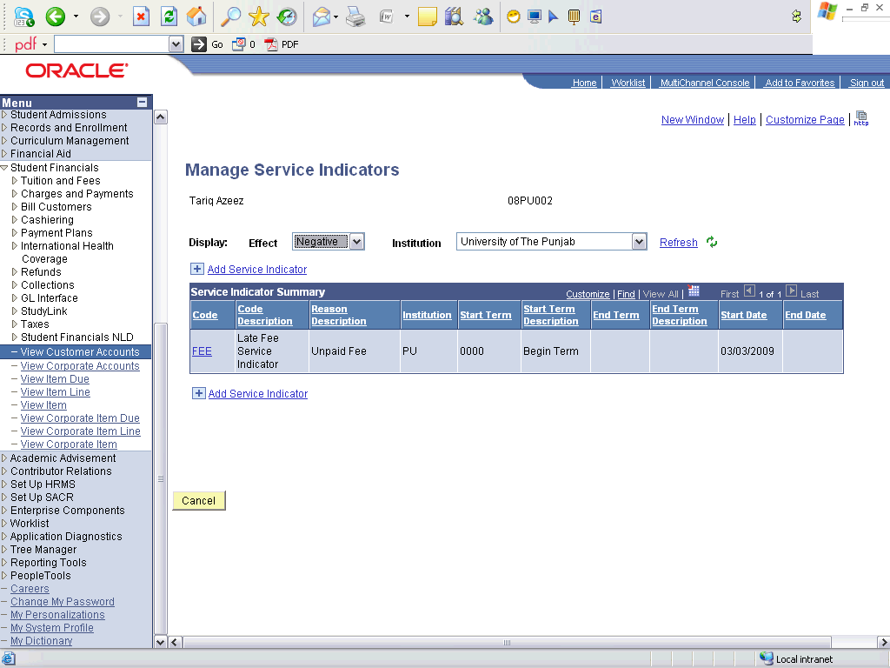

Step | Action
 | Click an entry in the Code column.
Point to the Amount object.
This is the amount that is not paid yet.

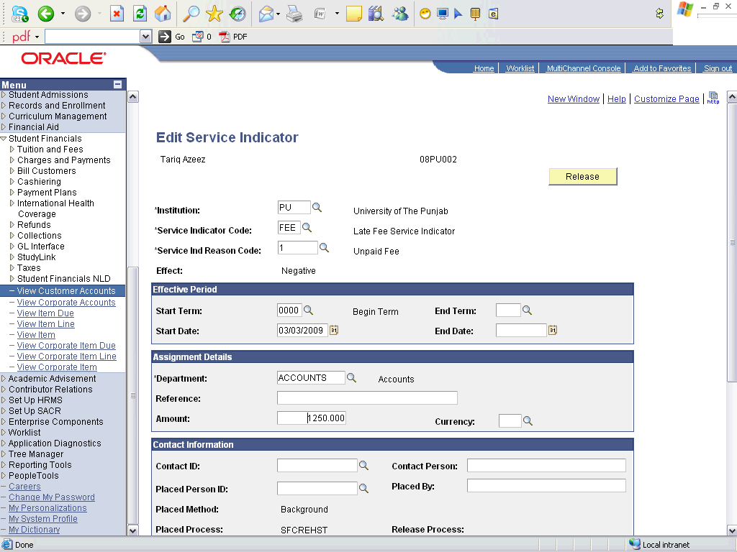

Step | Action
Click the object.
After the student has paid fee then Release teh indicator.

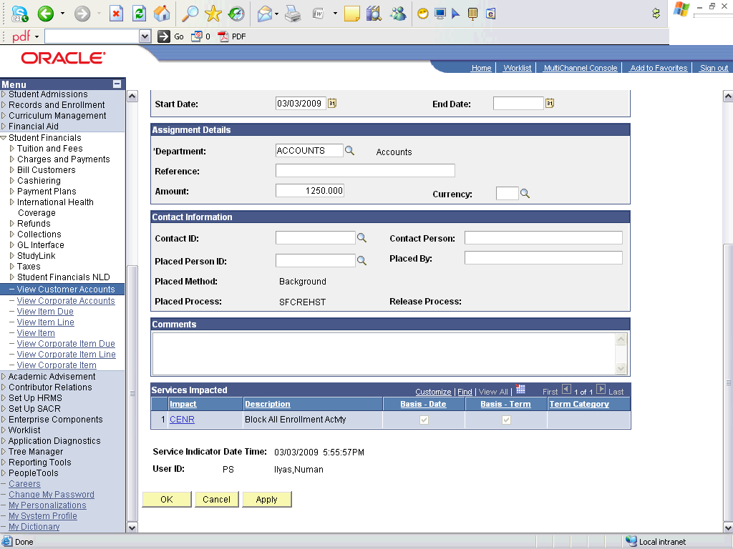

Step | Action
 | Click the OK button.
 | End of Procedure.

Refunds

Performing a Refund

Procedure

Step | Action
 | Click the Student Financials link.

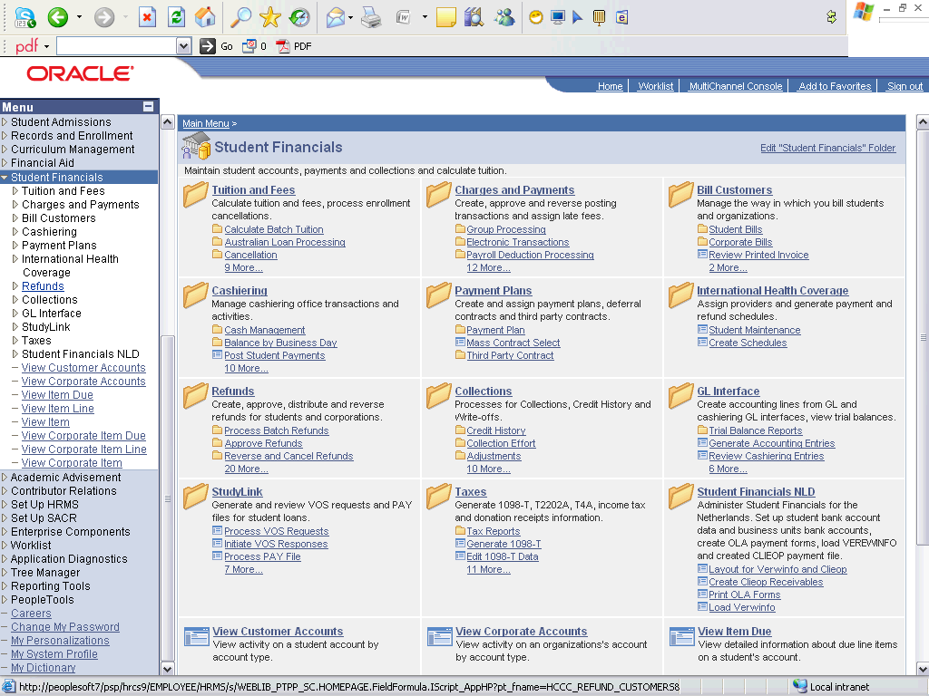

Step | Action
 | Click the Refunds link.
 | Click the Student Refund link.

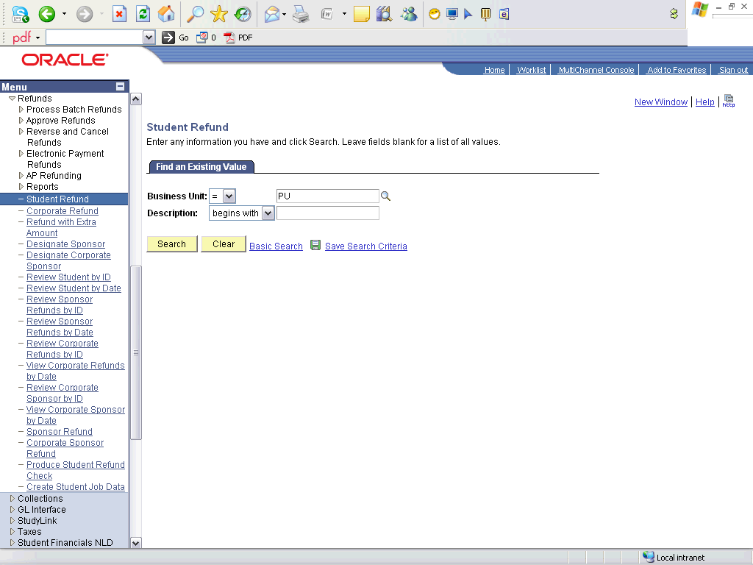

Step | Action
 | Click the Search button.

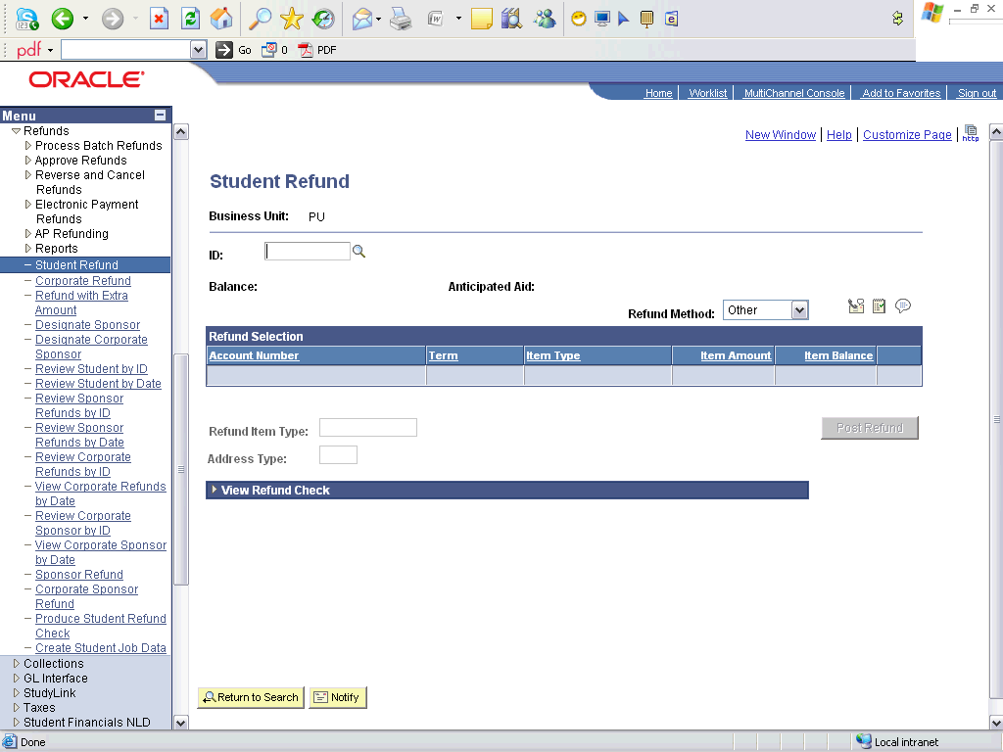

Step | Action
 | Enter the desired information into the ID field. Enter "08PU002".
 | Click the Look up Refund Item Type (Alt+5) button.
 | Click an entry in the Description column.
 | Enter the desired information into the Address Type field. Enter "HOME".
 | Click the Post Refund button.
 | Click the Expand section button.
 | Click the Student Accounts link.

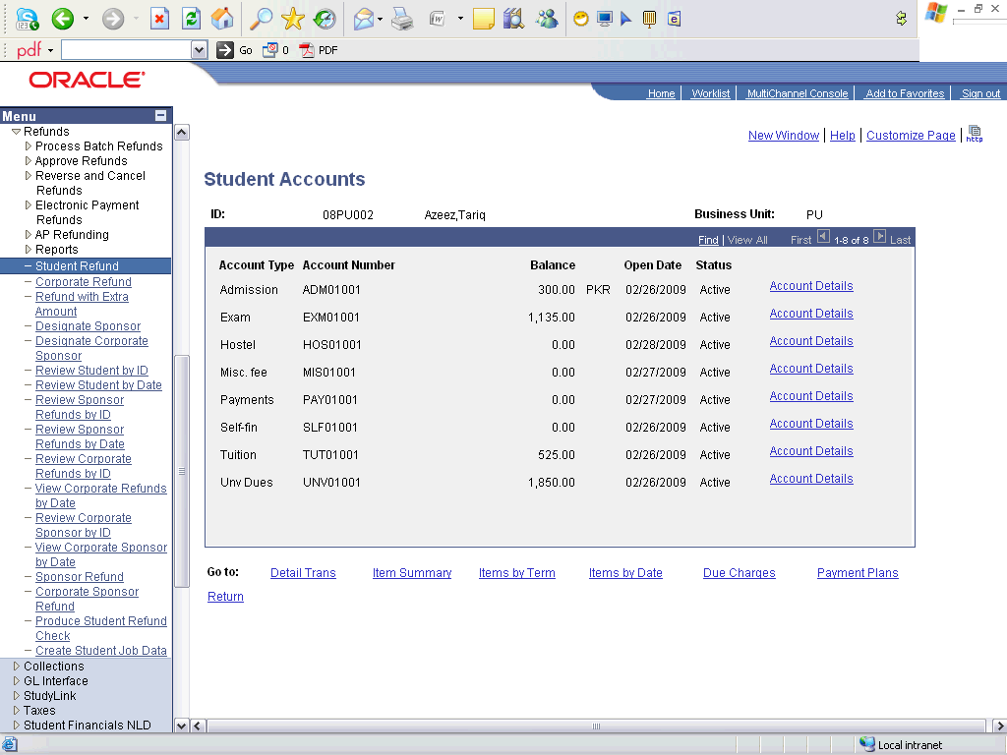

Step | Action
Point to the object.
The extra payment has now been refunded

Step | Action
 | Click an entry in the Account Details column.

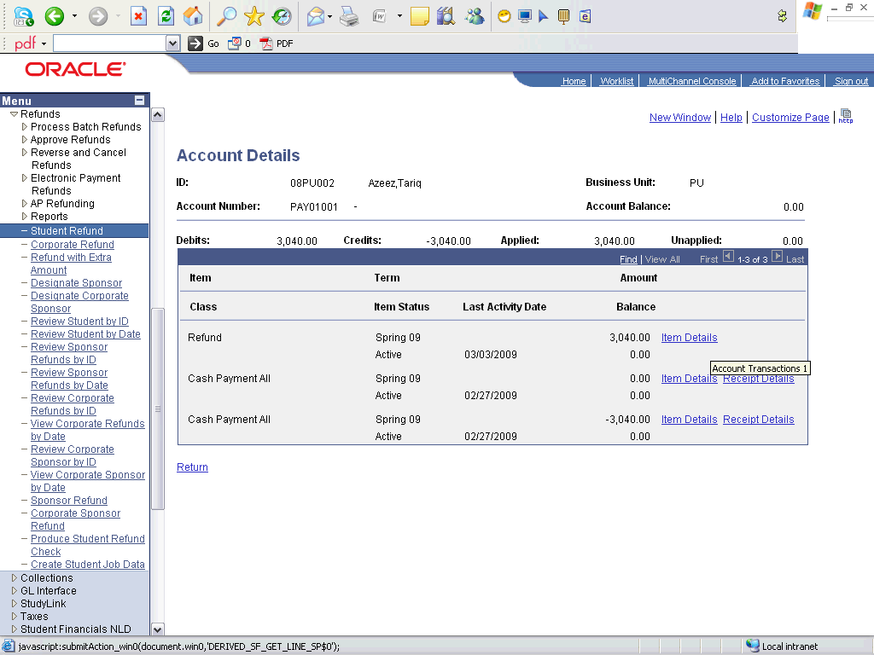

Step | Action
Point to the object.
The refund transaction
 | End of Procedure.

Reversals

Charge Reversal

Procedure

Step | Action
 | Click the Student Financials link.

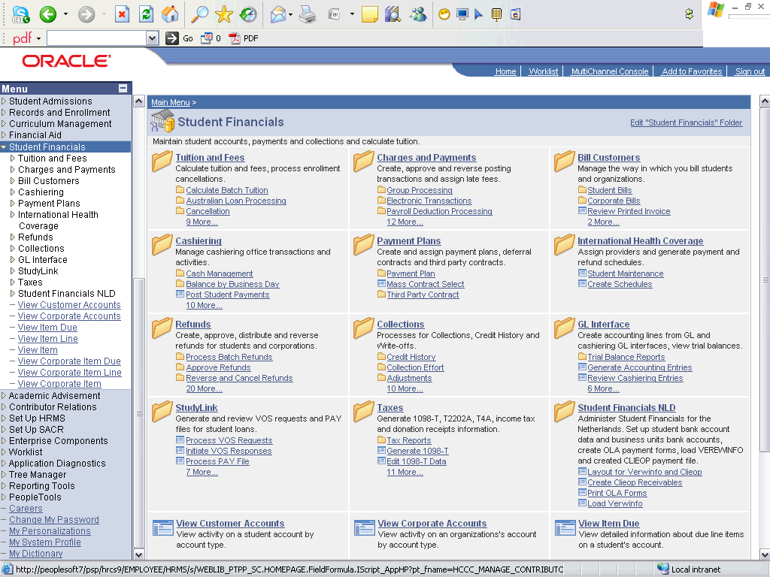

Step | Action
 | Click the Charges and Payments link.
 | Click the Reversals link.
 | Click the Reverse Charge link.

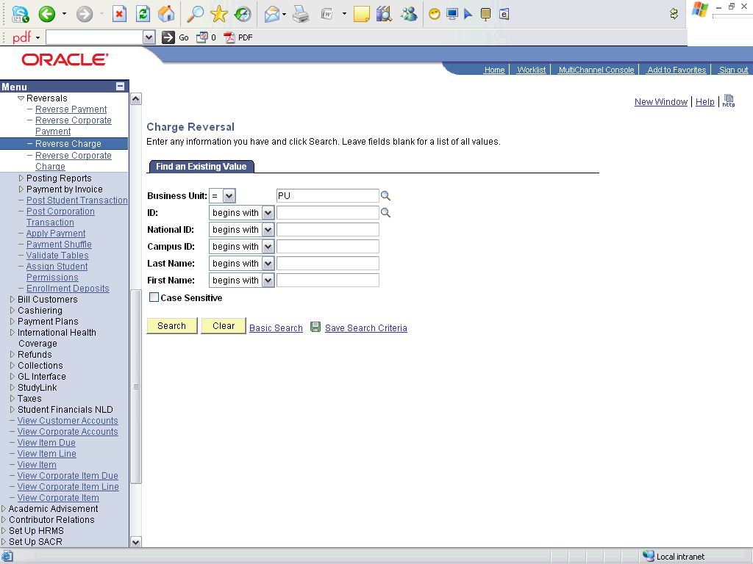

Step | Action
 | Enter the desired information into the ID field. Enter "08PU002".
 | Click the Search button.

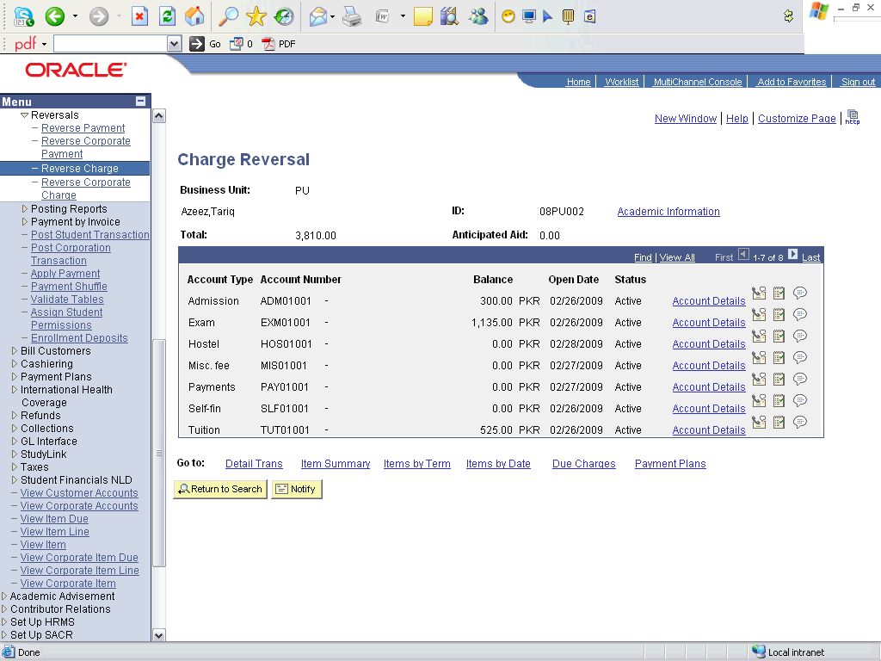

Step | Action
Click an entry in the Account Details column.
Go to account details whose charges are to be reserved.

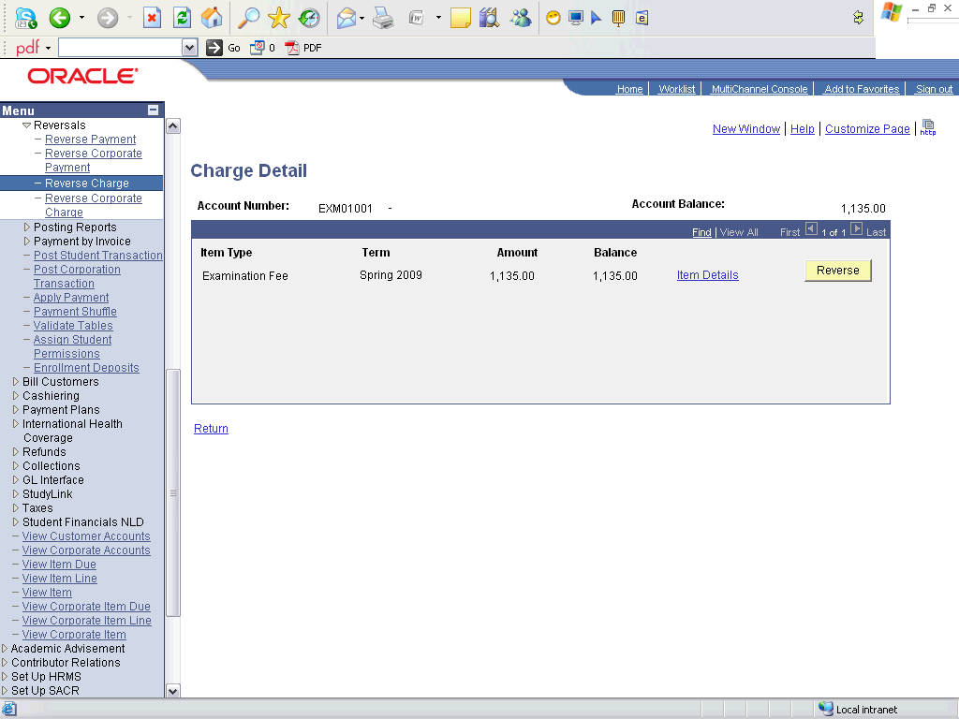

Step | Action
 | Click the Reverse button.

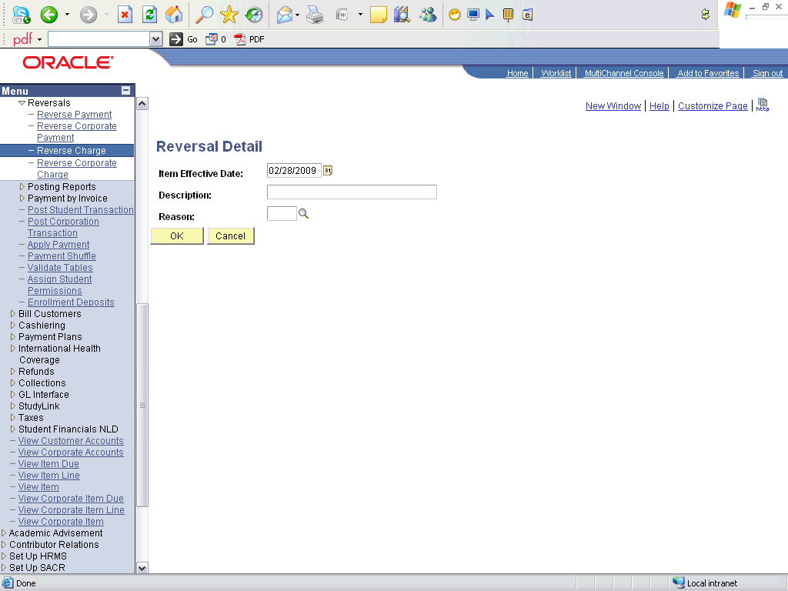

Step | Action
 | Enter the desired information into the Description field. Enter "Waived off".
 | Click the OK button.

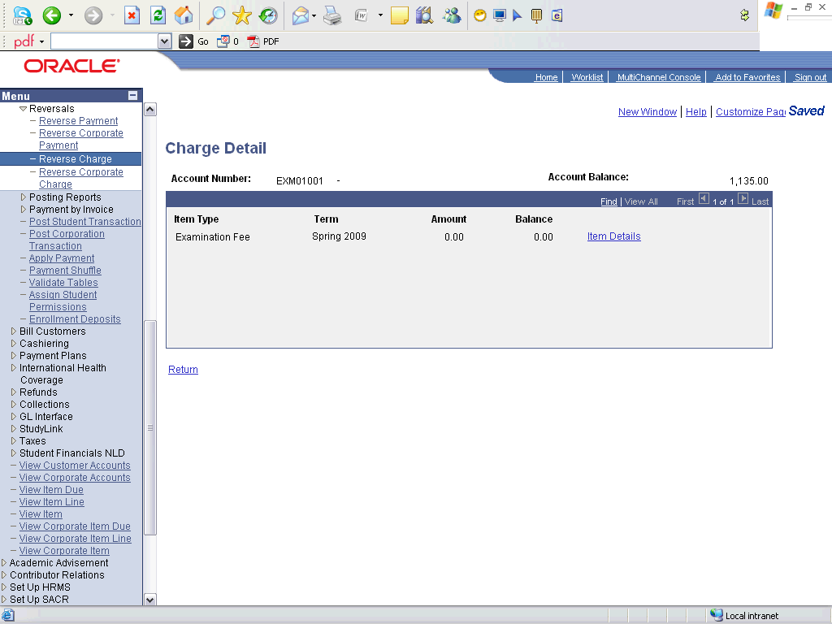

Step | Action
 | Click the Return link.
 | Now the amount is zero, therefore, the charge is been rerversed
 | End of Procedure.

Payment Reversal

Procedure

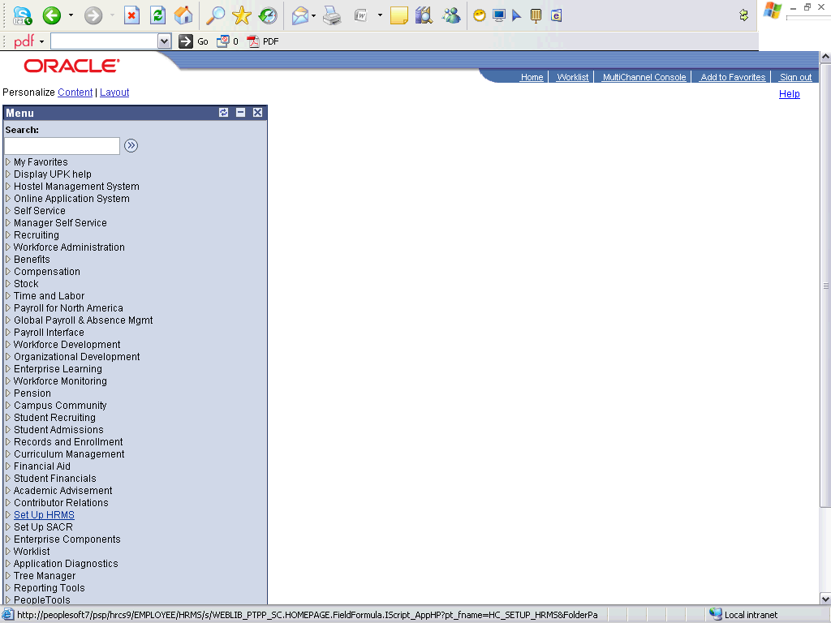

Step | Action
 | Click the Student Financials link.

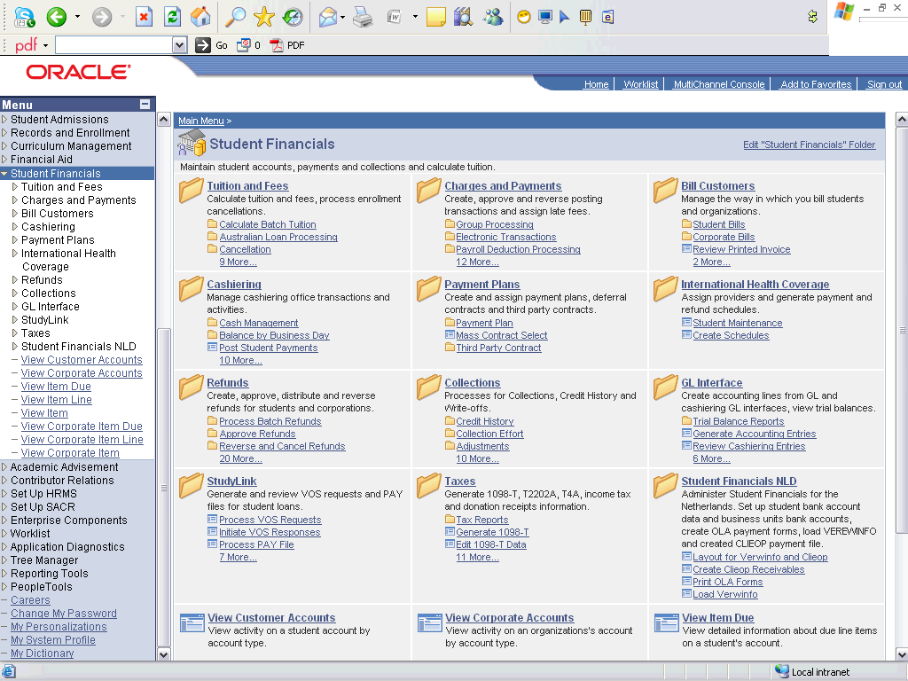

Step | Action
 | Click the Charges and Payments link.
 | Click the Reversals link.
 | Click the Reverse Payment link.

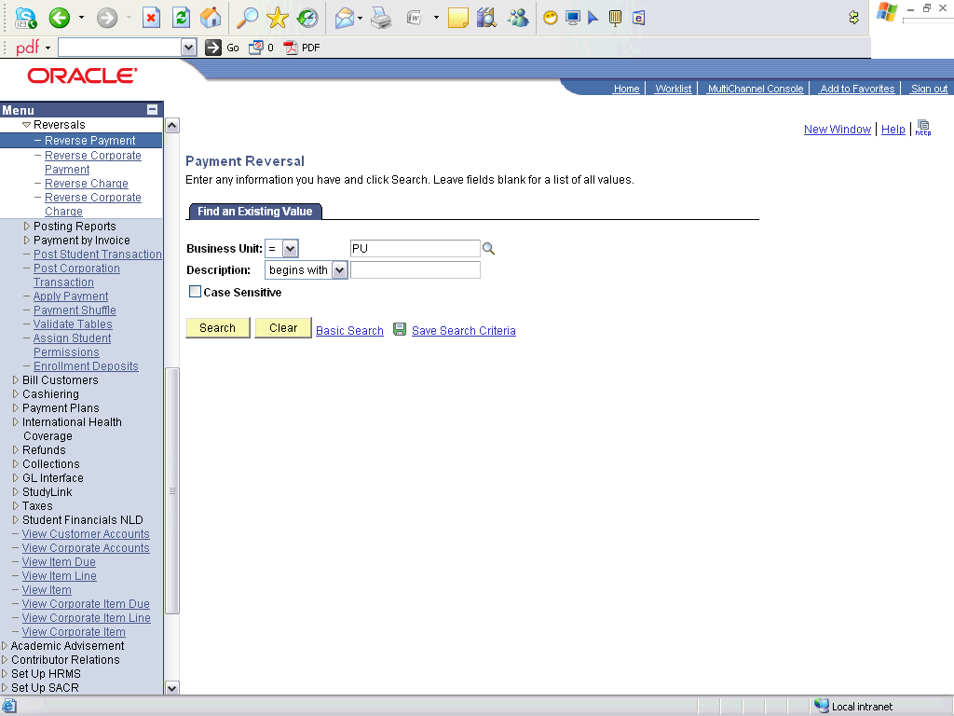

Step | Action
 | Click the Search button.

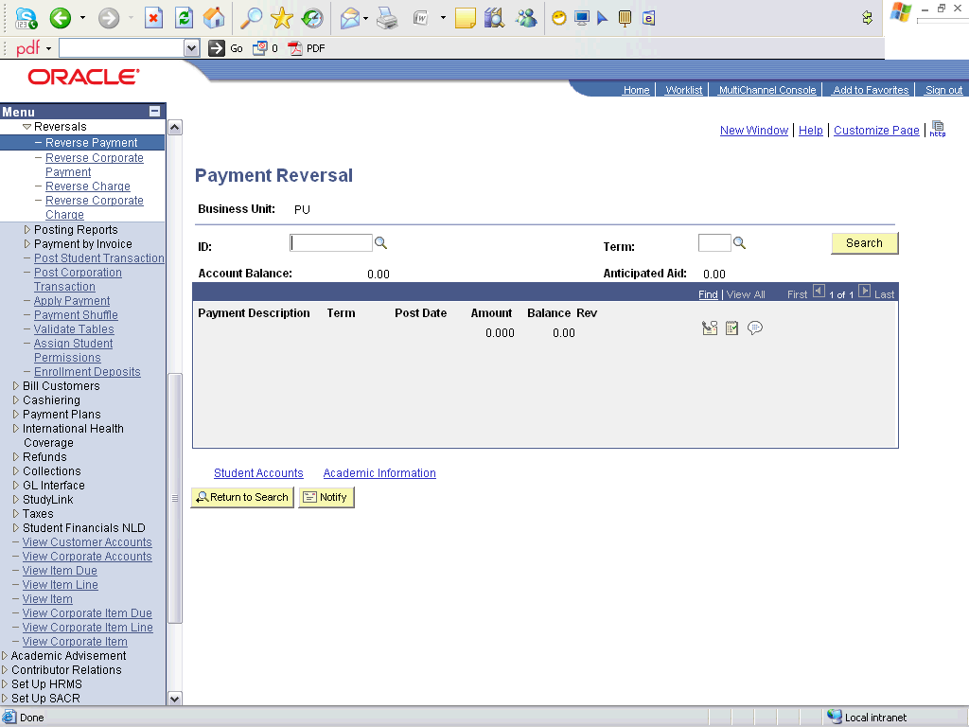

Step | Action
 | Enter the desired information into the ID field. Enter "2009phdsa01".
 | Enter the desired information into the Term field. Enter "0913".
 | Click the Search button.
 | Click the Reverse button.

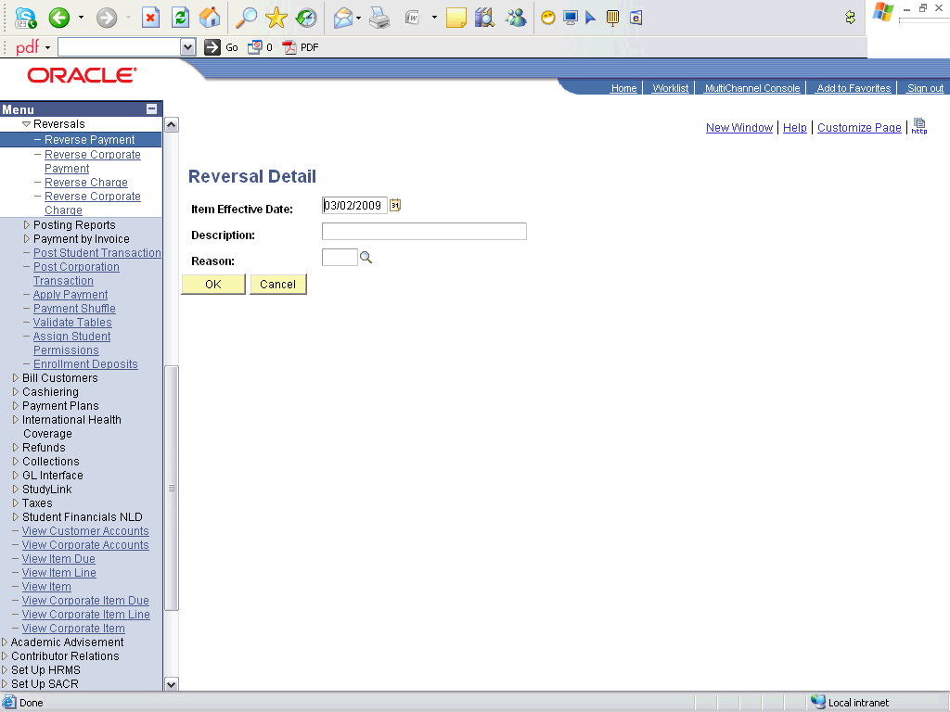

Step | Action
 | Enter the desired information into the Description field. Enter "Mistake".
 | Click the OK button.

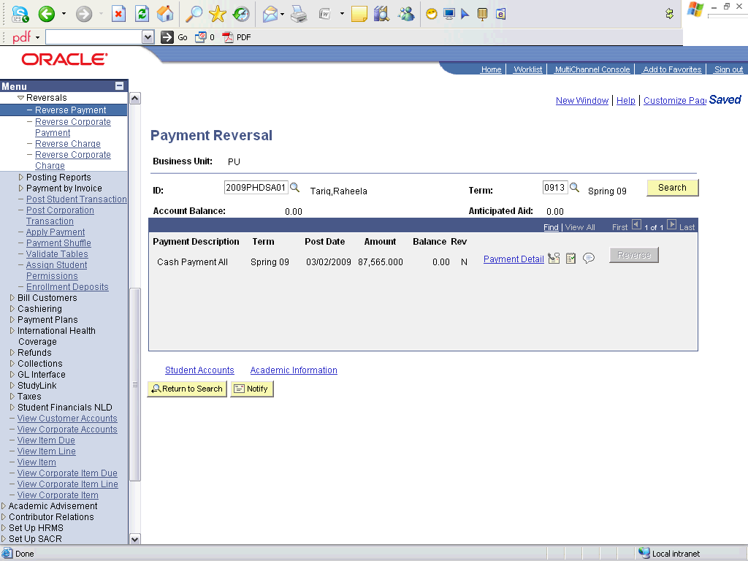

Step | Action
 | Click the Student Accounts link.

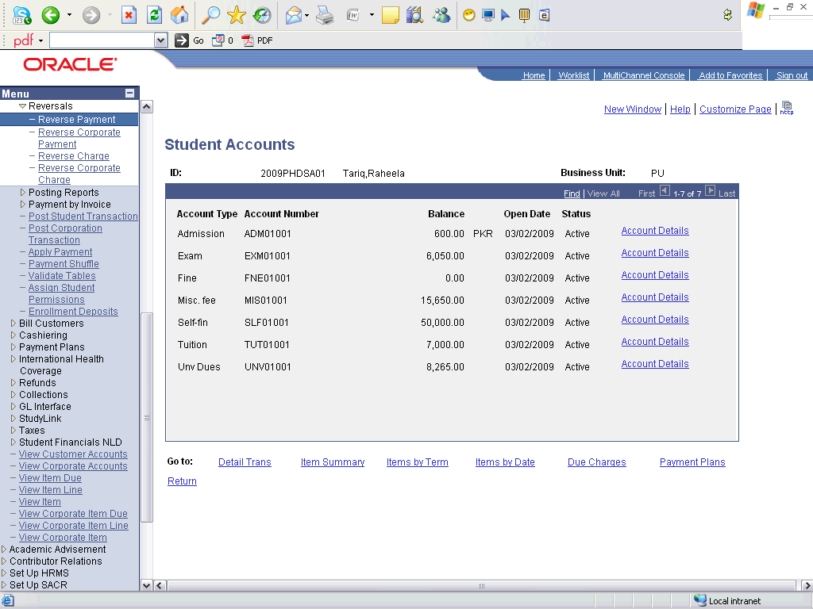

Step | Action
Click the object.
The payment is reversed, and the charges are again active in the student's account
 | End of Procedure.

Scholarships and Waivers

Applying Scholarhips

Procedure

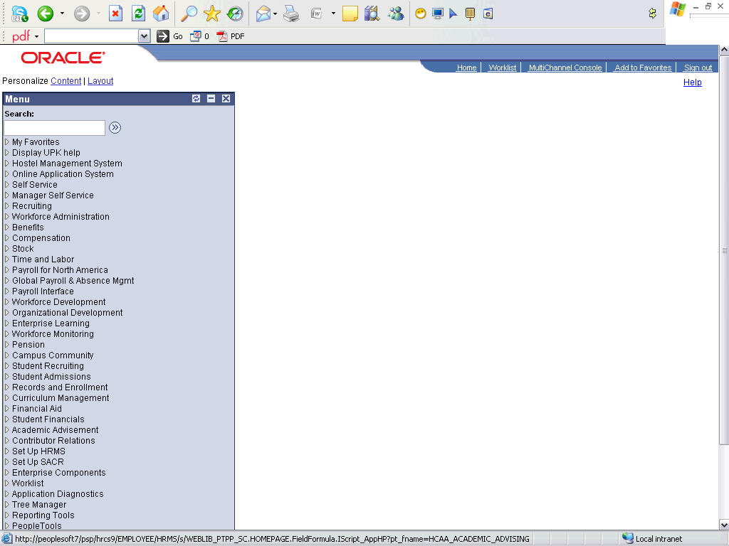

Step | Action
 | Click the Student Financials link.

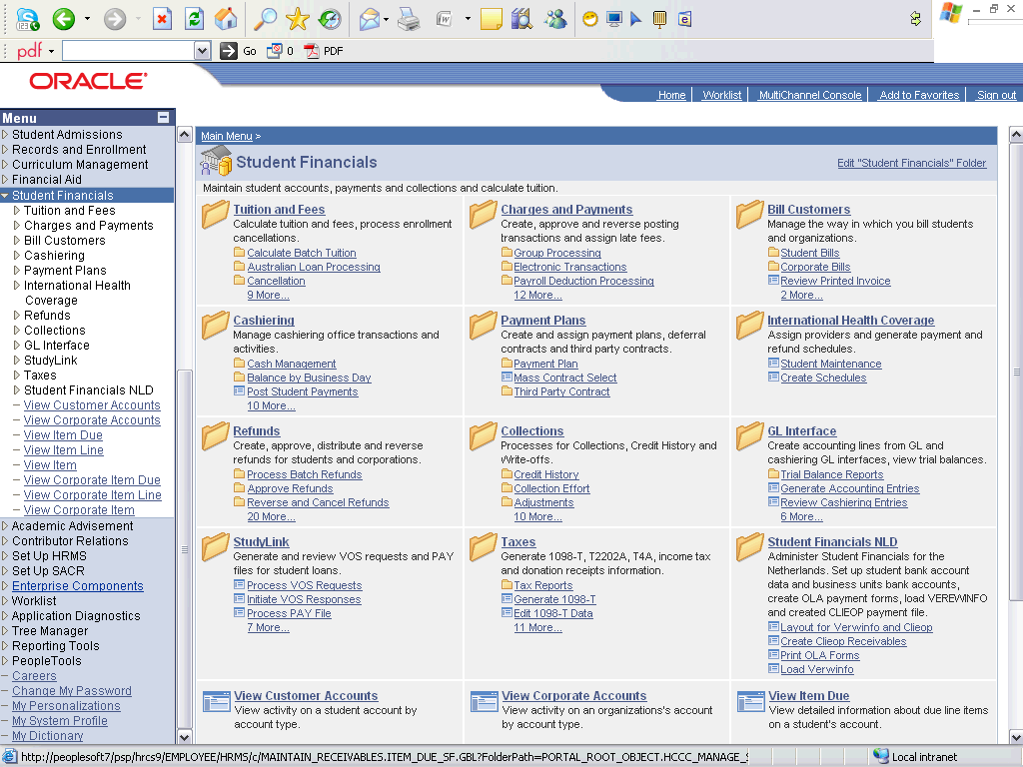

Step | Action
 | Click the Charges and Payments link.
 | Click the Post Student Transaction link.

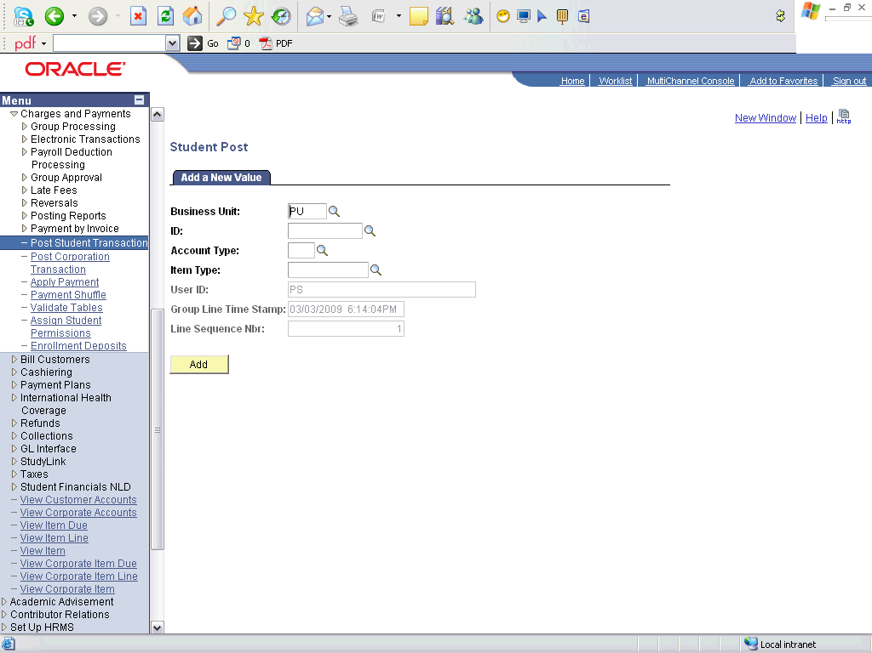

Step | Action
 | Enter the desired information into the ID field. Enter "2009phsda01".
 | Enter the desired information into the Account Type field. Enter "SCH".
 | Click the Look up Item Type (Alt+5) button.
 | Click an entry in the Description column.
 | Click the Add button.

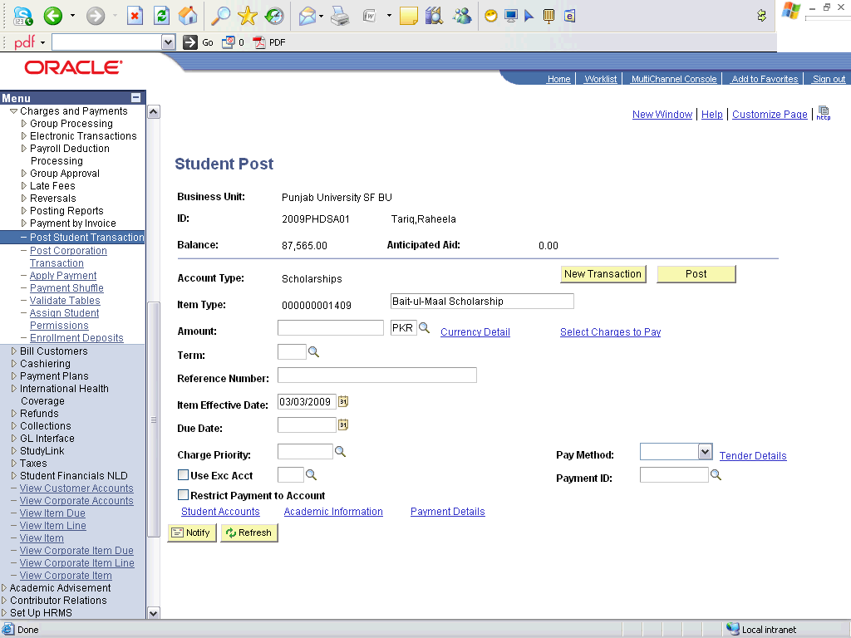

Step | Action
 | Enter the desired information into the Amount field. Enter "15000".
 | Enter the desired information into the Term field. Enter "0913".
 | Click the Post button.
 | Click the Student Accounts link.

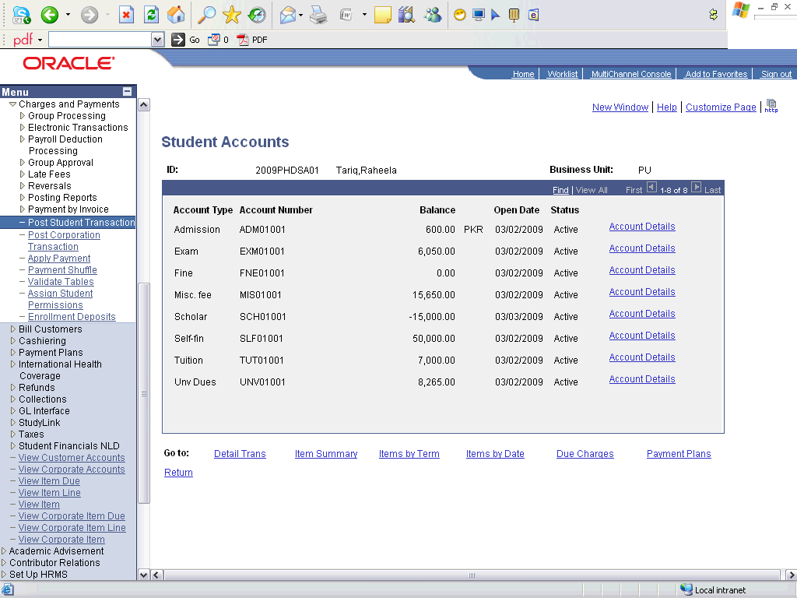

Step | Action
 | Click an entry in the Account Details column.
 | Scholarship is awarded to the student in his/her account. Now refund the amount.

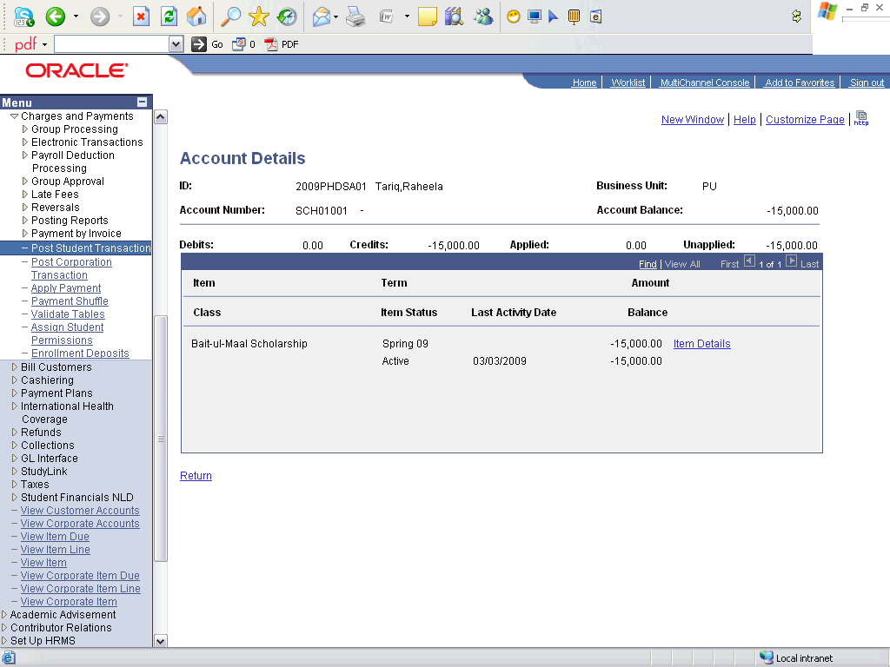

Step | Action
 | Click the Refunds link.

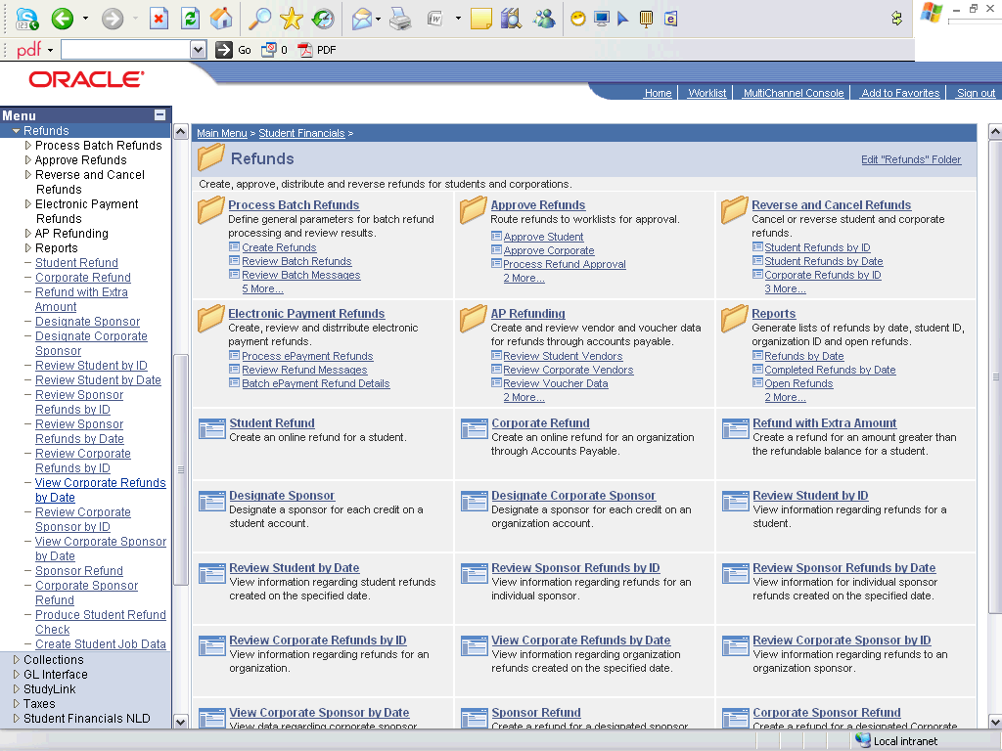

Step | Action
 | Click the Student Refund link.

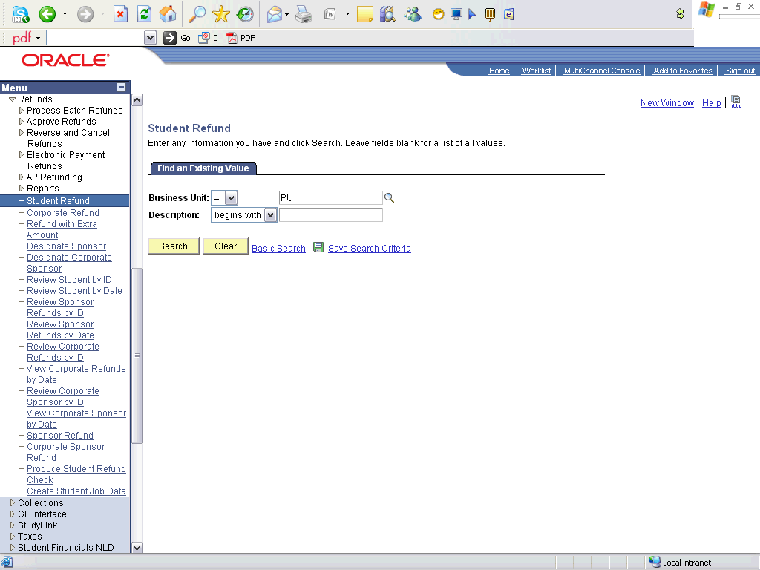

Step | Action
 | Click the Search button.

Step | Action
 | Enter the desired information into the ID field. Enter "2009phdsa01".
 | Click the Look up Refund Item Type (Alt+5) button.
 | Click an entry in the Description column.
 | Enter the desired information into the Address Type field. Enter "HOME".

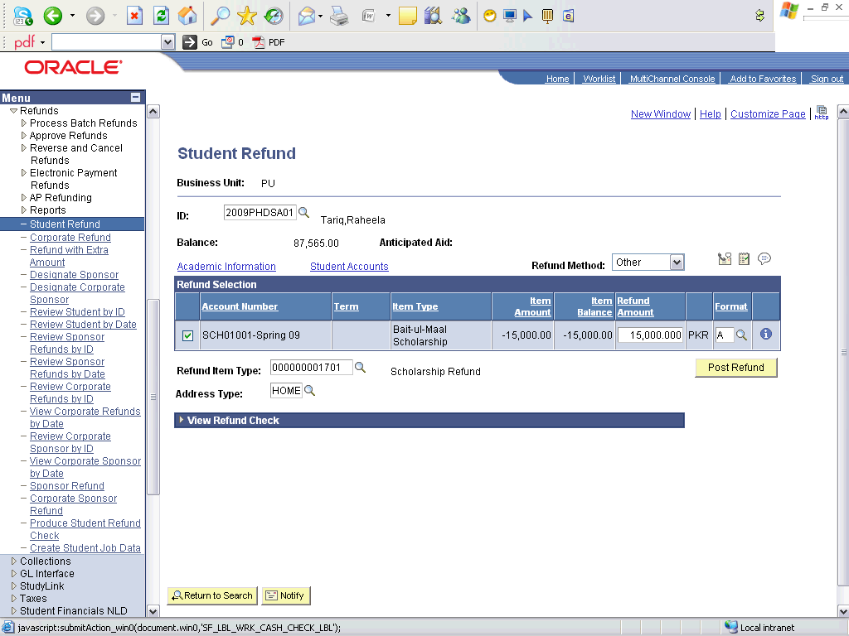

Step | Action
 | Click the object.

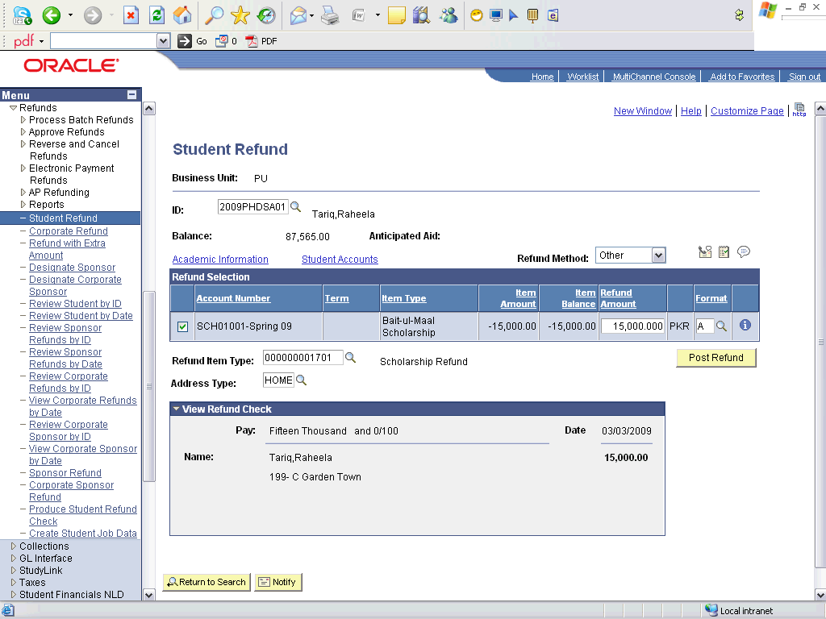

Step | Action
 | Click the Post Refund button.
 | End of Procedure.

Applying Waivers - Automatically

Procedure

Step | Action
 | Click the Records and Enrollment link.

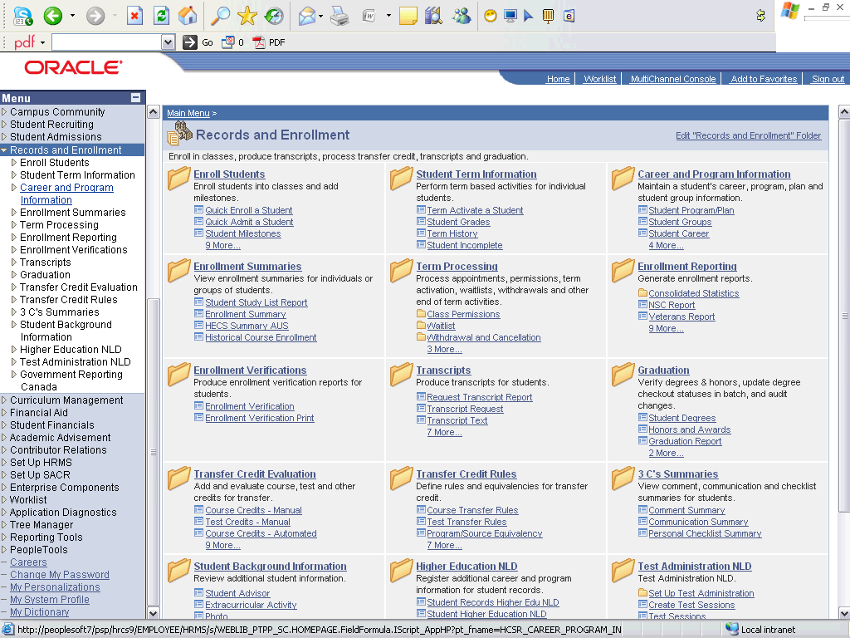

Step | Action
 | Click the Career and Program Information link.
 | Click the Student Groups link.

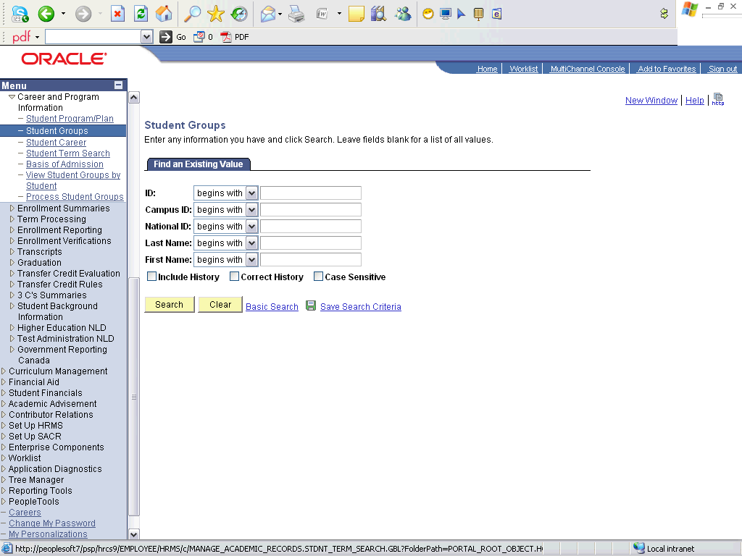

Step | Action
 | Enter the desired information into the ID field. Enter "2009desgn01".
 | Click the Search button.

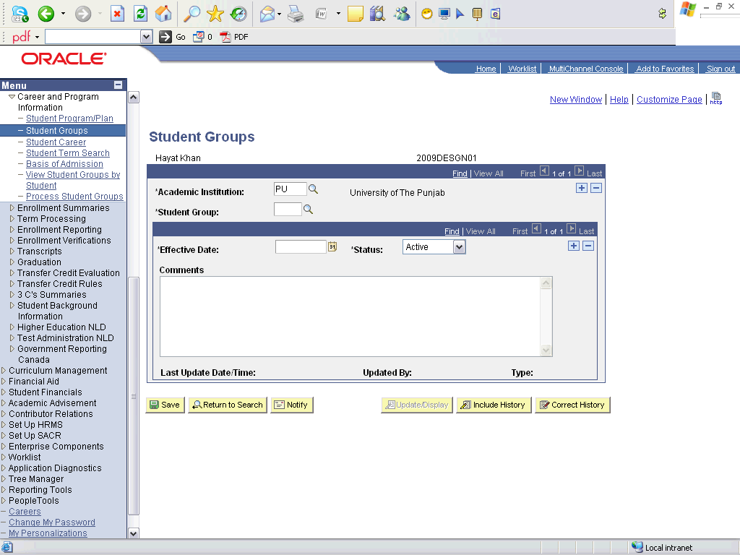

Step | Action
 | Click the Look up Student Group (Alt+5) button.
Click an entry in the Description column.
Just add the student in the appropriate student group.
 | Click the Save button.
 | Click the Student Financials link.

Step | Action
 | Click the Tuition and Fees link.
 | Click the Tuition Calculation link.

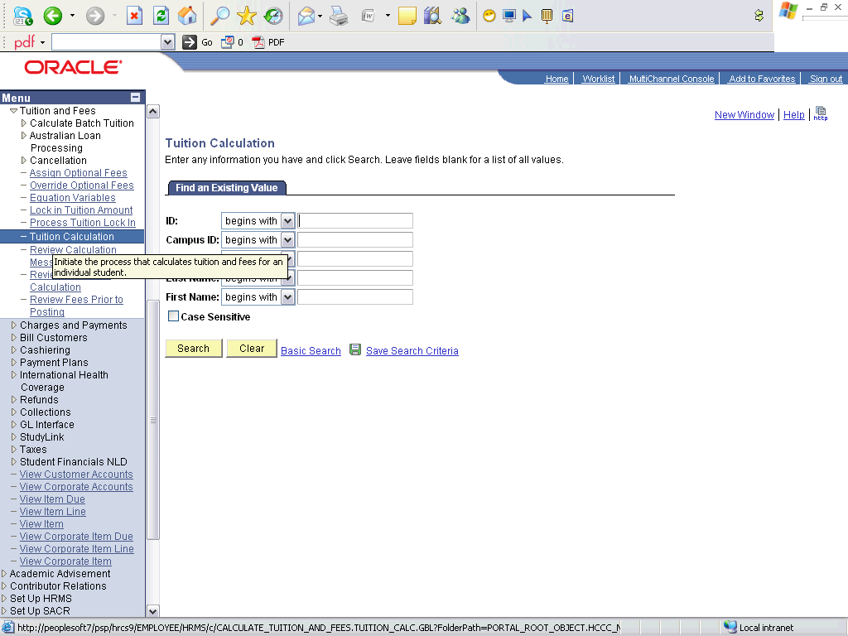

Step | Action
 | Enter the desired information into the ID field. Enter "2009desgn01".
 | Click the Search button.

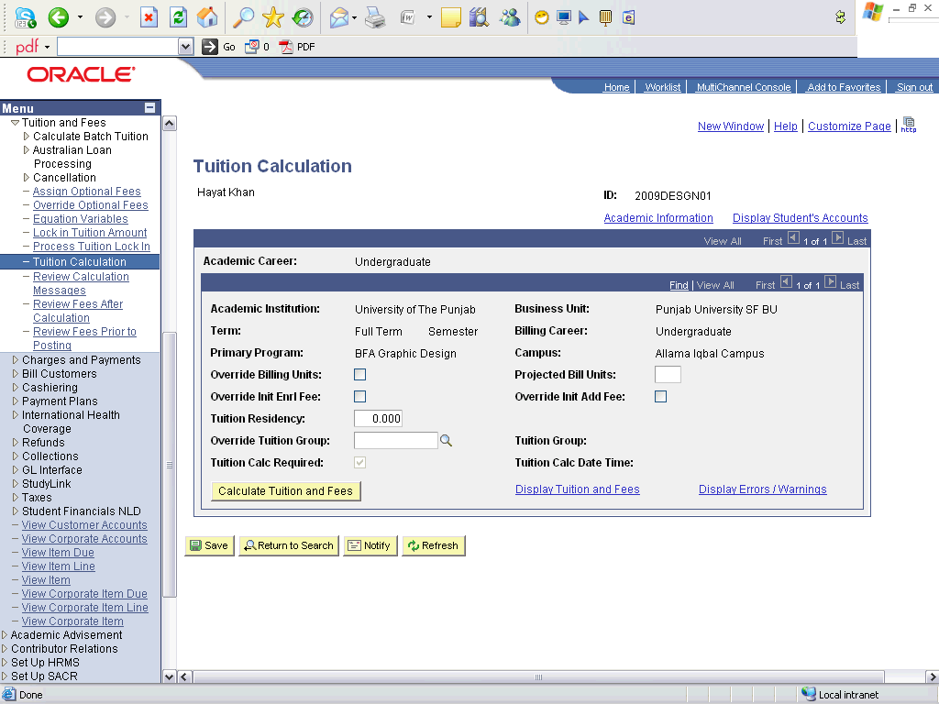

Step | Action
 | Click the Academic Institution: button.
 | Click an entry in the Display Tuition and Fees column.

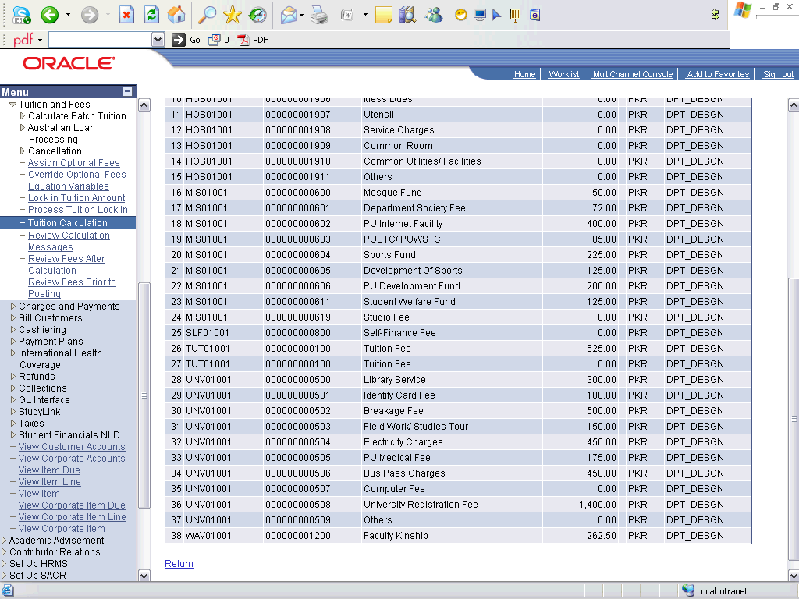

Step | Action
Click the object.
50% waiver on the tuition fee is automatically calculated and applied.
 | End of Procedure.

Applying Waivers - Manually

Procedure

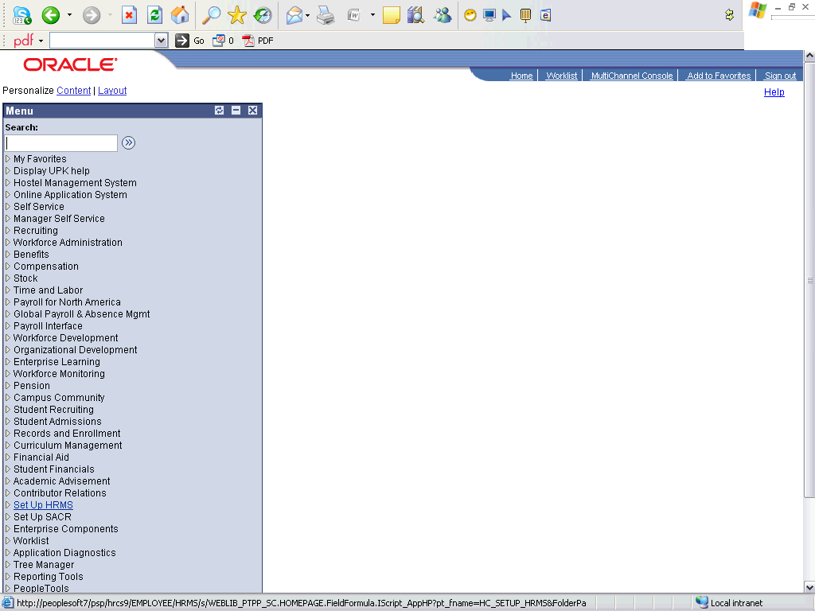

Step | Action
 | Click the Student Financials link.

Step | Action
 | Click the Charges and Payments link.
 | Click the Post Student Transaction link.

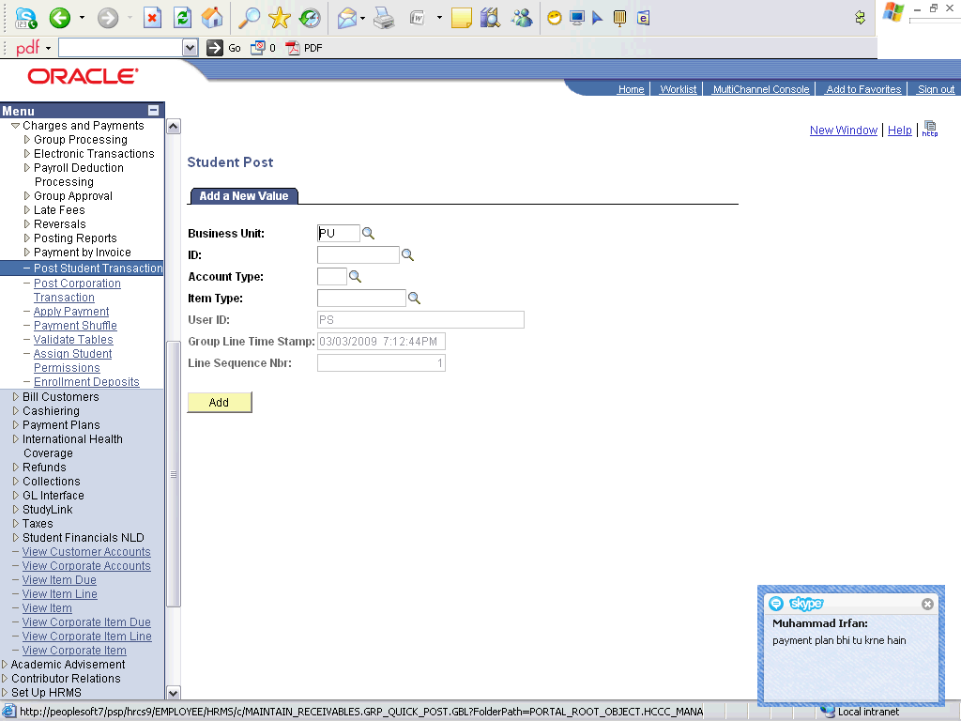

Step | Action
 | Enter the desired information into the ID field. Enter "0050".
 | Enter the desired information into the Account Type field. Enter "WAV".
 | Click the Look up Item Type (Alt+5) button.
 | Click an entry in the Description column.
 | Click the Add button.

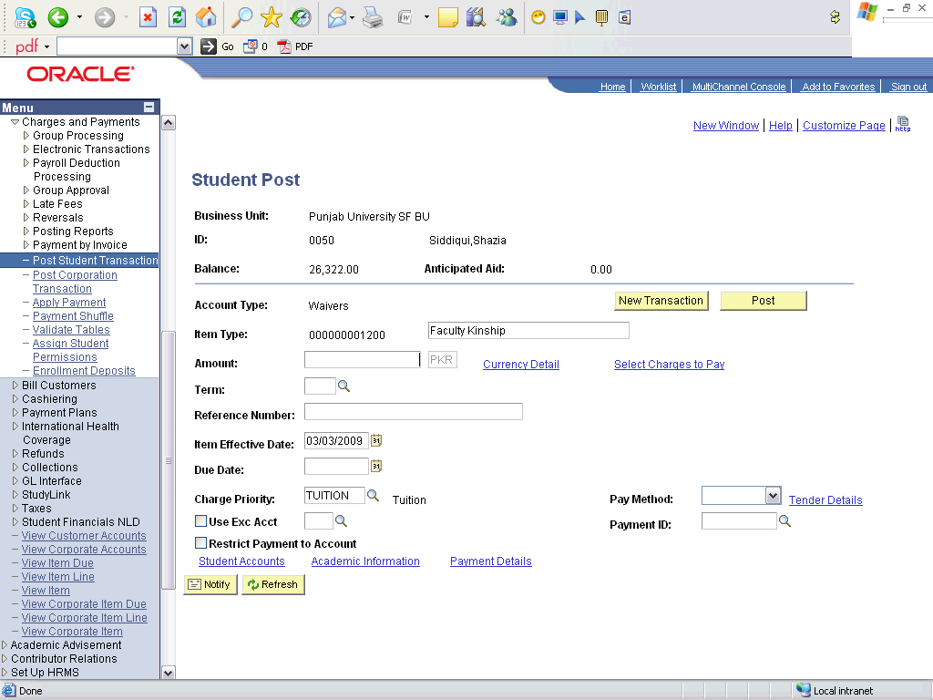

Step | Action
 | Enter the desired information into the Amount field. Enter "7500".
 | Enter the desired information into the Term field. Enter "0913".
 | Click the Post button.
 | Click the Student Accounts link.

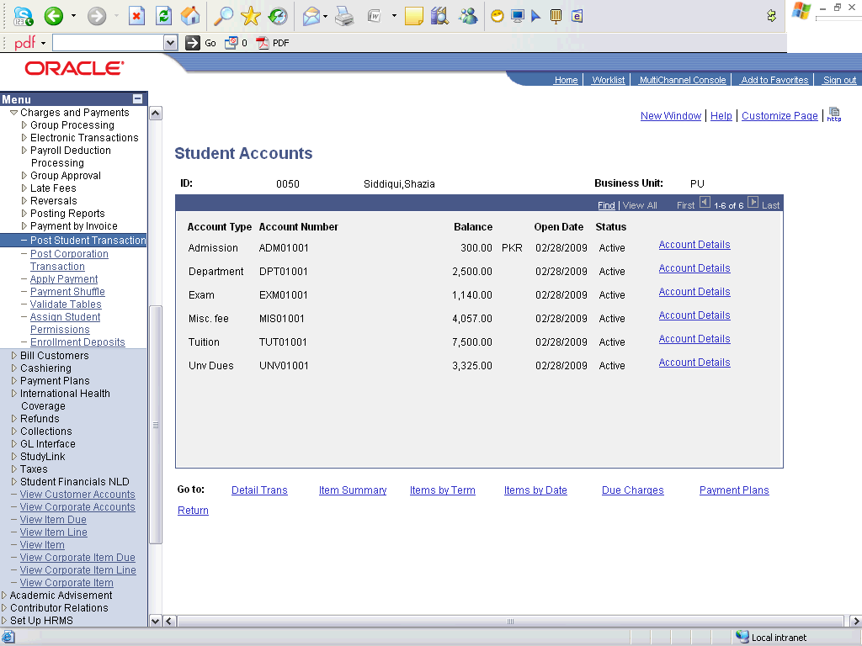

Step | Action
 | Click an entry in the Account Details column.

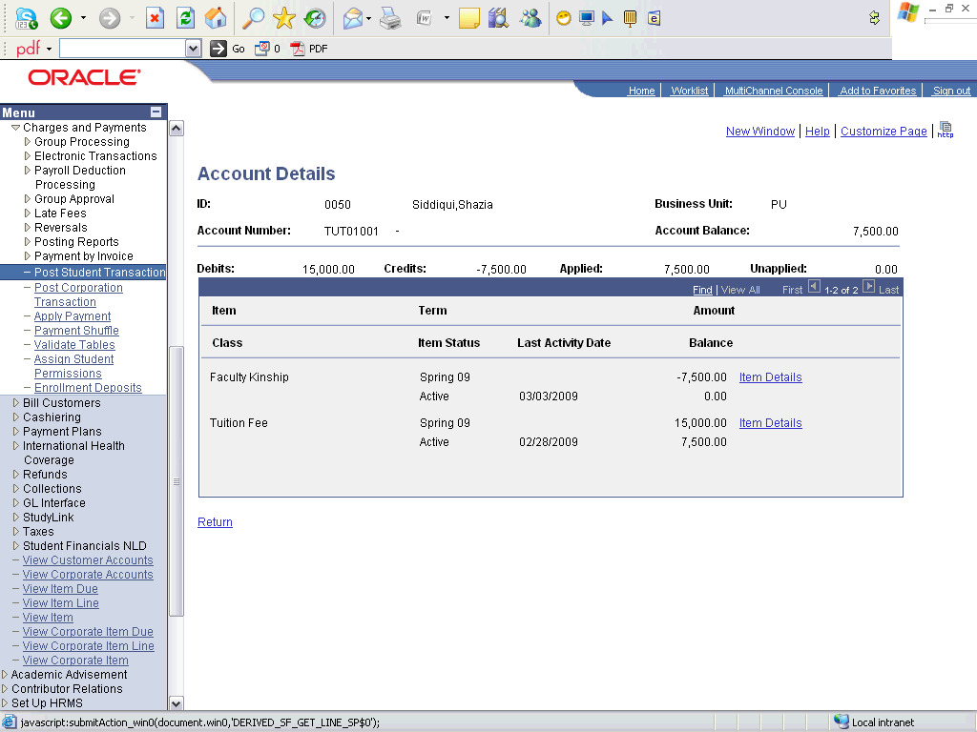

Step | Action
Click an entry in the Item Details column.
50% of the tuition fee has been waived off. Since the tuition fee was 15000 and waiver has waived off 7500 from the total for only the tuition fee.

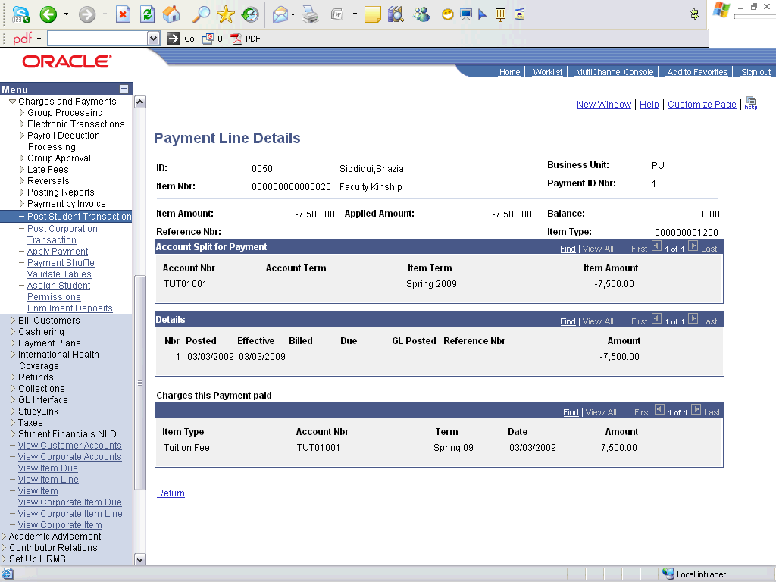

Step | Action
 | Point to the object.
 | End of Procedure.

Installments

Create Payment Plan

Procedure

Step | Action
 | Click the Student Financials link.

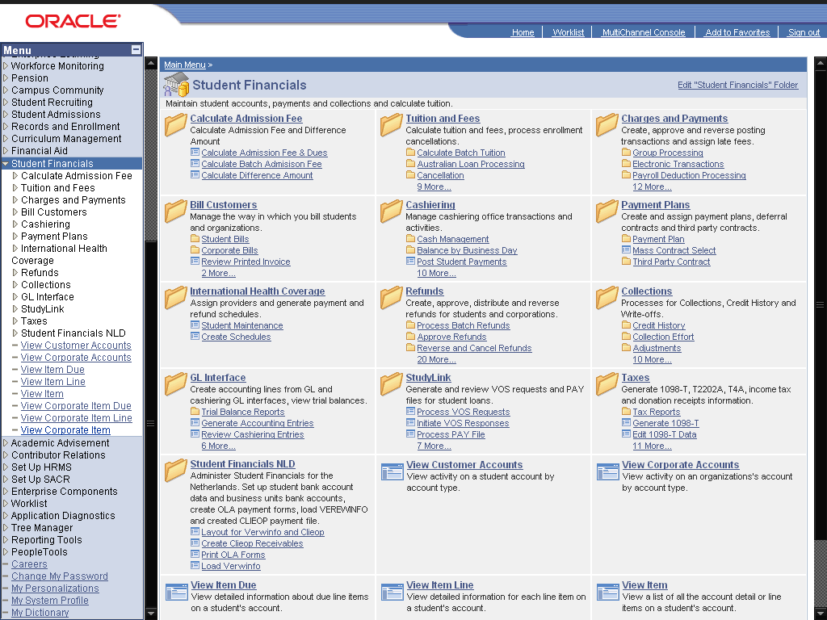

Step | Action
 | Click the Payment Plans link.
 | Click the Payment Plan link.
 | Click the Create link.

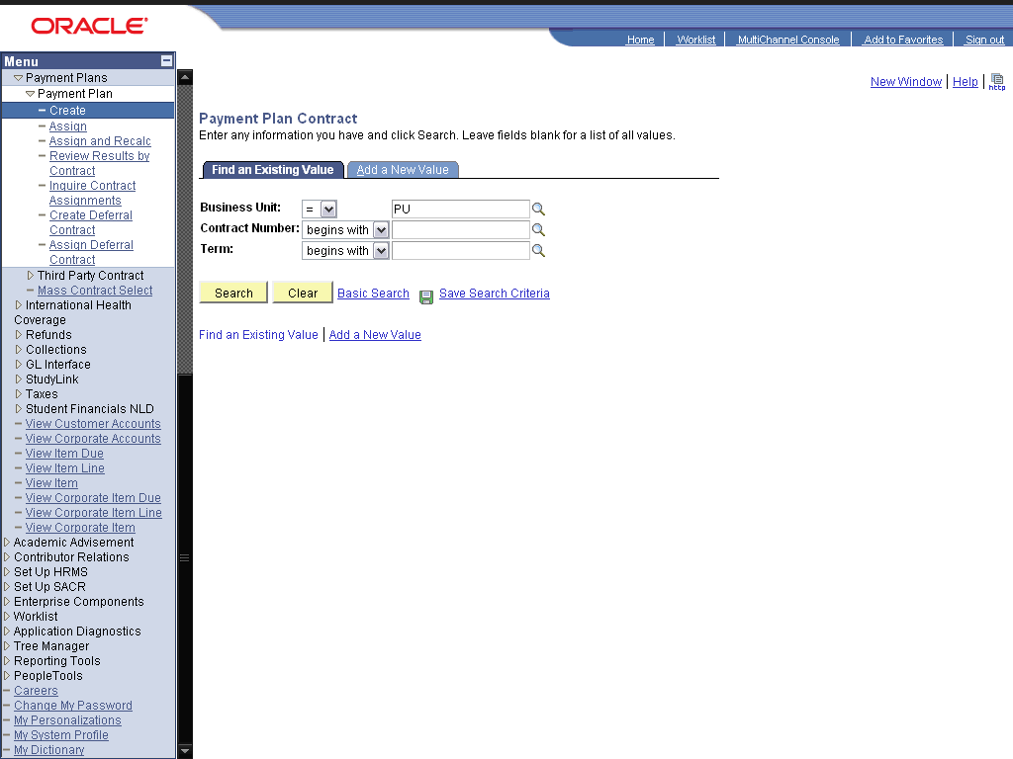

Step | Action
 | Click the dd a New Value link.
 | Click the Add button.
 | Enter the desired information into the Description: field. Enter "Spring 2009 Plan".
 | Enter the desired information into the Short Description: field. Enter "2009".
Enter the desired information into the Total Budget Amt: field. Enter "50000".
Enter total amount that can be the maximum limit of total installments of the students assigned to this payment plan.
Enter the desired information into the Payment Due Days: field. Enter "5".
Due days after the billing dates of payment plans.
Enter the desired information into the Number Of Payments: field. Enter "2".
Total number of installments
Enter the desired information into the Term: field. Enter "0091".
Term for which the payment plan is made
Enter the desired information into the Last Date: field. Enter "09/20/2009".
It should be the last date of the term
 | Click the Billing Cycle: list.

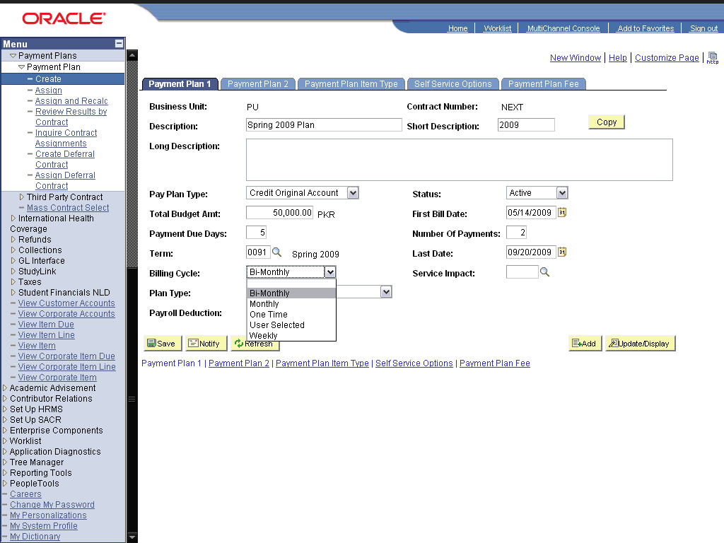

Step | Action
Click the Plan Type: list.
Select the billing cycle, that after how much time the next installment can be billed and can be made due for the students.

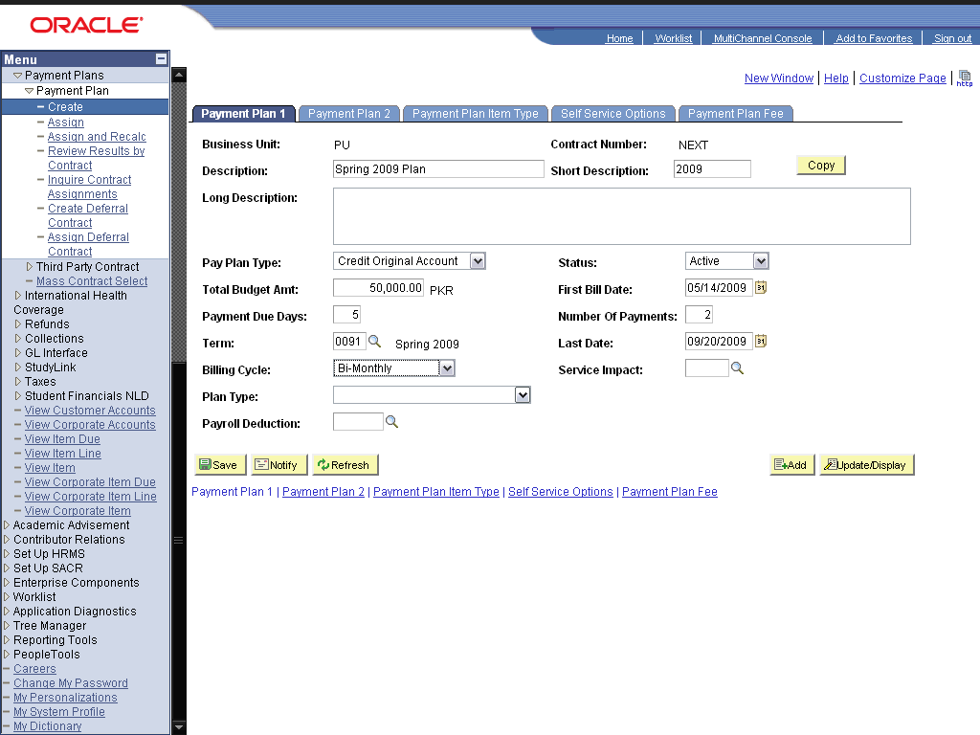

Step | Action
 | Click the Payment Plan 2 link.
 | Click the *Plan Type: list.

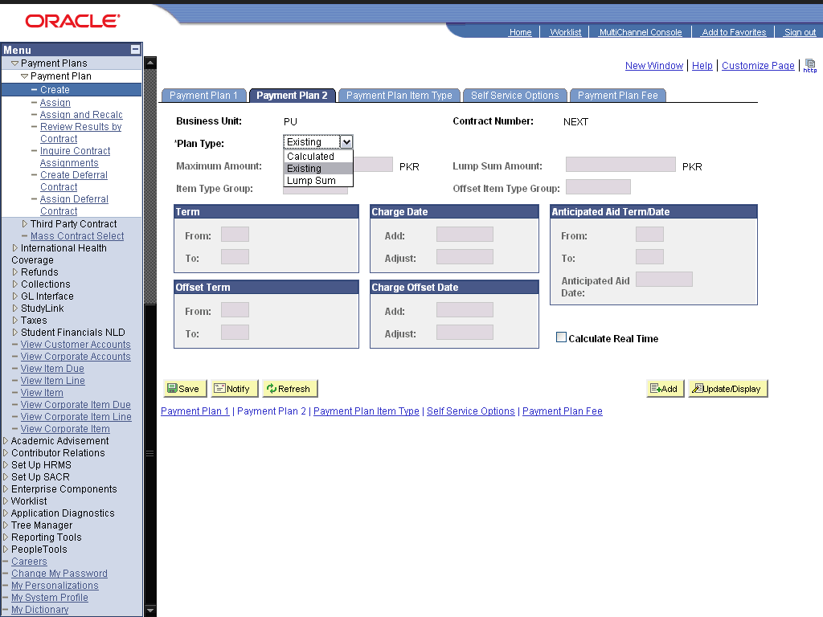

Step | Action
Click the cell.
Select "Calculated" in Plan Type. This value is selected so that the fee and installments are automatically calculated.

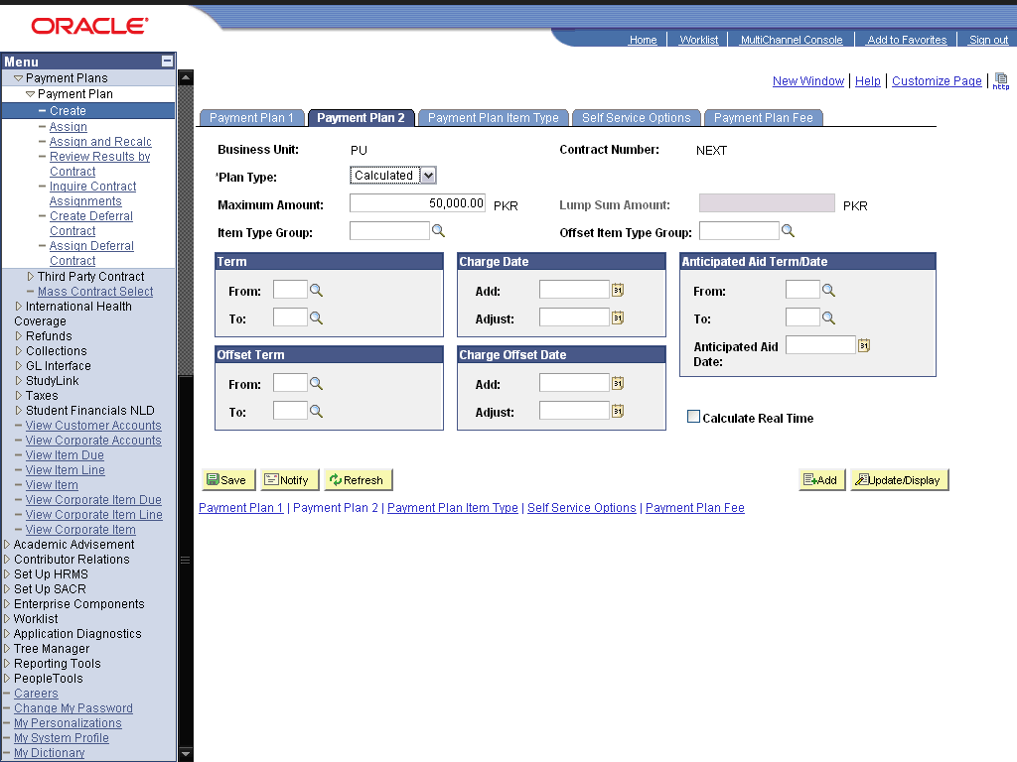

Step | Action
 | Enter the desired information into the Item Type Group: field. Enter "INSCHARGE".
 | Enter the desired information into the Offset Item Type Group: field. Enter "INSCHARGE".
 | Enter the desired information into the From: field. Enter "0091".
 | Enter the desired information into the To: field. Enter "0091".
Enter the desired information into the Add: field. Enter "01/01/2009".
It should be the term start date or some days before the term start date.
Enter the desired information into the Adjust: field. Enter "09/10/2009".
It should be a few days before term end date.
 | Enter the desired information into the From: field. Enter "0091".
 | Enter the desired information into the To: field. Enter "0091".
 | Enter the desired information into the Add: field. Enter "01/01/2009".
 | Enter the desired information into the Adjust: field. Enter "09/10/2009".
 | Click the Calculate Real Time option.
 | Click the Payment Plan Item Type link.
 | Click the Extra Payments Option: list.

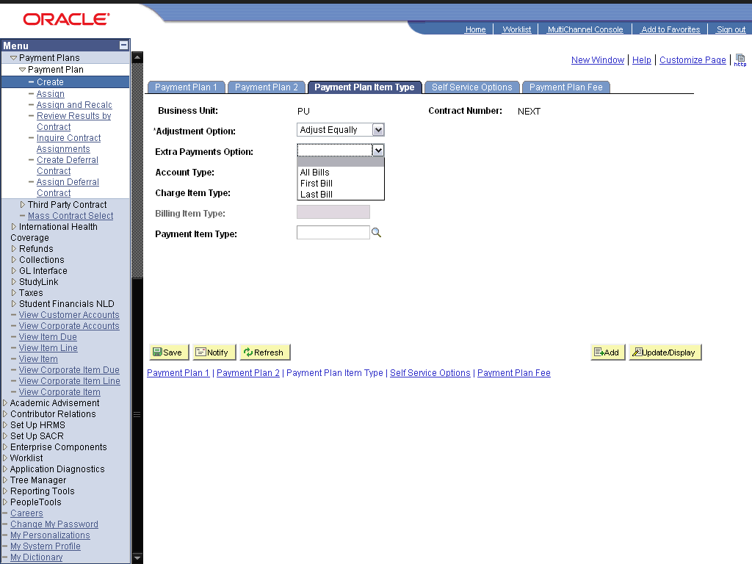

Step | Action
 | Click the cell.

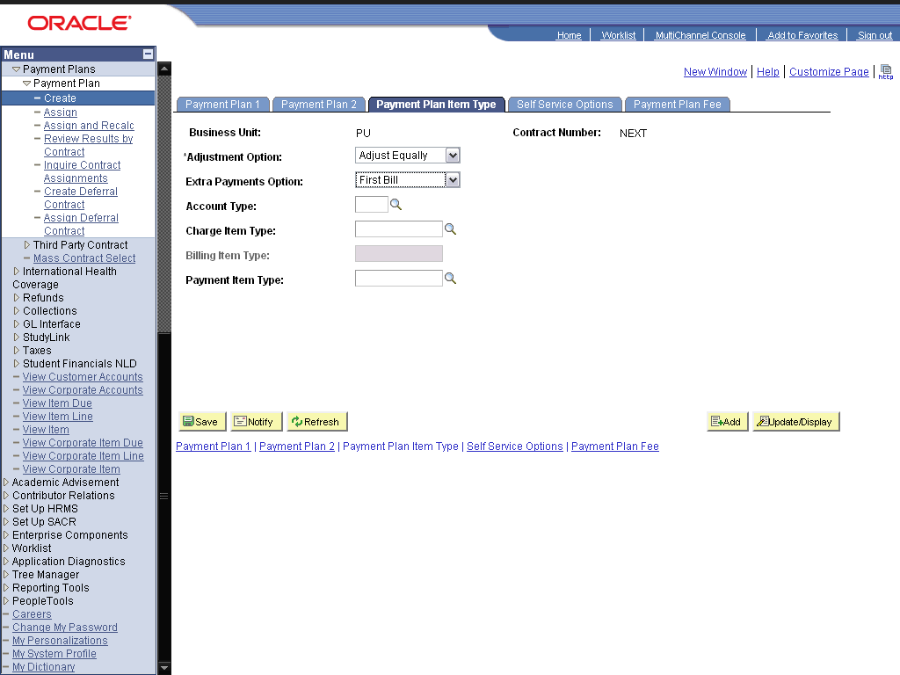

Step | Action
 | Enter the desired information into the Account Type: field. Enter "INS".
 | Click the Look up (Alt+5) graphic.
 | Click the 000000001500 link.
 | Click the Look up Payment Item Type (Alt+5) graphic.
 | Click the 000000001501 link.
 | Click the Save button.
 | End of Procedure.

Assign Payment Plan

Procedure

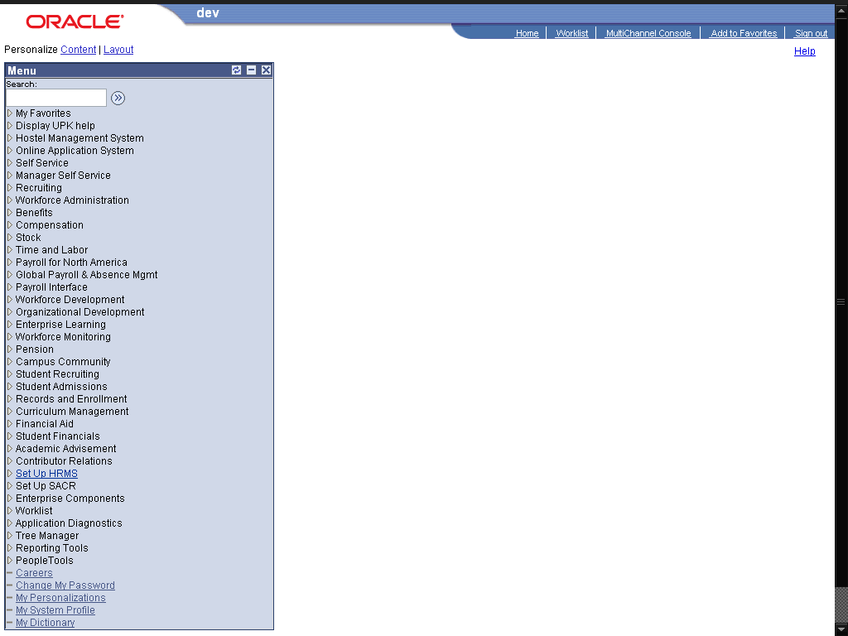

Step | Action
 | Click the Student Financials link.

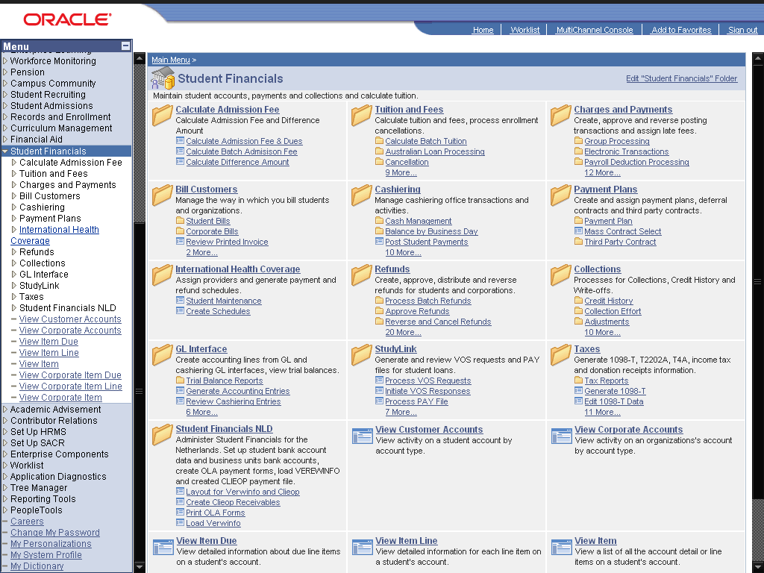

Step | Action
 | Click the Payment Plans link.
 | Click the Payment Plan link.
 | Click the Assign link.

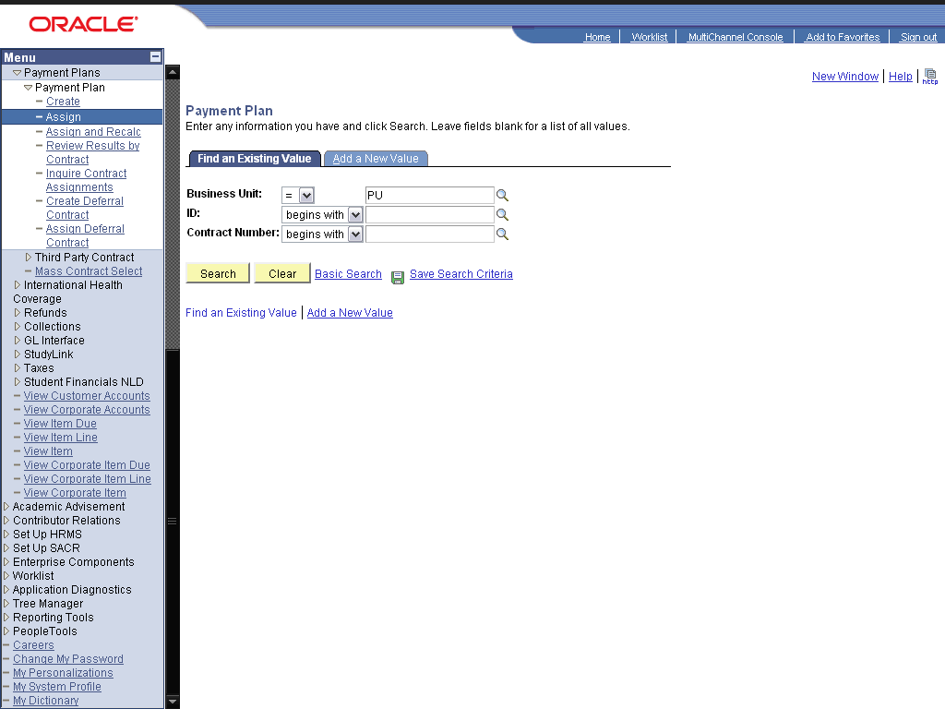

Step | Action
 | Click the dd a New Value link.
 | Enter the desired information into the ID: field. Enter "2009POL0001".
Enter the desired information into the Contract Number: field. Enter "5".
Enter the contract number i.e., the payment plan ID
 | Click the Add button.
 | Click the Payment Plan 2 link.
Click in the Payments: field.
You can change the number of payments for some students, if you want to.
 | Click the Post button.
Click in the Amount: field.
This is the total fee of the student that is divided into two equal installments for the students.

Step | Action
Click the Student Financials link.
Now we see the student account after assigning him/her to payment plan. The previous charges are paid and new charges of "Installment charge" is applied to student the number of times of its installments.

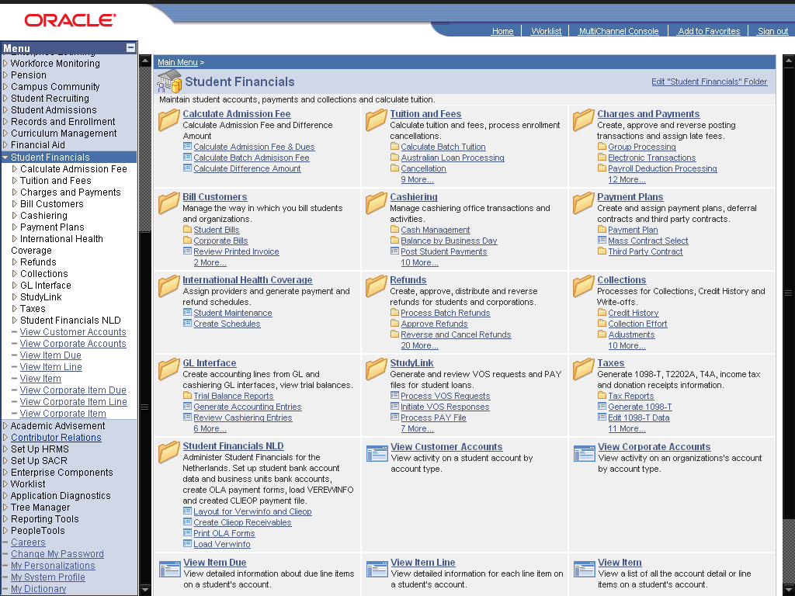

Step | Action
 | Click the View Customer Accounts link.

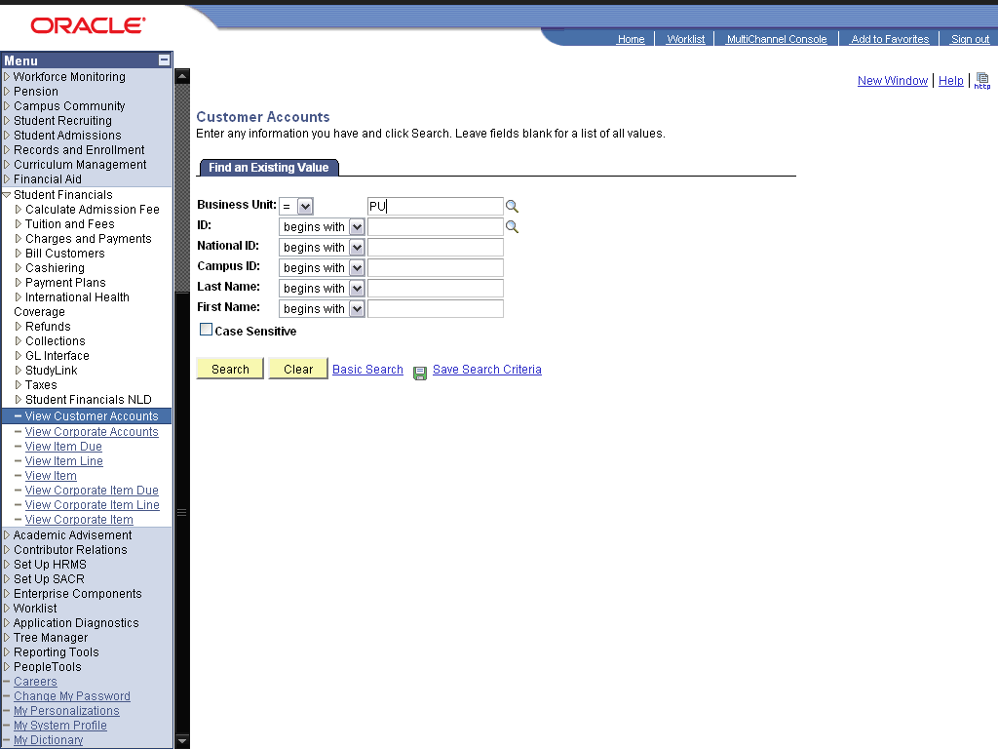

Step | Action
 | Enter the desired information into the ID: field. Enter "2009POL0001".
 | Click the Search button.
Click in the 6,272.00 field.
here you see that all charges (dues) applied to the student are paid by this installment, and an installment account is added with the total due fee.
 | Click the Account Details link.
Click in the 3,136.00 field.
Two installment charges are added to the account (since we made two installments for the student). These are of equal charges.
 | Click the object.
Click the Return link.
See the due date of the 1st installment. And also the effective date after which it can be billed.
 | Click the Item Details link.
Point to the 07/19/2009 object.
This is the due date of the second installment.
 | End of Procedure.

